Recreational Fishing Grants Program

Intermediate Grants

Guidelines and Conditions

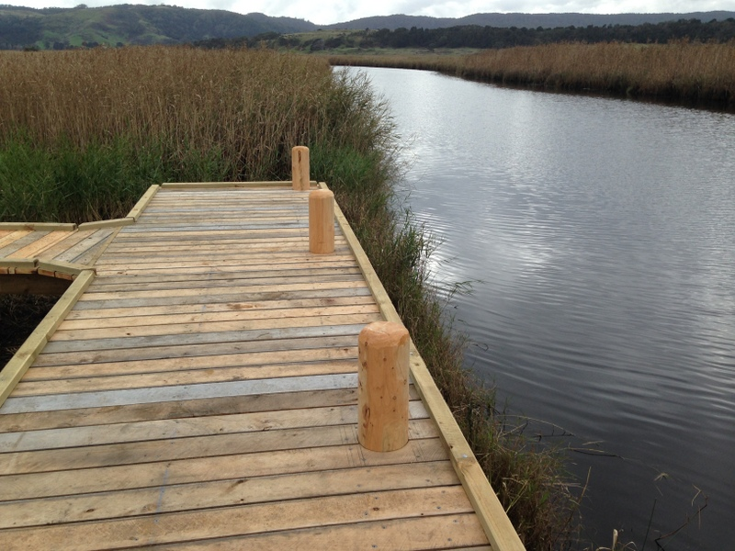

All Abilities Fishing Fish Platform, Aire River –
RFL funded project undertaken by the Association of Geelong and District Angling Clubs

recreational fishing grants program
Every year the Victorian Government, through the Recreational Fishing Licence Trust Account, disburses revenue derived from the sale of Recreational Fishing Licences to projects that will improve recreational fishing in Victoria.
The Recreational Fishing Grants Program consists of four separate programs;
- A Small Grants Program that is continually open to fund small projects (up to $5,000 - GST Exclusive)
- An Intermediate Grants Program that is continually open to fund medium sized projects ($5,001 to $50,000 - GST Exclusive)
- A Large Grants Program (for projects from $5,001 to $100,000 - GST Exclusive)
- A Commissioning Program for large priority projects (generally more than $100,000).

INTERMEDIATE GRANTS PROGRAM
The Intermediate Grants Program provides funding of up to $50,000 (GST exclusive) towards projects that improve recreational fishing.
The following guidelines and conditions are provided to assist grant applicants in preparing and submitting applications to the Intermediate Grants Program.
Please note that we may make the information that is provided by a grant applicant in a grant application publicly available.

- All projects must deliver a clear benefit to public recreational fishing in Victoria.
- Preference will be given to proposals which provide co-funding or in-kind financial contributions towards the overall cost of the project.
- Grants will be offered to incorporated angling clubs and associations, community groups and committees of management. Grants will not be available to individuals.
- Funding is limited and not all project applications can or will be supported. The Victorian Fisheries Authority will not enter into discussion regarding the outcomes of a successful or unsuccessful application.
- No projects will be funded on an ongoing basis, and only 90% of grant funding will initially be allocated for a project; the remaining 10% of project funding will be allocated on the timely and satisfactory completion of the project.
- The grant applicant will be responsible for any expenditure/costs over the approved amount of grant funding.
- The grant applicant will provide evidence of support from the relevant land/waterway managers for construction, ownership and ongoing maintenance of the asset.
- All funded projects must be completed within 12 months of signing a funding agreement. Variations and extensions may be sought where unforeseen circumstances arise, provided the project owner has provided Victorian Fisheries Authority staff with regular updates leading up to the request.

What is likely to be funded:

infrastructure and access projects (minor boat ramps or kayak launches/landings, access paths, jetties, platforms)

Fish cleaning tables

installation of instream habitat (woody, boulders, lunkers)

Riparian work (fencing, planting, stiles)

Reef establishment (estuarine, lakes)

Research (stock assessment of a local waterway, electrofishing).

What is unlikely to be funded:

Projects that do not provide a clear benefit for recreational fishers.
- Capital works and improvements to facilities that are not open and freely accessible to the fishing public.
- The purchase of any club equipment (e.g. fishing rods and reels, IT and audio-visual equipment, trailers, communal tinnies, etc.).
- Recreational fishing competitions and associated prizes, fundraising events, and activities primarily of a commercial nature.

Project Management Fees
Project management is the discipline of planning, organising, securing and managing resources to bring about the successful completion of specific project goals and objectives.
Preference will be given to projects where project management activities are undertaken as a financial or in-kind contribution by the project proponent(s).
However, the Victorian Fisheries Authority recognises that effective project management can make a significant contribution to the success of a project.
Applicants may include reasonable project management costs as an expense in their application, such as the cost of travel, accommodation, and meals which are a direct result of managing the project.
Grant recipients must maintain a record of how all project funds are expended, including any project management costs, and are required to provide a financial statement detailing all the costs being claimed. It is important to note that project management fees are to cover external costs incurred during the delivery of the project. They cannot subsidise existing internal costs and applicants are not entitled to derive an income from the grant funds allocated to the project.
The amount of project management costs which can be claimed will be capped at ten percent of the total grant amount. These costs will be considered on a case-by-case basis.
Project management activities claimed as an expense cannot also be claimed as an in-kind contribution for the project. In-kind costs should be shown separately.
Please call The Secretariat, Recreational Fishing Grants Program, on 8392 6872 during normal business hours or email: rec.fishinggrants@vfa.vic.gov.au for further information on project management.

Project Management Requirements
- To demonstrate a rigorous procurement process has been undertaken in line with the Victorian Fisheries Authority procurement guidelines.
- Obtain all relevant planning, environmental and development permits and approvals applying to the project;
- Demonstrate the project addresses and adheres to the relevant Australian standards in terms of design and safety standards;
- Provide evidence of sufficient public liability insurance as required, covering the project’s activities and outcomes.
- Demonstrate an ability to be able to operate and maintain the facility and to make a commitment to a future high standard of operation and maintenance;
- Be prepared to participate in on-site inspections of the project before, during and after the construction of a facility.
- Submit project updates (including photos) and progress reports before, during and after project completion. Online reporting at three-month intervals, or as requested; and
- Enter into a formal funding agreement with the Victorian Fisheries Authority.

The Application Process
For information on the opening and closing dates for the Intermediate Grants Program please visit the Victorian Fisheries Authority website. It is anticipated that the program will be open continuously as long as there is sufficient budget. Any change to this will be published on the Victorian Fisheries Authority website.
All enquiries and communications regarding a project proposal or related matter should be referred directly to:
The Secretariat, Recreational Fishing Grants Program
PO Box 4509, Melbourne VIC 3001.
Telephone: 8392 6872 during normal business hours
Email: rec.fishinggrants@vfa.vic.gov.au
Only proposals submitted in the prescribed template will be accepted.
The receipt of grant applications will be acknowledged in writing by The Victorian Fisheries Authority.
All eligible grant applications will be assessed and prioritised by the Recreational Fishing Grants Working Group (Working Group) whose role is to provide advice to the Minister for Fishing and Boating on the expenditure of all Recreational Fishing Licence Trust Account revenue. Information on the Working Group can be found at https://vfa.vic.gov.au/recreational-fishing/recreational-fishing-grants-program/grants-working-group
Grant applications that are recommended for funding by the Working Group will be referred to the Minister for consideration and approval as soon as practicable.
Following the Minister's approval to disburse funds to eligible projects, the Secretariat, will inform grant applicants of the success or otherwise of their application. It is expected that all grant applicants will be advised of the outcome within three months of the application being received.
There is no right of appeal in respect to any decision made to fund or not fund any proposed project and no correspondence will be entered into following an applicant's receipt of written advice that an application was unsuccessful.
Successful grant applicants will be required to:
- enter into a Project Funding Agreement
- submit regular Progress Reports as specified in the Project Funding Agreement
- submit an Acquittal/Final Report within 60 days of completing the project
- provide notification of any proposed variations or extensions to the project objectives, timetable, work plan or budget, by submitting a Project Variation application form, which will need to be assessed and approved by the Working Group
- Operate public liability insurance as required, covering the project's activities and outcomes, and
- Keep records of all expenditure associated with the grant for a minimum of five years.
- Include an audit opinion or certification by an independent auditor to verify that your financial reconciliation is a true and fair view of the income and expenditure of the project in your project acquittal. You will need to either upload a scan of the opinion or certification signed by an independent auditor with your Acquittal Report in the Acquittal. An independent auditor is a member of the Institute of Chartered Accountants, CPA Australia or the National Institute of Accountants, who is not employed by or related to the funding recipient.
Note: The Victorian Fisheries Authority reserves the right to inspect any project and/or request a financial/project implementation audit at any given time.
Funds will be allocated to successful projects as soon as possible following approval of the grant application. Grant applicants must submit a Tax Invoice or Invoice, made out to the 'The Victorian Fisheries Authority' or 'VFA' for payment of the grant. Tax Invoices or Invoices (as applicable) should be forwarded to The Secretariat, Recreational Fishing Grants Program, PO Box 4509, Melbourne VIC 3001 or Email: rec.fishinggrants@vfa.vic.gov.au
Any unspent RFL project funds must be returned no later than 60 days after the completion of the project. Cheques for such payments shall be made out to 'The Victorian Fisheries Authority' or 'VFA' and forwarded to The Secretariat, Recreational Fishing Grants Program, PO Box 4509, Melbourne VIC 3001.

Goods and Services Tax
- With the exception of any grant that qualifies as an ‘appropriation’ by way of payments made between ‘government related entities’ for general funding arrangements or non-commercial transactions, grant payments made under this program will be inclusive of GST and project costings should also be inclusive of the GST.
- Withholding tax will apply where grant recipients are unable to provide an ABN and the supplier does not satisfy reason/s for their exemption from the tax as stated on the Australian Taxation Office’s Statement by supplier – Reason for not quoting an Australian Business Number (ABN) to an enterprise.

Promotion and Branding
A common condition of Victorian government funding for services or project activity is that recipients must agree to follow the Victorian Fisheries Authority’s guidelines for acknowledging the government’s funding.
Successful applicants will be required to acknowledge the government’s funding support on signage, in published or printed materials, speeches, or other forms of presentations.
Detailed guidelines on Promotion and Branding will be provided as part of a funding agreement.

