Target One Million

Better Fishing Facilities Fund

Guidelines and Conditions

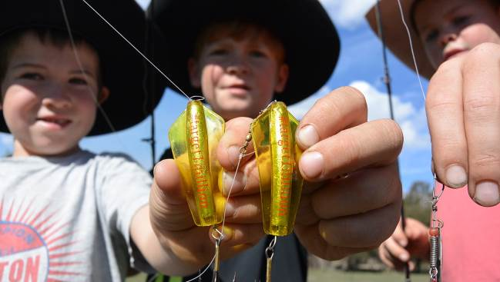
Young Anglers from the Corryong Fishing Club

Target one million
The government has allocated $46 million over 4 years to deliver a range of commitments under the Target One Million program to grow recreational fishing in Victoria.
One of the key components of the Target One Million program is the delivery of the Better Fishing Facilities grants program which will guide investment into;
- Recreational fishing reefs and Fish Aggregating Devices (FADS),
- improving access for land and boat based fishers, and;
- delivering better recreational fishing facilities and infrastructure.

Better Fishing Facilities Grants Program
The Better Fishing Facilities grant program provides funding up to $100,000 towards recreational fishing infrastructure and access projects.
The following guidelines and conditions are provided to assist grant applicants in preparing and submitting applications to the Better Fishing Facilities grants program.

- All projects must deliver a clear benefit to, and have the support of recreational fishers.
- Projects which lead to increased participation will be given priority for grant funding.
- Preference will be given to proposals which provide co-funding or in-kind financial contributions towards the overall cost of the project.
- Where the projects benefits are shared with user groups other than recreational fishers co-funding will be sought.
- Grants will be offered to statutory bodies/government agencies and incorporated bodies/associations. Grants will not be available to individuals.
- Funding is limited and not all project applications can or will be supported. The Victorian Fisheries Authority will not enter into discussion regarding the outcomes of a successful or unsuccessful application.
- No projects will be funded on an ongoing basis, and only 80% of grant funding will initially be allocated for a project; the remaining 20% of project funding will be allocated on the satisfactory completion of the project.
- The grant applicant will be responsible for any expenditure/costs over the approved amount of grant funding.
- Provide evidence of support from the relevant land/waterway managers for construction, ownership and ongoing maintenance of the asset.
- All funded projects must be completed within six months of signing a funding agreement. (Variations and extensions may be sought where unforeseen circumstances arise, provided the project owner has provided Victorian Fisheries Authority staff with regular updates leading up to the request.)

What is likely to be funded?:
Projects that improve access to marine, estuarine and inland waters for boat based fishers by:
- Installing new or upgrading existing boat launching facilities
- Installing new and upgrading existing jetties and pontoons to assist launching and retrieval of vessels
Improve access to marine, estuarine and inland waters for land based fishers by:
  - Re-opening or upgrading tracks and roads to popular land based fishing locations,
  - Building new or upgrading existing piers and jetties
  - Installing pedestrian styles
Improve facilities at popular recreational fishing locations including:
- Provision of lighting
- Provision of seating and shelters
  - Install fish cleaning tables/facilities
  - Install educational and informative signage

Develop new or expand existing recreational fishing reefs to benefit recreational fishing species
Deploy Fish Aggregating Devices (FADS) for popular recreational species
Restore and enhance riparian and aquatic habitat for recreational fishing species

What is unlikely to be funded:
- Projects that do not provide a clear benefit for recreational fishers.
- An project that reduces public access, or provides access and/or facilities for select groups only (other than those with special needs).
- Any ‘dredging’ works related to boat launching facilities.
- Reduce or restrict other access opportunities in surrounding area as a consequence of the proposed works.

Requirements of all grant recipients
- To demonstrate a rigorous procurement process has been undertaken in line with organisational policy, prior to the approval of works. In the absence of a procurement policy, the recipient must adhere to the Victorian Fisheries Authority procurement guidelines.
- Obtain all relevant planning, environmental and development permits and approvals applying to the project;
- Demonstrate the project addresses and adheres to the relevant Australian standards in terms of design and safety standards;
- Provide evidence of sufficient public liability insurance as required, covering the project’s activities and outcomes.
- Demonstrate an ability to be able to operate and maintain the facility and to make a commitment to a future high standard of operation and maintenance;
- Be prepared to participate in on-site inspections of the project before, during and after the construction of a facility. Submit project updates and progress reports at three month intervals, or as necessary; and
- Enter into a formal funding agreement with the Victorian Fisheries Authority.

Project Management Fees
The Victorian Fisheries Authority recognises that effective project management can make a significant contribution to the success of a project. However Project Management Fees are widely considered an ‘in-kind’ contribution towards a project.
For clarification or to discuss please contact Victorian Fisheries Authority on (03) 8392 6833 during business hours or email: improving.fishing@vfa.vic.gov.au

The Application Process
The Better Fishing Facilities Program has no defined opening or closing dates for the receipt of grant applications. It is anticipated that each year the program will run for as long as budget remains, with any change to be published on the Victorian Fisheries Authority website.
All enquiries and communications regarding a project proposal or related matter should be referred directly to the appropriate Project Officer or to the Target One Million team. Potential applicants are encouraged to contact a Project Officer at their earliest convenience to discuss the likelihood of a project receiving funding. Project Officers can be contacted on 8392 6833, or via email improving.fishing@vfa.vic.gov.au
Only proposals submitted in the prescribed template will be accepted. The receipt of grant applications will be acknowledged in writing by the Victorian Fisheries Authority.
All eligible grant applications will be assessed and prioritised by Victorian Fisheries Authority.
Following approval to disburse funds to eligible projects, grant applicants will be informed of the success or otherwise of their proposal. There is no right of appeal in respect to any decision made to fund or not fund any proposed project.
Successful grant applicants will be required to:
- Enter into a Project Funding Agreement;
- Demonstrate public liability insurance as required, covering the project’s activities and outcomes.
- Undertake procurement activities in line with the Victorian Fisheries Authority Procurement Policy.
- Notify Victorian Fisheries Authority of any proposed variations or extensions to the project objectives, timetable, work plan or budget. The proponent will need to submit and have approved a Project Variation Application form; and
- Submit a Final Report and Grant Acquittal within 60 days of completing the project;

Goods and Services Tax
- With the exception of any grant that qualifies as an ‘appropriation’ by way of payments made between ‘government related entities’ for general funding arrangements or non-commercial transactions, grant payments made under this program will be inclusive of GST and project costings should also be inclusive of the GST.
- Withholding tax will apply where grant recipients are unable to provide an ABN and the supplier does not satisfy reason/s for their exemption from the tax as stated on the Australian Taxation Office’s Statement by supplier – Reason for not quoting an Australian Business Number (ABN) to an enterprise.
- Refer to Appendix A for the purchasing thresholds and design drawings and work permit requirements that apply to the grants program.

Promotion and Branding
A common condition of Victorian government funding for services or project activity is that recipients must agree to follow the Department’s guidelines for acknowledging the government’s funding. Aligning with the current Victorian government branding and funding acknowledgment guidelines.
Successful applicants may also be required acknowledge the government’s funding support on signage, in published or printed materials, speeches, or other forms of presentations.
Detailed guidelines on Promotion and Branding will be provided as part of a funding agreement.
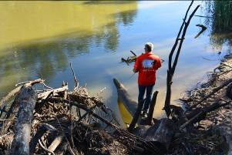
Target One Million – Better Fishing Facilities

