The use of slot limits to improve the Victorian Murray cod fishery

Consultation paper

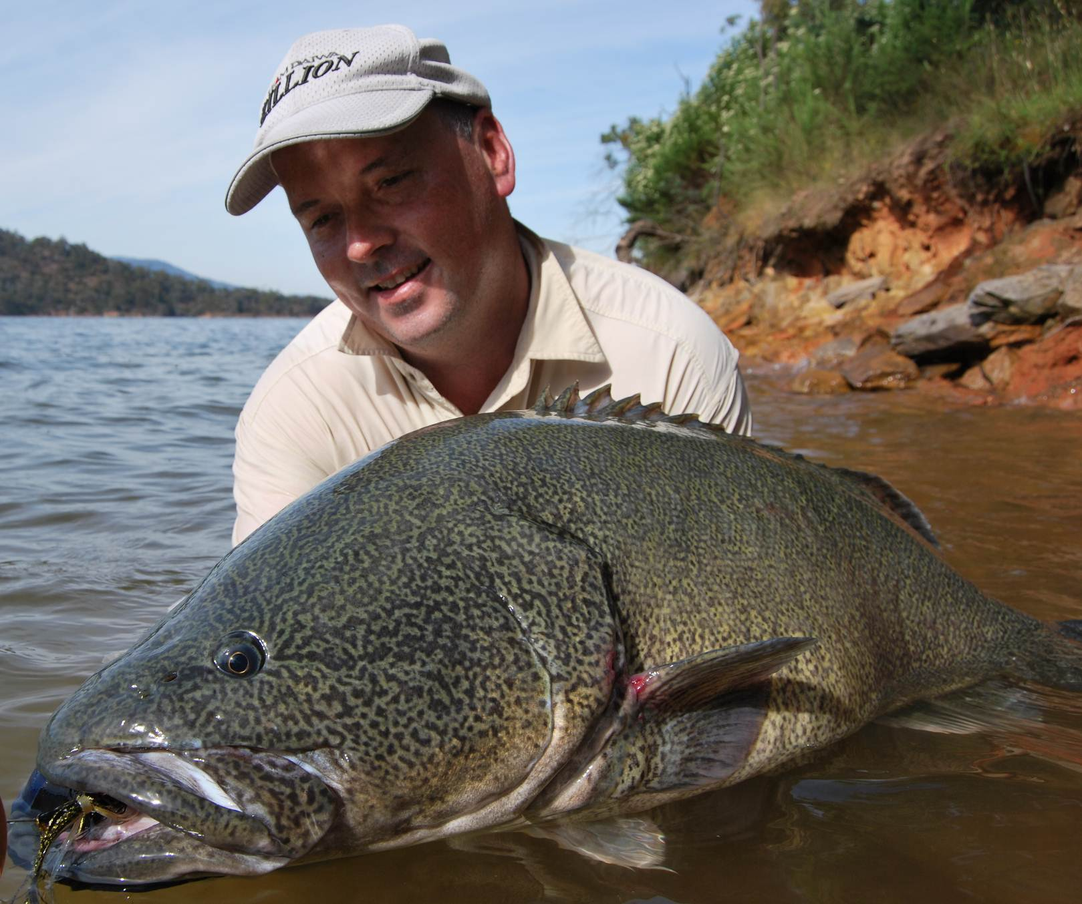

© The Department of Environment and Primary Industries 2014
 State of Victoria
This work is licensed under a Creative Commons Attribution 3.0 Australia licence. You are free to re-use the work under that licence, on the condition that you credit the State of Victoria as author. The licence does not apply to any images, photographs or branding, including the Victorian Coat of Arms, the Victorian Government logo and the Department of Environment and Primary Industries logo. To view a copy of this licence, visit http://creativecommons.org/licenses/by/3.0/au/deed.en
Printed by Impact Digital, Brunswick.
ISBN 978-1-74146-025-4 (Print)
ISBN 978-1-74146-026-1 (pdf)
Cover photo: Marc Ainsworth with a 103 cm Murray cod caught at Lake Eildon (Photo source: Marc Ainsworth)
Accessibility
If you would like to receive this publication in an alternative format, please telephone the DEPI Customer Service Centre on 136186, email customer.service@depi.vic.gov.au, or via the National Relay Service on 133 677 www.relayservice.com.au. This document is also available on the internet at www.depi.vic.gov.au

Disclaimer
This publication may be of assistance to you but the State of Victoria and its employees do not guarantee that the publication is without flaw of any kind or is wholly appropriate for your particular purposes and therefore disclaims all liability for any error, loss or other consequence which may arise from you relying on any information in this publication.

Contents
Overview 2
Introduction 3
Victoria’s Murray cod fisheries 4
Murray cod populations and recreational fishing 5
Discussion 6
Slot limits: What are they? 6
Historical approach to managing recreational take of Murray cod 6
Are the current fishery management actions effective? 7
Slot limit research and modelling for Murray cod 8
Which slot limits deliver the most benefits to the Murray cod fishery? 8
Why do slot limits work for Murray cod? 9
What are the social considerations? 10
Compliance issues across the basin 10
Victorian Murray cod reference group workshop 10
Comparison with the proposed New South Wales Murray cod slot limit approach 10
Conclusions 13
We want your comments 14
References and further reading 15
Appendix: Victorian Murray cod Reference Group 16
Terms of Reference 16
Workshop 16

Overview
Murray cod are an iconic Australian native fish species that is highly valued by recreational fishers. In 2011 and 2012, Victorian Department of Environment and Primary Industries scientists examined current and past bag and size limits against a range of harvest slot limits. This consultation paper explores the use of slot limits as an alternative fishery management tool to optimise Murray cod fishery benefits. It also takes into account the social and compliance issues associated with introducing slot limits in the context of a Murray-Darling Basin Murray cod fishery.
The scientific analyses showed that the slot limits of 40 to 60 cm, 50 to 60 cm and 50 to 70 cm, when compared to current and past regulations, will build Murray cod populations over time, increasing the number of Murray cod available for recreational fishers to harvest and increase the number of larger mature brood fish which are protected by regulation. In light of this research, a series of options were presented to a reference group of recreational fishers, fisheries managers and researchers. The reference group strongly supported implementation of a 50 to 70 cm slot limit state-wide for Murray cod, with a reduction in bag limit from 2 to 1 fish per day in rivers whilst maintaining the bag limit in impoundments at 2 fish per day.
This advice and subsequent discussion with key recreational fishing stakeholder bodies leads Fisheries Victoria to propose the introduction of these regulation changes by Fisheries Notice. It is believed that these regulation changes will further improve populations and fisheries of Murray cod in Victoria. Recreational fishers are encouraged to provide feedback on this proposal as part of a Fisheries Notice public consultation process.

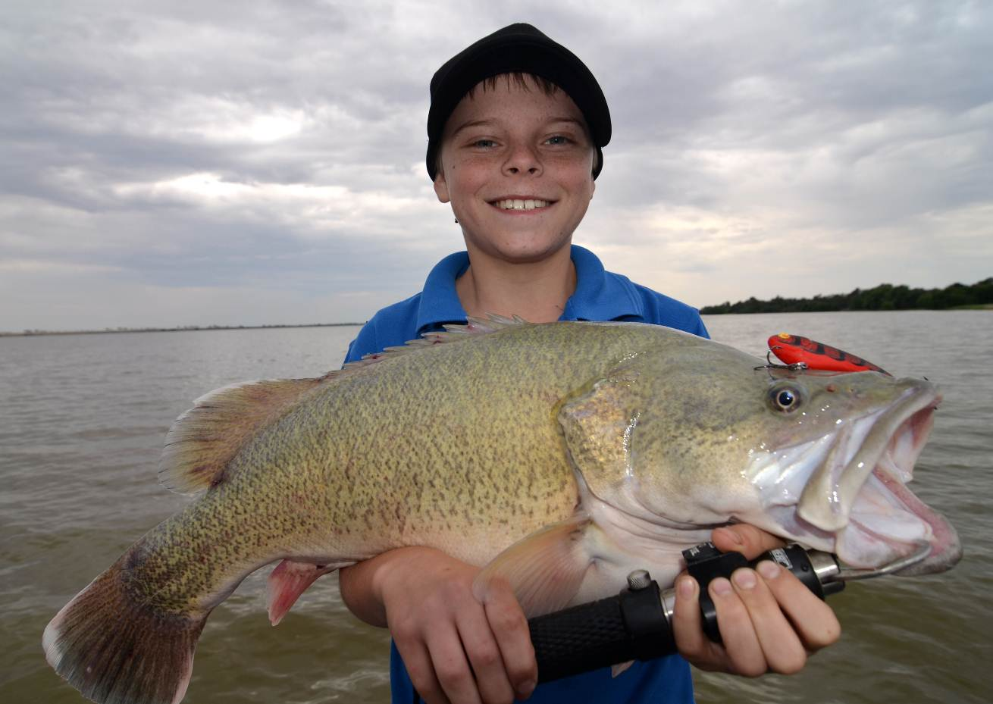
Jock MacKenzie with a Murray cod caught at Kangaroo Lake near Kerang (Photo source: Rod MacKenzie)

Introduction
Murray cod is an iconic Australian native fish of the Murray-Darling Basin (MDB) that is highly valued by recreational fishers. Once a significant part of the inland commercial fishery, Murray cod are no longer harvested for sale from
public waters. Murray cod are a species of national significance under the Environment Protection and Biodiversity Conservation (EPBC) Act and are listed as threatened internationally and under Victoria’s Flora and Fauna
Guarantee Act.
While Murray cod populations have declined significantly from early-European settlement levels, researchers and recreational fishers have observed an appreciable increase in the abundance and size of Murray cod in some Victorian waters over the last decade. Key factors likely to be contributing to this trend include: Fishery regulations that constrain recreational fisher take e.g. size and bag limits
- Increases in fish stocking
- Adoption of improved fishing technology / methods leading to higher catch rates
- Changing fishing attitudes (increase in the number of caught Murray cod released)
- Habitat rehabilitation (re-snagging) and improved connectivity (fishways)
Notwithstanding some positive signs of recovery in some Murray cod populations, there remains a long-list of ongoing threats that continue to impact on native fish populations including; barriers to fish migration, irrigation infrastructure, reversed seasonal irrigation flows, land clearing and siltation, invasive aquatic pests, removal of woody habitat, pollution and illegal fishing.
The establishment of a coordinated Murray Cod Fishery Management Group (MCFMG) across the Murray-Darling Basin is focusing efforts to recover Murray cod populations by addressing some of the key threats to this fishery. Importantly the MCFMG is looking to establish more reliable and cost effective ways of monitoring Murray cod populations in collaboration with recreational fishers and research organisations (Forster 2011).

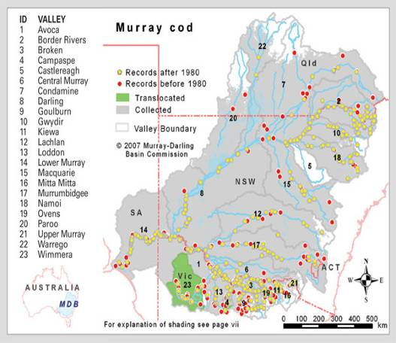
Figure 1. Recorded distribution of Murray cod in the Murray-Darling Basin (Murray Darling Basin Authority)

Victoria’s Murray cod fisheries
Murray cod are native to the MDB including Victorian Rivers and lakes north of the Great Dividing Range. This includes river basins of the Upper Murray, Kiewa, Ovens, Broken, Goulburn, Campaspe, Loddon and Avoca Rivers (Figure 1). Murray cod have also been successfully introduced into the Wimmera River basin and the Yarra River. Murray cod breed naturally in most waters but populations are also enhanced with fish stocking. Popular Murray cod fisheries are shown in Table 1. In 2011/2012, more than one million Murray cod were stocked into 32 Victorian rivers, lakes and impoundments (Figure 2).
Table 1. Popular Victorian Murray cod fisheries.
Lakes | River reaches
Lake Eildon | Loddon River (weir pools)
Lake Nillahcootie | Campaspe River (weir pools)
Kangaroo Lake | Goulburn River (downstream of Nagambie)
Lake Nagambie | Broken River (lower reaches)
Taylor Lakes | Gunbower Creek
Lake Eppalock | Kiewa River (lower reaches)
Kow Swamp | Ovens River (lower reaches)
With the exception of the Ovens River, the listed rivers or lakes are stocked by Fisheries Victoria

Figure 2. Numbers of Murray cod stocked throughout Victoria from 1999-2013.

Management of Murray cod populations in river reaches generally focusses on the long-term sustainability of wild self-recruiting populations; whereas Murray cod in lakes are mainly managed by stocking hatchery fish i.e. “put and take’. For this reason, different fishery management strategies may be considered for ‘wild’ riverine Murray cod fisheries and stocked impoundment fisheries.
Current Victorian recreational fishery regulations to specifically protect Murray cod include:
- a bag / possession limit of 2 fish,
- an annual closed season from 1 September to 30 November,
- A minimum size of 60 cm and a maximum size limit of 100 cm.

Murray cod populations and recreational fishing
In recent years anglers and researchers alike noticed that Murray cod populations in highly-fished rivers contained relatively few fish larger than the legal minimum length (Figure 3). In a Fisheries Victoria survey of the recreational fishery for Murray cod in five river reaches in 2006-2007 and 2007-2008, anglers released between 58% and 95% of their total catch. However, most of these fish were released because they were smaller than the legal minimum length, which were 50 cm and 55 cm in respective seasons . Release rates of Murray cod larger than the legal minimum length (i.e. “voluntary release rates”) were much lower – from 0% to 32% released depending upon the river reach. Trials suggest a very high proportion of Murray cod that are caught and released by angling methods survive this process . Nevertheless, there remains an ongoing need to promote best practice release methods because catch and release is popular and wide-spread and poor practices may impact fish of all sizes.
The impacts of recreational fishing on Murray cod populations and their size distribution (refer Figure 3) is more likely to be noticed in rivers where there is expected to be relatively more fishing pressure compared to lakes. The Murray cod population length distribution histogram below is typical and strongly suggests angling pressure is directly influencing the abundance of Murray cod above the legal minimum size of 60 cm. This pattern of skewed population size distribution is evident in many rivers throughout Victoria where Murray cod are targeted by recreational fishers

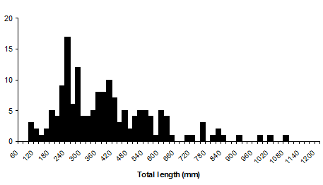
Murray cod abundance
Figure 3. This research data sourced from the mid-Murray river region shows an example of the typical size structure of a sample of Murray cod in rivers caught after the regulation change to a 600 mm (dashed line) legal minimum length.

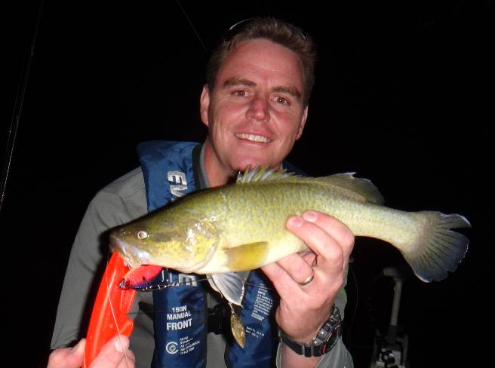
Jarrod Martin with a small Murray cod of common size in many populations. (Photo source: Tim Curmi)

Discussion

Slot limits: What are they?
Slot limits are a form of size regulation that set both a minimum and a maximum size to create a window where fish can be taken by anglers, i.e. fish can only be taken when their length is within a prescribed length “slot”.
Slot limit regulations protect the larger breeding fish from angler harvest and by doing so create a higher brood stock population. The width of the slot limit (between the lower and upper size limits) can be used to lower total harvest i.e. the narrower slot width, the less fish are available to remove from the population. Upper slot limits are often used to reduce the take of larger mature fish necessary for breeding purposes while lower limits protect the small ones, while enabling relatively abundant medium-sized fish to be taken. The current Victorian recreational fishery regulations for Murray cod include a wide slot length limit of 60 cm minimum size and a 100 cm maximum size.
While slot limits have been widely used for many years to manage recreational fisheries worldwide , their potential to improve recreational fisheries has only recently been recognised in Australia. For example in 2012, Fisheries Victoria introduced slot limits for Dusky Flathead in Gippsland Lakes of 30 cm to 55 cm. In this case the rationale was to limit the potential over-harvested of large female brood fish that could impact on breeding and recruitment to the fishery. Recent anecdotal feedback suggests the average size of flathead in Lake Tyers has increased since the introduction of slot limits, although this is yet to be confirmed by fishery independent studies.
For a range of fish species over a long time, anglers have promoted the message that we need to “put the big females back, to ensure we protect the future of the fishery.” Slot limits are a key management tool to regulate this in a recreational fishery.
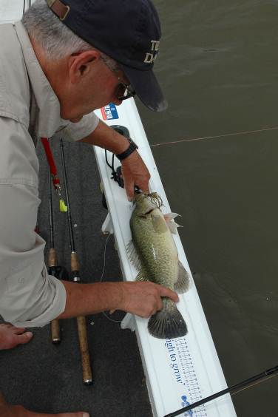
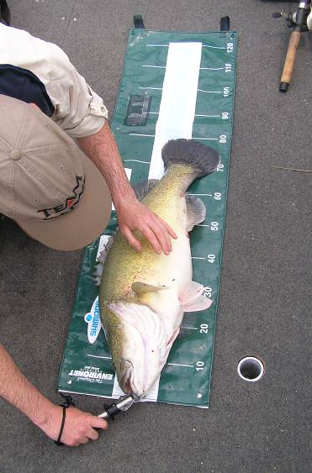

Ross Winstanley measuring Murray cod: 43 cm (left) and 74 cm (right) (Photo source: Marc Ainsworth)

Historical approach to managing recreational take of Murray cod
To protect Murray cod stocks from over-fishing, fisheries managers have to date largely relied on increasing the minimum size limit at which Murray cod can be taken by recreational fishers. This rationale intended to enable young maturing fish the opportunity to spawn at least once before they reach the size at which they can be taken (Note: depending on local conditions, most Murray cod typically reach maturity at between 50 to 55 cm). This approach for example in New South Wales has resulted in the minimum legal size limit of Murray cod increasing a number of times e.g. in 1975 (50 cm minimum size limit), in 2007 (55 cm minimum size limit) and, in 2009 (60 cm minimum size limit).
This approach assumes early maturing Murray cod successful breed in their first season i.e. those under 60 cm. This assumption is not necessarily reflected in Murray cod hatcheries where larger Murray cod > 70 cm are considered more productive breeders as they are more experienced and yield more eggs. For example, a mature female Murray cod of 53 cm will produce around 10,000 eggs compared with 22,000 eggs for a 64 cm fish and 90,000 eggs for a 100 cm fish (Kailola, 1993). For wild stocks of many fish species around the world, it has been shown that the large older females contribute proportionally the most to raising the next generation.

Are the current fishery management actions effective?
It is likely that current fisheries regulations, including minimum size limits at which Murray cod can be retained, combined with bag limits, fish stocking and other factors have positively contributed to an increase in abundance and average size of Murray cod in many Victorian populations. However, Murray cod populations are still only a fraction of their pre-European levels and there remains considerable scope to further enhance Victoria’s Murray cod fisheries. In addition, research has demonstrated that in high fishing pressure scenarios current regulations may not be sustainable for Murray cod fishing (Allen et al. 2009).
Under the current 60 cm minimum size, recreational fishers are able to take two Murray cod for the table. These fish often weigh in excess of 4 kilograms each (refer table 1 – Murray cod length vs. estimated weight). Some fishers are reluctant to take fish of this size because:
- 60 cm + Murray cod are mature breeders which are perceived as having a higher net value to the fishery than smaller fish
- 60 cm + Murray cod may be less palatable (more fatty deposits), than smaller fish.
- 60 cm + Murray cod may provide an excessive amount of food for the angler i.e. two fish of this size will provide more food than is required.
- The minimum size for Murray cod (60 cm) is significantly larger and heavier than other targeted angling species e.g. Golden perch (30cm).

Table 2. Average weight of Murray cod against total length (Anderson et al. 1992)
Total length | Average weight
30 cm |  | 0.460 kg
40 cm |  | 1.1 kg
50 cm |  | 2.3 kg
60 cm |  | 4.1 kg
70 cm |  | 6.9 kg
80 cm |  | 10.6 kg
90 cm |  | 15.6 kg
100 cm |  | 21.3 kg +

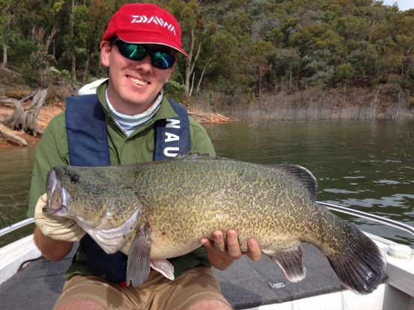
Scott Douglas and a 68 cm Murray cod caught at Lake Eildon. (Photo source: John Douglas)

Slot limit research and modelling for Murray cod
In 2011 and 2012, Victorian Department of Environment and Primary Industries (DEPI) scientists examined the effects of changing Murray cod size and bag limits. Two independent research groups built independent Murray cod population models and compared current and past bag and size limits against a range of harvest slot limits (Table 3). Both population models were based on a typical Murray Darling Basin riverine population with variable natural recruitment and informed by the latest available information on Murray cod mortality, growth rates and harvest rates (sources listed in Appendix 1). More detailed descriptions of the population modelling are available in Allen et al. (2009) and Koehn and Todd (2012).
Table 3. Harvest slot limit scenarios tested in the population models
Scenario | Harvest slot limit
Current regulations | 60 to 100 cm
Past regulations | 50 to 100 cm
Conservative slot | 40 to 60 cm
Conservative slot | 50 to 60 cm
Conservative slot | 50 to 70 cm
Traditional change of raising legal minimum length | 70 to 100 cm

Which slot limits deliver the most benefits to the Murray cod fishery?
The models showed conservative slot limits (40-60, 50-60 and 50-70 cm) all offer significant benefits in Murray cod sustainability over existing and past regulations through increasing the abundance of large fish contributing to the breeding population, and also increasing the numbers of mid-sized fish available for harvest. Recreational fishers could benefit from the introduction of conservative slot limits in three-ways;
- an increase in the long-term sustainability of the fishery,
- a build-up in abundance of large metre-plus Murray cod, and
- an increase in numbers of mid-sized fish available for harvest.
Specifically, the modelling suggested the 40 to 60 cm slot limit followed by the 50 to 70 cm slot limit were most effective at building Murray cod stocks over time, when compared with current regulations.
If either slot limit was introduced, the fish population models suggest the rate at which positive changes will occur will depend upon the level of fishing pressure in any particular area. Increases in the harvest rates are likely to be noticed quickly and may occur within 5 years of slot limit introduction, particularly in highly fished areas e.g. in rivers. Noticeable increases in the abundance of large (1 m+) fish should occur between 5 and 10 years and will continue to increase over at least a 15-year period.
The modelling also considered the impact of changing bag limits from 2 fish per day to 1 fish per day. Because most recreational fishers fail to reach their bag limit of 2 fish per day (Fulton 2011), changing the bag limit to 1 fish per day made little impact and was not reported on further. However, if the size limit was lowered from 60 to 50 cm, more fish could be legally taken and the likelihood of fishers reaching their bag limit of 2 fish per day would increase. Under this scenario, reducing the bag limit from 2 to 1 fish per day may be worth considering.

Why do slot limits work for Murray cod?
To illustrate why conservative harvest slot limits may be more beneficial for Murray cod stocks than existing regulations, an average Murray cod age-length curve is displayed below (Anderson et al. 1992) with overlay and discussion of the existing slot limit of 60-100 cm and a conservative slot limit of 50-70 cm.
Under the current regulation slot limit of 60-100 cm, Murray cod are vulnerable to harvest for approximately ten years of their life (Figure 4). Fish are protected from harvest until they reach 60 cm (average 6-7 years of age) then are only again protected from harvest once they reach over 100 cm in length (average 16-17 years of age).

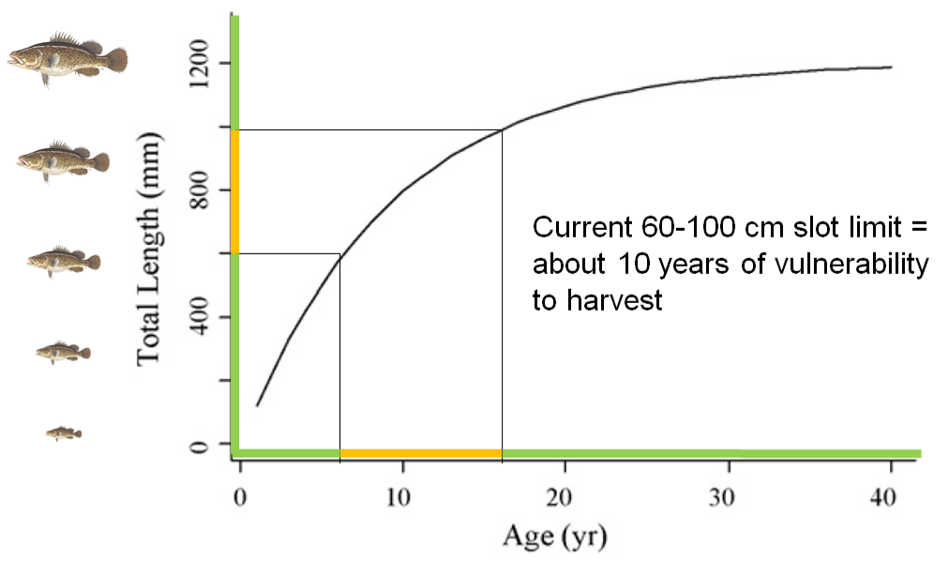

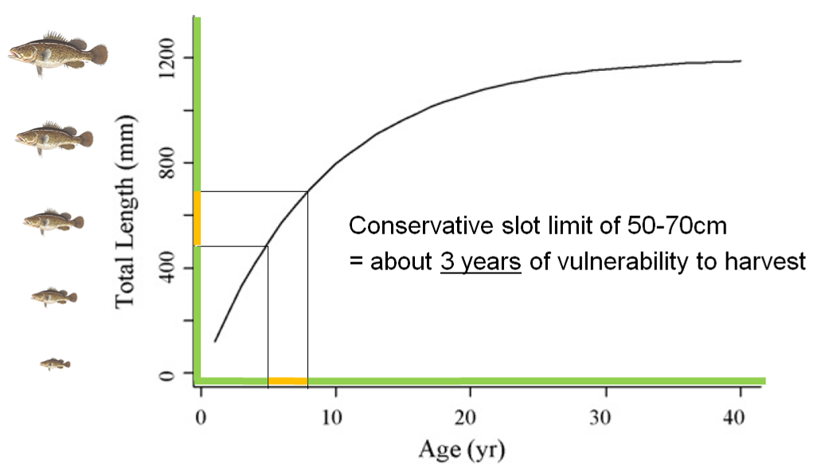
Figures 4 and 5. Average age-length curve for Murray cod from Anderson et al. (1992) with current regulations of 60-100 cm (top) and conservative harvest slot limit of 50-70 cm (bottom). Green indicates fish of this length and corresponding age are protected from legal harvest, yellow indicates fish of this length and corresponding age are vulnerable to legal harvest.

Under a conservative harvest slot limit of 50-70cm, Murray cod are vulnerable to harvest for approximately three years (Figure 5). Fish are protected from harvest until they reach 50 cm (5-6 years of age) and then protected from harvest once they reach over 70 cm in length (average 8-9 years of age). This conservative slot limit protects more larger fish from harvest and the population benefits because larger fish produce significantly more eggs than smaller fish. This in turn results in more fish being available to harvest in the conservative slot of 50-70 cm. This is the primary reason why conservative harvest slot limits are more beneficial to Murray cod populations and fisheries in terms of greater sustainability, presence of large fish and harvest potential.

What are the social considerations?
Victorian recreational fishers report that in many waters the abundance and size of Murray cod caught over the last decade has improved markedly. Many fisher’s associate these improvements in the fishery with the lifting of the Victorian minimum size limits for Murray cod e.g. 50 cm minimum size limit introduced in 1975 and , a 60 cm minimum size limit introduced in 2009 (Note, in New South Wales an additional 55 cm minimum size was introduced in 2007). While these changes have undoubtable improved the quality of the Murray cod fishery, it is also worth noting that the number of Murray cod stocked in Victoria has substantially increased over time (Figure 2).
Recreational fishers may better understand and value the traditional fisheries management approach of increasing size limits rather than the proposed narrow slot limit approach. Therefore the widespread adoption of slot limits for Murray cod are unlikely to be supported without adequate and widespread explanation of the science and rationale to recreational fishers.
Some of the social drivers for Murray cod recreational fishers may include:
- Interest in taking a Murray cod for the table that satisfies the food needs of the fisher and or his / her family,
- Perception that larger fish are more valuable as breeding fish,
- Reluctance to take a large Murray cod because of decreased palatability e.g. fatty deposits in larger fish,
- Social expectations and peer pressure to catch and release all Murray cod,
- Concern that Murray cod populations cannot sustain recreational harvesting.
Preliminary feedback to Fisheries Victoria from recreational fishers through regional fishing forums suggests a Murray cod slot limit of 50 – 70 cm may best address the social expectations of recreational fishers. It appears for those Murray cod fishers interested in taking a fish for the table, there was clearly a general preference for take a smaller sized Murray cod rather than remove a large breeding fish that may be excessive to their needs. Fisheries regulations provide for the sustainable harvest (take) of Murray cod. Recreational fishers are expected to operate within these rules however the choice of fishers to either retain or release a legal size fish is very much a personal one.

Compliance issues across the basin
In general terms, a state or basin-wide and consistent approach to Murray cod bag and size limits is easier to understand, communicate and regulate than applying different regulations for each jurisdictions or waters. However, there is scope within the management of the Murray cod fisheries across the Murray-Darling Basin to trial different bag and size limit scenarios. As state (and territory) fisheries jurisdictions look to improve Murray cod monitoring methods at basin-wide reference sites, the effect of different fisheries regulations can be assessed and may add to our understanding of the Murray cod fishery i.e. through examination by the Murray Cod Fishery Management Group.

Victorian Murray cod reference group workshop
In light of the rationale, research, social and compliance considerations mentioned here, a series of options were presented to a reference group of recreational fishers and fisheries managers at workshop on 21 February 2014 (Appendix). The reference group strongly supported a 50 to 70 cm slot-limit to be applied state-wide for Murray cod. The group also recommended a reduction in the Murray cod bag limit from 2 to 1 fish per day in rivers whilst maintaining the bag limit in impoundments at 2 fish per day. It is believed that these regulation changes will further improve populations and fisheries of Murray cod in Victoria.

Comparison with the proposed New South Wales Murray cod slot limit approach
In May 2013, New South Wales Fisheries released a consultative paper proposing changes to a bag and size limits for a range of freshwater and marine species caught by recreational fishers. Specifically, they proposed the introduction of slot limits for Murray cod with a minimum size of 60 cm and a maximum size of 80 cm, a reduction in the bag limit from 2 to 1 fish per day and the removal of closed season in some stocked “put and take” lake based Murray cod fisheries. The outcomes of this public consultation and review have not yet been finalised.
To some extent the NSW proposed slot limit (60 to 80 cm) validates DEPI’s science in favour of the adoption of slot limits to protect larger breeding females which was first proposed through the basin-wide Murray Cod Fishery Management Group in 2011.
More recently, DEPI scientists were asked to compare the performance of the 60 to 80 cm and the 50 to 70 cm slot limit scenario’s. The slot limits were evaluated using population modelling similar to the previous research. These slot limit results were compared over two different levels of fishing pressure (U):
- Low fishing pressure where 15% of Murray cod are harvested from each year-class (e.g. Lower Goulburn, Ovens River)
- High fishing pressure where 30% of Murray cod are harvested from each year-class (e.g. Murray and Loddon Rivers).
The results of slot limits were evaluated after 15 years of implementation based on the following three criteria (Table 4).

Table 4. Criteria and definitions which slot limit scenarios were evaluated against
Criteria | Definition and modelling measure
Sustainability | An index of robustness to overfishing. Measured as Spawning Potential Ratio (SPR): population egg-production relative to the unfished condition
Large trophy fish | Number of large (greater than 1 metre in length) fish in population
Harvest potential | Number of individual Murray cod in the population that are available to harvest

According to the modelling outputs, both the 60 to 80 and 50 to 70 cm slot limits offer significant improvements in terms of sustainability (Figure 6), large trophy fish (Figure 7) and potential harvest (Figure 8) to the Murray cod population and fishery compared with the current slot limit of 60 to 100 cm.
However when comparing the 60 to 80 cm and 50 to 70 cm slot limit directly, the results suggest the 50 to 70 cm slot limit out performs the 60 to 80 cm slot limit on all criteria. For example, in low fishing pressure situations the 50 to 70 cm slot limit improves sustainability by 11% (calculated by (42-38)/38*100%), number of large trophy fish by 17% and number of fish available to harvest by 40%. In high fishing pressure situations the 50 to 70 cm slot limit improves sustainability by 7%, number of large trophy fish by 45% and number of fish available to harvest by 48%.
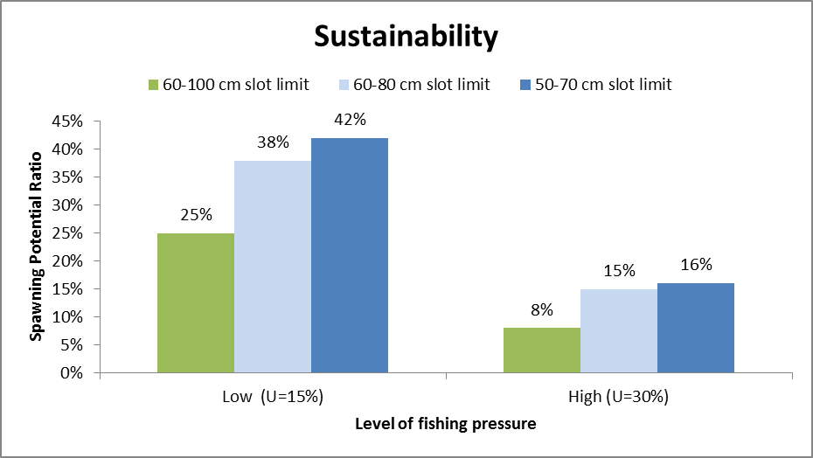
Figure 6. Predicted sustainability of simulated Murray cod population after 15 years of implementing 60-80 and 50-70 cm harvest slot limit scenarios

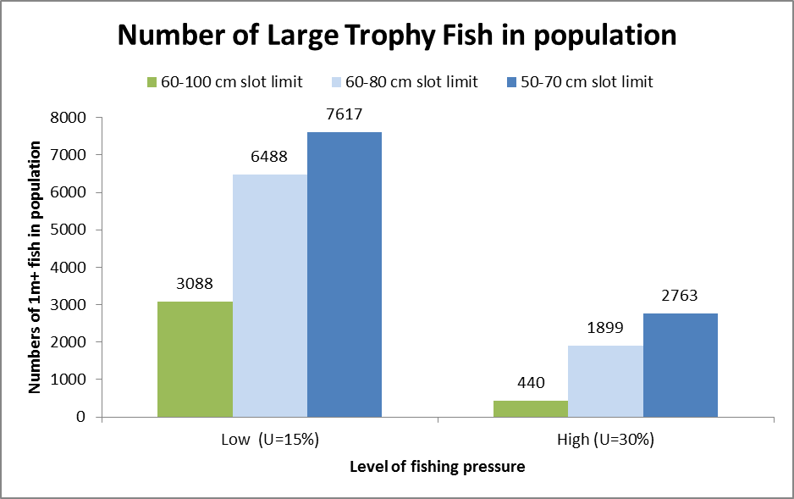
Figure 7. Predicted numbers of large trophy fish present in simulated Murray cod population after 15 years of implementing 60-80 and 50-70 cm harvest slot limit scenarios.
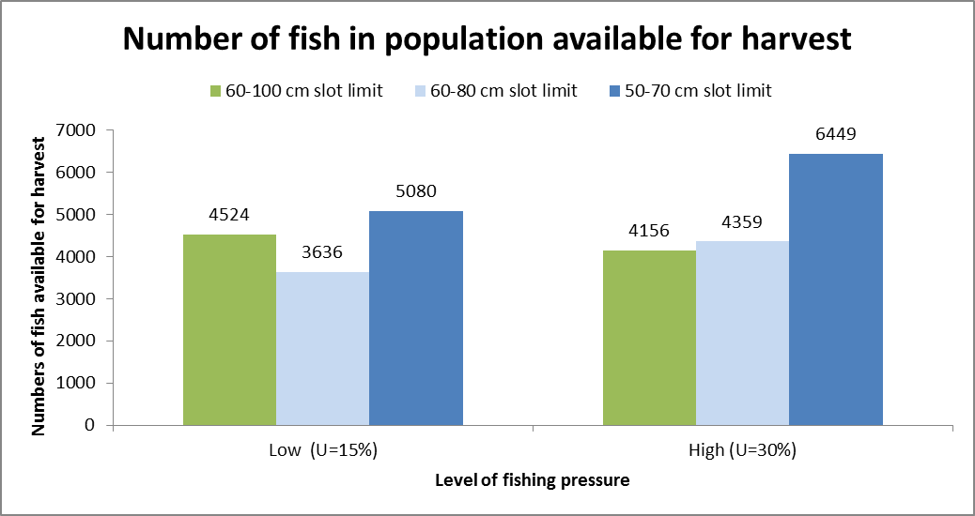
Figure 8. Predicted numbers of fish available to harvest in simulated Murray cod population after 15 years of implementing 60-80 and 50-70 cm harvest slot limit scenarios.

Conclusions
Fisheries management drivers to rebuild Murray cod populations and improve recreational fishing outcomes have guided an investigation of alternative strategies for regulating the Murray cod fishery. This science from this investigation was taken into account along-side the views of Victorian anglers, some of whom would prefer to retain a smaller sized Murray cod for the table.
Based on international experience and detailed analysis using fish population modelling, fisheries managers now recognise the potential benefit of slot limits as an alternative strategy for further improving the Murray cod population and recreational fishery.
Social considerations are equally valid and the results of this investigation were considered by a reference group of experienced Murray cod recreational fishers, fisheries managers and researchers.
The reference group strongly supported implementation of a 50 to 70 cm slot limit state-wide for Murray cod, with a reduction in bag limit from 2 to 1 fish per day in rivers whilst maintaining the bag limit in impoundments at 2 fish per day.
It is believed that these proposed regulation changes will build Murray cod populations and improve recreational fishing for Murray cod in Victoria.

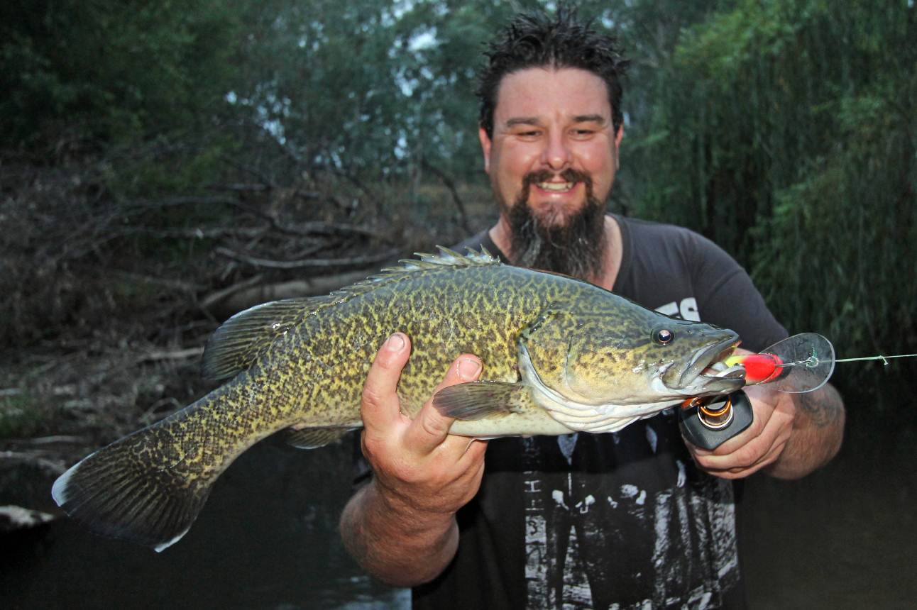
Robbie Alexander and a 54 cm Murray cod caught on the King River. (Photo source: Robbie Alexander)

We want your comments
Fisheries Victoria is seeking your comments in relation to the Victorian Murray cod management proposed in this consultation paper. In particular we seek an indication of your views or preferred options in relation to:
- Implementation of 50 to 70 cm slot limit state-wide
- Reduction in bag limit from 2 to 1 fish per day in rivers (whilst maintaining the bag limit in lakes and impoundments at 2 fish per day)
Please provide a written response to this consultation paper by Friday 29 August 2014 to:

Taylor Hunt
Fisheries Manager, Fisheries Victoria
PO Box 114
Queenscliff VIC 3225

Or

Taylor.hunt@depi.vic.gov.au

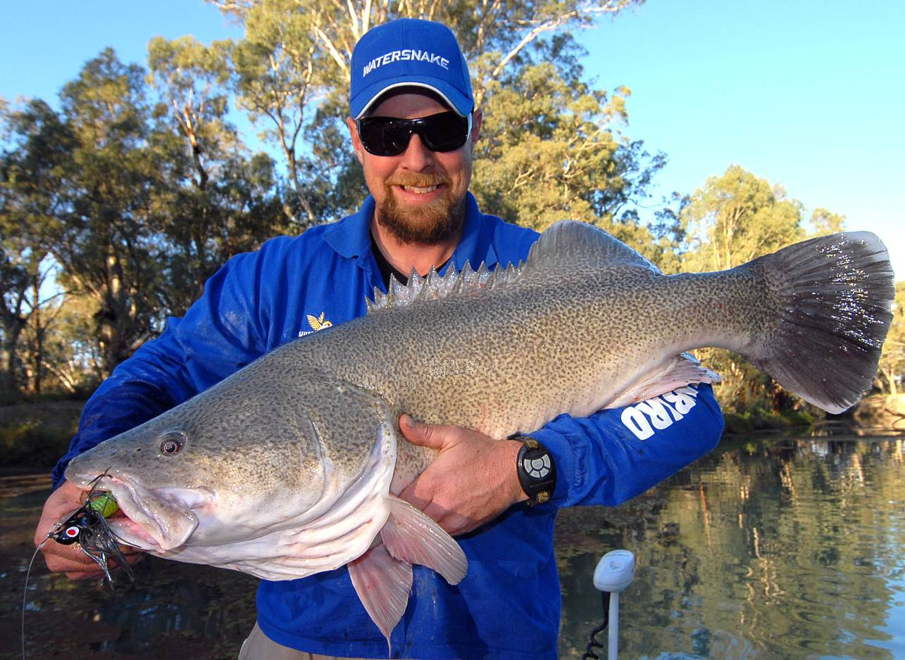
Fisher with a large Murray cod caught at Mullaroo Creek. (Photo source: Rod MacKenzie)

References and further reading
For a copy please email: Taylor.hunt@depi.vic.gov.au

Allen, M. S., P. Brown, J. Douglas, W. Fulton and M. J. Catalano 2009. An assessment of recreational fishery harvest policies for Murray cod in southeast Australia. Fisheries Research 95: 260-267. 260-267.
Anderson, J. R., A. K. Morison and D. J. Ray 1992. Age and growth of Murray cod, Maccullochella peelii (Perciformes: Percichthyidae), in the lower Murray-Darling Basin, Australia, from thin sectioned otoliths. Australian Journal of Marine and Freshwater Research 43: 983-1013.
Brown, P. (2010). Sustainability of recreational fisheries for Murray cod: Creel surveys on the Murray, Goulburn, Ovens and Loddon rivers 2006-2008. Recreational Fishing Grant Program - Research Report, Department of Primary Industries Victoria.
Douglas, J., P. Brown, T. Hunt, M. Rogers and M. Allen 2010. Evaluating relative impacts of recreational harvest and discard mortality on Murray cod (Maccullochella peelii peelii). Fisheries Research 106: 18-21.
Forster, A. 2011. Enhanced Murray cod recreational fisheries outcomes across the Murray-Darling basin through improved collaboration and alignment of management and research activities. FRDC Project Report No. 2009/060, Fisheries Research Development Corporation.
Fulton, W. 2011. Sustainability of recreational fisheries for Murray Cod in the Murray-Darling Basin. Final report to Fisheries Research and Development Corporation Project No. 2006/053. Queenscliff, Victoria, Department of Primary Industries.
Gwinn, D. C., M. S. Allen, F. D. Johnson, P. Brown, C. R. Todd and R. Arlinghaus 2013. Rethinking length-based fisheries regulations: the value of protecting old and large fish with harvest slots. Fish and Fisheries.
Koehn, J. D. and C. R. Todd 2012. Balancing conservation and recreational fishery objectives for a threatened fish species, the Murray cod, Maccullochella peelii. Fisheries Management and Ecology.
Nicol, S., C. Todd, J. Koehn and J. Lieschke 2004. How can recreational angling regulations help meet the multiple objectives for the management of Murray cod populations. Management of Murray cod in the Murray-darling Basin: Statement, Recommendations and Supporting Papers. Canberra, ACT.
Rogers, M. W., M. S. Allen, P. Brown, T. Hunt, W. Fulton and B. A. Ingram 2010. A simulation model to explore the relative value of stock enhancement versus harvest regulations for fishery sustainability. Ecological Modelling 221: 919-926.
Todd, C. R., T. Ryan, S. J. Nicol and A. R. Bearlin 2005. The impact of cold water releases on the critical period of post-spawning survival and its implications for Murray cod (Maccullochella peelii peelii): a case study of the Mitta Mitta River, southeastern Australia. River Research and Applications 21(9): 1035-1052.

Appendix: Victorian Murray cod Reference Group

Terms of Reference
1. Act in the best interest of Victoria’s fisheries resources rather than advocate for any particular organisations, interest group or regional concern.
2. Assist Fisheries Victoria:
- Given available information and science, is there a case to change Murray cod recreational fishing size/bag limits?
- If so, what changes are proposed and why?
- How are recreational fishers likely to respond?
3. Do not circulate the group’s draft documents
4. When ready – help communicate the issues to recreational fishers e.g. representative fisher organisations and the media

Workshop
Date and time: Friday 21st February 2014, 3.00pm – 6.00pm
Location: Fisheries Victoria Snobs Creek Hatchery, 455 Goulburn Valley Highway, Eildon
Invitees:
Robbie Alexander Fishing Journalist, King, Kiewa and Ovens River fisher
Bill Classon Australian Fishing Network
Wally Cubbin Goulburn Valley Angling Association, Goulburn River fisher
Tim Curmi Murray, Ovens and King River fisher
John Douglas Fisheries Victoria, Management and Science
Taylor Hunt Fisheries Victoria, Management and Science
Rob Loats Wimmera Anglers Association, Wimmera region fisher
Jarod Lyon Arthur Rylah Institute, Waterway Management and Restoration
Rod MacKenzie Fishing Journalist, Fishing guide, Murray River fisher
Jarrod Martin Central Victorian Lure Caster Series Coordinator
Andy McCarthy Lake Eildon fisher
Russell Strongman Fisheries Victoria, Education and Compliance
Steve Vidler Snobs Creek Angling Club, Snobs Creek Hatchery
Ross Winstanley Unaffiliated Angler, Murray River fisher

Apologies:
Marc Ainsworth Fisheries Victoria Communications, Fishing Journalist
Gary Hodges Fisheries Victoria, Education and Compliance
Roger Miles Loddon and Campaspe River fisher, Fishing guide
Steve Threllfall Trelly’s Tackleworld, Shepparton region fisher

Chair:
Anthony Forster Fisheries Victoria, Management and Science


Victorian Murray cod reference group workshop (Photo source: Wally Cubbin)

