Toolondo Reservoir Recreational Fishery Advisory Group
Key findings and recommendations
August 2015
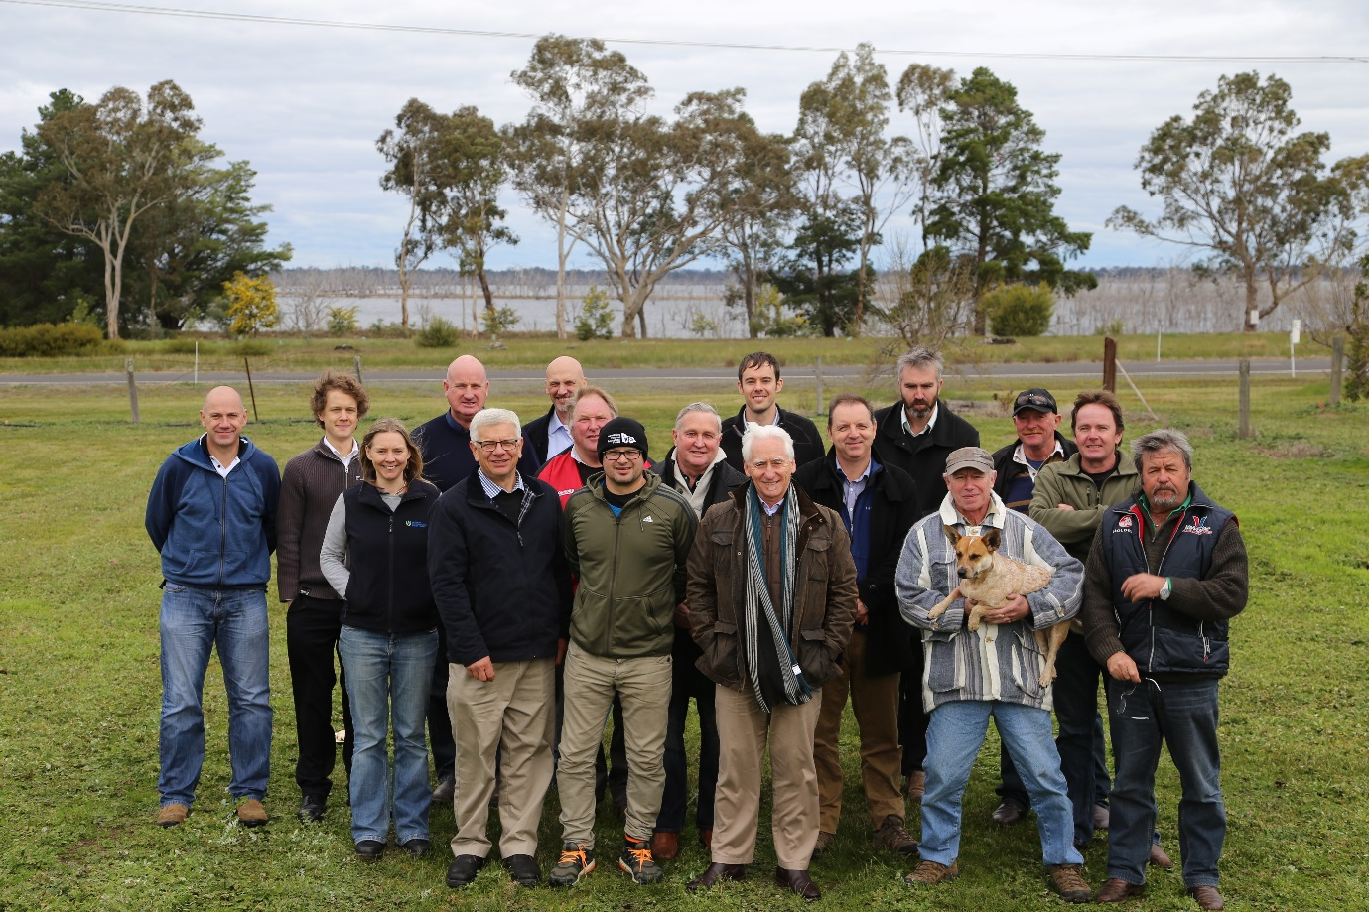

Contents
Introduction 1
Background 2
Key findings 3
TRRFAG Response to terms of reference 3
Recommendations 8
Short-term 8
Long-term strategies to support recreational fishing: 9
Attachment 1. 10
Attachment 2. 12
Attachment 3. 13
Attachment 4. 14
Attachment 5. 15
Attachment 6 17
Attachment 7. 18

Introduction
Recreational fishing is one of the most popular outdoor activities in Australia with almost one in five people (19%) identifying themselves as recreational fishers. In 2009, an Ernst and Young report indicated that 721,000 Victorians participated in recreational fishing. This activity annually generates around $825 million in fishing related expenditure and employs 5,200 people. Much of this social
and economic activity occurred in regional Victoria and was associated with travel and fishing
related tourism.
State and federal government agencies support recreational fishing through policy development, regulation and compliance, fish stocking, habitat restoration, applied research, improving access and angler education. Each year, Fisheries Victoria stocks around three million native fish and trout in more than 250 waterways across Victoria to improve recreational fishing and recover threatened native species.
In 2014, the State Government’s Target One Million policy made a number of commitments to improve recreational fishing with a “plan to get more people fishing, more often”. One of these policy actions was to ensure “Lake Toolondo will remain Victoria’s best trout fishing location, with a local advisory group established to take action on minimum water levels”.

Background
Toolondo Reservoir is an outstanding stocked recreational trout fishery, but as a balancing water storage facility, its water levels have fluctuated considerably over the last few decades. Toolondo Reservoir has a small natural catchment and relies on water transfers from Rocklands Reservoir. Water transfers can be made when Rocklands Reservoir is holding greater than 116,000 mega litres (ML) of water. With the recent construction of the Wimmera Mallee Pipeline, which replaced the former open channel supply arrangements, the reservoir system is not required to meet the same consumptive demands as historically required. Toolondo Reservoir’s operational significance has been reduced and its maximum operating level is now 50% (46,200 ML) of its previous full supply level (96,430 ML). Toolondo also has a large dead storage where anything less than 40 000 ML held in volume requires pumping. Without significant additional rainfall over the remainder of 2015 to improve the water resource situation, current water levels at Toolondo Reservoir are expected to fall, which will impact on the performance of the recreational fishery. These risks are exacerbated by dry conditions as the Wimmera and Glenelg regions have, over the last three years, experienced historically low rainfall (Attachment 1).
In January 2015, the State Government purchased 5 000 ML of water for delivery to Toolondo Reservoir, which increased water volume from 7,420 ML to 10,355 ML equating to an increase from 16 to 27% of storage capacity and water levels by 210mm. This allocation safeguarded trout populations in response to concerns that falling water levels may cause trout to die and the resulting loss of the recreational fishery.
The Toolondo Reservoir Recreational Fishery Advisory Group (TRRFAG) was established in March 2015 and has since met on five occasions. The TRRFAG has been asked to provide advice on:
- What water levels are needed to maintain an effective recreational fishery at Toolondo Reservoir, including a scientific review of the relationship between water depth, water quality and the historical performance of the recreational fishery.
- Short and longer-term, options and strategies to maintain a recreational fishery at Toolondo Reservoir, including all water supply options.
- Other strategies and actions to enhance recreational fishing opportunities at Toolondo Reservoir and surrounding regional waterways.
The TRRFAG includes 18 members drawn from; Grampians Wimmera Mallee Water (GWMWater), Local Council, Fisheries Victoria, VRFish, Victorian Environmental Water Holder, Glenelg Hopkins Catchment Management Authority (CMA), Wimmera CMA and local recreational fishing representatives. The TRRFAG is independently chaired by Mr Joe Helper, former Minister for Agriculture. The TRRFAG reports to the Executive Director, Fisheries Victoria.
The TRRFAG will also inform GWMWater through its development of Recreation Management Plans for Rocklands Reservoir and Toolondo Reservoir.

Key findings

TRRFAG Response to terms of reference
Term of reference 1. What water levels are needed to maintain an effective recreational fishery at Toolondo including a scientific review of the relationship between water depth, water quality and the historical performance of the recreational fishery?
Fisheries Victoria undertook a review of the Toolondo Reservoir fishery which synthesised fishery and environmental information to inform decisions regarding the management of the fishery. This work included the deployment of water quality monitoring equipment at Toolondo Reservoir and, a review of the recreational fishery performance over a twenty-three year period including past fish population and angler catch surveys.

Key findings:
The high performance of Toolondo Reservoir as a recreational fishery is predominantly due to the trophic upsurge of nutrients associated with the refilling of the Reservoir.
Given water temperature (and dissolved oxygen) tolerances of trout and past observations of fish kills in Toolondo Reservoir, a minimum water depth of 2.5 metres is required to preserve the trout fishery.
Using this information, Toolondo Reservoir fishery management objectives were prepared by the TRRFAG. Uncertainty around future water availability requires an adaptive fishery management response under two scenarios: 1) When water levels can be maintained above 2.5 metres and,
2) when extended drought conditions cannot maintain critical water depths to preserve a quality trout fishery. Management objectives (and strategies to implement these objectives) were specified for each scenario.

Key findings:
When water is available, maintain depths above 2.5 metres and manipulate water levels to flood the margins in spring to boost fishery productivity. Stock brown trout where water security provides minimum water levels above 2.5 metres for at least 2 years.
When water is not available to maintain water depths above 2.5 metres (drought condition), wait for the drought to break and, after water is delivered into Toolondo Reservoir that provides water security and minimum water levels above 2.5 metres for at least 2 years, stock trout to capitalise on high productivity conditions (trophic upsurge). Stock ongrown (large) rainbow and/or brown trout when water level, water quality and fishery access conditions enable the creation of a reasonable (short term) winter fishery.
To ensure the fishery is meeting desired management objectives, implement a fishery monitoring program including angler surveys and fish sampling.

The TRRFAG identified a significant knowledge gap about the water depth of Toolondo Reservoir. When the water resource depth gauge read ‘0’, there was still visible water across the reservoir. Existing bathymetry information was adequate for water resource management, but was not adequate for determining the volume of water required to meet the fishery management objective of maintaining the fishery above 2.5 metres. The TRRFAG commissioned Dr Dion Iervasi from Austral Research and Consulting P/L to undertake a bathymetry survey of the bottom of Toolondo Reservoir. Based on this report, the baseline water depth should be set at 154.2 m AHD + 2.5m = 156.7m AHD (11,178 ML) (refer attachment 2). At this level (2.5m), there is a significant area of water temperature refuge for trout in the south body of water and connectivity between the North and Eastern waterbodies.

Key findings:
A new bathymetry survey has generated a more accurate reservoir capacity table which will be adopted by GWMWater.
Within Toolondo Reservoir there are three distinct waterbodies with different bathymetric characteristics. The larger waterbody may provide the best refuge for trout in drying climatic conditions.
Term of reference 2. Short and longer-term, options and strategies to maintain a recreational fishery at Toolondo Reservoir including all water supply options.
The TRRFAG commissioned Mr Jim Keary, Director, Hunter H²0 P/L as an independent expert not directly associated with the existing Wimmera / Glenelg water management regime to review the Wimmera Headwork’s Supply system to meet Toolondo Reservoir fishery management objectives. The focus of this work was to review management rules and operations of the system as they impact Toolondo Reservoir. Advice was sought on how Toolondo Reservoir can be sustained as a fishery; a) within existing storage management rules and objectives b) by amendment of these rules and or c) by changing these operating practices.
Hunter H2O identified an initial list of 16 broad options (see Table 1) for more permanent water for Toolondo Reservoir. Through TRRFAG workshops, these options were evaluated and reduced to five key considerations; 1) short-term purchases, 2) long-term water entitlement purchase, 3) clarity of storage management rules, 4) development of Toolondo Recreational Management Plan and 5) recreational and environmental water synergies.

Drought implications
The task of finding more permanent water for Toolondo Reservoir has been overshadowed by the escalating effects of drought conditions including the continuation of historically low rainfall in the Wimmera and Glenelg catchments (attachment 1), and warnings of strong El Niño conditions from the Bureau of Meteorology during 2015. These concerning conditions are driving water use efficiency and water conservation efforts by entitlement holders. Options to purchase short or long-term water for Toolondo Reservoir on the market are diminishing as water resources become more scarce and entitlement holders are generally guarding against the worsening drought conditions. The TRRFAG clearly felt the Toolondo recreational fishery is not able to be, nor should it be, safe-guarded against drought conditions. Under drought, water should be first made available to higher priority and essential uses.
The TRRFAG also recognised that unlike other water uses, fish don’t consume water and Storage Managers should always look to consider multi-use of water in storages to serve recreational, environmental and storage efficiency values.

Key findings:

Drought conditions
2.1 The Toolondo recreational fishery is not able to be, nor should it be, safe-guarded against drought conditions. In these conditions, limited available water should be first made available to higher priority water uses.

Water entitlement
2.2 The purchase of permanent water entitlement allocations on the market is currently unlikely to be feasible, but could be pursued subject to a cost benefit analysis.

Storage Manager
2.3 Work with Fisheries Victoria, VRFish and local fishers to make information on the levels and transfers of Wimmera-Glenelg storages more publically availably each month and more easily accessible to anglers and the community more widely.
2.4 Clearly delineate the Storage Manager role at GWMWater and more fully describe the roles and responsibilities of the water management governing groups.
2.5 GWMWater identify formal functions required to be performed by the Storage Manager and clearly separate these functions from those of the bulk entitlement holder. Formal terms of reference should be updated and published for each group.
2.6 The management of transfer of water to Toolondo Reservoir must also take into account water quality requirements. In particular the risk of salt accumulation over time due to evaporative concentration would need to be managed.

Recreational Management Plan
2.7 Fisheries Victoria work with recreational fishers and GWMWater to identify opportunities to improve recreational access and amenity at Toolondo Reservoir. This will be a valuable input to the Lake Toolondo Recreational Management Plan development which will commence in late 2015. Funding will be available under the Target One Million infrastructure/access program (e.g. improve: boat ramps, car parking, camping and recreation amenity and signage).

Social values of water
2.8 Clarify the significant social benefits of water and refer to the Water Minister for investigation and further action given the broader state wide implications of this matter and the current study underway, commissioned by the Department of Environment, Land, Water and Planning.

Short-term water trading
2.9 Seek to negotiate the trade of unused water allocations to meet short term Toolondo Reservoir Fishery management objectives when there is sufficient system water to satisfy existing recreational water allocations in the Wimmera system.

Use of Environmental Water
The TRRFAG worked closely with the Victorian Environmental Water Holder and the Glenelg Hopkins and Wimmera CMA’s to understand the rationale, nature and extent of environmental water use in both catchments. An independent review of Toolondo Reservoir environmental values was undertaken by Dr Andrew Sharpe from Jacobs P/L. The scope of this review was limited to published information, interviews with local experts and a site inspection.
The review addressed four key areas:
1) The water dependent environmental values at Toolondo Reservoir,
2) An assessment of the water regime to support those values,
3) Comparison of the water-dependent environmental values in Toolondo Reservoir against the Wimmera and Glenelg Rivers and,
4) The merits of water dependent environmental values of man-made versus natural waterways.

Key findings:
2.10 Environmental water allocations will have greater environmental benefit in the Wimmera and Glenelg Rivers than Toolondo Reservoir.
2.11 A case may be made to use environmental water in Toolondo in wet years if 1) Toolondo requires water at this time 2) a proportion of the flow required in both rivers is met by natural events and passing flows, and, 3) this can be accommodated without compromising the use of carryover water reserves for dry periods.
The TRRFAG acknowledged the importance of environmental flows to sustain important water dependent environmental values, particularly for highly regulated and altered waterways facing drought conditions. The TRRFAG also acknowledged the large-scale use of environmental flows is a relatively new field of science (first managed in the Wimmera system since 1988), with more work needed to improve environmental water use effectiveness and optimise environmental outcomes. The TRRFAG also noted uncertainty from some recreational fishers about the effectiveness and value of large-scale environmental water allocations, particularly in the Glenelg River system. For example, between 2010/11 and 2014/15 the Glenelg River and Wimmera systems received 56,459 ML and 48,496 ML of passing environmental flows respectively, which are volumes exceeding the maximum operating capacity of Toolondo Reservoir (46,200 ML).

Key findings:
2.12 Given the considerable quantities of environmental water that has been used in the Glenelg and Wimmera catchments, and the value of this water, there is a pressing need to better quantify and explain the environmental (and social) outcomes from this significant investment as identified by; the funding partners of the Wimmera Mallee Pipeline, the Commonwealth government, the Victorian Government and the customers of the Wimmera Mallee water storage and delivery system.

Term of reference 3. Other strategies and actions to enhance the recreational fishing opportunities at Toolondo Reservoir and surrounding regional waterways.
The TRRFAG recognised the overall performance of Rocklands Reservoir as a recreational fishery has been disappointing, particularly at low water levels, despite it being stocked with trout for many decades. The TRRFAG identified Rocklands Reservoir as a large and secure water-body with potential to support a high quality native stocked recreational fishery. Development of Rocklands Reservoir as a native stocked recreational fishery could provide a more secure and reliable opportunity for fishing in the region, particularly during a drying climate. Fisheries Victoria inspected the site, spoke to local angling club representatives and reviewed an unsuccessful native fish stocking risk-assessment proposal submitted by the Glenelg Hopkins Catchment Management Authority in 2006. Fisheries Victoria has identified new information that may be useful in re-assessing a native fish stocking proposal for Rocklands Reservoir. The stocked native fish species most suitable to enhance Rocklands Reservoir as a recreational fishery include; Murray cod, Golden Perch and estuary perch. Two of these species (Murray cod & Golden perch) are outside of their natural range and so, in accordance with departmental translocation policy guidelines, a detailed risk assessment would need to be submitted to the Translocation Evaluation Panel for consideration.

Key findings:
3.1 As a matter of priority, investigate the potential to create a high quality native fishery in Rocklands Reservoir by undertaking a fish stocking risk assessment in accordance with departmental translocation policy.

Recommendations

Short-term
- The purchase of annual tradable water for Toolondo Reservoir only be considered by State Government when there is sufficient system water to satisfy full allocations for existing recreational water entitlements in the Wimmera system (refer attachment 6 - Bulk Entitlement Water Share Table column B).
- Manage Toolondo Reservoir recreational fishery in accordance with the TRRFAG Fishery Management Objectives and, consider stocking of ongrown (large) rainbow and/or brown trout when water level, water quality and fishery access conditions enable the creation of a reasonable (short term) winter fishery.
- Fisheries Victoria work with recreational fishers, Horsham Rural City Council and GWMWater to identify opportunities to improve recreational access and amenity at Toolondo Reservoir in the development of the Lake Toolondo Recreational Management Plan with funding available under the Target One Million infrastructure and access program (e.g. improve: boat ramps, car parking, camping and recreation amenity and signage).
- The Toolondo Reservoir depth gauge should be reset by GWMWater to better reflect the maximum depth of Toolondo Reservoir. This means the minimum water depth required to achieve 2.5m is 156.7m AHD.
- As a priority, investigate the potential to create a high quality native fishery in Rocklands Reservoir by undertaking a fish stocking risk assessment in accordance with departmental translocation policy.
- Fisheries Victoria, VRFish and local fishers to work with water storage managers to make information on the levels and transfers of water between Wimmera-Glenelg storages more publically available on a monthly basis with easy access for anglers and the community more widely.
- Clearly delineate the Storage Manager role at GWMWater and more fully describe the roles and responsibilities of the water management governing groups.
- Recreational fishers be represented in the steering committee for future bulk entitlement reviews.

Long-term strategies to support recreational fishing:
- Better explain and quantify to recreational fishers and other communities of interest, the environmental (and social) outcomes from the significant investment in environmental water in the Wimmera and Glenelg catchments by funding partners of the Wimmera Mallee Pipeline, the Commonwealth government, the Victorian Government and the customers of the Wimmera Mallee water storage and delivery system.
- In addition to the findings from the Alluvium Group review commissioned by the Department of Environment, Land, Water and Planning, work with key stakeholders to identify ways to better integrate current environmental watering and possible reform to headworks operations to provide improved social outcomes for Lake Toolondo and to maximise community benefits of water use across the system.

Attachment 1.

Overview of current drought conditions in the Glenelg / Wimmera catchments
During the millennium drought, the Wimmera / Glenelg Catchments were among the most severely impacted regions in Australia. Over the past three years, there has once again been a deficit in rainfall and associated reductions in the available water across the region. Figure 1 shows that rainfall in the headworks area has been ‘very much below average’. This has profoundly affected catchment performance and inflows, and together with user demand, has decreased water volumes held in Rocklands Reservoir and prevented water being transferred to Toolondo Reservoir. GWMWater recently announced that for the 2015/16 water year the opening seasonal allocations would be at ‘0 %’. All entitlement holders will be relying on their carryover from previous years of unused water allocations to meet their demands this year.
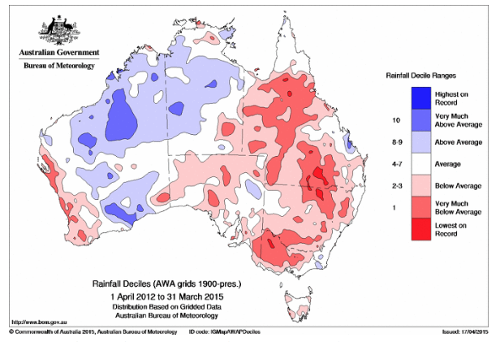
Figure 1. Rainfall Decile Ranges from 2012-2015 across Australia.
Source: Bureau of Meteorology

Toolondo Reservoir water levels in the past
Based on existing operating (trigger) rules that enable the supply of water from Rocklands Reservoir to Toolondo Reservoir, hydrological modelling (Figure 2) shows that Toolondo Reservoir would have had water levels that exceed 2.5 metres in 93.4 years out of 100 years based on long term averages. Had the existing rules been in place the whole time, water levels would have fallen below this level on only three occasions - 1902, 1946 and during the millennium drought between 2000 and 2011. However, inflows to Rocklands Reservoir between 2000 and 2015 (to date) have been substantially lower than historic norms. Figure 3 shows a comparison between Toolondo storage levels under three inflow scenarios (Historic, last 35 years and last 25 years) which represent three possible future climate scenarios. If the last 35 years climate data is used then water levels would exceed 2.5m in Toolondo in about 69% of months and if the last 25 years climate data is used then water levels would exceed 2.5m in Toolondo in about 57% of months.
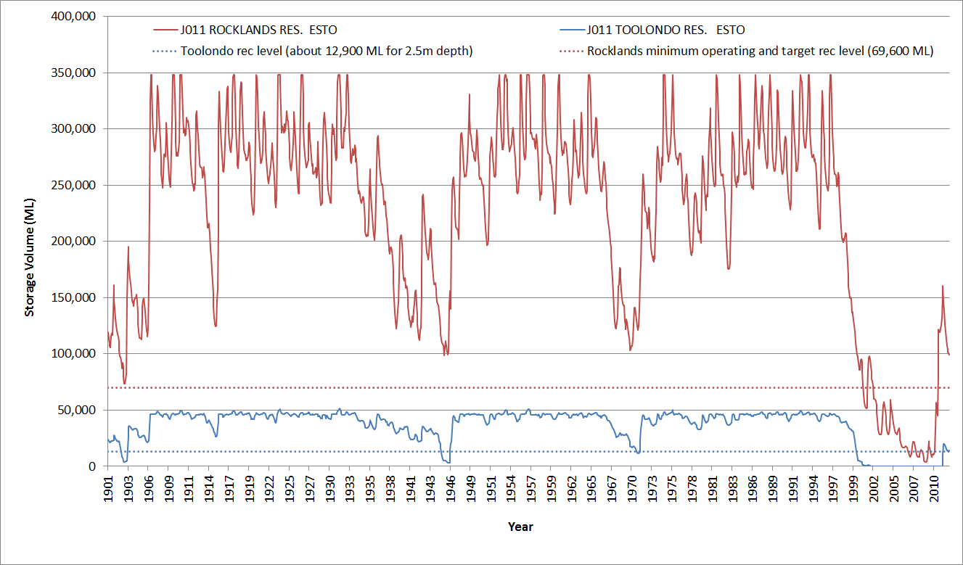
Figure 2. Modelled changes in the amount of water stored in Rocklands Reservoir
and Toolondo Reservoir assuming historic climate.
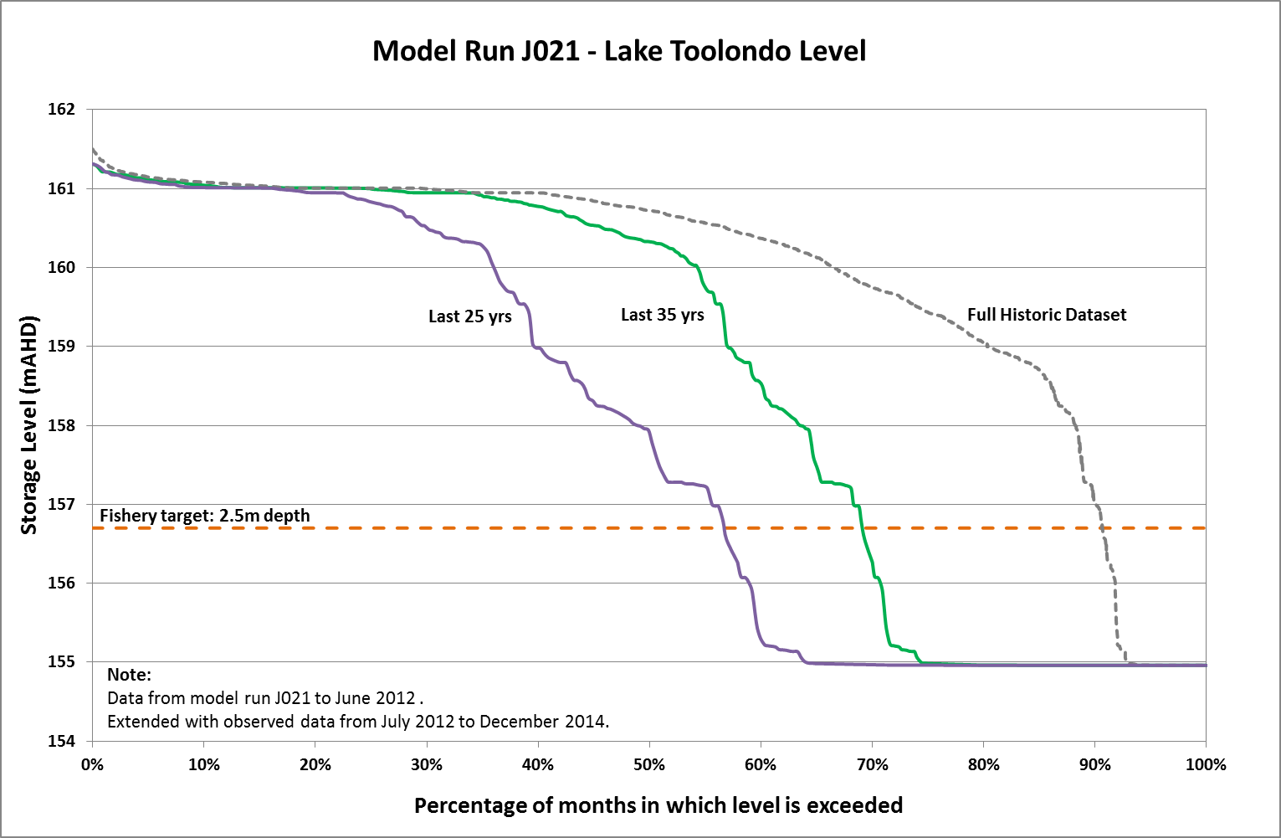
Figure 3. Toolondo storage levels under three inflow scenarios
(Historic, last 35 years and last 25 years). Source GWMWater, August 2015

Attachment 2.

Complete bathymetry data map based on data collected in the Austral Research and Consulting survey.

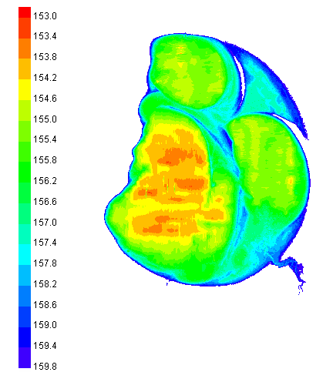

Figure 4. Toolondo Reservoir Bathymetry. Colours correspond to relative level AHD. RL 153.5 AHD represents the base of the reservoir and water level at the time of the survey was RL 156.7 AHD.

Attachment 3.
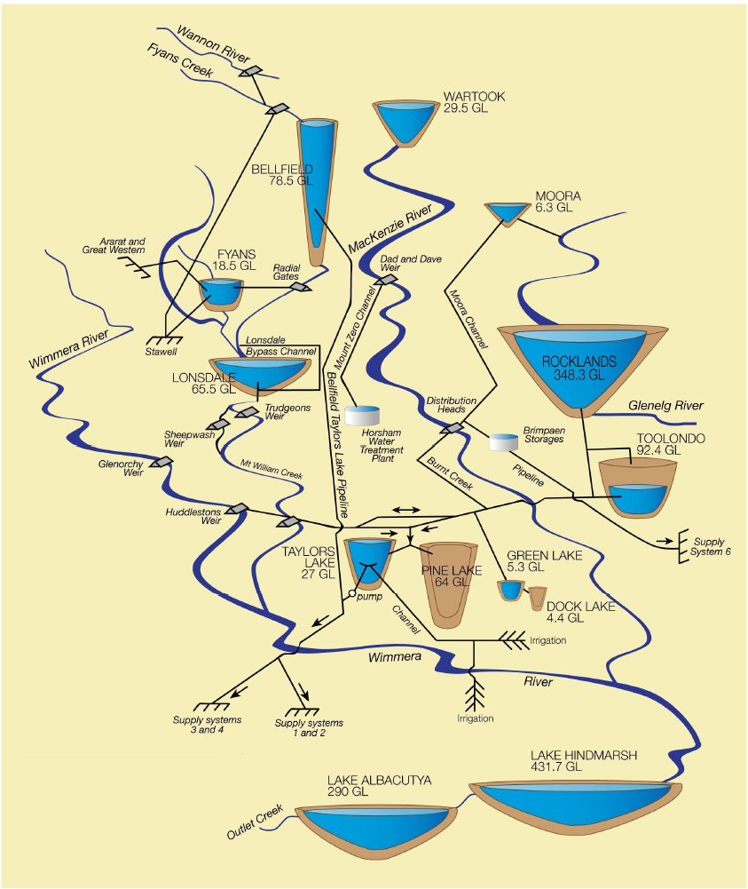
Figure 5. Overview of Wimmera / Glenelg Water management scheme.

Attachment 4.
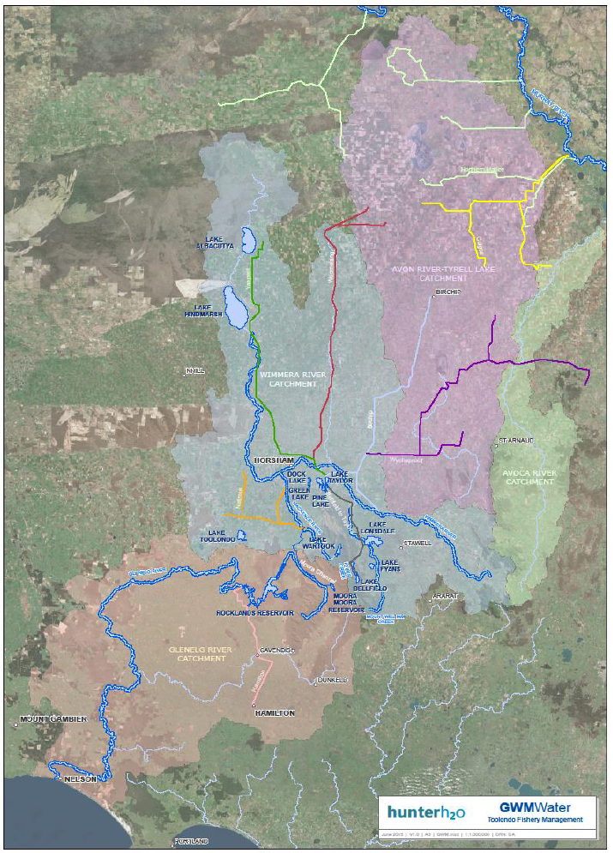
Figure 6. Glenelg Wimmera Mallee Water Supply System from Hunter H2O report.

Attachment 5.

Table 1. Overview of 16 options and response to find more permanent water for Toolondo Reservoir.
No. | Option | TRRFAG response
Options within Bulk Water Entitlement Framework
1 | Maintain current arrangements | Supported when drought conditions dictate higher water use priorities
2 | Purchase a secure water entitlement | Not supported. Cost of purchasing water is prohibitive.
3 | Install a syphon at Toolondo to reduce pumping costs | Not supported. Capital costs too high.
4 | Traditional Toolondo fishery benefits provided as system losses | Not supported. Inconsistent with water use efficiency objectives and water entitlement holders expectations.
5 | Manage Toolondo as secondary storage | Supported in principle if system losses can be offset through water trade, but not in drought conditions.
6 | Environmental water used for Toolondo environmental benefits | Not supported. Lower priority environmental values at Toolondo and limited environmental water available in drought conditions.
7 | Part of Wimmera recreational water entitlement used | Not supported. Insufficient water available for this purpose.
8 | Negotiate to secure short term water opportunities | Supported in principle subject to outcomes of negotiating the trade of water with entitlement holders, only after higher water use priorities are satisfied.
9 | Invest in piping of headworks open supply channels to save water | Not supported. Capital costs too high.
Options outside the Bulk Water Entitlement Framework
10 | Recreational and environment water managed together | Supported in principle but limited environment water available at present and not able to be accommodated under existing Environmental Watering framework.
11 | Reduce current consumptive and / or environmental entitlements | Not supported. Cannot reasonably reduce water entitlement holders allocation for this purpose.
12 | Change water management trigger (Rocklands Reservoir) rules | Not supported. Triggers in place for water use efficiency.
Options that challenge and extend the Advisory Group objectives
13 | Invest in non-water improvements for Toolondo Fishery | Supported with proposals developed as part of the GWMW Management planning processes.
14 | Don’t require permanent fishery water through millennium drought | Supported as drought conditions dictate higher water use priorities.
15 | Create fishery model to optimise Toolondo fishery | Supported in principle. Information on catch and stocking rates can be used to optimise the performance of the Toolondo fishery.
16 | Manage Toolondo and Rocklands (or region) fisheries together | Supported in principle. The development of Rocklands Reservoir will be investigated.

Table 2. Summary of Environmental Delivery and Passing Flows in the Glenelg and Wimmera River systems 2010-2015
Season | Glenelg River |  |  |  |  | Wimmera System
 | Passing Flows (ML) | Regulated Enviro  (ML) | Compensation Flow  (ML) |  | Glenelg Total  (ML) |  | Passing Flows  (ML) |  | Regulated Enviro  (ML) | Wimmera Total  (ML)
2010/11 | 11,293 | 1,965 | 0 | 13,258 |  |  | 24,053 | 7,065 |  | 31,118
2011/12 | 17,265 | 3,514 | 3300 | 24,079 |  |  | 12,610 | 14,183 |  | 26,793
2012/13 | 12,127 | 19,386 | 1602 | 33,115 |  |  | 6,947 | 30,730 |  | 37,677
2013/14 | 10,645 | 10,207 | 2145 | 22,997 |  |  | 4,038 | 19,532 |  | 23,570
2014/15 | 5,129 | 15,449 | 50 | 20,628 |  |  | 848 | 18,159 |  | 19,007
Totals | 56,459 | 50,521 | 7,097 | 114,077 |  |  | 48,496 | 89,669 |  | 138,165

Table 3. Public submissions received resulting from media release (11 June 2015) and noted by the TRRFAG.
Date | Author | Subject summary
16 June 2015 | Brian Murrell | Current shortage of water and prudent management required for all water users. Does not support environmental water allocation to Toolondo. TRRFAG TOR be made publically available. Broader community be consulted prior to finalisation.
17 June 2015 | Hugh Smith | Re-establishment of Toolondo Reservoir back into the system for water storage and securing fishery
2 July 2015 | Brad Stephens | Importance of Toolondo Reservoir fishery, suggested improvements to sustaining fishery and recreational amenity

Attachment 6

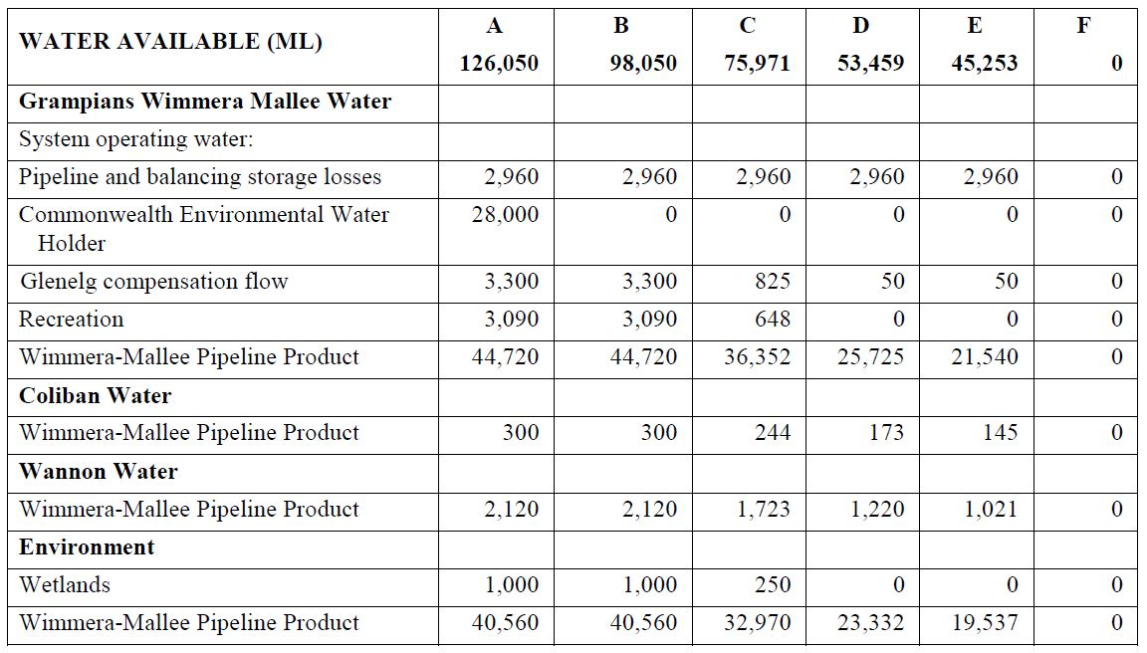
Bulk Entitlement Water Share Table

Attachment 7.

Technical reports inputs commissioned and considered by the TRRFAG
Iervasi, D. (2015) Toolondo Reservoir Bathymetry Survey – Report for Grampians Wimmera Mallee Water (GWMWater) and Fisheries Victoria. Austral Research and Consulting. July 2015
Ingram, B.A. (2015) A review of the recreational fishery of Toolondo Reservoir and its future prospects. Fisheries Victoria Science Report Series No. 8.
Keary, J and Holmes N. (2015) Review of Wimmera Headworks Supply System to Meet Toolondo Fishery Management Objectives. Project No. 4257 – 001. Hunter H2O. July 2015.
Sharpe, A. (2015) Independent review of Toolondo Reservoir environmental values. Jacobs Group. June 2015.

