Marine and Freshwater Discovery Centre
Volunteer Program Information
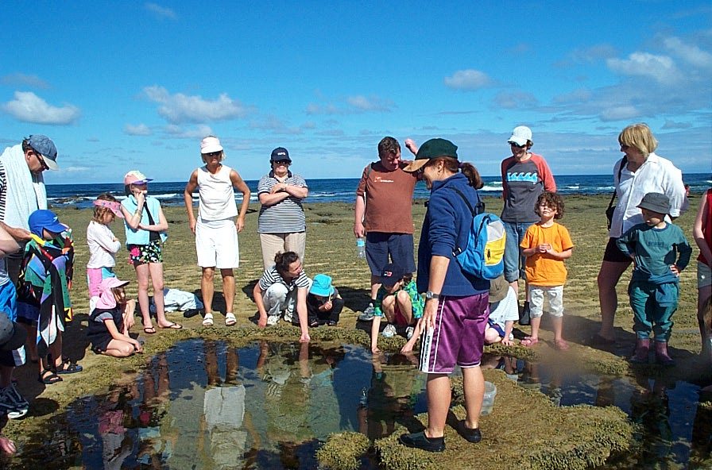
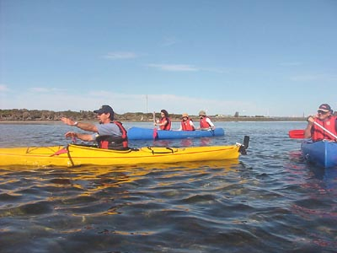
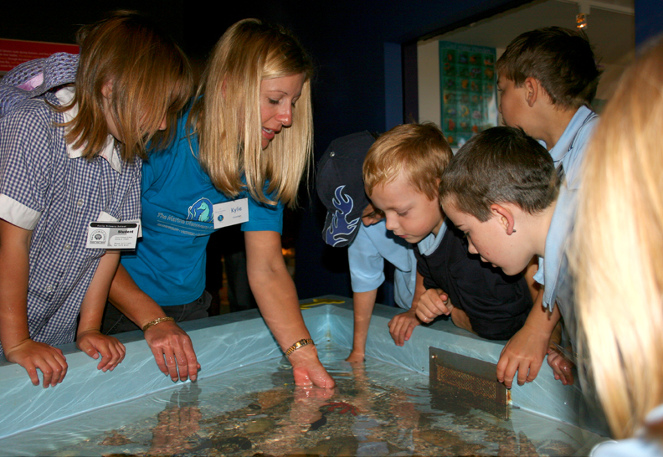

Welcome! You have the opportunity to be an important member of a small group of highly committed people working to make the Marine and Freshwater Discovery Centre (MFDC) a place of excellence in marine and freshwater education. Without you, many
of the 40,000 visitors to the Centre each year would not have the same opportunities to experience our unique coastal environments they presently enjoy through the MFDC. Put simply, a large part of the Centre's programs would not operate without the efforts of
our volunteer team.

Your rewards? They are the looks of excitement on children's faces as you help them make their next exciting discovery; the satisfaction you will gain from challenging their parents to think about the most ordinary sea creature in a new and interesting way and the heartfelt gratitude of the staff.

Your actions and efforts as a MFDC volunteer are important influences on the attitudes of our visitors and ultimately, the state of our environment. We hope that your time as a volunteer will be a long and fruitful one - for you, for the Centre and for the environment.

The MFDC is an education facility of the Victorian Fisheries Authority (VFA) It has been operating at Queenscliff since 1983, providing education services to students, teachers, families and tourists.

Two main programs are conducted at the MFDC:
- a schools program which provides unique field and aquarium experiences for students of all ages
- a series of holiday programs which provide direct encounters with the environment for family groups
As a volunteer, you may assist with a cross-section of these programs, depending on your interests, abilities and availability.

A brief history of the Marine and Freshwater Discovery Centre
The MFDC was established in 1983. In the first six months, 2000 students took part in Victoria’s first Marine Education Program.
In 1987, the first volunteers assisted with the January holiday program.

Our approach to learning: small steps to sustaining our seas
"Learning", for us, is not an end unto itself. It is one important, necessary component of a suite of strategies by which we aim to change people's behaviour.

Behavioural changes can take years to achieve. We recognise that we are only one of many influences on people's lives, and that there are many ways in which people learn. It is here that the art of interpretation is potentially our most useful tool.

Working With Children Check (WWCC)
All staff and volunteers must apply for and pass a WWCC. There is no fee for volunteers. Application forms can be picked up
(and lodged) at any Post Office. You may need to make an appointment with your local post office.

Interested? Here’s what you need to do:
- Fill out the application form attached and return them to the MFDC.
- Apply for your Working with Children Check (WWCC) at a post office
- Organise a day during our school holiday program that you can come along and see how the centre operates.
You can do this by emailing alex.giannuzzi@vfa.vic.gov.au
- Any questions? Send them through to alex.giannuzzi@vfa.vic.gov.au
or phone us on (03) 5258 3344

Volunteer Course Registration Form

Return this form to: MFDC PO Box 114 Queenscliff 3225 or E-mail: alex.giannuzzi@vfa.vic.gov.au

Name:

Address: Postcode:

Phone: Email address:

How did you find out about volunteering at the MDC?

Have you had a Working with Children check? (please circle) Yes No

If Yes, please send a copy to us when you return this form. If No, you will need to obtain an application form and apply

What skills can you offer the MFDC? Eg) First Aid, snorkelling, teaching, canoeing, animal husbandry etc.

Do you have any health issues that may affect the type of volunteering work you do?

Emergency contact details
Name (& relationship): Phone:

Can you speak another language? (Please circle) Yes No
If yes, please list

Referee (preferably an employer or professional associate)
Name: Phone:

Please enter any comments or further information you feel we need to know

Photos and Video Consent for VFA Terms and Conditions of Consent
a) By signing this form I consent to VFA, at its discretion to copy or reproduce such material (whether by photo, film or other electronic
or printed media) as the VFA may determine, without acknowledgment of myself and without the entitlement to any remuneration of
compensation now or in the future. I agree that I will have no further rights in the images including moral rights and copyright.
b) The VFA agrees not to use any image in a manner that may be deemed adverse, or defamatory to the person signing this form.
The VFA further agrees that it will not use the image knowingly for any political or commercial gain.
c) VFA is committed to protecting personal information provided by you in accordance with the principles of the Information Privacy
Act 2000. A copy of the Department’s Privacy Policy can be obtained from www.dedjtr.vic.gov.au.

Signed: Date:

Volunteer acknowledgement and agreement
  I understand that I am volunteering my services to the MFDC, Fisheries Victoria and DEDJTR and that I will not receive any
remuneration for those services.
 I understand that as a Volunteer, I am covered by VFA’s insurance
 I understand that I am covered by VFA’s public liability insurance in respect of accidental damage that I may cause to other people
or property in the course of providing their services to the MFDC as a volunteer but that I will be personally liable for any deliberate
or negligent damage caused to any person or property whilst a volunteer of the MFDC
 I agree that if this registration is approved that I will only volunteer under the guidance and supervision of staff from MFDC
 I understand that the MFDC reserves the right to terminate my engagement as a volunteer at its discretion

Declaration
I declare that the above information is true and correct. I also declare that I am 18 years and over.

Signed: Date:

All information contained in this Volunteer Registration Form will remain confidential and only be used by VFA for the specific purpose of the appointment and management of volunteers.

