
Victorian Giant Crab Fishery

Stock Assessment Report
2014/15 Season

February 2016

February 2016

© The State of Victoria Department of Economic Development, Jobs, Transport and Resources
This work is licensed under a Creative Commons Attribution 3.0 Australia licence. You are free to re-use the work under that licence, on the condition that you credit the State of Victoria as author. The licence does not apply to any images, photographs or branding, including the Victorian Coat of Arms, the Victorian Government logo and the Department of Environment and Primary Industries logo. To view a copy of this licence, visit http://creativecommons.org/licenses/by/3.0/au/deed.en
ISBN 1 74146 111 1
Accessibility
If you would like to receive this publication in an alternative format, please telephone the Customer Service Centre 136 186, email customer.service@depi.vic.gov.au, via the National Relay Service on 133 677 www.relayservice.com.au. This document is also available on the internet at www.economicdevelopment.vic.gov.au
Disclaimer
This publication may be of assistance to you but the State of Victoria and its employees do not guarantee that the publication is without flaw of any kind or is wholly appropriate for your particular purposes and therefore disclaims all liability for any error, loss or other consequence which may arise from you relying on any information in this publication.

Victorian Giant Crab Fishery Stock Assessment Report: 2014/15 Season

Adrian Linnane¹, Richard McGarvey¹, John Feenstra¹, Lachlan McLeay¹ and David J. Reilly²

¹South Australian Research and Development Institute, PO Box 120, Henley Beach, South Australia 5022
²Fisheries Victoria, Department of Economic Development, Jobs, Transport, and Resources, PO Box 114, Queenscliff, Victoria 3225

Summary
In 2014/15, the total allowable commercial catch (TACC) for giant crab was 10.5 tonnes. The total landed catch was 10.5 tonnes, of which 10.2 tonnes was targeted.

The targeted catch rate in 2014/15 was 0.99 kg/24 hour potlift, which is above the limit reference point of 0.52 kg/24 hour potlift for the fishery.

Introduction
This document reports time series of giant crab (Pseudocarcinus gigas) catch and catch rate (expressed as kg per 24 hour potlift) from mandatory daily logbook returns. The catch data are summarised by licencing year (July-June), while the catch rate data are summarised by fishing year (November–September).

Separate giant crab and southern rock lobster fishing returns were mandated with the introduction of quota management in November 2001. For returns prior to April 1998, target species was not specified and effort targeted at giant crab was separated from effort targeted at southern rock lobster on the basis of two criteria. Where pots were set at depths greater than 140 metres or where more than 70% of the combined catch of these two species was giant crab, all of the effort was assumed to be targeted at giant crab. Following the introduction of quota management, separate logbooks for the giant crab and southern rock lobster fisheries led to some inconsistencies in the reporting of the target species. This resulted in a reduced giant crab catch per unit effort (CPUE) overall, which was inconsistent with the observations of the most active fishers. A second measure of CPUE was therefore introduced involving the targeted catch and effort for only those fishers landing more than one tonne of giant crab in a fishing year.

Giant crab targeted CPUE is expressed as kg per 24 hour potlift because the pots are usually left to soak for several days. Prior to 2001/02, soak days were estimated by counting days between entries in the daily logbook, with the maximum soak days in this calculation capped at seven days. Logbooks were modified during the 2001/02 fishing year to collect soak days directly. A recent review undertaken by the Victorian Rock Lobster and Giant Crab Resource Assessment Group highlighted that a four-day soak-time cap was more appropriate. In addition, a slope value of 0.38 was implemented for the relationship between soak time and catch rate.

Giant Crab Stock Assessment Results: 2014/15
The total landed catch of giant crab by all fishers in 2014/15 was 10.5 tonnes of which 10.2 tonnes was targeted (Figure 1). The targeted catch rate in 2014/15 was 0.99 kg/24 hour potlift (Figure 2).

The assessment was undertaken comparing the biological stock performance indicator of targeted CPUE against the giant crab biological reference points (Figure 2). The reference points prescribed in the Management Plan are based on ‘fishing year’ (November–September) and include a limit reference point (mean for the 3‐fishing‐year period from 1998/99 to 2000/01) (0.52 kg/24 hour potlift), and the trigger reference point (80% of limit reference point) (0.42 kg/24 hour potlift).

Based on the estimate of 0.99 kg/24 hour potlift, the targeted CPUE in 2014/15 was above the limit reference point (0.52 kg/24 hour potlift). A size frequency sample of approximately 600 individuals was also recorded by fishers in 2014/15 and is compared against length frequency data from previous seasons in Figure 3.

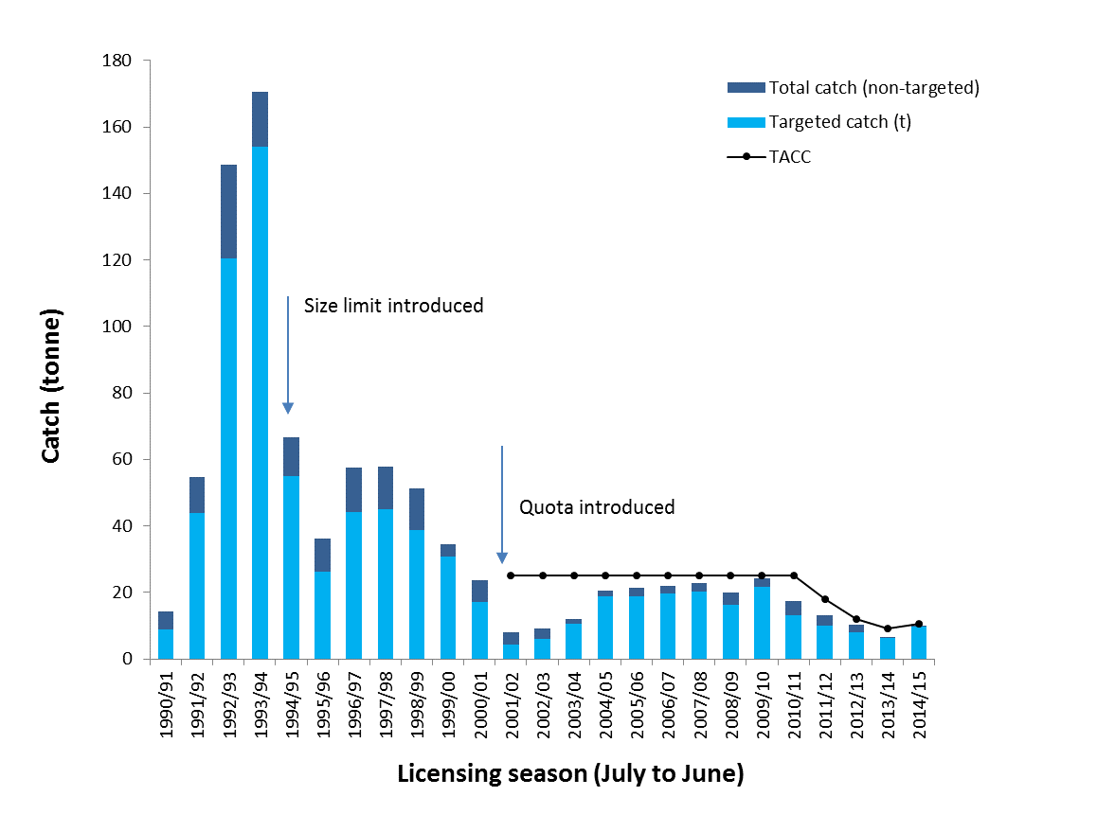

Figure 1. Total catch (t) and targeted catch history for the Victorian Giant Crab Fishery. Black line indicates TACC introduction in 2001 (25 t).

Figure 2. Catch rate of giant crab (kg/24 hour potlift) corrected for a maximum of 4 days soak, with a slope of 0.38 for all fishers landing > 1000 kg.

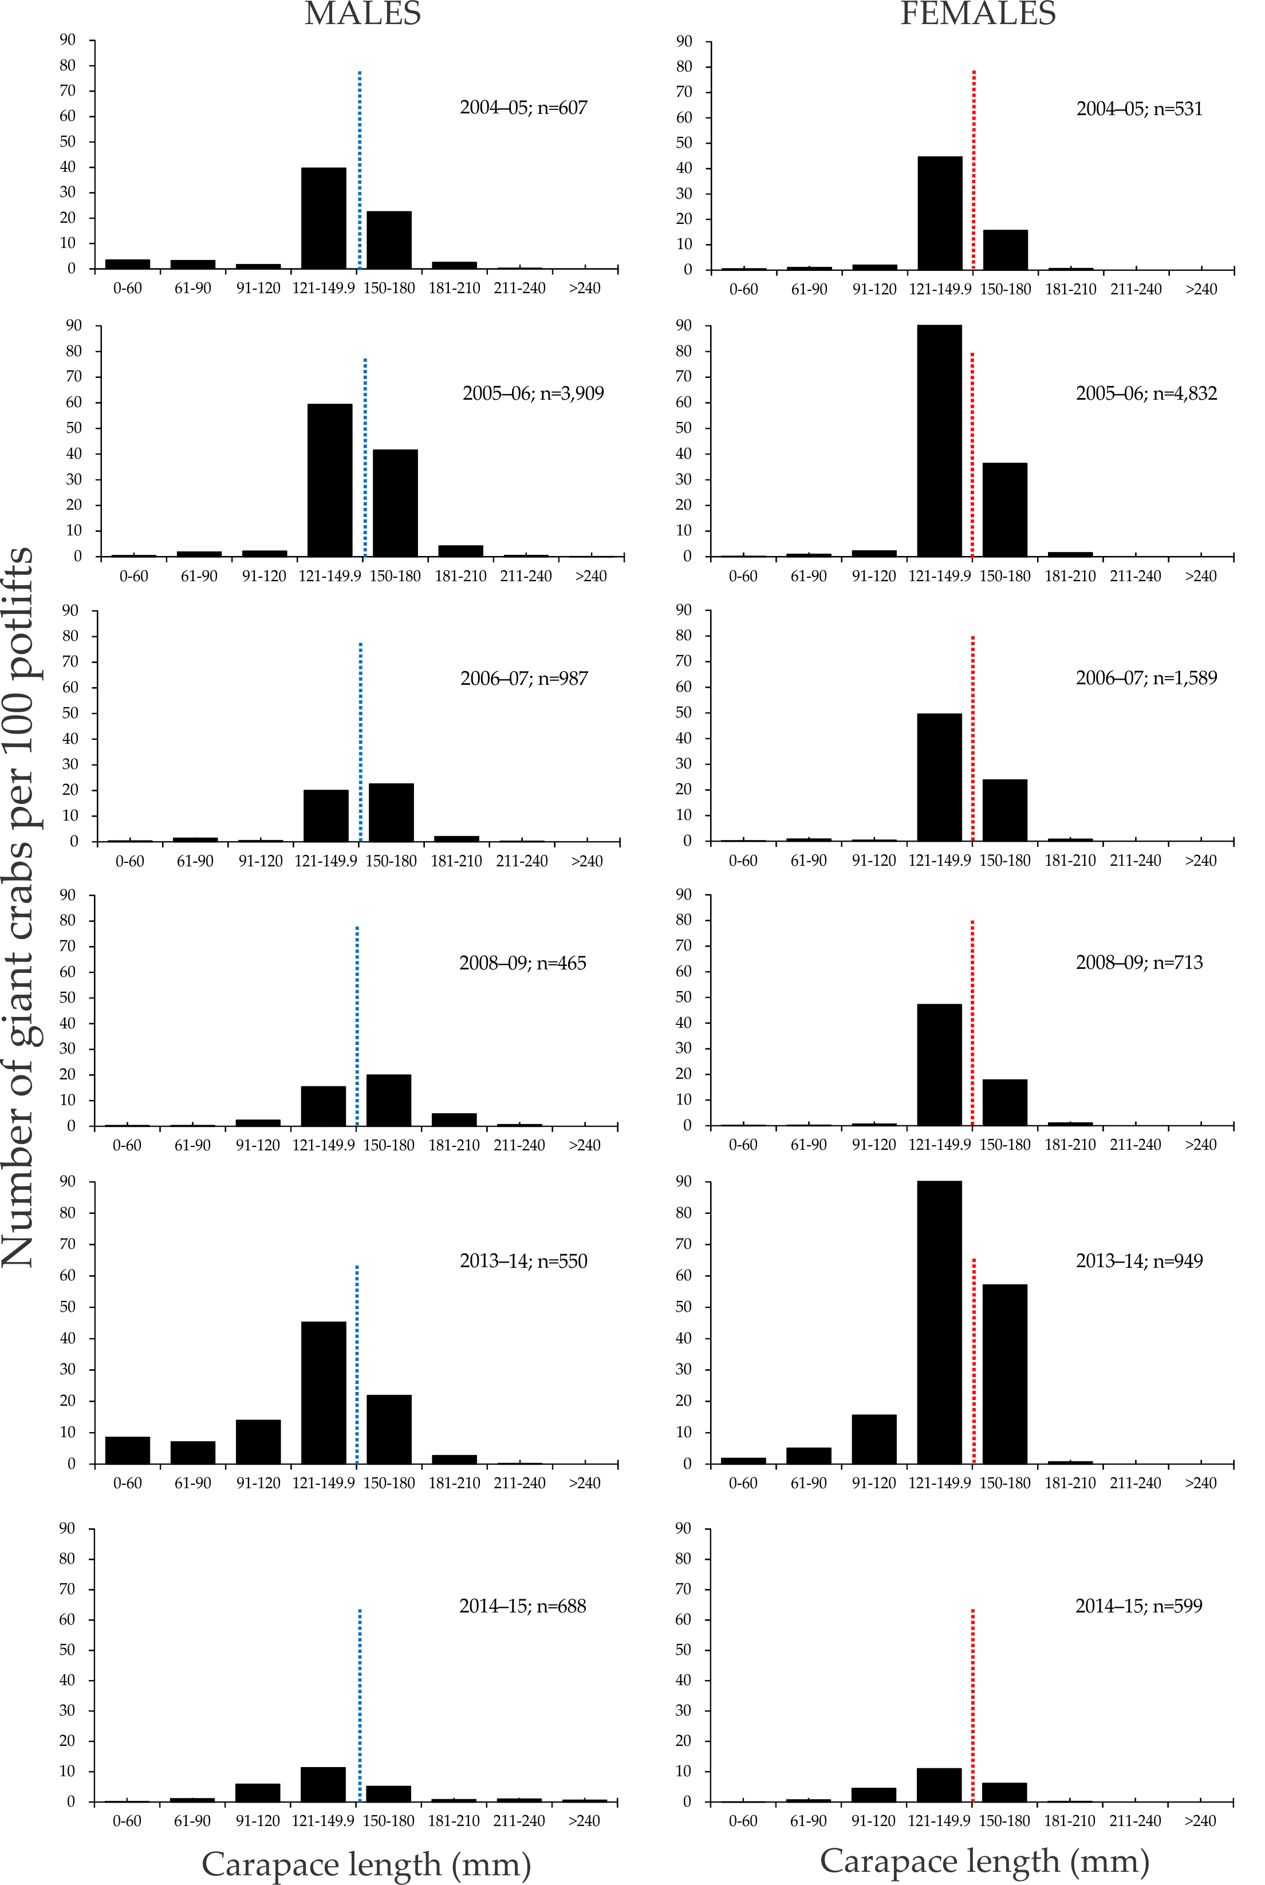

Figure 3. Length-frequency distribution of the number of male (left) and female (right) giant crabs per 100 potlifts, collected by the onboard observer program between fishing years from 2004–05 to 2008–09 and as supplementary catch data by giant crab fishers in the 2013–14 and 2014–15 fishing years (1 Nov–31 Oct). n = total number of crabs measured.
Table 1. Giant crab total catch, targeted catch, effort and catch rate during fishing years (16 November–14 September) from 1990–91 to 2014–15.

Fishing  Year | Total Catch  (tonne) | Target Catch Fishers >1 tonne | Effort (Soak*pots) Fishers >1 tonne (‘000s) | Catch rate Fishers > 1 tonne
1990-91 | 18.5 | 12.7 | 19.9 | 0.64
1991-92 | 56.7 | 44.4 | 27.9 | 1.59
1992-93 | 226.2 | 186.8 | 66.5 | 2.81
1993-94 | 121.9 | 108.4 | 33.7 | 3.21
1994-95 | 38.8 | 26.8 | 22.1 | 1.21
1995-96 | 40.9 | 31.0 | 23.2 | 1.34
1996-97 | 68.5 | 54.2 | 42.6 | 1.27
1997-98 | 50.6 | 37.2 | 50.4 | 0.74
1998-99 | 50.2 | 39.6 | 80.8 | 0.49
1999-00 | 25.3 | 19.9 | 49.2 | 0.41
2000-01 | 19.5 | 14.0 | 21.1 | 0.67
2001-02 | 9.6 | 2.0 | 1.7 | 1.18
2002-03 | 8.4 | 1.1 | 2.9 | 0.39
2003-04 | 10.5 | 4.4 | 2.7 | 1.66
2004-05 | 22.7 | 12.6 | 9.8 | 1.29
2005-06 | 21.7 | 15.6 | 9.3 | 1.68
2006-07 | 22.8 | 14.4 | 8.9 | 1.62
2007-08 | 27.6 | 12.6 | 10.0 | 1.26
2008-09 | 27.2 | 11.6 | 10.6 | 1.09
2009-10 | 16.4 | 7.1 | 9.8 | 0.72
2010-11 | 11.3 | 1.5 | 2.9 | 0.52
2011-12 | 12.6 | 6.7 | 6.9 | 0.97
2012-13 | 8.8 | 7.9 | 7.3 | 1.09
2013-14 | 6.5 | 6.4 | 7.0 | 0.91
2014-15 | 10.5 | 10.2 | 10.4 | 0.99

Data Source: Fisheries Victoria Catch and Effort Database (December 2015) for period 1990-91 to 2014-15.

Table 2. Giant crab total allowable commercial catch by quota year between 2001–02 and 2014–15.

QUOTA YEAR | PERIOD | TACC (t)
2001-02 | 16 Nov – 31 Mar | 25
2002-03 | 1 Apr – 31 Mar | 25
2003-04 | 1 Apr – 31 Mar | 25
2004-05 | 1 Apr – 31 Mar | 25
2005-06 | 1 Apr – 31 Mar | 25
2006-07 | 1 Apr – 31 Mar | 25
2007-08 | 1 Apr – 31 Mar | 25
2008-09 | 1 Apr – 31 Mar | 25
2009-10 | 1 Apr – 31 Mar | 25
2010-11 | 1 Apr – 30 Jun | 31
2011-12 | 1 Jul – 30 Jun | 18
2012-13 | 1 Jul – 30 Jun | 12
2013-14 | 1 Jan 14 – 30 Jun | 9
2014-15 | 1 Jul - 30 Jun | 10.5

Data Source: Fisheries Victoria Catch and Effort Database (December 2015) for period 1990-91 to 2014-15.

