Victorian Giant Crab Fishery
Stock Assessment Report

2013/14 SEASON

March 2015



© The State of Victoria Department of Economic Development, Jobs, Transport and Resources
This work is licensed under a Creative Commons Attribution 3.0 Australia licence. You are free to re-use the work under that licence, on the condition that you credit the State of Victoria as author. The licence does not apply to any images, photographs or branding, including the Victorian Coat of Arms, the Victorian Government logo and the Department of Environment and Primary Industries logo. To view a copy of this licence, visit http://creativecommons.org/licenses/by/3.0/au/deed.en
ISBN 1 74146 111 1
Accessibility
If you would like to receive this publication in an alternative format, please telephone the Customer Service Centre 136 186, email customer.service@depi.vic.gov.au, via the National Relay Service on 133 677 www.relayservice.com.au. This document is also available on the internet at www.economicdevelopment.vic.gov.au
Disclaimer
This publication may be of assistance to you but the State of Victoria and its employees do not guarantee that the publication is without flaw of any kind or is wholly appropriate for your particular purposes and therefore disclaims all liability for any error, loss or other consequence which may arise from you relying on any information in this publication.

Victorian Giant Crab Fishery Stock Assessment Report: 2013/14 Season

Adrian Linnane¹, Richard McGarvey¹, John Feenstra¹, Lachlan McLeay and David J. Reilly²

¹South Australian Research and Development Institute, PO Box 120, Henley Beach, South Australia 5022
²Fisheries Victoria, Dept of Economic Development, Transport, Jobs and Resources, PO Box 114, Queenscliff, Victoria 3225

Summary
In 2013/14, the total allowable commercial catch (TACC) for giant crab was 9 tonne. The total landed catch was 6.5 tonne, of which 6.4 tonne was targeted.

The targeted catch rate in 2013/14 was 0.53 kg/24 hour potlift, which is marginally above the limit reference point of 0.52 kg/24 hour potlift for the fishery.

Introduction
This document reports time series of giant crab (Pseudocarcinus gigas) catch and catch rate (expressed as kg per 24 hour potlift) from mandatory daily logbook returns. The catch data are summarised by licencing year (July-June) while the catch rate data are summarised by fishing year (November–September).

Separate giant crab and southern rock lobster fishing returns were mandated with the introduction of quota management in November 2001. For returns prior to April 1998, target species was not specified and effort targeted at giant crab was separated from effort targeted at southern rock lobster on the basis of two criteria. Where pots were set at depths greater than 140 metres or where more than 70% of the combined catch of these two species was giant crab, all of the effort was assumed to be targeted at giant crab. Following the introduction of quota management, separate logbooks for the giant crab and southern rock lobster fisheries led to some inconsistencies in the reporting of the target species. This resulted in reduced giant crab CPUE overall, which was inconsistent with the observations of the most active fishers. A second measure of CPUE was therefore introduced involving the targeted catch and effort for only those fishers landing more than one tonne of giant crab in a fishing year.

Giant crab targeted CPUE is expressed as kg per 24 hour potlift because the pots are usually left to soak for several days. Prior to 2001/02, soak days were estimated by counting days between entries in the daily logbook, with the maximum soak days in this calculation capped at seven days. Logbooks were modified during the 2001/02 fishing year to collect soak days directly. A recent review undertaken by the Rock Lobster & Giant Crab Resource Assessment Group (RLRAG) highlighted that a four-day soak-time cap was more appropriate. In addition, a slope value of 0.38 was implemented for the relationship between soak time and catch rate.

Giant Crab Stock Assessment: 2013/14

The total landed catch of giant crab by all fishers in 2013/14 was 6.5 tonne of which 6.4 tonne was targeted (Table 1, Figure 1). The targeted catch rate in 2013/14 was 0.53 kg/24 hour potlift (Table 1, Figure 2).

The assessment was undertaken comparing the biological stock performance indicator of targeted CPUE against the giant crab biological reference points (Figure 2). The reference points prescribed in the Victorian Giant Crab Fishery Management Plan are based on ‘fishing year’ (November–September) and include a limit reference point (mean for the three‐fishing‐year period from 1998/99 to 2000/01) (0.52 kg/24 hour potlift), and the trigger reference point (80% of limit reference point) (0.42 kg/24 hour potlift).

Based on the estimate of 0.53 kg/24 hour potlift, the targeted CPUE in 2013/14 was marginally above the limit reference point (0.52 kg/24 hour potlift). A size frequency sample of approximately 500 individuals was also recorded in 2013/14, as part of work undertaken by on-board observers, and is compared against length frequency data from 2004/05 to 2008/09 in Figure 3.

Table 1. Giant crab total and targeted catch, effort and CPUE during fishing years (16 November–14 September) from 1990–91 to 2013–14.

Fishing  Year | Total Catch  (tonne) | Targeted Catch  (tonne) | Target Catch Fishers >1 tonne | Effort Fishers >1 tonne (000s) | Targeted CPUE kg/24 hr/potlift
1990-91 | 18.5 | 4.7 | 4.5 | 4.8 | 0.64
1991-92 | 56.7 | 38.5 | 35.6 | 21.1 | 1.59
1992-93 | 226.2 | 186.5 | 184.5 | 105.2 | 2.81
1993-94 | 121.9 | 109.5 | 108.4 | 65.1 | 3.21
1994-95 | 38.8 | 24.9 | 22.4 | 21.8 | 1.21
1995-96 | 40.9 | 33.1 | 31.0 | 35.9 | 1.34
1996-97 | 68.5 | 53.5 | 51.4 | 55.1 | 1.27
1997-98 | 50.6 | 30.6 | 29.3 | 56.8 | 0.73
1998-99 | 50.0 | 20.5 | 19.5 | 31.9 | 0.49
1999-00 | 25.3 | 13.3 | 12.2 | 20.0 | 0.40
2000-01 | 19.5 | 9.9 | 8.8 | 10.2 | 0.67
2001-02 | 9.6 | 8.1 | 5.5 | 14.4 | 0.75
2002-03 | 8.4 | 6.5 | 4.6 | 20.7 | 0.28
2003-04 | 10.5 | 10.1 | 9.5 | 18.1 | 1.16
2004-05 | 22.7 | 20.1 | 19.0 | 34.5 | 1.15
2005-06 | 21.7 | 20.1 | 19.3 | 38.4 | 1.35
2006-07 | 22.8 | 21.6 | 21.5 | 41.2 | 1.18
2007-08 | 27.6 | 25.7 | 25.2 | 56.0 | 0.94
2008-09 | 27.2 | 24.7 | 23.8 | 64.6 | 0.77
2009-10 | 16.4 | 14.7 | 13.7 | 51.7 | 0.51
2010-11 | 11.3 | 10.4 | 9.1 | 34.7 | 0.26
2011-12 | 12.6 | 11.0 | 10.1 | 50.8 | 0.54
2012-13 | 8.8 | 8.7 | 7.9 | 33.8 | 0.53
2013-14 | 6.5 | 6.5 | 6.4 | 26.6 | 0.53

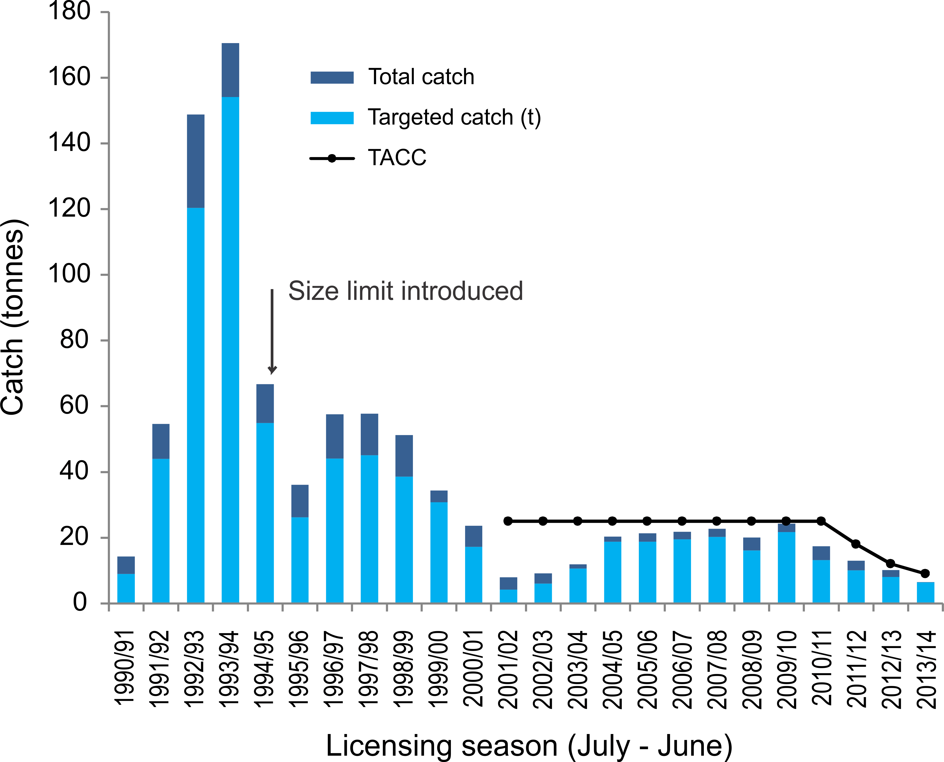

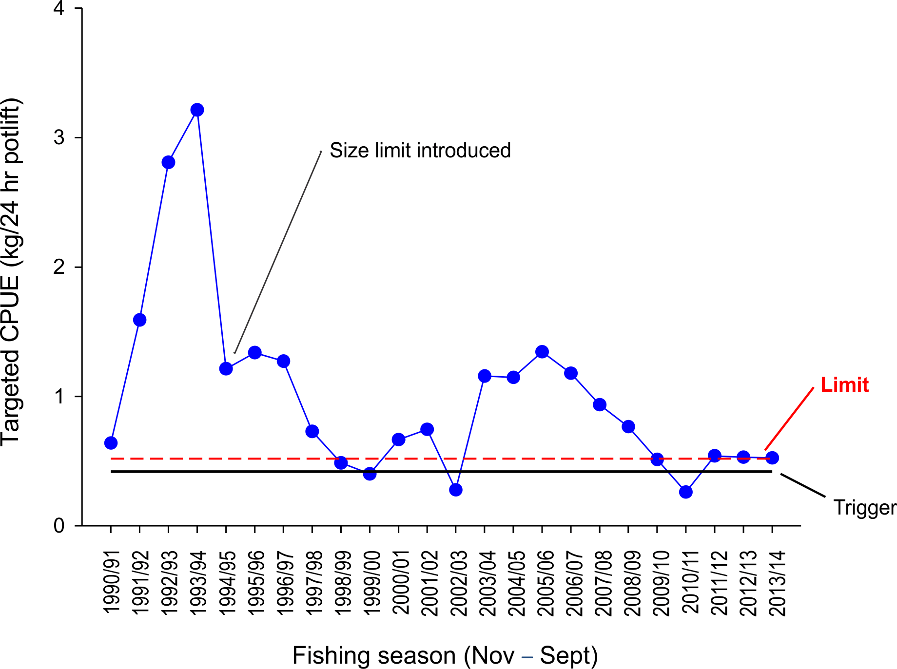
Figure 1. Total catch (t) and targeted catch history for the Victorian Giant Crab Fishery. Black line indicates TACC introduction in 2001 (25 t).

Figure 2. Catch rate of giant crab (kg/24 hour potlift) corrected for a maximum of 4 days soak, with a slope of 0.38 for all fishers landing > 1000 kg.

Figure 3. Length-frequency distribution of the number of male (left) and female (right) giant crabs per 1,000 potlifts, collected by the on-board observer program from 2004/05 to 2008/09 fishing years and as supplementary catch data by giant crab fishers in 2013/14 fishing year (1 Nov–31 Oct) . n, total number of crabs measured.

