Harvest Strategy for the Victorian Wrasse (Ocean) Fishery

Table of contents
1 Background 2
2 What is a harvest strategy and why is one required for the commercial wrasse fishery? 3
3 Wrasse biology 4
4 The harvest strategy for the Victorian Wrasse (Ocean) Fishery 5
4.1 Objectives and performance indicators for the Wrasse (Ocean) Fishery 5
4.1.1 Long term sustainability of wrasse 5
4.1.2 Economic efficiency of the Wrasse (Ocean) Fishery 6
4.1.3 Cost effective and participatory management 6
4.2 Operation of the Wrasse (Ocean) Fishery Harvest Strategy 6
4.2.1 Harvest control rules 7
5 Data collection 9
6 Commercial wrasse size limit 11
7 Wrasse harvest using rock lobster pots 11
8 Ongoing refinement and review of this harvest strategy 11
9 References 12

Background
There are currently 22 Wrasse (Ocean) Fishery Access Licences issued under the Fisheries Act 1995. Licences are not transferrable because sustainability concerns for the fishery led to a 1997 decision to remove latent effort and excess capacity from the fishery. After a rapid rise in annual catch in the 1990s to a peak of just under 90 tonnes in 1998/99, catches stabilised to between 40 and 50 tonnes during 2000 to 2004. With the decrease in effort because of fewer licences, catches fell again to between 30 to 40 tonnes during 2005 to 2009 and have remained between 20 and 30 tonnes since. The fishery extends along the entire length of the Victorian coastline and out to 20 nautical miles offshore, except for marine reserves.
Among the 14 licences that were active last year, around half accounted for about 80 per cent of the commercial Victorian wrasse harvest so there are concerns that the mobilisation of the significant amount of latent effort in this fishery could have a large and detrimental impact on the its sustainability.
On 1 April 2017, the Fisheries Regulations 2009 will be amended to list the Wrasse (Ocean) Fishery Access Licence as a transferable licence class (i.e. they can be sold, bequeathed or operated by a person other than the licence holder), subject to a Ministerial Direction. Once the Ministerial Direction is in place, licence holders will be able to transfer and/or lease the licences. It is envisaged that this harvest strategy will be endorsed by the Minister responsible for fisheries at the same time the Ministerial Direction is declared to help manage any sustainability concerns arising from the activation of latent effort and/or an increase in catch (Fisheries Victoria 2016a). Each licence may have only one nominated operator.
Two native wrasse species, Bluethroat Wrasse (Notolabrus tetricus) and Purple Wrasse (also called Saddled Wrasse) (N. fucicola), comprise approximately 90 per cent of the commercial Victorian wrasse harvest (Figure 1). Both species are highly abundant on reefs in Victoria and Tasmania (Edgar 1997) and are classified as being of least concern on the IUCN Red List.
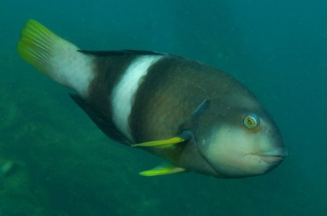
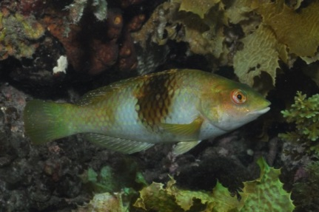
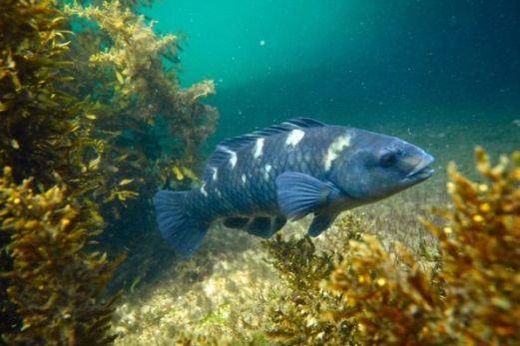
Negligible amounts of Rosy Wrasse (Pseudolabrus psittaculus), Senator Wrasse (Pictilabrus laticlavius) and Southern Maori Wrasse (Ophthalmolepis lineolatus) are harvested by Victorian wrasse fishers.
Figure 1. Male (left) and female (centre) Bluethroat Wrasse (Notolabrus tetricus). Purple Wrasse (N. fucicola; right) Sources: Rick Stuart-Smith/Reef Life Survey (http://fishesofaustralia.net.au/home/species/257); accessed on 1 Mar 2017]; derrickcruz/ iNaturalist.org. Accessed from http://fishesofaustralia.net.au/home/species/253 on 1 Mar 2017].
The commercial wrasse fishery is managed primarily by:
- Legal minimum size: Bluethroat Wrasse must be at least 28 centimetres total length; all other species must be at least 27 centimetres; and
- Gear restrictions: fishers can use no more than six fishing lines and these must not have more than 3 hooks or one jig attached; longlines are not permitted.
Most wrasse is harvested by hook and line although commercial rock lobster fishers who also hold a commercial wrasse licences can keep those fish that they catch in their pots. Licence holders holding entitlements in other Victorian fisheries, including the ocean, scallop, Port Phillip Bay/ Western Port and trawl fisheries and rock lobster fishers without a wrasse licence may only take up to eight wrasse per day.
Recreational wrasse harvest is believed to be low relative to the current and potential commercial harvest based on much higher landings more than a decade ago, the extent of kelp dominated reef habitat along the Victorian coast and the ubiquity of wrasse as one of the more readily visible (to divers) scale-fish inhabitants among those reefs.

What is a harvest strategy and why is one required for the commercial wrasse fishery?
Harvest strategies provide formal and structured frameworks that guide fishery management decision-making processes and assist in achieving fisheries management objectives by ensuring that managers, fishers and other stakeholders understand and document how they will respond to various desirable and undesirable fishery conditions before they occur and therefore avoid ad-hoc decision-making. They bring together all of the key elements and management functions used to make decisions about the level of fishing activity that should be applied to a fish stock or a management unit to maximize the likelihood of achieving ecological, economic and social sustainability.
Harvest strategies are widely used internationally and throughout Australian fisheries management jurisdictions and represent a best-practice approach to fisheries management decision-making (Sloan et al 2014).
The degree to which the impact of fishing on the wrasse resource will change with transferability is uncertain but it is reasonable to expect that increases in catches and the intensity of catches taken from specific reef areas will occur as new entrants actively participate in the fishery. It is pertinent to point out that concern about latent effort was expressed by wrasse fishers in 2001 (Smith et al 2001).
Effective fisheries harvest strategies are comprised of three key components that guide fishery managers and stakeholders in ensuring the sustainability of the fishery:
- Objectives: clearly stated policy and/or management objectives often related to ensuring biological sustainability, security of access and/or socio-economic benefits;
- Performance indicators: one or more indicators used to track performance of each of the objectives; their values are linked to defined reference points or benchmarks called targets (where we want the fishery to be), triggers (early warnings that the fishery has deteriorated to a point where action should be taken) and limits (where we do not want the fishery to be (Figure 2); and
- Harvest control rules: predetermined management responses, usually controls on harvest or effort, which are invoked when a performance indicator is above, below or between specific reference points.
To reduce the risk of reaching the limit reference, it is necessary to establish trigger levels that provide early warning to management and industry that the fishery status has deteriorated to a point where management action can be taken in a timely manner to prevent the limit being breached and therefore reduce the risk of a fishery collapse.
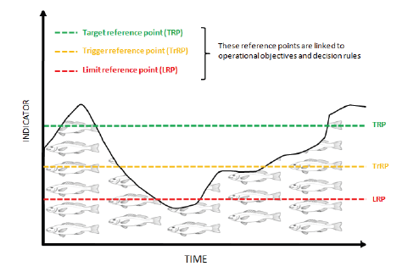
Figure 2. Graphical representation of the relationship between a stock performance indicator and the reference points (Sloan et al 2014). Note that the indicator data used in this graph is for illustration purposes and does not reflect the performance of the Victorian commercial wrasse fishery.

Wrasse biology
There are several biological characteristics of Victorian commercial wrasse that are relevant to sustainable harvest:
- they are relatively long lived;
- they have a long larval period which provides the potential for widespread dispersal;
- females mature below the legal minimum length
- individuals tend to remain close to a home reef and are territorial;
- for Bluethroat Wrasse, reef-based groups are generally comprised of a larger male and a harem of smaller females;
- Bluethroat Wrasse all develop as females and some change to males to replace the dominant males removed from the reef; and
- wrasse inhabit reefs that are often deeper than the depths at which commercial fishers target them.
Bluethroat Wrasse may attain a total length of up to 50 centimetres and live for up to 23 years; females mostly mature at about 5 to 8 years of age and at about two thirds their maximum size (Smith et al. 2003). Males can reach at least 50 cm total length and mature at approximately 8 years age (Smith et al. 2003).They inhabit depths up to 160 metres, whereas fishers mostly operate in depths shallower than 30 metres to reduce their losses due to barotrauma where the swim bladder expands and damages the fish as it is hauled to the surface. Bluethroat Wrasse is a hermaphroditic species in that females at some point in their lives, transition to male. This species does not migrate extensively among reefs and the males exhibit territorial behaviour whilst guarding their female harem against competing males.
Purple Wrasse attain a maximum size of 45 centimetres, and for Victorian populations may live at least 16 years, and are found at depths up to 90 metres (Smith et al. 2003). Unlike the Bluethroat Wrasse, sex does not change after maturity which means that the exploitable stock may comprise similar proportions of both sexes (Bray 2017b).
Wrasse have a relatively long larval period (Bluethroat Wrasse: 44 to 66 days; Purple Wrasse: 40 to 87 days) leading to potentially wide dispersal that can repopulate depleted areas. The two species are thought to interbreed to produce hybrids (Edgar 1997).

The harvest strategy for the Victorian Wrasse (Ocean) Fishery
This harvest strategy is consistent with Australian National Guidelines for The Development of Fisheries Harvest Strategies (Sloan et al 2014) and Fisheries Victoria’s Guide for Wild Catch Fishery Management Plans (Fisheries Victoria 2016).
Technical details of the harvest strategy are based on the Harvest Strategy Framework for The Southern and Eastern Scalefish and Shark Fishery (AFMA 2015), which draws on the Commonwealth Harvest Strategy Guidelines (DAFF 2012). These national guidelines use multi-tier assessments (Tiers 1 through 4) based on the level of complexity and information available for fisheries under federal jurisdiction and have been extensively reviewed and compare favourably among the best currently in use worldwide.
The Tier 4 assessment approach, which the Commonwealth SESSF (Southern and Eastern Scalefish and Shark Fishery) relies heavily on and which is most suited for the Victorian wrasse fishery, is used for fisheries where insufficient data is available to support a model-based assessment (Tier 1) or during the years between periodic Tier 1 assessments which are more demanding of data, time, and analytical resources.
Catch, effort and gear type are currently the only information available for the commercial Victorian wrasse fishery. This harvest strategy is therefore commensurate with the Tier 4 approach as there is little reliable information on the current biomass, fishing mortality or exploitation rate, making the use of empirical proxy measures of biomass and fishing pressure necessary.

Objectives and performance indicators for the Wrasse (Ocean) Fishery
The following objectives will guide management of the Wrasse (Ocean) Fishery within the legislative framework of the Victorian Fisheries Act 1995. This harvest strategy will, however, only consider the objectives related to biological sustainability (4.1.1) and cost effective and participatory management (4.1.3). Biological sustainability is fundamental to ensuring that the other objectives can be achieved; cost effective and participatory management recognises the role that cost recovery has in specifying management, research and compliance services and the critical role that fisher knowledge plays in managing the wrasse resource.

Long term sustainability of wrasse
- maintaining the total harvest of wrasse, and harvest of wrasse at individual reefs, at levels which ensures the sustainability of wrasse species and avoids localised depletion; and,
- allowing fishing for wrasse in a manner that has minimal ecological impact.

Economic efficiency of the Wrasse (Ocean) Fishery
- implementing transferable licences.

Cost effective and participatory management
- ensuring that the management of the wrasse fishery and the provision of associated services are efficient, effective and responsible using regulatory approaches that are enabling and incentive-based;
- users of the commercial wrasse resource pay for the cost of services from which they benefit and services that address risks created by their activities; and
- enabling participation by fishers in fisheries management, taking account of the respective responsibilities of government and fishers.

Operation of the Wrasse (Ocean) Fishery Harvest Strategy
This harvest strategy uses standardised catch-per-unit-effort (CPUE) as the primary indicator and proxy for biomass (B) and catch as a secondary proxy for fishing mortality (F). Standardising CPUE removes the influence of factors that are not related to wrasse abundance including seasonal effects, spatial differences among reefs or catch reporting areas and fisher ability and experience. Standardisation will not necessarily eliminate all the effects of fluctuations between years that may be unrelated to biomass so the 3-year moving average CPUE will be used for comparison against CPUE reference values.
Commercial wrasse catches are much lower now than in the past, but have been relatively stable across Victoria for more than a decade. The Commonwealth approach to harvest strategies often uses as a reference a CPUE value that is indicative of stocks that are at some equilibrium value during a period (i.e. a reference period). The key assumption of this approach is that biomass during the reference period is no smaller than the biomass that will produce the maximum sustainable yield (MSY).
The reference period chosen for the Wrasse (Ocean) Fishery Harvest Strategy is 2004/05 to 2014/15. During this period catches were relatively stable compared with the overall catch history. Given the apparent stability of recent catches, the focus of this harvest strategy is to safeguard the existing biomass from unsustainable depletion rather than to rebuild it.
Nevertheless, there are fluctuating catch and catch rate patterns within different areas of the fishery that need to be addressed in this harvest strategy. Due to the clear spatial structure of this fishery resulting from fishers operating primarily out of ports (despite being permitted to fish state-wide), monitoring and assessment of the performance indicators will occur into West, Central and East zones based on the historic distribution of fishing effort: (Figure 3). Trigger and limit reference points for each zone are based on the pattern of CPUE history within that zone.
This harvest strategy uses values that accord with the Commonwealth harvest strategy policy (Figure 2):
- Target reference point: forty per cent of the proxy (CPUE) for pre-fished biomass proxy (B₄₀), which represents biomass at maximum sustainable yield (B_{MSY});
- Trigger reference point: the CPUE representing B₃₀, i.e. half-way between B₄₀ and the limit reference point, B₂₀; and
- Limit reference point: the CPUE representing one-half of B_{MSY} (i.e. B₂₀).
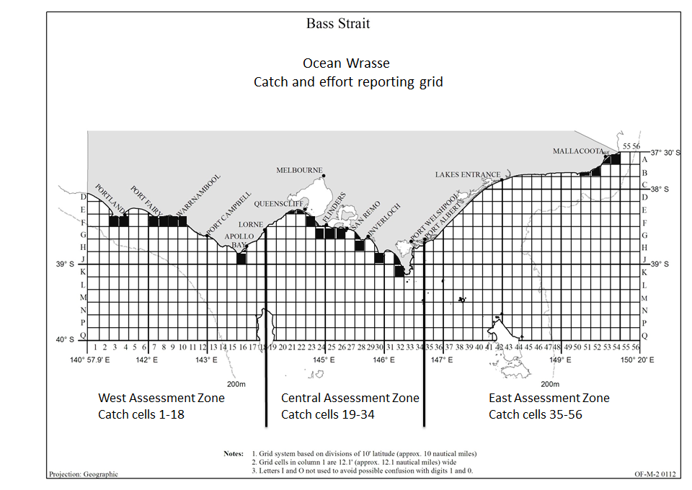
Figure 4 shows the results from application of the harvest strategy to each of the three assessment zones. Three year moving averages of standardised CPUE values have remained above the trigger reference in all instances, although the pattern appears to be trending downwards towards the trigger reference point in the Western Zone and came close in the Central Zone during 2004/05 but has since shown an increasing trend.
Figure 3. Map of the ocean wrasse catch and effort reporting grid indicating broad sub-divisions that will be used for assessment and harvest strategy operation (West, Central, East). Black cells indicate the grid cells that have accounted for approximately 80 per cent of the wrasse handline harvest since 2003.

Harvest control rules
Harvest control rules are invoked in response to stock status as measured by the performance indicators against their respective trigger and limit reference points (Figure 2). The aim of the harvest control rule(s) is to stop the CPUE or other indicator from continuing on a downward trend toward the limit value, to stabilise and, eventually, to reverse its trend. The CPUE 3-year moving average will determine if a further stepwise reduction is needed to reverse the decline and will be reviewed after three years.
Where the proxy measures (i.e. CPUE for biomass; catch for fishing mortality) have not been subject to a comprehensive evaluation, such as is the case with the Victorian wrasse fishery, performance that falls below trigger and limits will initiate discussions between Fisheries Victoria and industry stakeholders using a set of pre-agreed criteria to determine if the proxy is truly reflecting the status of the stock or some non-biological aspect of fishery performance.
These criteria will include considerations such as effort creep from changes in fishing practice, changes in market requirements, in the number of participants and/or their geographic areas of operation, depletion at highly localised reef scales, environmental/habitat changes and the effects of weather and market on when and where fishing has occurred.
It is expected that these criteria will be developed during the twelve months following approval by the Minister of this harvest strategy.
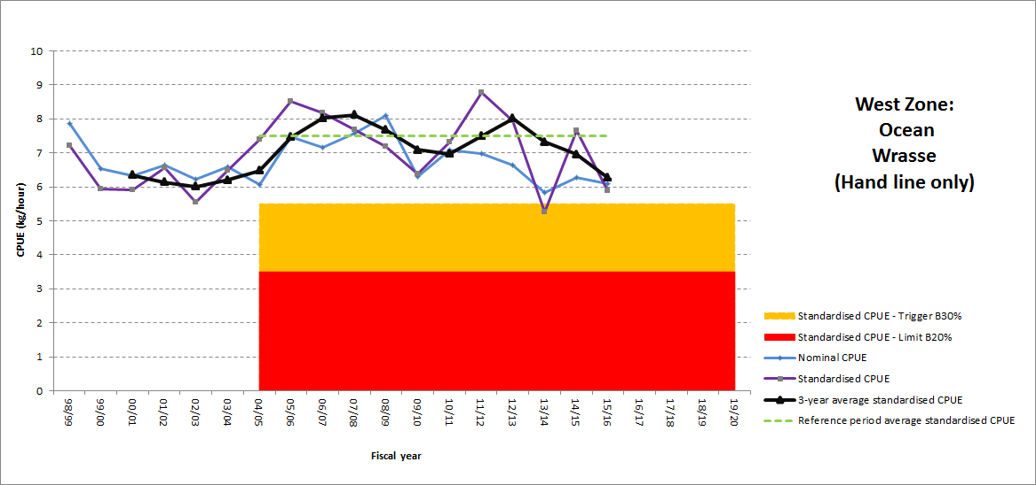
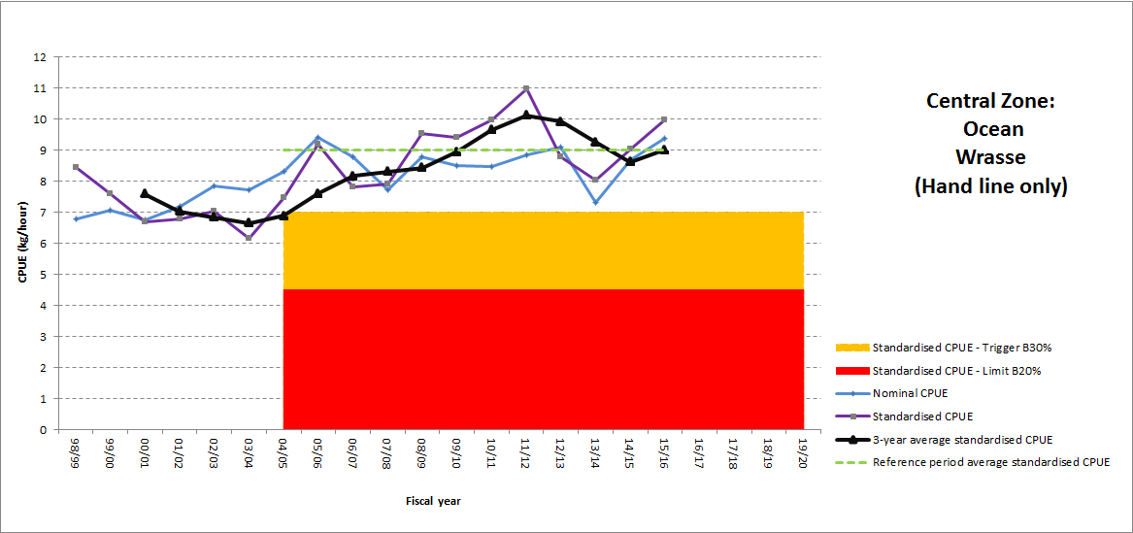
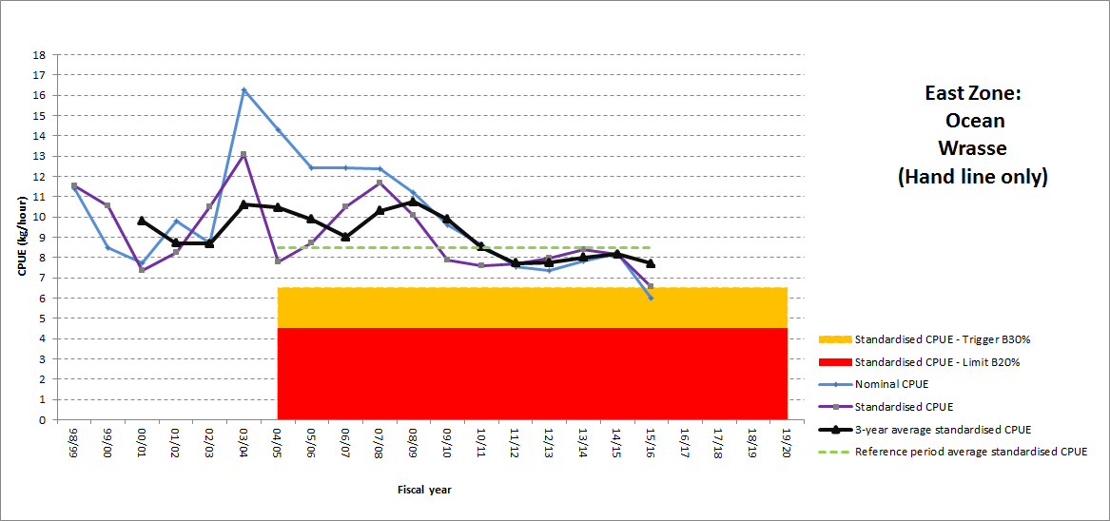
Figure 4. Stock performance in the three commercial assessment zones relative to the 2004/05 to 205/16 reference period.
Where stock issues are identified, a harvest control rule, developed in consultation with industry, will be applied to attempt to redress the problem with the expectation that there will be subsequent improvement in the performance over a period that is commensurate with what is known about the life history of the species.
Explicit control rules will need to be developed with industry over the coming twelve months as it becomes clearer how the fishery capacity, distribution of effort, and participants change as a result of license transferability being implemented.
Wrasse are relatively long lived (Bray 2017a) and have relatively low rates of adult natural mortality so recovery from depletion is likely to be slow. On the other hand, reproductive potential is well protected by the current size limit, the large areas of wrasse habitat that are currently not fished and the ability of Bluethroat Wrasse females to transform into males.
In the absence of a catch quota, options available to reduce fishing pressure (i.e. catch), if it is determined that a stock problem exists, include:
- limits on effort;
- limits on catch;
- changes to the size limits; and
- spatial and temporal closures.
It is important to note that whatever approach is chosen it should be assessed prior to implementation to determine the likely impact on reducing fishing mortality. Assessing the likely effectiveness of alternative management strategies will be included with the development of control rules.
The decision process is illustrated by a flow chart which shows each step in a sequence per the assessment outcome from the previous step (Figure 5). The final outcomes are in the form of application of the harvest control rules or no action if the agreed criteria show that the reason for the CPUE change is not due to stock status. This decision process is repeated as part of a regular cycle of assessing the stock.

Data collection
This harvest strategy will, initially, use the combined standardised CPUE of all wrasse species due to historically inconsistent reporting of each species in the catch. Improvements to the logbooks that fishers submit each month to Fisheries Victoria, including better species identification, reporting of discard numbers (wrasse discards only, dead or alive) and improved effort reporting, will improve data to inform management for each species and the fishery in general. These changes to the logbooks come into effect on 1 April 2017.
Fisheries Victoria fisheries scientists will work with licence holders to implement a voluntary program whereby management of the fishery can be improved by commercial fishers collecting additional data on their catch. This information could include, for example, lengths of retained and discarded catch to evaluate changes in length-frequency and potentially the sex of retained and discarded catch of Bluethroat Wrasse.
Fisheries Victoria will also discuss with commercial fishers the development of a smartphone app that will make the collection of catch and effort data more efficient. Similar apps are being used in the Victorian sea urchin and Port Phillip Bay dive scallop fisheries.

Figure 5. Flow chart illustrating links between performance and decisions about harvest control.

Commercial wrasse size limit
The commercial legal minimum size limit for Blue Throat wrasse is 28 centimetres and 27 centimetres for all other species. Some Wrasse (Ocean) access licence holders believe that a 30 centimetre legal minimum length is appropriate as smaller fish are not desired by the market.
Fisheries Victoria will consult with Wrasse (Ocean) access licence holders after the licence class becomes transferable to determine if there is widespread support for changing the commercial legal minimum length.

Wrasse harvest using rock lobster pots
About 94 per cent of the wrasse harvested by commercial fishers over the past ten years was taken by hook and line with the remainder by commercial rock lobster fishers using pots and other entitlement holders. It is Fisheries Victoria’s position that the commercial wrasse fishery will remain predominantly a hook and line fishery but acknowledges that the use of pots has been allowed for many years and is practiced by a small number of rock lobster fishers.
Fisheries Victoria will continue to monitor wrasse harvest by rock lobster pots and the relevant circumstances including catch, the impact it may have on the fishery and fisher views. If the catch by rock lobster pots exceeds ten per cent of the annual wrasse harvest, Fisheries Victoria will consider modifying management of the fishery to prevent further increases in rock lobster pot harvest.

Ongoing refinement and review of this harvest strategy
Transferability of wrasse licences may lead to significant short and long-term changes in how the fishery operates and the impact of fishing on the stocks. There is little point in developing a harvest strategy that cannot be implemented or that leads to unintended outcomes.
This harvest strategy is based on the seven to eight active fishers and the catch history that they have reported as a licence condition. Provision is necessary to accommodate for large changes in the participation rate, distribution of effort, gear types, and individual operators which at present, is predominately two boat-based fishers operating under a single licence using handlines. Activation of all 22 licences could increase the current fleet effort from typically 14 handlines or less to 44 or more.
The harvest strategy must therefore be responsive and adaptive when warranted and it may evolve as the fishery changes, more data become available, the range of potential indicators of stock performance increases and there is greater insight about which among these indicators is the most responsive to changes in the stock.
The challenge for Government and industry is to make adequate provision for adaptation to these potential changes. Sound management principles dictate therefore that a harvest strategy for the commercial wrasse fishery follows a pattern of plan implement assess revise. This ongoing process of improvement/ adaptation should occur outside of the period during which routine determination of stock status occurs.
To achieve this, this harvest strategy will operate on an assessment cycle in which performance indicator status is assessed and updated annually unless a formal assessment is requested in response to an emerging or unforeseeable issue with the stock or the fishery. Annual meetings with industry will be held to discuss performance of the fishery and this effectiveness of this harvest strategy.

References
AFMA 2015. Harvest Strategy Framework for The Southern and Eastern Scalefish and Shark Fishery 2009 Amended (FEBRUARY 2015). Canberra. 25 pp.
Bray, D.J., 2017a. Notolabrus tetricus in Fishes of Australia, accessed 05 Feb 2017, http://fishesofaustralia.net.au/home/species/257
Bray, D.J., 2017b, Notolabrus fucicola in Fishes of Australia, accessed 05 Feb 2017, http://fishesofaustralia.net.au/home/species/253
DAFF 2012, Commonwealth Fisheries Harvest Strategy Policy and Guidelines discussion paper, November 2012, Department of Agriculture, Fisheries and Forestry, Canberra.
Emery, T., Lyle, J. & Hartmann, K. 2016. Tasmanian Scalefish Fishery Assessment 2014/15. IMAS, Hobart. 216 pp.
Fisheries Victoria 2016a. Wrasse (Ocean) Fishery – Management Proposal: Introducing transferable licences and improved management arrangements for the Victorian Wrasse (Ocean) Fishery. 18 pp.
Fisheries Victoria 2016b. Guide for Wild Catch Fishery Management Plans. Fisheries Victoria Internal Report Series No. 64. 14 pp.
Sloan, S. R., Smith, A.D.M., Gardner, C., Crosthwaite, K., Triantafillos, L., Jeffries, B. and Kimber, N. 2014. National Guidelines to Develop Fishery Harvest Strategies. FRDC Report – Project 2010/061. Primary Industries and Regions, South Australia, Adelaide, March.
Smith, D.C., Montgomery, I., Sivakumaran, K.P., Krusic-Golub, K., Smith, K. & Hodge, R. 2003. The fisheries biology of bluethroat wrasse (Notolabrus tetricus) in Victorian waters. Final report to the Fisheries Research and Development Corporation, Project 1997/128. Fisheries Research and Development Corporation, Queenscliff, Victoria.

Authorised by the Department of Economic Development, Jobs, Transport and Resources
1 Spring Street Melbourne Victoria 3000
Telephone (03) 9651 9999
© Copyright State of Victoria,
Department of Economic Development, Jobs, Transport and Resources 2017
Except for any logos, emblems, trademarks, artwork and photography this document is made available under the terms of the Creative Commons Attribution 3.0 Australia license.
This document is also available in an accessible format at economicdevelopment.vic.gov.au

International Union for Conservation of Nature and Natural Resources (www.iucnredlist.org/)

