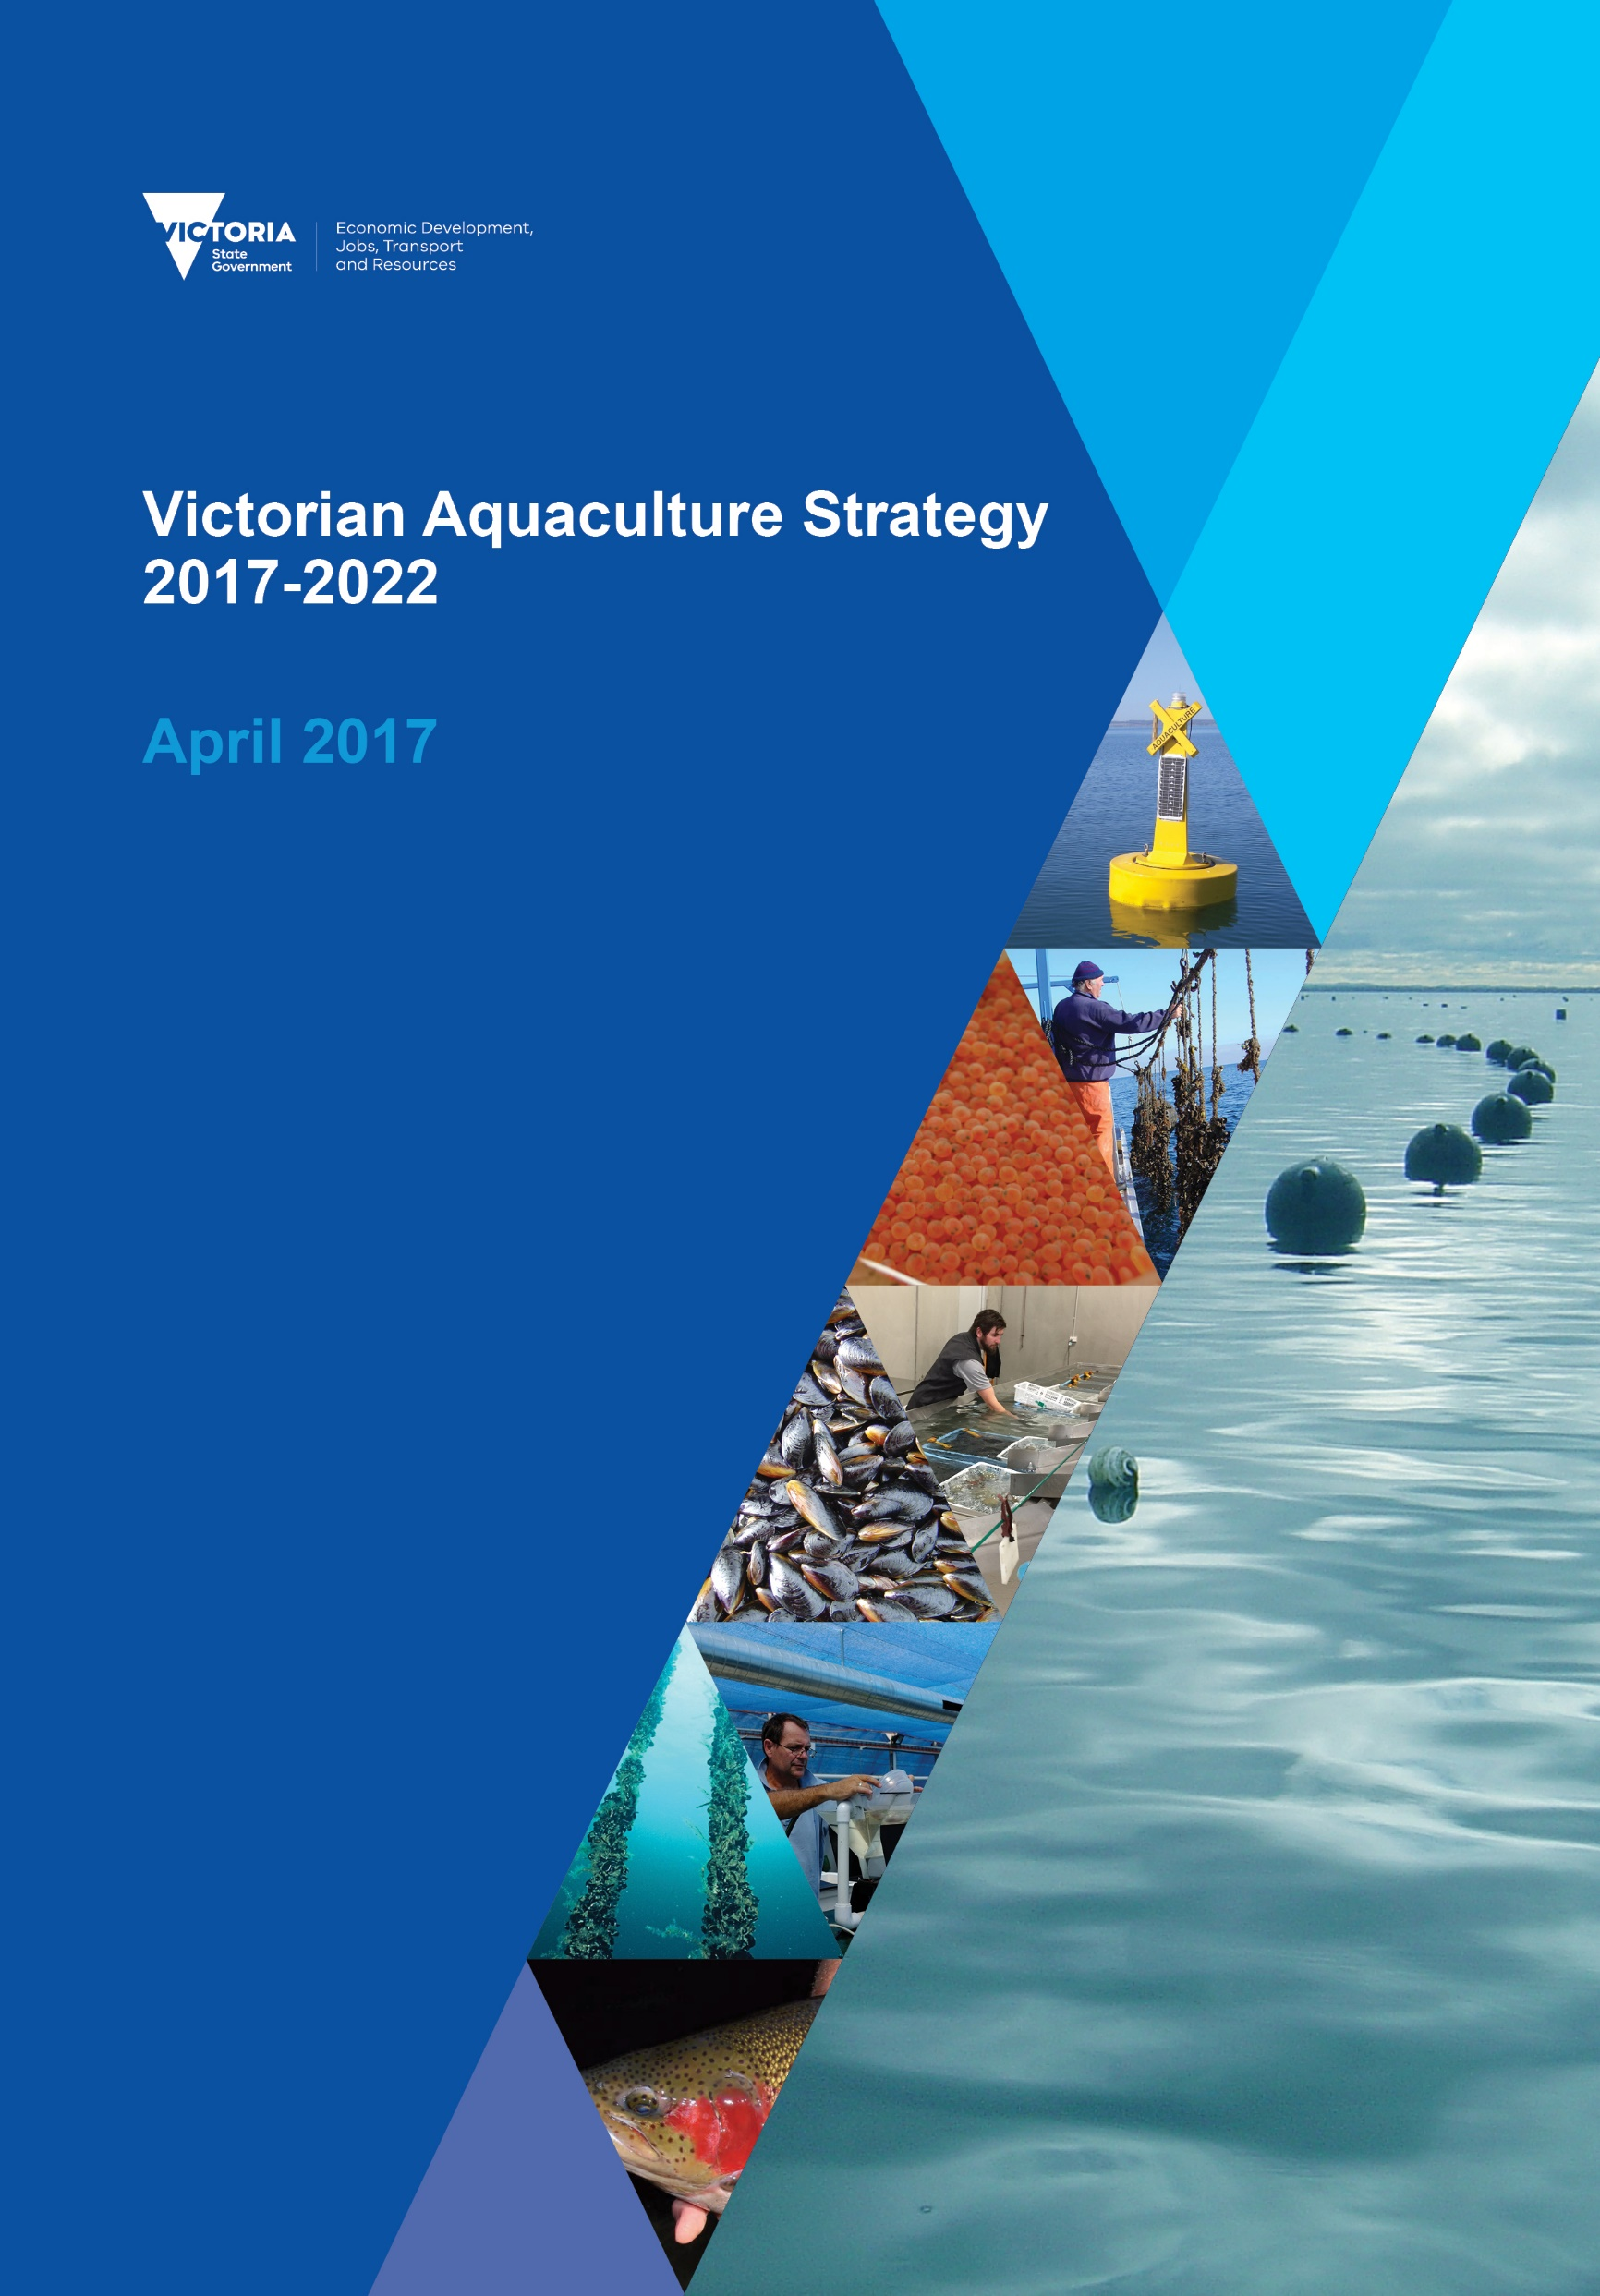

Authorised by the Victorian Government  
Department of Economic Development, Jobs, Transport and Resources  
1 Spring Street Melbourne Victoria 3000  
Telephone (03) 9651 9999

© Copyright State of Victoria,   
Department of Economic Development, Jobs, Transport and Resources 2017

Except for any logos, emblems, trademarks, artwork and photography this document is made available under the terms of the Creative Commons Attribution 3.0 Australia license.

This document is also available in an accessible format at economicdevelopment.vic.gov.au

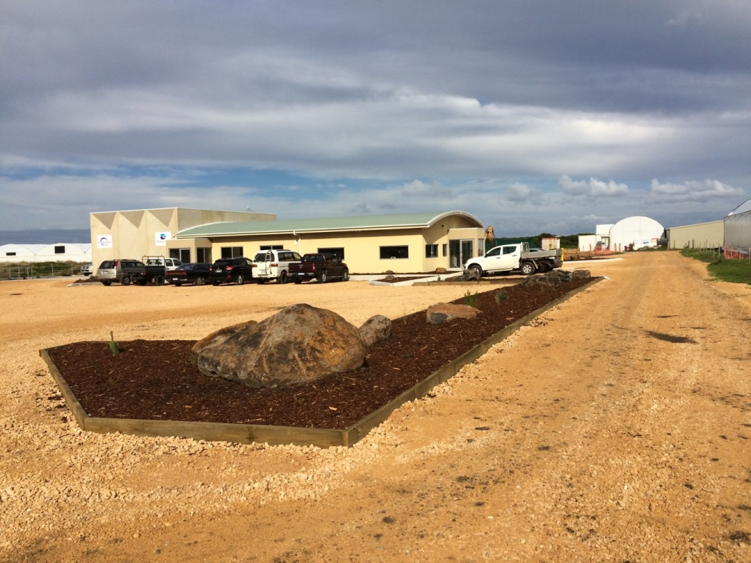

Image: New office complex at Southern Ocean Mariculture abalone farm at Port Fairy

Table of contents

Introduction 2

Foreword by the Minister for Agriculture 2

Background 3

Status of the industry 4

Victoria’s competitive advantages 6

Growth opportunities 6

The changing operating environment 7

Vision for Victorian aquaculture 8

Focus areas for action 9

Implementation 11

Review 12

Acronyms 13

References 13

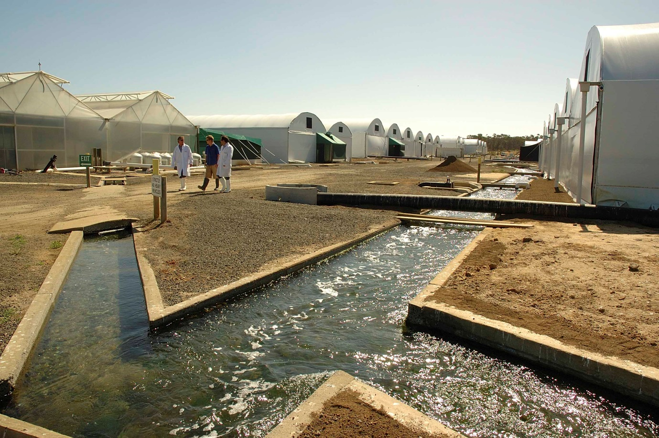

Image: Jade Tiger abalone farm, Indented Head

# Introduction

Our vision for the future of aquaculture in Victoria is:

**A productive, growing and sustainable aquaculture industry valued by the community**

Victoria will pursue:

* Productive aquaculture farms using sustainable practices;
* High quality seafood for Victorians and export;
* Aquaculture is supported and valued by the community; and
* An efficient regulatory environment that supports business.

This Aquaculture Strategy has been developed by the Department of Economic Development, Jobs, Transport and Resources in conjunction with the Victorian aquaculture industry and other stakeholders including Victorian Traditional Owners, VRFish, FutureFish Foundation, the Environmental Protection Agency and PrimeSafe.

# Foreword by Minister Pulford

Victoria is well placed to support a vibrant aquaculture sector.

We have experienced and committed people across industry, government and the community who understand the potential of aquaculture to contribute to the growing local and international demand for seafood.

We have the natural resources on land and water needed for successful aquaculture systems and established food supply chains for its products. We have robust food safety and biosecurity systems and a strong capacity for research and innovation.

This Strategy builds on our advantages. It sets a vision for a productive, growing and sustainable aquaculture industry that is valued by the Victorian community.

The Strategy acknowledges Victorian Traditional Owners as having an underpinning interest in the landscapes, freshwater and marine environments across Victoria. It also recognises the interests of commercial and recreational fishers in the long term sustainability and health of Victorian fisheries.

In launching this Strategy the Victorian Government has committed to make available new offshore aquaculture sites in the Pinnace Channel Aquaculture Fisheries Reserve. It is a practical commitment to the development of aquaculture operations that will create new jobs and contribute to our food and fibre export growth.

I welcome the contribution of stakeholders and industry in developing this strategy and their commitment to achieve its vision. I look forward to a bright future for aquaculture in Victoria.

**Jaala Pulford**

Minister for Agriculture

# Background

The world's population is growing faster than the supply of fish. The chart below compares the value of Victorian aquaculture with the state’s wild catch fisheries.

The graphs shows that between 1989 and 2015 aquaculture production increased from 8 million to 37 million, whilst at the sametime commeriail fisheies started at 40 million, increased to 110 million in 2001 and has slowly decreased back to 50 million. The graph highlights the increasing importance of seafood production in Victoria.

Figure 1: Comparison of the value of Victorian aquaculture with the state’s wild catch fisheries

There is an opportunity for Victorian aquaculture to provide extra fresh seafood and capitalise on its close proximity to markets such as Melbourne.

In 2013-14, Victoria’s aquaculture gross value of production was $25 million (ABARES 2015). Nearly half was edible exports (mainly abalone, trout, barramundi and mussels) sold primarily into Asian, Middle Eastern and US markets. A further 9% ($2.8m) was non-edible production (aquarium fish). The remainder was sold within Australia through fish markets or direct to retailers, supermarkets, restaurants distributors and consumers.

Over the next five years, Victoria’s population growth is likely to drive continued increases in demand for both imported and locally produced seafood. This presents supply opportunities for the local aquaculture industry.

The expansion of the aquaculture sector will also support Victoria’s growing recreational fishing sector. Aquaculture enhances recreational fishing opportunities by creating new or improved habitats around farm infrastructure, improving local species diversity and providing a sustainable supply of bait (e.g. mussels) for use by recreational fishers.

# Status of the industry

The value of Victorian aquaculture production rose by 23 per cent ($5 million) to $25 million in 2013-14. The 2013-14 figure of $25 million represents approximately 3% of Australian aquaculture production (ABARES 2015). This can be compared with Victorian wild catch fisheries production of $54.6 million in 2013-14.

Production by value is dominated by the abalone (43%), and the salmonid sector (27%), followed by native finfish (14%), bivalve shellfish (9%), ornamental fish (4%), and yabby (<1%)**.**

Fisheries collects data on the weight of production, which is multiplied by prices supplied by industry to obtain estimated values and percentage calculations

In terms of Australia, Victoria is the largest producer of freshwater trout (82%) and farmed abalone (51%) and a significant producer of mussels (29%), barramundi and goldfish (ABARES 2015).

The chart below shows Victorian aquaculture production by sector since 1989.

Figure 2: Victorian aquaculture production by sector

There is a strong regional presence of aquaculture throughout Victoria. In some cases, industry sector clusters share suitable growing environments such as for salmonid farming in the cooler north east region. Figure 3 below shows the key aquaculture production locations across the state.

Sizeable investment is occurring as abalone farms expand to meet growing Asian and domestic demand. Recirculation technology is increasingly being used where control of the environment enables production of high-value warm-water finfish such as barramundi for export markets.

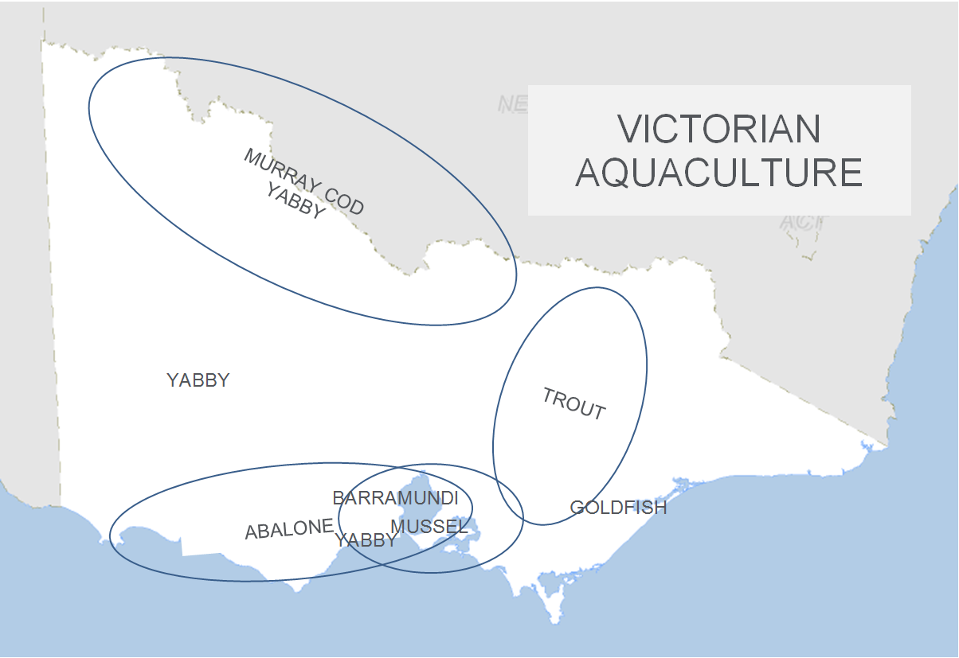

Figure 3: Key production locations for Victorian aquaculture

# 

# Victoria’s competitive advantages

The Victorian aquaculture industry is diverse and operates within a range of regional, climatic, social and biological environments, some of which are ideally suited to commercial aquaculture. Victoria's climate has a more suitable growing environment for abalone, trout, mussels and goldfish in comparison to most other Australian states. Its northern areas are better suited to the grow-out of Murray cod, yabby and other native warm water species.

There are twelve aquaculture reserves (two land based and ten offshore) set aside for the purpose of aquaculture. These aquaculture reserves are near to the markets of Melbourne   
and overnight delivery to Sydney markets. This proximity to large urban hubs provides the opportunity to command high returns for fresh product sold into seafood markets or restaurants as well the ability to export product via the Melbourne / Sydney international airports.

More broadly, Victoria’s diverse population provides particular market opportunities, as part of an existing wholesale seafood network or as niche products direct to local restaurateurs.

Rainbow trout

Image: Rainbow trout are grown in the cool waters of the Murrindindi region   
(Photo courtesy Goulburn River Trout)

# Growth opportunities

Some of the key industry development opportunities include:

* Offshore marine bivalve shellfish aquaculture
* Land-based and offshore abalone aquaculture
* The use of Recirculating Aquaculture System for intensive farming of salmonids
* Barramundi and native fish farming in intensive Recirculating Aquaculture System
* Open water Murray cod aquaculture for Asian markets or for public waters stocking
* New species development (species, areas and technologies) such as farming of kingfish, tuna, eels and other species

**The changing operating environment**

Major trends and factors taken into account in the development of this strategy include:

* The increasing competition for access to coastal land, river frontage and for use of sustainable supplies of fresh water
* Regional employment and the growing population in coastal regions of Victoria
* The increasing vertical integration of aquaculture operations with tourism opportunities in regional areas (for example: fish outs and food trails)
* The increasing demand from consumers for clean, ‘green’ sustainable fisheries products
* The complexity and impact of national and state-based regulatory frameworks for Victorian aquaculture
* The increased need for economies of scale and the impact of industry consolidation
* The impact of extreme weather events and climate change
* Increasing market access requirements for strong biosecurity and traceability
* The increasing price and scarcity of fresh water requires greater efficiency and commercial multiple use strategies
* The inability of wild capture fisheries to satisfy Australia’s current and increasing seafood demand.

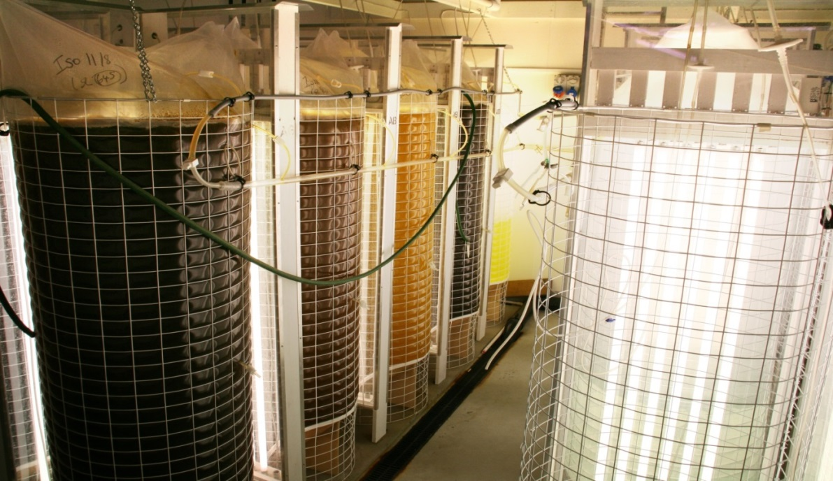

Image: Algae being grown in bags to feed the 600 million selectively bred mussel spat produced at the Queenscliff shellfish hatchery

# Vision for Victorian aquaculture

**A productive, growing and sustainable aquaculture industry valued by the community**

The high level outcomes of this strategy are:

* Productive aquaculture farms using sustainable practices;
* High quality seafood for Victorians and export;
* Aquaculture is supported and valued by the community; and
* An efficient regulatory environment that supports business.

Table showing the Vision, high level outcomes, short term outcomes, ouputs & activities plus inputs.

The aquaculture strategy recognises that the development of Aboriginal interests and opportunities is an element throughout the vision, outcomes, outputs and inputs.

Figure 4: Intervention logic

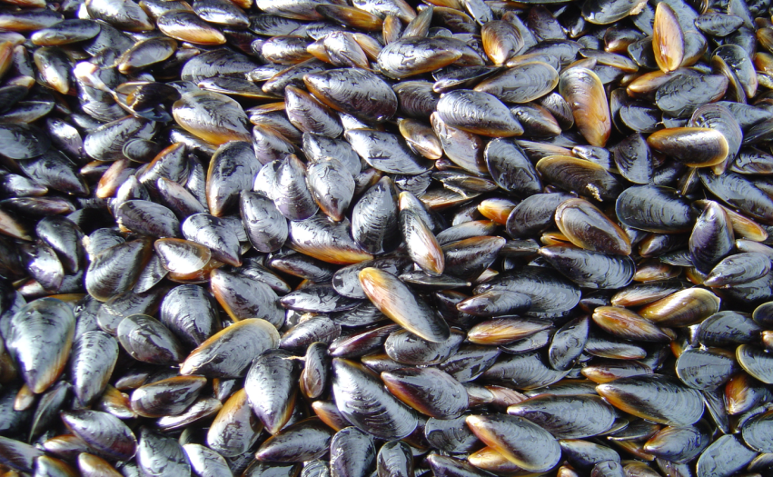

Image: Blue mussels

# Focus areas for action

This strategy includes a number of focus areas for action over the life of this strategy.

These are summarised under the following themes:

1. **Aquaculture development initiatives**
   1. Assist Investment and Economic Projects and Regional Development Victoria to attract and facilitate aquaculture investment (on-going) (Lead: Investment and Economic Projects and Regional Development Victoria, Collaborate: Fisheries)
   2. Expand marine aquaculture by allocating remaining offshore marine waters (by 30 June 2017) (Lead: Fisheries, Collaborate: DELWP)
   3. Assist with the development of harbour berthing for aquaculture operators (by 30 June 2017) (Lead: Parks Victoria, Collaborate: Fisheries)
   4. Prepare management plans for Point Lillias and Avalon Aquaculture Reserves (by 30 June 2017 and 30 June 2018 respectively) (Lead: Fisheries, Collaborate: Industry)
   5. Secure land-based shellfish hatchery capacity beyond 2021/22 (by 30 June 2019) (Lead: Industry, Collaborate: Fisheries)
   6. Engage with Victorian aboriginal groups to identify aquaculture development opportunities and support initiatives in this area (on-going) (Lead: Fisheries, Collaborate: Aboriginal groups).
2. **Industry capacity building**
   1. Identify and support leadership training opportunities for industry members (by 30 June 2019) (Lead: Fisheries, Collaborate: Industry)
   2. Facilitate industry representation by supporting an aquaculture forum which will meet a minimum of two times per year (on-going) (Lead: Fisheries, Collaborate: Industry).
3. **Research and development outputs**
   1. Identify and prioritise research and development needs (annually) (Lead: Fisheries, Collaborate: Industry)
   2. Implement collaborative aquaculture research and development projects (on-going) (Lead: Fisheries, Collaborate: Industry)
   3. Facilitate international knowledge and technology transfer to the local industry (on-going) (Lead: Fisheries, Collaborate: Industry)
   4. Explore possibility for culturing of new species in Port Phillip Bay and Western Port (by 30 June 2018) (Lead: Fisheries, Collaborate: Industry).
4. **Aquatic animal health management**
   1. Identify and progress actions to help secure and retain market access for aquaculture products (on-going) (Lead: Fisheries, Collaborate: Department Agriculture & Water Resources, Ag Vic, Industry)
   2. Update the abalone translocation protocol and amend to include the Abalone Health Accreditation Program (by 30 June 2017) (Lead: Fisheries, Collaborate: Ag Vic, Industry)
   3. Investigate mechanisms used elsewhere for disease event recovery to improve local practices (by 30 June 2019) (Lead: Fisheries, Collaborate: Ag Vic, Industry)
   4. Investigate demand and opportunities for industry supported biosecurity emergency stock insurance scheme (by 30 June 2018) (Lead: Fisheries, Collaborate: Ag Vic, Industry).
5. **Public engagement and education**
   1. Develop a strategic communications plan for the sector, including identifying opportunities for greater use of social media (by 30 June 2017) (Lead: Fisheries, Collaborate: Industry)
   2. Seek funding to commission a socio-economic assessment of the Victorian aquaculture industry (by 30 June 2017) (Lead: Fisheries, Collaborate: Industry)
   3. Communicate results to build community awareness of and support for aquaculture (by 30 June 2018) (Lead: Fisheries, Collaborate: Industry)
   4. Develop a code of conduct to promote animal welfare credentials (by 30 June 2018) (Lead: Fisheries, Collaborate: Ag Vic, Industry).
6. **Regulatory improvement**
   1. Review shellfish quality assurance regulations to ensure all risks are being managed and to identify technical efficiencies, streamline classification and monitoring to address algal bloom risks. (by 30 June 2017) (Lead: Fisheries, Collaborate: PrimeSafe, Industry)
   2. Engage with other regulatory authorities to streamline regulatory requirements in priority areas identified by the industry (by 30 June 2017) (Lead: Fisheries, Collaborate: EPA, Industry)
   3. Advocate for the standardisation of translocation protocols between states where possible (by 30 June 2018) (Lead: Fisheries, Collaborate: Industry)
   4. Review aquaculture licensing to identify opportunities to streamline by simplifying or reducing licence classes and standardising inland licence conditions (by 30 June 2018) (Lead: Fisheries, Collaborate: Industry)
   5. Provide input to development of relevant state and/or national policies and guidelines to support regulatory streamlining (by 30 June 2018) (Lead: Fisheries, Collaborate: Industry)
   6. Work with Marine Safety Victoria to introduce a speed limit for vessels within and near aquaculture reserves (by 30 June 2017) (Lead: Fisheries, Collaborate: Marine Safety Victoria, Industry)
   7. Support discussions to reduce costs and red tape associated with minor use permits for agricultural chemicals (by 30 June 2018) (Lead: Fisheries, Collaborate: Industry).

# Implementation

Actions will be implemented over the next five years to achieve the vision and outcomes outlined in this strategy within available funding. This will be achieved through active ongoing collaboration between the Aquaculture Industry, Victorian government agencies, Aboriginal groups and Commonwealth agencies where relevant.

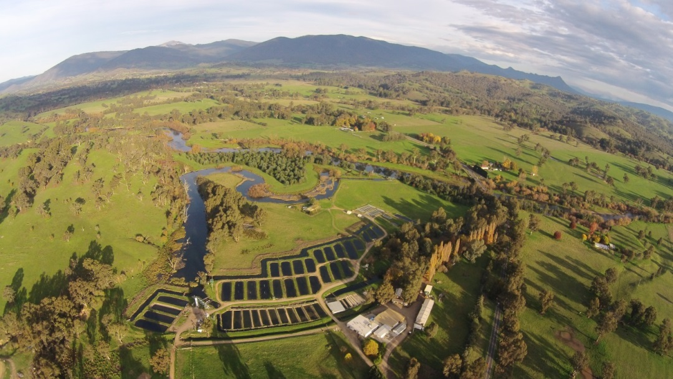

Image: Aerial view of the Goulburn River Trout farm in Thornton, the largest trout farming enterprise in Australia.

# Review

Annual updates will be provided to the industry through the Aquaculture Forum on the progress of the Strategy. After five years a review will be undertaken to assess the effectiveness of the strategy against the actions and timelines. This will identify improvements that can be included in a future aquaculture strategy.

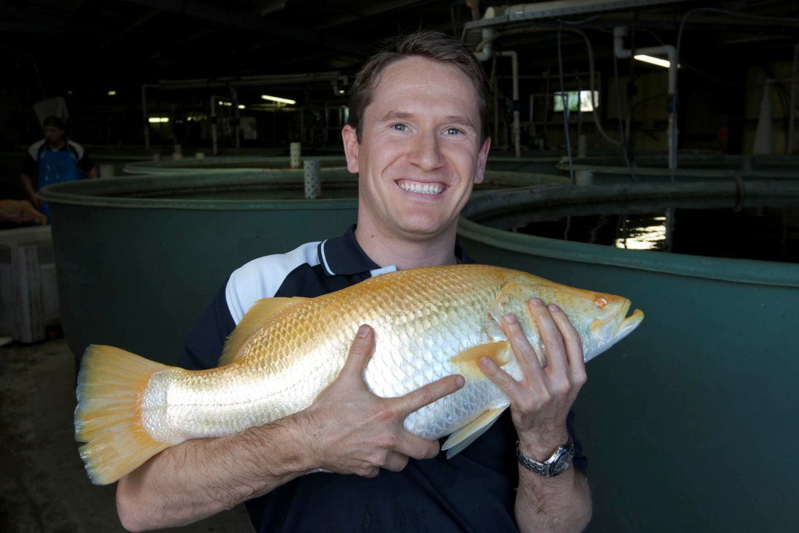

Image: Boris Musa, CEO Mainstream Aquaculture, with a world famous selectively bred Golden Barramundi

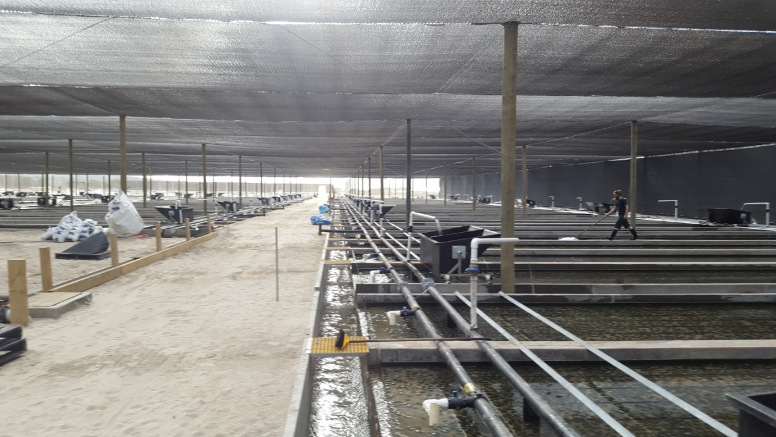

Image: Abalone farms are expanding – Coastal Seafarms, Portland is increasing the number of slab tanks to enable greater production.

# Acronyms

ABARES Australian Bureau of Agriculture and Resource Economics and Sciences

FAO Food and Agriculture Organization of the United Nations

DEDJTR Department of Economic Development, Jobs, Transport and Resources

DELWP Department of Environment, Land, Water and Planning

Industry All aquaculture licence holders

Fisheries Fisheries Victoria is a division within DEDJTR

DAWR Department of Agriculture Water and Resources (Commonwealth)

EPA Environment Protection Authority

# References

FAO 2016 http://www.fao.org/3/a-i4899e.pdf

ABARES 2015 Savage, J & Hobsbawn, P 2015, Australian fisheries and aquaculture

statistics 2014, Fisheries Research and Development Corporation project 2014/245. ABARES, Canberra, December. CC BY 3.0.

