Corner Inlet Fishery Management Advisory Committee

May 2026
Overview
The Corner Inlet Fishery Management Advisory Committee (CIFMAC) met on the 14 May 2026. The fishery continues to maintain its status as a key supplier of Victorian seafood. A new rock flathead science model will improve the fishery’s ability to ensure the fishery operates sustainably and maintains strong ethical practices. Key discussion points included:
- Catch and effort trends
- King George Whiting recruitment
- Rock Flathead stock synthesis modelling
- Project updates
- Seagrass restoration
- Compliance updates
Catch and Effort
Key fish species, such as rock flathead, calamari and gummy shark are performing well, both commercially and recreationally. Seine netting effort has increased slightly, and mesh netting effort was down. Catch of King George Whiting (KGW) was down, likely a result of lowered recruitment in recent years. However, surveys indicate recruitment has increased in 2025, which will be reflected in the fishery in 2027.
King George Whiting Recruitment
King George Whiting recruitment has been reduced for several years, which has resulted in a reduction in harvestable fish in Victoria’s bays and inlets as reflected in both commercial and recreational catch rates. This is likely due to climatic factors occurring where spawning adults congregate in parts of western Victoria/eastern South Australia. Recruitment in 2025 increased, which will be reflected in catch rates in 2027/28.
Rock Flathead Stock Synthesis Model
VFA scientists have developed a model which predicts the overall biomass of rock flathead in Corner Inlet. The model works by incorporating a range of variables such as catch data, length frequency, mortality, age and growth, fecundity and more. The model gives fisheries management the tools to make meaningful assessments of the fisheries sustainability. The model currently shows the rock flathead biomass is performing well, with a few years of excellent recruitment driving a strong fishery.

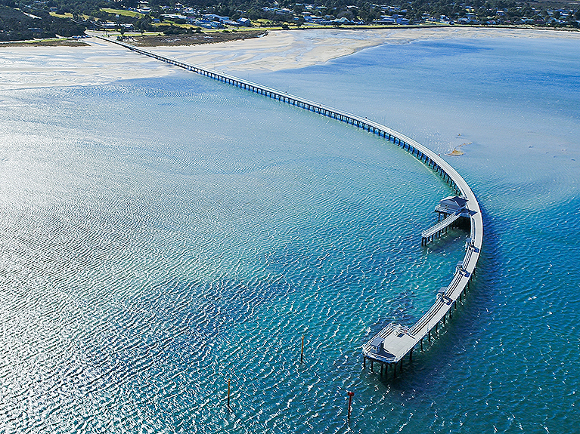
Project Updates
The rock flathead age and growth study is currently underway. Collected fish are currently being processed and will soon be sent to an aging facility.
Commercial catch and effort reporting logbooks have been updated to include a target species box. This was done to improve the accuracy of the VFA’s stock assessments by improving the resolution of fishing effort for priority species.
The Corner Inlet Fishery’s export approval is due for renewal in August and as such, the VFA has applied to maintain the fisheries approval. Currently, demand for fresh local fish is high, so fish are sold on the local market rather than internationally. However, export approval status is a good indicator that the fishery is performing sustainably.
Seagrass Restoration
Commercial fishers within Corner Inlet have been working to begin a seagrass restoration project, which aims to restore up to 50 hectares of degraded broad leaf seagrass. Permits for the project are currently with Parks Victoria for approval. Once approved, fishers intend to begin in the next few months. Many of Corner Inlets commercial fishers will donate their time and vessels to undertake this project.
Compliance Update
Compliance in the fishery continues to be high in both the commercial and recreational sectors. Education efforts regarding fishing within the fishing regulations will continue to be a focus for enforcement.

