**Fisheries Act 1995**

**FISHERIES NOTICE**

I, Luke O’Sullivan, Acting Chief Executive Officer of the Victorian Fisheries Authority, as delegate for the Minister for Outdoor Recreation, having undertaken consultation in accordance with Section 3A of the **Fisheries Act 1995** (the Act), make the following Fisheries Notice under Section 152 of the Act:

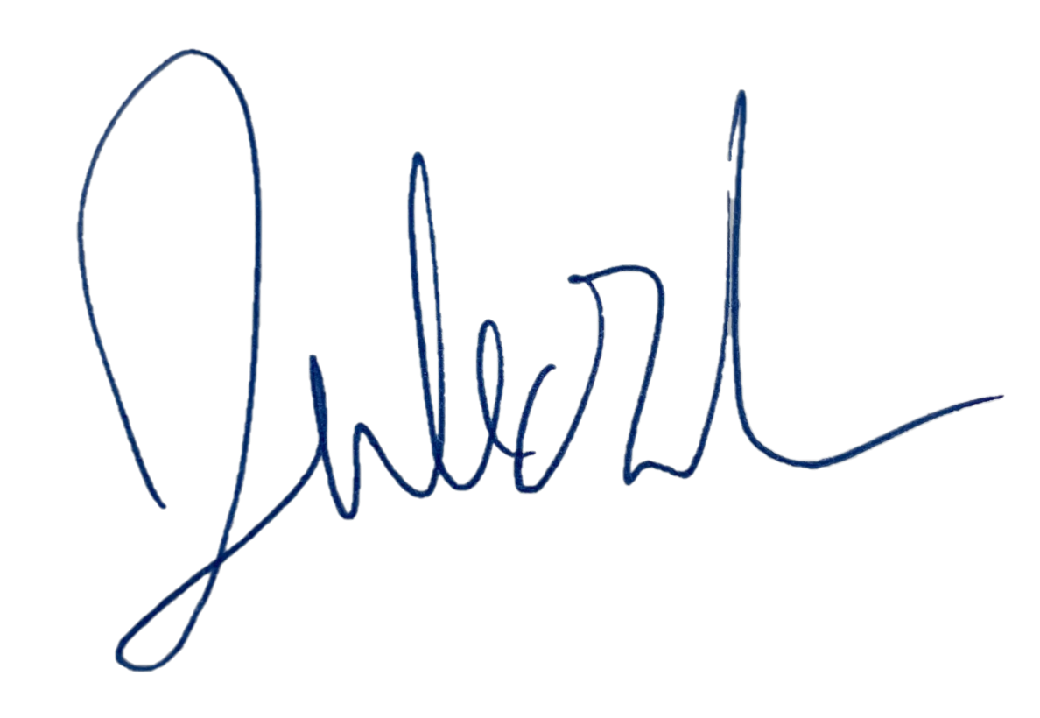23/12/2024

# Luke O’Sullivan

# Acting Chief Executive Officer

**Victorian Fisheries Authority**

## Fisheries (SPIDER CRAB) Notice 2025

1. ***Title***

This Notice may be cited as the Fisheries (Spider Crab) Notice 2025.

1. ***Objective***

The objective of this Notice is to set a reduced recreational catch and possession limit for spider crabs across Victorian waters.

1. ***Authorising provision***

This Notice is made under section 152 of the Act.

1. ***Commencement***

This Notice comes into operation on 1 February 2025.

1. ***Definitions***

In this Notice –

***‘spider crab’*** means spider crabs from the family Majidae*;*

***‘the Act’***means the **Fisheries Act 1995***.*

1. ***Catch and possession limit***

A person must not take from or possess in, on or next to any Victorian waters more than 15 spider crab on any one day.  
  
Penalty: 20 penalty units

1. ***Revocation***

Unless sooner revoked, this Notice will be revoked on 31 January 2026.

**Note:** Section 152(3) of the Act provides that if a Fisheries Notice is inconsistent with any regulations, management plan, Ministerial direction, licence or permit, the Fisheries Notice prevails to the extent of the inconsistency.

**Note**:Penalties under this notice are set in accordance with section 152(7)(c) of the Fisheries Act which allow the imposition of penalties not exceeding 50 penalty units for a contravention of an offence under a fisheries notice.