Pipi Fishery Management Plan Steering Committee

Fishery Background Paper
Overview
‘Pipi’ is the common name given to the small bivalve, Donax deltoides, which is found on high-energy sandy beaches in the intertidal zone. The Victorian fishery covers the entire Victorian coastline, with the exception of Port Phillip Bay and Marine National Parks where shellfish cannot be harvested in the intertidal region.
There are known harvestable quantities of pipi on beaches in Discovery Bay and surrounds in the west and in Venus Bay and surrounds in the east of the State. The western pipi beds are targeted primarily by commercial fishers whereas Venus Bay is primarily a recreational fishery (Figure 1).
The Commercial Fishery
In Victoria, there are eleven classes of Fishery Access Licences (FAL) that authorise commercial pipi harvest. Most of these licence classes, however, cannot, in practice, be used to harvest pipi due to equipment restrictions and/or because the licence does not authorise fishing in areas where pipis are found.
Below is the list of the licence classes and the number of licences issued in each class that have some likelihood of harvesting pipi (as of June 2016).
- Ocean Fishery Access Licence (162)
- Bait (General) Fishery Access Licence (5)
- Mallacoota Lower Lake (Bait) Fishery Access Licence (1)
- Snowy River (Bait) Fishery Access Licence (2)
Since April 2008, 24 licence holders have recorded ‘pipi’ catches (16 Ocean, 3 Bait (General), 2 Inshore (Trawl), 1 Snowy River (Bait), 1 Mallacoota Lower Lake (Bait) and 1 Westernport/Port Phillip Bay). It is likely that some of these fishers operating in low energy, muddy environments where cockles, not pipis, are the dominant bivalve species, recorded Anadaria and/or Katelysia sp. as pipi catch.
Most of the commercial pipi harvest to date has been taken under Ocean Fishery Access Licences (OFAL). OFALs are not transferable and cannot be sold or leased to or operated by another fisher. Fishing effort under an OFAL is input controlled; a dip net or hand gathering are the only methods that OFAL holders can use to harvest pipis. There is, however, no limit on the number of employees that can be engaged by an OFAL holder to assist in harvest.
There is, therefore, considerable latent effort in the fishery due to the number of licences that could potentially harvest pipi and to the unlimited number of people who can assist an OFAL holder and other licence classes. It should be noted, however, that relatively few OFAL fishers have chosen to target pipi to date.
The main area for commercial pipi harvesting has been in Discovery Bay in the west. Catches increased from 21 kg in 2008/09 (licensing year – April to March) to over 90,000 kg (90 tonnes) in 2013/14. A number of management arrangements were introduced in December 2013 (see ‘Fishery Management’ below). In the 2014/15 licensing year, 81 tonnes of pipi were removed, followed by 57 tonnes in 2015/16.
Commercial fishing also occurs in Venus Bay but on a much smaller scale. There are less than five fishers harvesting in Venus Bay so the catch data has not been reported here.
The Recreational Fishery
Unlike commercial fishing, the number of recreational fishers and the volume of their catch is unknown. Most recreational pipi fishing occurs in Venus Bay although anecdotal evidence suggests increasing numbers of recreational fishers are visiting Discovery Bay and elsewhere.
Recreational fishing is primarily confined to the summer months when it can be particularly intensive. For example, Fisheries Officers from the Department of Economic Development, Jobs, Transport and Resources (DEDJTR) inspected more than 2,000 people in Venus Bay over the 2014/15 summer holidays, which was only a fraction of those harvesting pipi during this time. The compliance rate for this operation was approximately 90%.
The Indigenous Fishery
There is no data available on indigenous pipi fishing but pipis were clearly an important food source in the past as evidenced by the presence of pipi shell middens in many coastal areas of Victoria, including Discovery Bay and Cape Liptrap Coastal Parks.
Available research
To date, research on the pipi resource in Victoria has focussed on Venus Bay and recreational harvesting. There have been three field studies of the pipi stocks in Venus Bay. Lewis (2010, Lewis & Scarpaci 2010, Lewis et al 2013) surveyed Venus Bay from November 2009 to February 2010, Early et al (2011) from August to October 2011, and Parry (2013) in December 2013.
All three field studies found that, in areas close to beach access points, there was a lower biomass and fewer mature pipis (‘maturity’ was arbitrarily assigned to pipi larger than 37mm but there is no estimate of the size at maturity of pipi in Venus Bay) than in areas remote (>3km) from beach access points. Overall, however, the Venus Bay pipi fishery remains sustainable as the majority of the fishing occurs over a short period (i.e. summer) and the eastern half of Venus Bay acts a potential source of replenishment for the harvested areas. There is little recreational fishing, and minimal commercial fishing, for pipis in this less accessible area.
The University of Melbourne commenced a three-year study, funded by the Recreational Fishing Licence Trust, in late 2015 to assess the sustainability of recreational and commercial pipi harvest in Venus Bay.
Environmental concerns
The areas of pipi that are currently targeted by commercial and recreational fishers are found in Coastal Parks; Discovery Bay Coastal Park in the west and Cape Liptrap Coastal Park in the east. An issue for commercial pipi harvesting in some locations is transporting catch through, and within, these coastal Crown land areas (see ‘Other issues’ below).
These coastal environments have significant natural and cultural values, including nesting sites on the beach for threatened shorebirds like the Hooded Plover, Sanderling and Little Tern, as well as significant Aboriginal archaeological sites such as shell middens. Apart from nesting in the areas where pipi are harvested, some species of shorebird, including migratory species, also utilise pipi as a food source.
Discovery Bay Coastal Park is included in the Ngootyoong Gunditj Ngootyoong Mara (NGNM) South West Management Plan, which was completed in 2015. Under the goal of “Authorised uses of public land in the planning area are subject to conditions that minimise the effects on values and visitors”, there is a strategy to “Support measures to improve the sustainability of any pipi fishing in Discovery Bay Coastal Park. Adopt measures to prevent impacts to Hooded Plovers and other threatened shorebirds, Aboriginal middens and safety of visitors on access tracks and beaches, such as access restrictions to areas and during the Hooded Plover breeding season from July-August to March-April” (page 97).
Cape Liptrap Coastal Park has its own management plan. Under the aim of “Provide opportunities for recreational fishing while minimising the impacts on parks value”, there are three management strategies which relate to supporting and liaising with Fisheries Victoria in order to ensure the sustainability of fish populations and fishing activities (page 23).
The Discovery Bay Coastal Park is in the process of being nominated for Ramsar listing as a site that includes wetlands of international importance. The proposed boundary of the Ramsar site will include Discovery Bay Coastal Park, including the beach to the low water mark, and the Lower Glenelg National Park upstream to where the Glenelg River enters it.
The Glenelg-Hopkins Catchment Management Authority, which is overseeing the nomination process, has stated that ‘businesses, land owners and day-to-day land users won't be impacted by a successful Ramsar listing, as every element nominated in the application is already protected.” This means that the important natural elements of the park, like threatened shorebirds, are already protected, so existing regulations won’t change with a successful listing. Ramsar listing occurs under the Environment Protection and Biodiversity Conservation Act 1999 (EPBC Act). Under the EPBC Act, pre-existing activities can continue as long as they are lawful under State law. New activities, which may have an impact on the ecological character of a declared wetland, must be approved under the EPBC Act (D. McLean, Department of Environment, pers. comm.).
Fishery management
The Commercial Fishery
The rapid and substantial increase in commercial pipi catch in Discovery Bay, in the absence of information on stock status, prompted DEDJTR to close the coastline between Suttons Rocks and the Lake Yambuk outlet to commercial pipi harvest as a precautionary measure (Figure 2). A 35 mm minimum size limit and the requirement to prior-report fishing activity were introduced for the area that remained open to fishing. These arrangements were implemented via a Fisheries Notice in December 2013.
DEDJTR extended the closure from Suttons Rocks to the Victorian/NSW border in 2014 to protect pipi populations in other parts of Victoria. In order to allow commercial fishing to occur in areas where it had operated historically, areas (commercial grid squares) where 100kg or more had been caught since 2012 remained open. This did not include the area of Discovery Bay, east of Suttons Rocks through to Lake Yambuk, even though fishing had occurred here, as this was closed due to sustainability concerns in the absence of information on stocks. Four areas remained open to commercial pipi harvest (Figure 3). The size limit and requirement to prior-report was applied to these areas.
These arrangements were continued in 2015 but the current Fisheries Notice will expire in October 2016. The Department has also initiated management of the Victorian pipi fishery through a management planning process.
The Recreational Fishery
Recreational pipi fishing is managed using input controls (i.e. recreational fishing licence unless exempt, harvest by hand only) and bag/possession limits.
In 2009, the statewide recreational bag limit was reduced for Venus Bay (i.e. Cape Liptrap Coastal Park between Point Smythe and Arch Rock) from 5 litres of whole pipi/1 litre of pipi meat per person per day to 2 litres of whole pipi/0.5 litre of pipi meat to ensure that the resource was shared amongst users. The reduced limit remains in place to date.
The possession limit is the maximum amount that a person can possess at any one time while in, on or next to Victorian waters. It is the same as the bag limit (i.e. if you are in, on or next to Victorian waters between Point Smythe and Arch Rock, you can only have 2 litres of whole pipi (0.5 litre of pipi meat) in your possession).
Specific information on the recreational fishing regulations is available in the Victorian Recreational Fishing Guide which is available from tackle shops, online (http://agriculture.vic.gov.au/fisheries) or as a smartphone application.
The Indigenous Fishery
Indigenous pipi fishers do not need to hold a recreational fishing licence to harvest pipi, but are subject to the recreational bag/possession limits, if:
- the person is fishing in an area of land subject to a natural resource agreement put in place under the Victorian Traditional Owner Settlement Act 2008; and
- the person is a member of the traditional owner group to which the agreement applies; and
- there is an agreed means by which authorised officers can verify that the person is a member of the traditional owner group.
Traditional owners who meet these criteria can also apply for a Traditional Owner Recognition Permit that allows them to take fish species and/or numbers of fish that are not currently permitted under a recreational fishing licence.
Access by Traditional Owners to the commercial pipi fishery will be addressed through the management planning process, consistent with DEDJTR policy. Fisheries Victoria, on behalf of the Steering Committee, is consulting with relevant Traditional Owner groups.

Other issues
Vehicle access for commercial fishers
A key issue for commercial fishing in some locations is effective access to the fishing grounds through coastal Crown land including the Coastal Parks. To date, this has only been an issue in Discovery Bay Coastal Park but, as the Venus Bay pipi population is also located within a Coastal Park, it could be a concern for elsewhere in the State in the future.
Vehicle access on public land falls within the portfolio of the Minister for Environment, Climate Change and Water and is managed by Parks Victoria and the Department of Environment, Land, Water and Planning (DELWP).
Discovery Bay Coastal Park includes the beach to the low water mark. Fishers are, therefore, operating in boundaries of the park while fishing and transporting their catch and are subject to relevant legislation and regulation.
The use of motor vehicles off-road in Discovery Bay Coastal Park is prohibited under the Land Conservation (Vehicle Control) Regulations 2013 unless permitted. The use of two-wheel drive and four-wheel drive vehicles, bicycles and motor cycles is prohibited on tracks that are closed to the public under the National Parks Regulations 2013 unless permitted. There is also a long-standing policy of no private vehicles access to coastal Crown land and beaches in Victoria, which was recently restated in the Victorian Coastal Strategy 2014.
There are a number of concerns associated with use of vehicles in coastal parks including potential damage to significant Aboriginal sites, the impact on threatened species, beach damage (erosion of dunes, damage to native flora, sand compaction, prevention of natural sand movement, spread of invasive plants), noise and disruption to other beach users.
This is an ongoing management issue for Parks Victoria and DELWP.
Food safety
Commercial fishers who sell pipis for human consumption must be authorised by PrimeSafe under the Victorian Seafood Safety Act 2003. The authorisation involves determining the risks that consuming shellfish poses to human health and preparing a monitoring strategy and Food Safety Plan that effectively manages these risks.
A number of Victorian commercial pipi fishers are authorised by Primesafe to sell pipi for human consumption and it is understood that others may be seeking authorisation.
It is an offence under the Fisheries Act 1995 for recreational fishers to sell their catch. It is also an offence under the Seafood Safety Act 2003 for a person to conduct a seafood business without a seafood safety licence.
Pipi as bait or food
The recreational sector place a high value on pipi for bait, particularly for catching species such as King George Whiting, which leads to high prices (~$20 per kg). Currently, the bulk of the pipi bait supply is sourced from South Australia with some coming from Venus Bay and Discovery Bay.
Pipis are also prized as a food source. In Victoria, some licence holders are accredited by Primesafe to sell pipi for human consumption from a classified area. Other licence holders are pursuing accreditation for other areas. Many recreational fishers harvest pipi for food and for bait.

Figure 1. The main areas of pipi harvest in Victoria

Figure 2. Area closed to commercial pipi harvesting (between Suttons Rocks and Lake Yambuk outlet) - implemented December 2013

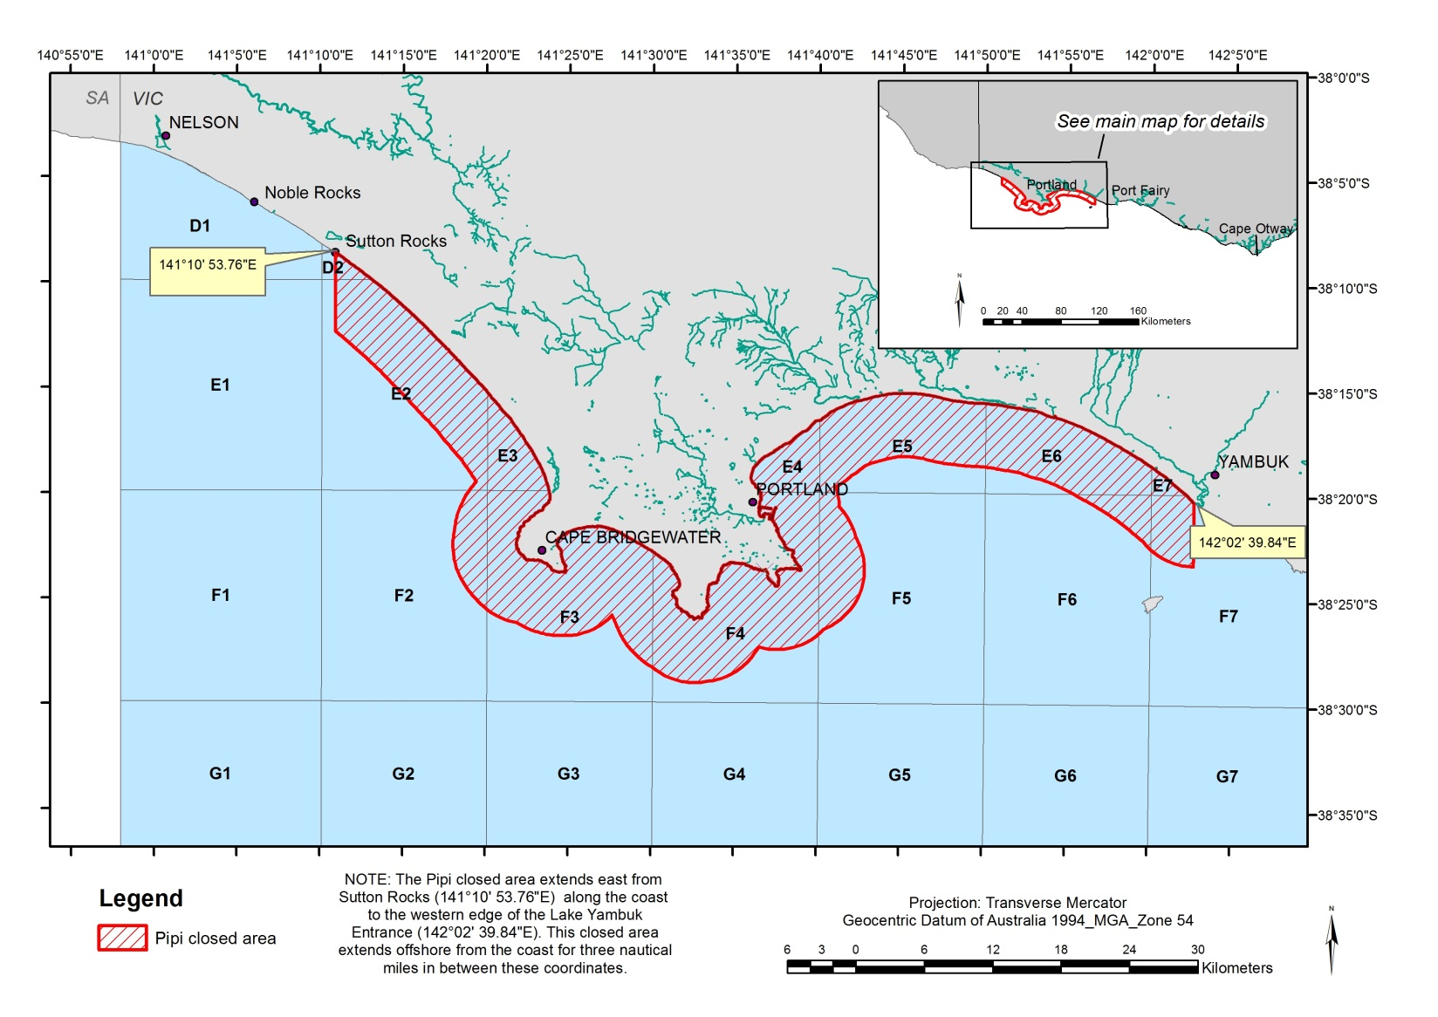
Figure 3. Areas that remained open to commercial pipi harvesting – implemented October 2014

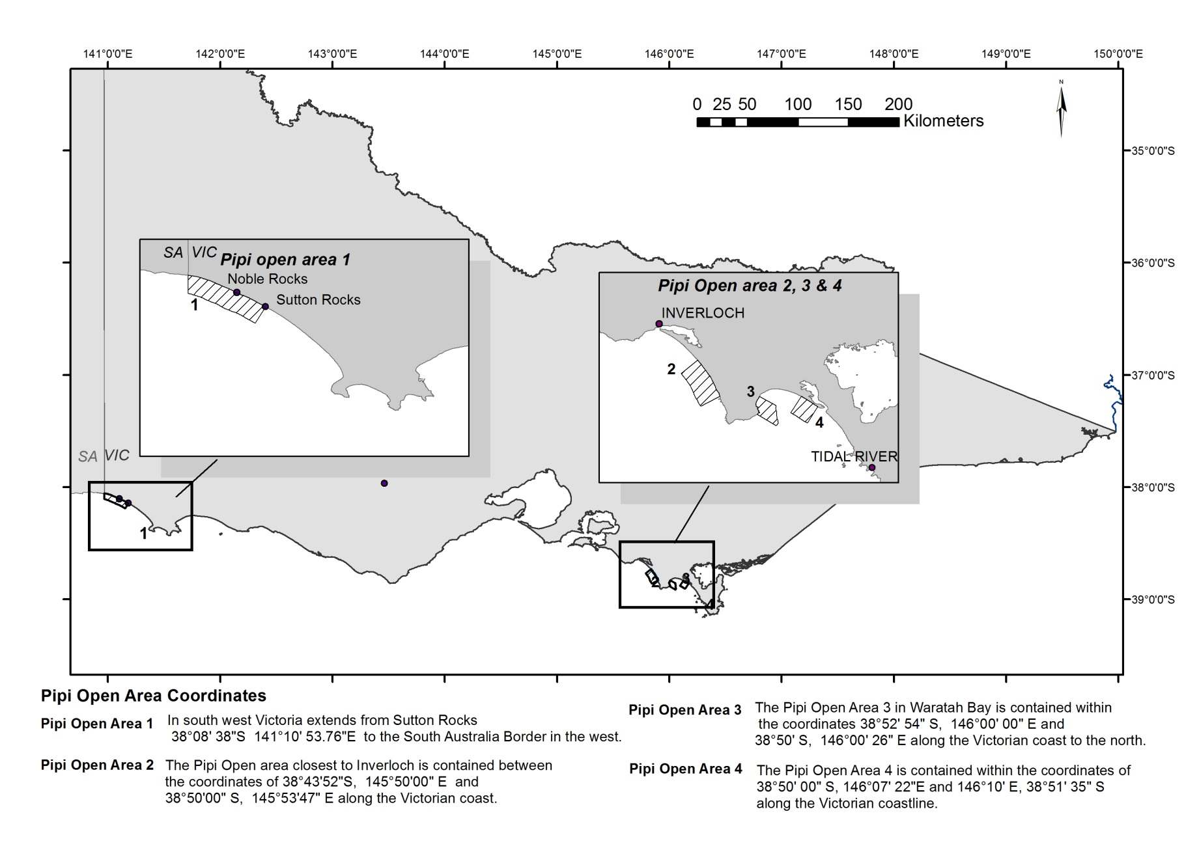

Licence classes (and the number of licences issues in each class) that are authorised to harvest pipi, but are unlikely to, due to equipment restrictions and/ or area of operation - Corner Inlet Fishery Access Licence (FAL) (18), Gippsland Lakes FAL (10), Gippsland Lakes (Bait) FAL (9), Lake Tyers (Bait) FAL (1), Sydenham Inlet (Bait) FAL (2), Trawl (Inshore) FAL (54) and Westernport / Port Phillip Bay FAL (10).
Twenty-seven of the 189 issued Ocean Fishery Access Licences were omitted from this list as they are valid only whilst operating a vessel that is nominated against a Rock Lobster, Scallop (Ocean), Trawl (Inshore) or Purse Seine Fishery Access Licence.
Five of the 12 issued Bait (General) Fishery Access Licences can access pipi as they can harvest by hand or with other appropriate equipment in waters where pipis are found.
This does not exclude vehicles required for park management or those acting under, or in accordance with, a permit issued under the National Parks Act.

