

HARVEST STRATEGY FOR the central zone of the victorian abalone fishery

2025

C. Dixon and J.Lowe

May 2025

About MRAG Asia Pacific

MRAG Asia Pacific is an independent fisheries and aquatic resource consulting company dedicated to the sustainable use of natural resources through sound, integrated management practices and policies. We are part of the global MRAG group with sister companies in Europe, North America and the Asia Pacific.

2/29 Woodstock Rd PO Box 732 P: +61 7 3371 1500

Toowong Qld 4066 Toowong Qld 4066 F: +61 7 3100 8035

Australia Australia E: info@mragasiapacific.com.au

Preferred citation: Dixon, C.D., and Lowe, J (2025). Harvest Strategy for the Central Zone of the Victorian Abalone Fishery 2025. MRAG Asia Pacific, Brisbane, Australia.

ISBN: 978-0-6456995-0-0

Published: 15 May 2025

Acknowledgements

Funds for this work were obtained through the Victorian Fisheries Authority (VFA), obtained through licence fees. We are grateful to Michael Cleland for assistance in the provision and interpretation of data. Anthony McGrath and Melissa Schubert (VFA) reviewed the document.



|  |
| --- |
| Disclaimer: The results and analyses contained in this Report are based on a number of technical or otherwise specified assumptions and parameters. The user must make their own assessment of the suitability for its use of the information or material contained in or generated from the Report. Although all reasonable efforts have been made to ensure quality, MRAG does not warrant that the information in this report is free from errors or omissions. To the extent permitted by law, MRAG does not accept any liability to any party for expenses, losses, damages and costs arising directly or indirectly from using this Report. |

Table of Contents

1. Introduction 2

2. Results 3

3. Discussion 10

4. Future research Error! Bookmark not defined.

5. References 11

6. Appendix 1 12

1.1. Step 1. Calculate nominal CPUE from raw data provided by VFA 12

1.2. Step 2. Import predicted data from Genstat analysis and rescale 12

1.3. Step 3. Smooth standardised CPUE data for the reference period and calculate Reference Points 12

1.4. Step 4. Categorise CPUE for current and previous five years of data against the Reference Points 12

1.5. Step 5. Determine which Catch Control Rule applies 13

1.6. Step 6. Calculate the Primary Indictor (4yr gradient change) and categorise 13

1.7. Step 7. Calculate the Secondary Indicator (2yr ratio) and categorise 14

1.8. Step 8. Calculate the Primary Categorisation Result based on the Primary and Secondary Indicators 14

1.9. Step 9. Calculate the Tertiary Indicator (4yr gradient change) and categorise 14

1.10. Step 10. Determine the final category 15

1.11. Step 11. Determine the catch, lower and upper limits 16

# Introduction

A harvest strategy sets out a decision-making framework necessary to achieve defined biological and economic objectives for commercial fish stocks in a given fishery (DAWR 2018). Harvest strategies outline:

* processes for monitoring and assessing the biological (and economic) conditions of commercially fished species within fisheries against fishery-specific reference levels (a reference point or points)
* pre-determined rules that control fishing activity according to the biological conditions of the fishery (as defined by monitoring and/or assessment)—these rules are referred to as harvest control rules or decision rules.

The primary tool used to manage the impact of the Victorian Abalone Fishery is a Total Allowable Commercial Catch (TACC). In the Draft Harvest Strategy for the Victorian Eastern and Central Zone Blacklip Abalone Fishery (VFA 2019a), a suggested TACC range for each zone is arrived at via explicit decision rules that result in upper and lower catch limits (referred to as Optimal Target (OT) catches) at the Spatial Management Unit (SMU) scale. VFA (2019a) states *“Decisions regarding catch limits are therefore set out in advance, ensuring that fishers, fishery managers and other relevant stakeholders know what action will be taken in response to the conditions in the fishery”*.

This Harvest Strategy Report documents the results from applying the most up-to-date data from the Central Zone of the Victorian Abalone Fishery through the Draft Harvest Strategy process, as documented in Version 2 of VFA (2019a). This report uses data up to and including the current quota year. Raw catch effort and CPUE data were received by MRAG Asia Pacific on 10 September 2024.

No FIS sites were surveyed in 2024. The Draft Harvest Strategy therefore relies entirely on CPUE data.

A step-by-step summary of how the Reference Points (RPs) and the Primary, Secondary and Tertiary Indicators were calculated and classified is provided in the Appendix, designed to be read in conjunction with previous Victorian Abalone Methods reports (VFA 2019a; VFA 2019b). All rules are applied at the SMU scale. These methods include approaches with FIS data, even though they were not applied for this assessment.

This year’s report includes several changes. Firstly, a revised CPUE standardisation model has been applied following recommendations made through the Abalone Scientific Working Group (ASWG). The new model has been applied to the CPUE performance measure and RPs and includes data from 2003 onward. Secondly, two alternative scenarios of RPs are presented. The first set of RPs follow the method described in the Appendix, with standardised CPUE RPs calculated from a historic CPUE dataset using the new standardisation model. The alternative set of results uses the original RPs described in VFA (2019a) which are based on nominal CPUE data.

The operational objectives of the Draft Harvest Strategy from VFA (2019a) state that “*This harvest strategy aims to achieve three main operational objectives, which link to the overarching objectives for the management of the fishery*”. These operational objectives are to:

1. Maximise the likelihood of biomass remaining within the target range.
2. Minimise the risk of biomass falling to levels where it could impair recruitment.
3. Minimise the risk of biomass falling below the limit reference point.

# Results

Table 1 contains the calculated standardised RPs, the Current Status and applicable Catch Control Rules for each SMU within the Central Zone. This table was created using the methods (Steps 1 to 3) outlined in the Appendix, however for CPUE data only.

Table 2 contains the calculations of the Primary and Secondary Indicators used to determine the Primary Category, and the Final Category for each SMU within the Central Zone (noting no Tertiary Indicator was calculated). The 2024/25 OTs used here include carry-over catch, as this is what will be assessed against in the stock assessment. This table was created using the methods (Steps 4 onwards) outlined in the Appendix.

Table 3 uses the nominal RPs published in VFA (2019a) and follows the same methodology for Table 1. Table 4 provides suggested OTs based on the nominal RPs calculated in the same manner as for Table 2.

The Primary and Secondary Indicator for the Central Zone is plotted in Figure 1. Nominal and standardised CPUE datasets for the Central Zone are plotted in Figure 2, relative to the standardised RPs.

*Standardised CPUE Reference Points*

Standardised mean annual CPUE in 2023 was above the above the Threshold RP at all SMUs except for Prom Eastside where CPUE was below the Threshold RP but above Limit Reference Point (RP) (Table 1). Prom Eastside has been between the Limit and Threshold RPs for 14 consecutive years, and thus CCR2 applies (Table 5). CCR1 applies for all other SMUs.

The Primary Category and Final Category was Increasing for the Back Beaches, Phillip Island and Flinders SMUs (Table 2). Where CPUE has been above the Threshold for three years or more, and the Final Category (Table 2) is Increasing, the maximum increase in OT that can be considered is 25% (i.e. CCR1 – 125%, Table 1) and this was the case for each of the Back Beaches, Phillip Island and Flinders SMUs. All other SMU Primary and Final Categories were Stable. There was no catch from Port Phillip Bay in 2023/24 and it maintains its zero OT. The total zone target catches ranged from 218.2 t to 255.3 t based on the sum of the SMU level lower and upper catch ranges, respectively.

*Nominal CPUE Reference Points*

Results against the nominal RPs were generally more conservative than for the standardised RPs. The only exception was for Prom Eastside which was assessed as above the Threshold and thus CC1 would apply. However, Flinders, Kilcunda and Prom Westside were all assessed as being between the Limit and Threshold levels for more than 5 years, and thus CCR2 applied. Of the three SMUs eligible for an increase up to 25% under the standardised RPs above, the Back Beaches was the only SMU to have been over the threshold for the minimum 3 years. As a result, a more conservative zone target catch range from 213.0 t to 241.7 t was recommended based on the sum of the SMU level lower and upper catch ranges, respectively.

**Table** **1**: Standardised Reference Points for Central Zone SMUs, mean annual CPUE from 2018 - 2023 and applicable catch control rules (CCR).

| SMU | Limit RP | Threshold RP | Target RP | 2018 | 2019 | 2020 | 2021 | 2022 | 2023 | Current Status | Years at Status | CCR |
| --- | --- | --- | --- | --- | --- | --- | --- | --- | --- | --- | --- | --- |
| BACK BEACHES | 50 | 70 | 90 | 67.1 | 65.0 | 68.8 | 73.5 | 79.0 | 79.3 | Above Threshold | 3 | 1 - 125% |
| CAPE LIPTRAP | 40 | 60 | 90 | 63.9 | 61.7 | 62.9 | 66.1 | 73.1 | 72.8 | Above Threshold | 21 | 1 |
| CAPE OTWAY | 50 | 70 | 100 | 70.2 | 68.8 | 71.2 | 70.9 | 68.9 | 71.5 | Above Threshold | 1 | 1 |
| CLIFFY GROUP | 40 | 60 | 80 | 66.7 | 60.9 | 62.5 | 65.0 | 68.6 | 69.6 | Above Threshold | 21 | 1 |
| FLINDERS | 40 | 60 | 90 | 56.3 | 55.8 | 56.5 | 66.0 | 66.1 | 69.9 | Above Threshold | 3 | 1 - 125% |
| KILCUNDA | 40 | 60 | 100 | 60.8 | 58.5 | 60.7 | 64.7 | 66.4 | 64.9 | Above Threshold | 4 | 1 |
| PHILLIP ISLAND | 40 | 60 | 90 | 60.4 | 61.1 | 58.6 | 62.0 | 69.3 | 72.2 | Above Threshold | 3 | 1 - 125% |
| PROM EASTSIDE | 40 | 60 | 70 | 52.0 | 47.7 | 49.5 | 51.0 | 53.0 | 52.9 | Limit to Threshold | 14 | 2 |
| PROM WESTSIDE | 40 | 60 | 90 | 59.5 | 53.5 | 66.7 | 61.8 | 67.3 | 66.3 | Above Threshold | 4 | 1 |
| SHIPWRECK COAST | 50 | 80 | 130 | 97.2 | 90.4 | 83.6 | 96.0 | 96.6 | 97.9 | Above Threshold | 21 | 1 |
| SURFCOAST | 40 | 60 | 70 | 51.7 | 54.2 | 55.4 | 54.7 | 60.3 | 61.5 | Above Threshold | 2 | 1 |

**Table** **2**: Harvest Strategy results for Central Zone SMUs, with suggested target catch ranges. OT= Optimal Target.

| SMU | 4yr gradient | Primary Indicator | 2yr ratio (% change) | Secondary Indicator | Primary Category | Tertiary Indicator | Final Category | 2024/25 Target Catch (OT, t) | Total catch, Lower (t) | Total catch, Upper (t) |
| --- | --- | --- | --- | --- | --- | --- | --- | --- | --- | --- |
| BACK BEACHES | 5.30 | Increasing | 0.3 | Stable | Increasing | NA | Increasing | 41.5 | 41.5, 43.6 | 47.7, 51.9 |
| CAPE LIPTRAP | 1.46 | Stable | -0.4 | Stable | Stable | NA | Stable | 9.4 | 8.9 | 9.9 |
| CAPE OTWAY | -0.15 | Stable | 3.8 | Stable | Stable | NA | Stable | 49.0 | 46.6 | 51.5 |
| CLIFFY GROUP | 3.98 | Stable | 1.5 | Stable | Stable | NA | Stable | 4.7 | 4.5 | 4.9 |
| FLINDERS | 6.89 | Increasing | 5.8 | Increasing | Increasing | NA | Increasing | 20.5 | 20.5, 21.5 | 23.6, 25.6 |
| KILCUNDA | -0.77 | Stable | -2.2 | Stable | Stable | NA | Stable | 9.3 | 8.8 | 9.8 |
| PHILLIP ISLAND | 8.27 | Increasing | 4.1 | Stable | Increasing | NA | Increasing | 34.0 | 34.0, 35.7 | 39.1, 42.5 |
| PROM EASTSIDE | 2.49 | Stable | -0.2 | Stable | Stable | NA | Stable | 4.8 | 4.1 | 4.6 |
| PROM WESTSIDE | 0.67 | Stable | -1.5 | Stable | Stable | NA | Stable | 21 | 20.0 | 22.1 |
| SHIPWRECK COAST | 4.98 | Stable | 1.4 | Stable | Stable | NA | Stable | 29.2 | 27.7 | 30.7 |
| SURFCOAST | 4.35 | Stable | 1.9 | Stable | Stable | NA | Stable | 1.7 | 1.6 | 1.8 |
| Total |  |  |  |  |  |  |  | 225.1 | 218.2, 223.0 | 245.7, 255.3 |

**Table 3**: Nominal Reference Points (VFA 2019a) for Central Zone SMUs, mean annual CPUE from 2018 - 2023 and applicable catch control rules (CCR).

| SMU | Limit RP | Threshold RP | Target RP | 2018 | 2019 | 2020 | 2021 | 2022 | 2023 | Current Status | Years at Status | CCR |
| --- | --- | --- | --- | --- | --- | --- | --- | --- | --- | --- | --- | --- |
| BACK BEACHES | 50 | 70 | 100 | 67.1 | 65.0 | 68.8 | 73.5 | 79.0 | 79.3 | Above Threshold | 3 | 1 - 125% |
| CAPE LIPTRAP | 40 | 60 | 120 | 63.9 | 61.7 | 62.9 | 66.1 | 73.1 | 72.8 | Above Threshold | 21 | 1 |
| CAPE OTWAY | 50 | 70 | 100 | 70.2 | 68.8 | 71.2 | 70.9 | 68.9 | 71.5 | Above Threshold | 1 | 1 |
| CLIFFY GROUP | 40 | 60 | 110 | 66.7 | 60.9 | 62.5 | 65.0 | 68.6 | 69.6 | Above Threshold | 21 | 1 |
| FLINDERS | 50 | 70 | 100 | 56.3 | 55.8 | 56.5 | 66.0 | 66.1 | 69.9 | Limit to Threshold | 18 | 2 |
| KILCUNDA | 50 | 70 | 110 | 60.8 | 58.5 | 60.7 | 64.7 | 66.4 | 64.9 | Limit to Threshold | 14 | 2 |
| PHILLIP ISLAND | 50 | 70 | 110 | 60.4 | 61.1 | 58.6 | 62.0 | 69.3 | 72.2 | Above Threshold | 3 | 1 |
| PROM EASTSIDE | 40 | 50 | 80 | 52.0 | 47.7 | 49.5 | 51.0 | 53.0 | 52.9 | Above Threshold | 3 | 1 |
| PROM WESTSIDE | 50 | 70 | 100 | 59.5 | 53.5 | 66.7 | 61.8 | 67.3 | 66.3 | Limit to Threshold | 13 | 2 |
| SHIPWRECK COAST | 40 | 60 | 130 | 97.2 | 90.4 | 83.6 | 96.0 | 96.6 | 97.9 | Above Threshold | 21 | 1 |
| SURFCOAST | 40 | 60 | 70 | 51.7 | 54.2 | 55.4 | 54.7 | 60.3 | 61.5 | Above Threshold | 2 | 1 |

**Table 4**: Harvest Strategy results for nominal Reference Points for Central Zone SMUs, with suggested target catch ranges. OT= Optimal Target.

| SMU | 4yr gradient | Primary Indicator | 2yr ratio (% change) | Secondary Indicator | Primary Category | Tertiary Indicator | Final Category | 2024/25 Target Catch (OT, t) | Total catch, Lower (t) | Total catch, Upper (t) |
| --- | --- | --- | --- | --- | --- | --- | --- | --- | --- | --- |
| BACK BEACHES | 5.30 | Increasing | 0.3 | Stable | Increasing | NA | Increasing | 41.5 | 41.5, 43.6 | 47.7, 51.9 |
| CAPE LIPTRAP | 1.46 | Stable | -0.4 | Stable | Stable | NA | Stable | 9.4 | 8.9 | 9.9 |
| CAPE OTWAY | -0.15 | Stable | 3.8 | Stable | Stable | NA | Stable | 49.0 | 46.6 | 51.5 |
| CLIFFY GROUP | 3.98 | Stable | 1.5 | Stable | Stable | NA | Stable | 4.7 | 4.5 | 4.9 |
| FLINDERS | 6.89 | Increasing | 5.8 | Increasing | Increasing | NA | Increasing | 20.5 | 19.5 | 21.5 |
| KILCUNDA | -0.77 | Stable | -2.2 | Stable | Stable | NA | Stable | 9.3 | 7.9 | 8.8 |
| PHILLIP ISLAND | 8.27 | Increasing | 4.1 | Stable | Increasing | NA | Increasing | 34.0 | 32.3 | 35.7 |
| PROM EASTSIDE | 2.49 | Stable | -0.2 | Stable | Stable | NA | Stable | 4.8 | 4.6 | 5.0 |
| PROM WESTSIDE | 0.67 | Stable | -1.5 | Stable | Stable | NA | Stable | 21 | 17.9 | 20.0 |
| SHIPWRECK COAST | 4.98 | Stable | 1.4 | Stable | Stable | NA | Stable | 29.2 | 27.7 | 30.7 |
| SURFCOAST | 4.35 | Stable | 1.9 | Stable | Stable | NA | Stable | 1.7 | 1.6 | 1.8 |
| Total |  |  |  |  |  |  |  | 225.1 | 213.0, 218.1 | 240.6, 241.7 |

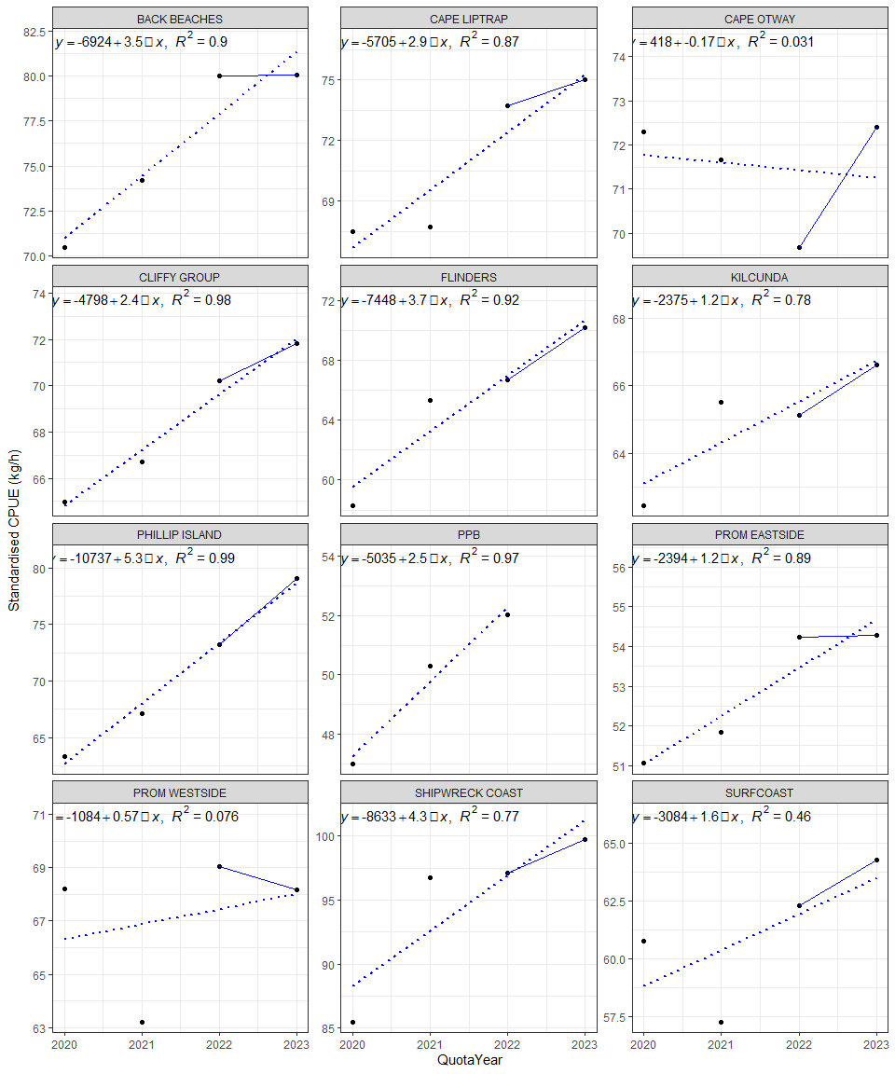

Figure 1: Standardised CPUE for each SMU in the Central Zone from 2020 to 2023. Dashed line and equation represent line of best linear regression fit (i.e. Primary Indicator) for time step 1 through to time step 4, while the solid line represents the ratio from the two most recent years (i.e. Secondary Indicator). Note: y-axes differ between SMUs.

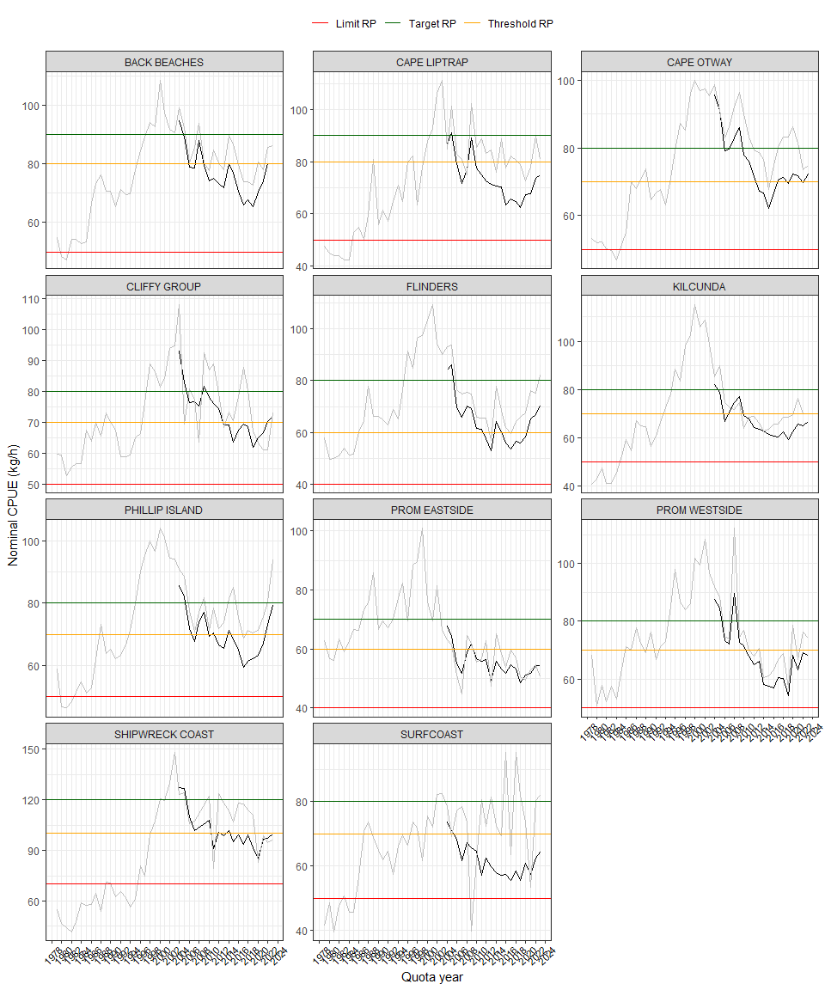

Figure 2: Nominal CPUE (grey lines) for the Central Zone from 1979 to 2023 and standardised CPUE (Black lines) from 2003 to 2023. Note that the RPs are calculated from rules applied to the 3-year running average of smoothed standardised CPUE between 1989 and 2015 (see Appendix).

# Discussion

The results from the Draft Harvest Strategy for the Central Zone reflect stable or improving CPUE trends in recent years, with three SMUs having an Increasing outcome (Back Beaches, Phillip Island and Flinders) and all other SMUs having a Stable outcome. Overall, this resulted in a suggested TACC range from 218.2 t to 255.3 t, with the current 2024/25 TACC at 225.1 t.

Previous Stock Assessment and Draft Harvest Strategy reports have identified the need for a review of components of the Draft Harvest Strategy. In 2025, a revised CPUE standardisation model was applied to both the Draft Harvest Strategy and the Stock Assessment Report, following recommendations from the ASWG. The data used were filtered based on an agreed set of criteria also recommended by the ASWG. In this report, the outcomes from the Draft Harvest Strategy compared the results from assessment against standardised CPUE RPs, as used for Draft Harvest Strategy outputs in recent years, versus the original nominal RPs published in VFA (2019a).

The standardised RPs are based on a dataset that extends back to 1978 to include the current reference period 1988 to 2015. Previous Draft Harvest Strategy reports have used the same long-term dataset for both the CPUE measure and RPs. However, the Stock Assessment Report presents standardised CPUE outputs only from 2003 onward. This has meant that the results for the last four years of CPUE trends at the SMU scale have been different between Stock Assessment and Draft Harvest Strategy reports, which has drawn some criticism. On this basis, the CPUE measure in this report utilised the revised CPUE standardisation model based on filtered data from 2003 onward, as these were considered the most reliable and the results are comparable to the Stock Assessment Report. This creates further uncertainty in the relevance of the RPs.

Comparison of standardised and nominal RPs indicated that the nominal dataset was overall more conservative, however the differences were neither consistent nor logical. For example, using the standardised RPs the Flinders SMU had been above the Threshold level for three years and thus CCR1 was applied. Given it had an Increasing Final Category, the suggested OT range was a 0% to 25% increase. Comparing the nominal RPs for the Flinders SMU, the CPUE measure had been between the Limit and Threshold RPs for 18 consecutive years and thus CCR2 was applied, which resulted in a suggested OT range of -5% to +5%. The reverse occurred for the Prom Eastside SMU, which had CCR2 applied under standardised RPs but CCR1 applied under the nominal RPs.

In conclusion, there is an urgent need to reassess the RPs for the Central Zone, particularly the reference period which was chosen from the start of the quota introduction in 1988, to a contemporary date (2015) at the time they were established. There is now another ten years of data available, and there is a better understanding of the CPUE dataset with new filters and a simplified standardisation model. Also, there is now a better understanding of the history of the fishery, in particular the current fishery footprint which has contracted substantially toward shallow water reefs in the last two decades. It would seem logical that the next step in improving the Harvest Strategy would be to develop revised RPs through the ASWG, based on a more contemporary period of the fishery beginning sometime on or after 2003 where data is more reliable.

The FRDC Project 2019-118 *“Drawing strength from each other: simulation testing of Australia’s abalone harvest strategies”* includes an MSE of the current Draft Harvest Strategy for Central and Eastern Zones. The results from this study may be useful in the re-evaluation of the Draft Harvest Strategy through the ASWG. In addition, Tasmania and South Australia have recently developed approaches to address hyperstability using diver logger data. The applicability of this approach for the Central Zone should be investigated.

# References

DAWR. 2018. “Commonwealth Fisheries Harvest Strategy Policy. Second Edition.” Melbourne: Department of Agriculture; Water Resources, Canberra, Australia.

Dichmont, C.M, Dixon, C.D., and Potts, J. (2022). Developing a new CPUE standardisation for the Central and Eastern Zones of the Victorian Abalone Fishery. MRAG Asia Pacific, Brisbane, Australia.

Dixon, C.D., Potts, J. and Dichmont, C.M. (2022). Draft Stock Assessment for the Central Zone of the Victorian Abalone Fishery 2020/21. MRAG Asia Pacific, Brisbane, Australia.

Dixon, C.D., Lowe, J. and Potts, J. (2023). Draft Stock Assessment for the Central Zone of the Victorian Abalone Fishery 2021/22. MRAG Asia Pacific, Brisbane, Australia.

Dixon (2023). Review of fishery independent surveys for the Central and Eastern zones of the Victorian Abalone Fishery. MRAG Asia Pacific, Brisbane, Australia.

VFA. 2019a. “Draft Harvest Strategy Victorian Central and Eastern Zone Blacklip Abalone Fishery. Draft Version 2. VFA, February 2019.”

VFA. 2019b. “Victorian Abalone - Methods used for fishery assessment, Version 1.4 30 June 2019.”

# Appendix 1

## Step 1. Calculate nominal CPUE from raw data provided by VFA

Raw data provided by VFA contains a unique record of catch per diver per day, for each Reef Code. Using these data, the arithmetic mean CPUE for each Quota Year and SMU was calculated. Throughout this report, these data are referred to as the *nominal CPUE data*.

## Step 2. Applying data filters and calculating the standardised CPUE measure

The following filters were applied to raw catch, effort and CPUE data from 2003 onward:

* Removed CPUE <25 kg/h and >250 kg/h at the reefcode/day scale
* Removed daily catches <20 kg/day and >1300 kg/day for the Shipwreck SMU and >800 kg/day for all other SMUs
* Removed daily effort <20 minutes/day and >9 hours/day

The standardised CPUE was then calculated using a linear mixed-effects model, specified as follows:

Throughout this report, this is referred to as the *standardised CPUE*.

## Step 3. Calculation of standardised Reference Points for the reference period

For the standardised Reference Points, the revised standardisation model in Step 2 was applied to historic CPUE data. Peaks and troughs in annual standardised CPUE were smoothed by using a running three-year average. These data are referred to as the *smoothed standardised CPUE* throughout this report.

Reference Points (RPs) are based on the smoothed standardised CPUE for the reference period 1989 to 2015, as 1989 was the first year the TACC was established. The limit, threshold and target reference points were based on the following rules:

* The Limit RP was 2/3 of the minimum smoothed standardised CPUE in the series, rounded up to the nearest 10 (e.g., 2/3rds of 63 kg/hr would be 42 kg/hr, rounded up to 50 kg/hr).
* The Threshold RP was the minimum CPUE in the series, rounded up to the nearest 10.
* The Target RP was the maximum CPUE in the series, rounded down to the nearest 10.

In situations when the *Limit and Threshold* are equal, or the *Threshold and Target* are equal, firstly the Threshold was increased and the Target was increased, resulting in a conservative outcome.

## Step 4. Categorise CPUE for current and previous five years of data against the Reference Points

For the current year, and previous five years of data, the standardised CPUE calculated in Step 2 for each SMU is categorised against the RP calculated in Step 3 using the Catch Control Rules defined in Table 5. If the CPUE is below the Limit Threshold, it is categorised “Below Limit” (and coloured red, Table 5), if the CPUE is between the Limit and the Target Threshold, it is categorised as “Limit to Threshold” (coloured orange, Table 5), and if the CPUE is above the Target Threshold, it is categorised as “Above Threshold” (coloured green, Table 5).

## Step 5. Determine which Catch Control Rule applies

To determine which Catch Control Rule (CCR) applies, the categorisation of the current year’s CPUE and duration at the current status is matched against the CCR provided in Table 5. For example, if the current CPUE is above the Threshold reference point, and has been for the previous 2 years, Catch Control Rule 1 (CCR1) applies, but if it has been above the Threshold reference point for greater than 2 years, Catch Control Rule 1 applies with an OT of 125% (Table 5). If the current CPUE has been between the Limit and the Threshold reference points for the previous 5 years, CCR1 applies; but if for greater than five years, Catch Control Rule 2 applies (CCR2). In instances when the CPUE has fallen below the Limit reference point for the previous 2 years, CCR2 applies, and if for greater than 2 years, then the fishery is closed and a structured fishing survey is implemented (Table 5).

**Table 5**: Table 3: Applicable catch control rules (CCR).

|  | Duration at current status | | | |
| --- | --- | --- | --- | --- |
| Current Status | ≤ 2yrs | >2yrs | ≤ 5yrs | >5yrs |
| Above Threshold | CCR1 |  |  |  |
| Above Threshold |  | CCR1, 125% |  |  |
| Limit to Threshold |  |  | CCR1 |  |
| Limit to Threshold |  |  |  | CCR2 |
| Below Limit | CCR2 |  |  |  |
| Below Limit |  | Close fishery & implement structured fishing |  |  |

## Step 6. Calculate the Primary Indictor (4yr gradient change) and categorise

To calculate the Primary Performance Indicator (i.e. the four-year gradient) the four most recent years of data (2017 to 2020 quota years) were plotted and a linear regression line was fitted (see Appendix 1). The percentage change in CPUE over the four years as defined by the line of best fit, was calculated (see Appendix 1). This Primary Indicator was categorised against the rules defined in Table 4. For example, if the indicator is > 5%, it is classified as Increasing; if the indicator is between -5 and 5%, it is classified as Stable, and if the indicator is less than -5%, it is classified as Decreasing (Table 6).

**Table 6**: Table 4: Applicable performance indicator change rules.

| Performance Indicator % Change | Category |
| --- | --- |
| >5% | Increasing |
| -5 to 5% | Stable |
| <5% | Decreasing |

## Step 7. Calculate the Secondary Indicator (2yr ratio) and categorise

To calculate the Secondary Performance Indicator, the ratio of the standardised mean CPUE estimates from 2020 were compared to the 2019 estimates. This Secondary Indicator was categorised against the rules in Table 6.

## Step 8. Calculate the Primary Categorisation Result based on the Primary and Secondary Indicators

Based on the Primary Indicator calculated in Step 6 and the Secondary Indicatory calculated in Step 7, Table 7 is used to determine the Primary Categorisation. For example, if the Primary Indicator trend is Decreasing, regardless of the trend in the Secondary Indicator, the Primary Categorisation is always Decreasing. If the Primary Indicator trend is Stable, and the Secondary Indicatory trend is Decreasing, and the Primary Categorisation is Decreasing, otherwise it is Stable. If the Primary Indicator is Increasing and the Secondary indicator is Decreasing, the Primary Categorisation is Stable, otherwise it is Increasing (Table 7).

**Table 7**: Primary Categorisation rules.

|  |  | Secondary Indicator trend | | | |
| --- | --- | --- | --- | --- | --- |
|  |  |  |  |  |  |
|  |  | Decreasing | Stable | Increasing | NA |
| Primary Indicator Trend | Decreasing | Decreasing | Decreasing | Decreasing | Decreasing |
| Stable | Decreasing | Stable | Stable | Stable |
| Increasing | Stable | Increasing | Increasing | Increasing |

## Step 9. Calculate the Tertiary Indicator (4yr gradient change) and categorise

Note no FIS data were collected in 2024 so the following was not caulcated.

The Tertiary Indicator, for each SMU, was calculated as followed:

1. Obtain the legislated LML for the target SMU
2. Using the Length Frequency data set, convert the measured length of abalone within the target SMU to weight using the following relationship: $Weight=3.34*{10}^{-4}*{\left(Length\right)}^{2.857}$
3. Using the Length Frequency data set, determine the number of abalone that are 0-20 mm (N20) and 0-40 mm (N40) below the LML, for each Site within the target SMU, per year (i.e., between 2016 and 2020).
4. Using the Length Frequency data set, estimate the average weight (calculated in (2)) of N20 abalone (calculated in (3)) for each Site within the target SMU, per year.
5. Estimate the total weight of N20 abalone by multiplying the number of individuals in the N20 class (from (3)) with the average weight of individuals in that class (from (4))
6. Calculate the ratio of N20 to N40 abalone (from (5)) for the target SMU, per year (i.e., summed over Site within SMU)
7. Estimate the average weight per individual abalone in the N20 group, weighted by the sample size from each Site
8. Adjust the Genstat standardised abundances from the FIS with the ratio in (6). This is the number of PreRecruits Corrected.
9. Multiply the PreRecruits.Corrected (from (8)) by the average weighted mean of each N20 abalone in (5) to obtain the Final Grams Per 30 m Transect.
10. Fit a simple linear model to the final grams of abalone per 30 m transect and estimate the 4 yr percent gradient change.

## Step 10. Determine the final category

The Final Categorisation Rules are defined in Table 6 and depend on the Primary categorisation and the trend of the Tertiary Indicator. For example, if the Primary categorisation is Decreasing and the Tertiary Indicator trend is Increasing, the Final Categorisation is Stable, otherwise it is Decreasing. If the Primary categorisation is Stable, regardless of the Tertiary Indicator, the Final Categorisation is Stable. If the Primary Categorisation is Increasing, and the Tertiary indicator is Decreasing, the Final Categorsation is Stable, otherwise it is Increasing (Table 8).

**Table 8**: Final Categorisation rules.

|  |  | Tertiary Indicator trend | | |
| --- | --- | --- | --- | --- |
|  |  |  |  |  |
|  |  | Decreasing | Stable | Increasing |
| Primary Categorisation Result | Decreasing | Decreasing | Decreasing | Stable |
| Stable | Stable | Stable | Stable |
| Increasing | Stable | Increasing | Increasing |

NB., in situations when the resulting CCR is “1 -125%” (Step 5), the Final Category *must be* Increasing, otherwise the CCR is overwritten as “1”.

## Step 11. Determine the catch, lower and upper limits

Firstly, the percentage change applicable needs to be identified from Table 9, based on the CCR identified in Step 5 and the Final Category from Step 10. These percentage changes are used to calculate the lower and upper limits of Total Allowable Catch.

**Table 9**: Rules to calculate the percent change in OT based on CCR and Final Category.

| CCR | Final Category | Lower bound | Upper bound |
| --- | --- | --- | --- |
| 1 - 125% | Increasing | 0-5 | 15-25 |
| 1 | Increasing | 0-5 | 15 |
| 1 | Stable | -5 | 5 |
| 1 | Decreasing | -15 | -5 |
| 2 | Increasing | -5 | 5 |
| 2 | Stable | -15 | -5 |
| 2 | Decreasing | -25 | -15 |