**Recreational Fishing Licence**

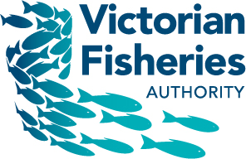

**Trust Account 2017/18**

A report to each House of Parliament on the disbursement of Recreational Fishing Licence Revenue

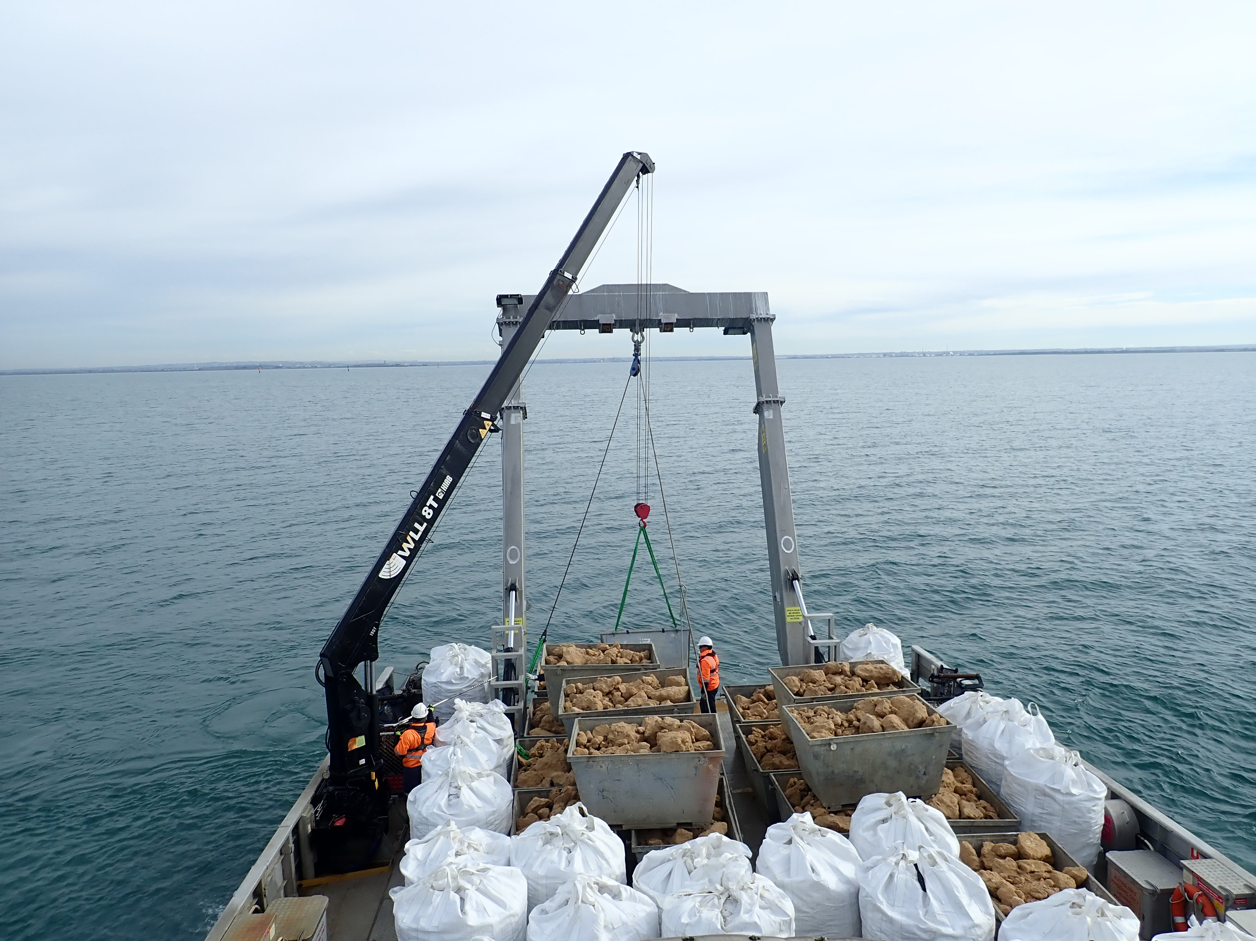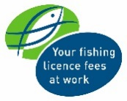

|  |
| --- |
| © The State of Victoria, Victorian Fisheries Authority, September 2018  This work is licensed under a Creative Commons Attribution 3.0 Australia licence. You are free to re-use the work under that licence, on the condition that you credit the State of Victoria as author. The licence does not apply to any images, photographs or branding, including the Victorian Coat of Arms, the Victorian Government logo and the Victorian Fisheries Authority logo. To view a copy of this licence, visit <http://creativecommons.org/licenses/by/3.0/au/deed.en>  **Accessibility** If you would like to receive this publication in an alternative format, please telephone the Customer Service Centre 136 186, email rec.fishinggrants@vfa.vic.gov.au, via the National Relay Service on 133 677 www.relayservice.com.au. This document is also available on the internet at [www.vfa.vic.gov.au](http://www.vfa.vic.gov.au)  **Disclaimer** This publication may be of assistance to you but the State of Victoria and its employees do not guarantee that the publication is without flaw of any kind or is wholly appropriate for your particular purposes and therefore disclaims all liability for any error, loss or other consequence which may arise from you relying on any information in this publication. |

Cover image: Reef base consisting of recycled shells and limestone rubble being deployed as part of the Port Phillip Bay Shellfish Reef Restoration Project.

Contents

Foreword 2

*Fisheries Act 1995* 3

Enforcement & Education 4

Snobs Creek Fish Production and Stocking 6

*Target One Million* 7

Financial Report 8

Notes to the Financial Report 10

Note 1 - Statement of Accounting Policies 10

Note 2 - Payments to Recreational Fishing Grants Program and other projects during 2017/18 11

[Note 3 - Proposal to fund 2017/18’s approved Recreational Fishing Grant Program projects,   
and other items in 2018/19 and beyond as applicable 15](#_Toc522709496)

Note 4 - Cash assets 23

Statutory Certification 24

Independent Audit Report from Auditor-General 25

Foreword

A report to each House of Parliament on the disbursement of Recreational Fishing Licence Revenue from the Recreational Fishing Licence Trust Account, 2017/18

Every year the Victorian Government provides revenue from the sale of recreational fishing licences to projects that improve recreational fishing, through the Recreational Fishing Licence (RFL) Trust Account.

As the Minister for Agriculture, I recognise the significant contribution that recreational fishing continues to make to the State’s economy and the social wellbeing it brings to those who participate in this wonderful outdoor activity.

The Recreational Fishing Grants Working Group has continued to provide me with valuable advice on how RFL funds should be disbursed through the Recreational Fishing Grants Program over the past 12 months.

Following the Working Group’s recommendations, I recently announced that $1,154,022 will be allocated to 16 new projects through the 2017/18 round of the Large Grants Program. These projects include a Maribyrnong River native fish revival project, increasing fish habitat in the Snowy, Mitta Mitta, Rubicon, Merri and Goulburn Rivers, installing fishing pontoons at Nhill Lake and the Wimmera River, monitoring the southern bluefin tuna and striped trumpeter recreational fisheries in western Victorian waters, and the development of a Fishcare ‘Get Hooked’ app for use in schools.

A further $359,055 was allocated via the Commissioning Grants Program; $219,055 to produce a range of popular education and communication products that assist recreational anglers to understand and comply with fishing regulations, and $140,000 for the monitoring of key marine and estuarine fisheries.

The Small Grants Program has again been very popular with over $95,000 being provided for 40 projects during 2017/18. This program has now funded over 340 projects worth more than $890,000 since its inception in 2010.

I am also very pleased to advise that during 2017/18 an additional $2,331,282 was allocated towards the implementation of the Target One Million plan, which included the state-wide fish stocking program, the Better Fishing Facilities   
Program, the Defibrillator for Fishing Clubs Program, and expanding the Angler Diary Program.

During 2017/18, Recreational Fishing Licence Trust Account funds were again committed or disbursed to fund:

* Increased fish stocking into lakes and rivers;
* The deployment of thirteen Fisheries Officers to boost enforcement and education;
* VRFish, to provide advice to the Victorian Government about the broad range of recreational fishers’ views on the management of the State’s fisheries resources;
* The Victorian Fishcare program, which delivers responsible fishing education and events to the community;
* Projects approved through previous rounds of the Recreational Fishing Grants Program for access and facilities, education, information and training, recreational fisheries research and fish habitat improvement.
* Recreational Fishing Licence commissions paid to sellers; and
* The costs incurred in the administration of the Recreational Fishing Licence, Grants Program and the Recreational Fishing Grants Working Group.

Fishing licence revenue and the Target One Million plan have continued to deliver significant investment into recreational fishing to grow participation and help regional businesses that rely on the associated tourism. I’m sure that recreational fishers cross the state will agree that increased fish stocking, better facilities, more enforcement and more education are fundamental to sustainable fishing in the future and it is pleasing to know that the next generation of anglers will enjoy these benefits.

I have pleasure in providing to each House of Parliament this report on the receipts and disbursements from the Recreational Fishing Licence Trust Account for 2017/18.

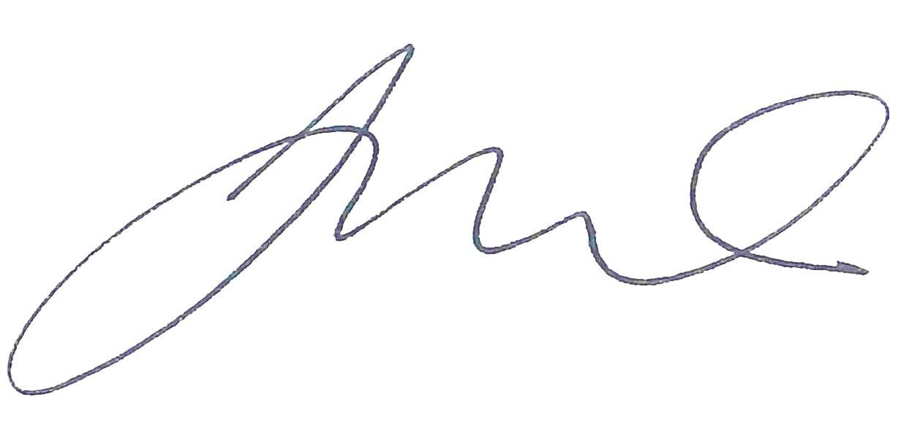

Hon Jaala Pulford MP  
Minister for Agriculture

18 September 2018

*Fisheries Act 1995*

Pursuant to Section 151B(4) of the *Fisheries Act 1995*, the Minister (responsible for Victoria’s fisheries) must cause a report on how amounts paid into the Recreational Fishing Licence (RFL) Trust Account were disbursed –

(a) to be prepared by 1 October each year; and

(b) to be laid before each House of Parliament on or before the seventh sitting day of that House after the report has been prepared.

For the information of Honourable Members, the RFL Trust Account came into effect on 1 April 2001.

The 2017/18 financial year is the seventeenth full year of the RFL Trust Account’s operation.

The Victorian Auditor-General has audited the receipts received, and disbursements made from the RFL Trust Account in 2017/18.

Enforcement & Education

In 2017/18, Recreational Fishing Licence (RFL) Trust Account receipts contributed $2,026,644 to the Victorian Fisheries Authority’s compliance budget.

RFL Trust Account receipts, when added to ongoing recurrent funding of fisheries compliance (education and enforcement) activities, contributes substantially to the delivery of recreational fisheries compliance services in Victorian coastal and inland locations.

Fisheries Officers have continued to have good contact with recreational fishers in the field during the last year. Table 1 summarises yearly totals for contacts in the recreational fishing sector. The work is divided into categories based on species, locations or other activities. Over 56,300 total contacts were made with recreational fishers by Fisheries Officers during the reporting period. Compliance contacts with Fisheries Officers totalled over 46,000, with Table 1 showing the number of offenders, verbal warnings, official warnings, infringement notices, and briefs of evidence for the year.

In addition, Fisheries Officers attended 21 angling club meetings, conducted3,922 advisory contacts with recreational fishers, made 49 contacts during fish stocking events and 618 contacts during recreational fishing related shows, forums and clinics.

Table 1.

|  |  |  |  |  |  |  |
| --- | --- | --- | --- | --- | --- | --- |
| **Recreational** | **Officer contacts with recreational fishers** | **Number of offenders** | **Verbal warnings issued** | **Official warnings issued** | **Infringement notices issued** | **Briefs of evidence compiled** |
| Abalone (intertidal zone) | 221 | 125 | 95 | 58 | 85 | 2 |
| Abalone (on land) | 1530 | 323 | 113 | 171 | 223 | 11 |
| Abalone (on water) | 184 | 23 | 7 | 5 | 12 | 0 |
| Bass yabbies | 66 | 0 | 0 | 0 | 0 | 0 |
| Bay & Inlet - other (on land) | 5819 | 380 | 166 | 143 | 112 | 1 |
| Bay & Inlet - other (on water) | 2154 | 122 | 47 | 31 | 47 | 2 |
| Bay & Inlet - Port Phillip (on land) | 13515 | 786 | 271 | 338 | 211 | 3 |
| Bay & Inlet - Port Phillip (on water) | 1273 | 76 | 26 | 21 | 25 | 0 |
| Bay & Inlet - Western Port (on land) | 2646 | 159 | 64 | 44 | 47 | 0 |
| Bay & Inlet - Western Port (on water) | 936 | 77 | 32 | 26 | 19 | 0 |
| Freshwater (on land) | 7189 | 737 | 265 | 237 | 264 | 2 |
| Freshwater (on water) | 2810 | 173 | 56 | 54 | 74 | 0 |
| Intertidal other | 171 | 66 | 45 | 20 | 10 | 0 |
| Intertidal pipis | 1862 | 261 | 145 | 75 | 52 | 1 |
| Intertidal Port Phillip | 270 | 180 | 97 | 89 | 98 | 3 |
| Intertidal red shore crab | 257 | 40 | 18 | 8 | 22 | 0 |
| Marine Safety (on land) | 1735 | 329 | 262 | 62 | 92 | 1 |
| Marine Safety (on water) | 1997 | 418 | 328 | 69 | 98 | 0 |
| Murray cod | 1706 | 63 | 36 | 15 | 23 | 0 |
| Ocean (on land) | 3749 | 263 | 97 | 98 | 78 | 1 |
| Ocean (on water) | 553 | 23 | 8 | 6 | 9 | 0 |
| Rock lobster (on land) | 273 | 21 | 7 | 12 | 5 | 0 |
| Rock lobster (on water) | 216 | 17 | 5 | 4 | 9 | 0 |
| Scallops (on land) | 10 | 1 | 0 | 0 | 1 | 0 |
| Scallops (on water) | 16 | 1 | 0 | 0 | 1 | 0 |
| Spiny Cray | 537 | 28 | 21 | 20 | 15 | 3 |
| **Totals** | **51,695** | **4,692** | **2,211** | **1,606** | **1,632** | **30** |

All Fisheries Officers provide services to the recreational fishing sector and interact with recreational fishers through:

* contact with recreational fishers in the field;
* attending angling club meetings;
* attending recreational fishing-related shows, family fishing events, forums and clinics;
* attending fish stocking/liberation events;
* liaising with grant recipients regarding the successful completion of infrastructure projects under the annual Recreational Fishing Grants Program (Large Grants);
* advising fisheries management on issues relating to recreational fishing;
* assisting Fisheries Management, Policy, Science and Licencing Branch on matters relating to recreational fishing;
* responding to recreational fishing issues raised from the 13FISH Offence Reporting Line;
* producing recreational fishing-related media releases/distributing booklets and pamphlets;
* investigating recreational fishing-related offences and prosecuting where necessary;
* collecting intelligence related to recreational fishing offences;
* participating in recreational fishing-related educational activities with school groups and the broader recreational fishing community; and
* engaging with culturally and linguistically diverse communities.

The Victorian Fisheries Authority in conjunction with the recreational fishing community strives to achieve high levels of voluntary compliance amongst recreational fishers. By working collaboratively and by continuing to promote responsible and ethical fishing, we are better positioned to ensure both fish for now and fish for the future.

Snobs Creek Fish Production and Stocking

In 2017/18, Recreational Fishing Licence (RFL) Trust Account receipts contributed $1,894,797 to the Victorian Fisheries Authority’s fish production and stocking budget. This includes the base amount of $920,000 (approved by the RFL WG in May 2012, ongoing) to support fish production and stocking from Snobs Creek, an additional $566,630 to boost fish stocking to a record 6 million fish through Target One Million and funds expended to finalise the RFL commissioning grant titled “Better Recreational Fishing through Informed Fish Stocking” ($408,167). Additional funding was provided   
by the State Government which contributed towards achieving this year’s record fish stocking.

RFL Trust Account receipts, when added to state government funding of fish stocking and production activities, contributes significantly to the delivery of recreational fisheries state-wide stocking program.

The combined funds are used to operate the fish hatchery at Snobs Creek, costs associated with the delivery of fish across the state and for the purchase of additional fish.

In 2017/18 the Victorian Fisheries Authority grew 670,260 native fish and 1,174,003 salmonid fish that were stocked into public waters. In additional to these fish the VFA purchased 4,242,092 mixed species of fish that were picked up and delivered to various locations across the state.

During 2017/18 VFA staff associated with the production and delivery of fish carried out the below activities:

* Management of broodstock across all species
* Harvesting of eggs from all species
* Feeding fish of all ages
* Careful movement of fish as they develop
* Animal health monitoring and management
* Our stocking vehicles travelled 169,347 km’s which took 405 days to undertake

The VFA works closely with anglers and other key stakeholders to coordinate the successful breeding and delivery of fish across the state.

A list of all waters stocked can be found at <https://vfa.vic.gov.au/stockingdatabase>

|  |  |  |  |  |  |  |  |
| --- | --- | --- | --- | --- | --- | --- | --- |
| **Species** | **Barwon South West** | **Gippsland** | **Grampians** | **Hume** | **Loddon Mallee** | **Port Phillip** | **Grand Total** |
| Australian Bass |  | 474,500 |  |  |  |  | **474,500** |
| Estuary Perch | 7,000 |  |  |  |  |  | **7,000** |
| Golden Perch | 205,650 |  | 247,000 | 973,495 | 1,084,836 | 5,000 | **2,515,981** |
| Macquarie Perch |  |  |  | 17,500 |  |  | **17,500** |
| Murray Cod | 215,322 |  | 60,000 | 756,699 | 597,834 |  | **1,629,855** |
| Silver Perch |  |  | 54,000 | 37,000 | 126,000 | 18,000 | **235,000** |
| Trout Cod |  |  |  | 3,500 |  |  | **3,500** |
| **Natives Total** | 427,972 | 474,500 | 361,000 | 1,788,194 | 1,808,670 | 23,000 | **4,883,336** |
| Brook Trout | 3,270 |  |  |  |  |  | **3,270** |
| Brown Trout | 72,449 | 24,575 | 98,560 | 166,217 | 259,914 | 8,750 | **630,465** |
| Chinook Salmon | 29,715 |  |  |  |  |  | **29,715** |
| Rainbow Trout | 59,225 | 48,775 | 126,018 | 216,023 | 52,022 | 37,506 | **539,569** |
| **Salmonids Total** | 164,659 | 73,350 | 224,578 | 382,240 | 311,936 | 46,256 | **1,203,019** |
| **Total** | **592,631** | **547,850** | **585,578** | **2,170,434** | **2,120,606** | **69,256** | **6,086,355** |

*Target One Million*

In 2017/18, Recreational Fishing Licence (RFL) Trust Account receipts contributed $2,331,282 towards the Victorian Fisheries Authority’s implementation of the *Target One Million* initiative.

RFL Trust Account receipts, when added to state government funding contributes significantly to the delivery of the *Target One Million* projects. Since the beginning of the *Target One Million* initiative the Victorian Government has invested an unprecedented $33.3 million of state revenue in the delivery of the initiative and is on track to reach a total investment of $37 million. Over the same period $2.65 million co-investment has been sourced from the Recreational Fishing Licence trust.

*Target One Million* has achieved many outstanding results so far and is continuing to deliver fantastic on ground outcomes. Below is a list of the projects implemented as part of the initiative.

* Remove commercial netting in Port Phillip Bay
* Save Lake Toolondo
* Establish a marine stocking program
* Open trout cod fisheries at Beechworth
* Create an exciting barramundi fishery at Hazelwood Pondage
* Remove boating restrictions at Blue Rock Lake
* Provide over 180 Victorian fishing clubs grants of $2,000 to help strengthen their clubs
* Deliver school education and children’s fishing programs
* Grow the trout opening festivals
* Build over 40 new facilities across Victoria to make fishing access better
* Ban netting at Gippsland lakes’ river mouths
* Make Fisheries Victoria a statutory authority
* Establish an exciting new native fishery at Rocklands Reservoir
* Provide over 50 angling clubs approved to receive a defibrillator
* Stocked a record 6 million fish in Victoria
* Undertake a recreational fishing survey
* Expand the Angler Diary program
* Returned fishing to Dartmouth Pondage

A key component of the successful implementation of these projects has been the communication and support provided by key stakeholders to coordinate recreational fishing improvements across the state.

More information on *Target One Million* can be found at

www.vfa.vic.gov.au/targetonemillion

Financial Report

Report concerning how amounts paid into the Recreational Fishing Licence Trust Account were disbursed in 2017/18 financial year

|  |  |  |
| --- | --- | --- |
| **Receipts 2017/18** | **$** |  |
| **Total receipts from RFL sales**  258,531 RFL's sold (as at 24 July 2018*) including: 34,252 three-year licences, 111,615 one-year licences, 12,406 28-day licences, 100,183 three-day licences and 75 48-hour licences.  *Running a report on RFL sales several weeks after 30 June each year allows for more returns from RFL sales outlets to be captured, therefore providing a more accurate figure on total sales for the financial year. | $7,831,804.19 |  |
| **Interest – investments** | $36,250.00 | *Fisheries Act 1995*, S. 151B(5) enables money standing to the credit of the Account to be invested in any manner in which funds may be invested under the *Trustee Act* *1958*. |
| **Refunds: RFGP projects** | $2,606.95 | Project SG469 Curdievale Anglers Club. Lighting - Curdievale boat ramp. $115.00  Project SG271 Fishcare South West Inc. Local knowledge fishing in the South West. $366.70  Project SG367 Nangiloc Fishing Club. Primary School Education and Fishing Day. $875.25  Project SG317 VRFish. Game Fishing Education and Awareness Video. $1,250.00 |
| **GST Receipts** | $28,104.96 |  |
| **Total receipts for the year** | $7,898,766.10 |  |

|  |  |  |  |  |
| --- | --- | --- | --- | --- |
| **Disbursements 2017/18** | **$** | |  | |
| **Recreational Fishing Grants Program and other projects** | $1,484,034.08 | | Payments to 78 projects - see Note 2. | |
| **Target One Million Implementation** | $2,331,282.02 | |  | |
| **Fisheries Enforcement & Education Branch** | $2,026,644.00 | |  | |
| **Fish Stocking**  The purchase and stocking of native and salmonid fish to improve recreational fishing in Victorian waterways. | $920,000.00 | |  | |
| **VRFish** | $456,552.00 | |  | |
| **Fishcare Victoria Inc.** | $220,555.80 | |  | |
| **Community Information**  Recreational Fishing Grants Program/Recreational Fishing Licence disbursement reporting related advertising & publicity. | $68,853.07 | |  | |
| **Recreational Fishing Licence (RFL) 6% sales commissions**  Applicable to sales commissions incurred during 2016/17, paid in 2017/18 financial year. | $152,319.15 | |  | |
| **Costs and expenses incurred in the administration of RFLs** |  | |  | |
| Salaries and on-costs. | $384,415.19 | |  | |
| Business, corporate & other levies (common domain access levy, OH&S levy, training & development levy, centre leader levy, CBD accommodation and workstation charge, computer internal lease costs). | $25,060.78 | |  | |
| Professional and contract services. | $404,794.96 | |  | |
| Agency labour hire. | $47,509.30 | |  | |
| Postal expenses, parking, vehicle hire, accommodation, printing, stationery, telephones, banking charges, office equipment, software maintenance, external learning and  IT assistance. | $49,083.97 | |  | |
| **Recreational Fishing Grants Working Group**  Sitting fees, sustenance, accommodation, vehicle hire, venue hire, and personal expenses. | $9,302.01 | |  | |
| **Total disbursements for the year** | $8,580,406.00 | |  | |
| **Net cash inflow/(outflow)** | ($681,639.90) | |  | |
| **Cash as at 1 July 2017** | $6,907,370.53 | | Includes unspent funds relating to VFA-led projects (see page 12) which were refunded back to the RFL Trust Account due to DEDJTR year-end corporate finance processes outside of the RFL reporting period. | |
| **Cash as at 30 June 2018** | $6,225,730.63 | | Provision to fund previously approved Recreational Fishing Grant Program projects extending into 2018/19 and beyond as applicable and other items totalling $3,907,651.30 - see Note 3.  Cash balance includes $2,500,000 which has been invested – see Note 4. | |
| Amounts are net of applicable GST | |  | |  |

Notes to the Financial Report

These notes form part of and should be read in conjunction with the financial report of the Recreational Fishing Licence Trust Account.

Note 1 - Statement of Accounting Policies

*Basis of preparation.*

This special purpose financial report has been prepared in accordance with the provisions of the *Fisheries Act 1995*.

The report has been prepared on a cash basis to report on how levies and application fees received in respect of recreational fishing licences have been disbursed from the trust account.

Note 2 - Payments to Recreational Fishing Grants Program and other projects during 2017/18

|  |  |  |
| --- | --- | --- |
| **Projects initially announced in 2011/12** |  |  |
| **Large Grants Program** |  |  |
| Fish habitat enhancement of the Ovens River (Wangaratta region). 3rd & final year of funding. Total project funding of $75,000. | $30,000.00 | North East Catchment Management Authority |
| **Sub-Total** | **$30,000.00** |  |
| **Projects initially announced in 2012/13** |  |  |
| **Large Grants Program** |  |  |
| Monitor the Chinook salmon fish stocking program at lakes Purrumbete and Bullen Merri. Balance of funding. Total project funding of $115,667. | $11,361.28 | Lake Purrumbete Angling Club Inc. |
| Development of approaches to monitor and manage recreational catch of ‘western stock’ snapper to meet sustainability and recreational fishery objectives. Partial funding. Total project funding of $262,206. | $5,254.00 | Victorian Fisheries Authority |
| **Sub-Total** | **$16,615.28** |  |
| **Large Grants Program** |  |  |
| Renewed Fish Habitat for both Native & Trout Fishing in King River NE Victoria.  90% instalment of year three funding. Total project funding of $190,226.82. | $54,269.59 | King Valley Tourism Association |
| Improving Recreational Fishing Access at Konongwootong Reservoir. Balance of 10% of funding. Total project funding of $231,818.18 over three years. | $23,181.82 | Wannon Water Corporation |
| Improving access to and evaluating the effectiveness of a Merri River Estuary Fish Habitat Hotspot. Balance of 10% of funding. Total project funding of $80,181.82 over three years. | $8,018.18 | Glenelg Hopkins Catchment Management Authority |
| **Sub-Total** | **$85,469.59** |  |
| **Projects initially announced in 2014/15** |  |  |
| **Large Grants Program** |  |  |
| Assessing the sustainability of Venus Bay’s recreational and commercial pipi harvest. 90% instalment of year three funding. Total project funding of $71,565. | $18,899.10 | University of Melbourne |
| Implementing better practice Murray cod fishery management. Instalment of year three funding. Total project funding of $99,935. | $15,100.00 | Victorian Fisheries Authority |
| Understanding the stock structures, biology and population status of mulloway in Victoria. 90% instalment of year three funding. Total project funding of $78,545.45. | $8,378.18 | Nature Glenelg Trust |
| Increasing fish habitat in the Pyramid Creek. Balance of 10% of funding. Total project funding of $61,342.72. | $6,134.27 | North Central Catchment Management Authority |
| Increasing knowledge of Victoria’s growing recreational yellowtail kingfish fishery. Balance of 10% funding. Total project funding of $147,907.50. | $4,895.00 | Victorian Fisheries Authority |
| All abilities fishing platform on the Aire River. Balance of 10% of funding. Total project funding of $42,615.91. | $4,261.59 | Association of Geelong & District Angling Clubs |
| **Sub-Total** | **$57,668.14** |  |
| **Projects initially announced in 2015/16** |  |  |
| **Large Grants Program** |  |  |
| Creating Sustainable Anglers Program (600 school based workshops and 150 community events). 90% instalment of year two funding. Total project funding  of $109,090.91. | $32,727.27 | Fishcare Victoria |
| Rebuild 400 square metre patches of shellfish dominated natural reefs in Port Phillip Bay and monitor the benefits of these reefs to recreational fishers. 90% instalment of year two funding. Total project funding of $133,636.36. | $30,272.73 | Albert Park Yachting & Angling Club |
| Partnering with recreational fishers in a tagging program to understand the movements of Victorian King George whiting to their spawning areas.  90% instalment of year two funding. Total project funding of $69,944.55. | $20,779.36 | University of Melbourne |
| Three fishing platforms for the area on Sawtells Inlet upstream from the bridge and flood gates. Balance of 10% of funding. Total project funding of $82,272.73. | $8,227.27 | Tooradin Foreshore Committee of Management |
| Construction of a fishing jetty on the Yarriambiack Creek Weir pool in the township  of Warracknabeal. Balance of 10% of funding. Total project funding of $63,000. | $6,300.00 | Warracknabeal Angling Club |
| Monitoring of river blackfish that were translocated into rehabilitated habitat sites  in the Tarwin River. 90% instalment of year two funding. Total project funding  of $20,191.04. | $6,057.31 | West Gippsland Catchment Management Authority |
| Pilot Multicultural Responsible Fishing Program to provide information to targeted multicultural groups on litter management, fish size and bag limits along the lower Barwon estuary. Balance of 10% funding. Total project funding of $14,090.91. | $1,409.09 | Barwon Coast Committee of Management |
| Assess the feasibility of hatchery production of fingerlings of selected flathead species for a marine stock enhancement program. Partial balance of funding.  Total project funding of $25,000. | $677.00 | Victorian Fisheries Authority |
| **Sub-Total** | **$106,450.03** |  |
| **Projects initially announced in 2016/17** |  |  |
| **Commissioning Grants Program** |  |  |
| 2017/18 Communication and Compliance Products (production of a series of communication products and measuring devices to provide recreational fishers with up-to-date information on Fisheries regulations). Partial year one funding. Total project funding of $219,800. | $79,927.00 | Victorian Fisheries Authority |
| Informing sustainable management and optimisation of Victoria's wild catch marine and estuarine recreational fisheries. Partial year one funding. Total project funding of $130,000. | $73,532.00 | Victorian Fisheries Authority |
| **Sub-Total** | **$153,459.00** |  |
| **Large Grants Program** |  |  |
| Increasing fishing habitat in the Little Murray River. 90% instalment of year one funding. Total project funding of $89,834.54. | $80,851.09 | North Central Catchment Management Authority |
| Assessing post-release survival of Swordfish from recreational fishing.  90% instalment of year one funding.Total project funding of $80,549.09. | $72,494.18 | University of Tasmania |
| Lower Buckland River instream habitat and riparian restoration. 90% instalment  of year one funding. Total project funding of $58,100.00. | $52,290.00 | Australian Trout Foundation Inc. |
| Wild Trout Fisheries Management Program – Phase 2. Total project funding  of $105,454.55. | $45,000.00 | Department of Environment, Land, Water and Planning |
| Upper Goulburn Catchment instream habitat enhancement. 90% instalment of year one funding. Total project funding of $65,681.82. | $31,950.00 | Goulburn Broken Catchment Management Authority |
| State-wide recreational tagging program to investigate mulloway movements.  90% instalment of year one funding. Total project funding of $51,272.72. | $19,669.09 | Nature Glenelg Trust |
| Mid Goulburn River instream habitat enhancement - Mangalore. 90% instalment of year one funding. Total project funding of $21,560.00. | $19,404.00 | Goulburn Broken Catchment Management Authority |
| Capturing the status and planning for the future of dusky flathead fisheries of eastern Victoria. Partial year one funding. Total project funding of $30,200. | $17,388.00 | Victorian Fisheries Authority |
| Hughes Creek habitat connections. 90% instalment of year one funding plus balance of 10% funding. Total project funding of $13,636.37. | $13,636.37 | Goulburn Broken Catchment Management Authority |
| Point Richards boat ramp fish cleaning table. 90% instalment of year one funding. Total project funding of $13,256.37. | $11,930.73 | Bellarine Bayside Foreshore Committee of Management |
| Indented Head boat ramp fish cleaning table. 90% instalment of year one funding. Total project funding of $13,056.37. | $11,750.73 | Bellarine Bayside Foreshore Committee of Management |
| Recreational fishing information shelter. 90% instalment of year one funding.  Total project funding of $7,416.37. | $6,674.73 | Balmoral District Angling Club |
| **Sub-Total** | **$383,038.92** |  |
| **Small Grants Program** |  |  |
| Community Fishing Festival 2017 | $5,000.00 | Yarra Valley Fly Fishers Inc. |
| World Fish Migration Day Event | $4,832.73 | North Central Catchment Management Authority |
| Rays in Our Bays | $4,586.00 | Fishcare Victoria Inc. |
| Mates Day on the Bay 2017 | $4,422.72 | Futurefish Foundation |
| Get Hooked on fishing at St Mary’s Program | $4,227.27 | St Mary’s House of Welcome |
| Australia Day Weekend Surf Fishing Carnival | $4,100.00 | Veronica Maybury Memorial Recreational Reserve CoM. |
| Kids Come and Try Fishing Day | $4,050.00 | Nathalia Angling Club |
| Schools Fishing Program | $4,036.36 | Colac Otway Shire |
| Kids Try Fishing Day | $3,810.00 | Kyabram Anglers Club Inc. |
| Community partnership for carp removal | $3,680.00 | Wangaratta Sustainability Network |
| Kids Fishing Fun Program | $3,501.45 | City of Wodonga |
| Promotion of endangered fish | $3,500.00 | Native Fish Australia Inc. |
| Boat Safety and Fishing Education Day | $3,000.00 | Wimmera Offshore Anglers Sport & Game Fishing Club |
| Junior Fishing Day | $2,818.18 | Churchill & District News |
| Come and Try Fishing Day for People with a Disability | $2,650.00 | Nathalia Angling Club |
| Carp Muster Educational Days | $2,650.00 | Wangaratta Sustainability Network |
| Ron Nelson Memorial Junior Fishing Clinic | $2,587.27 | Association of Geelong & District Angling Clubs |
| Lake Boga signage upgrade | $2,570.00 | Goulburn Murray Water |
| Morwell Lake Family Fishing Day | $2,454.55 | Italian Australian Sporting & Social Club |
| Kings Billabong pest eradication and community education | $2,400.00 | Nangiloc Fishing Club |
| Lake William Hovell signage upgrade | $2,350.91 | Goulburn Murray Water |
| Come Try Fishing Day | $2,250.00 | Charlton Angling Club |
| Simpson Dam fishing platform | $2,150.00 | Simpson & District Lions Club |
| Bream Classic 2017 | $2,000.00 | Twin Rivers Business & Tourism |
| Gone Fishing Day | $1,705.00 | Strathbogie Euroa Angling Club |
| Teach Kids to Fish Day | $1,500.00 | Oakdale Angling Club |
| Come n Try Fishing - Seadays Festival 2018 | $1,420.00 | Port Welshpool Working Group Inc. |
| Live fish display at boat show | $1,385.00 | Native Fish Australia |
| Carp A Thon Family Day | $1,272.73 | St Paul’s Anglican Grammar School |
| [Dart Dam Trout Trolling Tournament](http://p00713.doi.vic.gov.au:8000/OA_HTML/OA.jsp?OAFunc=ICXPOR_RCV_SRCH_PAGE&reqHeaderId=%7B!!ByeZEJURgfYjGbW3GlkYtA%7D&fromSession=Y&porOrigin=ICX_CAT_SHOP_HOME&_ti=1147553912&oapc=5&oas=j4xuZr5lJG0a4x9DqHheYQ..) | $1,230.00 | Dartmouth Alpine Anglers Club |
| Gone Fishing Day | $1,121.00 | Horsham Angling Club |
| 2017 Kids Come n Try Fishing Day | $1,022.40 | Ballarat & District Anglers Association |
| Twilight Fishing on the River | $856.00 | Horsham Angling Club |
| Gone Fishing Day 2017 | $800.00 | Casterton Angling Society |
| Campaspe Carp Catch 2017 | $610.00 | Rochester & District Angling Club |
| Campaspe Carp Catch 2017 | $600.00 | Longlea & District Landcare Group |
| Campaspe Carp Catch 2017 | $500.00 | Kyneton Angling Club |
| Campaspe Carp Catch 2017 | $500.00 | Strathallan Family Landcare |
| Campaspe Carp Catch 2017 | $500.00 | Echuca Moama Landcare Group |
| Campaspe Carp Catch 2017 | $454.55 | North Central Catchment Management Authority |
| **Sub-Total** | **$95,104.12** |  |
| **Part A: Disbursements net of GST** | **$927,805.08** |  |

**Disbursements for pre-existing Fisheries projects.**

The projects below have been reported in a different format to previous years due to Victorian Fisheries Authority (VFA) commencing as a statutory authority from 1 July 2017 and timing of expenditure incurred is in line with VFA’s annual report.

|  |  |  |
| --- | --- | --- |
| **Projects initially announced in 2013/14** |  |  |
| **Commissioning Grants Program** |  |  |
| Better Recreational Fishing Through Informed Fish Stocking (stocking an additional 1,110,000 fish over 3 years, fish surveys, development of an on-line fish stocking search engine, and captive breeding of Macquarie perch). Balance of funding.  Total project funding of $990,600.00 over three years. | $408,167.00 | Victorian Fisheries Authority |
| Wild Trout Fisheries Management Program (investigate the likely cause(s) of the decline in wild trout fishing in Victoria and, where possible, improve wild trout fishing through informed fisheries management interventions). Balance of funding.  Total project funding of $560,000.00 over three years. | $79,268.00 | Victorian Fisheries Authority |
| **Projects initially announced in 2015/16** |  |  |
| **Large Grants Program** |  |  |
| Marine and estuarine finfish recreational fisheries monitoring program 2015/16.  Total project funding of $62,000. | $51,262.00 | Victorian Fisheries Authority |
| Create marine fish habit maps which can be used by key managers of marine habitats and associated catchments to improve recreational fishing outcomes.  Total project funding of $30,000. | $17,532.00 | Victorian Fisheries Authority |
| **Part B: Disbursements net of GST** | **$556,229.00** |  |
|  |  |  |
| **TOTAL** |  |  |
| **Part A: Disbursements net of GST** | **$927,805.08** |  |
| **Part B: Disbursements net of GST** | **$556,229.00** |  |
|  | **$1,484,034.08** |  |

Note 3 - Proposal to fund 2017/18’s approved Recreational Fishing Grant Program projects, and other items in 2018/19 and beyond as applicable

Proposal to fund previously approved Recreational Fishing Grants Program projects extending into 2018/19 financial year and beyond as applicable, and other items

| **Project No.** | **Region** | **Project category** | **Proponent** | **Project site** | **Type of waters** | **Project duration** | **Proposal** | **Funding** | **Other contributions/comments** |
| --- | --- | --- | --- | --- | --- | --- | --- | --- | --- |
| 1718COM0001 | State-wide | Commissioning Grant | Victorian Fisheries Authority | State-wide | State-wide | 1yr | 2018/19 Commissioning and Compliance Products. | $219,055.70 | VFA in-kind project management. |
| LG1718146 | State-wide | Research | Victorian Fisheries Authority | State-wide | Marine | 2yr | Victorian Game Fishing: knowledge, movement and best practice for catching and releasing shortfin mako and gummy sharks | $205,000.00 | VFA financial: $88,000  In-kind: Deakin, VRFish, volunteers - $47,000 |
| LG1718110 | Port Phillip & Western Port | Sustainability & Habitat Improvement | Victorian Fisheries Authority | Port Phillip & Western Port | Estuarine | 3yr | Maribyrnong River Native Fishery Revival | $200,000.00 | VFA: $415,000, Melbourne Water: $300,000, Parks Vic/ DELWP: $400,000. |
| 1718COM0002 | State-wide | Commissioning Grant | Victorian Fisheries Authority | State-wide | Marine & estuarine | 1yr | Informing sustainable management and optimisation of Victoria’s wild catch marine and estuarine recreational fisheries. | $140,000.00 | VFA management, analysis and reporting of recreational fishery catch data: $170,000. |
| COM00001 | State-wide | Commissioning Grant | Victorian Fisheries Authority | State-wide | State-wide | 1yr | 2017/18 Commissioning and Compliance Products. Balance of funding. Total project funding of $219,800. | $139,873.00 | VFA in-kind project management. |
| LG1718 | Gippsland | Sustainability & Habitat Improvement | East Gippsland CMA | East Gippsland | Estuarine | 1yr | Improving Instream Habitat for Key Recreational Species in the Snowy River | $110,000.00 | Compliments major works undertaken by EGCMA through the Snowy River Rehabilitation project. |
| LG1718144 | State-wide | Education, Information & Training | Fishcare Victoria Inc. | State-wide | All | 1yr | Fishcare - Get Hooked on Fishing App | $107,545.00 | Fishcare $6,000+ financial and $26,000+ in-kind. |
| 16/17/94 | State-wide | Research | Victorian Fisheries Authority | State-wide | Inland | 2yr | Population status and report cards for key native recreational fisheries. Total project funding  of $100,000.00. | $100,000.00 | DELWP: $300,000 over  3 years. Victorian Fisheries Authority: $200,000 over  3 years (2016/17, 2017/18 & 2018/19). |
| LG1718 | Northern | Sustainability & Habitat Improvement | North East CMA | Northern | Inland | 1yr | Mitta Rehabilitation Project - Mitta Mitta River, from the high-water mark of Lake Hume to the township of Eskdale. | $88,000.00 | Complimented by MDBA Channel Capacity Program works ($380,000). |
| COM/10/11/04 | Northern | Commissioning Grant | Victorian Fisheries Authority | Northern Victoria | Inland | 3yr | Building northern native fisheries, great fishing on the Campaspe, Loddon & Gunbower systems. Balance of 10% funding. Total project funding  of $779,500. | $77,950.00 | VFA: $260,000. |
| LG1718 | Port Phillip & Western Port | Access & Facilities | Corinella Foreshore Reserve Inc. | Corinella | Marine | 1yr | Stair Access to Corinella Foreshore | $71,400.00 | Corinella Foreshore Reserve Inc. $14,240 |
| 16/17/97 | Northern | Research | DELWP, Arthur Rylah Institute | Northern | Inland | 2yr | Wild Trout Fisheries Management Program – Phase 2. 2nd year and balance of funding Total project funding of $105,454.54. | $60,454.54 | $60,000 from Target One Million program to fund  2 annual wild trout fishing conferences. VFA project management - $15,200. |
| COM00022 | State-wide | Commissioning Grant | Victorian Fisheries Authority | State-wide | Marine & estuarine | 1yr | Informing sustainable management and optimisation of Victoria’s wild catch marine and estuarine recreational fisheries. Balance of funding. Total project funding of $130,000. | $56,468.00 | VFA management, analysis and reporting of recreational fishery catch data: $170,000. |
| LG1718107 | South West | Education, Information & Training | Pepperell Research & Consulting Pty Ltd | Portland | Marine | 1yr | Enhancement of citizen science in the recreational fishery for southern bluefin tuna in Victoria. Location: Portland, Victoria | $56,030.00 | Various in-kind: $28,000 |
| LG1718 | Northern | Access & Facilities | Jeparit Anglers Club | Jeparit | Inland | 1yr | Fishing Pontoon on the Wimmera River Jeparit | $55,500.00 | Jeparit Anglers Club $3,000 and ongoing maintenance. |
| LG1718 | South West | Access & Facilities | Hindmarsh Shire Council | Nhill | Inland |  | Nhill Lake Fishing Pontoon | $54,700.00 | Hindmarsh Shire: $10,000 Nhill Lake CoM in-kind: $1,250 |
| 15/16/01 | State-wide | Education, Information & Training | Fishcare Victoria Inc. | State-wide | State-wide | 3yr | Creating Sustainable Anglers Program (600 school based workshops and 150 community events).  3rd year and balance of funding. Total project funding of $109,090.91. | $43,636.36 | Anticipated dollar for dollar contribution of in-kind Fishcare volunteer effort to match  this grant. |
| LG1718 | Northern | Sustainability & Habitat Improvement | Goulburn Broken Catchment Management Authority | Northern | Inland | 1yr | Lower Goulburn River: Re-snagging for native  fish habitat | $44,840.00 | The GBCMA will provide project management. |
| LG1718153 | South West | Sustainability & Habitat Improvement | Deakin University | Gellibrand River | Inland | 1yr | Establishing a Southern River Blackfish spawning and recruitment monitoring network in the Gellibrand River Catchment | $34,480.00 | Deakin University  in-kind: $14,350 |
| 16/17/70 | Northern | Sustainability & Habitat Improvement | Goulburn Broken Catchment Management Authority | Northern | Inland | 1yr | Wild Trout Fisheries - Upper Goulburn Instream Habitat Enhancement. 2nd year and balance of funding. Total project funding of $65,681.82 | $33,731.82 | State Government funded Angler Riparian Partnership Program - $100,000 over  4 years |
| LG1718130 | Port Phillip & Western Port | Education, Information & Training | Macedonian Community Welfare Association Inc. | Port Phillip & Western Port | All | 2yr | Metropolitan Migrant and Refugee Seniors Sustainable Fishing Education Program: Overcoming Multicultural Barriers to Sustainable Recreational Fishing | $32,614.00 | Total financial and in-kind contributions from MCWA = $29,500. |
| 16/17/63 | State-wide | Research | Nature Glenelg Trust | State-wide | Marine & Estuarine | 3yr | A state-wide recreational tagging program to investigate mulloway movements. 2nd and 3rd year and balance of funding Total project funding of $51,272.73. | $31,603.63 | Recreational fishers in-kind: $74,000. VFA, Fishcare and the Australian National Sportfishing Association in-kind: $20,000. Nature Glenelg Trust in-kind: $10,000. |
| LG1718115 | Northern | Access & Facilities | Murtoa Angling Club | Murtoa | Inland | 1yr | Build a new fishing jetty over one year on Lake Marma in Murtoa for improved access to recreational fishing | $31,520.00 | Project management and ongoing maintenance by Murtoa Angling Club and Lake Marma CoM. |
| 13/14/54 | Northern | Sustainability & Habitat Improvement | North East Catchment Management Authority | Northern | Inland | 3yr | Mitta Mitta River Habitat Rehabilitation Project- Eskdale to high water mark of Lake Hume. Balance of 10% funding. Total project funding  of $266,981.82. | $26,698.18 | Financial: $325,000 from MDBA for fish surveys, bank stabilisation works, fence  and revegetation works.  In-kind: NECMA project management. |
| 14/15/33 | Northern | Research | Victorian Fisheries Authority | Northern | Inland | 3yr | Implementing better practice Murray cod fishery management. 3rd year and balance of funding. Total project funding of $99,935. | $25,425.50 | In-kind. Volunteer recreational anglers: $57,600. |
| LG1718140 | Northern | Sustainability & Habitat Improvement | Goulburn Broken Catchment Management Authority | Rubicon River | Inland | 1yr | Rubicon River Fish Habitat Enhancement Project | $24,500.00 | The 4-year ($100,000) State Government funded Angler Riparian Partnership Program compliment this project. |
| LG1718156 | South West | Research | Victorian Recreational Fishing Peak Body | South West | Marine | 2yr | Pilot study of striped trumpeter in western Victorian waters through citizen science | $24,132.00 | Various in-kind: $30,920 |
| 12/1323 | State-wide | Research | Victorian Fisheries Authority | State-wide | Marine | 3yr | Development of approaches to monitor and manage recreational catch of ‘western stock’ snapper to meet sustainability and recreational fishery objectives. Balance of 10% funding. Total project funding of $262,206. | $21,056.60 |  |
| 15/16/30 | Port Phillip & Western Port | Research | University of Melbourne | Port Phillip & Western Port | Marine | 3yr | Partnering with recreational fishers in a tagging program to understand the movements of Victorian King George whiting to their spawning areas.  3rd year and balance of funding. Total project funding of $69,944.55. | $19,427.54 | $10,000 per annum co-funding for salary support. Volunteer labour contribution of anglers, 2000 hours @$25 per hour = $50,000. |
| 12/1317 | Northern | Research | Greenfish Consulting Pty Ltd | Murray Darling Basin | Inland | 3yr | Develop and implement a consistent method for assessing the sustainability of Murray cod in the Murray Darling Basin. Balance of 10% funding. Total project funding of $150,000. | $15,000.00 | FRDC $375,000, Native Fish Strategy $23,900, Fisheries Victoria $36,000, PIRSA Fisheries $30,000. |
| LG1718137 | South West | Sustainability & Habitat Improvement | Glenelg Hopkins Catchment Management Authority | South West | Inland | 1yr | Merri River Fish Habitat Hotspot - Stage 2 Platypus Park | $13,761.00 | GHCMA: $7,500  Various in-kind: $3,100 |
| 15/16/17 | Port Phillip | Sustainability & Habitat Improvement | Albert Park Yachting & Angling Club | Port Phillip | Marine | 2yr | Rebuild 400 square metre patches of shellfish dominated natural reefs in Port Phillip Bay and monitor the benefits of these reefs to recreational fishers. Balance of 10% funding. Total project funding of $133,636.36. | $13,363.64 | Total co-funds = $150,000 (Inc. $20,000 from Albert Park Yachting Angling Club). Minimum of $30,000 of  in-kind contribution. |
| 16/17/87 | Gippsland | Education, Information & Training | Victorian Fisheries Authority | Gippsland | Estuarine | 1yr | Dusky flathead conference: capturing the status and planning for the future. Balance of funding. Total project funding of $30,200. | $12,811.00 | $10,000 through the 'Target One Million' initiative. $10,000 in-kind. |
| 14/15/34 | Port Phillip & Western Port | Research | Victorian Fisheries Authority | Port Phillip & Western Port | Marine | 2yr | Increasing knowledge of Victoria’s growing recreational yellowtail kingfish fishery. Balance of 10% funding. Total project funding of $147,907.50. | $9,895.75 | VFA: $20,000 financial, $83,000 in-kind. |
| 16/17/95 | Northern | Sustainability & Habitat Improvement | North Central Catchment Management Authority | Northern | Inland | 1yr | Increasing fish habitat in the Little Murray River. Balance of 10% of funding. Total project funding  of $89,834.55. | $8,983.45 | VicRoads: $10,000 to transport 10 truckloads of timber. NCCMA in-kind project management: $16,870. |
| 15/16/36 | West Gippsland | Research | West Gippsland Catchment Management Authority | Tarwin River | Inland | 3yr | Monitoring of river blackfish that were translocated into rehabilitated habitat sites in the Tarwin River. 3rd year and balance of funding. Total project funding of $20,191.04. | $8,076.42 | The WGCMA will contribute $3,118.50 to produce  a promotional video for  the project. |
| 16/17/48 | State-wide | Research | IMAS - University of Tasmania | State-wide | Marine | 1yr | Assessing post-release survival of Swordfish from recreational fishing. Balance of 10% funding. Total project funding of $80,549.09. | $8,054.91 | $68,580 - Fisheries Research and Development Corporation.  $30,000 - Tasmanian State Government. $5,000 - Game Fishing Association of Australia. $9,000 - TarFISH. |
| 14/15/06 | South West | Research | Nature Glenelg Trust | South West | Estuarine | 3yr | Understanding the stock structures, biology  and population status of mulloway in Victoria. Balance of 10% funding. Total project funding  of $78,545.45. | $7,854.55 | In-kind: Recreational fishers: $37,000 for the collection of samples. SARDI-PIRSA, Murdoch University and Fish Ageing Services Pty Ltd - $15,000.  Nature Glenelg Trust: $10,000. |
| 14/15/40 | Gippsland | Research | University of Melbourne | Venus Bay | Marine | 3yr | Assessing the sustainability of Venus Bay’s recreational and commercial pipi harvest. Balance of 10% funding. Total project funding of $71,565. | $7,156.50 | Financial: $8,600.  In-kind: $89,105. |
| 15/16/56 | State-wide | Research | Victorian Fisheries Authority | State-wide | Estuarine & Marine | 1yr | Marine and estuarine finfish recreational fisheries monitoring program 2016/17. Balance of  10% funding Total project funding of $62,000. | $6,200.00 | VFA is committed to fund the management, analysis and reporting of recreational fishery catch data collected. |
| 13/14/25 | State-wide | Education, Information & Training | Zoological Parks and Gardens Board | State-wide | State-wide | 3yr | Install a further 90 ‘Seal the loop' fishing line disposal bins around Victoria. Balance of 10% funding. Total project funding of $60,000. | $6,000.00 | In-kind: Interpretive displays, presentations and an onsite education program at Melbourne Zoo to accompany the initiative. Communication and media support. |
| 16/17/67 | Northern | Sustainability & Habitat Improvement | Australian Trout Foundation | Northern | Inland | 1yr | Lower Buckland River In-stream Habitat and Riparian Restoration. Balance of 10% funding. Total project funding of $58,100. | $5,810.00 |  |
| 15/16/54 | State-wide | Research | Victorian Fisheries Authority | State-wide | State-wide | 1yr | Continuation of State-wide Angler Diary Program in 2016/17. Balance of 10% funding. Total project funding of $54,000. | $5,400.00 | VFA project management, analysis and reporting support. In-kind $60,000. |
| 14/15/27 | State-wide | Education, Information and Training | Victorian Fisheries Authority | State-wide | State-wide | 3yr | Cool Tools to Learn the Rules. Balance of  10% funding. Total project funding of $50,000. | $5,000.00 | VFA. In-kind $90,000. |
| 15/16/43 | State-wide | Sustainability & Habitat Improvement | Victorian Fisheries Authority | Marine | Inland | 1yr | Create marine fish habit maps which can be used by key managers of marine habitats and associated catchments to improve recreational fishing outcomes. Balance of 10% funding.  Total project funding of $30,000. | $3,000.00 | Project management in- kind contribution from VFA. $15,000. |
| 14/15/15 | South West | Access & Facilities | Association of Geelong & District Angling Clubs Inc. | Princetown | Estuarine | 1yr | Fishing Platform on the Gellibrand River at Princetown. Balance of 10% funding. Total project funding of $27,921.65. | $2,792.16 | Co-funding from VFA: The Recreational Fishing Initiative - $32,434.45. In-kind: Association of Geelong and District Angling Clubs $1,500.00 |
| 15/16/46 | State-wide | Research | Victorian Fisheries Authority | State-wide | Estuarine and Marine | 1yr | Assess the feasibility of hatchery production of fingerlings of selected flathead species for a marine stock enhancement program. Balance  of funding. Total project funding of $25,000. | $1,823.00 | The project team will seek to obtain matching funds from the Target-One-Million (TOM) program in 2016/17. |
| 14/15/41 | Northern | Research | Bendigo & District Fly Fishers Inc. | Harcourt | Inland | 1yr | Rebuilding the trout fishery at Barkers Creek (Harcourt) Reservoir. Balance of 10% funding. Total project funding of $24,946. | $2,494.60 | In-kind: VFA - $3,000. Bendigo and District Fly Fishers Club - $3,000. ARI - ‍$2,350. |
| 16/17/84 | Northern | Sustainability and Habitat Improvement | Goulburn Broken Catchment Management Authority | Northern | Inland | 1yr | Goulburn River Instream Habitat Enhancement - Mid Goulburn River - Mangalore. Balance of  10% funding. Total project funding of $21,560.00. | $2,156.00 | The GBCMA are undertaking a number of complimentary riparian restoration projects (including fencing, weed control and re-vegetation). |
| 15/16/19 | South West | Research | Lake Purrumbete Angling Club Inc. | Lake Purrumbete | Inland | 1yr | Managing redfin perch in Lake Purrumbete - modelling impacts of fish reduction on population size and structure. Balance of 10% funding.  Total project funding of $14,500. | $1,450.00 |  |
| 16/17/80 | South West | Access & Facilities | Bellarine Bayside Foreshore Committee of Management | Point Richards | Marine | 1yr | Point Richards Boat Ramp Fish Cleaning Table. Balance of 10% funding. Total project funding  of $13,256.36. | $1,325.64 | Bellarine Bayside Foreshore Committee of Management  in-kind: $1,400. |
| 16/17/81 | South West | Access & Facilities | Bellarine Bayside Foreshore Committee of Management | Indented Head | Marine | 1yr | Indented Head Boat Ramp Fish Cleaning Table. Balance of 10% funding. Total project funding  of 13,056.36. | $1,305.64 | Bellarine Bayside Foreshore Committee of Management  in-kind: $1,400. |
| 16/17/66 | South West | Education, Information & Training | Balmoral & District Angling Club Inc. | Balmoral | Inland | 1yr | Balmoral Fishing Information Shelter. Balance of 10% funding. Total project funding of $7,416.36. | $741.64 | $550 financial contribution. $2,400.00 labour in-kind. |
|  |  |  |  |  |  |  | **Sub-total** | **$2,286,097.77** |  |

**Other items**

| **Project No.** | **DEPI Region** | **Project category** | **Proponent** | **Project site** | **Type of waters** | **Project duration** | **Proposal** | **Funding** | **Other contributions/comments** |
| --- | --- | --- | --- | --- | --- | --- | --- | --- | --- |
| Not applicable | State-wide | Not applicable | Fishcare Victoria Inc. | State-wide | State-wide | 1yr | 2017/18 Core funding. Total project funding  of $216,847.71 | $22,096.78 | Nil financial contributions. |
|  |  |  |  |  |  |  | **Sub-total** | **$22,096.78** |  |
|  |  |  |  |  |  |  | **Sub-total** | **$2,308,194.55** |  |

**Proposal to fund RFL sales commission not claimed**

|  |  |  |  |  |  |  | **Proposal** | **Funding** |  |
| --- | --- | --- | --- | --- | --- | --- | --- | --- | --- |
|  |  |  |  |  |  |  |  | $9,884.78 | Excludes RFL sales commission receipts not submitted by licence sellers. |
|  |  |  |  |  |  |  | **Sub-total** | $9,884.78 |  |
|  |  |  |  |  |  |  | **Sub-total** | **$2,318,079.33** |  |

**Proposal to fund 2017/18’s approved Recreational Fishing Grants Program projects and emerging recreational fisheries issues in 2018/19**

|  |  |  |  |  |  |  | **Proposal** | **Funding** |  |
| --- | --- | --- | --- | --- | --- | --- | --- | --- | --- |
|  |  |  |  |  |  |  |  | $3,907,651.30 |  |
|  |  |  |  |  |  |  | **Total** | **$6,225,730.63** |  |
|  |  |  |  |  |  |  | Balance remaining | $0.00 |  |

Note 4 - Cash assets

Cash as at 30 June 2018 of $6,225,730.63 shown in the financial statement includes $2,500,000 which has been invested pursuant to Section 151B(5) *Fisheries Act 1995.*

Statutory Certification

I certify the attached Financial Report for the Recreational Fishing Licence Trust Account has been prepared in accordance with the *Fisheries Act 1995*.

I further state that, in my opinion, the information set out in the Receipts & Disbursements Report and notes to the financial report, presents fairly the financial transactions during the year ended 30 June 2018.

I am not aware of any circumstance which would render any particulars included in the financial report to be misleading or inaccurate.

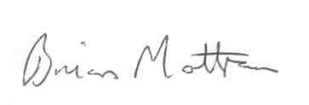

**Brian Mottram**Manager – Recreational Initiatives  
Victorian Fisheries Authority

18 September 2018

Independent Audit Report from Auditor-General

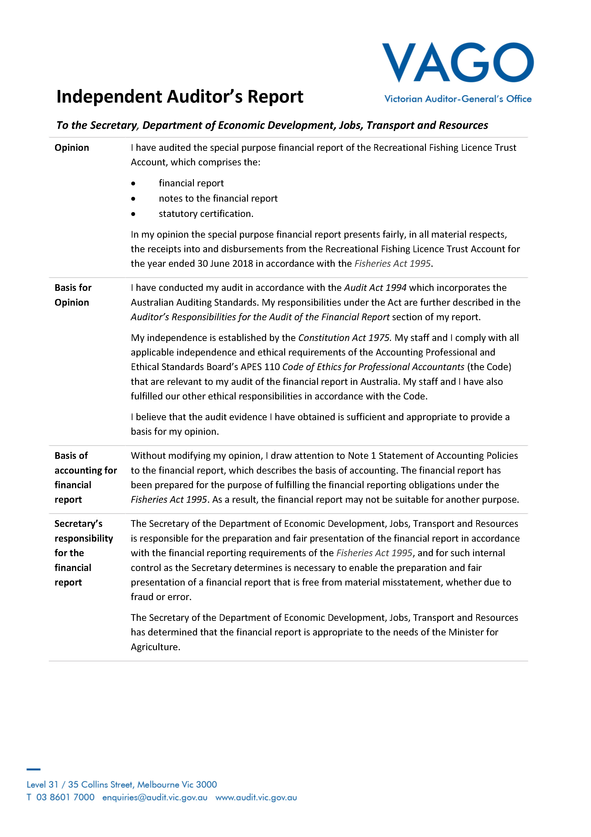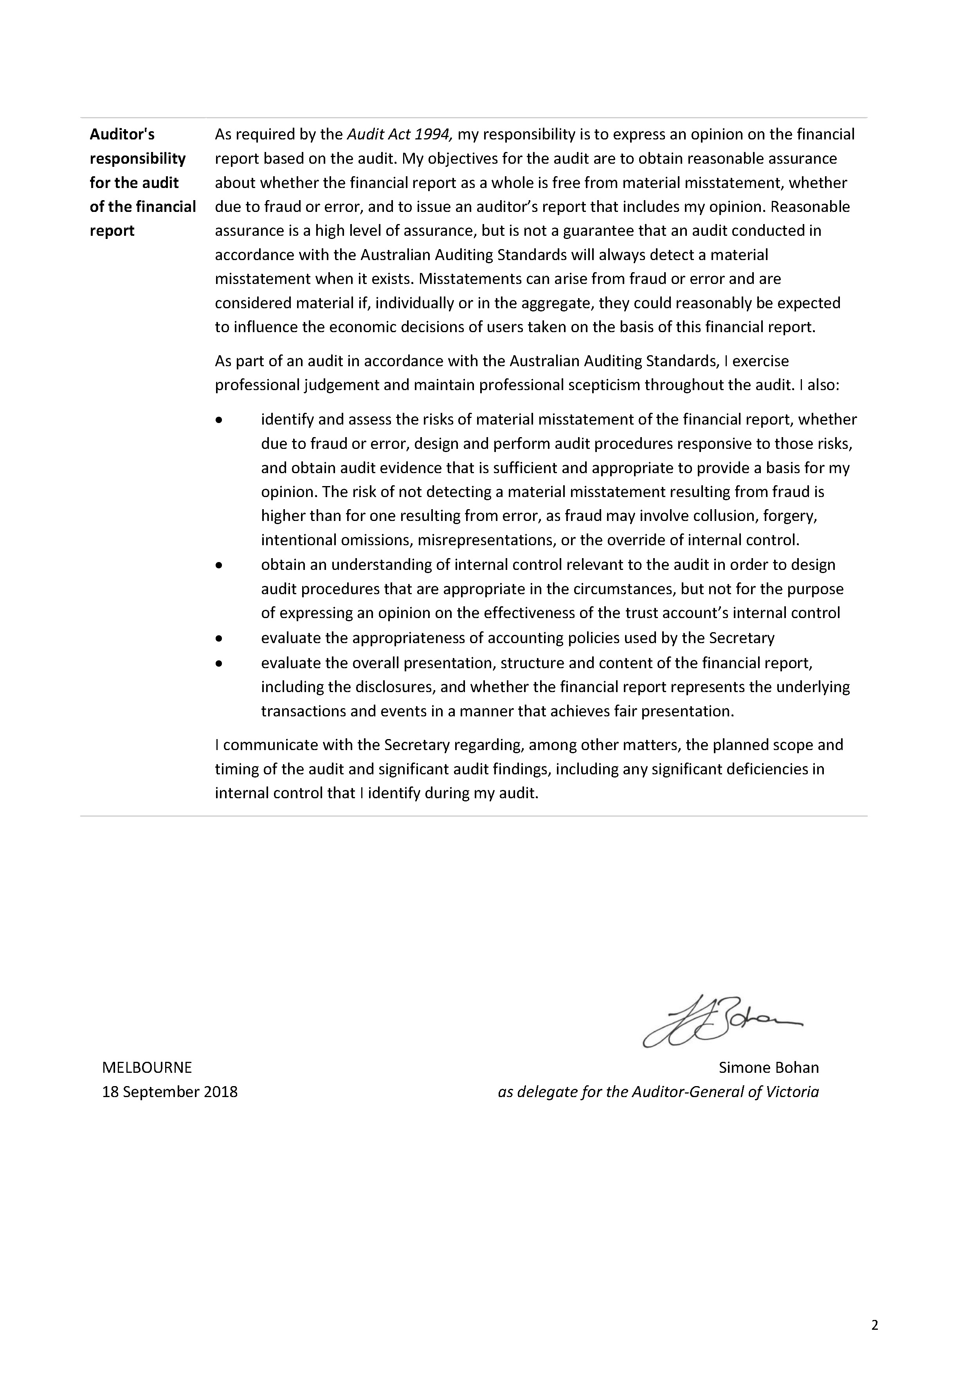

This page is intentionally blankThis page is intentionally blank

Customer Service Centre **136 186**

vfa.vic.gov.au