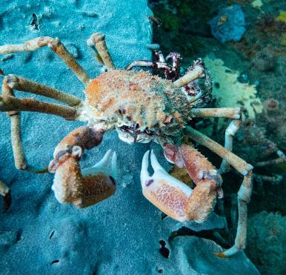
Defining movement characteristics of Victoria’s Giant spider crab

Victorian Fisheries Authority Science
Report Series No. 17
Defining movement characteristics of Victoria’s Giant spider crab

Green, C., Klemke, J., Jalali, A.

April 2021
Victorian Fisheries Authority
© The State of Victoria, Victorian Fisheries Authority, April 2021
This work is licenced under a Creative Commons Attribution 3.0 Australia licence. You are free to re-use the work under that licence, on the condition that you credit the State of Victoria as author. The licence does not apply to any images, photographs or branding, including the Victorian Coat of Arms, the Victorian Government logo and the Victorian Fisheries Authority logo.
To view a copy of this licence, visit http://creativecommons.org/licences/by/3.0/au/deed.en
Printed by Victorian Fisheries Authority, Melbourne, Victoria.
Preferred way to cite this publication
Green, C., Klemke, J., Jalali, A. (2021) Defining movement characteristics of Victoria’s Giant spider crab. Science Report Series No.17
ISBN 978-0-6450503-6-3 (Print)
ISBN 978-0-6450503-7-0 (Online)
Contact Details:
Victorian Fisheries Authority
1 Spring Street Melbourne VIC 3001

Accessibility
If you would like to receive this publication in an alternative format, please telephone the Customer Service Centre on 136 186, email customer.service@ecodev.vic.gov.au, or via the National Relay Service on 133 677, www.relayservice.com.au.
This document is also available on the internet at www.vfa.vic.gov.au
Disclaimer
This publication may be of assistance to you but the State of Victoria and its employees do not guarantee that the publication is without flaw of any kind or is wholly appropriate for your particular purposes and therefore disclaims all liability for any error, loss or other consequence which may arise from you relying on any information in this publication.

Contents
List of Tables i
List of Figures i
Summary 1
Introduction 2
Methods 3
Results 5
Discussion 9
Acknowledgements 10
References 10
Appendix 1 11

List of Tables
Table 1. Summary of giant spider crabs tagged on 30 July 2020. Satellite tag details include the number mrPAT release dates that were programmed. 6
Table 2. Deployment location, moved location, distance covered and speed of Giant spider crabs from southern Port Phillip Bay. * denotes potential error with location moved see discussion for description. 7
List of Figures
Figure 1. A dorsal view illustration of a Giant Spider Crab (Left; Museum Victoria); and the distribution of Giant spider crab Leptomithrax gaimardii in Australia (Right; Atlas of Living Australia). 2
Figure 2. Giant spider crab aggregation in southern Port Phillip Bay (Image credit: Brett Illingworth). 2
Figure 3. Monofilament harness prepared to be fitted on to a Giant spider crab (left); Giant spider crab fitted with the harness and mrPAT satellite tag (right). 4
Figure 4. General location where 15 Giant spider crabs were collected, fitted with satellite tags and released on 30 July 2020 (Green location mark). Insert illustrates location of the tagging site relative to Port Phillip Bay, Victoria, Australia. 5
Figure 5. Deployment location (yellow circle) and approximate position giant spider crab location (grey circles) in southern Port Phillip Bay. Size of the grey circle reflects the relative duration each crab was at liberty; numbers accompanying each location represents days at liberty. 6
Figure 6. Minimum and maximum water temperature data collected from satellite tags. Temperature data is only provided where temperature was obtained. Note that maximum temperature displayed for 29th / 30th July 2020 represents ambient air temperature. 7
Figure 7 (Continued). Minimum and maximum water temperature data collected from satellite tags. Temperature data is only provided where temperature was obtained. Note that maximum temperature displayed for 29th / 30th July 2020 represents ambient air temperature. 8

Summary
In Port Phillip Bay during the cooler winter months, Giant spider crabs (Leptomithrax gaimardii) aggregate in large numbers thought to be associated with moulting and reproduction. Aggregations occur at multiple locations in the bay, including a regular aggregation close to Rye or Blairgowrie pier. This is the only well-known crab aggregation that is regularly accessible to both pier-based recreational divers, fishers and public. There is high public interest in this species from stakeholder groups, highlighting the importance of careful and informed future management of the fishery. The Victorian Fisheries Authority (VFA) is responsible for the management of fishing for Giant spider crab and providing for diverse fishing opportunities for future generations to enjoy. The VFA adopts a balanced management approach to the Giant spider crab fishery, incorporating science and providing for diverse community values. The daily catch and possession limit for spider crabs, including giant spider crabs, was recently halved from 30 to 15 to better balance spider crab values and more equitably share spider crabs between fishers and other stakeholders. The Victorian Fisheries Authority believes that the Giant spider crab stock is essentially at virgin biomass levels given the low recreational catch and the spatially and temporally discrete fishing location/periods.
Determining movement characteristics and stock structure of a fishery is important as it defines a species distribution, individual stock boundaries, connectivity from one region to another, and is vital for fisheries management purposes. Gaining a greater understanding of stock structure and connectivity of a species allows fisheries managers to objectively determine if a species should be managed as a single, or multiple entities. For example: Giant spider crabs have a wide distribution across south east Australian marine waters, being common in shallow waters but found to more than 800m depth. If a stock of Giant spider crabs within Port Philip Bay solely functions as a separate entity compared to crabs caught at other locations within their natural distribution, should they be managed separately?
In an Australian first during late July 2020, 15 Giant spider crabs collected near Blairgowrie in southern Port Phillip Bay, Victoria, Australia, were fitted with satellite tracking devices and released in their natural environment to gain a greater understanding of their movement characteristics post-aggregation. Data supported the hypothesis that crabs disperse post-aggregation where they are likely to remain independent before aggregating again. Location data was successfully obtained from 12 crabs. Independent of the time at liberty, all 12 crabs were found in <15 metres of water. No animals were found to have moved to deeper parts of Port Phillip Bay during their maximum time at liberty (77 days) which was previously thought to have occurred. Although most animals were found within 7 km of their deployment location, two Giant spider crabs were observed to travel much further distances. One crab travelled approximately 12 km in 77 days where it was found to reside off Swan Island; whereas, another crab travelled approximately 42 km in 55 days where it was located outside Port Phillip Bay near Cape Shank. While there appears to be a misunderstanding by some stakeholders that giant spider crab only aggregate in southern Port Phillip Bay off Rye and Blairgowrie; this project validates that crabs have the ability to move in other regions of Port Phillip and not restricted in moving within Port Phillip Bay’s boundaries. Aggregations have been observed off Queenscliff, Swan Bay and St. Leonards.
Such movement activity supports the hypothesis that giant spider crabs have the capacity to move large distances, are capable of stock replenishment via immigration and emigration and not solely restricted to southern Port Phillip Bay. Giant spider crabs are found along the coast of Victoria and beyond, as such connectivity of crab stocks within PPB with crab stocks offshore cannot be dismissed.

Introduction
The giant spider crab Leptomithrax gaimardii (H. Milne Edwards, 1834) is Victoria’s largest spider crab and can reach 16 cm across their carapace or shell, and 70 cm across their legs (Taylor, 2011). They can be identified by their orange colour and very long legs in comparison to the size of the carapace (Edgar, 2000); and can have seaweed, sponges or sea squirts attached to their exoskeleton. Distributed predominantly along the south eastern coast of Australia (Atlas of Living Australia) they inhabit depths of up to 800 m although seasonally abundant in shallow inshore embayment’s and estuaries during winter (Gardner 1999; Turner 2001; https://collections.museumvictoria.com.au/species/14370). Giant spider crabs are scavengers, eating a range of different types of food on or near the seafloor and have been observed inflicting non-lethal impacts on the northern Pacific seastar (Asteria amurensis) (Ling et al 2013). Research of the abundance of fish and invertebrates conducted in Port Phillip Bay from 1990 to 2002 indicated the presence of giant spider crab between 7 and 17 metres (Parry et. al. 2003).

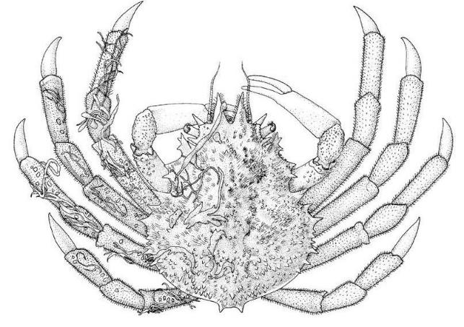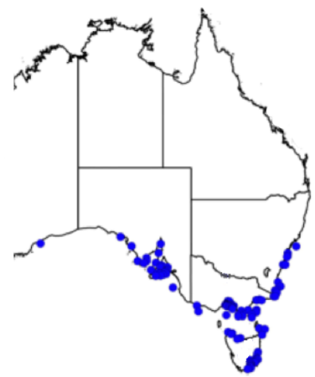
Figure 1. A dorsal view illustration of a Giant Spider Crab (Left; Museum Victoria); and the distribution of Giant spider crab Leptomithrax gaimardii in Australia (Right; Atlas of Living Australia).
During the cooler months from late May to July, Giant spider crabs are thought to move from deeper waters of Victoria’s Port Phillip Bay and coastal waters into shallow water <5m deep as a part of an annual migration/aggregation cycle. Such aggregations (Figure 2) have been noted to occur in waters of southern Port Phillip Bay (e.g. Rye, Blairgowrie, St Leonards, Queenscliff) particularly around the full moon, and in protective waters of eastern Victoria’s Gippsland Lakes system. However, there are also anecdotal reports by divers of giant spider crab aggregations at a range of other locations around Port Phillip Bay and other Victorian coastal waters. Aggregations are not only restricted to Victoria but also occur in adjoining states of South Australia and Tasmania (Gardener, 1999). Aggregations are often visible from the water’s surface as their aggregative form is distinguishable compared to other sand/reef or algae habitats.
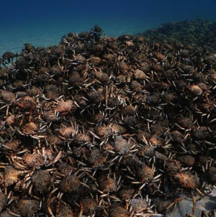
Figure 2. Giant spider crab aggregation in southern Port Phillip Bay (Image credit: Brett Illingworth).

Spider crabs are a highly prized seafood and commercially harvested around the world. Commercial fishing for the giant spider crabs in Port Phillip Bay is restricted due to recent changes to Port Phillip Bay Fishery Access Licences and the removal of scallop dredging more than two decades ago. In April 2022, all commercial netting will cease in Port Phillip Bay. The recreational fishery is managed by the Victorian Fisheries Authority using a catch limit of 15 crabs and compliance with regulations is generally high. Giant spider crabs are taken as a bycatch in other State and Commonwealth fisheries in South East Australia. The Victorian Fisheries Authority believes that the giant spider crab stock is essentially at virgin biomass levels given the low recreational catch and the spatially and temporally discrete fishing locations/periods.
Determining movement characteristics and stock structure of a species is important as it defines distribution boundaries, connectivity from one region to another and is required for fisheries management purposes. The stock structure for Giant spider crab has yet to be defined in south eastern Australia. However, they have been reported to be found off the coast of South Australia (Michael Steer; South Australian Research and Development Corporation), D'Entrecasteaux Tasmania (Sean Tracey; Institute for Marine and Antarctic Studies) and off the southern coast of New South Wales (John Stewart; NSW Fisheries) (Figure 1). Broad distribution of Giant spider crabs along coastal regions of south eastern Australia infers a level of connectivity possibility attributed to larval dispersion or movement along the ocean floor. Movement characteristics of Giant spider crabs has yet to be researched and is an important factor when considering population connectivity. Such information provides an insight of the spatial connectivity of crabs within and possibly outside Port Philip Bay where aggregations occur. As such, understanding movement characteristics will be focused on Giant spider crabs found in southern Port Phillip Bay post-aggregation and will be used to address a knowledge gap of this species.
This study aims to
- Use satellite tags to explore movement characteristics of Giant spider crabs tagged in southern Port Phillip Bay.
This research will also compliment a future genetic population connectivity study. During 2021, the VFA is collaborating with Deakin University to determine stock structure of Giant spider crabs in south eastern Australia including analysing the connectivity of Giant spider crabs within Port Phillip Bay compared with those found along Victoria’s coastline adjacent to Bass Strait.

Methods
Tagging techniques used on crustaceans are well established, for example wired label tags have been used to study movement and growth characteristics of blue swimmer crabs in Western Australia (WA research angler program No 29); and acoustic telemetry has been used to track snow crab Chionoecetes opilio movements off Nova Scotia, Canada (Cote et.al. , 2019). Only one study has been found using satellite technology to track movement of crabs. Davidson and Hussey (2019) successfully tagged and monitored movement patterns of the porcupine crab (Neolithodes grimaldii) in Northern Davis Strait, Eastern Canadian Arctic.
Annual aggregations of Giant spider crab occur in various locations in Port Phillip Bay and beyond. However, a well-known aggregation has been regularly occurring in recent years near Blairgowrie and Rye piers (Victoria) that is visible and accessible to public off piers and targeted by recreational fishers. As such, movement characteristics were studied within these locations.
On 30th July 2020 (post crab aggregation), 15 Giant spider crabs were collected by divers, fitted with Mark Report Pop-up Archival Tags (mrPAT; Wildlife Computers Ltd) and released at the approximate location of capture.
Research vessels positioned scientific divers at locations of southern Port Phillip Bay approximately 1 km offshore from Blairgowrie (Victoria). At approximately 10 metres depth, a giant spider crab was collected by hand by holding on to the carapace (external shell) and transferring it to a submerged 20L bucket. A lid was placed onto the bucket and brought to the research vessel. The crab was transferred to a shallower seawater filled wide bucket (similar to a ‘fish bin’ – 80x40cm) onboard the vessel. Biological information such as carapace length, width and sex were recorded from each Giant spider crab. Methods used to attach mrPAT’s to Giant spider crabs were like those described by Davidson (2019). Tags were secured using a harness method whereby a 2 mm fluorocarbon line was positioned around the crab’s carapace between the third and fourth legs and secured with 3 mm crimps (Figure 3). The satellite tag leader line, approximately 10cm in length, was secured to the crab harness and crimped. To reduce the impact of the tag buoyancy on the natural behaviour of the crab, a small lead weight (10g) was fitted to the leader line which meant the tag was only slightly positively buoyant. Each individual crab was transferred back to the 20L bucket, lid replaced, and taken to the ocean floor where it was released. During the entire tagging procedure impact such as stress to the animal was minimal.
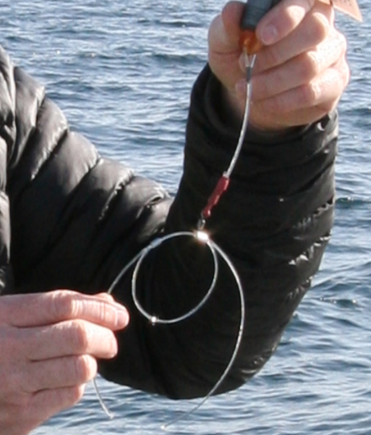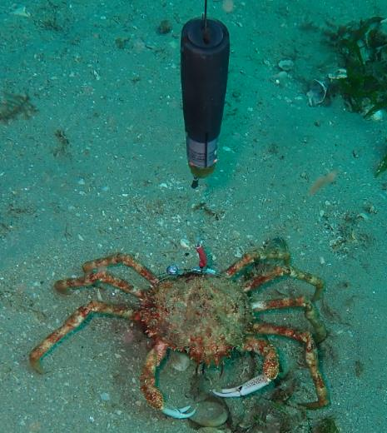
Figure 3. Monofilament harness prepared to be fitted on to a Giant spider crab (left); Giant spider crab fitted with the harness and mrPAT satellite tag (right).

One tag assigned to each Giant spider crab was programmed using TagAgent (Wildlife Computers) to be automatically released on a weekly basis (7 days) from 30 July 2020. This enabled short, medium, and long-term movement capability to assessed. As such, the most amount of time a spider crab will have a tag attached will be approximately four months. Four months at liberty will give an indication of where crabs are during the cooler and warmer water temperatures seasons. When tags are released from the harness they float to the surface where they connect to the Argos satellite network once the dry sensor has been activated. Tags were programmed to transmit continuously every 90 second for the duration of the battery life (Hussey et al., 2018).
Project success was determined by successfully tagging and gaining movement information. Any movement characteristics obtained from the tags will be considered a success (whether they have moved or not). The harness will remain on the crab until the next moult which is anecdotally thought to occur on an annual basis. Crabs moult by exiting their own exoskeleton from the rear of the animal. Consequently, the harness will remain on the old exoskeleton after moulting and is highly unlikely to impede the moulting process.
Data obtained from the mrPATs included the date and time each tag was water activated, date and time the tag was released activated for release, whether the tag was released prematurely due to mortality or shedding/moulting, location and accuracy of the location determined, the time which the tag first surfaced until the location was determined. Time at liberty was transformed to decimal days and the average speed (m per day) was calculated. Speed was estimated based on the Giant spider crab travelling a direct line).
Unlike GPS quality locations with a known accuracy (typically 10’s m at worst), Argos locations are a far more complex to derive, using complex filtering algorithms from infrequent short data messages from the tag. At best, the algorithms produce a lat/long with a stated accuracy (radius of error) of < 250 m in ideal situations (frequent surfacing, close intervals and good weather) to > 1,500 m if the uplinks are sparse and weather conditions not ideal. Such error classification is reported for each tag.
Tagging Giant spider crabs was granted animal ethics approval by the Deakin University Animal Ethics Committee (B21-2020 – Understanding movement characteristics of giant spider crabs in Port Phillip Bay).

Results
A total of 15 Giant spider crabs (7 male, 8 female) were successfully tagged on 30 July 2020, approximately 1.2 km north east from the Blairgowrie foreshore (Figure 4).. Size of crabs ranged from 90 – 124 mm carapace length. Upon release, crabs appeared active and very capable of moving along the ocean floor without being impeded by the harness or a slightly positively buoyant tag attached. Crabs successfully recorded movement data from 1 – 77 days at liberty. Seven of the 15 tagged crabs released their tags at the programmed schedule date (Table 1). Four tags where classified as ‘floaters’ indicating that tags prematurely detached from the crab due to factors such as, death, harness detachment or the shedding the tag harness during moulting. Despite premature tag release, such data is still valuable in determining movement. Data was not available for three tagged crabs possibly due to tags being released but caught in algae, under reefs or other structures.
The time between satellite tags reaching the ocean surface and the time in which the tags connected to satellites to acquire a latitude and longitude location varied from 22 minutes to 18 hours (Table 1). As such the location of the tag can only be assumed to be an approximate location of the crab given the tag can drift in association with variable oceanographic conditions (tide, wind etc).

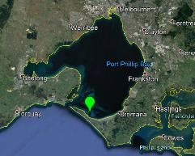
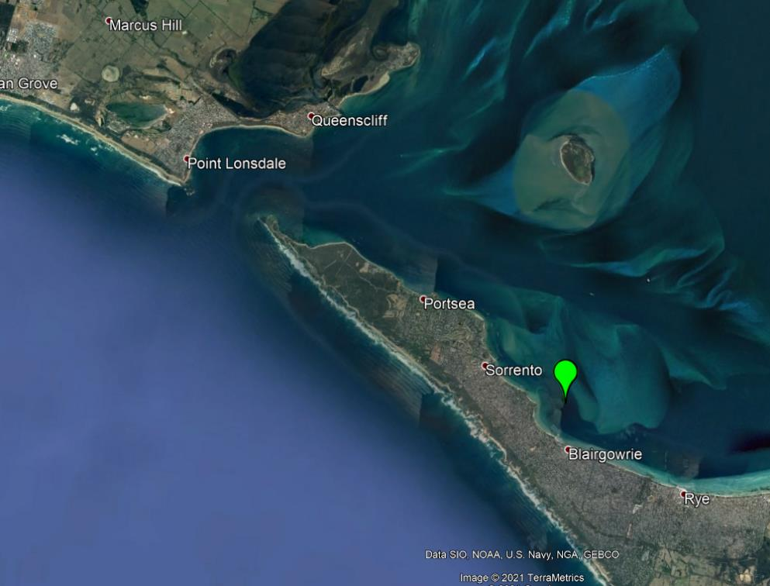
Figure 4. General location where 15 Giant spider crabs were collected, fitted with satellite tags and released on 30 July 2020 (Green location mark). Insert illustrates location of the tagging site relative to Port Phillip Bay, Victoria, Australia.

Table 1. Summary of giant spider crabs tagged on 30 July 2020. Satellite tag details include the number mrPAT release dates that were programmed.
Tag ID | Crab size (carapace length, mm) | Sex | Release programmed (days) | Expected release date | Actual release date | Deployment length (days) | Number of days tag was prematurely released | Release reason | Time Release initiated (UTC) | Time tag reached surface (UTC) | Time from pin burn to surfacing (hh:mm:ss) | First location (UTC) | Time from surfacing to first location (hh:mm:ss)
31 | 90 | Male | 7 | 6-Aug-2020 | 6-Aug-2020 | 7 | 0 | Scheduled | 2:06:00 | 10:23:00 | 8:17:00 | 10:45:59 | 0:22:59
32 | 93 | Male | 14 | 13-Aug-2020 | 13-Aug-2020 | 14 | 0 | Scheduled | 2:24:00 | 10:26:00 | 8:02:00 | 11:16:26 | 0:50:26
33 | 114 | Female | 21 | 20-Aug-2020 | 20-Aug-2020 | 21 | 0 | Scheduled | 2:33:00 | 11:32:00 | 8:59:00 | 19:34:38 | 8:02:38
34 | 104 | Male | 28 | 27-Aug-2020 | 27-Aug-2020 | 28 | 0 | Scheduled | 2:36:00 | 11:44:00 | 9:08:00 | 12:11:12 | 0:27:12
35 | 109 | Female | 35 | 3-Sep-2020 | 31-Jul-2020 | 1 | 34 | Floater | 4:00:00 | 4:00:00 | 0:00:00 | 7:01:01 | 3:01:01
36 | 103 | Female | 42 | 10-Sep-2020 | 10-Sep-2020 | 42 | 0 | Scheduled | 2:58:00 | 14:58:00 | 12:00:00 | 20:53:18 | 5:55:18
37 | 102 | Female | 49 | 17-Sep-2020 | 20-Sep-2020 | NA |  | Unknown | NA | NA | NA | NA | NA
38 | 90 | Male | 56 | 24-Sep-2020 | 24-Sep-2020 | 56 | 0 | Scheduled | 3:05:00 | 13:08:00 | 10:03:00 | 21:41:22 | 8:33:22
39 | 102 | Female | 63 | 1-Oct-2020 | 19-Oct-2020 | 18 | 45 | Scheduled | 3:10:00 | 1:35:00 | 22:25:00 | 7:26:54 | 5:51:54
40 | 100 | Female | 70 | 8-Oct-2020 | 21-Sep-2020 | 53 | 17 | Floater | 1:00:00 | 1:00:00 | 0:00:00 | 8:42:50 | 7:42:50
41 | 95 | Male | 77 | 15-Oct-2020 | 15-Oct-2020 | 77 | 0 | Scheduled | 3:29:00 | 12:30:00 | 9:01:00 | 7:19:31 | 18:49:31
42 | 105 | Female | 84 | 22-Oct-2020 | 23-Oct-2020 | NA | NA | NA | NA | NA | NA | NA | NA
43 | 95 | Male | 91 | 29-Oct-2020 | NA | NA | NA | NA | NA | NA | NA | NA | NA
44 | 101 | Female | 98 | 5-Nov-2020 | 23-Sep-2020 | 55 | 43 | Floater | 2:00:00 | 2:00:00 | 0:00:00 | 10:47:23 | 8:47:23
45 | 124 | Male | 105 | 12-Nov-2020 | 9-Sep-2020 | 41 | 64 | Floater | 3:00:00 | 3:00:00 | 0:00:00 | 6:37:15 | 3:37:15

Giant spider crabs were observed to have moved within various regions of southern Port Phillip Bay (Figure 5). There was no clear correlation between days at liberty and distance F_{(1,9)} =1.13, p=0.314 (Table 2). Most crabs were with 2 km of the foreshore; however, at least three crabs would have experienced depths of approximately 20 m whilst at liberty. Greatest distance travelled included one moving 12 km towards Queenscliff (Figure 5; Appendix 1; Tag ID No. 41) and another moving approximately 42 km reaching a coastal location off Cape Shank (Figure 5; Appendix 1, Tag ID No. 44). Water temperature experienced by giant spider crabs ranged from 10ºC to 15ºC (Figure 6). Giant spider crab tag numbers 38, 39 and 44 displayed in an increase water temperature with time.
77
77
Figure 5. Deployment location (yellow circle) and approximate position giant spider crab location (grey circles) in southern Port Phillip Bay. Size of the grey circle reflects the relative duration each crab was at liberty; numbers accompanying each location represents days at liberty.
Table 2. Deployment location, moved location, distance covered and speed of Giant spider crabs from southern Port Phillip Bay. * denotes potential error with location moved see discussion for description.

Tag ID | Crab size (carapace length, mm) | Sex | Deployment length (Decimal days) | Deployment Location  (Lat and Long) | Moved location  (Lat and Long) | Distance between deployed location and moved located (km) | Average Speed km/decimal day | Error classification | ARGOS Satellite location accuracy
31 | 90 | Male | 7.09 | -38 21.073 144 46.593 | -38.345 144.779 | 0.72 | 0.10 | 1 | 500 - 1500 m
32 | 93 | Male | 14.10 | -38 21.006 144 46.435 | -38.354 144.768 | 0.68 | 0.05 | 2 | 250 - 500 m
33 | 114 | Female | 21.11 | -38 21.001 144 46.435 | -38.368 144.857 | 7.54 | 0.36 | 3 | <250 m
34 | 104 | Male | 28.11 | -38 20.994 144 46.436 | -38.349 144.780 | 0.54 | 0.02 | B | No error value
35 | 109 | Female | 1.17 | -38 20.826 144 46.471 | -38.324 144.755 | 3.08 | 2.64* | 1 | 500 - 1500 m
36 | 103 | Female | 42.12 | -38 20.826 144 46.471 | -38.366 144.809 | 3.68 | 0.09 | 3 | <250 m
37 | 102 | Female | NA | -38 20.826 144 46.471 | NA | NA | NA | NA | NA
38 | 90 | Male | 56.13 | -38 20.826 144 46.471 | -38.360 144.777 | 1.45 | 0.03 | 3 | <250 m
39 | 102 | Female | 63.13 | -38 20.738 144 46.498 | -38.337 144.799 | 2.31 | 0.04 | 2 | 250 - 500 m
40 | 100 | Female | 53.04 | -38 20.729 144 46.501 | -38.359 144.785 | 1.74 | 0.03 | 2 | 250 - 500 m
41 | 95 | Male | 77.15 | -38 20.729 144 46.501 | -38.256 144.689 | 12.47 | 0.16 | 3 | <250 m
42 | 105 | Female | NA | -38 20.729 144 46.501 | NA | NA | NA | NA | NA
43 | 95 | Male | NA | -38 20.729 144 46.501 | NA | NA | NA | NA | NA
44 | 101 | Female | 55.08 | -38 20.761 144 46.558 | -38.481 144.883 | 42.00 | 0.76 | 3 | <250 m
45 | 124 | Male | 41.13 | -38 20.814 144 46.472 | -38.290 144.837 | 8.36 | 0.20 | 2 | 250 - 500 m

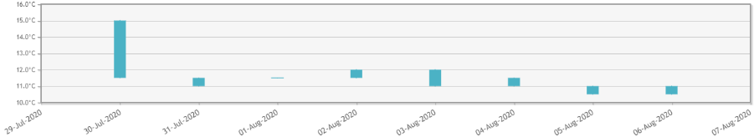
Tag 31
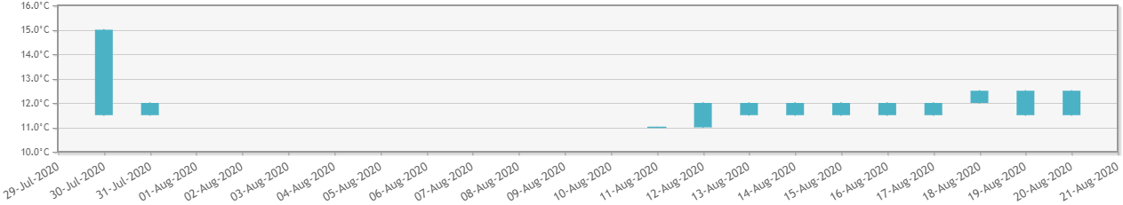
Tag 33
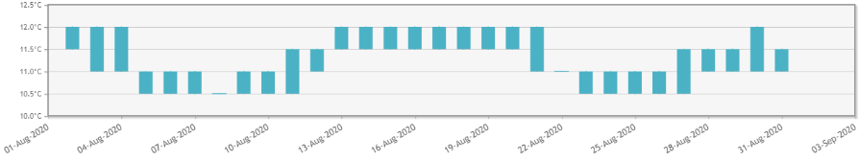
Tag 36
Figure 6. Minimum and maximum water temperature data collected from satellite tags. Temperature data is only provided where temperature was obtained. Note that maximum temperature displayed for 29th / 30th July 2020 represents ambient air temperature.

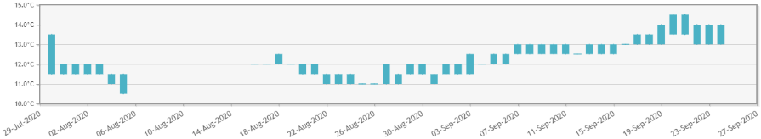
Tag 38
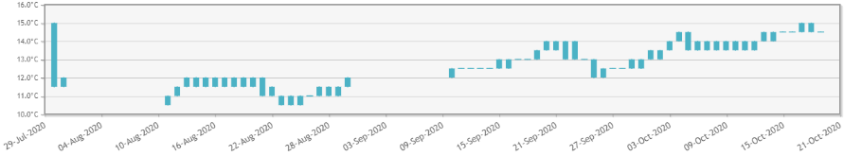
Tag 39
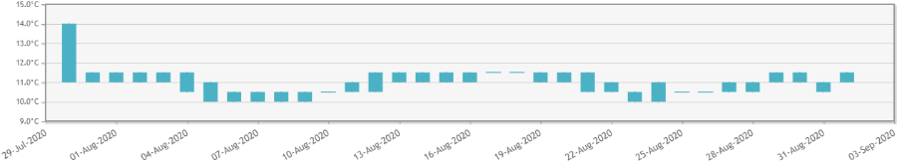
Tag 40
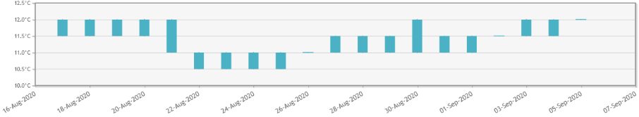
Tag 41
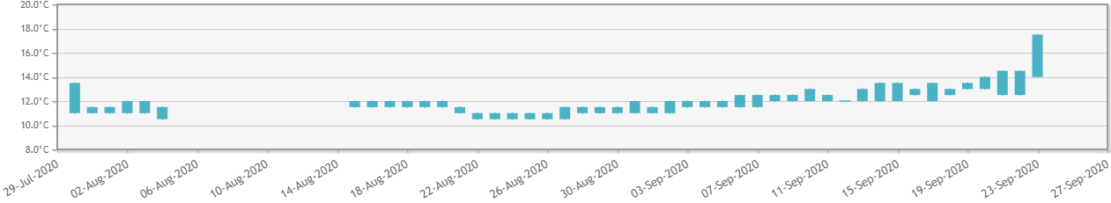
Tag 44
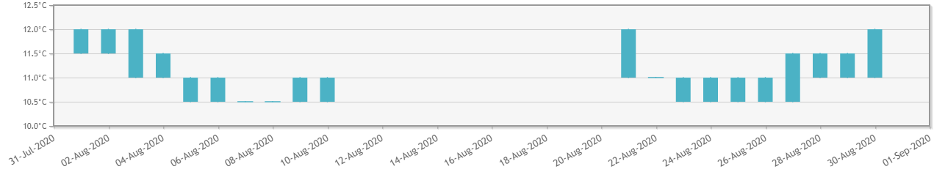
Tag 45
Figure 7 (Continued). Minimum and maximum water temperature data collected from satellite tags. Temperature data is only provided where temperature was obtained. Note that maximum temperature displayed for 29th / 30th July 2020 represents ambient air temperature.

Discussion
Gaining a greater understanding of a species population dynamics is important when considering alternative management regimes. Movement characteristics of individuals can provide an insight of the connectivity a species has within its distribution and its accessibility to important habitats for feeding, reproduction, or protection. Historically, tagging crustaceans has been used extensively throughout world to delineate temporal and spatial movement patterns (DeWolfe, 1974). Technological advances such as acoustic telemetry has greatly enhanced knowledge of movement characteristics of several crustaceans including snow crab (Chionoecetes opilio) (Cote et al., 2019; Nichol et al., 2017), American horseshoe crab (Limulus polyphemus) (Martinez et al., 2018), Atlantic rock crab (Cancer irroratus) (Comeau et al., 2012), and scampi (Metanephrops challenger) (Tuck et al., 2015). Acoustic tagging technologies are very useful when investigating movement characteristics where likely movement patterns are understood, and an acoustic receiver array adequate to capture movement can be deployed to capture observations. However, capturing spatial and temporal movement activity using satellite technology can provide a baseline of movement characteristics where an acoustic array may not be sufficient in capturing larger movement and may be less beneficial in such circumstances. As such, new information and techniques can be applied to gain further insight on movement, habitat utilization and distribution.
In an Australian first, 15 Giant spider crabs were successfully harnessed with satellite tags and movement characteristics obtained. Although three tags did not provide data for analysis, 12 animals provided valuable knowledge of their movement within and outside of Port Phillip Bay, Victoria, Australia. Data supported the hypothesis that these crabs disperse post-aggregation where they are likely to be solitary entities. Independent of the time at liberty, all crabs were found in <15 metres of water. No crabs were found to have moved to deeper parts of Port Phillip Bay which was previously thought to have occurred. The speed that giant spider crabs move (0.03 – 0.76 km/day) are within the speed range of other crabs including snow crabs (Chionoecetes opilio) (0.1–1.1 km per day, Nichol et al.,2017), and porcupine crabs (Neolithodes grimaldii) (Davidson and Hussey; 2019). However, Giant spider crab Tag ID35, recorded a speed of 2.64 km per day during the one day while it was at liberty. Given the relatively poor level of satellite accuracy (500 – 1500m) and the short period of time at liberty (~1 day), it is unlikely that its recorded location (and therefore speed) was reflective of its actual speed and was not used in further analyses.
Although most animals were found within 7km of their deployment location, two giant spider crabs were observed to travel much greater distances. Giant spider crab Tag ID No. 41 travelled 12.47 km in 77 days where it was found to reside off Swan Island whereas Giant spider crab Tag ID No. 44 travelled approximately 42 km in 55 days where it was located outside Port Phillip Bay near Cape Shank. There appears to be a misunderstanding by some stakeholders that giant spider crab only aggregate in southern Port Phillip Bay; however, this project validates that crabs have the ability to move in other regions of Port Phillip and capable of moving out of into Bass Strait. Since tagging, this Giant spider crab (Tag ID No.44) successfully moved to the mouth of Port Phillip Bay (‘The Rip’) where it would have experienced relatively high levels of water current, then travelled outside Port Phillip Heads where it moved south east along Victoria’s coastline. Accuracy of the tag/crab found at this location was within 250m. Such movement activity supports the hypothesis that giant spider crabs have the capacity to move large distances and not solely restricted to southern Port Phillip Bay. Giant spider crabs are found along the coast of Victoria and beyond, as such connectivity of crab populations within PPB with crabs offshore cannot be dismissed, albeit only one observation. Similarly, giant spider crab individuals and aggregations have been observed in other regions of Port Phillip Bay including St. Leonards and Queenscliff.
The accuracy of the tags position is reliant on two main factors, the Argos Satellite Location accuracy and the time the satellite spent on the surface while attempting to find a satellite to obtain a position. For most tags (five of the 15) accuracy was within 250 m while eight tags were classified as being accurate within 500m. The time it took for a tag to connect to satellites after surfacing ranged from 23 minutes to 18 hours. A number of factors influence the length of time it takes to connect to a satellite and acquire a position including the number of satellites within the connective orbit and sea surface conditions. For example, during rough oceanographic conditions tags may become swamped by waves causing connectivity issues. It is expected that the greater period of time which a tag is floating will reflect a greater distance between the location of the crab and the observed location of the floating tag. Incorporating drift speed and direction was not incorporated into this study as it was thought to be to dynamic to accurately describe.
Port Phillip Bay covers 1930 km² and has a diverse array of habitats and oceanographic systems. Tagged Giant spider crabs were subjected to various water temperatures (mostly within Port Phillip Bay). Temperatures recorded were similar to those expected to be found in adjacent waters such as Western Port Bay and even further east of the state (Corner Inlet and Gippsland Lakes system). As such oceanographic conditions with favourable habitat and food availability would likely support Giant spider crabs in Western Port Bay and other regions along Victoria and Bass Strait.
Such movement activity supports the hypothesis that giant spider crabs have the capacity to move large distances, are capable of stock replenishment via immigration and emigration and not solely restricted to southern Port Phillip Bay. Giant spider crabs are found along the coast of Victoria, as such connectivity of crab stocks within PPB with crab stocks offshore cannot be dismissed. Further research is planned to accompany movement characteristics to further delineate the stock structure in Port Phillip Bay and connectivity with giant spider crabs found in Victoria’s offshore environment and adjacent jurisdictions (South Australia, Tasmania, and New South Wales).

Acknowledgements
This project was funded by the Victorian Fisheries Authority.
Brent Womersley co-ordinated logistics for conducting research diving. Dive services were provided by John Rudge (KINA Diving). Scientific dive services were provided by Ben Cleveland and Holly Baird.
Luke English volunteered his services, vessel (RedBoats), and dive crew to help locate and photograph spider crabs during collection, tagging and releasing.
Rowan Calder (Wildlife Computers) provided invaluable information on the interpretation of tagging data.
Finally, many thanks go to community Facebook groups including Spider Crabs Melbourne and the Spider Crab Alliance, the Victorian National Parks Association, Environment Victoria, Dolphin Research Institute, Port Phillip Bay Eco Centre and key opinion leaders including PT Hirschfield, AJ Morton, Jacqui Younger, Fam Charko, Sheree Marris, Brett Illingworth and Pang Quong whose contribution in supporting the development of this research is appreciated.
Dallas D’Silva provided comments on the report.

References
Comeau, L.A., Sonier, R., Hanson, J.M., 2012. Seasonal movements of Atlantic rock crab (Cancer irroratus Say) transplanted into a mussel aquaculture site. Aquacult. Res. 43 (4), 509–517. https://doi.org/10.1111/j.1365-2109.2011.02856.x.
Cote, D., Nicolas, J.-M., Whoriskey, F., Cook, A.M., Broome, J., Regular, P.M., Baker, D., 2019. Characterizing snow crab (Chionoecetes opilio) movements in the Sydney bight (Nova Scotia, Canada): a collaborative approach using multiscale acoustic telemetry. Can. J. Fish. Aquat. Sci. 76 (2), 334–346. https://doi.org/10.1139/cjfas- 2017-0472.
DeWolfe, A., 1974. The Lobster Fishery of the Maritime Provinces: Economic Effects of Regulations (No. Bulletin 187). Department of the Environment, Fisheries, and Marine Services.
Edgar, G.J. (2000) Australian Marine Life – The Plants and Animals of Temperate Waters. Reed New Holland
Gardner, C. (1999) Spider crab aggregation on Tasmania’s northwest coast. Invertebrata No.14.
Green MA, Stuart-Smith RD, Valentine JP, Einoder LD, Barrett NS, Cooper AT and Stalker MD (2012) Spotted Handfish monitoring and recovery actions – 2011–2012. Report for Derwent Estuary Program and Caring For Our Country. CSIRO Marine and Atmospheric Research and Institute of Marine and Antarctic Studies.
Hussey, N., Orr, J., Fisk, A., Hedges, K., Ferguson, S., Barkley, A., 2018. Mark report satellite tags (mrPATs) to detail large-scale horizontal movements of deep water species: first results for the Greenland shark (Somniosus microcephalus). Deep Sea Res. Oceanogr. Res. Pap. 134, 32–40. https://doi.org/10.1016/j.dsr.2018.03.002.
Ling S.D., Johnson, C.R. (2013) Native spider crab causes high incidence of sub-lethal injury to the introduced seastar Asterias amurensis
Martinez, S.E.D., Halliday, W.D., Malkoski, V., Juanes, F., Danylchuk, A.J., 2018. Assessing the movements of American horseshoe crabs (Limulus polyphemus) around a marine protected area in Cape Cod, MA, USA. Estuar. Coast Shelf Sci. 210, 79–86. https://doi.org/10.1016/j.ecss.2018.06.016.
Nichol, D., Somerton, D., Kotwicki, S., 2017. Movement rates of mophometrically mature snow crabs, Chionoecetes opilio (O. Fabricius, 1788), in the eastern Bering Sea, Alaska (Brachyura: oregoniidae). J. Crustac Biol. 37 (4), 380–388.
Parry, G., Gason, A., Cohen, B. F., Asplin, M. D., Cornell, H. S., Heislers, S., McArthur, M.A., Paradise, T. A., and Werner, G.F. (2002). Trends in fish communities in Port Phillip Bay, 1990-2002. Marine and Freshwater Resources Institute Report No. 55. Marine and Freshwater Resources Institute: Queenscliff.
Stevens B.G. (2003) Timing of aggregation and larval release by Tanner crabs, Chionoecetes bairdi, in relation to tidal current patterns. Volume 65, Issues 1–3, December 2003, Pages 201-216. https://doi.org/10.1016/j.fishres.2003.09.015
Taylor, J. & Poore, G.C.B., 2011, Giant Spider Crab, Leptomithrax gaimardii, in Taxonomic Toolkit for marine life of Port Phillip Bay, Museum Victoria
Tuck, I.D., Parsons, D.M., Hartill, B.W., Chiswell, S.M., 2015. Scampi (Metanephrops challengeri) emergence patterns and catchability. ICES (Int. Counc. Explor. Sea) J. Mar. Sci.: J. Conseil 72 (Suppl. 1), i199–i210. https://doi.org/10.1093/icesjms/ fsu244.
Turner, E. (2001) Recent spider crab aggregations. Invertebrata 20.

Appendix 1

Appendix 1. Movement location and distance travelled of Giant spider crabs in Port Phillip Bay.

Atlas of Living Australia https://bie.ala.org.au/species/urn:lsid:biodiversity.org.au:afd.taxon:50b6d98f-cf91-4af3-b95a-565d8acd6b94#

