How riparian vegetation supports aquatic insects resulting in better
trout fishing

Diane Crowther and Phil Papas
Arthur Rylah Institute, DELWP

Aim:
To understand how riparian vegetation supports aquatic insect communities which results in better trout fishing.

Background:
Fly fishing is an historic and popular form of recreational fishing based on imitating the variety of insects, mainly aquatic, that are a food source for trout. Trout anglers have expressed concern over the apparent long term decline of aquatic insect communities in the upper Goulburn catchment area. One reason for the observed decline in aquatic insects may be due to changes over time in the type of riparian vegetation along river reaches.
As an important food source for trout, aquatic insect health is integral to support a healthy recreational trout fishery and any declines in health are of concern.
The focus of this project is to look for links between aquatic insect communities and riparian vegetation. The project findings will highlight connections between aquatic insects and plants and could be used to inform Catchment Management Authority (CMA) riparian planting programs. Healthy riparian vegetation will promote a healthy aquatic insect community and in turn will support a better trout fishery.

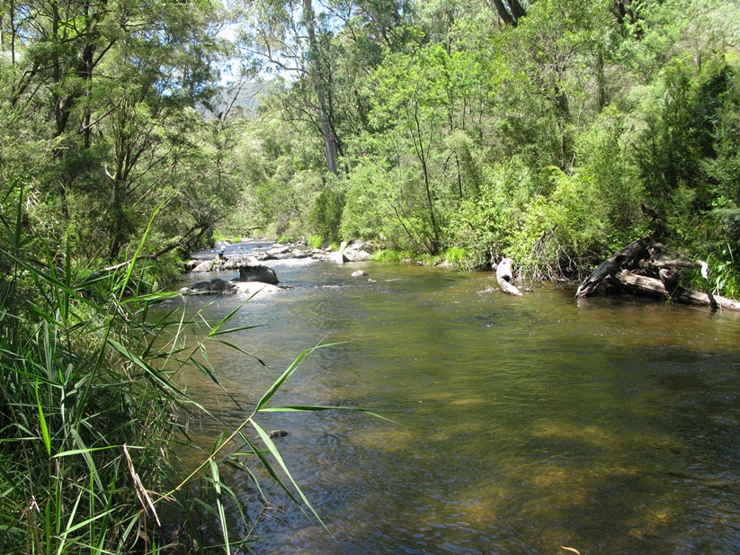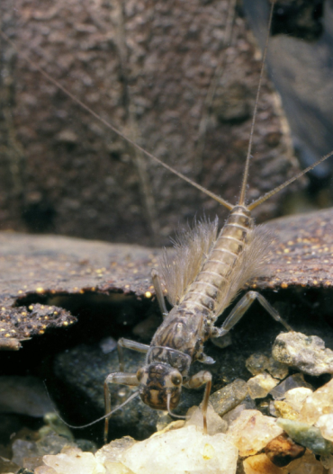

Riparian revegetation – how does it support the aquatic insect community?
(mayfly photo used with permission from J. Gooderham and E. Tsyrlin – The Waterbug Book 2002).

What we did:
- Focused the study on aquatic insect groups that are commonly reported in the diet of trout and occur in the upper Goulburn, Acheron and Rubicon rivers.
- Reviewed scientific literature and consulted aquatic insect experts and local anglers to identify associations of specific aquatic insects with riparian plants.
- This initial review revealed no specific associations and the study was re-focussed to identify and describe the role of riparian vegetation in supporting aquatic insect communities. This was done by a further literature review and consultation with aquatic insect experts.
- Visited revegetation/rehabilitation sites (Scorah and Tumbling Waters on the Rubicon River and Thornton’s Beach, Goulburn River) to gain an insight into the type of riparian plantings recently undertaken by the GBCMA.

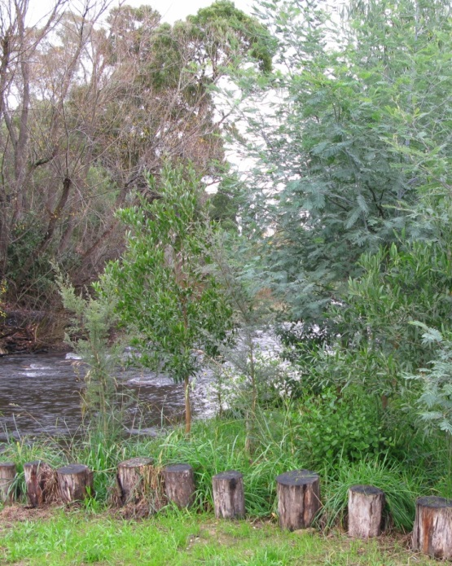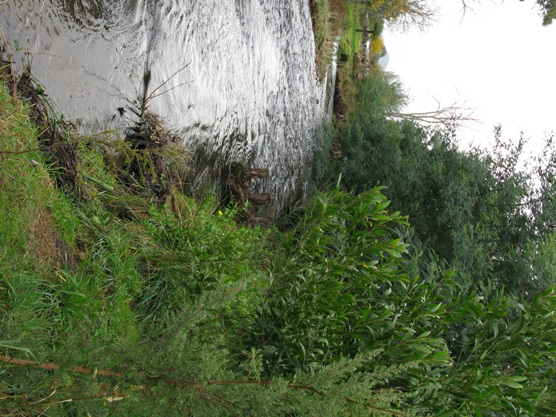

An example of endemic riparian revegetation and instream rehabilitation (instream alignment posts
to trap sediment and stabilise banks) on the Rubicon River at Tumbling Waters.

Key findings and implications to date:
- Associations between specific aquatic insects and riparian plants were not found in the initial review. This is likely because most adult aquatic insects are not dependent on bankside vegetation for many of their requirements such as feeding and egg laying. This is in contrast to many terrestrial insects such as butterflies and the willow sawfly grub which use particular riparian plants for their lifecycle requirements.
- Additionally, associations between instream detritus from specific riparian plants and the larval stages of aquatic insects were not found in the review. This represents a knowledge gap.

- The review therefore re-focused on identifying how riparian vegetation in general supports aquatic insect communities. These included:
  - inputs of leaves and woody debris into the waterway which is used by many larval insects for food and shelter
  - shading of the waterway to minimise the risk of temperature extremes which can be detrimental to aquatic insects
  - bank stabilization to minimise the risk of sediment inputs which can harm aquatic insect eggs and larvae
  - a food source for the minority of aquatic insect adults that feed on terrestrial vegetation.
- The review also identified that riparian vegetation composition, structure and density can influence the aquatic insect community. There is a change in these relationships over time, as the riparian vegetation matures. New plantings will get better with age and support more diverse aquatic insect communities.
- The origin of the riparian vegetation will also influence aquatic insect communities. For example:
  - Exotic riparian vegetation provides a higher initial instream food source but can decompose quickly and/or can be seasonally limited e.g. willows shed leaves in autumn. In contrast, native riparian vegetation provides year-round stream inputs which are generally slow to breakdown. This provides a longer-lasting food source for aquatic insects, in terms of both the biofilm which grows on it and the leaves themselves.
  - Native vegetation provides better case material for caddisflies as it is available all year round, is durable and less likely to be consumed by other animals. Caddisflies are a major component of trout diet.

Next steps:
- Communicate project knowledge, in the form of a fact sheet, to fishers and the broader community.
- Consider linking aquatic insects in existing community demonstration reaches to highlight the requirements and importance of these animals.
- Further investigations could be done to identify:
  - associations between instream detritus from specific riparian plants and the larval stages of aquatic insects
  - other habitat enhancements that can increase the abundance of aquatic insects, for example addition of instream woody habitat and boulder seeding
  - the role of riparian zones in supporting terrestrial insects which are an important food source for trout.

