The Golden Tag Competition
  - Victorian Fisheries Authority
9 August 2021

A Marsden Jacob Report

Prepared for Victorian Fisheries Authority
Marsden Jacob Associates
ABN 66 663 324 657
ACN 072 233 204
e. economists@marsdenjacob.com.au
t. 03 8808 7400
Office locations
Melbourne
Perth
Sydney
Newcastle
Brisbane

Authors
Jeremy Cheesman | jcheesman@marsdenjacob.com.au 0414 765 739
Lachlan Dawson | ldawson@marsdenjacob.com.au
LinkedIn - Marsden Jacob Associates
www.marsdenjacob.com.au

Acknowledgements
Marsden Jacob consulted widely for this report. We would like to acknowledge and thank all the people we engaged with during this project. The report is better for your input. All final recommendations and views in this report are attributable to Marsden Jacob unless otherwise stated.

Statement of Confidentiality
The contents of this report and any attachments are confidential and are intended solely for the addressee. The information may also be legally privileged. If you have received this report in error, any use, reproduction or dissemination is strictly prohibited. If you are not the intended recipient, please immediately notify the sender by reply e-mail or phone and delete this report and its attachments, if any.

Disclaimer
This document has been prepared in accordance with the scope of services described in the contract or agreement between Marsden Jacob Associates Pty Ltd ACN 072 233 204 (Marsden Jacob) and the Client. This document is supplied in good faith and reflects the knowledge, expertise and experience of the advisors involved. The document and findings are subject to assumptions and limitations referred to within the document. Any findings, conclusions or recommendations only apply to the aforementioned circumstances and no greater reliance should be assumed or drawn by the Client. Marsden Jacob accepts no responsibility whatsoever for any loss occasioned by any person acting or refraining from action because of reliance on the document. The document has been prepared solely for use by the Client and Marsden Jacob Associates accepts no responsibility for its use by other parties.

Summary
This report estimates the economic impacts of the Victorian Fisheries Authority Golden Tag Competition. Our work estimates an economic impact of $1.35 million of induced recreational fishing expenditure, and $316,000 prize stimulus attributable to the program across 2020-2021.
Our work shows the Golden Tag Competition generates significant economic impacts and benefits across Victoria. Impacts of the Golden Tag program to date are summarised below.
Summary of the Golden Tag Competition investment impact to date
56,000 fishing days attributable to GT
Changed fishing behaviour of 8,800 fishers
$380,000 VFA Golden Tag (GT) investment, including $316,000 prize money.

15 FTE in regions attributable to GT
$973,000 Gross Regional Product (GRP) attributable in regions to GT
$1.67 million fishing expenditure and prize stimulus attributable in regions to GT

Victorian Fisheries Authority (VFA) engaged Marsden Jacob to complete an assessment of the potential economic contributions of Golden Tag Competition investments. This work will support VFA with Monitoring, Evaluating and Reporting (MER) activities, and planning of future works.
To deliver this assessment we have (1) developed a high-level economic impact evaluation framework that builds on earlier assessments and makes best use of available VFA data (2) compiled information and undertaken an analysis of how behaviour of Victorian fishers has changed and expenditure has increased as a result of VFA’s $380,000 of investment in the Golden Tag Competition between 2020 – 2021 (3) used the outcomes of the analysis to estimate the economic contribution of expenditure attributed to the Golden Tag Competition as a result of fisher behaviour change and prize winning stimulus (4) discussed opportunities for future investment by VFA in similar competitions from a larger spread of Victoria’s regional communities.

Golden Tag Competition investments have generated significant economic contribution in Victorian regions to date.
Economic contribution measures how economic activity contributes to the economy through market transactions and output. In this evaluation we have estimated economic contribution of two aspects of the Golden Tag Competition:
(1) the economic contribution impact from behavioural change of anglers across Victoria, plus
(2) the economic contribution impact from consumption related to GT prize winnings.
Components of economic contribution accounting we estimate in this evaluation include:
- Expenditure is the additional economic activity that has been attributed to the Golden Tag Competition. For example, as a direct result of the Golden Tag Competition, it is estimated that around 8,800 additional fishers spent $1.35 million across Victoria on recreational fishing activities, plus an extra $316,000 of consumption has or will be spent from expenditure of prize winnings.
- Gross value-added (GVA) is a subset of expenditure. GVA is the total of all revenues, from final sales and (net) subsidies, which are incomes into local businesses because of the expenditure. GVA – Initial represents the economic returns on local capital and labour resources that stem directly from the expenditure. It measures the true contribution of the economic activity to the economy because it backs out leakage out of the economy. The major sources of GVA leakage are spending and importing goods from outside the local region.
- Economic activity generates salaries and thus employment. In this report we measure employment as the number of full-time equivalent jobs generated (FTE) and/or supported in the creation of local gross economic output and GVA. Employment – Initial is the FTE generated by GVA – Initial.
- Type 2A GVA (GVA – 2a) and Type 2A Employment (Employment – 2A) are also presented. GVA-2A illustrates the additional revenue for local businesses from second order sales and subsidies. Employment - 2A represents the FTE jobs generated by GVA – 2A when the flow on effect from expenditure in the economy is considered.
We estimate the additional $1.35 million of fisher expenditure across Victoria attributed to the Golden Tag Competition generated around $706,000 in initial GVA, based on modelled assumptions (Table 3). The expenditure also generates around $34,000 in GVA – 2A. This represents the economic impact ‘flow on effects’ are expected to have on the local community.
Additionally, we estimate the $316,000 of consumption expenditure related to prizes from the Golden Tag Competition generated around $161,000 in initial GVA, based on modelled assumptions (Table 2). The expenditures also generate around $72,000 in GVA – 2A.
Expenditure attributed to the Golden Tag Competition supports a significant number of jobs and employment across Victoria. Fisher expenditure of $1.35 million supports around 11.5 full time jobs directly across Victoria in 2020-21 (Table 3). When flow on effects (Employment – 2A) are included, the total full-time jobs supported by fisher expenditure is around 12 people. In addition, the stimulus expenditure of $316,000 related to Golden Tag Competition prizes supports around 2 full time equivalent positions (Table 2). Full time jobs supported by Competition prize stimulus grows to around 3 when flow on effects (Employment – 2A) are considered.
We note these economic contribution impacts are impacts to date. To the extent that fisher behaviour changes and additional prizes are won, economic impacts will change in the future.

Golden Tag Competition investments have generated significant economic contribution in Victorian regions targeted by the program.
The Golden Tag competition was targeted to deliver economic benefits to communities across Victoria impacted by the Bushfires in January 2020 and the Coronavirus lockdowns of 2020/2021. Our evaluation highlights this objective being achieved by the program. Almost half of all expenditure and economic contribution related to the Golden Tag Competition has remained in the Victorian regions targeted by the program (Table 2 and Table 3).
Table 1: Total direct economic contribution estimates attributed to the Golden Tag Competition in Victorian regions, 2020-2021
Region | 2020-2021 Expenditure | GVA initial | GVA- 2A | Employment initial | Employment 2A
Total | $1,666,000 | $867,000 | $106,000 | 13.7 | 1.3
Reward Consumption total | $316,000 | $161,000 | $72,000 | 1.9 | 0.8
Fisher behaviour Change | $1,350,000 | $706,000 | $34,000 | 11.7 | 0.6

Table 2: Direct economic contribution estimates of consumption related to reward stimulus from the Golden Tag Competition in Victorian regions, 2020-2021
Region | 2020-2021 Expenditure | GVA initial | GVA- 2A | Employment initial | Employment 2A
Reward Consumption total | $316,000 | $161,000 | $72,000 | 1.9 | 0.8
Central Victoria | $12,000 | $6,000 | $3,000 | 0.1 | 0.0
East Gippsland | $188,000 | $96,000 | $43,000 | 1.1 | 0.5
Goulbourn Valley including Eildon | $10,000 | $5,000 | $2,000 | 0.1 | 0.0
North East and Alpine | $104,000 | $53,000 | $24,000 | 0.6 | 0.3
Western Victoria Rocklands and Horsham | $2,000 | $1,000 | $0 | 0.0 | 0.0

Table 3: Direct economic contribution estimates of fisher expenditure attributed to the Golden Tag Competition in Victorian regions, 2020-2021
Region | 2020-2021 Expenditure | GVA initial | GVA- 2A | Employment initial | Employment 2A
Fisher behaviour Change Total | $1,350,000 | $706,000 | $34,000 | 11.7 | 0.6
Murray region | $259,000 | $136,000 | $7,000 | 2.3 | 0.1
Western Victoria, Rocklands and Horsham | $93,000 | $49,000 | $2,000 | 0.8 | 0.0
West Coast Blue Water | $126,000 | $66,000 | $3,000 | 1.1 | 0.1
Central Victoria | $197,000 | $103,000 | $5,000 | 1.7 | 0.1
South Central Coast | $31,000 | $16,000 | $1,000 | 0.3 | 0.0
Goulburn Valley including Eildon | $18,000 | $9,000 | $0 | 0.2 | 0.0
North-East and Alpine | $237,000 | $124,000 | $6,000 | 2.1 | 0.1
East Gippsland | $389,000 | $203,000 | $10,000 | 3.4 | 0.2

Future Opportunities
Feedback from stakeholders consulted for this work highlighted that the Golden Tag competition provides benefits above and beyond the economic contribution that is measured in this report. Economic contribution estimates illustrate that the competition pays off in an economic sense. The impact of the Golden Tag program extends beyond this primary benefit to likely include things like greater community wellbeing, and greater benefits from outdoor recreation. These aspects are important to programs like the Golden Tag Competition but are not measured in this evaluation. They could be measured in future VFA evaluations, and so contribute to future program design.
There is clear evidence that the Golden Tag Competition was widely supported. Victorian fishers and businesses surveyed in our work almost universally suggested that the program be repeated in the future and / or run more frequently.
If the Golden Tag Competition is repeated there are messages and lessons from the current program that will help design future programs. We discuss these in this report. They include:
- Increased marketing: stakeholders indicated the Golden Tag could have received wider promotion and have made suggestions around how future programs could do this.
- Varied marketing strategies: stakeholders have identified multiple marketing channels that VFA could use to promote future competitions like Golden Tag.
- Prizes: stakeholders have suggested ways that prizes could be structured to ensure prize money stays in the regions targeted, such as through tours, accommodation coupons in the region.

Contents

1. Introduction 8
1.1 Objectives 8
2. Evaluation framework 10
2.1 Measuring the economic impacts and outcomes of Golden Tag competition investments 10
3. Golden Tag Competition investment portfolio summary 13
4. Economic impact of consumption stimulated by Golden Tag Competition prizes 15
5. Economic impact of induced fisher behaviour attributed to the Golden Tag Competition 18
5.1 Survey Method 18
5.2 Economic Contribution analysis 22
6. Future opportunities 24
Appendix 1. Victorian regions 25
Appendix 2. Regional expenditure attributed to the Golden Tag Competition 26
Appendix 3. Profile of Survey Respondents 29
Appendix 4. AITI Input – Output Model 32

Tables
Table 1: Total direct economic contribution estimates attributed to the Golden Tag Competition in Victorian regions, 2020-2021 4
Table 2: Direct economic contribution estimates of consumption related to reward stimulus from the Golden Tag Competition in Victorian regions, 2020-2021 4
Table 3: Direct economic contribution estimates of fisher expenditure attributed to the Golden Tag Competition in Victorian regions, 2020-2021 5
Table 4: VFA Golden Tag competition investment summary by category (2020-21) 13
Table 5: Economic contribution estimates of consumption related to reward stimulus from the Golden Tag Competition in Victorian regions, 2020-2021 16
Table 6: Economic contribution estimates of consumption related to reward stimulus from the Golden Tag Competition across spending categories based on the ABS Household Expenditure Survey, 2020-2021. 16
Table 7: Direct economic contribution estimates of fisher expenditure attributed to the Golden Tag Competition in Victorian regions, 2020-2021 23
Table 8: Lessons for future programs 24
Table 9: Victorian region expenditure by output category 26

Figures
Figure 1 Overview of investments, outputs and outcomes of the Golden Tag Competition 10
Figure 2: Golden Tag competition tagged fish by Victorian region 14
Figure 3: Golden Tag competition prize stimulus by Victorian region 14
Figure 4: Golden Tag Competition reward expenditure summary by Victorian region 2020-2021. Bubble size shows total employment impact (Employment - initial plus Employment - 2A) of investment. 17
Figure 5: Outline of consultation of Victorian Fishers undertaken 18
Figure 6: ‘Top down’ survey respondent residential location 20
Figure 7: ‘Top Down’ survey respondents who had heard of the Golden Tag Competition 20
Figure 8: ‘Top Down’ survey respondents who participated in the Golden Tag Competition 21
Figure 9: ‘Top down’ survey respondents who changed their fishing behaviours because of the Golden Tag Competition 21
Figure 10: Attribution pathway 22
Figure 11: Expenditure attributed to induced fisher behaviour as a result of the Golden Tag Competition 22
Figure 12: Map of Victorian regions studied in this analysis 25
Figure 13: Gender of survey respondents 29
Figure 14: Age of survey respondents 30
Figure 15: Type of fisher survey respondents identified themselves as 30
Figure 16: Motivation for fishing of survey respondents 31
Figure 17: How survey respondents fish 31

- Introduction
How much value are we delivering to Victoria through investments in Golden Tag competition? What’s our return on investment?
The Victorian Fisheries Authority invested $380,000 in The Golden Tag competition over 2020-21 to deliver economic benefits to communities across Victoria. Detailed background information on The Golden Tag Competition is available on the VFA website here.
The program was initially proposed to bolster tourism in Victoria’s East Gippsland and North East regions, in response to the January 2020 bushfires. Recreational fishing is a key driver of tourism across Victoria’s East Gippsland and North East and the Golden Tag Competition was identified as an opportunity to support and reinvigorate their tourism industries.
In the first stage of the Golden Tag Competition, the VFA tagged more than 1,000 specially marked fish and released them into lakes and freshwater rivers across the bushfire affected areas. While the Golden Tag Competition’s main goal was to generate visitation to fire affected regions and support the communities financially, it also gave the communities something to be excited about and bolstered morale.
The Golden Tag Competition was put on hold in response to COVID-19 lockdowns from May 2020. In September 2020, when stay at home orders and travel restrictions were lifted, the Golden Tag Competition was expanded to also include several high-profile recreational fishing destinations across regional Victoria. These locations aligned with the Target One Million - phase 2, Recreational Fishing Tourism Plan and were chosen to support the COVID-19 recovery.
The expansion of the Golden Tag Competition planned to build on the momentum of the first phase of the program and continue to bolster regional visitation across Victoria to support communities that had been devastated by bushfires, COVID-19 lockdowns, or both. Almost 100 more fish were tagged in the expansion of the Golden Tag Competition and released across Victoria’s rivers and lakes.
  - Objectives
Victorian Fisheries Authority (VFA) engaged Marsden Jacob to complete a high-level assessment of potential economic contributions of Golden Tag Competition, and the economic benefit values that these investments might generate for Victoria’s region. This work will support VFA with future investment in initiatives to support Victorian communities through the sport of fishing. To deliver this assessment, we have:
- Developed a high-level investment evaluation framework that builds on earlier assessments and makes best use of available data. This framework is set out in the next section.
- Compiled information and undertaken an analysis of the expenditure related to the Golden Tag Competition. Results of this evaluation are summarised in Chapter 3. Detailed results by Victorian regions are provided in Appendix 2.
- Used the outcomes of the expenditure evaluation to estimate the economic contribution of expenditure related to the Golden Tag Competition at the regional level, where information is available. This work shows the economic contribution of the Competition to the Victorian regions. Results are summarised in Chapter 4 and 5. Detailed results by Victorian regions are provided in Appendix 2.
- Identified the potential opportunities of future investment VFA programs to the Victorian community. This is outlined in Chapter 6.
We note here that we are measuring the economic impacts of investment as distinct from the economic benefits or value of the investments. For example, increased fishing and physical activity by Victorians have economic benefit or value. These types of benefits would be in addition to the economic impacts we discuss in this paper.
We also note that any investment involves an opportunity cost, i.e the money committed to the Golden Tag Competition is not available to be invested elsewhere. We have not estimated the opportunity cost of these investments as part of this evaluation.

- Evaluation framework
The ultimate outcome of the Golden Tag competition is to support regional communities devastated by 2020 bushfires and Coronavirus pandemic lockdowns. These investments can also deliver economic benefits to local communities and continue to develop the experience of fishing in Victoria.
Figure 1 Overview of investments, outputs and outcomes of the Golden Tag Competition
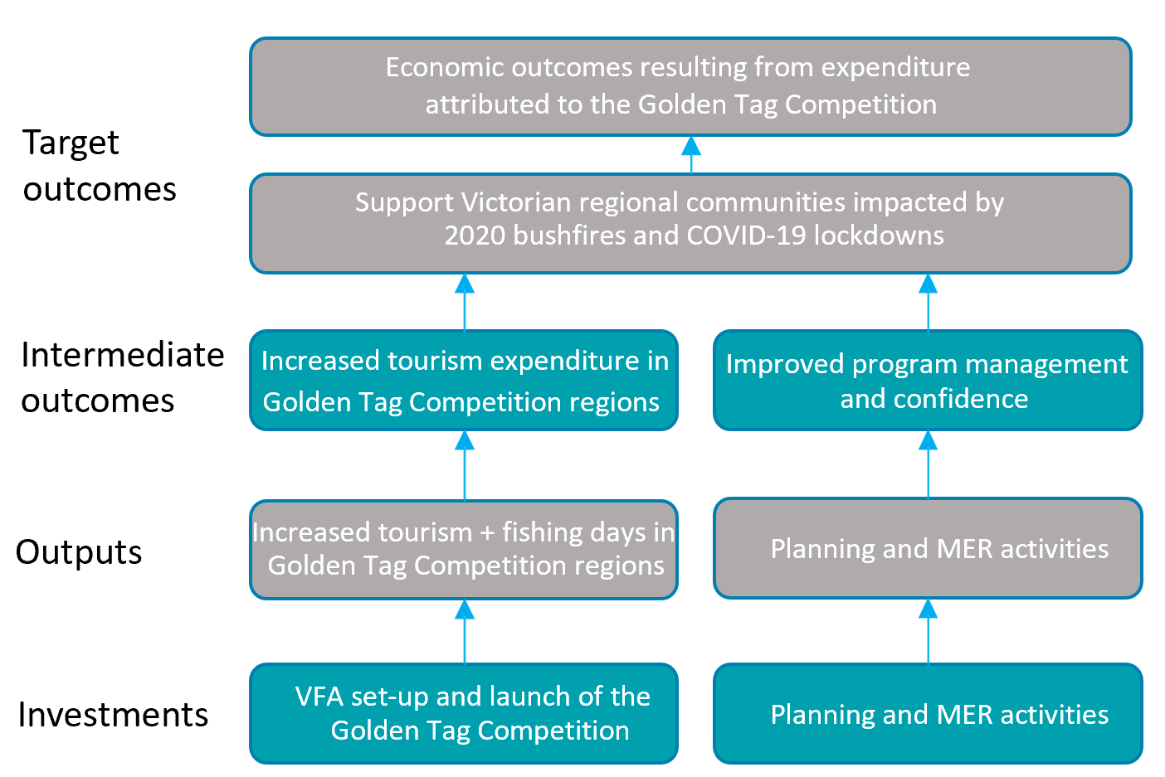
Figure 1 shows how the expenditure stimulated by the Golden Tag Competition can be traced through outputs and intermediate outcomes to target outcomes. Target outcomes are measured by economic contribution to Victorian regions attributed to the Golden Tag competition.
The timeframe for investments and outputs is in the ‘planning’ and ‘taking action’ phases. In this case these phases span the two years that the VFA has invested $380,000 in the Golden tag competition over (2020/2021).
  - Measuring the economic impacts and outcomes of Golden Tag competition investments
Economics is about how societies allocate limited resources to meet their needs and wants. It is about people making choices under conditions of scarcity and uncertainty. It is present in much of what we hear about and do in our daily lives.
Figure 1 shows that investments in the Golden Tag Competition, and the increased expenditure that can be attributed to the competition in Victoria’s regions, all result in some form of economic outcome.
For example, investment by the VFA in the Golden Tag Competition has resulted in additional fishing expenditure across Victoria. If fishers are increasing their expenditure at local fishing and tackle stores, this will result in extra in labour employment and stock purchases by the store, which creates economic impacts within local communities.
For this evaluation, we focus on direct, indirect and induced economic outcomes. We introduce each of these concepts briefly below.
    - Economic contribution
Economic contribution measures how economic activity contributes to the economy through market transactions and output. The significance of an activity is usually defined by its relative share of market transactions and output compared to other activities or sectors.
For the golden tag:
- Expenditure is the additional economic activity that has been attributed to the Golden Tag Competition. For example, because of the Golden Tag Competition it is estimated that around 8,800 additional fishers spent $1.35 million across Victoria and an extra $316,000 of consumption has or will be spent related to prize winning stimulus.
- Gross value-added (GVA) is a subset of expenditure. GVA is the total of all revenues, from final sales and (net) subsidies, which are incomes into local businesses because of the expenditure. GVA – Initial represents the economic returns on local capital and labour resources that stem directly from the expenditure. It measures the true contribution of the economic activity to the economy because it backs out leakage out of the economy. The major sources of GVA leakage are spending and importing goods from outside the local region.
- Economic activity generates salaries and thus employment. In this report we measure employment as the number of full-time equivalent jobs generated (FTE) and/or supported in the creation of local gross economic output and GVA. Employment – Initial is the FTE generated by GVA – Initial.
- Type 2A GVA (GVA – 2a) and Type 2A Employment (Employment – 2A) are also presented. GVA-2A illustrates the additional revenue for local businesses from second order sales and subsidies. Employment - 2A represents the FTE jobs generated by GVA – 2A, when the flow on effect from investment in the economy is considered.
In this evaluation, we measure the economic contribution of expenditure in Victorian regions because of the Golden Tag Competition.
Our economic contribution calculations rely on the Flinders University Economic Impact Analysis Tool. This purpose-built model was developed by the Australian Industrial Transformation Institute (AITI). It uses local government area (LGA) level data on economic and industry relationships to simulate revenue flows to existing businesses (direct contributions), flow-on effects to related industries from which purchases are made (indirect contributions), and effects from expenditures made through household income and salaries (induced contributions).
We discuss the AITI I-O model in more detail in Appendix 4. Our discussion includes limitations of the I-O modelling approach that readers should be aware of.
    - Direct, indirect, and induced impacts
Investments in the Golden Tag Competition in Victoria has direct, indirect, and induced impacts. Greater linkages generally translate into higher levels of impact within an economy, particularly for economic contributions. For example, when a region sources their goods and services (including labour) locally, there is a greater flow-on impact within the local economy. Where a region purchases more things from outside the region (i.e. they are dependent on imports) then more impact occurs outside the region boundaries.
The total impact of the investment within each region is the sum of the direct, indirect, and induced effects:
- Direct Impacts are economic impacts and values for activities that directly deal with regions or get the benefit of fisher expenditure. For example, a local restaurant selling a three-course dinner to a winner of the Golden Tag competition.
- Indirect Impacts are impacts accruing due to the activities undertaken by the sector.
- Induced Impacts represents the wider contribution of the fisher expenditure through the expenditures of those who are directly or indirectly employed by the region. In this report we refer to induced impacts as 2A impacts.

- Golden Tag Competition investment summary
The Golden Tag Competition included a portfolio of investment from the VFA across 2020-2021.
Investment in the Golden Tag Competition by the VFA is summarised in Table 4. Almost 1,150 fish were tagged as part of the Golden Tag Competition. The professional service costs outlined in Table 4 are directly related to the tag and release of these fish.
Key observations of VFA investment in the Golden Tag Competition include:
- Prizes and awards make up the large majority of VFA Investment in the Golden Tag Competition. Prizes account for about 85% of VFA investment across 2020 and 2021 (Table 4).
- Tagging of competition fish is largely concentrated in East Gippsland (Figure 2). 75% of the fish tagged within the Golden Tag Competition were released in East Gippsland. The region with the second largest number of tagged fish was the North-East and Alpine region of Victoria.
- Prizes awarded are also largely concentrated in East Gippsland (Figure 3). 60% of the prize money awarded as part of the Golden Tag Competition was won by participants in East Gippsland. Prizes awarded in North-East and Alpine accounted for the second largest concentration of prizes.
Table 4: VFA Golden Tag competition investment summary by category (2020-21)
Spending Category | 2020 | 2021
Total Investment | $239,000 | $140,000
Communications and Marketing | $11,000 | $1,000
General Costs | $1,000 | $0
Inventory & Supplies | $1,000 | $0
Livestock | $1,000 | $3,000
Consumables | $300 | $0
Travel Costs | $2,000 | $0
Professional Services | $43,000 | $0
Prizes and Awards | $180,000 | $136,000

Figure 2: Golden Tag competition tagged fish by Victorian region

Figure 3: Golden Tag competition prize stimulus by Victorian region

- Economic impact of consumption stimulated by Golden Tag Competition prizes
The economic contribution of the Golden Tag Competition includes two streams: (1) Increase in consumption by fishers who won a Golden Tag prize and (2) the change in fisher behaviour and expenditure attributed to the Golden Tag Competition. This chapter outlines the economic contribution of the $316,000 competition prize winning stimulus.
In this chapter we estimate how the $316,000 in Golden Tag Competition prize winnings create economic contribution in Victoria over 2020-21. By economic contribution, we mean the economic activity levels that are generated by spending of the $316,000 awarded to winners of the Golden tag competition across Victoria.
Our economic contribution calculations rely on the Flinders University Economic Impact Analysis Tool. This purpose-built model was developed by the Australian Industrial Transformation Institute (AITI) and draws on 2011 census industry of employment data and the 2009/10 national I-O table. It uses local government area (LGA) level data on economic and industry relationships to simulate revenue flows to existing businesses (direct contributions), flow-on effects to related industries from which purchases are made (indirect contributions), and effects from expenditures made through household income and salaries (induced contributions).
There are known limitations to I-O models. We discuss some key limitations in Appendix 4. Time and resourcing constraints prevented the use of computable general equilibrium (CGE) analysis in this project. CGE is our preferred approach for estimating economic impacts of investment activities.
Direct economic contribution estimates of the $316,000 of VFA rewards are summarised by location in Table 5.
Figure 4 shows LGA economic contribution, combining LGA Investment, GVA-Initial, GVA-2A, Employment – Initial and Employment – 2A in the one graph. Appendix 2 includes economic contribution summaries for each LGA.
Key observations include:
- Investments in the Golden Tag Competition generate economic contributions across Victorian regions. Table 5 shows that the $316,000 in rewards distributed by VFA as part of the Golden tag Competition generates around $161,000 in initial GVA and $72,000 in additional 2A GVA, based on modelled assumptions. In our view, GVA is the best measure of the impact of investment in a Victorian region. As discussed earlier, GVA is the total of all revenues, from final sales and (net) subsidies, which are incomes into local businesses. Those incomes are used to cover expenses (wages and salaries, dividends), savings (profits, depreciation), and (indirect) taxes. This means GVA measures economic returns on local capital and labour resources. It measures the contribution of the economic activity to the regions economy because it backs out leakage out of the economy.
A key result shown in Table 5 and Table 6 is that around half of all Golden Tag Competition Reward money remains in the regions as initial GVA.
- Investments in the Golden Tag Competition by the VFA support jobs and employment in Victorian regions. Investment of $316,000 supports around 2 full time jobs directly across 2020-21 in the local government areas. When flow on effects (Employment – 2A) are included, the total full-time jobs supported grows by around 1 person.
- Employment supported by the Golden Tag Competition will lead directly to jobs within the industry sectors the impacts are calculated for. The majority of jobs supported by the Golden Tag Competition are in the Other services sector. Consultation with a number of winners of the Golden Tag Competition showed that most prize winners spend their prize winnings locally on activities like house renovations, car upgrades, or saving for another fishing trip. For this reason we have used ABS household expenditure profiles as the basis for estimating the economic contribution of prize winning expenditure (Appendix 2).
Table 5: Economic contribution estimates of consumption related to reward stimulus from the Golden Tag Competition in Victorian regions, 2020-2021
Region | 2020-2021 Expenditure | GVA initial | GVA- 2A | Employment initial | Employment 2A
Reward Consumption total | $316,000 | $161,000 | $72,000 | 1.9 | 0.8
Central Victoria | $12,000 | $6,000 | $3,000 | 0.1 | 0.0
East Gippsland | $188,000 | $96,000 | $43,000 | 1.1 | 0.5
Goulbourn Valley including Eildon | $10,000 | $5,000 | $2,000 | 0.1 | 0.0
North East and Alpine | $104,000 | $53,000 | $24,000 | 0.6 | 0.3
Western Victoria Rocklands and Horsham | $2,000 | $1,000 | $0 | 0.0 | 0.0

Table 6: Economic contribution estimates of consumption related to reward stimulus from the Golden Tag Competition across spending categories based on the ABS Household Expenditure Survey, 2020-2021.
Household Spending Category | Initial Investment | GVA | GVA 2 | FTE | FTE 2
Grand Total | $316,000 | $161,000 | $72,000 | 1.9 | 0.8
Electricity, Gas, Water and Waste Services | $72,000 | $32,000 | $23,000 | 0.1 | 0.1
Retail Trade | $22,000 | $13,000 | $8,000 | 0.2 | 0.1
Accommodation and Food Services | $59,000 | $29,000 | $11,000 | 0.5 | 0.2
Transport, Postal and Warehousing | $55,000 | $25,000 | $13,000 | 0.2 | 0.1
Education and Training | $10,000 | $7,000 | $1,000 | 0.1 | 0.0
Health Care and Social Assistance | $25,000 | $17,000 | $5,000 | 0.2 | 0.1
Other Services | $73,000 | $38,000 | $11,000 | 0.6 | 0.2

Figure 4: Golden Tag Competition reward expenditure summary by Victorian region 2020-2021. Bubble size shows total employment impact (Employment - initial plus Employment - 2A) of investment.

- Economic impact of induced fisher behaviour attributed to the Golden Tag Competition
We estimate $1.35 million of fisher expenditure is attributable to the Golden Tag Competition, based on survey results. Estimates of change in fisher behaviour involved extensive consultation of Victorian Fishers and businesses.
Consultation of fishers and businesses across Victoria was undertaken in three stages (Figure 5): (1) a ‘top down’ survey of fishers registered in the Victorian Fisheries Authority database, (2) a ‘bottom up’ survey of the fishers that won a prize in the Golden Tag Competition, (3) a consultation of businesses in the fishing and service industry that may have experienced the effects of the Golden Tag Competition. Methods are introduced below.
Figure 5: Outline of consultation of Victorian Fishers undertaken
625 top-down
Registered VFA
Structured survey
Random sampling
54 bottom-up
Won a Golden Tag prize
Structured survey
Registered VFA
Full sampling
6 industry
Qualitative information, insights
Follow up interviews

  - Survey Method
The ‘top down’ survey polled 625 fishers across Victoria to investigate awareness of the Golden Tag Competition and whether the competition influenced fisher behaviour:
- Survey respondents were randomly sampled from VFA’s database of fishers who were registered while the Golden Tag Competition was in process (2020/21)
- 10,000 individuals were invited to complete the survey. Entry to a raffle with the chance to win a $200 BCF gift card was included in the invitation as inducement. Invitees were told that the survey was about VFA programs but were not told the survey was about the Golden Tag competition. This reduced the risk of self-selection bias, i.e. that people who knew about the Golden Tag program were more likely to participate in the survey.
- The ‘top down’ survey was structured and tested for readability, understanding and ease of completion with a small group of 50 respondents before being released to a wider audience.
- The survey was closed after 625 responses were achieved.
The ‘bottom up’ survey canvassed 54 of the winners of the Golden Tag Competition Victoria to investigate their awareness of the Golden Tag Competition before they won and whether the competition influenced their fisher behaviour:
- Survey respondents were randomly sampled from VFA’s database of fishers who had won the Golden Tag Competition.
- 100 individuals were randomly sampled from VFA’s database and invited to complete the survey to provide feedback.
- The ‘bottom up’ survey was structured in the same way as the ‘top down’ survey to ensure readability, understanding and ease of completion.
The figures below provide a high-level outline of where ‘Top down’ and ‘bottom up’ survey respondents were from and how their behaviours may have been influenced by the Golden Tag Competition:
- Most survey respondents had their primary residence within Victoria (Figure 6).
- Most survey respondents that had heard of the Golden Tag Competition were from Victoria, with a greater proportion coming from the East Gippsland region (Figure 7).

- Figure 8 illustrates where survey respondents who participated in the Golden Tag Competition were from. Participation was defined as knowingly fishing in a certain location because of the Golden Tag Competition.
- Figure 9 illustrates where survey respondents who changed their fishing behaviour because of the Golden Tag Competition lived. To be identified as changing their behaviour because of the Golden Tag Competition, participants stated they wouldn’t have fished in the location if the Golden Tag Competition was not running.
Figure 10 shows the pathway for attributing fishing activity to the Golden Tag competition. Overall:
- Just over half of all survey respondents had heard of the Golden Tag competition.
- Of these respondents around 8 percent said they had changed at least one area of their recreational fishing activity because of the Golden Tag competition was running.
- Of this 8 percent, around 40 percent of fishing activity was attributed to the Golden Tag program over 2020-21. This means fishers would have fished differently (at a different location, for different duration, in a different group size, or not at all) if it was not for the Golden Tag competition.
Figure 6: ‘Top down’ survey respondent residential location
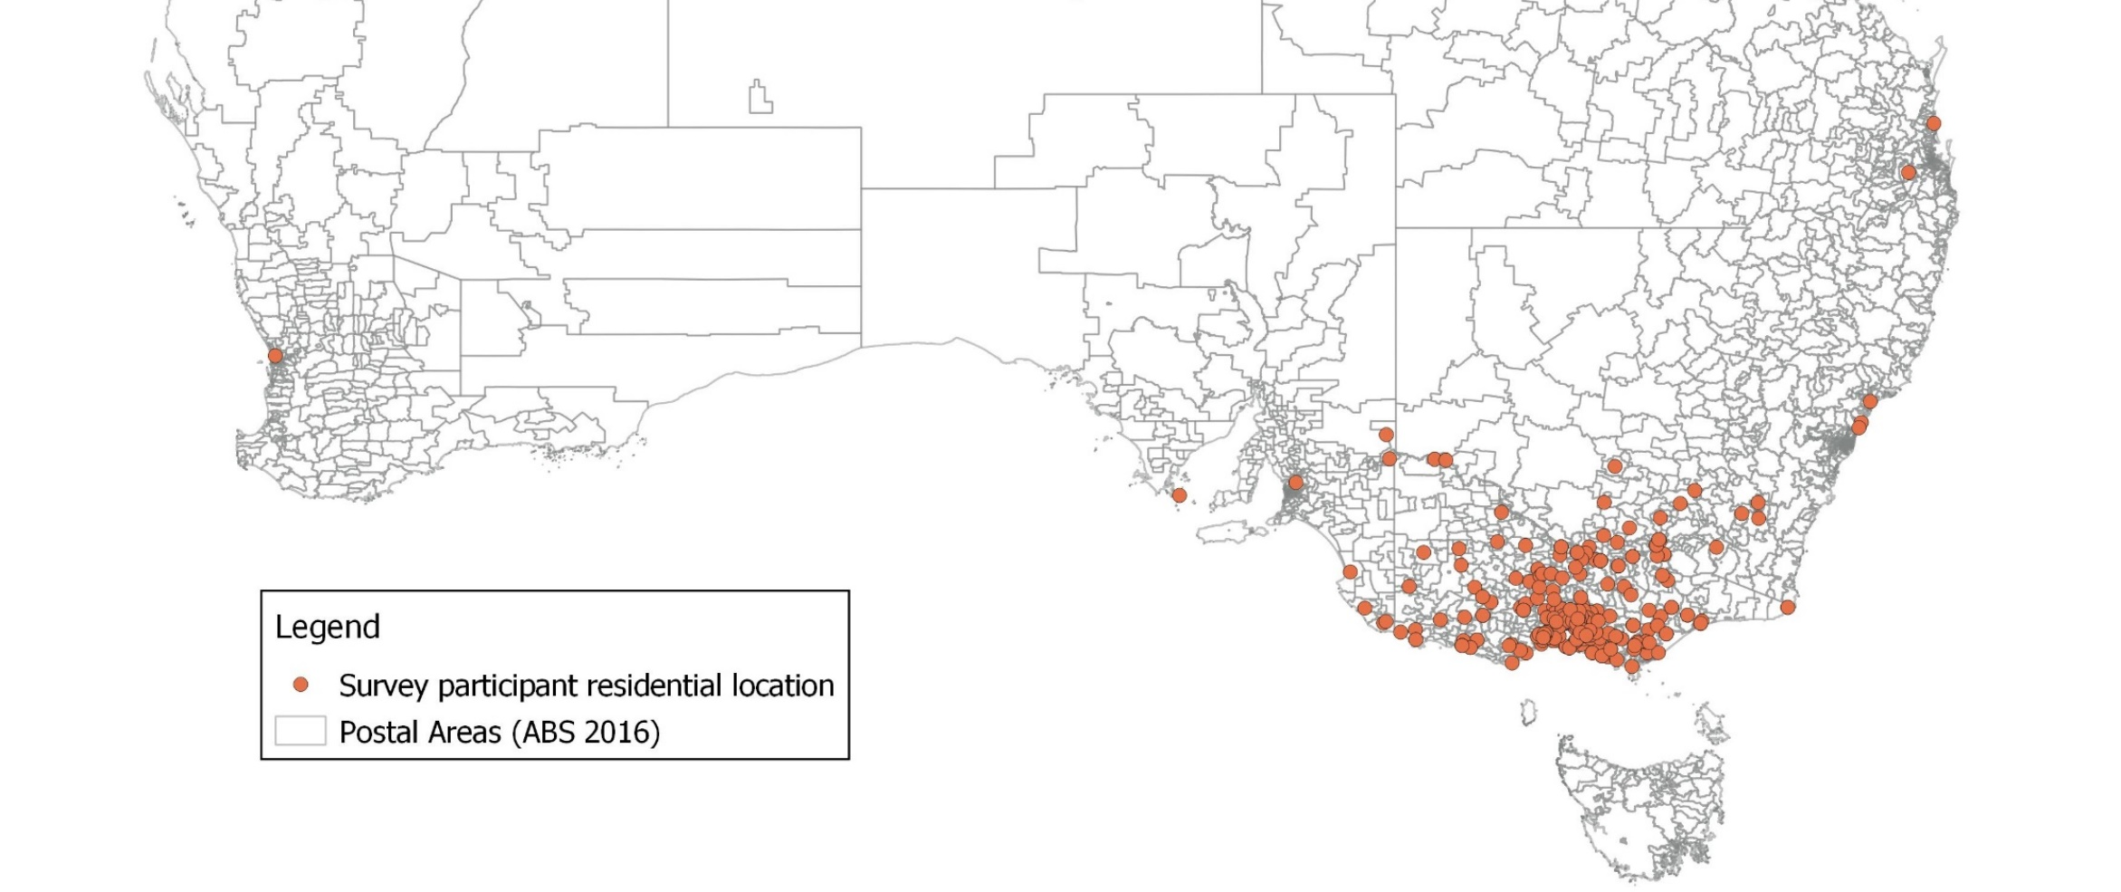
Figure 7: ‘Top Down’ survey respondents who had heard of the Golden Tag Competition
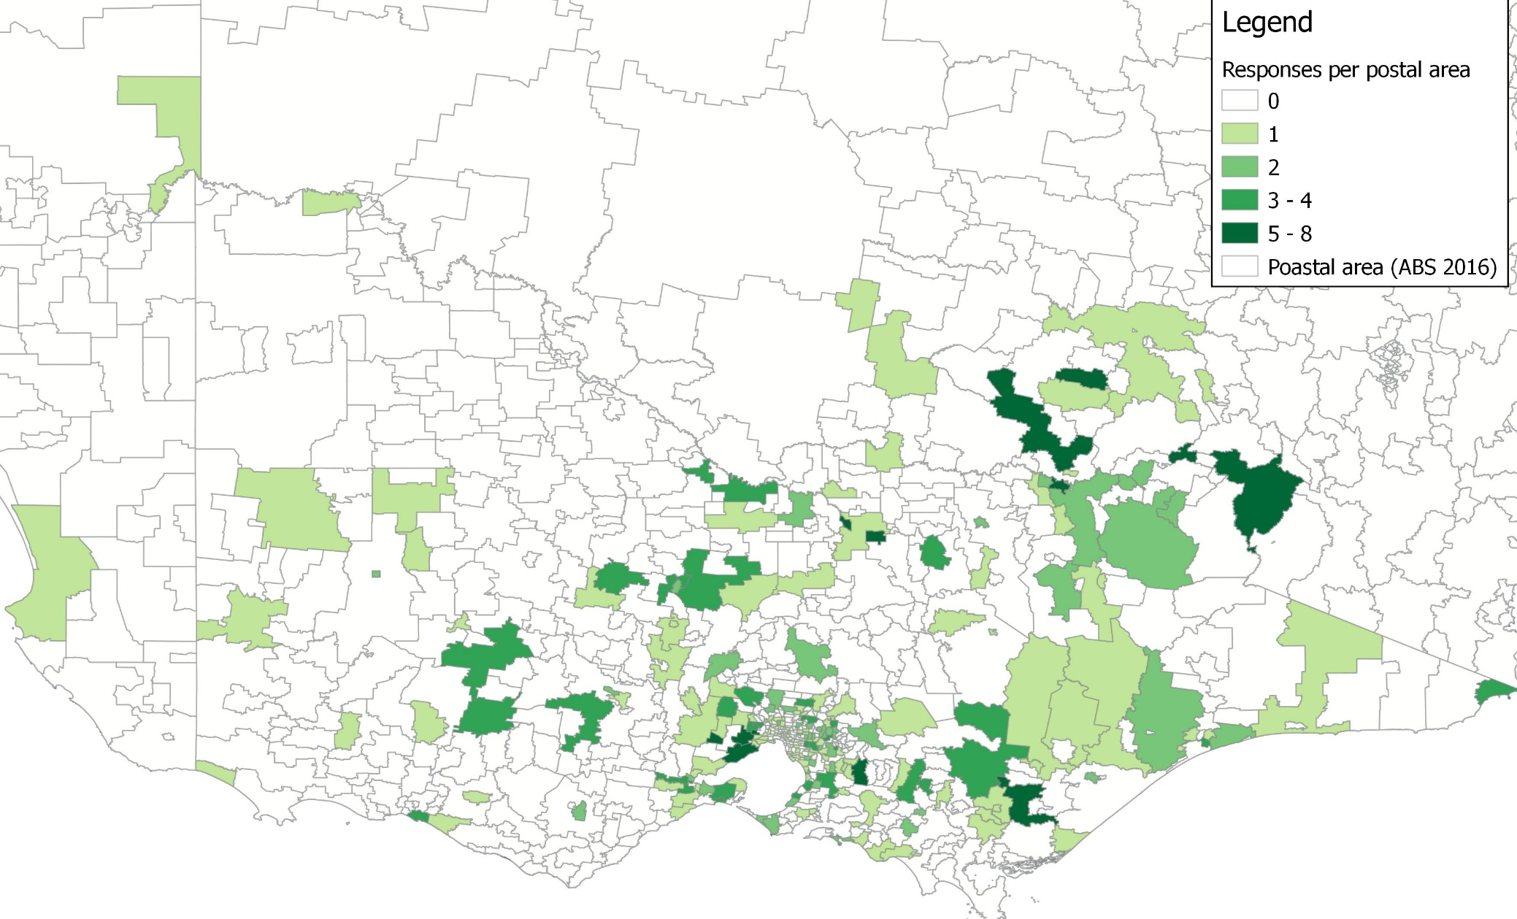
Figure 8: ‘Top Down’ survey respondents who participated in the Golden Tag Competition
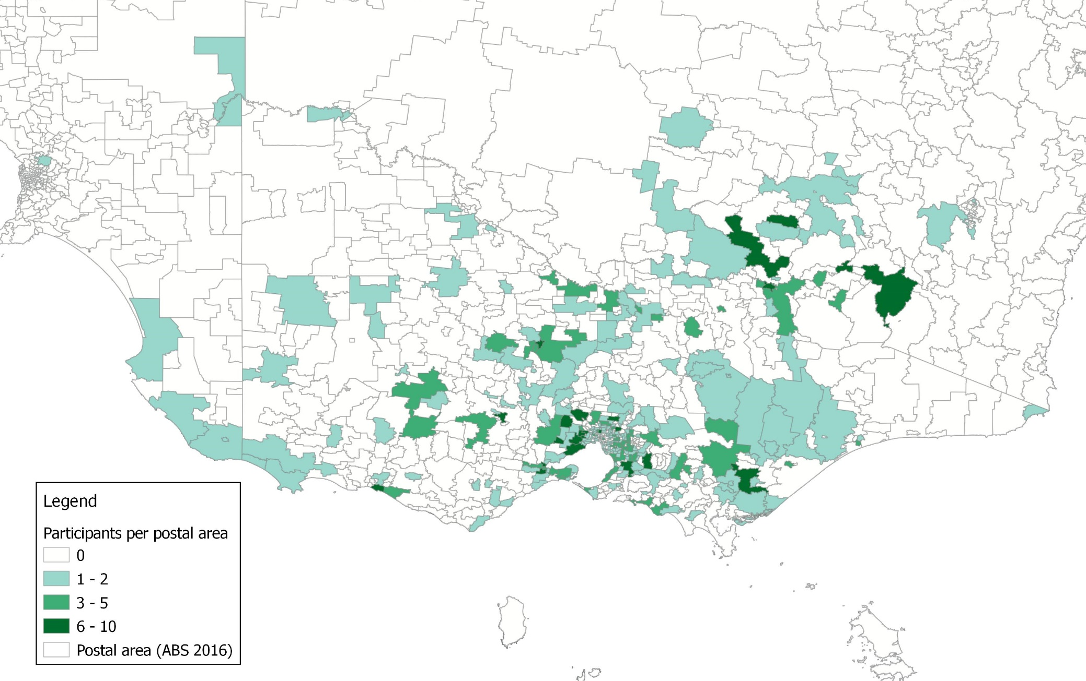

Figure 9: ‘Top down’ survey respondents who changed their fishing behaviours because of the Golden Tag Competition

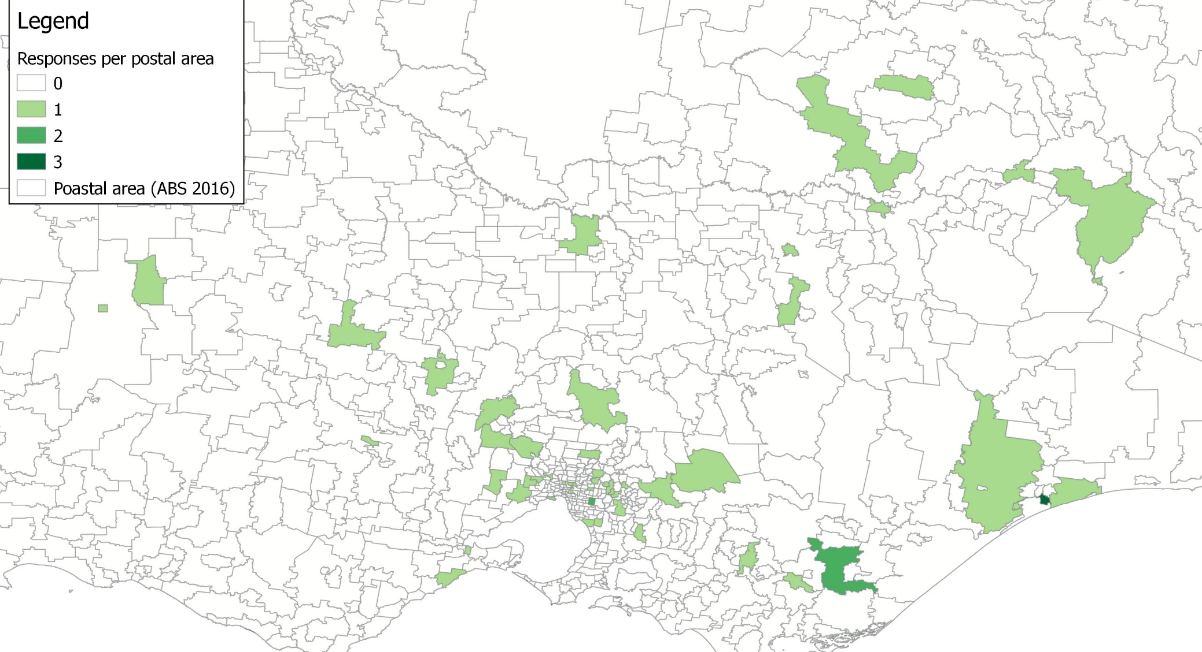
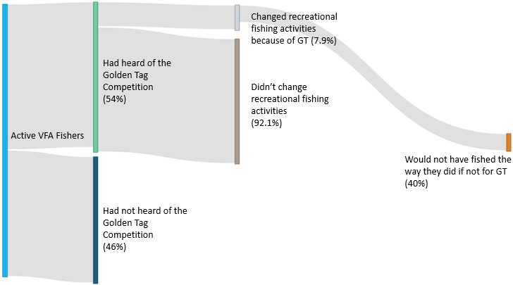
Figure 10: Attribution pathway

  - Economic Contribution analysis
The location, trip and expenditure data underlying the attribution pathway (Figure 10) was used to estimate the recreational fishing expenditure attributable to the Golden Tag program.
We estimated $1.35 million of fishing expenditure across Victoria can be attributed to the Golden Tag Competition. East Gippsland is expected to have received 30 percent of the stimulus impacts from induced fishing behaviour because of the Golden Tag Competition.
Figure 11: Expenditure attributed to induced fisher behaviour as a result of the Golden Tag Competition

Direct economic contribution estimates of the $1.35 million are summarised by region in Table 7. Table 7 shows LGA economic contribution, combining LGA Investment, GVA-Initial, GVA-2A, Employment – Initial and Employment – 2A in the one graph. Appendix 2 includes economic contribution summaries for each LGA.
Key observations include:
- Investments in the Golden Tag Competition generate significant economic contributions across Victorian regions. Table 7 shows that the $1.35 million of induced expenditure as part of the Golden tag Competition generates around $706,000 in initial GVA and $34,000 in additional 2A GVA, based on modelled assumptions. In our view, GVA is the best measure of the impact of investment in a Victorian region. As discussed earlier, GVA is the total of all revenues, from final sales and (net) subsidies, which are incomes into local businesses. Those incomes are used to cover expenses (wages and salaries, dividends), savings (profits, depreciation), and (indirect) taxes. This means GVA measures economic returns on local capital and labour resources. It measures the contribution of the economic activity to the regions economy because it backs out leakage out of the economy.
A key result shown in Table 7 is that around half of all Golden Tag Competition Reward money remains in the regions as initial GVA.
- Investments in the Golden Tag Competition by the VFA support significant jobs and employment in Victorian regions. Investment of $1.35 million supports around 11 full time jobs directly across 2020-21 in the local government areas. When flow on effects (Employment – 2A) are included, the total full-time jobs supported grows to around 2 total person.
Table 7: Direct economic contribution estimates of fisher expenditure attributed to the Golden Tag Competition in Victorian regions, 2020-2021
Region | 2020-2021 Expenditure | GVA initial | GVA- 2A | Employment initial | Employment 2A
Fisher behaviour Change Total | $1,350,000 | $706,000 | $34,000 | 11.7 | 0.6
Murray region | $259,000 | $136,000 | $7,000 | 2.3 | 0.1
Western Victoria, Rocklands and Horsham | $93,000 | $49,000 | $2,000 | 0.8 | 0.0
West Coast Blue Water | $126,000 | $66,000 | $3,000 | 1.1 | 0.1
Central Victoria | $197,000 | $103,000 | $5,000 | 1.7 | 0.1
South Central Coast | $31,000 | $16,000 | $1,000 | 0.3 | 0.0
Goulburn Valley including Eildon | $18,000 | $9,000 | $0 | 0.2 | 0.0
North East and Alpine | $237,000 | $124,000 | $6,000 | 2.1 | 0.1
East Gippsland | $389,000 | $203,000 | $10,000 | 3.4 | 0.2

- Future opportunities
There is clear evidence that the Golden Tag Competition was widely supported, both Victorian Fishers and businesses are asking that the competition be repeated. It’s understood that the competition provides benefits above and beyond economic contribution. Economic contribution results show that the competition pays off in an economic sense. If the Golden Tag Competition is repeated there are several key things that it would be good to focus on.
Feedback from stakeholders consulted for this work highlighted that the Golden Tag competition provides benefits above and beyond economic contribution that is measured in this report. Economic contribution payoff shows that the competition pays off in an economic sense.
The impact of the Golden Tag program extends beyond this primary benefit to likely include things like greater community wellbeing, and greater benefits from outdoor recreation. Secondary benefits are important to these types of programs but are not measured in this evaluation. They could be measured in future VFA evaluations, and so contribute to future program design.
There is clear evidence that the Golden Tag Competition was widely supported. Victorian fishers and businesses surveyed in our work almost universally suggested that the program be repeated in the future and / or run more frequently.
If the Golden Tag Competition is repeated there are key messages and lessons from the current program that will help design future programs. These are shown in Table 8.
Table 8: Lessons for future programs
Area | Observation | Recommendation
Marketing programs | - 50% of fishers surveyed said they hadn’t heard of the Golden Tag Competition  - All local businesses surveyed commented that the momentum of the program was lost after the COVID-19 lockdowns. | - Multi-channel marketing – WIN TV, billboards, radio  - Advertise at fisher hot spots  - More marketing throughout the program instead of being heavily concentrated at the beginning
Prizes | - Stakeholders suggested that various types of prizes could be offered to encourage prize money to stay in the region the fish is caught in. | - Various prizes could include accommodation coupons in the region, tours or location specific experience coupons.
Length | - All businesses and industries surveyed commented that they would like the program to be extended or run again. | - The program could become a regular yearly competition
Prize payments | - A number of winners of the Golden Tag Competition commented that the time taken to receive their prize was too long. | - Ensure payment structure is consistent and streamlined throughout the program

- Victorian regions
Fisher activity and expenditure was allocated across Victoria in 8 key fishing regions.
The ‘Top Down’ and ‘Bottom Up’ surveys asked participants to indicate which regions of Victoria they lived and fished in. The Victorian regions illustrated in Figure 12 were determined by VFA and designed to encapsulate the eight broad fishing regions across Victoria. Economic expenditure, gross value add (GVA) and Full-time equivalent positions (FTE) are grouped based on the Victorian regions shown in Figure 12.
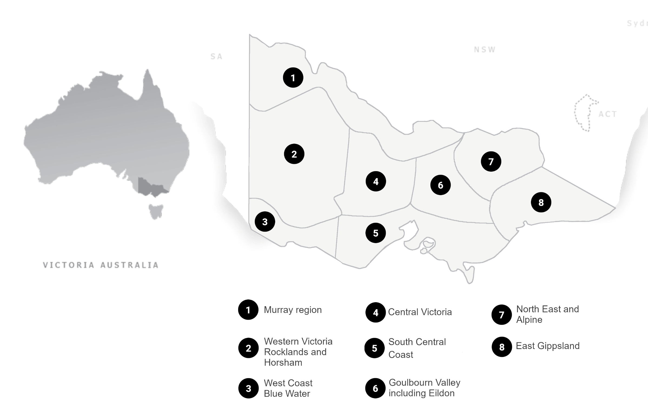
Figure 12: Map of Victorian regions studied in this analysis

- Regional expenditure attributed to the Golden Tag Competition
$316,000 of reward stimulus expenditure and $1,350,000 induced fisher expenditure was attributed to the Golden Tag Competition.
Expenditure in each Victorian region that was attributed to the Golden Tag Competition was estimated based on analysis of the ‘Top Down’ and ‘Bottom Up’ survey. The estimated expenditure attributed to reward stimulus and induced fisher behaviour in 2020 and 2021 is outlined in Table 9 below. Expenditure output categories were used by the Flinders University Input-Output model to calculate GVA and FTE in the Victorian regions.
Table 9: Victorian region expenditure by output category
Victorian Region | Output category | Reward Stimulus Expenditure (2020 - 21) | Induced Fisher Behaviour Expenditure (2020 - 21)
Grand Total |  | $316,000 | $1,350,000
Murray region
 | Electricity, Gas, Water and Waste Services
 | Retail Trade
 | Accommodation and Food Services |  | $233,100
 | Transport, Postal and Warehousing
 | Education and Training
 | Health Care and Social Assistance
 | Other Services |  | $25,900
Western Victoria Rocklands and Horsham
 | Electricity, Gas, Water and Waste Services | $450
 | Retail Trade | $100
 | Accommodation and Food Services | $400 | $83,700
 | Transport, Postal and Warehousing | $300
 | Education and Training | $50
 | Health Care and Social Assistance | $200
 | Other Services | $500 | $9,300
West Coast Blue Water
 | Electricity, Gas, Water and Waste Services
 | Retail Trade
 | Accommodation and Food Services |  | $113,400
 | Transport, Postal and Warehousing
 | Education and Training
 | Health Care and Social Assistance
 | Other Services |  | $12,600
Central Victoria
 | Electricity, Gas, Water and Waste Services | $2,700
 | Retail Trade | $1,000
 | Accommodation and Food Services | $2,000 | $177,300
 | Transport, Postal and Warehousing | $2,000
 | Education and Training | $300
 | Health Care and Social Assistance | $1,000
 | Other Services | $3,000 | $19,700
South Central Coast
 | Electricity, Gas, Water and Waste Services
 | Retail Trade
 | Accommodation and Food Services |  | $27,900
 | Transport, Postal and Warehousing
 | Education and Training
 | Health Care and Social Assistance
 | Other Services |  | $3,100
Goulbourn Valley including Eildon
 | Electricity, Gas, Water and Waste Services | $2,000
 | Retail Trade | $1,000
 | Accommodation and Food Services | $2,000 | $16,200
 | Transport, Postal and Warehousing | $1,700
 | Education and Training | $300
 | Health Care and Social Assistance | $1,000
 | Other Services | $2,000 | $1,800
North East and Alpine
 | Electricity, Gas, Water and Waste Services | $24,000
 | Retail Trade | $7,000
 | Accommodation and Food Services | $20,000 | $213,300
 | Transport, Postal and Warehousing | $18,000
 | Education and Training | $3,000
 | Health Care and Social Assistance | $8,000
 | Other Services | $24,000 | $23,700
East Gippsland
 | Electricity, Gas, Water and Waste Services | $43,000
 | Retail Trade | $13,000
 | Accommodation and Food Services | $35,000 | $350,100
 | Transport, Postal and Warehousing | $33,000
 | Education and Training | $6,000
 | Health Care and Social Assistance | $15,000
 | Other Services | $43,000 | $38,900

- Profile of Survey Respondents
The ‘Top Down’ survey of active fishers in the VFA database received 625 responses and the ‘Bottom Up’ survey of winners of the Golden Tag Competition received 54.
The profile of ‘Top Down’ and ‘Bottom Up’ survey respondents is outlined below to provide a high-level understanding of the results this analysis is based on.
Figure 13: Gender of survey respondents

Figure 14: Age of survey respondents

Figure 15: Type of fisher survey respondents identified themselves as

Note: A ‘Committed fisher’ was described as an individual whose life revolves around fishing and fishing is the centre of their social life. An ‘Advanced fisher’ was described as an individual who holds fishing as an important leisure activity and whose circle of friends includes many anglers. An ‘Active’ fisher was described as an individual who enjoys fishing among many other activities and occasionally goes fishing with friends. A ‘Casual’ fisher was described as an individual who does not hold fishing as a personally important leisure activity and whose social life rarely revolves around fishing.

Figure 16: Motivation for fishing of survey respondents

Figure 17: How survey respondents fish

- AITI Input – Output Model
We used the regional economic impact model developed by Flinders University to estimate the regional economic contribution of Golden Tag Competition investments from 2020 to the future.
The model provides measures of impacts from investments in on-ground structural and environmental works, planning and MER activities. This Appendix describes the structure of the I-O model and limitations of I-O models readers should be aware of.
The estimates generated by the regional economic impact model are underpinned by an input–output model developed by SGS Economics from national input–output figures from the ABS. This model shows the flow of goods and services between all the parts of the Australian economy. The figures developed for each local government area (LGA) disaggregate these total figures across LGA regions using known regional subtotals and forcing the relationship across all LGA regions to match the Australian total.
Using I-O to estimate order of magnitude economic impacts of expenditure related to Golden Tag Competition is considered reasonable, given the time and budget available to this project. However, I-O models have known limitations. These limitations mean I-O models may overstate the economic contribution of economic activity and investment.
The issues with I-O models include:
- The input–output approach assumes that relationships between industries are static. That is, productivity improvements are not factored in and historical relationships are assumed to hold. Businesses are not able to adjust to changes in prices to change the way they produce things.
- The input–output approach uses total production estimates. As a result, the relationships are average. However, if we think about where increases in spending might occur, we expect the spender to look for the best value option (or a marginal option). Using an average approach does not allow for using any underutilised capacity at the industry level or for the better use of existing machinery as production expands from its existing base.
- All of the expenditure is assumed to be new economic activities in each local government area. That is, input–output models assume that labour and equipment are, in effect, unemployed and with no constraints on their availability. This means that crowding out or industry substitution effects (including from saving) are assumed to be negligible. This means that there is sufficient slack in the local economy to service these stimuli without transferring significant resources from other uses. If that is not the case, then there is a tendency for input–output models to overstate economic value.
The input–output approach is also constrained by:
- the relevance of the most recent national input–output table, which was completed in 2009/10 and the Census industry of employment data from 2011.
- the high level of discretion that can be applied when disaggregating national tables to a state and regional industry level where those local levels of data are not available.
These issues mean that input–output modelling generally overstates the gross and net economic impact of industry sectors. Changes in spending in an industry, for example, are unlikely to generate the same impact as suggested by the application of input–output multipliers. Ignoring these effects can cause input–output based estimates to overestimate the overall impact on the economy.

