Preliminary observations on hatchery production of dusky flathead
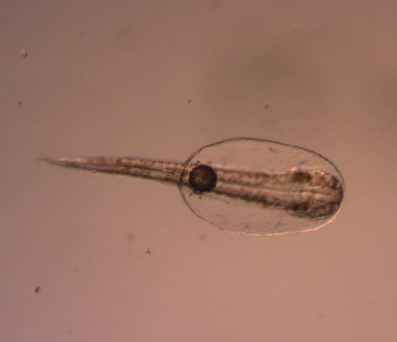
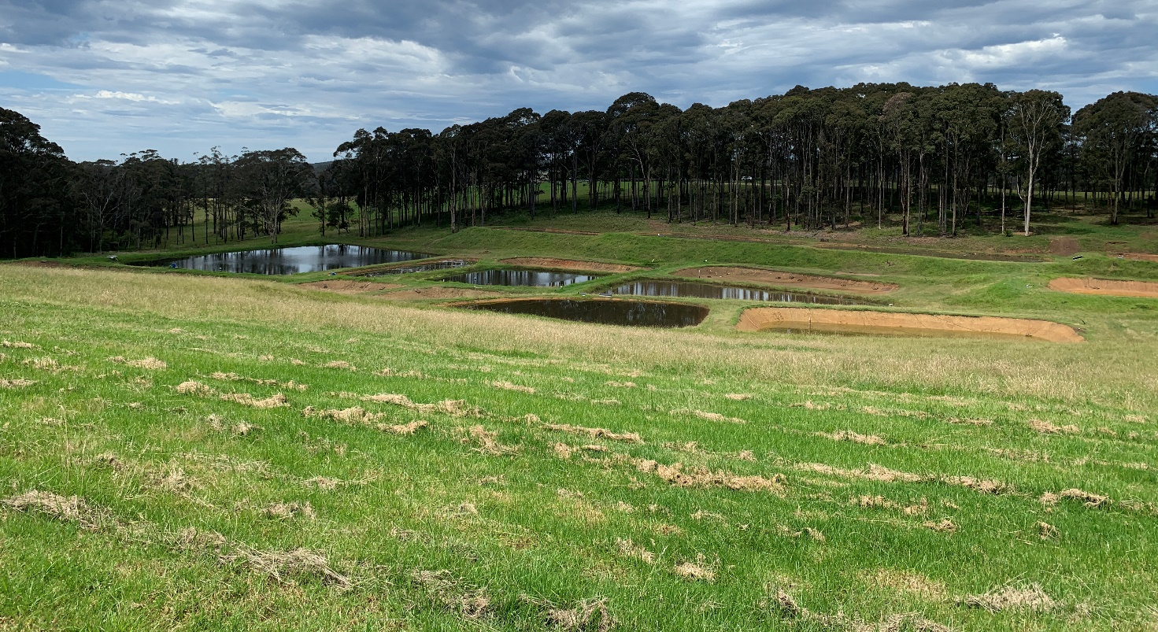
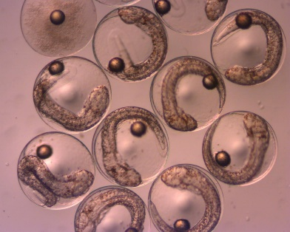
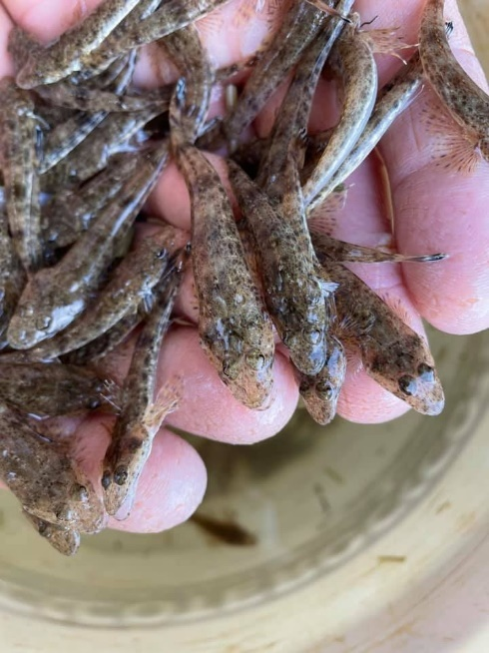
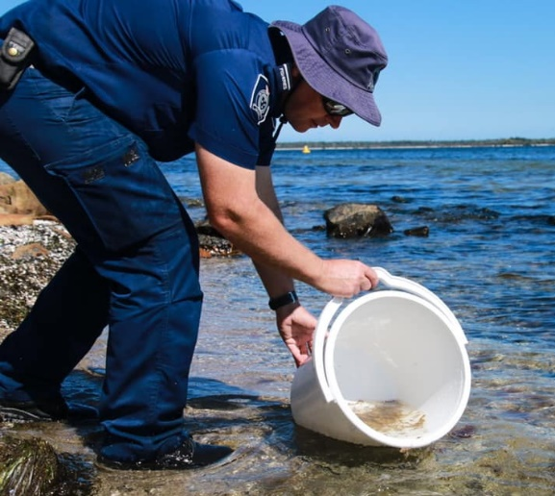

August 2023
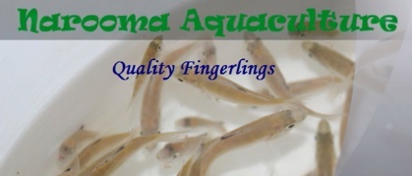
Victorian Fisheries Authority
Science Report Series No. 39

Preliminary observations on hatchery production of dusky flathead

Brett A. Ingram and Bruce Lawson

August 2023
Victorian Fisheries Authority
Science Report Series No. 39

Published by the Victorian Government, Victorian Fisheries Authority (VFA),
August 2023

© The State of Victoria, Victorian Fisheries Authority Melbourne, 2022
This publication is copyright. No part may be reproduced by any process except in accordance with the
provisions of the Copyright Act 1968.
Authorised by the Victorian Government, 1 Spring Street, Melbourne.
Printed by VFA Queenscliff, Victoria.
Preferred way to cite this publication:
Ingram, B.A. and Lawson, B. (2023). Preliminary observations on hatchery production of dusky flathead. Victorian Fisheries Authority Science Report Series No. 39. 21 pp.
ISSN 2203-3122 (Print)
ISSN 2204-6933 (Online)
ISBN 978-0-6457979-2-3 (Print)
ISBN 978-0-6457979-3-0 (pdf/online/MS Word)
Author Contact Details:
Dr. Brett Ingram
Fisheries Management and Science Branch, Victorian Fisheries Authority
Private Bag 20, Alexandra. Vic. 3714.
Mr Bruce Lawson
Narooma Aquaculture
Narooma. NSW. 2546. (http://www.narooma-aquaculture.com.au/)

Copies are available from the website www.vfa.vic.gov.au
For more information contact the VFA Customer Service Centre 136 186
Disclaimer
This publication may be of assistance to you but the State of Victoria and its employees do not guarantee that the
publication is without flaw of any kind or is wholly appropriate for your particular purposes and therefore disclaims all
liability for any error, loss or other consequence which may arise from you relying on any information in this publication.
Accessibility
If you would like to receive this publication in an accessible format, such as large print or audio, please telephone
136 186, or email customer.service@vfa.vic.gov.au
Deaf, hearing impaired or speech impaired? Call us via the National Relay Service on 133 677 or visit
www.relayservice.com.au
This document is also available in PDF format on the internet at www.vfa.vic.gov.au

Contents
Executive Summary 1
Introduction 2
Background 2
Objectives 2
Spawning in the wild 3
Genetic considerations 3
Genetic identification of stocked fish 3
Hatchery production 4
Broodstock 4
Capture and transport 4
Managing new fish on arrival at hatchery 4
Broodstock Holding Facilities 4
Sedation and anaesthesia 4
Water quality requirements 5
Broodstock size and condition 5
Relative fecundity 6
Spawning induction 7
Gamete assessment 7
Females 7
Males 7
Options for spawning dusky flathead 7
Hormone induced spawning of wild-caught broodstock 9
Artificial spawning following hormone induction 9
Natural spawning with and without use of hormones 10
Hormone induced spawning of captive-held broodstock 10
Egg incubation and hatching 11
Larvae and larviculture 12
Fry rearing (nursery culture) 13
Rearing in fertilised earthen ponds 13
Growth 13
Survival to harvest 14
Nutritional requirement and feeding 15
Diseases and health management 15
Conclusions and recommendations 16
Acknowledgements 18
References 18
Appendix I: Known diseases and parasites recorded from dusky flathead 20

List of Tables
Table 1. The spawning season of dusky flathead, rock flathead and sand flathead. 3
Table 2. Source and number of broodstock transferred to Narooma Aquaculture for spawning. 4
Table 3. Length, weight and condition of dusky flathead broodstock (Number measured: 41 females and 39 males). 5
Table 4. Subjective measures of assessment for dusky flathead milt and sperm (after Ingram et al. 2012). 7
Table 5. Subjective assessment of female dusky flathead. 8
Table 6. Number and size of hatchery-bred dusky flathead fingerlings stocked into waters between 2021 and 2023. 16

List of Figures
Figure 1. Dusky flathead in static flat-bottomed tanks. 5
Figure 2. Length-weight relationship of dusky flathead broodstock. 6
Figure 3. Injecting flathead broodstock with HRHa to induce ovulation. 9
Figure 4. Ovulated dusky flathead eggs. 9
Figure 5. Stripping eggs and milt from dusky flathead. 9
Figure 6. Relationship between latency period and fertilisation rate for stripped dusky flathead (red line = second degree polynomial curve). 10
Figure 7. Embryonic development of dusky flathead. (a) Fertilsied egg. (b) 1 hr PF showing 2 cell cleavage. (c) 1.5 hrs PF showing 4-cell cleavage. (d) 2.1 hrs PF showing 8-cell cleavage. (e) 2.9 hrs PF, late cleavage period, blastodisc is apparent. (f) 7.4 hrs PF, epiboly completed. (g) 24 hrs PF. (h) 26 hrs PF. (PF = post-fertilsation). 11
Figure 8. New hatched dusky flathead larva (27 hours post-fertilisation). 12
Figure 9. Dusky flathead fry prior to metamorphosis. 13
Figure 10. Appearance and size variation in dusky flathead fingerlings harvested from a fry rearing pond. 13
Figure 11. Length-weight relationship for pond-reared dusky flathead fingerlings. 14
Figure 12. Nematode (c.f. Philametra sp.) from the gonads of dusky flathead. 15
Figure 13. Releasing dusky flathead fingerlings into Gippsland Lakes. 16

Executive Summary
The Gippsland Lakes support an important and popular recreational fishery which is a major contributor to the economy and employment in the region. However, the stocks of some key species, especially dusky flathead (Platycephalus fuscus) have been in decline since the mid-late 2000s. Reasons for this are unclear but may be related to fishing pressure and prolonged periods of poor recruitment.
Fish stocking is an important and widely used tool in fisheries management to replenish, maintain or enhance fish populations, and can be an effective option for managing fish stocks where recruitment is limited. As part of the Gippsland Lakes Recreational Fishery Plan 2020, fishing stocking is a high priority action being used to help recover dusky flathead.
The Victorian Fisheries Authority (VFA) has engaged through a tender process an experienced commercial estuarine finfish farmer (Narooma Aquaculture) to develop reliable hatchery breeding methods for dusky flathead. Fingerlings produced will be released into selected East Gippsland estuaries as part of a three-year trial stocking program to improve recreational fishing outcomes. As part of the tender agreement, dusky flathead fingerlings suitable for stocking will be supplied over three years and hatchery production methods will be documented.
This report describes preliminary observations on hatchery production techniques for dusky flathead, including:
- broodstock capture, transport and hormone induced spawning induction,
- egg embryology, incubation and hatching
- larviculture and rearing fry in fertilised earthen ponds
- diseases and health management
- recommendations for improving production.
Over three breeding seasons 133,700 fingerlings produced at Narooma Aquaculture were stocked into waters in eastern Victoria (see table below). Released fish ranged from 22 – 85 mm (median 36 mm) in length and 0.14-3.91 g (median 0.32 g) in weight.

Number and size of hatchery-bred dusky flathead fingerlings stocked into waters between 2021 and 2023.
Water | Location | 2021 | 2022 | 2023 | Total
Bemm River | Bemm River | 5,000 |  | 5,000 | 10,000
Gippsland Lakes | Bancroft Bay (Metung) | 2,000 |  |  | 2,000
 | Cunningham Arm (Lakes Entrance) |  | 25,000 | 18,200 | 43,200
 | Lake King (Metung) | 20,000 |  | 9,700 | 29,700
 | North Arm (Lakes Entrance) | 20,000 | 10,600 | 18,200 | 48,800
Total |  | 47,000 | 35,600 | 51,100 | 133,700
Average weight (g) |  | 0.24 | 0.27 | 0.47 | 0.34

Introduction

Background
The Gippsland Lakes support an important and popular recreational fishery. Species most targeted by anglers include dusky flathead (Platycephalus fuscus), black bream (Acanthopagrus butcheri) and King George Whiting (Sillaginodes punctatus). The fishery is a major contributor to the economy and employment in the region. However, the stocks of some key species, especially dusky flathead and black bream, have been in decline (Conron et al. 2020).
Reasons for the decline in the catch of dusky flathead in Gippsland Lakes, Lake Tyers and Mallacoota Inlet since the mid-late 2000s are unclear but may be related to fishing pressure and prolonged periods of poor recruitment (i.e. low spawning success/stock replenishment) (Conron and Hamer 2018). The dusky flathead recreational fishery is managed through a bag/possession limit and both minimum and maximum size limits.
Fish stocking is an important and widely used tool in fisheries management to replenish, maintain or enhance fish populations, and is increasingly being applied to fisheries in coastal and marine fisheries (Welcomme and Bartley 1998, Bell et al. 2006, Ingram and De Silva 2015). Stocking can be an effective option for managing fish stocks where recruitment is limited. As part of the Gippsland Lakes Recreational Fishery Plan 2020 (Victorian Fisheries Authority 2020), fishing stocking is a high priority action being used to help recover stocks. Australian bass (Percalates novemaculeata) and estuary perch (P. colonorum) are already being released into tributaries of the lakes system to accelerate recovery of fish populations and stocking trials will be undertaken to speed up population recovery of dusky flathead (and black bream).
Flathead are considered as potential candidates for stocking Victorian estuaries because (Ingram 2019):
- They are a highly popular recreational angling species.
- Some stocks may need supplementation to overcome periods when recruitment is limited.
- They are relatively sedentary and so are less likely to move away from the area stocked.
- They can be bred in captivity.
There is limited information on captive breeding of dusky flathead. The species was first bred in captivity at the Bribie Island Research Centre (BIRC), Woorim, Qld (Queensland Department of Agriculture and Fisheries) in the 1990s (Palmer et al. 2000), to support a two-year pilot stocking program in the Maroochy River (Butcher et al. 2000, Butcher 2006). However, since then there has been no further work on breeding dusky flathead and currently there is no commercial hatchery-production of dusky flathead in Australia.
Consequently, the Victorian Fisheries Authority (VFA) has engaged through a tender process an experienced commercial estuarine finfish farmer (Narooma Aquaculture) to develop reliable hatchery breeding methods for dusky flathead. Fingerlings produced will be released into selected East Gippsland estuaries as part of a three-year trial stocking program to improve recreational fishing outcomes. Narooma Aquaculture (owned by Bruce Lawson), which has been in operation since 1999, specialises in commercial production of high quality and disease-free fingerlings, including Australian bass and estuary perch, for stocking public waters.
As part of the tender agreement, dusky flathead fingerlings suitable for stocking will be supplied over three years and annual reports will be provided that highlight,
- breeding methods used
- production outcomes
- key learnings / observations and,
- suggested ways to improve production methods.

Objectives
This document aimed to
- describe hatchery production methods for dusky flathead, drawing on experiences at the Narooma Aquaculture and available published information (i.e. Palmer et al. 2000)
- provide recommendations that may help improve production methods
- provide a summary of production outputs from each year that fingerlings were produced
- meet reporting requires for the tender agreement.

Spawning in the wild
Flathead species spawn mainly in spring and summer (Table 1). Initiation and duration of the spawning season may vary between locations (spatially) (Table 1) and years (annually). Spawning in southern species of flathead is likely to be influenced by increasing temperature and daylength. Salinity may also influence spawning success. For example, Bani and Moltschaniwskyj (2008) suggested that lower salinities in the Tamar River (Tas.) reduced reproductive output of sand flathead.
Dusky flathead in spawning condition are found in lower reaches of estuaries and coastal waters, but it is uncertain as to whether fish spawn in the estuary move to coastal waters just before spawning (Gray and Barnes 2015). Dusky flathead are thought to be able to spawn multiple times within the season (Gray and Barnes 2015). It is not known if dusky flathead spawn in Lake Tyers, though the population is thought to be self-sustaining and anglers report large females are almost always gravid leading into the spawning season (Nicholson and Gunthorpe 2008).

Table 1. The spawning season of dusky flathead, rock flathead and sand flathead.
Species | Aug | Sep | Oct | Nov | Dec | Jan | Feb | Mar | Apr | May | Source
Dusky flathead - NSW |  |  |  |  |  |  |  |  |  |  | Gray and Barnes 2008, Gray and Barnes 2015
- VIC |  |  |  |  |  |  |  |  |  |  | Hindell 2008

Genetic considerations
The ability of dusky flathead to move between estuaries, along with dispersal of eggs and larvae in coastal currents, suggests there is mixing between populations in adjacent estuaries.
In a study of the genetic structure of dusky flathead in coastal waters of NSW, a combination of mitochondrial and microsatellite markers was used in this study to evaluate structuring among fish from eight estuaries spanning much of the NSW coast (Taylor et al. 2020). Results revealed that seven of the eight estuaries were genetically homogeneous, indicating that dusky flathead form a single stock along the NSW coast where mixing likely occurs during early life phases and through limited adult movement. The one population that was generally different (St Georges Basin) likely suffers from limited connectivity due to a constricted entrance (Taylor et al. 2020).
The study by Taylor et al. (2020) suggested that dusky flathead in open estuaries of eastern Victoria will be similar to the NSW stock. Nevertheless, tissue samples of dusky flathead from Victorian populations are currently being analysed to determine their association with the NSW stock. Meanwhile, stocking of hatchery-bred dusky flathead into coastal Victorian waters currently utilises broodstock from Victorian estuaries, namely Mallacoota Inlet and Lake Tyers.

Genetic identification of stocked fish
Post stocking surveys will be conducted to monitor stocked dusky flathead and their contribution to populations being replenished. This will require a method to distinguish stocked fish from wild fish, which can be achieved through genetic parentage testing (DNA fingerprinting). Consequently, a DNA sample (finclip) will be collected from all broodfish used at Narooma Aquaculture to produce fish for stocking. These samples will be used to create a genetic broodstock library for future parentage testing of dusky flathead caught during post-stocking surveys.

Hatchery production

Broodstock

Capture and transport
Mature wild broodstock were caught from either Mallacoota Inlet, Lake Tyers or Lakes Entrance during the first three weeks of January each year (Table 2). All fish were caught by boat-based anglers that fished predominantly with soft plastic lures. Handling of caught fish was minimised to reduced stress and injury. Fish were held in:
- live well with constant water flow on board the fishing boat
- turkey crates (with vertical bars) that was weighted to sit on the substrate
- Truck and trailer-mounted transport tanks (fresh water periodically flushed through tank, water aerated with liquid oxygen).
Fish were transferred to the hatchery at Narooma Aquaculture in either 6 x500L tanks mounted on a truck or a trailer-mounted 800 L transport tank. Prior to transport, attempts were made to adjust salinity in transport water to approximately match that at the hatchery.
During transport dissolved oxygen levels were maintained at 80-130% saturation by lightly diffusing liquid oxygen through air stones. Stocking density was 7-13 kg/m³. Transport time between location of capture and the hatchery was 3 hrs (Mallacoota Inlet) to 4 hrs (Lake Tyers). Post-capture and transport mortality was very low (< 7%). Higher water temperatures (>20ºC) experienced during capture and holding before transport may have influenced survival.

Table 2. Source and number of broodstock transferred to Narooma Aquaculture for spawning.
Water | 2021 | 2022 | 2023 | Total
Lakes Entrance |  |  | 1 | 1
Lake Tyers |  | 15 | 32 | 47
Mallacoota Inlet | 43 | 68 | 33 | 144
Total | 43 | 83 | 66 | 192

Managing new fish on arrival at hatchery
Prior to transfer of fish from the transport tanks to tanks in the hatchery, water temperate and salinity were matched (during trials in 2022, salinity was 15 ppt and temperature was 22ºC). Fish were placed into isolation in static flat-bottomed tanks (1.0 - 1.6 m dia, water depth 15-16 cm) (stocking density: 15-23 fish/m², 60-150 fish/m³) under subdued lighting (Figure 1). Since dusky flathead appeared to prefer water movement within the tanks, each tank was provided with aeration and a small submersible pond pump to circulate water within the tank. Aquasonic Ammonia-Gone (Natures Best, Tasmania) (0.25 mL/L) was added to the tanks to neutralize ammonia. Under these holding condition fish did not appear stressed.
Prior to spawning trials, salinity in the tanks was increased to > 30 ppt to be consistent with the egg incubation salinities being used.

Broodstock Holding Facilities
At the BIRC, dusky flathead broodstock were maintained in 10,000L large fiberglass tanks (up 25 fish at 0.5-5 kg/fish) (Palmer et al. 2000). Although flathead are known to bury in the substrate, the tanks were not provided with substrate material to facilitate monitoring of fish and tank maintenance. When disturbed, broodstock tended to exhibit a flight response and consequently would bump into the sides of the tank (P. Palmer, pers comm.). Consequently, broodstock were held in reduced light conditions and disturbances were kept to a minimum. At the BIRC, broodstock were fed chopped fish (e.g. pilchards) supplemented with vitamins (Palmer et al. 2000). Broodstock could not be weaned onto artificial diets. Broodstock were not fed at Narooma Aquaculture.

Sedation and anaesthesia
All broodstock were anesthetised before measurement, gamete assessment, hormone injection and gamete stripping. Broodstock were anesthetised in aerated water containing Aqui-S (AQUI-S New Zealand Ltd, Lower Hutt, NZ) (0.01-0.1 mL/L, depending on size of fish).

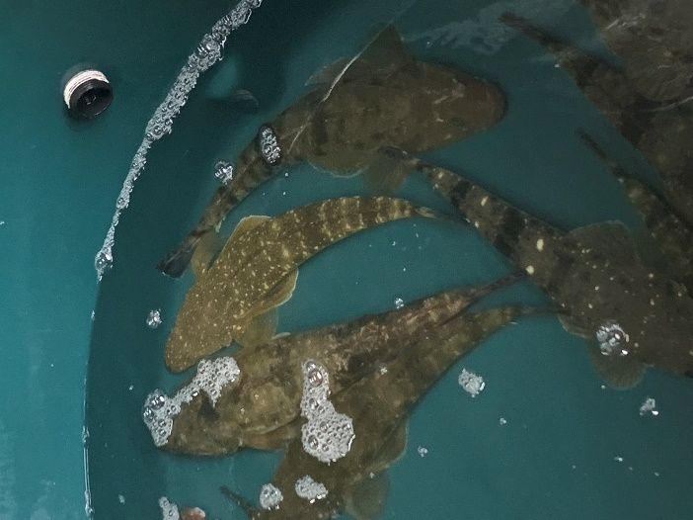
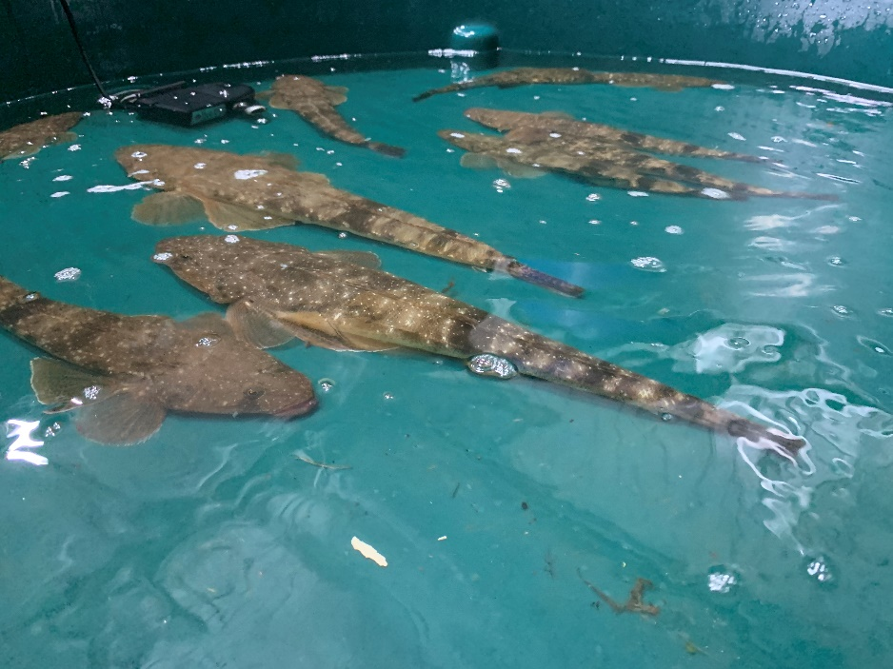
Figure 1. Dusky flathead in static flat-bottomed tanks.

Water quality requirements
There is no information on water quality requirements for dusky flathead. Since dusky flathead are estuarine, they are expected to have a relatively broad tolerance to salinity. Water quality parameter levels that dusky flathead broodstock were exposed to during transport and holding at Narooma Aquaculture were:
Salinity: 6 – 33 ppt
Temperature: 17 - 23ºC
pH: 7.0 – 8.0
Dissolved oxygen (DO): 79-130% saturation.

Broodstock size and condition
Dusky flathead are sexually dimorphic with females exceeding 100 cm and 7.5 kg while males being up to 61.5 cm TL (1.58 kg) (Gray and Barnes 2015). However, smaller (younger) fish were targeted as broodstock as larger fish are important contributors to local breeding populations, and are highly valued by recreational fishers, are more difficult to handle in captivity.
A summary of length, weight and condition of mature broodstock transported to Narooma Aquaculture is provided in Table 3. Females had a broader size range than males. The smallest mature females and males were similar in size whereas larger fish were females (Figure 2). Condition (K) was similar between sexes.
Size at maturity of dusky flathead varies across their range, with total length at 50% maturity for females being 32.8 cm in eastern Victoria (Hicks et al. 2015) and 56.8 cm in NSW (Gray and Barnes 2008). All males measured during January 2022 breeding trials were running ripe.

Table 3. Length, weight and condition of dusky flathead broodstock (Number measured: 41 females and 39 males).
Parameter | Female |  | Male
 | Range | Mean | Range | Mean
Total length (mm) | 350 – 560 | 443 | 350 - 460 | 391
Weight (g) | 220 - 1060 | 538 | 239 - 528 | 354
Condition (K)* | 0.48 – 0.74 | 0.59 | 0.51 – 0.66 | 0.58
* Condition (K) = weight (g) / (length (mm) x 10³) x 100

Relative fecundity
In the wild, potential annual fecundity of dusky flathead in eastern Victoria is 0.112 mil. eggs for smaller fish (32 cm TL) and up to 4.8 mil. eggs for larger fish (76.4 cm TL) (Hicks et al. 2015). Egg quality and mean relative fecundity is 704 eggs/g body mass, which does not change with body size (Hicks et al. 2015).
The number of eggs spawned by broodstock during breeding trials at Narooma Aquaculture was not determined.

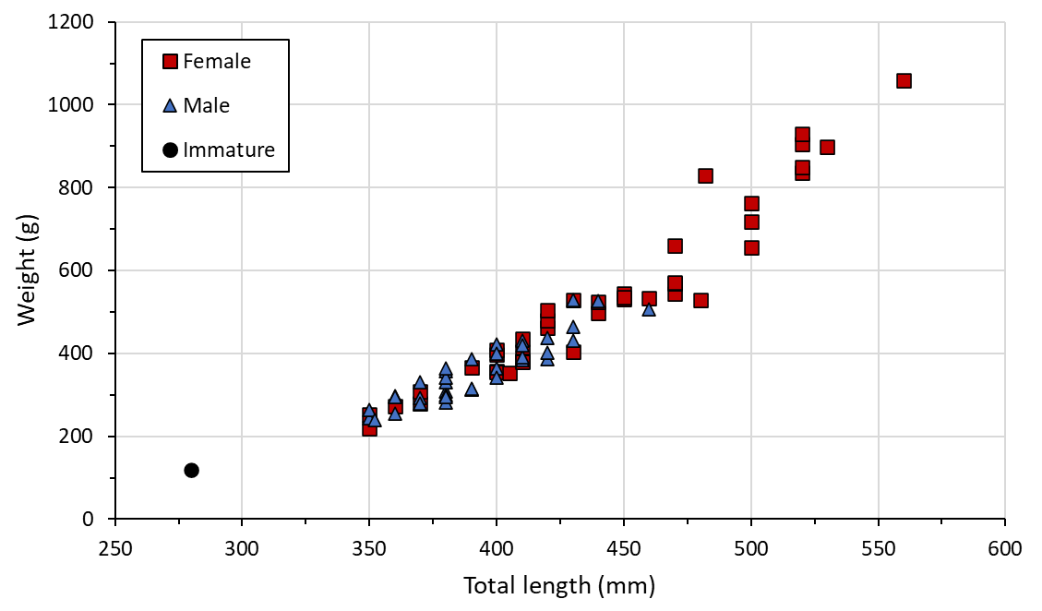
Figure 2. Length-weight relationship of dusky flathead broodstock.

Spawning induction

Gamete assessment

Females
Mature oocytes (i.e. post-vitellogenic stage) of dusky flathead are thought to be >0.4 mm in diameter (Hicks et al. 2015). Average oocyte diameter in five moribund broodstock that were autopsied during January at Narooma Aquaculture ranged 0.07 to 0.27 mm, which suggested that some females were not fully mature. However, the wide range of oocyte sizes present in one female, 0.12 – 0.44 mm in diameter, suggested that a proportion of oocytes were sufficiently developed for ovulation to be induced.
Limited attempts to obtain an oocyte samples from females before injected were unsuccessful. Consequently, in the absence of information on the size/maturity of oocytes, female maturity and readiness to spawn were assessed using the following characteristics (Table 5):
- The degree of convexity (distension) of the abdomen when held vertically by the jaw, a method first proposed by Bruce Lawson (Narooma Aquaculture), to indicate the developmental stage of ovaries.
- Flaccidity of the abdomen to indicate maturity of oocytes and readiness to spawn.
- Size and colour of the vent to indicate maturity of oocytes and readiness to spawn.

Males
Milt and sperm quality were assessed subjectivity using the measures described in Table 4. All males assessed were running ripe. Small amounts of milky milt could be expressed with slight to moderate pressure to the abdomen from most males while copious amounts of milt (up to 1 mL) was exuded from some males (8%). Sperm activity, which was examined in four males, was good to excellent. Sperm was readily activated saline water (32 ppt) and maintained motility for at least 2 minutes.

Table 4. Subjective measures of assessment for dusky flathead milt and sperm (after Ingram et al. 2012).
Milt volume obtained by applying pressure to abdomen | Milt consistency | Sperm activity assessed microscopically*
0 = Nil  1 = Small amount (drops)  2 = "Good" (up to 1 mL)  3 = “Lots” (>1 mL) | 1 = Very watery  2 = Watery/milky  3 = Milky  4 = Thick creamy-white | 0 = Nil activity  1 = Poor ('jiggly". <10% motile)  2 = Fair (10-50% motile)  3 = Good (50-90% motile)  4 = Excellent (>90% motile, in swirling masses)
* To assess sperm activity, a drop of freshly collected milt is placed on a clean microscope slide. A drop of saline water is also placed on the slide about 1 cm away from the drop of milt. A coverslip is then placed over both drops and the section of microscope slide where the two drops meet is immediately examined under high magnification (400x) to assess sperm activity.

Options for spawning dusky flathead
Spawning fish in captivity may require a range of different levels of intervention in the spawning process, which could include, provision of habitat (e.g. spawning structures), environmental manipulation (temperature and/or photoperiod change), hormonal stimulation (injection of a hormone) and combinations of these. Some fish species may spawn unassisted in captivity whereas others require significant intervention actions followed by hand stripping of gametes from males and females (artificial spawning). Based on previous spawning work conducted of Platycephalus species, the following options for spawning dusky flathead include:
- Hormone injection followed by natural spawning. This method has been used for bartail flathead (P. indicus) in which the buoyant fertilised eggs were collected daily from broodstock tanks (Hotta 2000).
- Hormone injection followed by artificial spawning. Mature dusky flathead were induced to spawn using a single injection of LHRHa at a dose rate of 25-30 μg/kg (Palmer et al. 2000).

Table 5. Subjective assessment of female dusky flathead.
Parameter | Stage 1 | Stage 2 | Stage 3
Convexity of abdomen when fish held vertically by jaw | Straight or concave  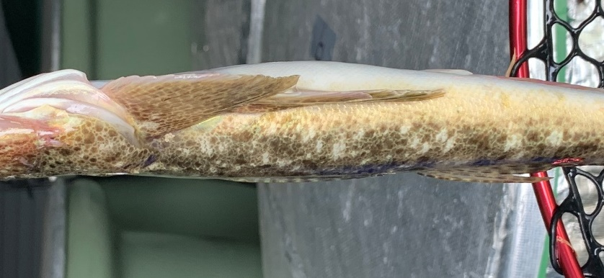 | Slight to moderate convexity  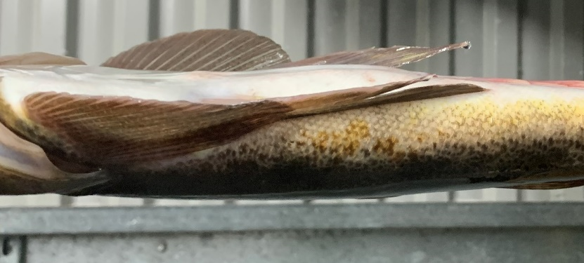 | Moderate to strong convexity  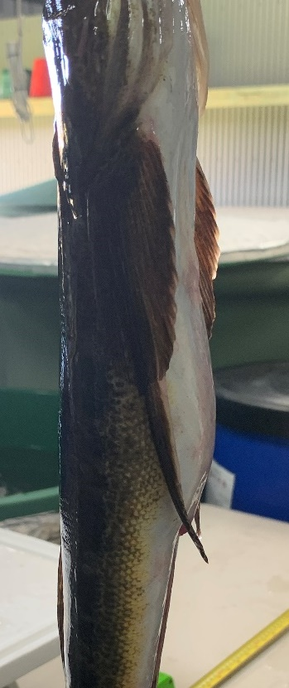
Abdomen flaccidity | Firm | Slightly to moderately flaccid | Moderate to very flaccid
Vent appearance | not swollen, white to pale pink in colour  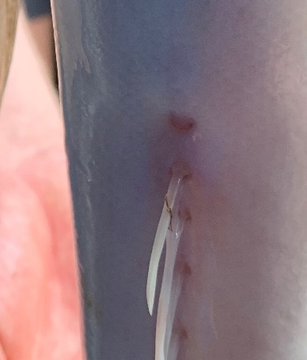 | Slightly swollen, pale pink to pink in colour  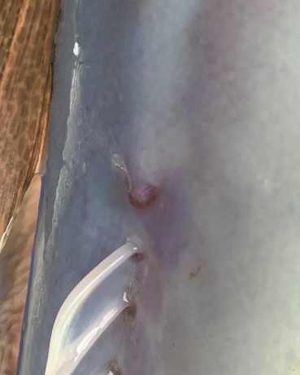 | Distended, swollen and reddish in colour  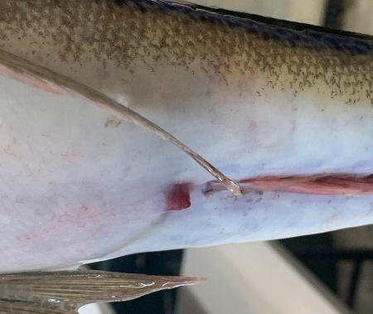

Hormone induced spawning of wild-caught broodstock

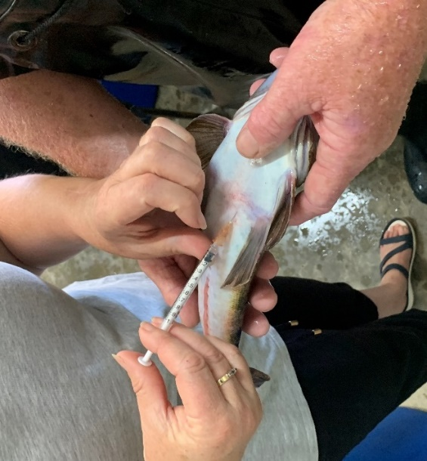
Artificial spawning following hormone induction
Figure 3. Injecting flathead broodstock with
HRHa to induce ovulation.

Hormone treatments
Fish at Narooma Aquaculture were injected during the evening so that stripping can occur during daylight hours.
Both females and males were injected intraperitoneally usually with a single dose of a Luteinizing Hormone – Releasing Hormone analogue (LHRHa) (des-Gly10, [D-Ala6] LH-RH Ethylamide) (Syndel, Nanaimo, Canada) at 30-40 μg/kg (Figure 3). This hormone dosage was thought to:
- induce ovulation in females where oocytes were >0.3 mm diameter
- enhance spermiation in males.
The effects of time between capture and spawning induction on spawning success is unknown, however, some broodstock that had been held for up to 4 days after capture were successfully induced to spawn.
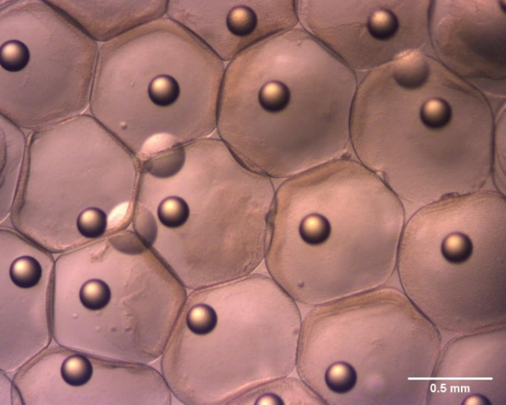
Some females that did not ovulate after an initial injection were subsequently induced to spawn after receiving a second injection of LHRHa at 30 μg/kg.
Figure 4. Ovulated dusky flathead eggs.

Ovulated eggs
Ovulated eggs stripped from dusky flathead were transparent, 0.60-0.98 mm in diameter and with a single oil globule (Figure 4).

Stripping and fertilising ovulated eggs
Eggs from ovulated females were hand-stripped and fertilised with milt stripped from males. A wet fertilisation method was used (Figure 5). Fish were sedated in Aqui-S before stripping. Both eggs and milt were stripped simultaneously into a 10 L bucket containing about 3-5 L seawater that was lightly aerated. Eggs were kept in the bucket and aerated for up to 10 mins before being transferred to an egg incubation tank. Dry fertilisation has been attempted but was less effective.

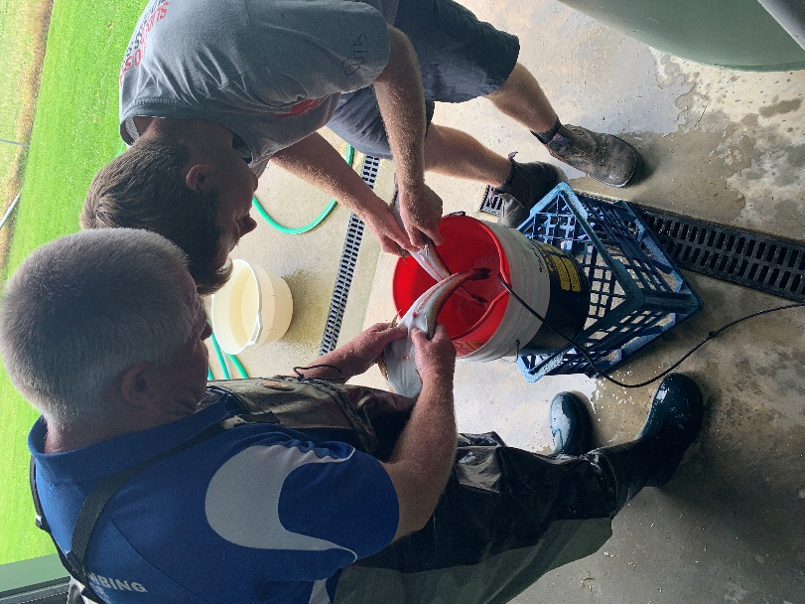
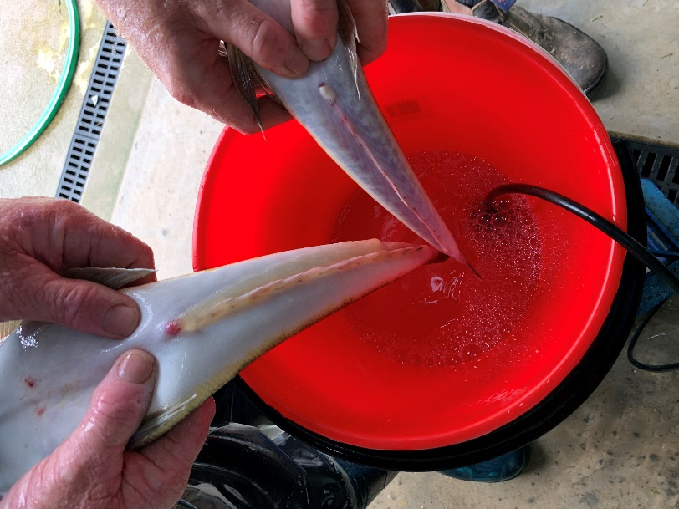
Figure 5. Stripping eggs and milt from dusky flathead.

Latency period and fertilisation rate
The latency period is defined as the time between hormone injection and stripping of gametes.
Following injection broodstock were placed into insulated circular tanks that were covered to reduce light and disturbance. Tanks were aerated and provided with a submersible pond pump to circulate water within the tanks. There was no water exchange. During the latency period water temperature and salinity ranged from 18-23ºC and 20-33 ppt, respectively.
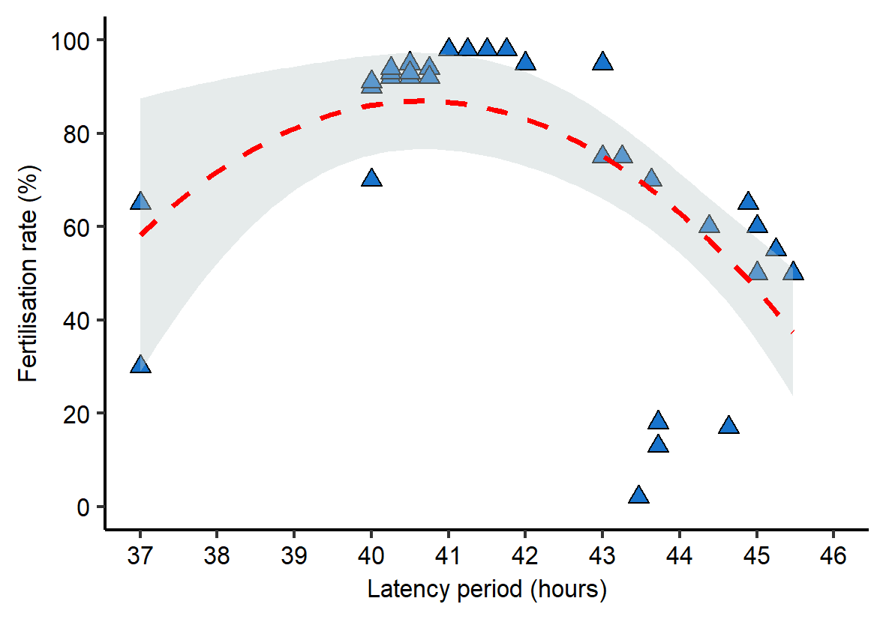
During 2021, 2022 and 2023 breeding trials fish were stripped 35 - 46 hours after an initial injection. Egg fertilisation rate ranged from 2-98% (mean 68%) with the highest values being recorded for fish stripped from 40-43 hours after injection (Figure 6). In comparison, fertilisation rates for dusky flathead eggs stripped at the BIRC ranged from 50-95% (P. Palmer, pers comm.).
Figure 6. Relationship between latency period and fertilisation rate for stripped dusky flathead
(red line = second degree polynomial curve).
Fish that received a second injection of LHRHa were stripped 35-37 hours later, and had fair to good fertilisation rates (up to 80%).
Variation in the latency period may be related to the maturity of fish, seasonality, water temperature and salinity at the location in the estuary where wild fish were caught (and proximity to spawning sights in estuaries). Sustained rainfall resulting in lower salinity in estuaries at the time broodstock were captured may have either delayed or impeded oocyte maturation leading to reduced spawning success and fertilisation rates for some fish.
Batches of eggs with low fertilisation rates (< 10%) were discarded due to difficulty in maintaining hygienic conditions.
Fertilised eggs are positively buoyant, which helps to separate them from negatively buoyant non-fertile eggs, which is typical of marine species with buoyant eggs (e.g. Partridge et al. 2003, Sundby and Kristiansen 2015, Hutchison et al. 2022). At Narooma Aquaculture separation of viable (fertilised) and non-variable eggs was achieved by briefly reducing aeration in tanks to allow non-fertile eggs to sink before being removed.

Natural spawning with and without use of hormones
Natural spawning in wild-caught broodstock after capture without the use of hormones has not been recorded.
During the spawning trials in January 2022, nine tanks were stocked with both female and male dusky flathead that were injected with a hormone (40 μg/kg LHRHa) to induce ovulation. Each tank contained 3-6 females and 3-6 males. Spawning occurred in eight tanks sometime before 43 hours post injection (at 22ºC).
In tanks where natural spawning occurred after hormone injection fertilisation rates ranged from 0-60% (mean 17%), which were generally lower than for stripped fish.

Hormone induced spawning of captive-held broodstock
Hormone induced spawning of dusky flathead that have been held overwinter in captivity (held for at least 6 months) has yet to be attempted.

Egg incubation and hatching
Embryonic development was rapid. By 3 hrs post-fertilisation tiers of blastomeres (making up the blastodisc) could be clearly seen sitting proud of the yolk cell and epiboly was complete by 8 hrs post-fertilisation (Figure 7). At 24 hrs post-fertilisation the body of the embryo was wrapped around the yolk ball and the eye orbits and tail bud were visible. At this stage there were slight body movements. By 26 hrs the tail was free of the yolk ball and hatching commenced 27 hours after fertilisation (at 22ºC) (Figure 7).

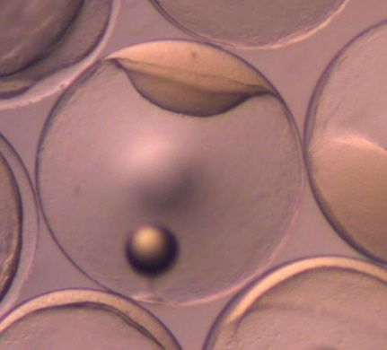
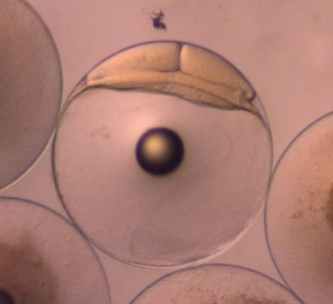
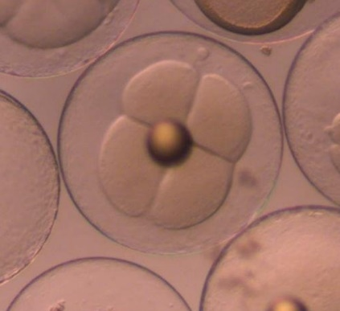
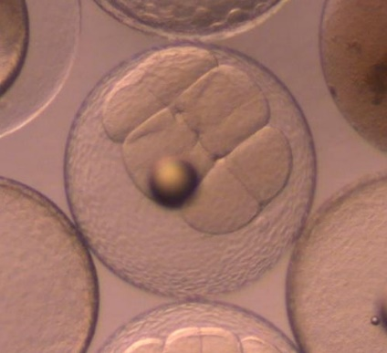
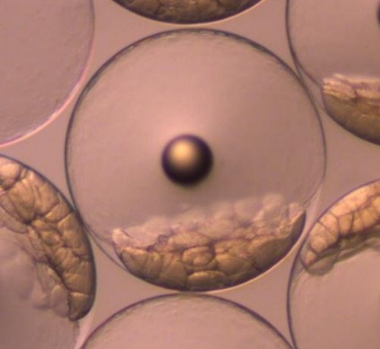
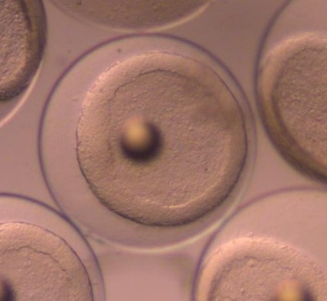
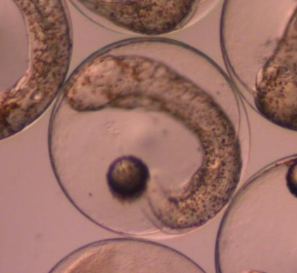
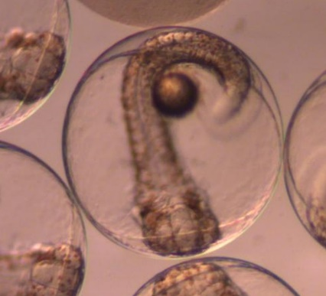
0.5 mm
(a) (b) (c)

(d) (e) (f)

(g) (h)
Figure 7. Embryonic development of dusky flathead. (a) Fertilsied egg. (b) 1 hr PF showing 2 cell cleavage. (c) 1.5 hrs PF showing 4-cell cleavage. (d) 2.1 hrs PF showing 8-cell cleavage. (e) 2.9 hrs PF, late cleavage period, blastodisc is apparent. (f) 7.4 hrs PF, epiboly completed. (g) 24 hrs PF. (h) 26 hrs PF. (PF = post-fertilsation).

Larvae and larviculture
At hatching larvae of dusky flathead were small, 1.75-1.89 mm in length, poorly developed and positively buoyant (Figure 8). The eye orbit, otic capsule and beating heart were visible but blood cells were not pigmented. The body of the embryo was covered with brownish melanophores. The yolk sac was cylindrical, just over half the length of the body and contained a single small oil globule at the posterior end. The mouth and pectoral fin buds were not apparent.
At Narooma Aquaculture, after hatching was completed, the aeration was reduced to allow any unhatched (dead) eggs to sink to the bottom of the tank and be removed by siphoning. After this, hydrogen peroxide was added to reduce bacterial loading. Larvae were not fed in the hatchery but stocked into fertilised earthen fry ponds at the onset of exogenous feeding, which occurred by the end of day 2 post-hatch.
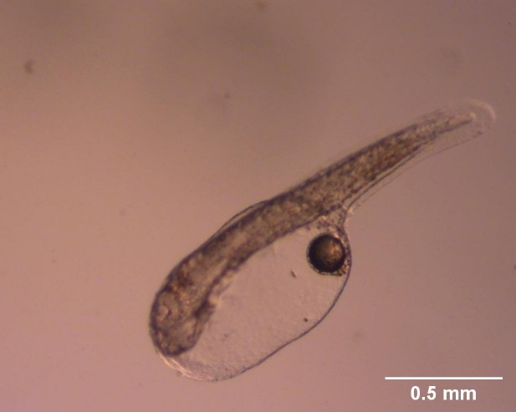
Figure 8. New hatched dusky flathead larva (27 hours post-fertilisation).

At the BIRC, dusky flathead larvae and fry of dusky flathead were reared using methods similar to those for barramundi (Palmer et al. 1992, Palmer et al. 2007). Initially larvae were reared in 5,000 L outdoor flat-bottomed tanks using controlled low-water exchange greenwater culture (GWC) methods (Palmer et al. 2007). Tanks, which had smooth light grey or light blue walls, were stocked with microalgae (Nanochloropsis ocilata), continuously aerated and covered with shade cloth to provide for low natural lighting. Larvae were transferred to the tanks prior to onset of feeding. Tanks were stocked with rotifers (Brachionus plicatilis), newly hatched brine shrimp (Artemia) nauplii and later nutritionally boosted brine shrimp nauplii as food for the larvae (Palmer et al. 2000, Butcher et al. 2003). Tanks were maintained at around 23ºC (using immersion heaters), salinity 30 ppt, pH 7.8-8.4 and total ammonia <1 ppm. Survival rates to metamorphosis during this stage, although difficult to estimate due to the small size and fragility of larvae, were generally high (>90%) (P. Palmer, pers comm.). After 15-19 days (18-22 days old), when larvae had metamorphosed to fry (approximately 11-15 mm in length), they were transferred to pre-fertilised nursery ponds (24-26.5ºC) for on-growing using natural plankton blooms.

Fry rearing (nursery culture)

Rearing in fertilised earthen ponds
Rearing of dusky flathead fingerlings at Narooma Aquaculture occurred in 0.06-0.07 ha earthen ponds that had been fertilised to encourage growth of plankton. Ponds were filled with brackish water (15-30 ppt) about 6 - 14 days before the planned stocking to allow time for the plankton blooms (especially rotifers) to develop. Before stocking, ponds were fertilised with superphosphate (30-70 kg/ha), ammonium sulphate (20-60 kg/ha) and muriate of potash (3-6 kg/ha), along with either lucerne or chaff, were added to encourage plankton blooms to develop.
Prior to stocking, larvae were acclimated to pond water conditions (i.e. salinity levels) by adjusting hatchery water to match the pond water conditions. Ponds were stocked with larvae at an estimated density of 25-50 larvae/m².
Pond temperatures typically ranged from 20-25ºC (up to 28ºC on hotter days).
Rearing the fry of dusky flathead at the BIRC was undertaken in outdoor fertilised nursey ponds (0.04 ha) using an extensive pond culture (“greenwater culture”) technique described by McGuren and Palmer (1997). In these ponds, fertilizers were added to encourage the growth of phytoplankton and, in turn, zooplankton (predominantly crustacean copepods), which was food for the fry. Nursery pond temperatures were 24-26.5ºC. Fry were stocked at densities up to 80,000 fry per 0.04 ha pond (up to 200 fry/m²), although lower stocking rates may have improved survival rates (Palmer et al. 2000).

Growth
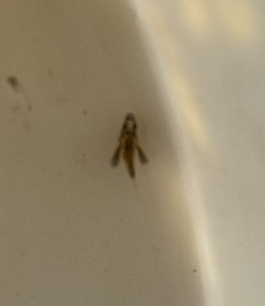
Prior to metamorphosis and becoming demersal, fry could be seen swimming in the water column (Figure 9). Growth rates of dusky flathead in fry rearing ponds at Narooma Aquaculture was highly variable, with fish of the same age reaching 27 to 85 mm after 9 weeks, which represents a growth rate of 0.38 – 1.25 mm/day (mean 0.62 mm/day) (Figure 10). The length-weight relationship for pond reared dusky flathead is best described by a 2nd degree polynomial equation (Figure 11).
Figure 9. Dusky flathead fry prior to metamorphosis.

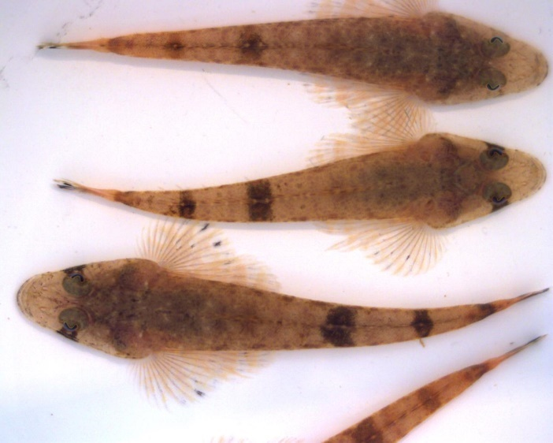
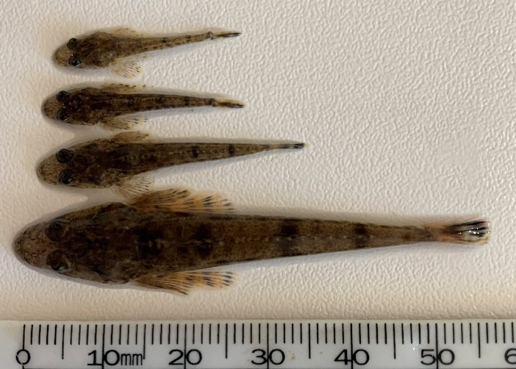
Figure 10. Appearance and size variation in dusky flathead fingerlings harvested from a fry rearing pond.

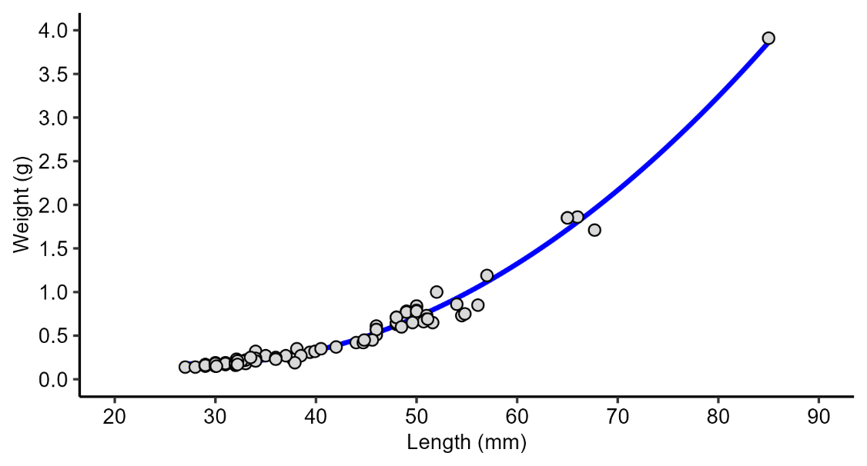
Weight = 0.0012·Length² – 0.0654·Length + 1.104
(R² = 0.98)
Figure 11. Length-weight relationship for pond-reared dusky flathead fingerlings.

Survival to harvest
Survival of dusky flathead to harvest of fry ponds at Narooma Aquaculture was highly variable, ranging from 0 – 50% after 8-9 weeks.
Rearing dusky flathead fry at the BIRC was undertaken through two sequential nursery pond phases, each lasting around 3 weeks, which was often necessary to grow fish to a larger fingerling size (40-50 mm). Survival rates during these two nursery pond phases was highly variable (12-100% for phase 1 and 20-68 % for phase 2) (Palmer et al. 2000). In comparison to dusky flathead, bartail flathead larvae reach a size of 31-40 mm TL with a survival rate of 11-27% by 50 days after hatching (Hotta 2000).
High variability in survival of pond-reared flathead fry has been attributed to:
- Irregular (and unpredictable) development of zooplankton blooms in the ponds (Palmer et al. 2000). This can be a feature of greenwater pond culture affecting growth and survival of fry (Anderson and Tave 1993, Culver and Geddes 1993).
- Entanglement and entrapment of fingerlings in mats of filamentous algae during harvest (Palmer et al. 2000). This problem has been experienced in some ponds at Narooma Aquaculture during 2021.
- Cannibalism, which is also a problem in the culture of juvenile bartail flathead (Hotta 2000). This may be exacerbated by the highly variable growth of fish and when food (prey) is limited (Baras and Jobling 2002).
- Fish stranding during harvest. Dusky flathead fingerlings tend to sit on the pond bottom, even in very shallow water and if the pond was drained too quickly fish became stranded out of water.
- Low salinity at the time of stocking and during the culture period. In 2022, the failure to recover fish from two ponds at Narooma Aquaculture was attributed to very low salinity (down to 5 ppt) in ponds during filling (typically ponds have a salinity > 15 ppt).
  - Low salinity may stress or even kill dusk flathead larvae; however, their salinity tolerance is unknown. Reducing salinities to 5 ppt during marking of dusky flathead fingerlings with oxytetracycline caused increased mortalities (Butcher et al. 2003).
  - Since dusky flathead lack a swim bladder, high salinity may help to keep larvae buoyant. However, at low salinities larvae may need to consume more energy to stay in the water column and amongst prey (plankton).
  - Reduced salinity may affect productivity of marine and brackish water plankton species (Brand 1984, Paturej and Gutkowska 2015), thereby reducing food (prey) availability.
- Rainfall. High rainfall and run-off of freshwater from land surrendering the ponds may not only reduce pond salinity but also cause loss of food (prey) with overflow of pondwater. An extended period of overcast in rainy days in 2020 may also have limited photosynthetic productivity

Nutritional requirement and feeding
There is no published information on the nutritional requirements of flathead in captivity. Experiences at the BIRC indicated that both captive-held broodstock and juveniles harvested from ponds were very difficult to wean onto artificial diets (pellets), but with persistence this was achieved for at least with one group of larger fingerlings (P. Palmer, pers comm.). Weaning difficulty has also been observed in bartail flathead (P. indicus) (Hotta 2000). Instead, fish have been fed on either live food (e.g. brine shrimp for juveniles), or fresh and thawed food (e.g. pilchards).

Diseases and health management
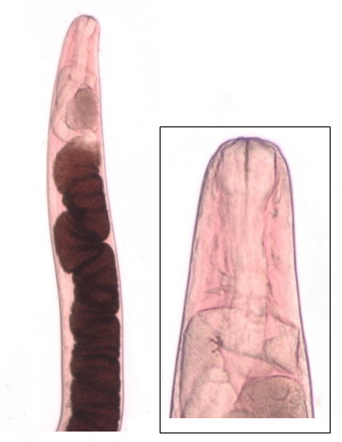
There have been no major diseases encountered in dusky flathead in captivity (Palmer et al. 2000). At the BIRC a standardized quarantine procedures involved treating newly collected wild broodstock with baths of freshwater and formalin to reduce parasite loads, and if injury had occurred at the time of capture, they were treated with OTC to minimize development of secondary bacterial infections (P. Palmer, pers comm.). Overseas, mass mortality of hatchery reared larvae due to viral nervous necrosis has been reported in bartail flathead in Japan (Song et al. 1997).
Figure 12. Nematode (c.f. Philametra sp.) from the gonads of dusky flathead.
At Narooma Aquaculture, newly caught broodstock were isolated in static tanks and their health monitored.
During breeding trials at Narooma Aquaculture large (up to 5 cm long), red-coloured nematodes (Figure 12) could be expressed from the gonads of some fish. The nematode was tentatively identified as a species of Philametra, which has previously been described from dusky flathead (e.g. Hossen et al. 2021). The effects of these nematodes on flathead are unknown, although their presence in large numbers may reduce fecundity and egg quality.
A list of known diseases and parasites recorded from dusky flathead is provided in Appendix I.

Conclusions and recommendations
This report has provided preliminary information on the breeding of dusky flathead and the production of fingerlings for stocking by drawing on experiences at the Narooma Aquaculture and available published literature. Over three breeding seasons a total of 133,700 fingerlings produced at Narooma Aquaculture were stocked into waters in eastern Victoria (Table 6) (Figure 13). At time of release fish ranged from 22 – 85 mm (median 36 mm) in length and 0.14-3.91 g (median 0.32 g) in weight. Based on the number of females injected each year and the number of fingerlings stocked each year, the level of production was 760-1,650 fingerlings per injected female (1,400-2,600 fingerlings/kg).

Table 6. Number and size of hatchery-bred dusky flathead fingerlings stocked into waters between 2021 and 2023.
Water | Location | 2021 | 2022 | 2023 | Total
Bemm River | Bemm River | 5,000 |  | 5,000 | 10,000
Gippsland Lakes | Bancroft Bay (Metung) | 2,000 |  |  | 2,000
 | Cunningham Arm (Lakes Entrance) |  | 25,000 | 18,200 | 43,200
 | Lake King (Metung) | 20,000 |  | 9,700 | 29,700
 | North Arm (Lakes Entrance) | 20,000 | 10,600 | 18,200 | 48,800
Total |  | 47,000 | 35,600 | 51,100 | 133,700
Average weight (g) |  | 0.24 | 0.27 | 0.47 | 0.34

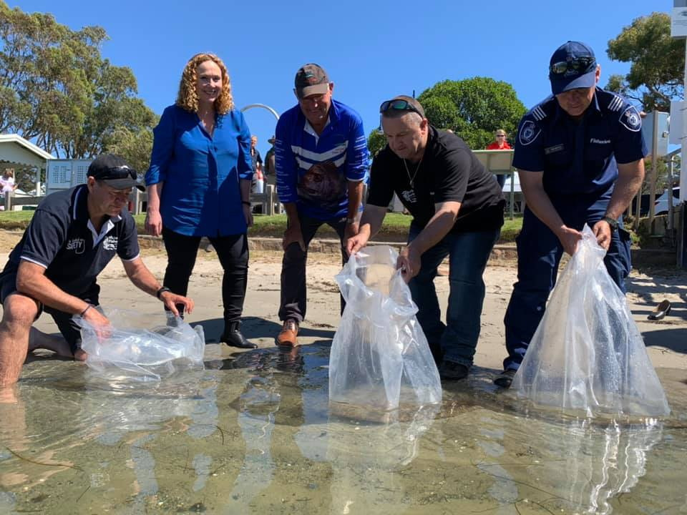
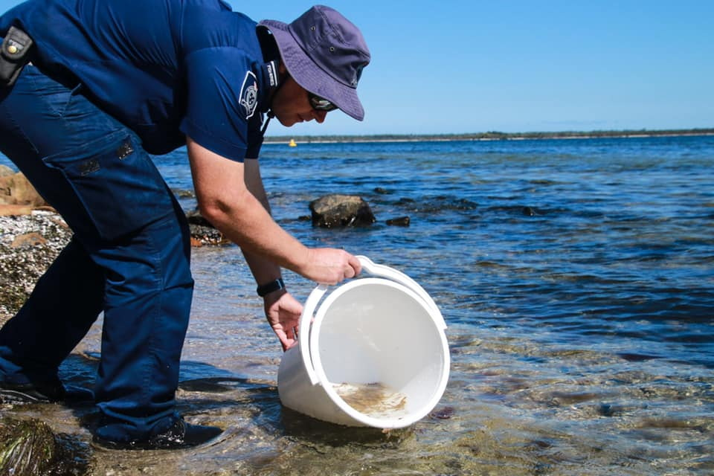
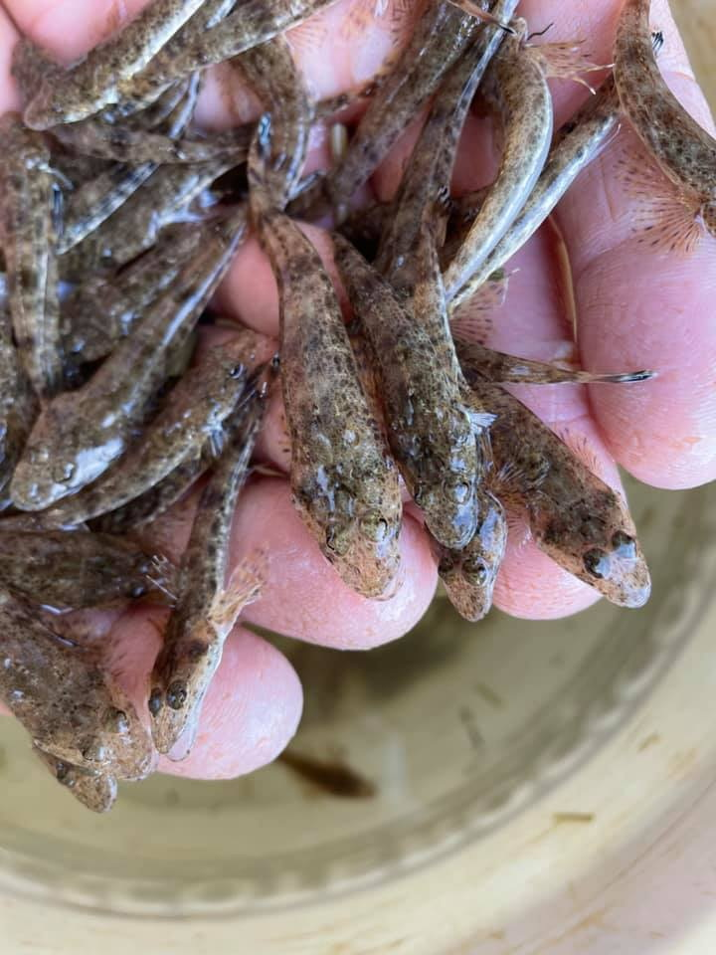
Figure 13. Releasing dusky flathead fingerlings into Gippsland Lakes.

Some recommendations for future dusky flathead breeding include the following.
- Although post-capture and transport mortality of broodstock was very low, addition of stress reducing chemicals to transport water, such StressGuardTM and PrimeTM (Seachem Laboratories, Madison, USA), may help alleviate stress and consequently improve wellbeing of fish and spawning outcomes
- Dusky flathead appear to prefer water movement within the tanks. Installation of a 12-volt water pump into transport tanks will facilitate water circulation, and also eliminate dead spots that may be low in dissolved oxygen (D. White, pers comm).
- Since dusky flathead are thought to spawn multiple times within a season (Bani and Moltschaniwskyj 2008, Gray and Barnes 2015), it may be possible that broodstock induced to spawn early in the spawning season can be re-conditioned and induced to spawn later in the season to increase level of production per fish. Some broodstock may be stocked into a dam and checked again later in the season to determine if they have mature eggs suitable for spawning.
- Time between capture in the wild and induction of spawning may influence gamete quality due to stress associated with capture, holding and transfer to captive conditions. Injecting broodstock as soon as possible after capture may reduce the effects of capture stress on gamete quality.
- Some changes to hatchery design may improve management of spawning. For example, holding females individually in smaller tanks after injection may aid with more actuate timing of stripping of individuals.
- The highly variable number of fingerlings harvested from ponds was attributed to several factors including:
  - Lack of food (i.e. stocking ponds at a time when plankton blooms lacked appropriate prey)
  - Death from entanglement and entrapment in filamentous algae
  - Cannibalism
  - Death from stranding during pond harvest
  - Negative effects of low salinity on both plankton bloom development and fish survival.
Options to improve recovery of fingerling from ponds may include:
  - Monitor plankton bloom development to ensure larvae are stocked at a time when preferred prey is present and abundant.
  - Explore options to manage filamentous algae blooms, such as manipulation of nitrogen and phosphorus concentrations (Mischke 2012)
  - Slow the rate of pond drainage to reduce stranding
  - Explore options for maintaining salinity in fry rearing ponds, such as constructing a large reservoir for storing saline water for use during low salinity periods and constructing dikes to divert rainwater run-off away from ponds.

Acknowledgements
The authors acknowledge the support of the Victorian Fisheries Authority (VFA) for funding production of dusky flathead at Narooma Aquaculture. Bev Lawson and Bradley Lawson (Narooma Aquaculture) are thanked for their assistance in the hatchery. The authors wish to thank Craig Ingram (VFA) and Dylan White (VFA) for comments on broodstock capture and transport. Dr Paul Palmer, Bribie Island Research Centre (BIRC), Queensland Department of Agriculture and Fisheries (QDAF), Woorim, Qld, provided advice on dusky flathead breeding at the BIRC in the mid-1990s.

References
Anderson, R.O. and Tave, D. eds. (1993). Strategies and tactics for management of fertilized hatchery ponds. The Hawthorne Press, New York. 256 pp.
Bani, A. and Moltschaniwskyj, N. (2008). Spatio-temporal variability in reproductive ecology of sand flathead, Platycephalus bassensis, in three Tasmanian inshore habitats: potential implications for management. Journal of Applied Ichthyology 24 (5): 555-561.
Baras, E. and Jobling, M. (2002). Dynamics of intracohort cannibalism in cultured fish. Aquaculture Research 33 (7): 461-479.
Bell, J.D., Bartley, D.M., Lorenzen, K. and Loneragan, N.R. (2006). Restocking and stock enhancement of coastal fisheries: Potential, problems and progress. Fisheries Research 80 (1): 1-8.
Brand, L.E. (1984). The salinity tolerance of forty-six marine phytoplankton isolates. Estuarine, Coastal and Shelf Science 18 (5): 543-556.
Butcher, A. (2006). Maroochy Fish Stocking Program. Pp. 78-81. In: Research, Development and Extension Priorities for Stock Enhancement, Fish Stocking and Stock Recovery National Workshop. Fisheries Research and Development Corporation and Recfish Australia, Brisbane, 6-7 February 2006.
Butcher, A., Burke, J. and Brown, I. eds. (2000). The Maroochy Estuary Fish-stocking Program 1995–99. Final Report. Department of Primary Industries, Queensland. 103 pp.
Butcher, A., Mayer, D., Willett, D., Johnston, M. and Smallwood, D. (2003). Scale pattern analysis is preferable to OTC marking of otoliths for differentiating between stocked and wild dusky flathead, Platycephalus fuscus, and sand whiting, Sillago ciliata. Fisheries Management and Ecology 10: 163-172.
Conron, S., Bell, J.D., Ingram, B.A. and Gorfine, H.K. (2020). Review of key Victorian fish stocks - 2019. Victorian Fisheries Authority Science Report Series No. 15. Victorian Fisheries Authority, Queenscliff. 173 pp.
Conron, S. and Hamer, P. (2018). Status of dusky flathead populations in Victoria. Pp. 11-12. In: 2018 Dusky Flathead Symposium: Proceedings (Lakes Entrance, 10 March 2018). Victorian Fisheries Authority, Melbourne.
Culver, D.A. and Geddes, M.C. (1993). Limnology of rearing ponds for Australian fish larvae: relationships among water quality, phytoplankton, zooplankton, and the growth of larval fish. Australian Journal of Marine and Freshwater Research 44: 537-551.
Gray, C. and Barnes, L. (2015). Spawning, maturity, growth and movement of Platycephalus fuscus (Cuvier, 1829) (Platycephalidae): fishery management considerations. Journal of Applied Ichthyology 31 (3): 442-450.
Gray, C.A. and Barnes, L.M. (2008). Reproduction and growth of dusky flathead (Platycephalus fuscus) in NSW estuaries. Fisheries Final Report Series No. 101. NSW Department of Primary Industries. 26 pp.
Hicks, T., Kopf, R.K. and Humphries, P. (2015). Fecundity and egg quality of dusky flathead (Platycephalus fuscus) in East Gippsland, Victoria. Institute for Land Water and Society, Charles Sturt University. Institute for Land Water and Society, Charles Sturt University, Report number 94. 34 pp.
Hindell, J.S. (2008). Gippsland Lakes dusky flathead tracking project. Recreational Fishing Grant Program – Research report October 2008. R/05/06/01. Arthur Rylah Institute, Department of Sustainability and Environment.
Hossen, M.S., Wassens, S. and Shamsi, S. (2021). Integrative species delimitation and community structure of nematodes in three species of Australian flathead fishes (Scorpaeniformes: Platycephalidae). Parasitology Research 120 (2): 461-480.
Hotta, K. (2000). Seed production of a marine teleost, Platycephalus sp. Bulletin of Toyama Prefectural Fisheries Research Institute (Japan).
Hutchison, M., Norris, A. and Nixon, D. (2022). The effect of salinity on jungle perch Kuhlia rupestris egg buoyancy and larval hatch rates. Aquaculture Research First published on-line 16 April 2022.
Ingram, B.A. (2019). Feasibility of stocking to enhance flathead fisheries. Recreational Fishing Grants Program Research Report, January 2019. Victorian Fisheries Authority, Melbourne. 35 pp.
Ingram, B.A. and De Silva, S.S. (2015). General aspects of stock enhancement in fisheries developments. In: Perspectives on culture-based fisheries developments in Asia. NACA Monograph Series No. 3 (De Silva, S.S., Ingram, B.A. and Wilkinson, S. eds.), pp. 27-37. Network of Aquaculture Centres in Asia-Pacific, Bangkok, Thailand.
Ingram, B.A., Ho, H.K., Turchini, G.M. and Holland, M. (2012). Gamete quality and spawning in captive Murray cod broodstock. Fisheries Victoria Research Report Series No. 58. Department of Primary Industries, Melbourne. 69 pp.
McGuren, J.J. and Palmer, P.J. (1997). Management of lined ponds at BIARC. Austasia Aquaculture 11 (3): 63-64.
Mischke, C.C. ed. (2012). Aquaculture pond fertilization: Impacts of nutrient input on production. John Wiley & Sons, Oxford.
Nicholson, G. and Gunthorpe, L. eds. (2008). Lake Tyers Fish Habitats 2006. Compiled by the Fish Habitat Assessment Group, Fisheries Victoria Assessment Report Series No. 45. Fisheries Victoria, Queenscliff. 25 pp.
Palmer, P., Burke, J., Burke, M., Cowden, K., McGuren, J. and Butcher, A. (2000). Develop the expertise and technology to induce captive dusky flathead and sand whiting to spawn on demand. In: The Maroochy Estuary Fish-stocking Program 1995-99. Final Report (Butcher, A., Burke, J. and Brown, I. eds.), pp. 26-36. Department of Primary Industries, Queensland.
Palmer, P.J., Burke, J.B., Willett, D.J. and Simpson, R.R. (1992). Development of a Low-Maintenance Technique for Rearing Barramundi (Bloch) Larvae. Queensland Department of Primary Industries Information Series. no.QI92036. Queensland Department of Primary Industries, Queensland. 19 pp.
Palmer, P.J., Burke, M.J., Palmer, C.J. and Burke, J.B. (2007). Developments in controlled green-water larval culture technologies for estuarine fishes in Queensland, Australia and elsewhere. Aquaculture 272 (1): 1-21.
Partridge, G.J., Jenkins, G.I. and Frankish, K.R. (2003). Hatchery Manual for the Production of Snapper (Pagrus auratus) and Black Bream (Acanthopagrus butcheri). Western Australian Maritime Training Centre Challenger TAFE, Fremantle. 152 pp.
Paturej, E. and Gutkowska, A. (2015). The effect of salinity levels on the structure of zooplankton communities. Archives of Biological Sciences 67 (2): 483-492.
Song, Z.R., Kanai, K., Yoshikoshi, K., Niiyama, H., Honda, A. and Ura, K. (1997). Mass mortalities of hatchery-reared larvae and juveniles of bartail flathead, Platycephalus indicus associated with viral nervous necrosis. Aquaculture Science 45 (2): 241-246.
Sundby, S. and Kristiansen, T. (2015). The principles of buoyancy in marine fish eggs and their vertical distributions across the world oceans. PLoS One 10 (10): e0138821.
Taylor, M.D., Becker, A., Quinn, J., Lowry, M.B., Fielder, S. and Knibb, W. (2020). Stock structure of dusky flathead (Platycephalus fuscus) to inform stocking management. Marine and Freshwater Research 71 (10): 1378-1383.
Victorian Fisheries Authority (2020). Gippsland Lakes Recreational Fishery Plan 2020. Victorian Fisheries Authority, Melbourne. 18 pp.
Welcomme, R.L. and Bartley, D.M. (1998). Current approaches to the enhancement of fisheries. Fisheries Management and Ecology 5: 351-382.

Appendix I: Known diseases and parasites recorded from dusky flathead
Parasite and disease group | Species | Body area affected | Reference
Crustaceans | Colobomatus rothae |  | West (1992)
Acanthocephalans | Corposoma ciavaturn |  | Johnston & Edmonds (1952)
 | Echinorhynchus sp. |  | Johnston (1910), Johnston & Deland (1929)
 | Serrasentis sagittifer  [syn S. socialis] |  | Johnston & Deland (1929), Yamaguti (1963), Young (1939)
Cestodes | Tetrarhynchus spp. |  | Johnston (1910)
Nematodes | Philometrids | Ovaries | Pollard (2014)
 | Philametra |  | Hossen et al. (2021)
 | Spirocamallanus platycephali | Lumen of intestine & rectum | Hooper (1983)
 | Thynnascaris sp. (type III) | Mesentery & organs of guts | Hooper (1983)
Monogeneans | Platycephalotrema mastix  [syn Pseudohaliotrema thysanophrydis] | Gills | Young (1968), Kritsky & Nitta (2019)
 | Platycephalotrema koppa | Gills | Kritsky & Nitta (2019)
Digeneans | Didymozoon brevicolle | Stomach wall | Lester (1980)
 | Indodidymozoon moretonensis | buccal cavity and branchial arches | Anderson & Cribb (1994)
 | Indodidymozoon suttiei | Flesh | Anderson & Cribb (1994)
 | Neometadidymozoon helicis | gill arches, walls of buccal cavity & underside of head | Lester (1979, 1980)
 | Rhopalotrema elusiva | Fins | Anderson (1998)
Skeletal abnormalities (Heterostosis) |  | skeleton | Johnson (1973)

References
Anderson, G.R. (1998). Rhopalotrema (Digenea: Didymozoidae), a new genus from Australian platycephalid fishes. Systematic Parasitology 41 (2): 81-86.
Anderson, G.R. and Cribb, T.H. (1994). Five new didymozoid trematodes (Platyhelminthes, Digenea) from Australian platycephalid fishes. Zoologica Scripta 23 (2): 83-93.
Hooper, J.N.A. (1983). Parasites of estuarine and oceanic flathead fishes (Family Platycephalidae) from Northern New South Wales. Australian Journal of Zoology 90: 1-69.
Hossen, M.S., Wassens, S. and Shamsi, S. (2021). Integrative species delimitation and community structure of nematodes in three species of Australian flathead fishes (Scorpaeniformes: Platycephalidae). Parasitology Research 120 (2): 461-480.
Johnson, C.R. (1973). Hyperostosis in fishes of the genus Platycephalus (Platycephalidae). Japanese Journal of Ichthyology 20 (3): 178-178.
Johnston, T.H. (1910). Notes and exhibitions - Entozoa. Proc. Linn. Soc. N.S.W. 35: 309-311, 522-523, 659-660, 804.
Johnston, T.H. and Deland, E.W. (1929). Australian Acanthocephala No.1 Census of recorded hosts and parasites. Trans Proc. Roy. Soc. S. Aust. 53: 146-154.
Johnston, T.H. and Edmonds, S.J. (1952). Australian Acanthocephala. No. 9. Transactions of the Royal Society of South Australia 75: 16-21.
Kritsky, D.C. and Nitta, M. (2019). Dactylogyrids (Platyhelminthes: Monogenoidea) infecting the gill lamellae of flatheads (Scorpaeniformes: Platycephalidae), with proposal of Platycephalotrema n. gen. and descriptions of new species from Australia and Japan. Diversity 11 (8): 132.
Lester, R. (1979). Descriptions of two new didymozoids from Australian fishes. The Journal of Parasitology: 904-908.
Lester, R. (1980). Host-parasite relations in some didymozoid trematodes. The Journal of Parasitology: 527-531.
Pollock, B. (2014). The annual spawning aggregation of dusky flathead Platycephalus fuscus at Jumpinpin, Queensland. Proceedings of the Royal Society of Queensland 119: 21.
West, G.A. (1992). Eleven new Colobomatus species (Copepoda: Philichthyidae) from marine fishes. Systematic Parasitology 23 (2): 81-133.
Yamaguti, S. (1963). Systema Helminthum: Acanthocephala. Vol. V. Interscience Publs, New York.
Young, M.R. (1939). Helminth parasites of Australia. A bibliography with alphabetical lists of authors, hosts and parasites. Tech. Comm. Bur. Helminth., St. Albans 23: 1-141.
Young, P.C. (1968). The taxonomy of some Dactylogyrid Monogenoidea from Australian fishes. Zoologischer Anzeiger: 269-279.

Condition (K) = weight (g) / (length (mm) x 10³) x 100.
Total number of post-vitellogenic oocytes in ovaries without atresia or post-ovulatory follicles.
Relative fecundity: potential fecundity / ovary free body mass (g).

