How does trout stocking contribute to wild trout fisheries?

John Douglas¹ and Jason Lieschke²
¹ Fisheries Victoria, DEDJTR, ² Arthur Rylah Institute, DELWP

Aim:
To understand whether trout stocking helps the wild brown trout river fisheries recover.

Background:
Fish stocking is an important tool in fisheries management and has been used for centuries in various applications.
One of the most important questions regarding stocking is “Do the stocked fish increase the overall number of fish in the population?”. Stocking results can vary depending on the environment and scenario, therefore we can’t assume it work’s everytime. For example, stocking can be very effective when recruitment is lacking—like the trout fisheries in many of Victoria’s lakes—however, it has found to be less effective when there is natural recruitment occurring.
Past fisheries research in Victoria on wild trout fisheries, and on fisheries worldwide, suggest that stocking on top of existing self-sustaining (breeding) populations is generally an ineffective long-term strategy to enhance wild stocks because it often provides a very low-return to anglers at considerable expense. In many instances, it is the other environmental conditions that constrain the size of the fish population, not recruitment levels.
However, anglers have a strong affinity with fish stocking as it seems to be logical that if you put fish in then there will be more fish in the river. Under this context stocking can often be seen as a fisheries management panacea or cure all, but the issue is much more complex and revolves about what is the limiting factor(s) of the population, and then, what is the best approach for intervention. If it is recruitment issues then stocking may be an effective option.
There is a case to reassess the effectiveness of fish stocking to enhance the wild trout fisheries in Victoria and to better communicate findings, educate stakeholders and re-examine the cost-effectiveness of this management option.
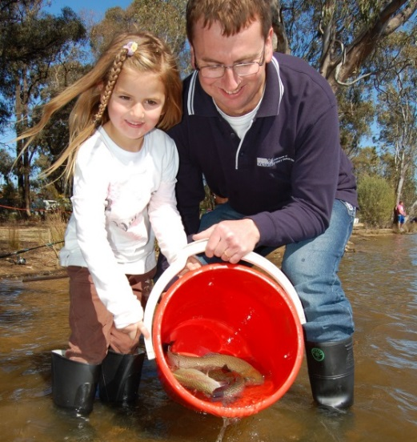
Fish stocking is an important fisheries management tool for improving fishing in key places and this project assessed whether it can assist wild trout fisheries recover.

What we did:
Undertake two stocking trials, one in the upper Goulburn River above Lake Eildon and another in the Howqua River. To date there have been two stocking events in each river, and one assessment in each river. Each river has received 5,000 one-year-old brown trout in 2014 and again in 2015. Stocking will continue in 2016. To identify the stocked fish from the wild fish, the stocked fish have been fin clipped.
All stocked fish have been clipped by the volunteers from the Mansfield and District Flyfishing Club who
also assisted in the release. The proportions of stocked fish and changes to overall fish abundance in the trout fishery and population will then be assessed as part of the monitoring of trout population and angler creel survey.
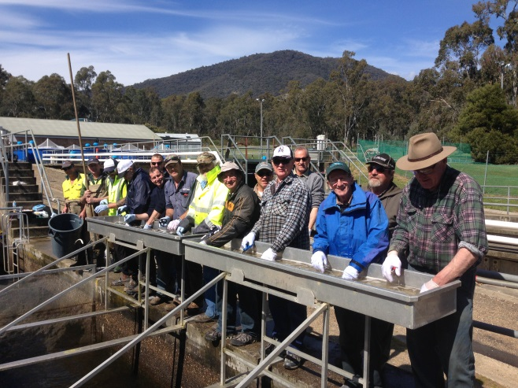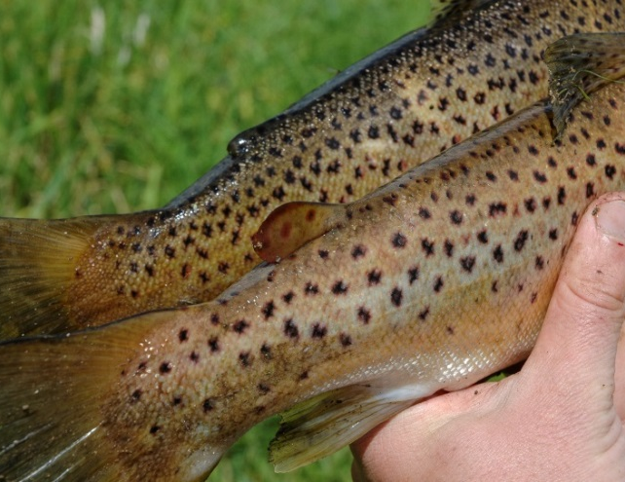
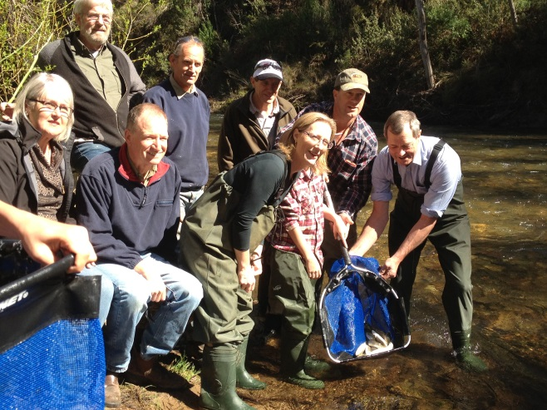
Volunteer Mansfield fishers assisted finclipping (adipose fin in 2015) and stocking the fish for the trial.
Key findings and implications to date:
The survey confirmed stocked fish survival in both rivers, which is a great start. However we need to collect more information on how those stocked fish move through the fishery, before we can interpret the success of the trial stockings.

Next steps:
- The third and final stocking of 5000 fish into each water is planned for winter 2016.
- Follow up surveys will provide information on the proportion of the population made up by the
stocked fish

