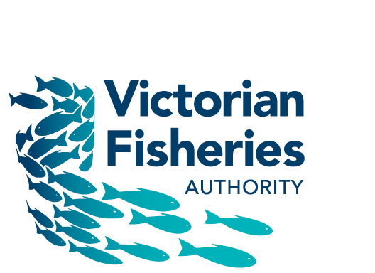

FISHERIES (VICTORIAN PIPI) NOTICE 2019 - Information Page

The management arrangements implemented by the Fisheries (Victorian Pipi) Notice 2019 (the Notice) continues the arrangements put in place in 2017.
These arrangements are in place until the Victorian Pipi Fishery (guided by the Victorian Pipi Fishery Management Plan 2018) is established in 2020.
The Notice continues the following management arrangements for commercial pipi harvest in Victoria:
- Opening marine waters to commercial pipi harvest except for a specified closed area in Venus Bay (to minimise conflict with recreational pipi harvest);
- Specifying a zero catch limit for all Ocean Fishery Access Licence (OFAL) holders, except for OFAL holders who are issued with an Endorsement Notice;
- For OFAL holders who are issued with Endorsement Notice, specifying:
  - a catch limit of 150kgs per day/trip, and 8 fishing days per calendar month;
  - a minimum size limit of 35mm;
  - a requirement to prior-report (and to cancel if deciding not to proceed), and post-report, fishing activity, and
  - a requirement to harvest pipi via one of four access points in Discovery Bay. No access points are specified for other parts of the State.
The four access points specified for Discovery Bay are the Nelson Ocean Beach Walking Track, the Noble Rocks Walking Track, Lake Mombeong Walking Track and the Swan Lake Access Track.
In addition, there will be total catch limits for two areas in Discovery Bay: 10 tonne from the South Australia/Victoria border to Sutton Rocks, and 50 tonne from Sutton Rocks to the northern border of Discovery Bay Marine National Park.
In order to qualify for an Endorsement Notice, OFAL holders must have harvested 1 tonne, or more, between 1 January 2012 and 31 December 2016, in any part of the State. In order to meet the aim of a sustainable, viable, small-scale, commercial pipi fishery, it is necessary to restrict the number of participants as there is considerable latent effort in the Ocean Fishery Access Licence class.

