2018-19 Ocean Scallop Fishery Total Allowable Commercial Catch
Statutory Consultation Plan
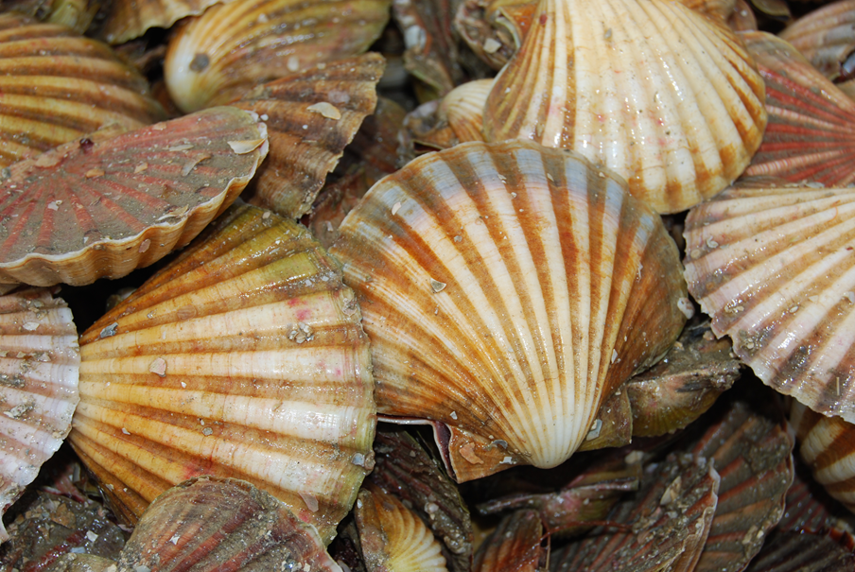

Contents
Preamble 3
Closing date for submissions 3
Flow chart of consultation 4
Consultation Plan 5
Notes 7

Preamble
Any submissions received in relation to the consultation being conducted by the Victorian Fisheries Authority will be published on the Victorian Fisheries Authority website. In making a submission, unless the person making the submission indicates to the contrary, they will be consenting to their submission, including their name only, being published on the Victorian Fisheries Authority website for 90 days from the conclusion of the consultative process.

Closing date for submissions
The closing date for the receipt of submissions for consultation on this matter is Thursday 8 March 2018.

Flow chart of consultation

Victorian Ocean Scallop Fishery Licence renewals are sent to Victorian Ocean Scallop Fishery Licence Holders before 1 April 2018
Victorian Fisheries Authority will publish the decision from the Chief Executive Officer Victorian Fisheries Authority regarding the 2018/19 fishing season in the Victoria Government Gazette before 1 April 2018

Victorian Fisheries Authority will write to all Scallop Fishery Licence Holders and key stakeholders to inform them about the decision before 1 April 2018
Outcomes of the consultation will form the basis of a recommendation to the Chief Executive Officer of the Victorian Fisheries Authority (as delegate of the Minister)
Stakeholders will be asked to provide written submissions regarding the proposed actions by 8 March 2018

Inform all Victorian Ocean Scallop Fishery Licence Holders and other key stakeholders of the proposed TACC for 2018/19

Consultation Plan

1 | Consultation Title | 2018/19 Ocean Scallop Total Allowable Commercial Catch
2 | Representative group/s being consulted | Commercial wild-catch: (Seafood Industry Victoria, Victorian Ocean Scallop Licence Holders),  Recreational fishing:  Aquaculture  Aboriginal communities:  Conservation interests: (Environment Victoria)  Other group/s (please specify):
3 | Managing Officer | Toby Jeavons, Marine and Estuarine Fisheries Manager
4 | Target Start Date | 15 February 2018
5 | Target End Date | 8 March 2018
6 | Background/History | The next quota period for the Victorian Ocean Scallop Fishery commences on 1 April 2018 and extends to 31 March 2019. A Total Allowable Commercial Catch (TACC) is determined each year for the fishery and distributed evenly amongst the 90 licence holders.  The TACC was set at zero tonnes for the 2010/11, 2011/12 and 2013/14 seasons due to the stock assessment surveys in 2009 and 2012 finding that the fishery was neither commercially nor biologically viable. The TACC was set at 135 tonnes in 2014/15, or 1.5 tonne per licence, and it has remained at this level since.  A 2018 stock assessment survey has been completed and indicates a continued low level of abundance throughout the fishery. Whilst the survey did find commercially available scallops, they were not at a level considered sufficient to provide ongoing recruitment to the fishery and justifiable of a TACC increase.
7 | Relevant Statutory provision | Sections 3A (consultation) and Section 64A (Further quota order of the Fisheries Act 1995)
8 | Purpose/objectives/scope | To inform stakeholders of the Fisheries Victoria proposal to implement a 135 tonne TACC for the 2018/19 season.
9 | Method | Broad industry consultation with key stakeholders via written communication.
10 | Communication Plan | Victorian Fisheries Authority will communicate the results of the consultation via publication in the Victoria Government Gazette and through written communication to licence holders and key stakeholders.
11 | Information provision | A letter detailing the proposed management arrangements including the draft Further Quota Order will be distributed to all identified stakeholders.
12 | Resources/advice (inc. purchase of advice) | Internal resources of the Victorian Fisheries Authority.
13 | Output (documentation / implementation) | A recommendation will be made to the Chief Executive Officer Victorian Fisheries Authority (as delegate) regarding the arrangements for the 2018/19 fishing season and the resulting decision will be published in the Victoria Government Gazette.
14 | Publication of results of consultation | Submissions received in relation to the consultation being conducted by the Victorian Fisheries Authority will be published on the Victorian Fisheries Authority website. In making a submission, unless the person making the submission indicates to the contrary, they will be consenting to their submission, including their name only, being published on the Victorian Fisheries Authority website for 90 days from the conclusion of the consultative process.
Consultation Plan prepared by:  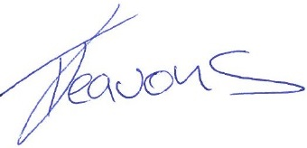  Toby Jeavons  Fishery Manager  Date: 09/02/18 |  |  | Approved/not approved  Dallas D’Silva  Director Fisheries Management and Science, Policy and Llicencing  Date:

Notes

Principles for effective consultation
To the extent that it is practicable (refer Section 3A (1) of the Fisheries Act 1995), the following consultation principles apply to decisions made by the Minister, Secretary (or delegate), which affect the use and conservation of Victoria's fisheries resources:
(a) That the purpose of the consultation and the consultation process are clear, open, timely and transparent;
(b) That the level of consultation reflects the likely impact of decisions on persons and fisheries resources;
(c) That the consultation process is adequately resourced;
(d) That the consultation process flexible and designed to take into account the number and type of persons and/or sector groups to be consulted and their ability to contribute to the process; and
(e) That the consultation process should involve consideration of representative advice which represents the views and values of the persons represented from appropriate sector groups including:
- Commercial wild-catch fishing
- Recreational fishing
- Aquaculture operators
- Aboriginal fishers/communities
- Conservation interests (as applicable)
The consultation process should consider expert advice from the most appropriate provider/s (as applicable) and any expert advice obtained during the consultation process should be made available to persons participating in the consultation process.
Statutory consultation under Section 3A (2) of the Fisheries Act 1995
Matters that have previously required consultation in accordance with the Fisheries Act 1995 (the Act) will continue to require consultation. These matters are now consolidated in the Act under Section 3A (2); these are:
(a) a decision by the Minister to declare or amend a management plan under Part 3;
(b) a decision by the Secretary to vary a class of fishery licence under section 54(1)(c);
(c) a decision under section 54(1)(d) by the Secretary to vary or revoke a condition imposed by the Secretary, or to impose a new condition, on a class of fishery licence;
(d) a decision by the Minister to give, revoke or amend a direction on matters relating to the management of fisheries or zones in a fishery under section 61;
(e) a decision by the Minister to make, revoke or amend a quota order in relation to a fishery under section 64, 64A, 66C or 66D;
(f) a decision by the Minister to make, revoke or amend an order declaring sub-zones in a quota fishery under section 64AB or 66E;
(g) a decision by the Minister to appoint a person as a member of the Commercial Fisheries Licensing Panel under section 132(2)(c) or 132(2)(d);
(h) a decision by the Minister to nominate a person to be appointed as a member of the Licensing Appeals Tribunal under section 135(2);
(i) decisions relating to the making and content of regulations in respect of royalties and levies imposed in accordance with sections 150 and 151;
(j) decisions by the Minister relating to priorities for the disbursement of funds that may be paid out of the Recreational Fishing Licence Trust Account under section 151B;
(k) a decision by the Minister to make a fisheries notice under section 152(1).
Statutory consultation NOT required
Statutory consultation is not required in relation to the following decisions—
(a) decisions which are specific to an individual licence or permit, the holder of a licence or permit or a person acting on behalf of a holder of a licence or permit; and
(b) reviewable decisions within the meaning of Section 137 of the Fisheries Act 1995.

