2021

VIC-eCatch

Quick Reference Guide - Abalone

Contents

**1.** **VIC-eCatch Login** 1

**2.** **Home Screen** 1

**3.** **My Quota** 2

**4.** **Preferences** 2

**5.** **Side Menu** 3

**6.** **Activity Log** 3

**7.****Catch Rate** …………………………………………………………………………………………………………………………..…. 4

**8. Activity Home** 6

**9.** **Set up Trip** 7

**9.** **Cancel Trip** 8

**10.** **Landing** 9

**11.** **Manage Trip** 10

**12.** **Allocate Catch** 15

**13.** **Catch Disposal Record (CDR)** 15

**14.** **View Only Pages** 17

**15.** **Administrator Take Over** 18

**16.** **Application Behaviours** 18

# **VIC-eCatch Login**

Login to VIC-eCatch using your PFN and Password in the respective fields.

Note – it is easiest to stay logged into the app. You need phone reception in order to log in. Once logged in, you don’t need phone reception to enter catch data as it will be stored in the phone and will be uploaded once you have regained a connection.

The version number is at the bottom of the login screen, if there are any issues please recite this number to the Duty Officer.

# **Home Screen**

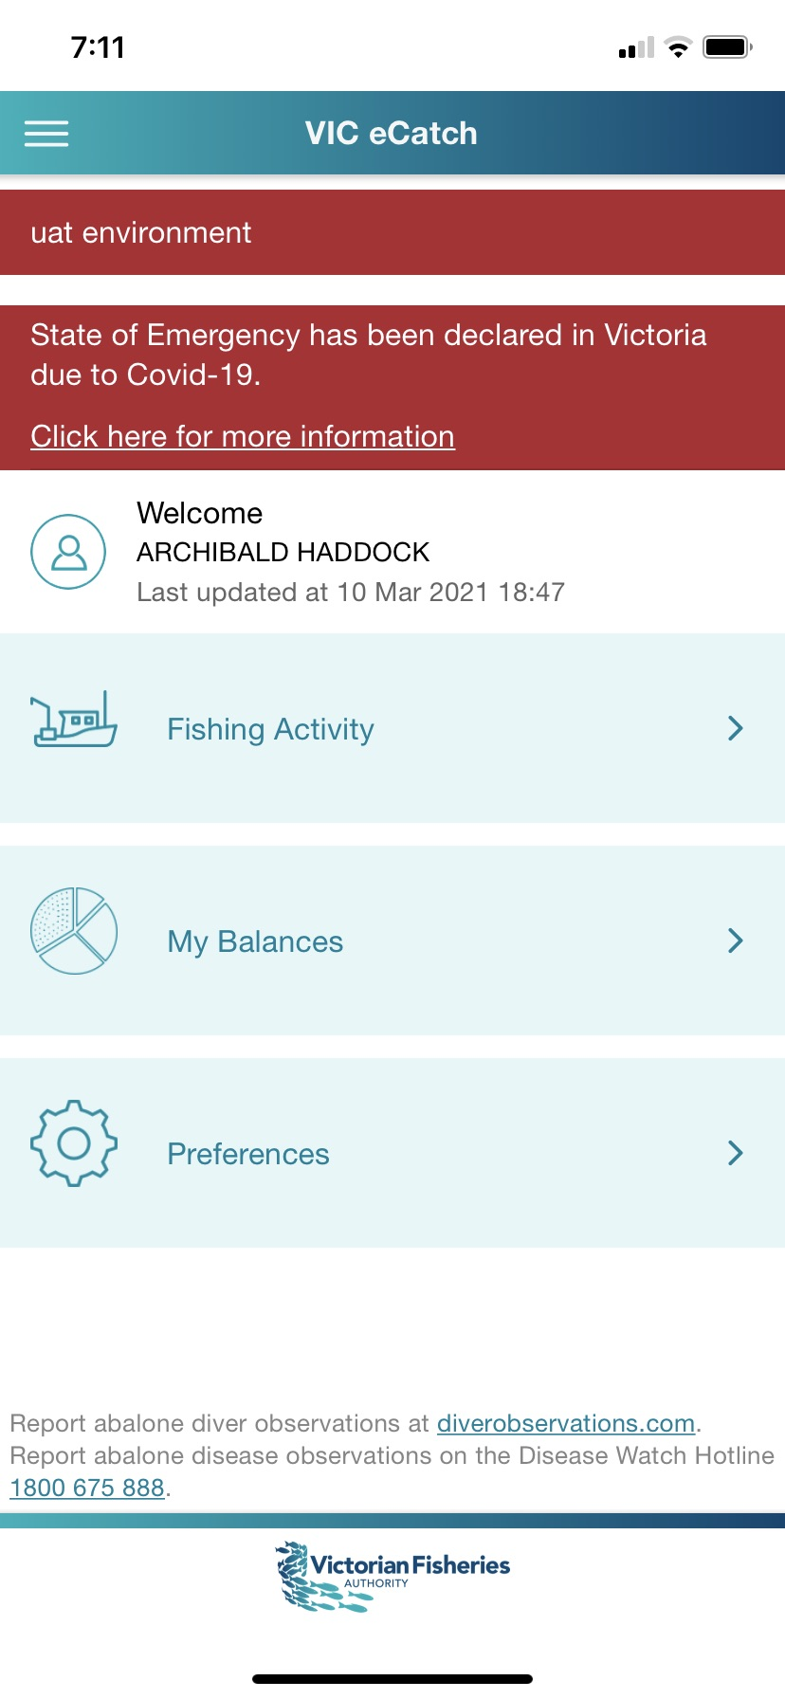

From the home screen you can navigate to Fishing Activity, My Balances and Preferences.



* The Fishing Activity feature allows the user to set up a trip, record your catch and effort and generate your Catch Disposal Record(s) for consigning abalone to a receiver.
* The My Balances feature allows you to view your quota balance(s).
* The Preferences feature allows you to set/edit your commonly used values, which will auto-populate throughout the app.

The ‘**hamburger icon**’ gives you the ability to navigate back to the Home screen, see your Activity Log, Catch Rate or Logout.

# **My Quota**

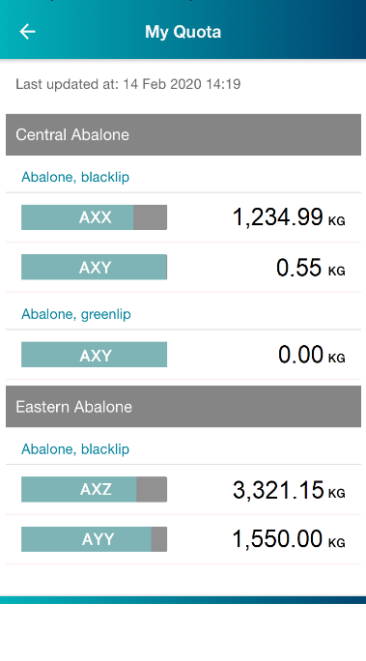

My Quota displays your licence(s) and species you can fish for and can be selected through My Balances in the Home screen.

The breakdown of quota is separated by zone as relevant to you, followed by species (Abalone blacklip and/or greenlip).

Your quota remaining on each licence is displayed in kilograms. The bar shows the quota available as a percentage of your quota (available quota percentage is grey).

Tapping the **back arrow**  takes you back to the Home screen.

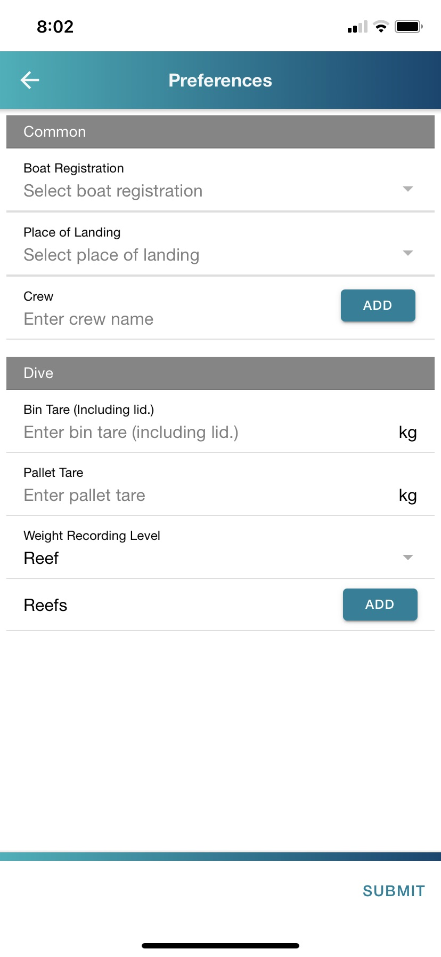

# **Preferences**

Preferences allows you to set your commonly used defaults. These can be edited at any time and values can also be changed within the catch record screens for an individual fishing trip if details differ with set preferences[1].

* The **boat registration** and **crew** fields will appear on the Setup trip screen.
* The **place of landing** will appear on the Landing screen.
* The **bin tare** and **pallet tare** sections will appear when entering the weight caught.
* The **weight recording level** allows you to choose whether you want to enter catch weight as a total of the **reef** (which is the default value) or weigh each **bin** individually.
* You can add **reefs** that you plan to fish, so you can choose from them when entering catch and effort data.

Press **submit** to save your defaults.

You can return to the Home screen by tapping the **back arrow**.

# **Side Menu**

The side menu allows you to navigate to the Home screen, your Activity Log, Catch Rate and to Logout of the app.

You access the menu via the **icon:**

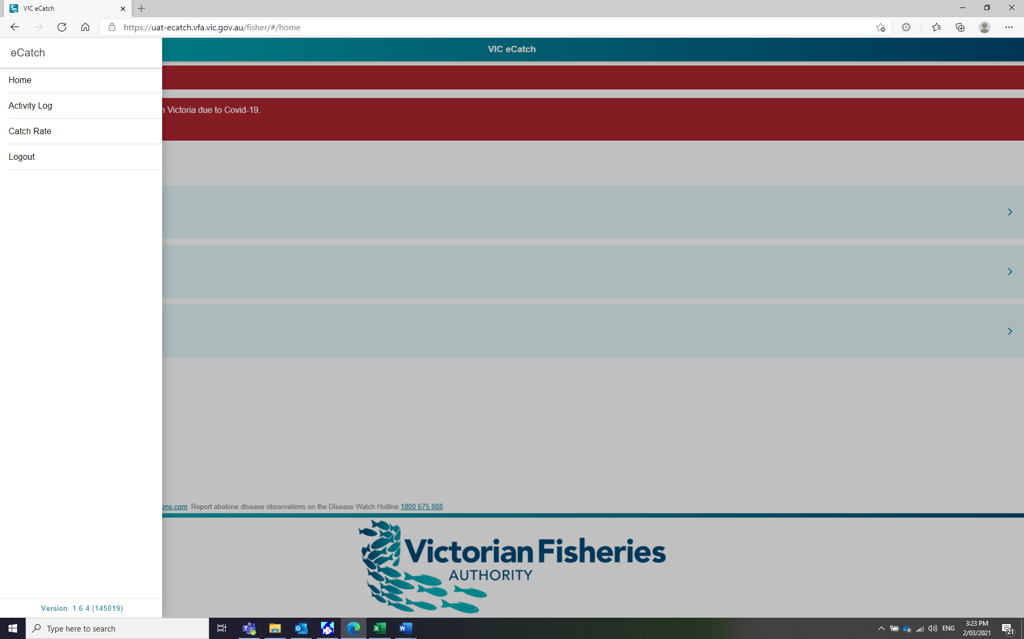



# **Activity Log**

The Activity Log contains a running list of activity that has occurred on the app. This screen will help to relay information to a Duty Officer if you need assistance or a Fisheries Officer at inspection if required.

**NOTE:** This log details the steps taken when using the app only and does not comprise information on diving/catch activity.

# **Catch Rate**

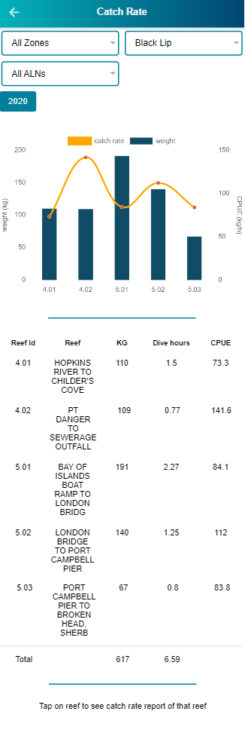

The Catch Rate report displays all catch weights and catch rates within reef codes that have been fished for the specified quota period. This screen has filters for selecting the following:

* Zone (select your preferred zone or ALL zones)
* ALN (select your preferred Licence or ALL ALN’s)
* Species (select Black or Green, or ALL Species)
* Quota season year (if it has been fished through eCatch)

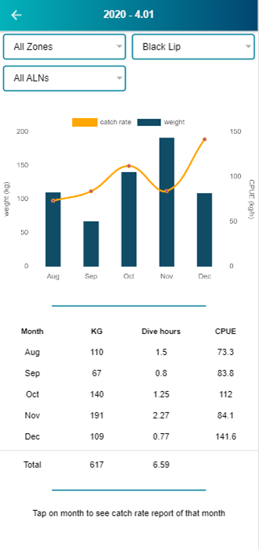

Catch and catch rate for reef Id within the specified quota period can be displayed by selecting a reef Id in the Catch Rate screen

If you select a preferred month, the display will show the catch rate report of that month for each day fishing occurred.

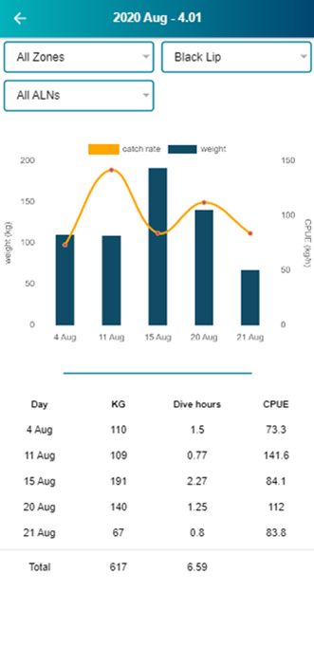

**Note:**

If your selection has **less** than 5 reefs or months, the information will show up in bubbles

If your selection has **more** than 5 reefs or months, the information will show up as a graph.

# **Fishing Activity Home**

The Fishing Activity Home is a step-by-step process where you set up your fishing trip, record catch data, allocate catch to your chosen licence(s) and generate catch disposal records (CDRs).

You can manage and view past and current steps within a trip.

The coloured tab indicates the active step. Greyed-out blocks are not active until the previous step in the process has been successfully completed.

# **Setup Trip**

The Setup Trip screen has mandatory fields for selecting a boat and a licence[2]. Crew name is optional.

If you have nominated a boat and crew member(s) in the Preferences section, it will appear here. These are not locked, so you can change both at this stage.

If Eastern or Western Zone Licences are selected, you will also be asked if you only want to fish in an Airport Reef or Discovery Bay.

Pressing **submit** will lock the selected licence(s) from further use until the fishing activity has been completed. After pressing **submit**, you will be taken back to the Fishing Activity homepage, which will now have a green tick next to **Setup Trip.** The **Cancel** and **Landing** tabs will be now coloured and enabled.

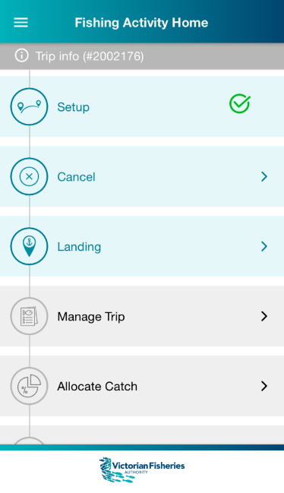

Once you have set up your trip, you will see a grey bar with a trip number displayed: **Trip info (number)**. This number is the **Trip ID.** Use this number when communicating with a Duty Officer.

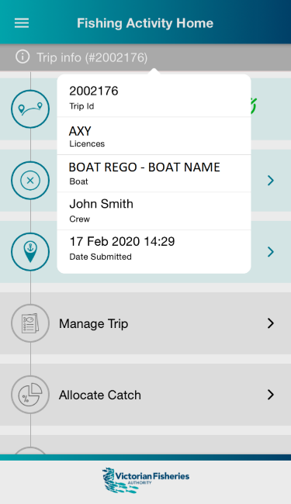If the bar is tapped, it will display details entered on the **Setup Trip** page. Tap the bar again to close the pop up.

# **Cancel Trip**

You can cancel a trip that is in the set-up phase by selecting Cancel on the Fishing Activity homepage. On the Cancel Trip screen you must enter a reason for the cancellation. The Cancel Trip feature is only to be used where **no fishing activity has occurred**, due to unforeseen circumstances. Once you have pressed submit, the licence that had been selected will be unlocked and available for a new fishing trip.

# **Landing**

The Landing screen details your landing information for your current trip. If you have entered a place of landing in your preferences, it will appear on this screen. You can change it by tapping on the icon.

You will need to indicate if you can weigh within 60 minutes of landing the abalone. It will default to ‘**yes’**. If you select ‘**no’** (by tapping on it), you will need to enter a reason.

Pressing **SUBMIT** will save these changes.

If you need to edit this page, it can be done by tapping the **Landing** tab on the Fishing Activity home screen.

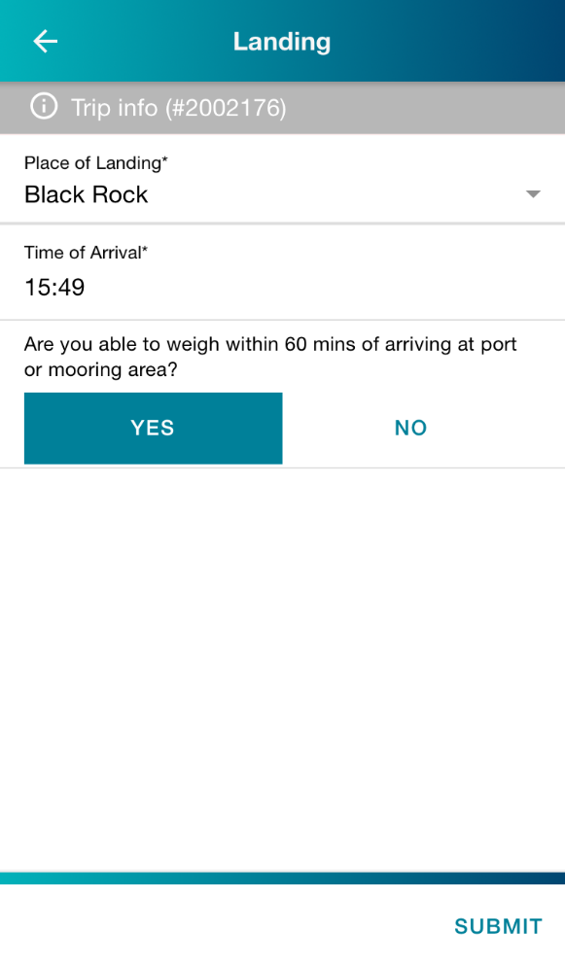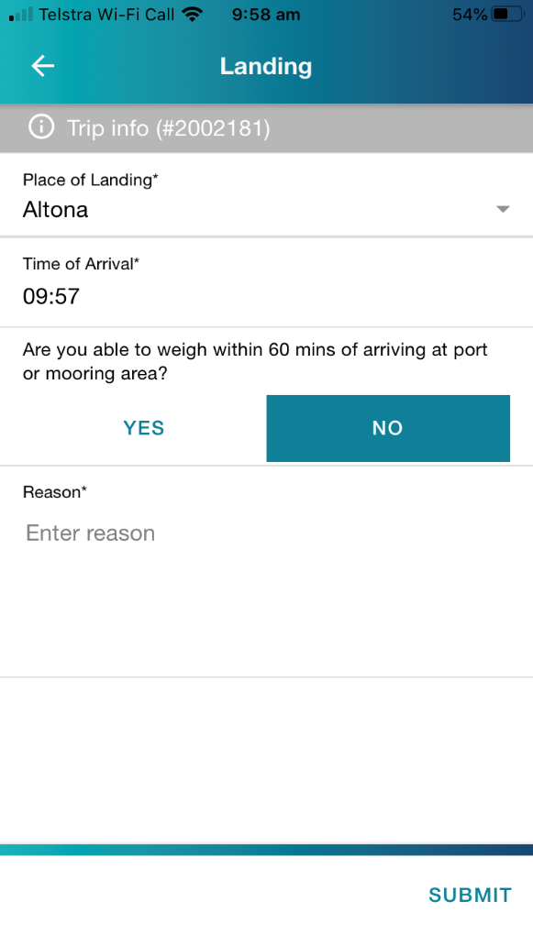

# **Manage Trip**

The Manage Trip workflow comprises several screens in which you enter your catch and effort information. Tapping the Manage Trip tab will take you to the Trip Status screen.

**Trip status**

The reefs set in your preferences will be visible on this screen. If no reefs are visible, either you have not saved any in your preferences or the ones you have saved are not applicable to the zone of the licence you have selected for the fishing trip.

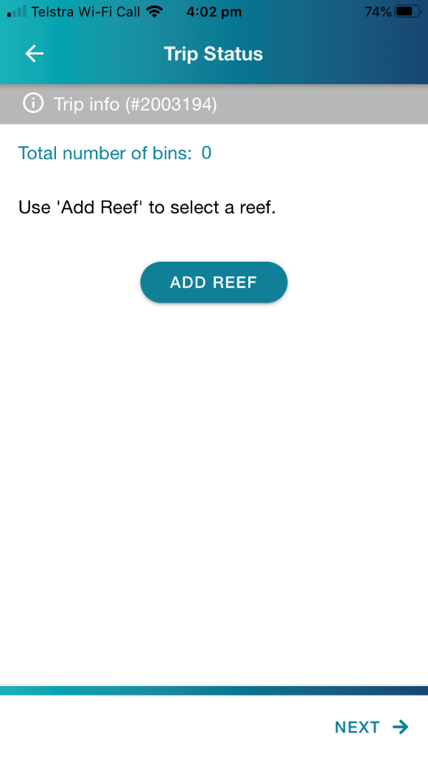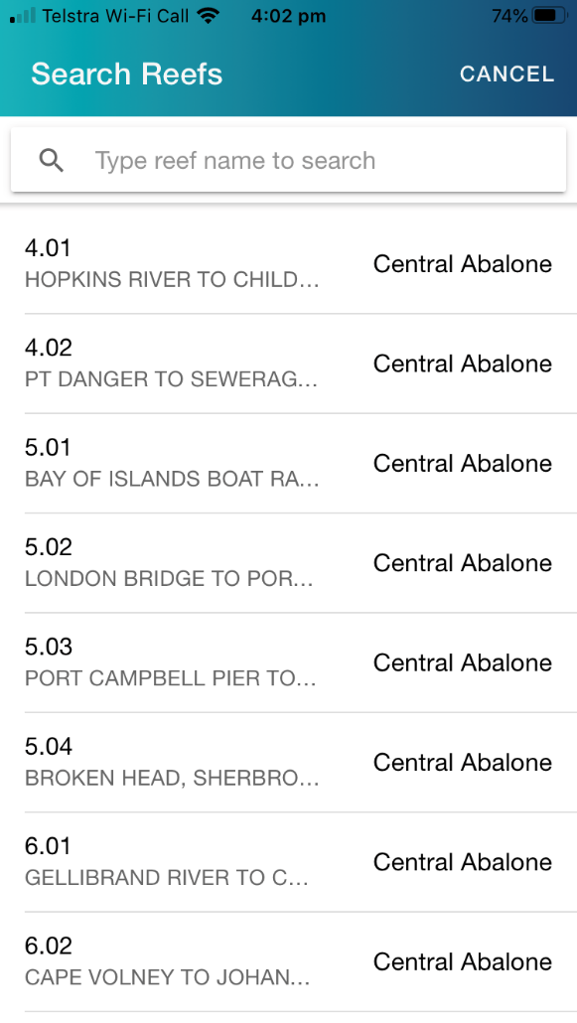From this screen you can **add reefs** or **delete reefs** as necessary.

**Add reef:**

You can add reefs to the trip by using the **ADD REEF** button, which will bring up a list of all the reefs in the zone of the selected licence(s).

**Delete reef:**

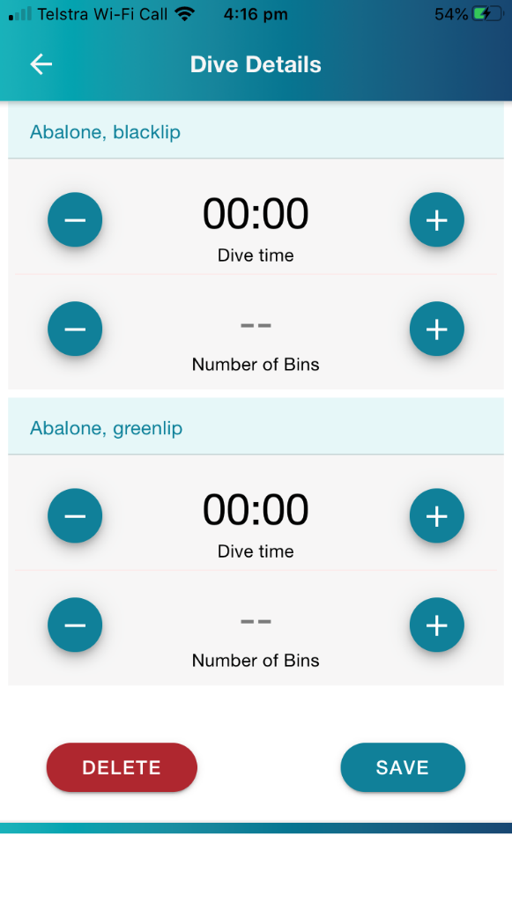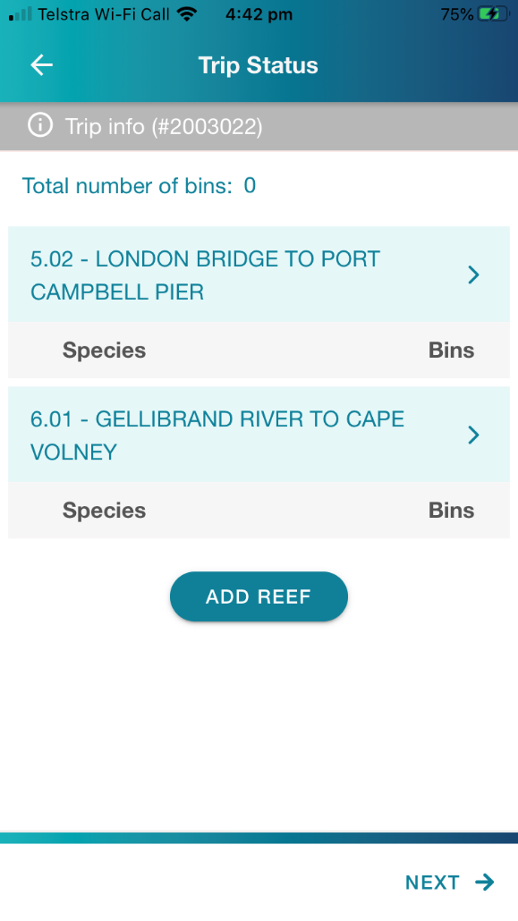You can delete a reef by tapping on the name of the reef (in the blue tab) to bring up the Dive Details screen. By scrolling to the bottom of the screen, you will see the **Delete** button. Tapping it will bring up a confirmation pop-up. Click **Yes** to delete.

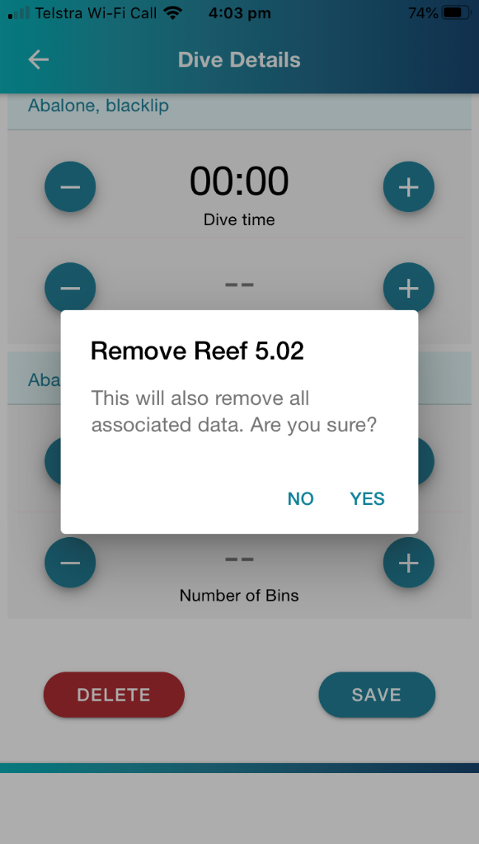

**Adding dive details**

The Trip Status screen is also where you can select the reefs you have fished and enter your dive details.



**Dive time** and **number of bins** can be added by tapping on the reef name (the light blue tab). This will open a new screen – Dive Details.

To enter information, you can either tap on the **00:00**, which will open a scroll, or you can hit the **+** and **–** buttons to add or subtract by 5-minute intervals. You can also do a combination of both.

Note: even if you haven’t taken any greenlip, you will need to enter a **0** in the number of bins field by tapping once on the **–** button.

Once you have finished, you can press **SAVE** to close the screen, which will take you back to the Trip Status screen.

Upon returning to the trip status page, each reef will display the number of bins entered for each species. Complete the process for each reef dived.

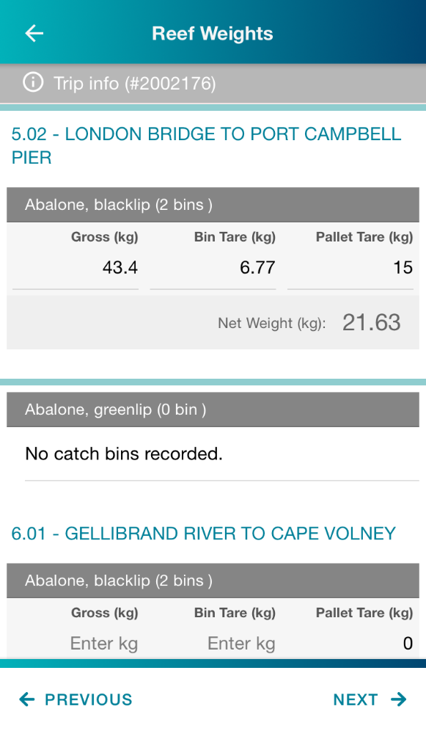**Reef weights**

If you had previously chosen **reef**,rather than **bin**, in your Preferences as your catch weight recording level, the Reef Weights screen will be the next screen to complete. If you had selected **bin** weighing, you will automatically be taken to that screen (see section below).

The screen is split up by each reef selected on the previous screen, and then each reef is divided up by the species.

Beneath each species, you must specify the amount of **gross weight** and **bin tare** in kilograms. **Pallet tare** is applicable only to some Eastern Zone weighing practices. **Bin and pallet tare can be set in the preferences and can be edited during reporting**. Alternatively, all can be entered each time if not set in preferences.

If on the previous screen you specified 0 bins have been caught for a species, then under the species ‘**No catch bins recorded’** will be displayed.

Once all weights have been entered, press **NEXT** to go to the Catch Weight Summary page. Pressing **PREVIOUS** will take you back to the Trip Status screen.

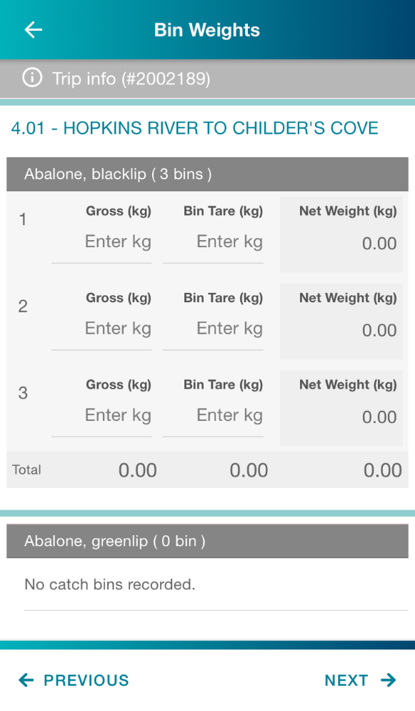**Bin weights**

If you set **bin** in your Preferences for your weight recording level, you will see the Bin Weights screen (rather than reef weights).

You will need to fill in the **gross weight** and **tare weight** of each bin.

If you had previously entered a **bin tare** in your Preferences, this field will be filled, but can still be altered for some, or all, bins if required.

Once all weights have been entered, press **NEXT** to go to the Catch Weight Summary page. Pressing **PREVIOUS** will take you back to the Trip Status screen.

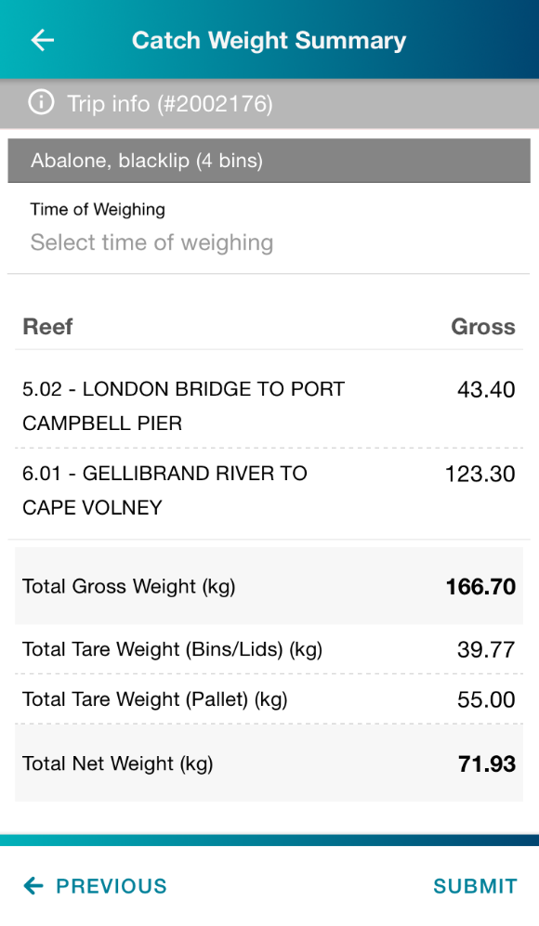**Catch Weight Summary**

The Catch Weight Summary screen contains a detailed view of your catch weights.

Similar to other screens, this screen is split up by species if the licence(s) selected can take both greenlip and blacklip. This screen provides an opportunity to review the entered information for accuracy.

On this page, you must enter the **Time of Weighing** by tapping on the tab. A drop-down scroll will appear and will default to your current time. You can scroll back or forth to find the correct time of weighing.

If an error is detected, pressing **PREVIOUS** will take you back to the Bin Weights or Reef Weights screen, depending on your set preference, where corrections can be made.

Pressing **SUBMIT** will save all the Manage Trip information. You will still be able to come back to edit the information if needed.

# **Allocate Catch**

In the Allocate Catch screen you can distribute catch across your nominated licences.

The Allocate Catch screen displays the **total catch** for the trip and the remaining **unallocated catch** to be allocated

In order to submit, the **unallocated catch** must be 0.

Enter the weight in the **Allocate Catch** field, outlined in blue. If you had selected multiple licences, you would see more than one line to fill in[3].

This screen is separated into a section for blacklip abalone and another for greenlip if allowed on the licence.

Pressing **SUBMIT** on this screen will lock the information in all previous screens. You will still be able to view them, but you won’t be able to edit them.

After submission, the quota will be deducted from the licences and your My Quota section will be updated.

You are now ready to create your Catch Disposal Record.

# **Catch Disposal Record (CDR)**

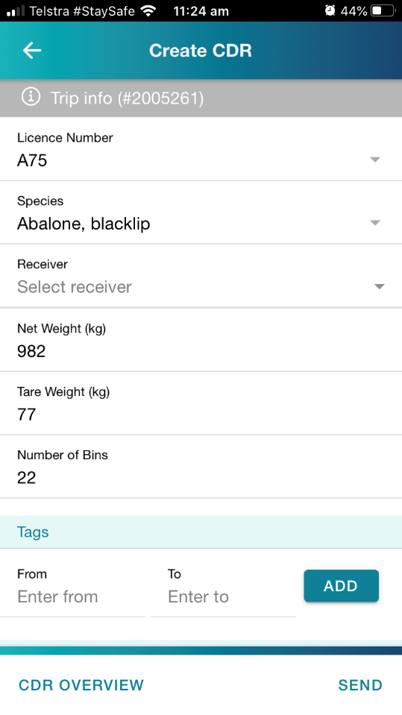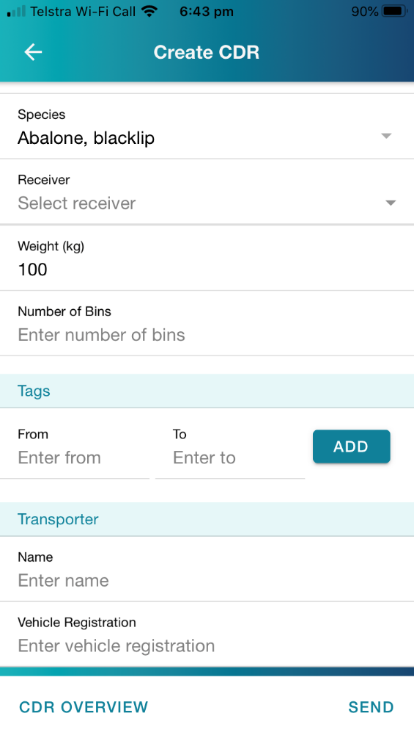

AXY

By pressing the CDR tab on the Fishing Activity Home you will first go to the Create CDR screen. Here you can create single or multiple CDRs as needed.

Separate CDRs need to be created for blacklip and greenlip catch. This can be changed by pressing the icon in the **Species** tab.

Select your **receiver[4]** by pressing the icon to open the list.

The total **Net Weight (kg)** of the catch will be automatically populated, as will the total **Tare Weight (kg)** of bins and lids and total **Number of Bins** associated with the trip for species selected in the CDR.

If multiple CDRs are to be created (*for different licences, to consign catch to different receivers, etc*) these figures can be amended to reflect the consignment[5]. When creating a subsequent CDR, the remaining balances will be auto-populated.

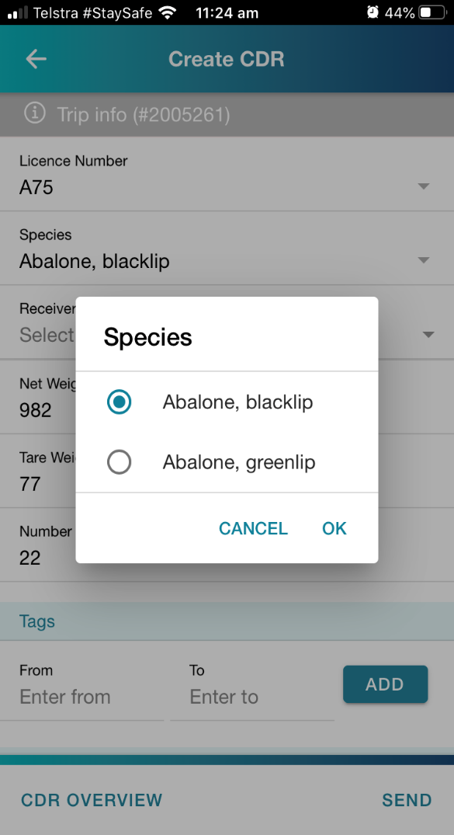

AXY

Enter bin **tag numbers** and press **ADD**. Repeat this if you need to add an individual tag or another sequence of tags.

In the **Transporter** section, enter the driver’s name and the vehicle registration.

By pressing SEND and submitting the CDR:

* It will be automatically sent to the Abalone Receiver to receive the consignment in their system.
* It will be automatically sent to your email account (*the email address associated with your Fisherweb Account*).

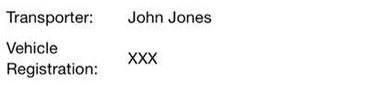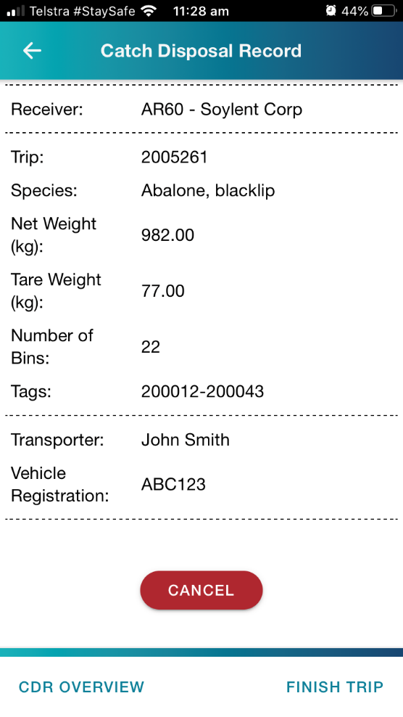

If you need to cancel a CDR because you’ve realised it has an error in it, press **CANCEL**, edit the information and press **RESEND**. Emails will be sent to you and the receiver to notify of the cancellation. The cancelled record will also be automatically removed from the receivers system. The associated catch amount will then be reinstated, and another CDR will need to be created for that catch.

You will need to create CDRs to account for all of your catch from a fishing trip. This function allows you to create multiple CDRs should you want to send catch to more than one Abalone Receiver.

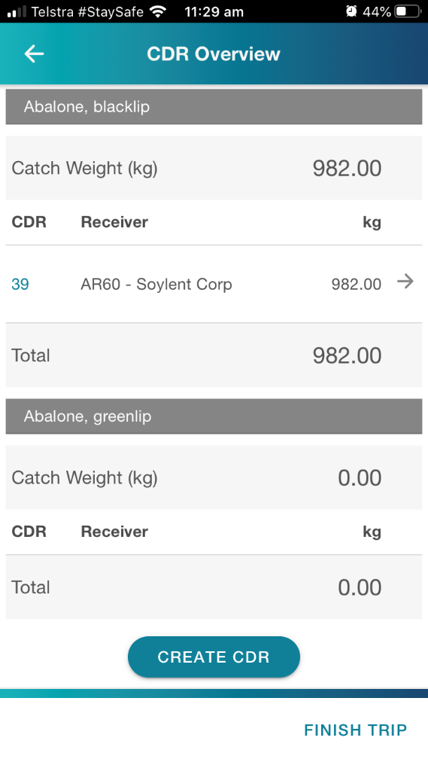After viewing the receipt, pressing the **CDR OVERVIEW** button will take you to the CDR Overview screen, which lists all of the created CDRs and has a button to **CREATE CDR** to repeat the above process.

Once all of the catch has been disposed of, tap the **FINISH TRIP** button to end the current trip and release the licence(s) associated with the trip for further use.

NOTE: The **FINISH TRIP** button will not be available to you until all catch from a trip has been consigned on a CDR.

# **View Only Pages**

After submitting the Allocate Catch section, the previous screens will become locked and you will no longer be able to edit them. The pages will still be viewable and have a banner indicating ‘**This page is view only’.**

# **Administrator Take Over**

During the trip, if you have any difficulty for any reason, you can ring the Commercia Fishers Duty Officer for help.

The Duty Officer will be able to guide you through the process so that you can complete it. The Duty Officer will also be able to take over completing the trip for you.

It’s important to note that once a Duty Officer enters any data in the fishing trip, the Duty Officer will have to complete the rest of the trip for you over the phone. You will no longer be able to enter data in that trip.

If the device you’re using is still functioning, but you need the Duty Officer to take over, you will be asked to logout.

To do this, tap on the icon to open a side menu. You will see the **logout** tab.

# **Application Behaviours**

**Log out**

If you try to log out and have an active trip underway, you will be prompted with a message notifying you that a trip is active and that that you will need to finish the trip before logging out or a Duty Officer will be required to finish the trip on your behalf.

If a trip is active and you log out, the licence(s) associated to the activity will still be considered ‘in-use’ until a Duty Officer completes the trip and therefore won’t be able to be used in a new setup trip.

**Uninstall**

If you uninstall the Vic-eCatch app whilst a trip is active, the trip will require assistance from a Duty Officer to complete it and you will not have access to view the trip. The licence(s) associated on the trip will be locked until the trip is completed.

**Closing the application**

If you completely close the application, the app will remember the last state it was in and you will be able to continue through the workflow as per usual. When closed if a trip is active you will be able to access the trip when the app is reopened.

**Trip info**

Each trip will have a unique ‘Trip info’ identification number. If you have called the Duty Officer for assistance, the Duty Officer may refer to this number to clarify that they are looking at the same active fishing trip.

# **TIPS for use**

* Stay logged into the app if you have security enabled at the lock screen of your phone.
* Log in when you have reception on your phone to ensure you can start entering catch and effort information.
  + You cannot log into the app unless you have reception on your phone and therefore will not be able to enter catch data.
* Once logged in, you can enter catch data even if there is no reception, as the phone will store it until you are back in reception.
  + Quota balances can also be assessed accurately if logging in when reception is available.

**Contacts**

|  |  |  |  |
| --- | --- | --- | --- |
| Contact | | No. | Purpose |
| Commercial Fishers Duty Officer | | 0418 519 215 | Enquiries relating to catch reporting via Vic-eCatch |
| Abalone Fishery Manager | Travis Baulch | 0400 002 940 | All general Vic-eCatch or fishery management enquiries |
| IT Project Manager | Jeanette Roberts | 03 8392 6864 | Connectivity/technical issues with Vic-eCatch |
| Operations Duty Officer | | 0419 844 781 | Compliance reporting (permits, other authorities and VMS |

1. *Weight Recording Level* cannot be altered once a fishing trip has commenced. It is important to ensure this is set appropriately prior to fishing to best assist work practices.
2. If you intend to operate on, or allocate catch to, multiple licences within a zone, it is necessary to select all relevant licences at this step.
3. If allocating catch to multiple licences, it is essential to ensure the weight entered matches that of the sealed/tagged bins that are to be consigned to a receiver on behalf of that licence.
4. Ensure a valid receiver is selected. AR53 “Small Sales” is a system generated number to facilitate activity authorised by Fisheries Permit & Exemption. This **cannot** be used without the appropriate authority.
5. If consigning catch to multiple receivers or on behalf of multiple licences, it is essential to ensure Net Weights and Tare Weights entered matches that of the sealed/tagged bins that are to be consigned on each CDR