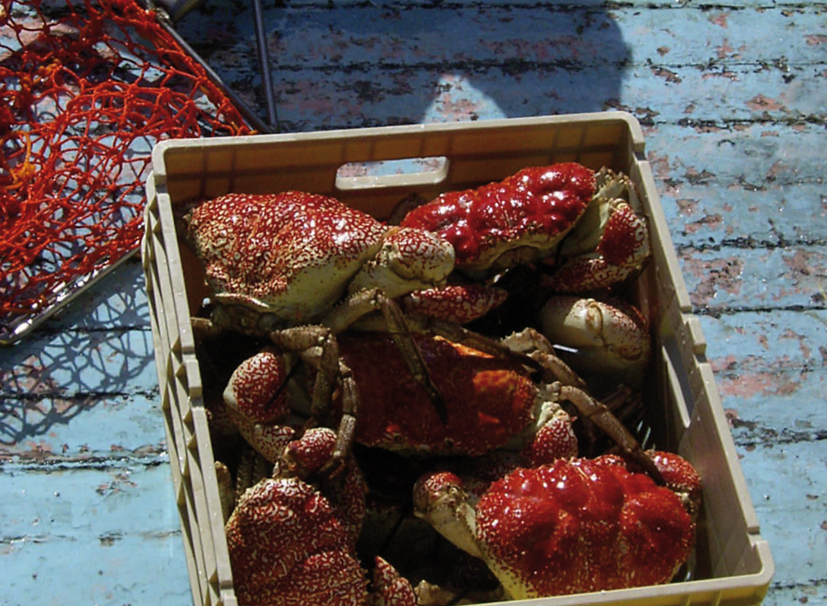

Victorian Giant Crab Fishery

Stock Assessment Report

2016/17 Season

Victorian Giant Crab Fishery
Stock Assessment Report for the 2016/17 Season

executive summary
In 2016/17, the total allowable commercial catch (TACC) for giant crab was 10.5 tonnes. The total landed catch was 10.4 tonnes, which was almost entirely targeted.
The targeted catch rate in 2016/17 was 1.26 kg/24 hour pot-lift, which is above the limit reference point of 0.52 kg/24 hour pot-lift for the fishery.

Background
This document reports time series of giant crab (Pseudocarcinus gigas) catch and catch rate (expressed as kg per 24 hour pot-lift) from mandatory daily logbook returns. The catch data are summarised by licencing year (July-June), while the catch rate data are summarised by fishing year (November–September).
Separate giant crab and southern rock lobster fishing returns were mandated with the introduction of quota management in November 2001. For returns prior to April 1998, target species was not specified and effort targeted at giant crab was separated from effort targeted at southern rock lobster on the basis of two criteria. Where pots were set at depths greater than 140 metres or where more than 70% of the combined catch of these two species was giant crab, all of the effort was assumed to be targeted at giant crab.
Following the introduction of quota management, separate logbooks for the giant crab and southern rock lobster fisheries led to some inconsistencies in the reporting of the target species. This resulted in a reduced giant crab catch per unit effort (CPUE) overall, which was inconsistent with the observations of the most active fishers. A second measure of CPUE was therefore introduced involving the targeted catch and effort for only those fishers landing more than one tonne of giant crab in a fishing year.
Giant crab targeted CPUE is expressed as kg per 24 hour pot-lift because the pots are usually left to soak for several days. Prior to 2001/02, soak days were estimated by counting days between entries in the daily logbook, with the maximum soak days in this calculation capped at seven days. Logbooks were modified during the 2001/02 fishing year to collect soak days directly. A recent review undertaken by the Victorian Rock Lobster and Giant Crab Resource Assessment Group highlighted that a four-day soak-time cap was more appropriate.

Results
The total landed catch of giant crab by all fishers in 2016/17 was 10.4 tonnes which was almost entirely targeted (Figure 1). The targeted catch rate in 2016/17 was 1.26 kg/24 hour pot-lift (Figure 2, Table 1) – well above recent years which have fluctuated between 0.8 and 1.1 kg / 24 hour pot-lift (Table 1).
The assessment was undertaken comparing the biological stock performance indicator of targeted CPUE against the giant crab biological reference points (Figure 2). The reference points prescribed in the Management Plan are based on ‘fishing year’ (November–September) and include a limit reference point (mean for the 3‐fishing‐year period from 1998/99 to 2000/01) (0.52 kg/24 hour pot-lift), and the trigger reference point (80% of limit reference point) (0.42 kg/24 hour pot-lift).
Based on the estimate of 1.26 kg/24 hour pot-lift, the targeted CPUE in 2016/17 was above the limit reference point (0.52 kg/24 hour pot-lift) and hence the trigger reference point.
No additional size-frequency data was collected in 2016/17, the average size of landed crabs has remained relatively consistent since 2006/07.

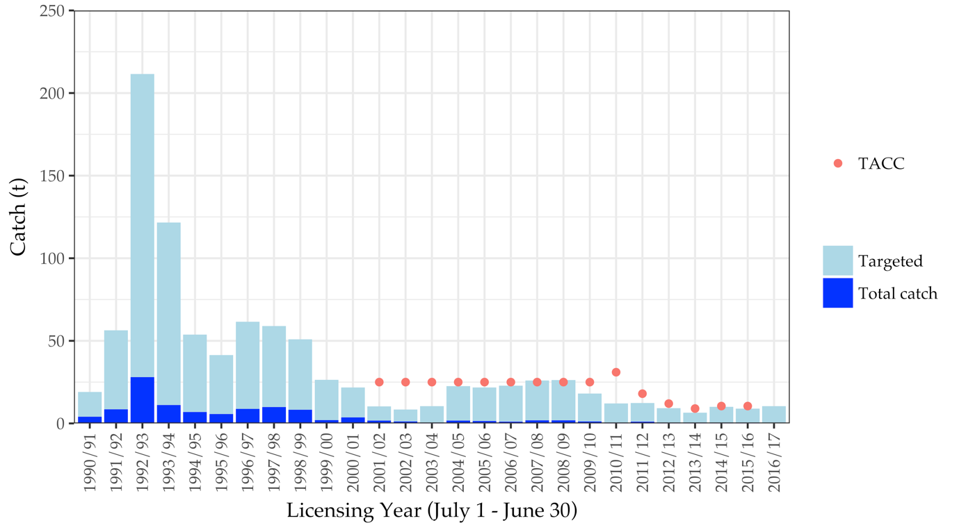
Figure 1: Total catch (t) and targeted catch history for the Victorian Giant Crab Fishery. Red dots indicate the TACC which was introduced for the 2001/02 season.

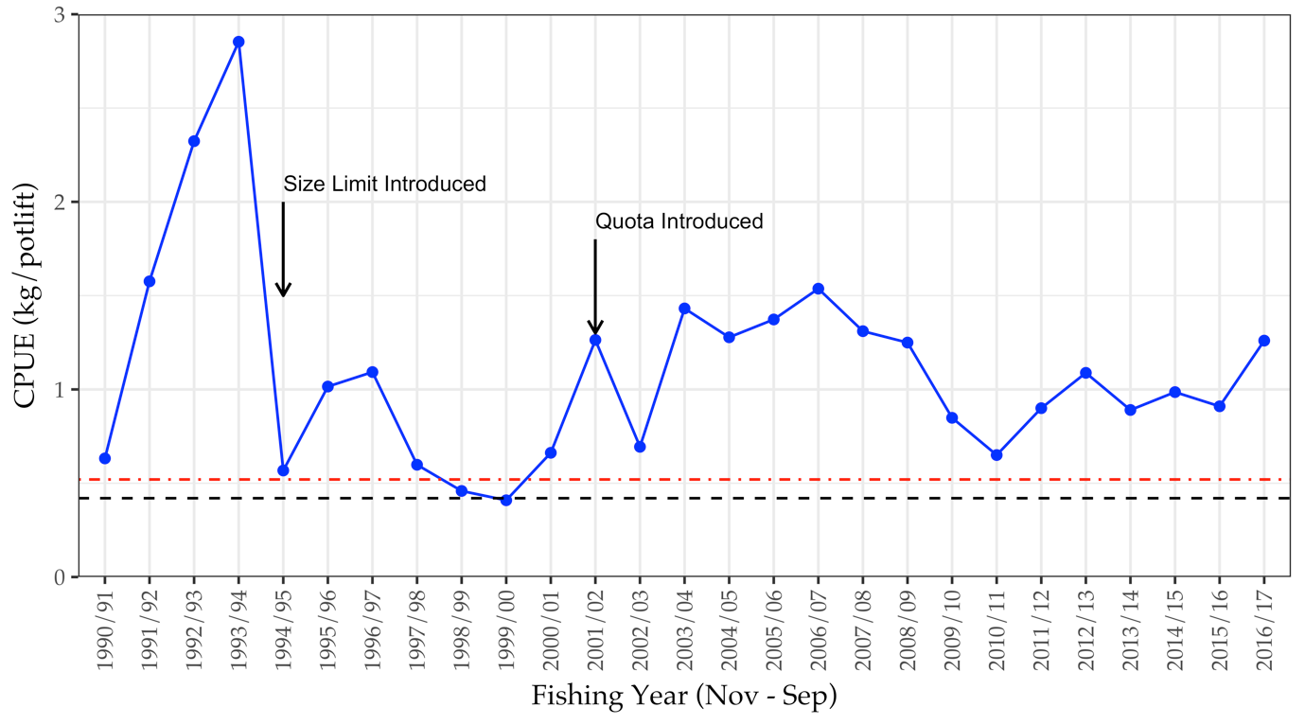
Figure 2: Catch rate of giant crab (kg/24 hour pot lift) corrected for a maximum of 4 days soak, with a slope of 0.38 for all fishers landing > 1000kg of giant crab in a given year and with > 300 days of fishing overall. Dashed red line and solid black line represent limit and trigger reference points, respectively.

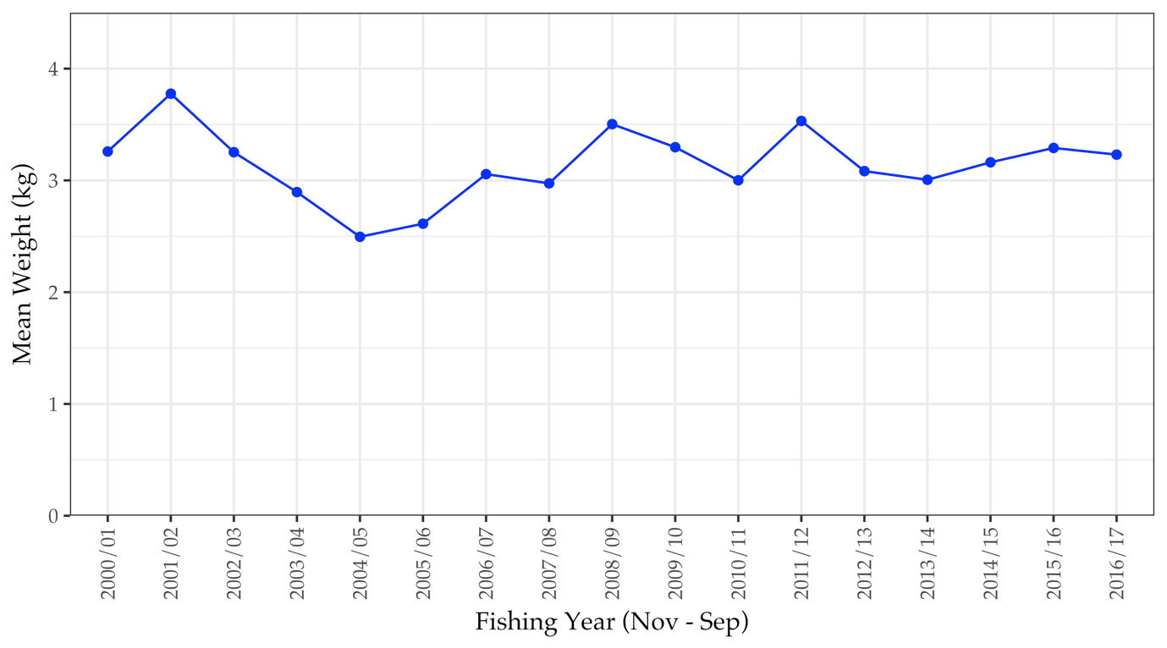
Figure 3: Mean weight (kg) per crab for all fishers from the 2000/01 fishing year onwards.

Table 1: Giant crab total catch, and catch rate during fishing years (16 November–14 September) from 1990/91 to 2016/17.

Fishing Year | Total Catch (t) | Catch Rate (fishers > 1t)
1990/91 | 18.9 | 0.63
1991/92 | 56.7 | 1.58
1992/93 | 226.8 | 2.32
1993/94 | 122.3 | 2.85
1994/95 | 38.8 | 0.57
1995/96 | 44.4 | 1.02
1996/97 | 68.7 | 1.09
1997/98 | 51.0 | 0.60
1998/99 | 50.4 | 0.46
1999/00 | 25.3 | 0.41
2000/01 | 19.7 | 0.66
2001/02 | 9.5 | 1.26
2002/03 | 8.4 | 0.69
2003/04 | 10.5 | 1.43
2004/05 | 22.7 | 1.28
2005/06 | 21.7 | 1.37
2006/07 | 20.3 | 1.54
2007/08 | 27.6 | 1.31
2008/09 | 27.2 | 1.25
2009/10 | 16.4 | 0.85
2010/11 | 11.3 | 0.65
2011/12 | 12.6 | 0.90
2012/13 | 8.8 | 1.09
2013/14 | 6.5 | 0.89
2014/15 | 10.5 | 0.99
2015/16 | 10.0 | 0.91
2016/17 | 9.0 | 1.26

Table 2: Giant crab total allowable commercial catch by quota year between 2001–02 and 2016–17.

Year | Season | TACC Set (t)
2001-02 | 16 Nov – 31 Mar | 25
2002-03 | 1 Apr – 31 Mar | 25
2003-04 | 1 Apr – 31 Mar | 25
2004-05 | 1 Apr – 31 Mar | 25
2005-06 | 1 Apr – 31 Mar | 25
2006-07 | 1 Apr – 31 Mar | 25
2007-08 | 1 Apr – 31 Mar | 25
2008-09 | 1 Apr – 31 Mar | 25
2009-10 | 1 Apr – 31 Mar | 25
2010-11 | 1 Apr – 30 Jun | 31
2011-12 | 1 Jul – 30 Jun | 18
2012-13 | 1 Jul – 30 Jun | 12
2013-14 | 1 Jan 14 – 30 Jun | 9
2014-15 | 1 Jul - 30 Jun | 10.5
2015-16 | 1 Jul - 30 Jun | 10.5
2016-17 | 1 Jul - 30 Jun | 10.5

