The Gippsland Lakes fishery
An overview
The Gippsland Lakes are a network of lakes, marshes and lagoons in east Gippsland, covering an area of about 354 square kilometres. The waterway is collectively fed by the Avon-Perry, Latrobe, Mitchell, Nicholson and Tambo rivers and a number of smaller creeks and comprises several large lakes including Lake Wellington, Lake King and Lake Victoria.
The region supports a range of natural values important to fisheries resources and is home to several commercial and recreational fisheries. Fishing in the Lakes provides significant value to recreational and commercial fishers, consumers of commercially caught fish and the broader local community. Both sectors are economically important to the region.

Commercial fishing in Gippsland Lakes
Commercial fishing in Gippsland Lakes is authorised under a number of commercial fishing licences. Those that use nets to harvest fish include Gippsland Lakes Fishery Access Licences, Gippsland Lakes (Bait) Fishery Access Licences and Eel Fishery Access Licences.
There are currently ten Gippsland Lakes Fishery Access Licence holders who use a range of methods (mostly mesh and haul seine nets) to harvest a range of species, ten Gippsland Lakes (Bait) Fishery Access Licence holders who use dip and seine nets (and other equipment) to harvest species such as anchovies, spider crabs, bass yabby and marine worms and two Eel Fishery Access Licence holders who use fyke nets to catch long and short finned eels.

Commercial catch and value
The annual catch of all species by commercial fishers in the Gippsland Lakes since the 1978/79 fishing season can be seen in Figure 1. Since 2000/01, the current Gippsland Lakes Fishery Access Licence holders have taken around 200 tonnes of fish per year. The landed value of this harvest is approximately $1.1 million annually (based on data from 2000/01 to 2010/11).
Figure 1. Annual catch of all species by commercial fishers in the Gippsland Lakes since 1978/79.
The main species taken by the current Gippsland Lakes Fishery Access Licence holders in order of decreasing annual catch are: black bream, tailor, yellow-eye mullet, dusky flathead, European carp, luderick and eastern king prawn. The average annual catch of the seven major species caught by the current Gippsland Lakes Fishery Access Licence holders since the 2000/01 fishing season can be seen in Figure 2.
Figure 2. Average annual catch of the five major species caught by the current Gippsland Lakes Fishery Access Licence holders since 2000/01.
The current Gippsland Lakes Fishery Access Licence holders use a range of methods to catch different species. The percentage of catch taken by since 2000/01 by each fishing method used can be seen in Figure 3. Around 69% of the annual catch is taken by some form of mesh net, 16% by haul seine and 5% by prawn stake net.
Figure 3. Percentage of catch by fishing method used by the current Gippsland Lakes Fishery Access Licence holders since 2000/01.
The Gippsland Lakes are divided into 13 fishing areas (area codes) for which commercial fishers are required to report their catch monthly to the Victorian Government (see Figure 4).
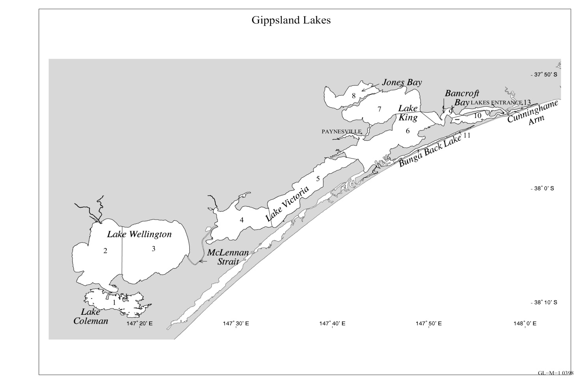
Figure 4. Map of the Gippsland Lakes commercial fishing area codes.
The average annual catch since the 2000/01 fishing season by the current ten Gippsland Lakes Fishery Access Licence holders for the major fishing areas in the Gippsland Lakes can be seen in Figure 5 (catches from several area codes are not presented as they were not significant contributors to commercial fishing activity).
Figure 5. Average annual catch by the current Gippsland Lakes Fishery Access Licence holders by area code since 2000/01.

Management controls on commercial fishing
Commercial fishers in the Gippsland Lakes are regulated by a number of management controls detailed in the Fisheries Regulations 2009. These rules include size limits, gear restrictions and area closures. The area closures include a general prohibition on the use of commercial fishing nets within 400 meters of the mouth of any river, creek or stream. This prohibition applies to all commercial fishing licences.
Gippsland Lakes Fishery Access Licence holders are also not permitted to use commercial fishing equipment within 400 metres of any part of the mouth of any river flowing into the Gippsland Lakes or Tom Roberts Creek, Toms Creek, Salt Creek or Maringa Creek. There are also a number of other places throughout the Lakes where Gippsland Lakes Fishery Access Licence holders are not permitted to use commercial fishing equipment.
A number of licence holders also abide by the Victorian Bays and Inlets Fisheries Association Environmental Management System.

Recreational fishing in Gippsland Lakes
The Gippsland Lakes is highly valued destination for recreational fishers, providing a wide range of fishing opportunities to keen anglers. Recreational fishers are subject to a range of management controls including size and bag limits and gear restrictions. However, so popular is recreational fishing in the Lakes, that on an annual basis, recreational catch may be equal to or exceed that of the commercial sector for some species.
For example, the most recent estimate of Victorian recreational black bream catch, from the National Indigenous and Recreational Fishery Survey for 2000-2001, is approximately 203 tonnes, of which approximately fifty percent was caught in the Gippsland Lakes (i.e. around 100 tonnes). This compares to an average annual commercial harvest of black bream of around 60 tonnes. To better understand the extent of the recreational catch, Fisheries Victoria is planning to undertake studies to further quantify the recreational harvest of key fish species.
A recent Ernst and Young report highlighted the economic contribution of recreational fishing to the Victorian economy, with expenditure by recreational fishers in the Gippsland region during 2013/14 estimated at $381 million.

Sustainability of the resource
The Status of Australian Fish Stocks Report 2014 lists recreational and commercial fishing for dusky flathead and tailor in Victoria as sustainable.
A stock assessment of black bream by Fisheries Victoria in 2012 found that the Gippsland Lakes stock were stable, although at a lower level of productivity compared to the 1970s and 1980s.
© The State of Victoria 2016.
Published by the Department of Economic Development, Jobs, Transport and Resources, February 2016
This publication is copyright. No part may be reproduced by any process except in accordance with the provisions of the Copyright Act 1968.
Authorised by the Department of Economic Development, Jobs, Transport and Resources, 1 Spring Street, Melbourne 3000
This work is licensed under a Creative Commons Attribution 3.0 Australia licence. You are free to re-use the work under that licence, on the condition that you credit the State of Victoria as author. The licence does not apply to any images, photographs or branding, including the Victorian Coat of Arms, the Victorian Government logo and the Department of Economic Development, Jobs, Transport and Resources logo. To view a copy of this licence, visit Creative Commons.
ISBN 978-1-925466-44-7 (pdf/online)
Accessibility
If you would like to receive this information/publication in an accessible format (such as large print or audio) please call the Customer Service
Centre on 136 186, National Relay Service/ TTY 133 677, or email customer.service@ecodev.vic.gov.au
Disclaimer
This publication may be of assistance to you but the State of Victoria and its employees do not guarantee that the publication is without flaw of any kind or is wholly appropriate for your particular purposes and therefore disclaims all liability for any error, loss or other consequence which may arise from you relying on any information in this publication.
For more information about DEDJTR go to economicdevelopment.vic.gov.au or phone the Customer Service Centre on 136 186.

