Is fishing pressure adversely impacting wild trout populations and the quality of the trout fishery?

Kylie Hall and Khageswor Giri
Fisheries Victoria, DEDJTR, Agriculture Research, DEDJTR

Aim:
Determine usage patterns of anglers to assess the fishing pressure on ‘wild’ trout river fisheries in the Upper Goulburn basin.

Background:
Many of the waters upstream of Lake Eildon in the north-eastern region of Victoria (Goulburn River basin, Mansfield Shire) are important nursery streams for Lake Eildon and support ‘wild’ self-sustaining recreational fishing for trout.
Determining the usage of these streams by anglers will enable an assessment of the impact of angler pressure and exploitation on these wild trout fisheries to assist in the management of these waters.

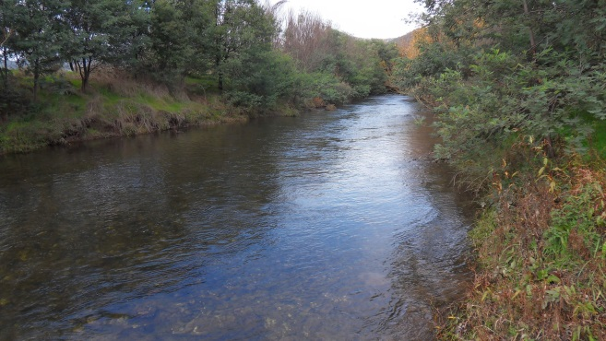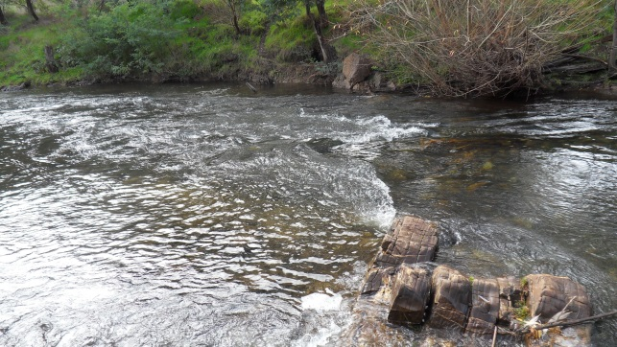
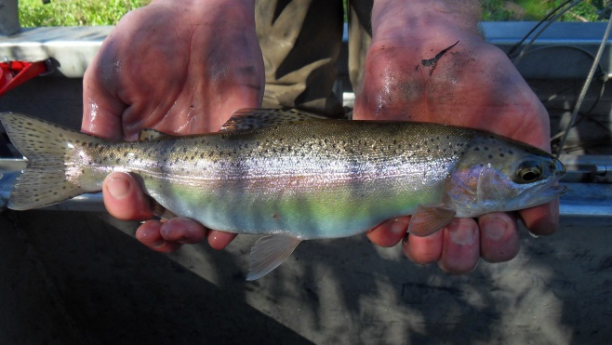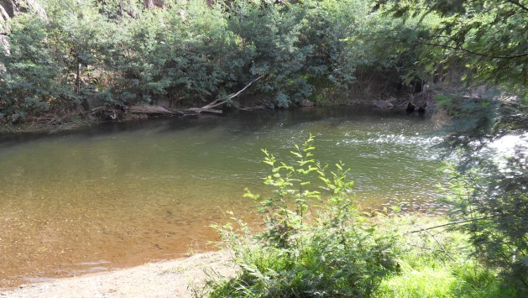
Howqua River, north eastern Victoria.

What we did:
Targeted surveys were conducted on-site at Upper Goulburn basin rivers over the 2014–2015 trout season with questions on visitor demographics, preferences, avidity, catch and effort. The creel clerk completed 13 days of driving to popular wild trout stream locations, including the townships of Jamieson, Woods Point and Mansfield, and campsites adjacent to the Goulburn, Howqua, Jamieson, Delatite and Big rivers and Running Creek. Interviews were conducted with visitors and individuals engaging in possible fishing activity to provide indications of fishing pressure, fisher behaviour, fisher avidity and visitor preferences.
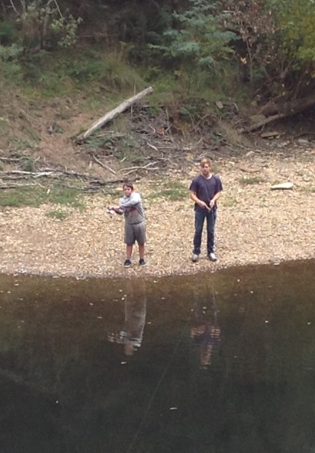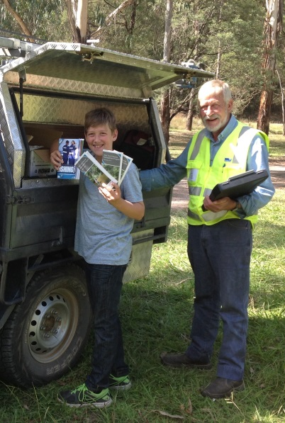
Wild trout fishery anglers were interviewed to assist in determining whether fishing pressure is adversely impacting on wild trout populations in the Upper Goulburn basin.
A tag reward program was established in a case-study river in the north-east of Victoria to understand the trout fishing rate of exploitation (tag returns). In the Howqua River, 100 trout caught during fish population surveys (27 brown trout in Dec 2014; 5 at Tobacco Flat; 4 at Pickerings Hut; 1 at Tunnel Bend; 1 at Eight Mile Flat; 4 at Cornhill Logging Track; 1 at Upper Howqua Road Crossing; 11 at Bindaree; 32 brown trout in March 2015; 4 at Frys Hut; 8 at Seven Mile Flat; 20 at Bindaree; April 2015; 23 brown trout in April 2015; 6 at Tobacco Flat; 4 at Frys Hut; 3 at Sheepyard Flat; 2 at Noonans Flat; 6 at Six Mile Flat; 2 at Seven Mile Flat) and were tagged with a high reward ($100) dart tag. Angler reported catches over one year will provide a measure of fishing catch, with the accumulated catch data used to provide an exploitation rate for the fishery. The tag reward program also engaged anglers in the research and encouraged participation in the north-east trout fishery.
Data recorded by Fisheries Officers based at Fisheries Victoria’s Alexandra Station was analysed for compliance trends in the observation of regulations by anglers. Fisheries Officers travel in excess of 45,000 kms per annum; predominantly patrolling salmonid fisheries within the Murrindindi and Mansfield Shires, and annual records are kept (financial year) of inspections of individuals actively engaged in recreational fishing. Fisheries Officers are rostered for patrols Monday–Friday, 15 weekends and 5 public holidays each year, and 60 shifts including hours outside of the typical 9–5 work hours (rostering must also allow for leave and training and education activities). Also note that Fisheries Officers often work in plain clothes and do undercover surveillance — so anglers should not assume that because they haven’t seen Fisheries Officers, that they haven’t been observed!
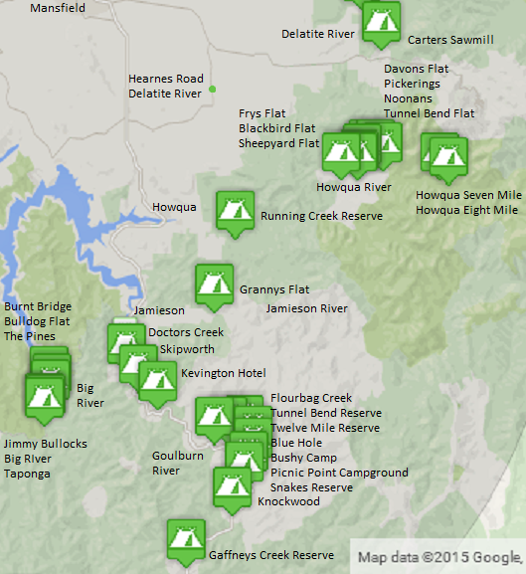
On-site angler survey locations, Upper Goulburn basin, north eastern Victoria.

Key findings and implications to date:
3 lines of inquiry:

Angler Interviews
- In the 2014–2015 trout open season, over the months of January to April 2015, 172 parties were interviewed adjacent to streams in the Upper Goulburn River Basin in the Mansfield Shire (Not all groups or camps observed were interviewed – the intent was to focus on likely fishers).
- The total number of people this represented was 1,401, of which one person was interviewed twice. On average, each party had 8 members.
- Almost 41% of those interviewed were less than 30 years of age. The median age group of those interviewed was 30 to 39 years. About 6% of those interviewed were 70+ years old (Figure 4).
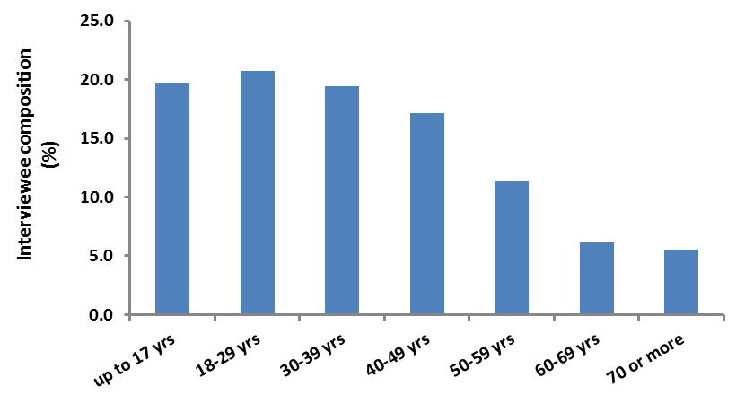
Figure 4: Age composition of interviewees.
- There were 4 local residents among those interviewed, the remainder were all visiting on holiday and more than 90% of the parties were staying for 2–7 days.
- 45% of the interviews were conducted near Howqua River (8 adjacent campsites) and 34% were adjacent to Goulburn River (12 adjacent campsites). Lesser numbers of interviews were conducted adjacent to Big River (4 campsites), Jamieson River (1 campsite) and Delatite River (2 campsites).
- Among the parties interviewed; 113 were fishing parties, whereby either the interviewee, or someone within their party had either been fishing, was fishing, or intended to fish, and 59 were non-fishing parties (Figure 5).
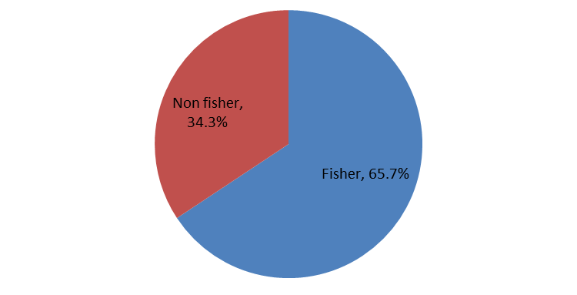
Figure 5: ‘Fisher’ or ‘Non fisher’ composition of parties.
- Each party was asked to rate the ‘importance of fishing’ in their choice of destination (on a 1–5 scale where 1 is very important and 5 is not relevant). For ‘fishing’ parties, the average score for the importance of fishing in destination choice was 3, indicating fishing was of average importance.
- When asked “How would you rate the most experienced fisher in your group, (or yourself if solo), as a trout angler?” with categories of ‘committed’, ‘advanced’, ‘active’ or ‘casual’ (definitions were provided if required, Table 1); most (70) of the fishing parties were categorised as ‘casual’ fishers (Figure 6).
Table 1. Angler type categorisation.
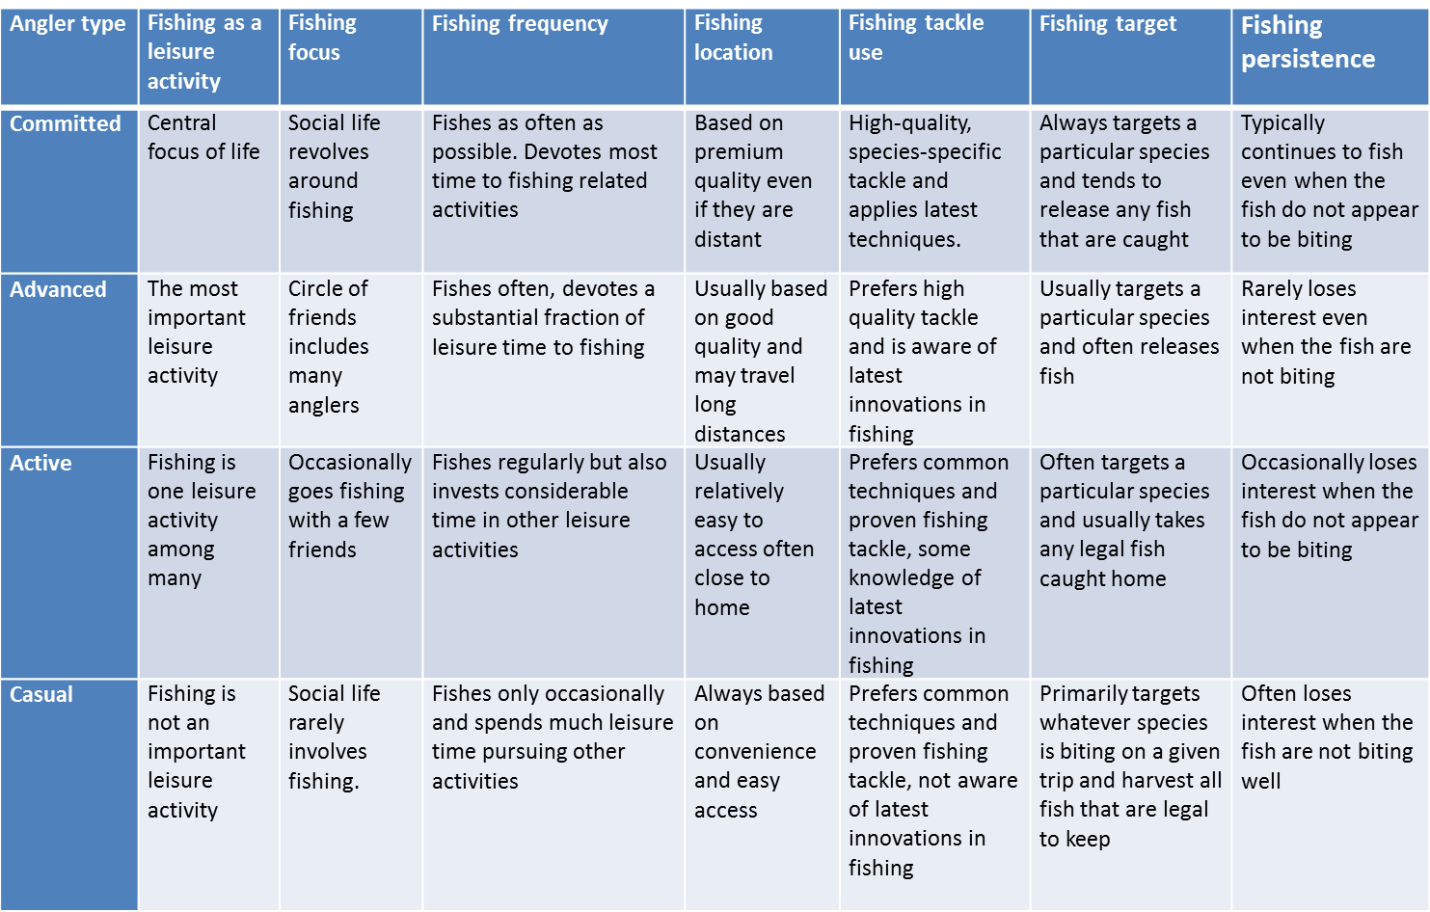

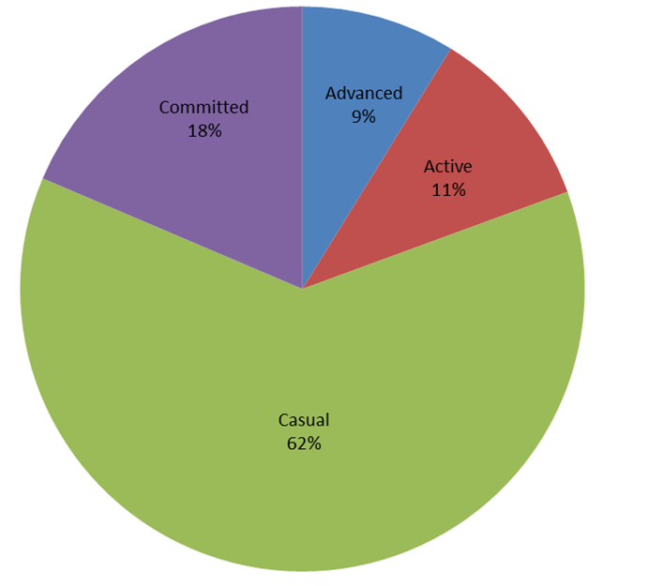
Figure 6: Most experienced angler ‘angler type’ composition of parties.

- ‘Committed’ and ‘advanced’ fishers were the ones who fished longest (Figure 7) with ‘casual’ fishers fishing for the least amount of time.
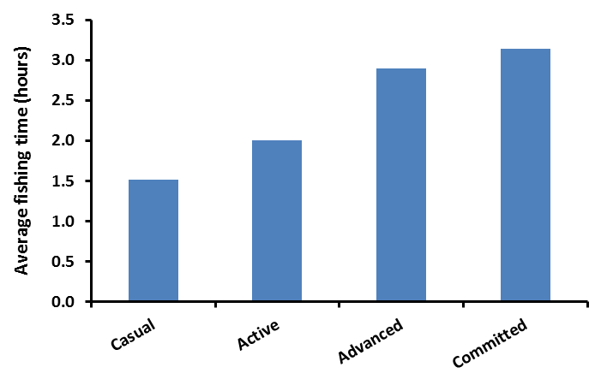
Figure 7: Average time spent fishing per day by ‘angler type’.
- A similar proportion of each of the fisher types (most experienced fisher in the group) stated that they would usually release all or most of the trout caught, with active anglers proportionally releasing more fish caught (Figure 8).

Figure 8. Proportional breakdown of harvest v release patterns of angler types.
- Postcodes of group members provide an indication of visitation to the Upper Goulburn region, and distances travelled. The majority of anglers were Victorian (90%), with 4% of postcodes indicating ‘local’ visitors from Mansfield and district.
- Of all interviewees, 176 individuals had been or were fishing.
- 368 hours were fished by 173 non-residents.
- Fishing parties who identified that they’d fished in the region more than 5 times in the past 2 years were asked to compare catch rates: 3 n/a, 2 unsure, 4 same, 14 lower (inc. 3 residents), 2 higher.
- Fishing parties who’d caught fish were asked if they were satisfied with their fishing: 12 unsatisfied, 10 satisfied, 3 unsure.
- 27% of fishing parties were using baited lines only, 19% were using lures only and 8% were fly fishing only. 30% of fishing parties were using both baited lines and lures and 9% of fishing parties were using both lures and flies.
- Reasons for dissatisfaction: ‘lack of fish’, ‘increased numbers of carp’, ‘blackberries’
- Reasons for satisfaction: ‘nice fish seen, good size’, ‘quality camp sites, love the area’
- Excluding the catches of residents, 25 brown and rainbow trout were caught by the visitors interviewed, ranging in size from 75 to 350 mm; all angler types released some fish, with only 8 fish retained; 5% of anglers retained fish.
- Resident fishers (3) (advanced and committed) reported catching upwards of 20 trout (averaging 200–300 mm) over the season to Feb/March, releasing all or most (all were dissatisfied with their angling — reporting ‘decreases in sizes and numbers of trout, increases in carp numbers’)
- Most anglers appeared to self-regulate with regards to ‘keep-able’ sized fish, and more avid anglers appeared to catch larger fish than casual anglers (thus, when more avid anglers did retain trout, they were generally of a larger size than those retained by casual anglers).
- General comments from fishers related to increased carp presence; cormorants; decreased flows and low water levels; increased water temperatures especially in lower reaches; increases in number of people/fishing pressure; blackberries along river edges and tracks; removal of willows in lower reaches; European wasps; rubbish.

Tag Recaptures
- As of July 2015 (and correct as of end October 2015), only 3 brown trout had been reported caught out of the 100 tagged; a low exploitation rate.

Compliance Data
- Data from the Alexandra Station are provided for financial years 2012–2015 with the number of contacts, and the number of offenders.
- Offences are additionally categorised by type, relating to the severity of penalty, ranging from verbal warnings, to official warnings, infringements (with financial penalties) and prosecutions (legal proceedings with court ordered outcomes).
- Prosecutions are initiated and charges are laid dependent upon the gravity of the offence(s). Matters are generally referred for prosecution where it is in the public interest for a matter to be dealt with by way of the Court; where behavioural recidivism is apparent, (repeat offenders), where there are multiple offences, or in instances where an offence is not infringeable.

Figure 1: Compliance Data Summary 2012–2013
Four out of the six prosecutions in 2012–2013 were related to salmonids, with three of five offenders ‘known’ to Fisheries Officers (ie. repeat offenders or recidivists). This ‘strike rate’ in the detection of recidivists is indicative of/and helps demonstrate that Fisheries Officers are vigorous in maintaining compliance and committed to the protection of Victorian salmonid resources.

Figure 2: Compliance Data Summary 2013–2014

Figure 3: Compliance Data Summary 2014–2015
One of the three prosecutions during the 2014–2015 period related to salmonids (in this instance not an Upper Goulburn stream, but relating to brook trout in the Rubicon River).
- Statistics have been consolidated for both 'on land' and 'on water' inspections, however no exceeded bag limits for salmonids 'on water' have been observed locally.
- Five out of nine prosecutions during this three year period were related to salmonid offences and in each instance related directly to offenders exceeding bag limits and were subject of multiple associated ancillary charges.
- Infringeable offenders exceeding bag limits may include species other than trout (eg Murray cod) which would reduce the incidence of salmonid-related offences.

Key findings:
1. Many visitors, few fishers; even casual anglers release; only 5% of fishers are taking fish caught.
2. Low exploitation
3. Good compliance; few over bag prosecutions.
This snapshot suggests that harvest rates appear low, we’re not overfishing our wild trout rivers.

Next steps:
The targeted angler surveys will again be conducted over the trout season in 2016–2017.

