2025/26 Eastern Zone Abalone TACC

Statutory Consultation Plan

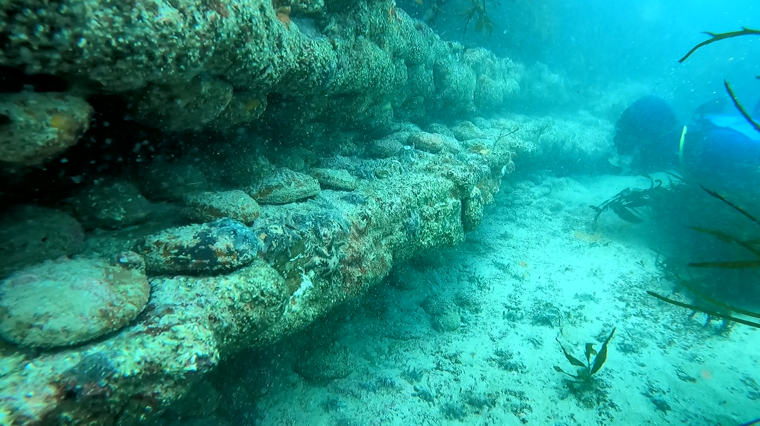

# Contents

2025/26 Eastern Zone Abalone TACC 1

Statutory Consultation Plan 1

Contents 1

Preamble 2

Closing date for submissions 2

flow chart of consultation 3

consultation plan 4

# Preamble

Any submissions received in relation to the consultation conducted by the Victorian Fisheries Authority will be published on the Authority’s website. In making a submission, unless the person making the submission indicates to the contrary, they will be consenting to their submission, including their name only, being published on the Authority's website from the conclusion of the consultative process.

## Closing date for submissions

The closing date for the receipt of submissions for consultation on the total allowable commercial catch (TACC) for each abalone fishery zone will be at least 10 working days after publication of the draft further abalone quota order (FAQO) and any associated fisheries notices.

Statutory consultation documents will be published on the VFA website following the TACC advisory forums with an expected completion date of 28 January 2025 for the Eastern Zone.

# flow chart of consultation

The Victorian Fisheries Authority (VFA) and zonal stakeholders attend total allowable commercial catch (TACC) forums.

Forum outcomes and written submissions form industry recommendation to the Chief Executive Officer (CEO) VFA (as delegate to the Minister responsible for fisheries) regarding TACC and supporting Fisheries Notice.

CEO VFA releases the proposed Further Abalone Quota Order and supporting Fisheries Notice for written comment to persons and organisations with relevant interests.

Written submissions and other relevant information considered by CEO VFA.

CEO VFA declares the Further Abalone Quota Order and supporting Fisheries Notice.

The VFA publishes the Further Abalone Quota Order and supporting Fisheries Notice in the *Victoria Government Gazette.*

Fisheries Victoria writes to inform all licence and quota holders of its decision

The VFA publishes its decision on its website.

The VFA writes to inform all licence and quota holders of its decision.

# consultation plan

|  |  |  |  |
| --- | --- | --- | --- |
| 1. 1 | 1. Consultation Title | 1. 2025/26 Eastern Zone Abalone TACC Setting Process | |
| 1. 2 | 1. Representative group/s being consulted | 1. ✓ Commercial wild-catch (Quota and licence holders, Eastern Zone Abalone Industry Association, Abalone Council Victoria, Seafood Industry Victoria) 2. ✓ Recreational fishing (VRFish, Scuba Divers Federation of Victoria)   ✓ Aboriginal communities (The Federation of Victorian Traditional Owner Corporations, Gunaikurnai Land and Waters Aboriginal Corporation)   1. ✓ Conservation interests (Environment Victoria, Victorian National Parks Association) | |
| 1. 3 | 1. Managing Officer | 1. Anthony McGrath – Abalone Fishery Manager | |
| 1. 4 | 1. Target Start Date | 1. 19 December 2024 | |
| 1. 5 | 1. Target End Date | 1. 28 January 2024 | |
| 1. 6 | 1. Background/ History | 1. The abalone fishery is one of Victoria's most valuable commercial fisheries.   The fishery has been managed under a system of quota controls since 1988. The TACC and the quantity of catch comprising an abalone quota unit is set for each quota period by a Further Abalone Quota Order published in the Victoria Government Gazette. Fisheries Notices that establish legal minimum lengths for relevant zones may also be required.   1. TACCs are set for blacklip abalone in the western, central and eastern zones and greenlip abalone in the western and central zones. 2. The next quota period extends from 1 April 2025 to 31 March 2026 for the Eastern Zone. | |
| 1. 7 | 1. Relevant Statutory provision | 1. Statutory consultation with stakeholders under Section 3A of the Fisheries Act 1995 is required prior to the Minister or delegate making decisions related to Further Abalone Quota Orders and Fisheries Notices. | |
| 1. 8 | 1. Purpose/objectives/scope | 1. To seek comment on the draft 2025/26 Further Abalone Quota Order and relevant Fisheries Notices. | |
| 1. 9 | 1. Method | Initial consultation on the recommended TACC to inform the Further Abalone Quota Orders and Fisheries Notices is undertaken via three zonal TACC advisory forums attended by industry stakeholders, invited stakeholders and VFA management, science and enforcement staff.  The Eastern Abalone Zone forum was held on 3rd and 4th December 2024.  Statutory consultation on the draft Further Abalone Quota Orders and Fisheries Notices is conducted via letters to persons/groups noted in section 2 of this consultation plan and the Departmental website.  The consultation period will extend for at least 10 working days following the release of the draft Further Abalone Quota Orders and Fisheries Notices.  All consultation is expected to be completed by no later than 28th January, 2025. | |
| 1. 10 | 1. Communication Plan | 1. Decisions regarding Further Abalone Quota Orders and Fisheries Notices are communicated through notices published in the Victoria Government Gazette and the VFA website. 2. Letters informing stakeholders of decisions regarding Further Abalone Quota Orders and Fisheries Notices are sent to all identified stakeholder groups listed above. | |
| 1. 11 | 1. Information provision | 1. Stakeholders will be provided with a copy of the draft 2025/26 Further Abalone Quota Order and supporting Fisheries (Eastern Abalone Zone) Notice. Other detailed information is presented in the zonal TACC forums and published on the VFA website. | |
| 1. 12 | 1. Resources/advice (inc. purchase of advice) | 1. Internal resources of VFA. | |
| 1. 13 | 1. Output (documentation / implementation) | 1. The 2025/26 Further Abalone Quota Order and supporting Fisheries Notices; letters to stakeholders; notices published in the Victoria Government Gazette; the departmental website; and a media release. | |
| 1. 14 | 1. Publication of results of consultation | 1. *Any submissions received in relation to the consultation being conducted by VFA will be published on the VFA website. In making a submission, unless the person making the submission indicates to the contrary, they will be consenting to their submission, including their name only, being published on the VFA website for 90 days from the conclusion of the consultative process.* | |
| Consultation Plan prepared by:   1. Anthony McGrath 2. Abalone Fishery Manager 3. Date: 16 / 12 / 2024 | | | Approved by:   1. Luke O’Sullivvan 2. A/CEO, Victorian Fisheries Authority 3. Date: |