|  |
| --- |
|  |

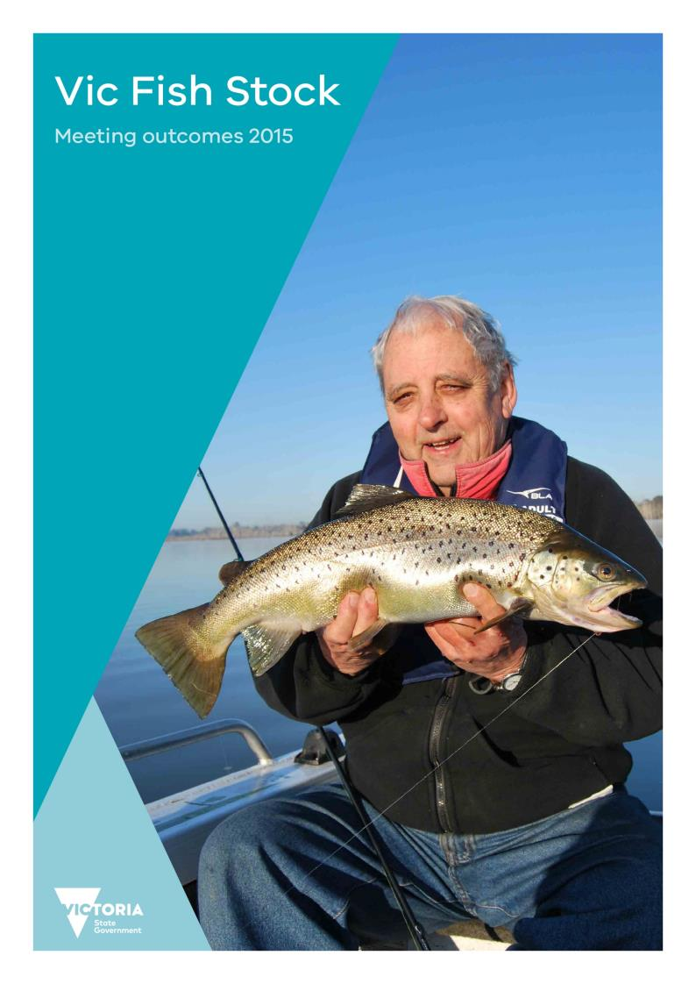

|  |
| --- |
| © The State of Victoria Department of Economic Development, Jobs, Transport & Resources, December 2015    This work is licensed under a Creative Commons Attribution 3.0 Australia licence. You are free to re-use the work under that licence, on the condition that you credit the State of Victoria as author. The licence does not apply to any images, photographs or branding, including the Victorian Coat of Arms, the Victorian Government logo and the Department of Economic Development, Jobs, Transport & Resources logo. To view a copy of this licence, visit <http://creativecommons.org/licenses/by/3.0/au/deed.en>  Printed managed by Finsbury Green.  ISBN 978-1-925466-35-5 (Print) ISBN 978-1-925466-36-2 (pdf)  For more information contact the DEDJTR Customer Service Centre 136 186  Front cover image: A cracking impoundment brown trout (Photo by Marc Ainsworwth).  **Accessibility** If you would like to receive this publication in an alternative format, please telephone the DEDJTR Customer Service  Centre on 136186, email [customer.service@ecodev.vic.gov.au](mailto:customer.service@ecodev.vic.gov.au), or via the National Relay Service on 133 677, [www.relayservice.com.au](http://www.relayservice.com.au). This document is also available on the internet at [www.vic.gov.au/fisheries](http://www.vic.gov.au/fisheries)  **Disclaimer** This publication may be of assistance to you but the State of Victoria and its employees do not guarantee that the publication is without flaw of any kind or is wholly appropriate for your particular purposes and therefore disclaims all liability for any error, loss or other consequence which may arise from you relying on any information in this publication. |

Contents

Introduction 1

Background 1

Fish stocking outcomes 2014-15 season — Summary 2

2015 Vic Fish Stock meeting outcomes 4

Improving fisheries state-wide 5

Target One Million 5

Talk Wild Trout Conference 8

Recreational Fishing Forums 9

Chinook salmon fishery developing 9

Estuary perch stocking update 11

Record number of golden perch stocked into Lake Eildon 12

Re-establishing Macquarie perch populations 12

Stocked fish assessment 12

School Holiday stocking program 15

Recreational Fishing Grants Program (RFGP) 17

Fishing for Grants? 17

Submitting a change to the fish stocking program 17

Fisheries Victoria contacts 18

Appendix 1 – Proposed fish stockings 19

Barwon South West and Grampians 20

Gippsland 35

Hume 39

Loddon Mallee 51

Port Phillip 57

Appendix 2 – Stocking Submission Check list 61

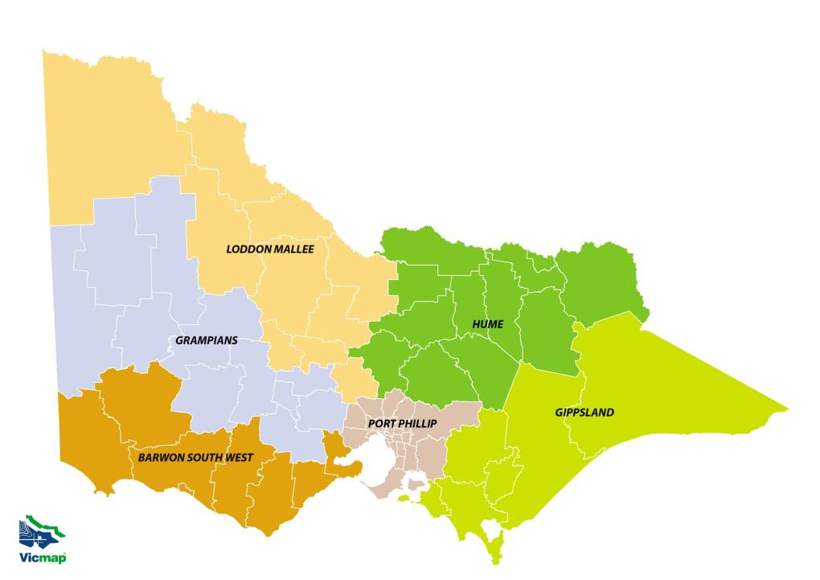Department of Economic Development, Jobs,   
Transport and Resources (DEDJTR) Regions.

Cartography by Information Integration  
Information Services Branch  
Department of Economic Development, Jobs, Transport and Resources  
[**ISB.InformationIntergration@ecodev.vic.gov.au**](mailto:ISB.InformationIntergration@ecodev.vic.gov.au)  
August 2013 G/7350

Introduction

Background

Every year the Department of Economic Development, Jobs, Transport & Resources, through Fisheries Victoria, stock many of Victoria’s inland lakes, impoundments and rivers with key recreational angling species to improve fishing opportunities for fishers across the state. The annual rounds of Vic Fish Stock regional consultative meetings plan the direction of these stocked fisheries. The meetings apportion the number of native fish to be stocked in the forthcoming summer (2015-16) and the number of salmonids that will be stocked in the following winter (2016). This document reports on the outcomes of the 2015 consultative meetings.

Vic Fish Stock meetings

The purpose of the Vic Fish stock meetings are for each waterbody, to consider recreational angling to:

* Determine the management objectives for the fishery
* Review the current fishery in light of the current year's stocking plan and identify any modifications required
* Draft the following year’s stocking plan
* Identify other issues relevant to fish stocking
* Identify current fishery management issues
* Assess additional proposals to the stocking program

The Vic Fish Stock meetings provide a forum for discussions on fish stocking regimes and related recreational fisheries management issues. In 2015 five meetings were held across regional Victoria:

Port Phillip —- held at Melbourne on the 3rd August 2015

Grampians/Barwon South West — held at Ballarat on the 4th August 2015

Loddon Mallee — held at Bendigo on the 5th August 2015

Hume — held at Benalla on the 6th August 2015

Gippsland — held at Traralgon on the 8 th September 2015

Submissions to change the stocking program are tabled from representative angler groups. This ensures that the submissions are supported by the relevant groups. Individuals who wish to submit changes are encouraged to contact the representation groups.

The meetings involve invited representatives from a range of stakeholder groups and include Fisheries Victoria, the Victorian Recreational Fishing peak body (VRFish), the Australian Trout Foundation (ATF), Native Fish Australia (NFA), Water Management Authorities, Catchment Management Authorities (CMAs), Department of Environment, Land, Water and Planning Primary Industries (DELWP) and fishing association representatives.

Draft outcomes from Vic Fish Stock meetings are prepared by Fisheries Victoria and circulated to meeting participants for comment prior to the publication of this document. This report summarises the key outcomes of the 2015 Vic Fish Stock meetings.

The Department acknowledges and values the important contribution made by stakeholders in this process, particularly those who volunteered their time to prepare for and attend these meetings.

Fish stocking outcomes 2014-15 season — Summary

Salmonid stocking outcomes

The 2014 Vic Fish Stock consultation proposed 609,400 salmonids to be stocked in the winter of 2015. A total of 541,787* salmonids were stocked which included the Family Fishing lakes. A breakdown of released salmonid species and numbers is presented in the following table.

All salmonids stocked were produced at Fisheries Victoria’s Snobs Creek hatchery.

2014-15 native fish stocking outcomes

The 2014-15 stocking plan for native fish was developed from the 2014 Vic Fish Stock report. It scheduled 1,587,450 native fish to be stocked in the summer of 2014-15. A total of 2,037,013 native fish were stocked. A breakdown of released native fish species and numbers is presented in the following table.

Funding from Recreational Fishing Licence (RFL) fees and the Recreational Fishing Initiative (RFI) has helped Fisheries Victoria stock fish into the lakes and rivers to improve freshwater fishing opportunities for anglers.

*estimate as some salmonid fish are scheduled to be stocked after the publication date

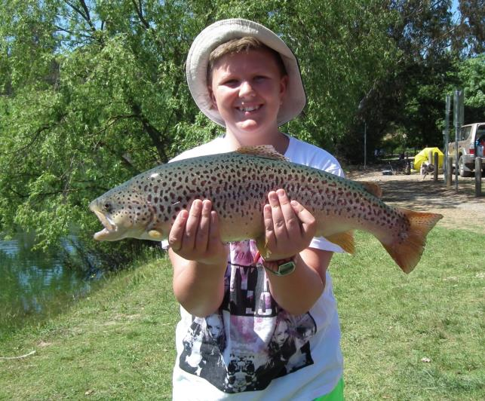

Riley Chlopek with a well-marked brown trout. Stocking ex Snobs Creek broodfish into Eildon pondage offers everybody the chance to catch a trophy fish. (Photo Steve Vidler)

|  |  |  |
| --- | --- | --- |
|  | **Target - Vic Fish Stock (2014)** | **Actual fish stocked** |
| **Salmonids (2015)** |  |  |
| Brown trout | 330,250 | 295,311 |
| Rainbow trout | 279,150 | 241,026 |
| Chinook salmon | 0* | 5,450 |
| **Sub total** | **609,400** | **541.787\*** |
| **Natives (2014-15)** |  |  |
| Australian bass | 123,000 | 120,000 |
| Estuary perch | 91,000 | 107,000 |
| Golden perch | 789,450 | 1,120,650 |
| Macquarie perch | 17,000** | 31,350 |
| Murray cod | 523,000 | 607,013 |
| Catfish | 5000** | 0 |
| Silver perch | 35,000 | 35,000 |
| Trout cod | 10,000** | 16,000 |
| **Sub total** | **1,587,450** | **2,037,013** |
| **Total** | **2,196,850** | **2,578,800** |

*Estimate, some fish still to be stocked after publication ** Numbers dependant on production

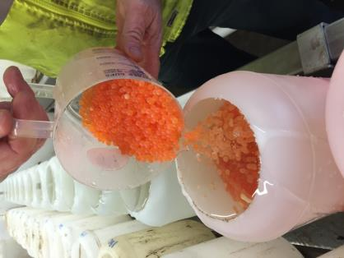 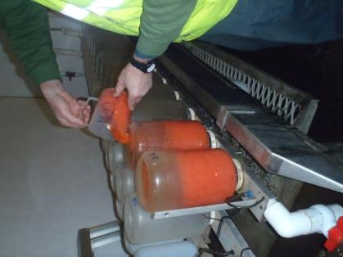

Where it all starts. Fertilised trout eggs being loaded into the incubators to grow the next batch of trout.

2015 Vic Fish Stock meeting outcomes

The 2015 Vic Fish Stock outcomes proposed a total of 2,485,000 native fish to be stocked into Victorian public waters in the summer of 2015-16 and 754,225 salmonids to be stocked in the winter of 2016. Details of the planned species and numbers to be stocked for each water body are detailed in Appendix 1.

The proposed fish release figures summarised here and listed in Appendix 1 are targets only. Numbers may vary and may be exceeded, or not attained, depending on hatchery conditions, water conditions (e.g. water quality, water levels), infrastructure maintenance, decisions of waterway managers, security of fish supply (e.g. unforseen impacts on production such as mortality, disease, quarantine status and availability of required stocks from private suppliers) and any unforeseen circumstances that could preclude planned fish releases. Fish allocations may, therefore, be amended prior to release.

Summary of proposed Vic Fish Stockings 2015-16

|  |  |
| --- | --- |
|  | **Proposed stocking numbers** |
| **Salmonids (2016)** |  |
| Brown trout | 393,100 |
| Rainbow trout | 304,125 |
| Chinook salmon | 57,000 |
| **Sub total** | **754,225** |
| **Natives (2015-16)** |  |
| Australian bass | 120,000 |
| Golden perch | 1,425,000 |
| Macquarie perch | 50,000** |
| Mulloway | 7,500 |
| Murray cod | 713,000 |
| Silver perch | 20,000 |
| Trout cod | 10,000** |
| Estuary perch | 183,500 |
| Catfish | 0” |
| **Sub total** | **2,485,000** |
| **Total** | **3,239,225** |

*Dependant on availability. Numbers determined if supply available, will purchase catfish.   
**Estimates only. Numbers dependant on outcomes of breeding.

Improving fisheries state-wide

An overview of selected state-wide inland fisheries management programs relating   
to fish stocking.

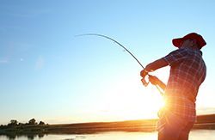Target One Million

The State Government has committed to delivering its *Target One Million* plan for recreational fishing, which will get more Victorians fishing more often.

Elements of *Target One Million* include:

* increase the number of fishers to one million by 2020
* halt commercial netting in Port Phillip and Corio Bays over eight years
* take action on water levels at Lake Toolondo
* establish Fisheries Victoria as a Statutory Authority
* pursue reciprocal licence arrangements with New South Wales
* ban netting at the mouths of rivers in the Gippsland Lakes
* establish a Better Fishing Fund
* increase fish stocking to 5 million fish per year
* open recreational trout cod fisheries in Beechworth
* stock barramundi into Hazelwood Pondage
* allocate 'Stronger Fishing Club' grants
* introduce a minimum legal size for trout
* grow the Victorian Trout Opening Festival
* remove horsepower and boat length restrictions at Blue Rock Lake
* undertake a state wide recreational catch survey
* deliver school education and children's fishing programs

Opening trout cod fishery

In an Australian first, recreational anglers can now fish for and harvest trout cod in two lakes in Victoria. Lakes Sambell and Kerferd are the only waters in Australia where the endangered trout cod can be legally targeted by recreational fishers. The commitment to establish the fishery is a key part of Target One Million plan – which will get more Victorians fishing more often.

The dedicated stocking program has seen 45,000 baby trout cod fingerlings released into the lakes since 2008, and with support from the National Trout Cod Recovery Plan, anglers can legally fish for trout cod   
in Beechworth.

Trout cod fingerling production at the Government’s Snobs Creek hatchery will expand and continue to support the recovery of the species in the wild, while further developing the two new fisheries.

To ensure the fisheries are sustainable, harvest of trout cod will be restricted to a daily bag limit of one per angler, and complemented by a minimum size of 40 cm and a maximum size of 50 cm.

Toolondo Reservoir fishery

The Toolondo Reservoir Recreational Fishery Advisory Group was established in March 2015 to secure the future of Toolondo Reservoir as one of Victoria's best trout fisheries. Over the next 6 months, the group commissioned three independent studies, deployed monitoring equipment and reviewed the performance of the fishery over the last twenty-three years. The Advisory Group's final draft report was presented to Government for consideration. In working with Water Agencies and Catchment Management Authorities, it's clear the Wimmera region continues to experience historically low rainfall levels and falling storage levels. The state government’s transfer of 5,000 megalitres to Toolondo Reservoir in January 2015 preserved water levels and extended the performance of the fishery. This resulted in some exceptional trout fishing over the last twelve months.

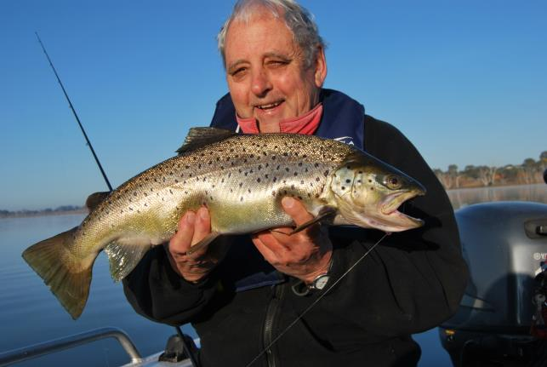

Toolondo brown trout. (Photo Marc Ainsworth)

Hazelwood Pondage Barramundi

Barramundi are a tropical species, highly prized by recreational fishers. Hazelwood Pondage near Moe is part of the cooling process of the power station and as a result has warm water. The site is being investigated for suitability for Barramundi with the view to stocking the lake with these hard fighting fish.

In May 2015, Fisheries Victoria established a local working group, completed a water quality review, deployed water temperature loggers and completed a tank-based acclimatisation trial (using Hazelwood Pondage water). In early 2016, there are plans to stock 1,000 barramundi (of various sizes) into the Pondage. At least 20 of these fish will be fitted with acoustic tags and a number of acoustic receivers will be deployed around the Pondage. The six month trial will help assess the growth and survival of barramundi and where these fish move. This information will help Fisheries Managers optimise stocking rates, manage participation levels and other user interactions.

Blue Rock Lake open to boating

Recreational anglers have better access to the developing bass fishery in Blue Rock Lake, near Moe, due to changed rules that modified horsepower and boat length regulations.

The changes to the boating regulation lift previous restrictions and fishing boats of any length and any engine size may now operate on Blue Rock Lake. Water skiing and jet skis will continue to be deterred via the 15 knot speed limit. These changes follow community consultation and are in place for a 12 month trial period.

The change of rules is great news for freshwater anglers in Gippsland and Melbourne’s east who have been keen to access the Australian bass fishery at Blue Rock from sport-fishing and trailer boats.

Since 2002, more than 160,000 Australian bass fingerlings have been stocked into Blue Rock, which has rapidly become one of Victoria’s premier destinations for the popular native fish.

The Lake is also home to a stocked population of brown trout and rainbow trout, along with a self-sustaining population of redfin, which are a great table fish.

To help promote this fantastic Bass fishery, some larger Bass were released that if caught, will earn a lucky fisher a fishing voucher at the local tackle store for fishing gear.

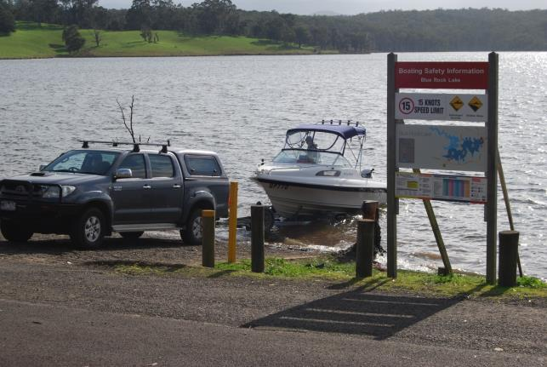

Fishers with larger boats can now access Blue Rock Lake’s bass fishery (Photo Marc Ainsworth)

Talk Wild Trout Conference

Anglers in north east Victoria have expressed concerns regarding the status of wild trout populations with reports of poor fishing across many streams, particularly during summer of 2013-14. Similar reports of poor fishing in wild trout streams have also been reported in locations outside Victoria including New South Wales, Tasmania and New Zealand.

In response to Victorian concerns, Fisheries Victoria commissioned Arthur Rylah Institute researchers to conduct [population surveys](http://agriculture.vic.gov.au/fisheries/recreational-fishing/wild-trout-fisheries-management-program/wild-trout-population-survey) of four north east trout streams in February 2014. The results were presented to a trout reference group, a public meeting in Mansfield and the state-wide Recreational Fishing Roundtable forum. The "Wild Trout Fisheries Management Program" was developed and implemented in September 2014. It is a collection of nine projects to be undertaken over three years that aim to deliver:

A clearer understanding of the cause(s) of the decline in wild trout fisheries, better understanding of priority trout populations' health and status, improved engagement with fishers to share our understanding of trout fisheries management, science and factors that drive the fishery, more responsive management of wild trout recreational fishing in Victoria, and improved fishing opportunities for wild trout in Victoria.

Communication is a key element of the program and a free one day conference was held in November 2015 at Mansfield.

The conference assembled around 200 recreational anglers, managers and researchers to share the findings of research conducted on riverine trout populations over the last 12 months.

The conference was all about sharing the results from the first year of field work so that anglers, and angling dependent businesses, build an understanding of our trout fisheries and their key drivers.

Conference topics ranged from the health of key trout streams, trout movement in the Delatite River from the acoustic tracking project, and the importance of riparian vegetation and shading on our streams.

The conference featured a key note address from Dr Dan Dauwalter of Trout Unlimited, which is an American non-government, angler based group committed to better trout and salmon fisheries through habitat restoration use by committed anglers to get the job done.

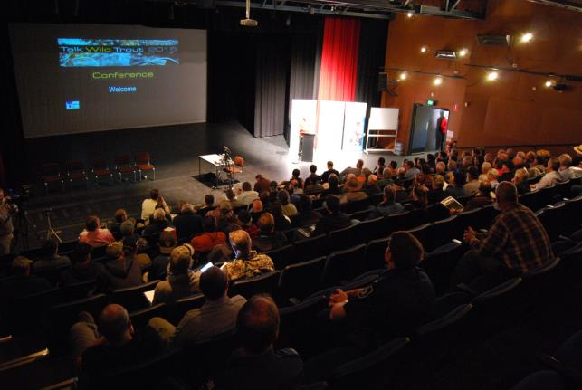

Talk Wild Trout 2015 Conference on 21 November 2015 was very well supported by recreational fishers (Photo Marc Ainsworth).

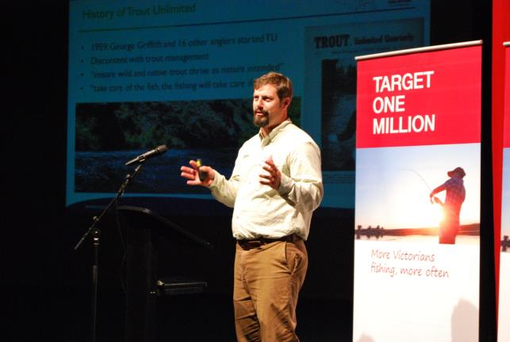

Dr Dan Dauwalter (Trout Unlimited, USA) presenting at the Talk Trout Conference (Photo Marc Ainsworth).

Further details about the conference and the Wild Trout Fisheries Management Plan (WTFMP) can be obtained from the Fisheries Victoria website: <http://agriculture.vic.gov.au/fisheries/recreational-fishing/wild-trout-fisheries-management-program>

Recreational Fishing Forums

Fisheries Victoria is always open to new ideas and ways to keep improving recreational fisheries opportunities for Victorian anglers. Each year a series of regional fishing forums are held throughout regional Victoria to update interested stakeholders about Fisheries Victoria’s management activities and hear their suggestions about ways in which recreational fishing can be improved in their region. The Recreational fishing forums are set to continue in 2016.

The forums are advertised widely in the media each year and anglers may also send in ideas online.   
See the Fisheries Victoria website for further details see the website at: <http://agriculture.vic.gov.au/fisheries/recreational-fishing/target-one-million/regional-recreational-roundtables>

Chinook salmon fishery developing

Victoria’s Chinook salmon fisheries in the crater lakes of western Victoria continue to improve. A review of trout and salmon stocking in Camperdown’s two crater lakes supported continuation of the current Chinook salmon stocking program approach in Lake Bullen Merri and highlighted the return to large scale releases of brown trout in Lake Purrumbete.

In March 2015, Fisheries Victoria fisheries managers met with freshwater anglers to share and review the monitoring results of the stocking trial. The trial is aimed to improve the quality of the Chinook salmon fishery in both lakes. The monitoring effort included a creel survey which had interviewed more than 1,100 anglers, and two years’ worth of catch and effort statistics collected by members of the Lake Purrumbete and Camperdown Angling Clubs across both Lake Purrumbete and Bullen Merri.

The study revealed that In Lake Bullen Merri, the stocked Chinook salmon had performed well, with high catch rates by anglers and some specimens reaching 3.4 kilograms.

In nearby Lake Purrumbete, Chinook salmon had also delivered high catch rates for anglers but had not grown as large as hoped.

The brown trout in Lake Purrumbete, although catch rates had fallen during the stocking trial, the average size was two kilograms and the size and catch rates saw many anglers satisfied with the fishery.

The feedback from anglers at the review, and from the creel survey, had indicated a strong desire to maintain the high performance of the Chinook salmon fishery at Lake Bullen Merri and for increased catch rates of brown trout in Lake Purrumbete.

Consequently, fisheries managers will adjust stocking plans for the lakes this year to optimise what each can deliver for freshwater anglers. The focus will be on further building the Chinook salmon fishery in Lake Bullen Merri, where they have done best. It will receive 20,000 Chinook salmon yearlings, 5000 rainbow trout and 5000 brown trout this year.

At Lake Purrumbete, brown trout stocking will be boosted to 20,000 yearlings along with 10,000 Chinook salmon and 5,000 rainbow trout.

“Fisheries Victoria highly value angler input and the crater lakes monitoring project and it is an excellent example of how anglers and fisheries managers can effectively work together to improve recreational fishing. Feedback was that recreational anglers greatly appreciated being able to contribute to fisheries management and have input into the stocking program.

<http://agriculture.vic.gov.au/fisheries/recreational-fishing/fish-stocking/chinook-salmon-stocking-returns>

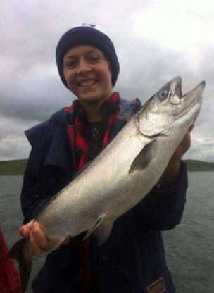 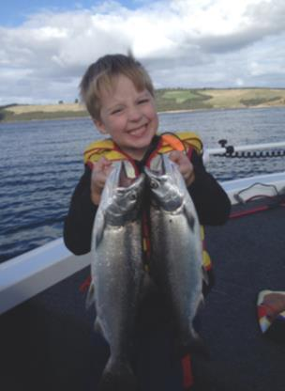

Smiling kids with quality fish. Chinook salmon stocking is a hit with Victorian anglers. (Photos by Geelong Fishing Charters (left)   
and Rick Maes (right)).

Estuary perch stocking update

Recent fish surveys revealed Victoria’s stocked estuary perch fisheries are performing well with some fish now above the legal minimum size of 27cm and available to catch.

The survey results were promising news for anglers given the significant effort that had gone into the estuary perch breeding program, which was funded by recreational fishing licence fees and the State Government.

Since 2012, more than 370,000 estuary perch fingerlings have been stocked into ten waters across the state to develop new fisheries for the species. Stocked waters have included lakes Hamilton, Beaufort, Struan, Albert Park, Karkarook, Bolac and Pertobe, the Werribee River, and Melton and Devilbend Reservoirs.

Six of these lakes were surveyed and the preliminary results indicate that estuary perch from each year’s stockings have survived and growth rates have been very good in most waters. Lake Bolac boasted the biggest estuary perch that measured 28.3cm and weighed 486 grams, most likely from the lake’s first stocking of 7,000 fingerlings in January 2012. Since then, the lake has been stocked with nearly 43,000 estuary perch fingerlings. At Lake Struan, the biggest estuary perch surveyed was 26.3cm and 375 grams. At Lake Beaufort, Albert Park Lake and Devilbend Reservoir, the biggest perch measured between 19 and 20cm, while at Lake Hamilton the largest was 16.3cm.

Unfortunately, because of historically low rainfall in the west of the state, Lake Bolac water levels are very low and an estuary perch fish salvage trail is underway.

A full report, including an analysis of growth, relative abundance and diet, will be available in January 2016.

Fisheries Victoria acknowledge and thank the recreational fishers involved in the ‘Perch Search’ who helped fisheries managers collect broodstock for the breeding program.

This project and others like it are creating new angling opportunities for Victorians and supporting the State Government’s ‘Target One Million’ plan.

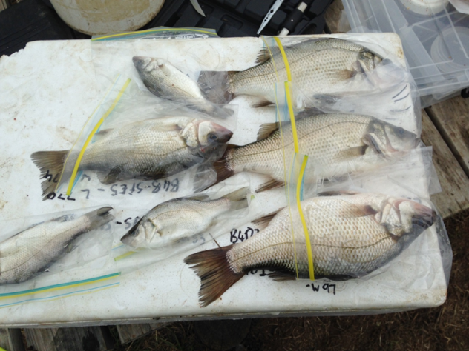

Some of the estuary perch sampled from Lake Bolac. Sizes indicate returns from each of the 3 years of stocking. (Photo Dion Lervasi)

Record number of golden perch stocked into Lake Eildon

A record number of golden perch were been stocked into Lake Eildon In the summer of 2014-15.

250,000 golden perch fingerlings have been released, eclipsing the previous biggest total of 233,500 in 2009. Golden perch are not thought to breed successfully in Lake Eildon, so stocking is a key way to maintain the fishery.

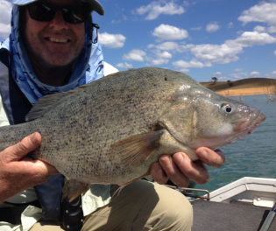 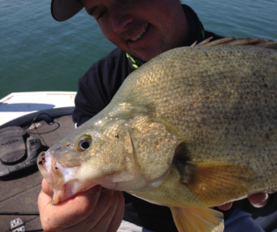

Eildon’s golden perch fishery produces quality fish. This is set to continue into the future with additional boosts to stocking numbers.   
(Photos by Marc Ainsworth and John Douglas).

Re-establishing Macquarie perch populations

Macquarie perch are native species which were historically abundant in the lower and mid Ovens River. The species has undergone dramatic decline to the point where they were considered locally extinct in the Ovens River. The species is formally listed as nationally endangered. A five year stocking program using Lake Dartmouth Macquarie perch broodfish and the translocation of wild sub-adult fish is being undertaken to re-establish Macquarie perch in the Ovens River. The fingerlings and translocated fish will generate a range of fish age and sizes similar to historical natural populations. This is an important first step toward re-establishing a self-sustaining Macquarie perch population with the long-term goal of creating a sustainable recreational fishery for the species.

Stocked fish assessment

Since the late 1980’s the Victorian government has invested considerably in native fish stocking aimed at improving recreational fishing. Since December 2010, three large-scale native fish stocking initiatives involving golden perch and Murray cod, and one major recreational fisher (creel) survey, have been conducted to assess the development and progress of the fisheries.

*Building Northern Native Fisheries* initiative aimed to stock an extra 670,000 native fish fingerlings into   
the Campaspe River, Gunbower Creek, Loddon River and Kow Swamp, in addition to the regular allocation of 180,000 native fish. A further 425,000 native fingerlings are expected to be stocked into these waters   
in 2014.

The “*Million Murray Cod”* *Program* (MMC), funded entirely by recreational fishing license fees stocked Lake Eildon with 1,150,000 Murray cod over three years and was considered to be the largest single-waterway stocking of Murray cod in Australia.

The *Lower Goulburn River enhancement initiative* saw 359,500 Murray cod and 527,700 golden perch released over a period of 4 years into Lake Nagambie and Goulburn Weir. The anglers of Nagambie Lakes have been creel surveyed to determine their perception of the native fish fishery and to monitor their catch.

The broad objective of this project was to assess the stocking initiatives above to address key knowledge gaps in the management of Victorian inland fisheries by answering recognised measures of stocking success including:

* Is there evidence of stocked fish survival?
* What is the percentage contribution from fish stocking to the fish population and fishery?
* Is there a net increase in fish abundance in the fish population and angler catch?
* Is there a net increase in fisher target preference, participation and/or satisfaction from fish stocking?

Golden perch and Murray cod fingerlings marked with calcein were released into the selected waters over four years from 2010/11. In 2014 electro-fishing surveys were conducted to capture fish from the stocked sites. Sampled fish were measured, aged and analysed for the presence of a calcein mark. Results from these surveys were compared with surveys conducted before the stocking events. Between December 2013 and April 2014, anglers fishing at Lake Eildon and the Nagambie Lakes were interviewed to assess catch and satisfaction. These results were compared with surveys conducted during 2010 and 20-11.

In waters that were stocked with calcein-marked golden perch, the percent of fish that were stocked ranged from 11% (lower Goulburn R.) to 54% (Campaspe R.) (overall mean 22%). The percent of Murray cod that were stocked ranged from 11% (lower Goulburn R.) to 100% (Campaspe R.) (overall mean 50%).

Lake Eildon Million Murray Cod

Based on extensive fish population sampling, stocked Murray cod represented the vast majority (99.6%) of Murray cod caught in Lake Eildon. As stocked Murray cod continue to grow, we can expect angler catch and satisfaction to improve in coming years.

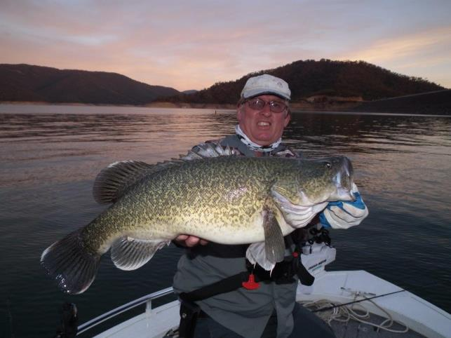

Lake Eildon’s Murray cod populations based on fish stocking and the fishery continues to grow in angler popularity. (Photo by Barb Vidler).

Nagambie Lakes creel survey

More anglers were targeting golden perch and Murray cod compared to the earlier survey. Golden perch and Murray cod represented 47% and 17%, respectively. A notable change in the views of anglers since the earlier survey has been the increase in dissatisfaction of other recreational activities.

A study of recreational fishing in the Nagambie Lakes has bench-marked angler catches, fishing methods, angler satisfaction and spending patterns to provide a clear picture of this developing fishery and how it can grow local tourism in the future. The study revealed most anglers were satisfied with their fishing experience and that catches were now dominated by golden perch and Murray cod, both of which had been stocked extensively in recent years.

Recreational fishing licence fees have helped stock more than one million golden perch and Murray cod fingerlings into the Nagambie Lakes system since 2009 so it is important that the anglers’ investment is paying off. The study was undertaken over four summer months by Fisheries Victoria with a contribution from the Shire of Strathbogie, which was also keen to know more about the role of fishing and its economic benefits to regional tourism.

Study highlights included:

* That 55 per cent of anglers’ catch consisted of golden perch, 19 per cent Murray cod, 16 per cent carp and 8 per cent redfin.
* One third of interviewed anglers specifically targeted Murray cod, golden perch or redfin with half happy to catch any species of fish in the Nagambie Lakes system.
* Nearly two thirds of anglers fished from the shore and most used bait.
* 60 per cent of anglers said they were either ‘very’ or ‘quite’ satisfied when asked about their satisfaction with the fishery over the previous 12 months.
* The total economic value of the fishery was estimated to be up to $500,000 annually, confirming that recreational fishing is not only socially significant, but also important to the regional economy.

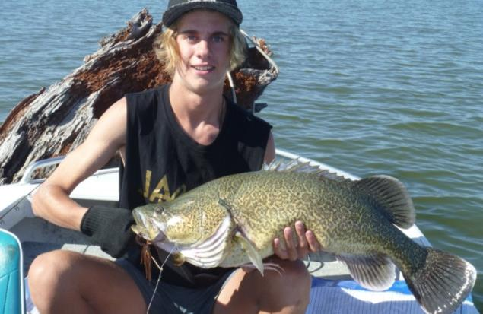

Baily Thomas with a nice Murray cod (Photo by Paul Thomas)

Fisheries Victoria acknowledges the input and efforts of Wally Cubbin and members of the Goulburn Valley Association of Angling Clubs for working closely with fisheries managers to develop the fishery into the community asset that the study clearly demonstrates.

Further analysis of the study’s findings and angler feedback will focus future investment in the fishery, which was expected to only improve as more stocked fish reached catchable size.

The study offered a glimpse of how popular recreational fishing had become in freshwater environments.

Lake Nagambie has become an angler’s delight and the study’s results ensure fishing in the area remains sustainable so future generations can enjoy this fabulous pastime and location.

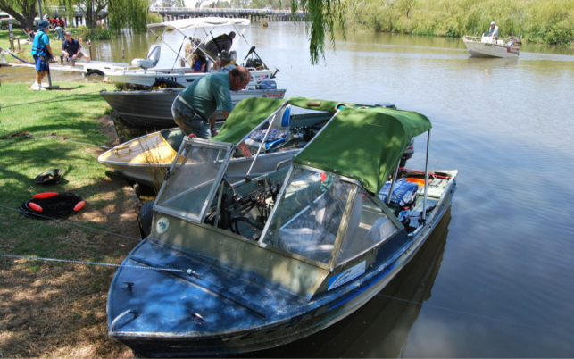

Nagambie Lakes and Goulburn Weir have developed into popular fisheries and provide an economic boost the regional economies   
(Photo by Marc Ainsworth)

Marine stocking trials

The State Government’s Target One Million plan included a commitment to implement a marine stocking program in Victoria. In August 2015, Fisheries Victoria Managers met with Gippsland representative anglers at the Lake Tyers Beach Angling Club where agreement was reached to trial the stocking of estuary perch in Lake Tyers (25,000) and mulloway (5,000) and Tamboon Inlet (2,500 mulloway).

5,000 mulloway fingerlings were stocked into Lake Tyers during October 2015 and 25,000 estuary perch fingerlings were stocked into Lake Tyers on January 2016.

A key success factor of this project has been the contribution of volunteer fishers who helped collect mature estuary perch from Gippsland waters for the breeding program.

Anglers from other coastal regions were invited to discuss marine stocking opportunities at Fisheries Victoria’s regional roundtable public forums in October, November and December – [www.vic.gov.au/regionalfishforums](http://www.vic.gov.au/regionalfishforums)

School Holiday stocking program

The school holiday stocking program sees over 70 mainly urban waters stocked with ready to catch rainbow trout. The waters are usually stocked prior to the 2nd and 3rd school holidays, although this does vary for some lakes. The program provides close to home angling for many people. The program looks to expand in the next few years. For more information on the waters included in the program check the website:

<http://agriculture.vic.gov.au/fisheries/recreational-fishing/fish-stocking/school-holiday-trout-stocking>

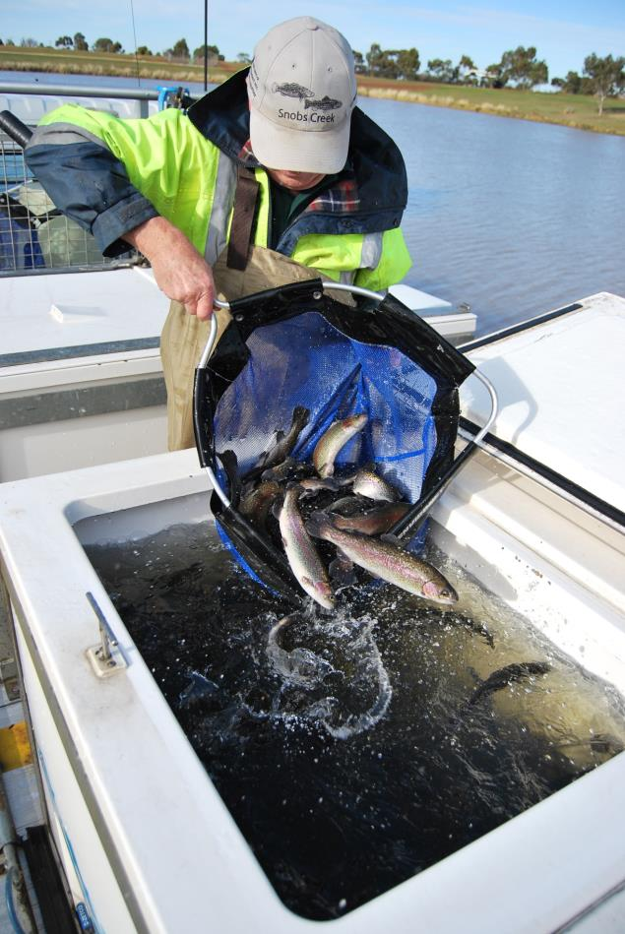

School holiday stocking program sees over 70 urban waters stocked with ready to catch fish (Photo by Marc Ainsworth)

Recreational Fishing Grants Program (RFGP)

Every year the Victorian Government, through the Recreational Fishing Licence Trust Account, disburses revenue derived from the sale of Recreational Fishing Licences to projects that will improve recreational fishing in Victoria.

Since its inception in 2001, the Recreational Fishing Grants Program (RFGP) has funded over 600 projects, worth more than $21 million throughout Victoria.

* A Small Grants Program, that is continually open to fund small projects (up to $5,000 - GST Exclusive)
* A Large Grants Program (for projects from $5,001 to $100,000)
* A Commissioning Program for large priority projects (generally in excess of $100,000).

The trust has also allocated an annual grant of $200,000 to Fisheries Victoria to secure additional native and salmonid species for the state-wide stocking program.

More information on the RFGP activities is available at the Fisheries Victoria website:  
[www.vic.gov.au/fishinggrants](https://t.e2ma.net/click/ra40o/ra0twh/3zfwsd)

Details on how to access grants are provided in the ‘Fishing for Grants’ section of this report.

Fishing for Grants?

Grants are available to help improve recreational fishing and facilities. Options for obtaining funding are through the Recreational Fishing Licence Trust Fund.

RFL Trust Fund Small Grants

The aim of the Small Grants Program is to provide funding of up to $5,000 (GST exclusive) for small projects which benefit public recreational fishing in Victoria.

The Grants are available to fishing clubs and other organisations. Information regarding the Small Grants Program Conditions & Guidelines can be obtained from the Fisheries Victoria website:

To apply for a small grant, applicants are required to use the online application form (at the web   
address above).

Further information on applying for a small grant can be obtained on the web or contact:

The Secretariat, Recreational Fishing Grants Program, GPO Box 4440 Melbourne, Victoria 3001   
Tel. (03) 9658 4779 or email: [rec.fishinggrants@ecodev.vic.gov.au](mailto:rec.fishinggrants@ecodev.vic.gov.au)

Submitting a change to the fish stocking program

Fisheries Victoria’s stocking program is constantly evolving as waterways and climatic conditions change. The need, or otherwise, to alter stocking regimes, in terms of the performance of a fishery or changed environmental conditions, is discussed annually at the Vic Fish Stock meetings.

Anglers wishing to submit a proposal to change the stocking program may do so by contacting Fisheries Victoria (see contact details below). Suggestions are best submitted through the representational fishing bodies to gain their support.

This current Vic Fish Stock document is a good reference to the current stocking program. Copies of the report can be accessed at the Fisheries Victoria website <http://agriculture.vic.gov.au/fisheries/policy-and-planning/publications-and-resources/vic-fish-stocking> or by requesting a hard copy from John Douglas   
(03 5770 8045).

The Fish Stocking for Recreational Purposes Policy is also relevant and anyone wishing to make a submission is encouraged to make them familiar with the document before doing so. A copy of the policy is available online at the Fisheries Victoria website.

A checklist of suggested subjects to address when making a submission is provided in Appendix 3.

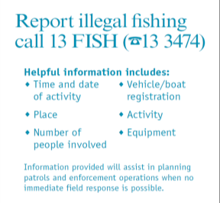Fisheries Victoria contacts

For inland fisheries management assistance:

Manager Inland Fisheries:   
Anthony Forster 03 8392 6871

Fish stocking enquiries  
John Douglas 03 5770 8045

For compliance assistance:

To report fisheries offences call 13 FISH (🕿13 3474).

For general enquiries:

Call the DEDJTR Customer Service Centre on 136 186   
or visit <http://agriculture.vic.gov.au/home>

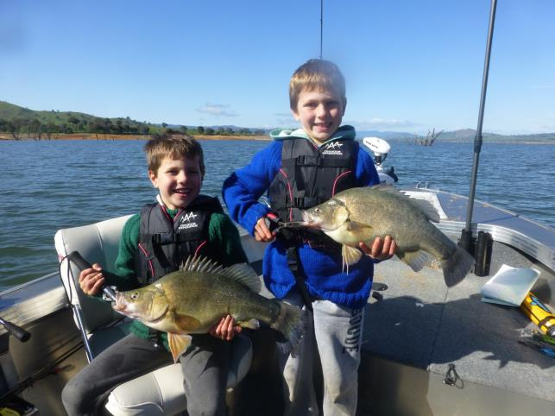

Max and Lachie Bottrell looked pleased with their golden perch from Hume Weir.

Appendix 1 – Proposed fish stockings

Using the Tables

The following tables present a summary of five Vic Fish Stock consultation meetings held across regional Victoria in 2015. They reflect the key outcomes from the minutes recorded at each meeting that were circulated to all participants prior to finalisation. Proposals for stockings were received prior to meetings. These proposals were discussed and a final position determined by consensus. The proposals were then costed against budgets and fish production capabilities and modified to suit but maintaining the intention of the stocking. The outcomes represent the shared decision of the meeting attendees resulting from this assessment.

Annual stocking refers to the on-going stocking program where waters are stocked with the fish each year. These stockings will continue each year unless altered at the Vic Fish Stock meetings or there is insufficient water to stock fish, or some other unforseen reason.

School holiday stockings refer to the stocking of ready to catch on-grown rainbow trout into small waters prior to selected school holidays.

Barwon South West and Grampians

Barwon Grampians

| **Water** | **Species** | **Stocking schedule** | **Type** | **Planned for 2015-16:** | **Stocking Requests  for 2016** | **Comments:** |
| --- | --- | --- | --- | --- | --- | --- |
| Alexandra Lake (Ararat) | Rainbow trout (adv) | Twice yearly | Family Fishing | 600 |  | 300 rainbow trout 2nd & 3rd Term School Holidays. |
| Aringa Reservoir (Port Fairy) | Brown trout | Annual stocking |  | 500 |  |  |
| Aringa Reservoir (Port Fairy) | Rainbow trout | Annual stocking |  | 1000 |  |  |
| Bannockburn Lagoon (Bannockburn) | Rainbow trout (adv) | Twice yearly | Family Fishing | 600 | Association Geelong & District Angling Clubs Inc. (GDAC) request 300 rainbow trout for 2nd & 3rd Term School Holidays | 300 rainbow trout 2nd & 3rd Term School Holidays. |
| Barwon River (Above the  Buckley Falls) | Brown trout | Annual stocking |  |  | GDAC request 2000 brown trout in each of 4 places above the Buckley Falls | Request not supported due to marginal stream conditions for trout and lack of fish returns to anglers from previous stocking assessments. |
| Barwon River (Geelong) | Estuary perch | Annual stocking |  |  |  | Water not currently on stocking program. Stocking numbers dependant on of estuary perch available. TEP in progress. 10000 if authority received. |
| Beaufort Lake (Beaufort) | Brown trout | Annual stocking |  | 1000 | GDAC request 1000 brown trout | Lake subject to low water levels. Not stocked in 2015 due to low water level. Stocking will resume when water levels sufficient for stocking. |
| Beaufort Lake (Beaufort) | Estuary perch |  |  | 0 | GDAC request 1000 estuary perch | Lake subject to low water levels. Stocking of estuary perch dependant on availability of estuary perch. Not stocked in 2014/2015 due to low water level. Stocking will resume when water levels sufficient for stocking |
| Beaufort Lake (Beaufort) | Rainbow trout | Annual stocking |  | 1000 | GDAC request 1000 rainbow trout | Lake subject to low water levels. Not stocked in 2015 due to low water level. Stocking will resume when water levels sufficient for stocking. |
| Bellfield Reservoir (Halls Gap) | Chinook salmon |  |  | 10000 |  | Stocking dependent on sufficient Chinook salmon numbers produced at Snobs Creek Hatchery. |
| Bellfield Reservoir (Halls Gap) | Rainbow trout | Annual stocking |  | 20000 | Wimmera Anglers Association (WAA) request 10000 rainbow trout |  |
| Bolac Lake  (Lake Bolac) | Estuary perch | Annual stocking |  | 0 |  | Not stocked with Estuary perch in 2014/2015 due to low water level. Stocking dependant on numbers of estuary perch available. Stocking may resume when water levels sufficient for stocking. |
| Bolac Lake  (Lake Bolac) | Rainbow trout | Annual stocking |  |  |  | Not stocked in 2014/15 due to low water level. Assess water security issues prior to stocking with rainbow trout. Stocking will resume when water levels sufficient for stocking. Stock 8000 annually if stocking proceeds. |
| Booroopki Swamp (Minimay) | Murray cod |  |  |  | WAA request 10000 Murray cod | Water is often dry for long periods. Currently dry. Will consider stocking only if lake refills sufficiently. |
| Bostock Reservoir (Ballan) | Brown trout | Annual stocking |  | 2500 | GDAC request 2500 brown trout | Annual stocking 2500 brown trout. Not stocked in 2015 due to low water. Stocking will resume when water levels sufficient for stocking. Fish stocked into nearby Pykes Creek Reservoir. |
| Bostock Reservoir (Ballan) | Chinook salmon |  |  | 1000 | GDAC request 1000 chinook salmon | Stocking dependent on Chinook salmon numbers produced at Snobs Creek Hatchery. |
| Bostock Reservoir (Ballan) | Rainbow trout | Annual stocking |  | 2500 | GDAC request 5000 rainbow trout | Annual stocking 2500 rainbow trout. Not stocked in 2015 due to low water. Stocking will resume when water levels sufficient for stocking. Rainbow trout stocked into nearby Pykes Creek Reservoir. |
| Boyds Waters (Geelong) | Rainbow trout (adv) | Annual stocking | Family Fishing | 200 | GDAC request 600 rainbow trout for the Ron Nelson Junior Fishing Clinic during Mid October | 400 rainbow trout stocked in 2015 for the Ron Nelson Junior Fishing Clinic. Boyds Waters temporarary site for this event due to high E.coli levels making Seagull Lake unsuitable to stock with rainbow trout. Special stocking for Ron Nelson Classic while Seagull Lake not available. |
| Bringalbert Lake (Bringalbert) | Golden perch | Annual stocking |  | 5000 | WAA request 5000 golden perch |  |
| Bullarto Reservoir (Bullarto) | Brown trout | Annual stocking |  | 500 |  |  |
| Bullarto Reservoir (Bullarto) | Rainbow trout | Annual stocking |  | 500 |  |  |
| Bullen Merri Lake (Camperdown) | Brown trout | Annual stocking |  | 5000 |  | Current stocking program in place no change. |
| Bullen Merri Lake (Camperdown) | Chinook salmon | Annual stocking |  | 20000 |  | Current stocking program in place no change. |
| Bullen Merri Lake (Camperdown) | Rainbow trout | Annual stocking |  | 5000 |  | Current stocking program in place no change. |
| Bungal Dam | Brown trout | Annual stocking |  |  | GDAC request 5000 brown trout | No stocking. Lake has no public access. |
| Burrumbeet Lake (Burrumbeet) | Brown trout | Annual stocking |  | 5000 | GDAC request 5000 brown trout | Annual stocking 5000 brown trout. Not stocked in 2015 due to low water level & water quality issues. Stocking will resume when lake levels suitable. |
| Burrumbeet Lake (Burrumbeet) | Rainbow trout | Annual stocking |  | 10000 | GDAC request 10000 rainbow trout | Annual stocking 10000 rainbow trout. Not stocked in 2015 due to low water level & water quality issues. Stocking will resume when lake levels suitable. |
| Calembeen Lake (Creswick) | Golden perch | Triennial stocking |  |  |  | Stocked every three years. Golden perch stocked in 2014/2015. Next golden perch stocking 2017/2018. |
| Calembeen Lake (Creswick) | Rainbow trout (adv) | Twice yearly | Family Fishing | 400 |  | 200 rainbow trout 2nd & 3rd Term School Holidays. |
| Carlislie River | Brown trout | Annual stocking |  |  | GDAC request 2000 brown trout GDAC comment that the trout coming out of the Carlislie River seem to be inbred and may need a new gene pool | Water not currently on stocking program. Stocking request not supported as river has self sustaining trout. |
| Carpolac Lake (Carpolac) | Golden perch | Annual stocking |  |  | WAA request 5000 golden perch | No golden perch stocking at present due to uncertainty regarding long term water security. Lake often low water levels. Water security issues were reviewed in 2014/2015 and as a result not stocked with golden perch in 2014/ 2015. Restock with 5000 anually if water fills sufficiently. Leave on stocking list until water management concerns determined. |
| Cartcarrong Lake (Winslow) | Brown trout | Annual stocking |  | 1000 |  | Annual stocking 1000 brown trout. Not stocked in 2015 due to low water level. Stocking will resume when water levels sufficient. |
| Cato Lake  (Stawell) | Rainbow trout (adv) | Twice yearly | Family Fishing | 600 | WAA request 300 rainbow trout twice yearly | 300 rainbow trout 2nd & 3rd Term School Holidays. |
| Charlegrark Lake (Booroopki) | Murray cod | Annual stocking |  | 10000 | WAA request  10000 Murray cod | Annual stocking dependant on water level. |
| Cobden Lake (Cobden) | Rainbow trout (adv) | Three per year | Family Fishing | 600 |  | 200 rainbow trout 1st, 2nd & 3rd Term School Holidays. |
| Colac Lake  (Colac) | Estuary perch | Annual stocking |  |  | GDAC request 100000 estuary perch | Stocking dependant on suitable water level and numbers of estuary perch available. |
| Colac Lake  (Colac) | Rainbow trout | Annual stocking |  |  | GDAC request 5000 rainbow trout | Advanced yearlings (min 150 g) for winter fishery. Stocking dependant on water level and angler access (boat). No rainbow trout stocked in 2015. If stocking undertaken, 5000 advanced rainbow trout. |
| Colbrook Reservoir (Colbrook) | Brown trout | Triennial stocking |  |  |  | Triennial stocking of brown trout. Next stocking of 600 brown trout in 2017. |
| Coleraine Lagoon (Coleraine) | Rainbow trout (adv) | Twice yearly | Family Fishing | 500 |  | 250 rainbow trout 2nd & 3rd Term School Holidays. |
| Cosgrave Reservoir (Creswick) | Brown trout | Annual stocking |  | 1000 |  |  |
| Cosgrave Reservoir (Creswick) | Rainbow trout | Annual stocking |  | 1000 |  |  |
| Dean Reservoir (Dean) | Brown trout | Annual stocking |  | 500 |  |  |
| Dean Reservoir (Dean) | Rainbow trout | Annual stocking |  | 500 |  |  |
| Deep Lake (Derrinallum) | Brown trout | Annual stocking |  | 1000 | GDAC request 1000 brown trout | Not stocked in 2015 due to low water level. Stocking to resume when sufficient water. |
| Deep Lake (Derrinallum) | Chinook salmon | Annual stocking |  |  |  | Stocking dependent on Chinook salmon numbers produced at Snobs Creek Hatchery. Stocking to resume when sufficient water. |
| Deep Lake (Derrinallum) | Rainbow trout | Annual stocking |  | 1000 | GDAC request 1000 rainbow trout | Stocking dependant on water level. Not stocked in 2015 due to low water level. Stocking to resume when sufficient water. |
| Dunkeld Arboretum (Dunkeld) | Rainbow trout (adv) | Twice yearly | Family Fishing | 400 |  | 200 rainbow trout 2nd & 3rd Term School Holidays. |
| Elingamite Lake (Cobden) | Brown trout | Annual stocking |  | 2000 | GDAC request 2000 brown trout | Access for stocking often limited. Stock later in the year when access is better for boats to stock fish. |
| Elingamite Lake (Cobden) | Chinook salmon | Annual stocking |  |  |  | Stocking dependent on Triploid Chinook salmon numbers produced at Snobs Creek Hatchery. Discuss potential numbers with Cobden  Angling Club. |
| Elingamite Lake (Cobden) | Rainbow trout | Annual stocking |  | 1000 | GDAC request 1000 rainbow trout | Elingamite Lake is being trialled as a triploid rainbow trout water. 1000 triploid rainbow trout stocked in 2014. There were no Triploid rainbow trout available in 2015. Resume stocking with triploid fish to replace standard fish, when available. |
| Esmond Lake (Ballarat) | Rainbow trout (adv) | Twice yearly | Family Fishing | 500 |  | 250 rainbow trout 2nd & 3rd Term School Holidays. |
| Ess Lagoon (Casterton) | Rainbow trout (adv) | Twice yearly | Family Fishing | 1000 |  | 500 rainbow trout 2nd & 3rd Term School Holidays. |
| Fyans Lake  (Halls Gap) | Brown trout | Annual stocking |  | 6000 | WAA request 6000 brown trout. GDAC request 10000 brown trout | Redfin predation on stocked brown trout consider larger 50g+ brown trout to be stocked during 2015. |
| Fyans Lake  (Halls Gap) | Rainbow trout | Annual stocking |  | 6000 | WAA request 6000 rainbow trout. GDAC request 10000 rainbow trout | Redfin predation on stocked rainbow trout endeavour for larger 50g+ rainbow trout to be stocked during 2015. Fisheries Victoria will endeavour to help if suitable sized rainbow trout are available. Was stocked with additional 2100 rainbow trout up to 1 kg in 2015 for Oceania's Fly Fishing Championships. |
| Gellibrand River | Brown trout | Annual stocking |  |  | GDAC request 2000 brown trout GDAC comment that the trout coming out of the Gellibrand River seem to be inbred and may need a new gene pool | Water not currently on stocking program. Stocking request not supported on genetic issues. |
| Gillear Lake (Allansford) | Brown trout | Annual stocking |  | 1000 |  |  |
| Gillear Lake (Allansford) | Rainbow trout | Annual stocking |  | 1000 |  |  |
| Glenlyon Dam (Glenlyon) | Rainbow trout (adv) | Twice yearly | Family Fishing | 400 |  | 200 rainbow trout 2nd & 3rd Term School Holidays. |
| Gong Gong Reservoir  (Brown Hill) | Brown trout | Annual stocking |  |  |  | Water managers request that no stocking of brown trout take place. Fisheries Victoria to discuss future angler access with water managers. |
| Gong Gong Reservoir (Brown Hill) | Rainbow trout | Annual stocking |  |  |  | Water managers request that no stocking of rainbow trout take place. Fisheries Victoria to discuss future angler access with water managers. |
| Great Western Racing Recreation Reserve Lake (Great Western) | Rainbow trout (adv) | Annual stocking | Family Fishing | 400 |  | 200 rainbow trout 3rd Term School Holidays. Possible stocking of 200 rainbow trout for 2nd Term School Holidays if conditions suitable for stocking. |
| Green Hill Lake (Ararat) | Brown trout | Annual stocking |  | 2000 | WAA request 2500 brown trout GDAC request 2000 brown trout | Not stocked in 2015 due to low water level. Stocking will resumed once sufficient water in lake. |
| Green Hill Lake (Ararat) | Rainbow trout | Annual stocking |  | 2000 | WAA request 2500 rainbow trout GDAC request 2000 rainbow trout | Not stocked in 2015 due to low water level. Stocking will resume when lake has sufficient water. |
| Green Lake (Horsham) | Golden perch | Annual stocking |  | 10000 | WAA request 20000 golden perch |  |
| Haddon Reservoir (Haddon) | Rainbow trout (adv) | Twice yearly | Family Fishing | 400 |  | 200 rainbow trout 2nd & 3rd Term School Holidays. |
| Hamilton Lake (Hamilton) | Brown trout | Annual stocking |  | 2000 |  |  |
| Hamilton Lake (Hamilton) | Estuary perch | Annual stocking |  | 18000 |  | Stocking dependant on numbers of estuary perch available. Received 18000 estuary perch in 2015 including translocated estuary perch from Lake Bolac salvage operation in Decemebr 2015. |
| Hamilton Lake (Hamilton) | Rainbow trout | Annual stocking |  | 3000 |  |  |
| Hanging Rock Lake (Woodend) | Rainbow trout (adv) | Twice yearly | Family Fishing | 600 |  | 300 rainbow trout 2nd & 3rd Term School Holidays. |
| Hepburn Lagoon (Newlyn) | Brown trout | Annual stocking |  | 5000 | GDAC request 5000 brown trout |  |
| Hepburn Lagoon (Newlyn) | Rainbow trout | Annual stocking |  | 5000 | GDAC request 5000 rainbow trout |  |
| Hopkins River  (Kent Ford Road Bridge to the Junction with the Mount Emu Creek) | Brown trout | Annual stocking |  | 6000 |  |  |
| Jack Emmett Lagoon  (Rupanyup) | Rainbow trout (adv) | Annual stocking | Family Fishing | 300 | WAA request 300 rainbow trout | 300 rainbow trout 3rd Term School Holidays. |
| Jubilee Lake (Daylesford) | Rainbow trout (adv) | Twice yearly | Family Fishing | 400 |  | 200 rainbow trout 2nd & 3rd Term School Holidays. |
| Jubilee Lake (Skipton) | Rainbow trout (adv) | Twice yearly | Family Fishing | 400 |  | 200 rainbow trout 2nd & 3rd Term School Holidays. |
| Konong Wootong Reservoir  (Konong Wootong) | Brown trout | Annual stocking |  | 2000 |  |  |
| Konong Wootong Reservoir  (Konong Wootong) | Rainbow trout | Annual stocking |  | 2000 |  |  |
| Lascelles Lake (Hopetoun) | Catfish |  |  |  |  | Potential catfish water if catfish become available. |
| Lascelles Lake (Hopetoun) | Golden perch | Annual stocking |  | 7000 | WAA request 5000 golden perch |  |
| Lascelles Lake (Hopetoun) | Silver perch | Annual stocking |  | 5000 |  |  |
| Learmonth Lake (Learmonth) | Brown trout | Annual stocking |  |  |  | Stocking dependant on water. Dry in 2015. Last stocked with 5000 brown trout in 1998. Reconsider stocking only when sufficient water. |
| Learmonth Lake (Learmonth) | Rainbow trout | Annual stocking |  |  |  | Stocking dependant on water level. Not stocked with rainbow trout in 2015 due to low water. Dry in 2015. Reconsider stocking with 5000 rainbow trout only when sufficient water. |
| Leigh River (Inverleigh) | Brown trout | Annual stocking |  |  | GDAC request 2000 brown trout | Decision postponed and wait on the stocking trials from Wild Trout program outcomes. |
| Lethbridge Lake (Lethbridge) | Rainbow trout (adv) | Twice yearly | Family Fishing | 600 | GDAC request 300 rainbow trout for 2nd & 3rd Term School Holidays | 300 rainbow trout 2nd & 3rd Term School Holidays. |
| Lismore Golf Club Lake (Lismore) | Rainbow trout (adv) | Annual stocking | Family Fishing |  |  | Last stocked with 100 rainbow trout 1999 2nd term School Holidays. Not stocked in 2015 due to low water level and potential public access issues and little demand. Reconsider stocking only when sufficient water present and any access issues clarified. |
| Lonsdale Lake (Deep Lead) | Rainbow trout | Annual stocking |  |  | GDAC request 2000 rainbow trout | Not supported. Lake has water level issues and managed as a redfin water. |
| Lower Stony Creek Reservoir (Durdidwarrah) | Brown trout | Annual stocking |  |  |  | Water not currently on stocking program. Potential new water. Angling access being sought with water managers. TEP required to be obtained for stocking 5000 brown trout. |
| Lower Stony Creek Reservoir (Durdidwarrah) | Rainbow trout | Annual stocking |  |  |  | Water not currently on stocking program. Potential new water. Angling access being sought with water managers. TEP required to be obtained for stocking 5000 rainbow trout. |
| Marma Lake (Murtoa) | Golden perch | Annual stocking |  | 2000 | WAA request 2000 golden perch |  |
| Marma Lake (Murtoa) | Rainbow trout (adv) | Three times per year | Family Fishing | 900 | WAA request 600 rainbow trout twice yearly | 300 rainbow trout 1st, 2nd & 3rd Term School Holidays. |
| McLeods Water Hole  (Drysdale) | Estuary perch (adv) | Annual |  |  |  | Potential urban stocking location for on-grown rainbow trout for summer urban fishery. Discussions underway with water manager to resolve. Fisheries will follow up further with council to investigate angler access. Stock if access provided. |
| McLleods Water Hole  (Drysdale) | Rainbow trout (adv) | Twice yearly | Family Fishing |  | GDAC request 300 rainbow trout for 2nd & 3rd Term School Holidays | Stocking request supported but requires further discussions with water manager. Fisheries will follow up further with council to investigate angler access. Stock if access provided. If resolved, stock 600 on-grown rainbow trout. |
| Merri River (Grassmere to Dennington) | Brown trout | Annual stocking |  | 8000 |  | Annual stocking 2,000 brown trout Grassmere to Wollaston & 6,000 brown trout below Weir to Dennington. |
| Miga Lake  (Miga) | Golden perch | Annual stocking |  | 5000 | WAA request 5000 golden perch |  |
| Minyip Wetlands (Minyip) | Rainbow trout (adv) | Annual stocking | Family Fishing | 200 | WAA request 200 rainbow trout | 200 rainbow trout 3rd Term School Holidays. |
| Moorabool Reservoir (Bolwarrah) | Brown trout | Annual stocking |  | 12000 | GDAC request 10000 brown trout |  |
| Moorabool Reservoir (Bolwarrah) | Rainbow trout | Annual stocking |  |  | GDAC request 5000 rainbow trout | Moorabool Reservoir has been considered as a brown trout water. Stocking request for rainbow trout supported depending further consultation with Ballarat Anglers. TEP required for stocking rainbow trout. When resolved, stock 5000 rainbow trout. |
| Moorabool River (Batesford & Morrissons) | Brown trout | Annual stocking |  |  | GDAC request 1000 brown trout at Batesford & 1000 brown trout at Morrissons | Water not currently on stocking program. Stocking request not supported. Flow dependant on Bungal Reservoir outflow. Small self sustaining trout population present. Low summer flows. |
| Mount Emu Creek (Skipton to Panmure) | Brown trout | Annual stocking |  | 3100 |  | Annual stocking of brown trout into Mount Emu Creek 3100 brown trout Skipton to Darlington 1100 brown trout - Skipton below Weir 500 brown trout, Pura Pura Bridge 200 brown trout, Chatsworth Road 200 brown trout and Darlington 200 brown trout & 2000 brown trout below Castle Carey Bridge to Panmure. |
| Moyne River (Rosebrook to Toolong North) | Brown trout | Annual stocking |  | 2000 |  | Annual stocking 2000 brown trout Rosebrook to Toolong North. |
| Murdeduke Lake (Winchelsea) | Chinook salmon | Annual stocking |  |  |  | Murdeduke Lake has been unsuitable for stocking due to low water level and high salinity since 2002. Stocking will only resume when water levels are sufficient and salinity reduced to suitable levels for trout survival. Last stocked with 2000 chinook salmon in 1999. |
| Murdeduke Lake (Winchelsea) | Rainbow trout | Annual stocking |  |  |  | Murdeduke Lake has been unsuitable for stocking due to low water level and high salinity since 2002. Stocking will only resume when water levels are sufficient and salinity reduced. Last stocked with 10000 rainbow trout in 2001. |
| Natimuk Lake (Natimuk) | Rainbow trout | Annual stocking |  |  | WAA request 5000 rainbow trout | The lake suffers from water security issues and trout stocking dependant on suitable water levels. Stocking will resume when sufficient water. Low water level during 2015 rainbow trout not stocked. If water available then stock 10000 rainbow trout. |
| Newlyn Reservoir (Newlyn) | Brown trout | Annual stocking |  | 4000 |  |  |
| Nhill Lake  (Nhill) | Rainbow trout (adv) | Annual stocking | Family Fishing | 200 | WAA request 300 rainbow trout | 200 rainbow trout 3rd Term School Holidays. |
| Old Hamilton Reservoir (Hamilton) | Rainbow trout (adv) | Twice yearly | Family Fishing | 400 |  | 200 rainbow trout 2nd & 3rd Term School Holidays. |
| Pertobe Lake (Warrnambool) | Rainbow trout (adv) | Three per year | Family Fishing | 900 |  | 300 rainbow trout 1st, 2nd & 3rd Term School Holidays. |
| Police Paddock Dams  (Horsham) | Rainbow trout (adv) | Annual stocking | Family Fishing | 900 | WAA request 600 rainbow trout twice yearly | 300 rainbow trout 1st, 2nd & 3rd Term School Holidays. |
| Purrumbete Lake (Camperdown) | Brook trout |  |  |  |  | TEP approved for Brook trout. Stocking plan needs to be developed in view of existing salmonid stocking arrangements in Purrumbete lake.. |
| Purrumbete Lake (Camperdown) | Brown trout | Annual stocking |  | 20000 | GDAC request 25000 brown trout | Current stocking program in place no change. |
| Purrumbete Lake (Camperdown) | Chinook salmon | Annual stocking |  | 10000 | GDAC request 25000 chinook salmon | Current stocking program in place no change. |
| Purrumbete Lake (Camperdown) | Rainbow trout | Annual stocking |  | 5000 | GDAC request 25000 rainbow trout | Current stocking program in place no change. |
| Pykes Creek Reservoir  (Ballan) | Brown trout | Annual stocking |  | 10000 |  | Currently developing the brown trout fishery. Stocked with 8,425 brown trout which included 2500 brown trout re-routed from Bostock Reservoir due to low water in Bostock Reservoir  in 2015. |
| Pykes Creek Reservoir  (Ballan) | Rainbow trout | Annual stocking |  | 3000 | GDAC request 5000 rainbow trout | Trialing the stocking of rainbow trout. 4950 rainbow trout stocked in 2015 which included 2500 rainbow trout re-routed from Bostock Reservoir due to low water in Bostock Reservoir in 2015. |
| Quarry Street Reserve Lake (Trentham) | Rainbow trout (adv) | Annual stocking | Family Fishing | 200 |  | 200 rainbow trout 2nd Term School Holidays. |
| Ratzcastle Lake (Kangawall) | Golden perch | Annual stocking |  | 5000 | WAA request 5000 golden perch | Low water level 2014/2015. Not Stocked in 2014/2015. 5000 golden perch allocated to lake were transferred and stocked into the Wimmera River in 2014/15. |
| Rocklands Reservoir (Balmoral) | Brown trout | Annual stocking |  | 2500 | WAA request 5000 brown trout + any surplus brown trout |  |
| Rocklands Reservoir (Balmoral) | Estuary perch |  |  |  | Potential estuary perch stocking water. | TEP required for stocking estuary perch. Fisheries Victoria to investigate. |
| Rocklands Reservoir (Balmoral) | Golden perch | Annual stocking |  |  | WAA request an amount of golden perch similar to Eildon Lake. M&NCAA request golden perch stocking to be investigated | TEP required for stocking golden perch. Full risk assessment required. |
| Rocklands Reservoir (Balmoral) | Murray cod | Annual stocking |  |  | M&NCAA request Murray cod stocking to be investigated | TEP required for stocking Murray cod. Full risk assessment required. |
| Rocklands Reservoir (Balmoral) | Rainbow trout | Annual stocking |  | 2500 | WAA request 5000 rainbow trout + any surplus rainbow trout |  |
| Saint Augustines Water Hole (Geelong) | Rainbow trout (adv) | Three time per year | Family Fishing | 1500 | GDAC request 500 rainbow trout for 2nd & 3rd Term School Holidays | 500 rainbow trout 1st, 2nd & 3rd Term School Holidays. |
| Seagull Lake (Geelong) | Rainbow trout (adv) | Three per year | Family Fishing |  |  | Not stocked in 2015 due to high E.coli counts resulting in poor water quality posing a health risk to the public. Signs have been erected by the Geelong City Council alerting the public to the issue of the high E.coli counts in Seagull Lake. Assess water quality issues prior to stocking in 2016. Stocking will only resume when public access permitted by water managers. |
| Simpson Recreation Reserve Lakes (Simpson) | Rainbow trout (adv) | Three per year | Family Fishing | 600 |  | 200 rainbow trout 1st, 2nd & 3rd Term School Holidays (100 rainbow trout into each lake). |
| St Georges Lake (Creswick) | Brown trout | Annual stocking |  | 1000 |  | St Georges Lake drained for maintenance works during 2014. Assess water level in St Georges Lake prior to brown trout being stocked in 2016. Not stocked in 2015. |
| St Georges Lake (Creswick) | Golden perch |  |  |  |  | TEP required for stocking golden perch. Stock when authority gained. |
| St Georges Lake (Creswick) | Rainbow trout | Annual stocking |  | 1000 |  | St Georges Lake drained for maintenance works during 2014. Assess water level in St Georges Lake prior to rainbow trout being stocked in 2015. Not stocked in 2015 but stocking will resume when water levels suitable. |
| Struan Lake (Foxhow) | Estuary perch | Annual stocking |  |  |  | Stocking dependant on water levels and numbers of estuary perch available. Not stocked 2015/16 due to low water level. 5000 when water sufficient. |
| Taylors Lake (Horsham) | Golden perch | Annual stocking |  | 50000 | WAA request 50000 golden perch | Stocking request supported. |
| Taylors Lake (Horsham) | Murray cod | Annual stocking |  | 20000 | WAA request 20000 Murray cod |  |
| Taylors Lake (Horsham) | Silver perch | Annual stocking |  | 0 |  | Silver perch stocking ceased. Stockingh of silevr perch not supported by the anglers. Lake requires survey to determine previous silevr perch stocking outcomes. |
| Tea Tree Lake (Mortlake) | Rainbow trout (adv) | Three per year | Family Fishing | 600 |  | 200 rainbow trout 1st, 2nd & 3rd Term School Holidays. |
| The Gong (Bunningyong) | Rainbow trout (adv) | Twice yearly | Family Fishing | 400 |  | 200 rainbow trout 2nd & 3rd Term School Holidays. |
| Tooliorook Lake (Lismore) | Brown trout | Annual stocking |  | 5000 | GDAC request 5000 brown trout | Not stocked in 2015 due to low water level. Lake suffers from low water levels in dry years. Stocking will resume when suitable water levels present. |
| Tooliorook Lake (Lismore) | Chinook salmon | Annual stocking |  |  | GDAC request 5000 chinook salmon | Stocking dependent on Chinook salmon numbers produced at Snobs Creek. Stocking only resume when water levels sufficient. |
| Tooliorook Lake (Lismore) | Rainbow trout | Annual stocking |  | 5000 | GDAC request 5000 rainbow trout | Not stocked in 2015due to low water level. Lake suffers from low water levels in dry years. Stocking request supported but assess water security issues prior to stocking rainbow trout in 2016. Stocking only resume when water levels sufficient. |
| Toolondo Reservoir (Toolondo) | Brown trout | Annual stocking |  | 20000 | WAA request 30000 brown trout. GDAC request 20000 brown trout | Stocking of brown trout dependant on water level. Water level still receding during 2015 and stocking likely to be modified or postponed depending on water levels in 2016. |
| Toolondo Reservoir (Toolondo) | Rainbow trout | Annual stocking |  | 10000 | WAA request 20000 rainbow trout. GDAC request 10000 rainbow trout | Stocking of rainbow trout dependant of water level. Water level still receding during 2015 and stocking to be modified or postponed depending on water levels. |
| Upper Stoney Creek Reservoir No1  (Durdidwarrah) | Brown trout | Annual stocking |  | 5000 |  | Water not currently on stocking program. Angling access being sought from water managers. TEP pending for stocking brown trout. Last stocked with 2000 brown trout in 1994. |
| Upper Stoney Creek Reservoir No1  (Durdidwarrah) | Rainbow trout | Annual stocking |  | 5000 |  | Water not currently on stocking program. Angling access being sought from water managers. TEP pending for stocking rainbow trout. |
| Victoria Lakes (Ballarat) | Rainbow trout (adv) | Twice yearly | Family Fishing | 800 |  | 400 rainbow trout 2nd & 3rd Term School Holidays. |
| Wallace Lake (Edenhope) | Brown trout | Annual stocking |  |  | WAA request 1000 brown trout | Assess water security issues prior to stocking 1000 brown trout in 2016. Not stocked in 2015. Stocking to resume only when water levels sufficient. |
| Wallace Lake (Edenhope) | Golden perch |  |  |  | WAA request 10000 golden perch | Stocking request not supported. Lake often suffers from low water. |
| Wallace Lake (Edenhope) | Rainbow trout | Annual stocking |  |  | WAA request 4000 rainbow trout | Assess water security issues prior to stocking 4000 rainbow trout in 2016. Not stocked in 2015. Stocking to resume only when water levels sufficient. |
| Wartook Lake  (Halls Gap) | Brown trout | Annual stocking |  | 6000 | WAA request 6000 brown trout | Request for 50g+ brown trout to be stocked in 2016 Stocking request supported. |
| Wartook Lake  (Halls Gap) | Rainbow trout | Annual stocking |  | 6000 | WAA request 6000 rainbow trout | Request for 50g+ rainbow trout to be stocked in 2016. Stocking request supported. |
| Wendouree Lake (Ballarat) | Brown trout | Annual stocking |  | 6000 |  | Historic stocking by the Ballarat Fish Hatchery in conjunction with Fisheries Victoria. |
| Wendouree Lake (Ballarat) | Brown trout | Annual stocking |  | 11000 |  |  |
| Wendouree Lake (Ballarat) | Rainbow trout | Annual stocking |  | 10000 |  | Lake also received a one off stocking of 1530rainbow trout up to 1kg (on top of the annual stocking) to support the Oceania's Fly Fishing Championships held in Wendouree Lake in November 2015. |
| West Barwon Dam (Forrest) | Brown trout | Annual stocking |  | 5000 | GDAC request 5000 brown trout | West Barwon Dam is historically considered as a rainbow trout water but brown trout to be trialled. Stocking request supported stock for 3 years. Fisheries to investigate if a TEP required. |
| West Barwon Dam (Forrest) | Rainbow trout | Annual stocking |  | 5000 | GDAC request 5000 rainbow trout |  |
| Wimmera River (Jeparit to Elmhurst) | Golden perch | Annual stocking |  | 60000 | WAA request 20000 golden perch at Jeparit, 30000 golden perch at Dimboola, 30000 golden perch at Horsham, 5000 golden perch at Glenorchy and 5000 golden perch at Elmhurst for a total of 90000 golden perch. M&NCAA support this request. | During 2014/2015 the Wimmera River received an annual stocking of 60000 golden perch. It also received an extra boost stocking of 10000 golden perch during 2014/2015 which were fish  re-directed from Carpolac & Ratzcastle Lakes that were not stocked due to low water levels. |
| Wimmera River (Jeparit to Horsham) | Silver perch | Annual stocking |  | 15000 | WAA request 5000 silver perch at Dimboola and 5000 silver perch at Horsham. M&NCAA support this request. | 7500 silver perch stocked at Dimboola & 7500 at Horsham. |
| Woady Yaloak River  (Werneth) | Brown trout | Annual stocking |  |  | GDAC request 5000 brown trout | Water not currently on stocking program. 2011 Vic Fish Stock meeting discussion was trout stocking not supported as trout present in the river and population range and abundance reflect environmental conditions. River has large sections of marginal trout habitat and limited angler access. Water may be stocked in future depending on findings from Wild Trout Management Program. |
| Wombat Reservoir (Daylesford) | Brown trout | Annual stocking |  | 1000 |  |  |
| Wombat Reservoir (Daylesford) | Rainbow trout | Annual stocking |  | 1000 |  |  |
| Wurdiboluc Reservoir (Winchelsea) | Brown trout | Annual stocking |  | 6000 | GDAC request 4000 brown trout |  |
| Wurdiboluc Reservoir (Winchelsea) | Rainbow trout | Annual stocking |  | 5000 | GDAC request 5000 rainbow trout | Stocking request supported. |
| Yarriambiack Creek (Beulah to Warracknabeal) | Golden perch | Annual stocking |  | 9000 | WAA request 3000 golden perch at Beulah, 3000 golden perch at Brim and 5000 golden perch at Warracknabeal | Stock 3000 golden perch at Beulah, Brim and Warracknabeal. |

Gippsland

| **Water** | **Species** | **Stocking schedule** | **Type** | **Planned for 2015-16:** | **Stocking Requests  for 2016** | **Comments:** |
| --- | --- | --- | --- | --- | --- | --- |
| Avon River (Stratford to Valencia Creek) | Australian bass | Annual stocking |  | 5000 |  |  |
| Bemm River | Estuary perch |  |  | 5000 |  | Replacement of broodstock used to produce estuary perch for restocking purposes. |
| Blue Rock Lake (Willow Grove) | Australian bass | Annual stocking |  | 25000 |  | Contiued development of Australian bass fishery. |
| Blue Rock Lake (Willow Grove) | Brown trout | Annual stocking |  | 15000 |  |  |
| Blue Rock Lake (Willow Grove) | Rainbow trout | Annual stocking |  | 10000 |  |  |
| Bunyip River | Brown trout | Annual stocking |  |  |  | Trout stocking in wild trout streams will be reviewed pending the outcomes of the Wild Trout Management Program. |
| Cowwarr Weir (Cowwarr) | Australian bass | Annual stocking |  | 2000 |  |  |
| Freestone Creek (Briagolong) | Australian bass | Annual stocking |  | 2000 |  |  |
| Glenmaggie Lake (Glenmaggie) | Australian bass | Annual stocking |  | 10000 |  |  |
| Glenmaggie Lake (Glenmaggie) | Rainbow trout | Annual stocking |  | 7000 |  | Stock rainbow trout during May. |
| Guthridge Lake (Sale) | Australian bass | Annual stocking |  | 1000 |  | Trial to develop urban bass fishery. Annual stocking 1000 Australian bass from 2014/2015 to 2016/2017. |
| Guthridge Lake (Sale) | Rainbow trout (adv) | Twice yearly | Family Fishing | 500 |  | 250 rainbow trout 2nd & 3rd Term School Holidays. |
| Heyfield Racecourse Lake (Heyfield) | Rainbow trout (adv) | Twice yearly | Family Fishing | 400 |  | 200 rainbow trout 2nd & 3rd Term School Holidays. |
| Hospital Creek (Tostaree) | Australian bass | Annual stocking |  | 3000 |  |  |
| Hyland Lake (Churchill) | Australian bass | Annual stocking |  | 1000 |  | Fisheries want to trial bass as a potential to create an urban water summer fishery. TEP required for stocking Australian bass. |
| Hyland Lake (Churchill) | Rainbow trout (adv) | Three per year | Family Fishing | 2750 |  | 750 rainbow trout 1st, 2nd & 3rd Term School Holidays + 500 rainbow trout in November. |
| Latrobe River | Brown trout |  |  |  |  | Trout stocking in wild trout streams will be reviewed pending the outcomes of the Wild Trout Management Program. |
| Loch River | Brown trout |  |  |  |  | Trout stocking in wild trout streams will be reviewed pending the outcomes of the Wild Trout Management Program. |
| Macalister River (D/s of L. Glenmaggie) | Australian bass | Annual stocking |  | 4000 |  | Stock Australian bass downstream of  Glenmaggie Lake. |
| Macalister River (D/s of L. Glenmaggie) | Brown trout | Annual stocking |  | 2000 |  | Stock brown trout downstream of Glenmaggie Lake |
| Macalister River (U/s Lake Glenmaggie to Licola) | Australian bass | Annual stocking |  | 5000 |  | Annual stocking of 5000 Australian bass upstream of Glenmaggie Lake. |
| Macalister River (U/s of L. Glenmaggie to Junction with the Wellington River) | Rainbow trout | Annual stocking |  | 9000 |  | Stock rainbow trout upstream of Glenmaggie Lake to Junction with the Wellington River. |
| Mitchell/ Wonnangatta River  (Augusvale to Junction of Wongungarra River) | Australian bass |  |  | 10000 |  |  |
| Morwell Lake (Morwell) | Rainbow trout (adv) | Three per year | Family Fishing | 1500 |  | 750 rainbow trout 2nd & 3rd Term School Holidays. |
| Narracan Lake (Moe) | Australian bass | Annual stocking |  | 10000 |  |  |
| Narracan Lake (Moe) | Brown trout | Annual stocking |  | 7000 |  |  |
| Narracan Lake (Moe) | Rainbow trout | Annual stocking |  | 3000 |  |  |
| Nicholson River (Old Weir Site) | Australian bass | Annual stocking |  | 8000 |  | Australian bass above Nicholson Weir site, Reduced the annual stocking to 8000 Australian bass. |
| Rainbow Creek (Heyfield/Cowwarr) | Australian bass |  |  | 2000 |  |  |
| Sanctuary Lake (Traralgon) | Rainbow trout (adv) | Twice yearly | Family Fishing |  |  | Water assessed but not suitable as urban lake at present due to open access to creek and urban development. |
| Tambo River (Bruthen to Junction with the Haunted Stream) | Australian bass | Annual stocking |  | 8000 |  | Enhance current Australian bass stocks in Tambo River. Stock up to the Junction of the Tambo River & Haunted Stream. |
| Tamboon Inlet | Estuary perch | Trial stocking |  |  |  | Flagged as potential marine staocking water. |
| Tamboon Inlet | Mulloway | Trial stocking |  |  |  | Flagged as potential marine staocking water. |
| Tanjil River | Brown trout | Annual stocking |  |  |  | Trout stocking in wild trout streams will be reviewed pending the outcomes of the Wild Trout Management Program. |
| Tarago River | Brown trout | Annual stocking |  |  |  | Trout stocking in wild trout streams will be reviewed pending the outcomes of the Wild Trout Management Program. |
| Thomson River  (D/s Cowwarr Weir) | Australian bass | Annual stocking |  | 5000 |  |  |
| Timbarra River (near Junction with the Tambo River) | Australian bass | Annual stocking |  | 10000 |  |  |
| Torongo River | Brown trout | Annual stocking |  |  |  | Angler interest in trout population status and potential for stocking. Surveys indicate stream has very good trout stocks and stocking not required. |
| Traralgon Creek (Downeys Lane to the Junction with the La Trobe River) | Australian bass | Annual stocking |  | 2000 |  |  |
| Turtons Creek (Below the Falls  to Mirboo) | Brown trout | Annual stocking |  |  | Leongatha Angling Club and the South Gippsland Fly Fishers request 2000 brown trout in Turtons Creek below the Falls to Mirboo | Trout stocking in wild trout streams will be reviewed pending the outcomes of the Wild Trout Management Program. |
| Tyers Lake | Estuary perch | Trial stocking |  | 25000 |  |  |
| Tyers Lake | Mulloway | Trial stocking |  | 7500 |  |  |
| Tyers River | Brown trout | Annual stocking |  |  |  | Trout stocking in wild trout streams will be reviewed pending the outcomes of the Wild Trout Management Program. |
| Tyers River  (Wirilda Park) | Australian bass | Annual stocking |  | 5000 |  |  |
| Upper Thomson River | Brown trout | Annual stocking |  |  |  | Trout stocking in wild trout streams will be reviewed pending the outcomes of the Wild Trout Management Program. |
| Valencia Creek  (U/s Valencia Creek) | Australian bass | Annual stocking |  | 3000 |  |  |

Hume

| **Water** | **Species** | **Stocking schedule** | **Type** | **Planned for 2015-16:** | **Stocking Requests  for 2016** | **Comments:** |
| --- | --- | --- | --- | --- | --- | --- |
| Allans Flat Dredge Hole  (Allans Flat) | Golden perch | Annual stocking |  | 1500 | Native Fish Australia (NFA) request stocking an additional 500 golden perch not stocked into Stanley Ditch Dam be stocked into Allans Flat Dredge Hole | Stocking increase request supported. |
| Allans Flat Dredge Hole  (Allans Flat) | Rainbow trout (adv) | Three per year | Family Fishing | 1550 |  | 350 rainbow trout 1st, 2nd & 3rd Term School Holidays + 500 rainbow trout in October. |
| Amaroo Lake (Shepparton) | Golden perch | Annual stocking |  | 500 |  | Part of the Kialla Lakes system at Shepparton. |
| Anderson Lake (Chiltern) | Golden perch | Annual stocking |  | 1000 |  |  |
| Anderson Lake (Chiltern) | Rainbow trout (adv) | Three per year | Family Fishing | 900 |  | 300 rainbow trout 1st, 2nd & 3rd Term School Holidays. |
| Arboretum Dam (Euroa) | Golden perch | Annual stocking |  | 500 |  |  |
| Arboretum Dam (Euroa) | Rainbow trout (adv) | Three per year | Family Fishing | 1200 |  | 400 rainbow trout 1st, 2nd & 3rd Term School Holidays. |
| Back Creek Road Dam (Yackandandah) | Golden perch | Annual stocking |  |  |  | Water not currently on stocking program. Requires Fisheries Victoria assessment of access etc. prior to stocking. Stock if assessed as suitable. |
| Back Creek Road Dam (Yackandandah) | Murray cod | Annual stocking |  |  |  | Water not currently on stocking program. Requires Fisheries Victoria assessment of access etc. prior to stocking. Stock if assessed as suitable. |
| Back Creek Road Dam (Yackandandah) | Rainbow trout (adv) | Three per year | Family Fishing |  |  | Water not currently on stocking program. Requires Fisheries Victoria assessment of access etc. prior to stocking. Stock if assessed as suitable. |
| Banimboola Lake (Dartmouth Pondage) | Brown trout | Annual stocking |  |  |  | Resume stocking of brown trout if water authority approval obtained. |
| Banimboola Lake (Dartmouth Pondage) | Rainbow trout | Annual stocking |  |  |  | Resume stocking of rainbow trout if water authority approval obtained. |
| Bartlett Lake (Tatura) | Golden perch | Annual stocking |  | 500 |  | Revert to annual stocking of 500 golden perch. |
| Bartlett Lake (Tatura) | Rainbow trout (adv) | Three per year | Family Fishing | 300 |  | 100 rainbow trout 1st, 2nd & 3rd Term School Holidays Stock for 1st Term School Holidays. |
| Benalla Lake (Benalla) | Golden perch | Annual stocking |  | 5000 |  |  |
| Benalla Lake (Benalla) | Murray cod | Annual stocking |  | 10000 |  |  |
| Boosey Creek (Katamatite) | Golden perch | Annual stocking |  | 11000 | Nurmurkah Fishing Club reduce golden perch by 50% to 1500 Upstream of Katamatite 1500 at Katamatite township and 1500 downstream of Katamatite. | . Stock 3000 golden perch upstream of Katamatite, 3000 golden perch at Katamatite and 3000 golden perch downstream of Katamatite. Tungamah Weir Pool to receive 2000 golden perch. |
| Boosey Creek (Katamatite) | Murray cod | Annual stocking |  | 3000 | Numurkah Fishing Club request reduce Murray cod by 50% to 500 Murray cod Upstream of Katamatite Township, 500 Murray cod Katamatite Township, 500 Murray cod Downstream of Katamatite. | Stock 1000 Murray cod upstream of Katamatite, 1000 Murray cod at Katamatite and 1000 Murray cod downstream of Katamatite. |
| Broken Creek | Murray cod | Annual stocking |  | 10000 | Numurkah Fishing Club request reduce by 50% to 500 Murray cod Tobruk Road bridge 500 Murray cod Union Road bridge 500 Murray cod Labuan Road bridge 500 Murray cod U/s Melville Street bridge 500 Murray cod Between Brenion & Melville Streets 500 Murray cod Goulburn Valley Highway bridge 1000 Murray cod Walsh's Bridge. Ongoing at the reduced rate. |  |
| Broken Creek  (Dip Bridge to Nathalia) | Golden perch | Annual stocking |  | 20000 | Numurkah Fishing Club request reduce by 50% to 1000 golden perch Tobruk Road bridge 1000 golden perch Union Road bridge 1000 golden perch Labuan Road bridge 1500 golden perch Upstream of Melville Street bridge 1500 golden perch Between Brenion & Melville Streets 500 golden perch Storm Water Settling Ponds 1500 golden perch Goulburn Valley Highway bridge 2000 golden perch Walsh's Bridge. Ongoing at the reduced rate. Nathalia Angling Club request 1000 golden perch @30cm+ stock between the 2 weirs at Nathalia for fishing event in November 2015 | Stock Stock from Dip Bridge to Nathalia (Tobruk Road bridge, Union Road bridge, Labuan Road bridge, Upstream of Melville Street bridge, Between Brenion & Melville Streets, Goulburn Valley Highway bridge, Walsh's Bridge. Stocked 50 golden perch @ 30cm+ for fishing event at Nathalia in 2015. |
| Broken River | Brown trout | Annual stocking |  |  | Tatong Angling Club request 1000 brown trout from below Nillahcootie Lake wall to the Swanpool bridge. | Trout stocking in wild trout streams will be reviewed pending the outcomes of the Wild Trout Management Program. Survey planned for 2015/16 to determine current fish population status. |
| Broken River | Golden perch | Annual stocking |  | 45000 |  | Stock from below Nillahcootie Lake to Gowangardie Weir, calceined marked. |
| Broken River | Murray cod | Annual stocking |  | 30000 |  | Fish spread from below Nillahcootie Lake to Gowangardie Weir. |
| Buckland River |  |  |  |  | Australian Trout Foundation request a 'one off' stocking with a mixture of 3000 mature brown and rainbow trout @ advanced yearlings at 600 at Buckland Bridge, 600 at AH Young's Campsite,  600 at Camp Flat - campsite, above and below Noonamena Bridge,  600 upstream of junction bridge/confluence of Buckland River West,  600 at Clear Creek | Water not currently on stocking program. Unclear over trout status in river. Trout stocking in wild trout streams will be reviewed pending the outcomes of the Wild Trout Management Program. General support from the Vic Fish Stock meeting for trout stocking if conditions are suitable. |
| Buffalo Lake (Dandongadale) | Brown trout | Annual stocking |  | 5000 |  |  |
| Buffalo Lake (Dandongadale) | Golden perch | Annual stocking |  | 10000 |  | Developing the golden perch fishery. Increase in golden perch numbers. Received additional boost stocking of 22860 golden perch during 2014/2015. |
| Buffalo Lake (Dandongadale) | Murray cod | Annual stocking |  | 10000 |  | Developing the Murray cod fishery. Received additional boost stocking of 13690 Murray cod during 2014/2015. |
| Cobbler Lake | Rainbow trout | Annual stocking |  |  |  | Water not currently on stocking program. Access and permission to stock from water managers required. TEP will be required for stocking rainbow trout. Supported but requires assessment of suitability, access and Parks Vic permission.  If suitable then stock 2000. |
| Corryong-Jerimal Creek | Murray cod | Biennial stocking |  | 0 |  | Biennial stocking of 2500 Murray cod stocked in 2014/2015. Next stocking in 2016/2017. |
| Corryong-Nariel Creek  (Between Colac Colac Bridge & Nankervis's Bridge) | Brown trout |  |  |  |  | Water not currently on stocking program. Stream beingh monitored by surveys under the Wild Trout Management Program. Trout stocking in wild trout streams will be reviewed pending the outcomes of the Wild Trout Management Program. |
| Craigmuir Lake (Mooroopna) | Golden perch | Annual stocking |  | 500 |  |  |
| Cudgewa Creek | Murray cod | Biennial stocking |  | 0 |  | Biennial stocking of 5000 Murray cod stocked in 2014/2015 Next stocking in 2016/2017. |
| Eildon Lake  (Eildon) | Brown trout | Annual stocking |  | 35000 |  |  |
| Eildon Lake  (Eildon) | Golden perch | Annual stocking |  | 100000 |  | Received extra boost stocking of 202740 golden perch during 2014/2015. |
| Eildon Lake  (Eildon) | Murray cod | Annual stocking |  | 80000 |  | Received Extra boost stocking of 16193 Murray cod during 2014/2015. |
| Eildon Lake (Eildon) | Rainbow trout | Annual stocking |  | 10000 |  | Lack of angler returns for rainbow trout from Lake Eildon. Future stocking of rainbow trout to be guided by research. Resume trial rainbow trout stocking in 2016 with marked fish. |
| Eildon Pondage Weir  (Eildon) | Brown trout  (ex brood) | Annual stocking |  | 1000 |  | Ex Brood brown trout + excess 2 yr old brown trout for trout festivals / competitions where possible. Dependant on number of Ex Brood brown trout stock available. |
| Eildon Pondage Weir  (Eildon) | Rainbow trout (adv) | Annual stocking |  | 14000 | Request to stock a mixture of 3000 brown & rainbow trout weighing above 180gs stocked for 10 months with Ex Brood stock released in the remaining 2 months to ensure a spread of fish all year. (Supported by The Australian Trout Foundation Inc.). | Increase frequency of rainbow trout stocking to monthly stockings. 1000 on-grown each month across year. Plus extra 1,000 rainbow trout for 2nd & 3rd Term School Holidays. |
| Eildon Pondage Weir  (Eildon) | Rainbow trout (ex brood) | Annual stocking |  | 1000 |  | Ex Brood rainbow trout + excess 2 yr old rainbow trout for trout festivals/competitions Dependant on number of Ex Brood rainbow trout stock available. |
| Eldorado Dredge Hole  (Eldorado) | Golden perch | Annual stocking |  | 1000 |  | Annual stocking 1000 golden perch. Potential catfish water if catfish available. |
| Eurobin Creek |  |  | |  | | --- | |  | |  | Australian Trout Foundation request a *'one off'* stocking with amixture of 600 mature brown and rainbow trout @ advanced yearlings at 200 at a point above the waterfall situated approx. 150 meters from Ovens River, 200 above and below Noonamena Bridge, 200 above and below the foot bridge adjacent to the picnic area approx. 500 meters above Noonamena Bridge | Water not currently on stocking program. Further information required regarding current status of trout population in creek. Trout stocking in wild trout streams will be reviewed pending the outcomes of the Wild Trout Management Program. General support from the Vic Fish Stock meeting for trout stocking if conditions are suitable. |
| Felltimber Creek Wetlands (Wodonga) | Rainbow trout (adv) | Three per year | Family Fishing | 1200 |  | 400 rainbow trout 1st, 2nd & 3rd Term School Holidays. |
| Fosters Dam (Glenrowan) | Golden perch | Annual stocking |  |  |  | Water considered too small for golden perch fishery. |
| Fosters Dam (Glenrowan) | Rainbow trout (adv) | Three per year | Family Fishing | 600 |  | 200 rainbow trout 1st, 2nd & 3rd Term School Holidays. |
| Golf Course Dam (Longwood) | Rainbow trout (adv) | Three per year | Family Fishing | 600 |  | 200 rainbow trout 1st, 2nd & 3rd Term School Holidays. |
| Goulburn River (Above Goulburn Weir to Seymour, including Nagambie) | Golden perch | Annual stocking |  | 200000 | Nagambie Angling Club request 20000 golden perch between the  5 bridges from the Goulburn Weir to the Murray River |  |
| Goulburn River (Above Goulburn Weir to Seymour, including Lake Nagambie) | Murray cod | Annual stocking |  | 50000 |  | Stock below Nagambie Weir to McCoy's Bridge. |
| Goulburn River (Below Goulburn Weir to McCoy's Bridge) | Golden perch | Annual stocking |  | 50000 | Nagambie Angling Club request 20000 golden perch between the 5 bridges from the Goulburn Weir to the Murray River | Calcein marked. |
| Goulburn River (Below Nagambie Weir to McCoy's Bridge) | Murray cod | Annual stocking |  | 50000 |  | Calcein marked. |
| Goulburn River (Edward Creek D/s to Jamieson) | Brown trout | Annual stocking |  | 5000 |  | 3 Year stocking trial of 5000 brown trout to be fin clipped adipose fin. This stocking of brown trout is in the Upper Goulburn River and 2016 stocking is the final year of trial. |
| Goulburn River (Eildon to Molesworth) | Brown trout | Annual stocking |  | 12000 | Request for a mixture of 15000 brown & rainbow trout stocked as soon as possible after the close of trout season from Eildon to Molesworth. (Supported by The Australian Trout Foundation Inc.) | Fish spread from below the gates at Eildon Pondage to Molesworth. Fish marked for future assessment. |
| Goulburn River (Trawool) | Macquarie perch | Annual stocking |  |  |  | Stocking of Macquarie perch dependant on Macquarie perch numbers produced. Stock Macquarie perch in the Trawool Area. 12750 Macquarie perch stocked in 2014/2015 calcein marked. Stock Macquarie perch up to Molesworth. |
| Greens Lake (Corop) | Golden perch | Annual stocking |  | 10000 |  |  |
| Greens Lake (Corop) | Murray cod | Annual stocking |  | 5000 |  | Revert to annual stocking of 5000 Murray cod. |
| Holland Creek (Tatong) | Brown trout | Annual stocking |  | 1000 |  | Stock above Spring Creek. On going stocking of creek will be reviewed based on findings of trout research from Wild Trout Management Program. |
| Howqua River (Between Sheepyard Flat & Running Creek) | Brown trout | Annual stocking |  | 5000 |  | 3 Year stocking trial of 5000 brown trout to be fin clipped adipose fin. This stocking of brown trout is between Sheepyard Flat to Running Creek in the Howqua River and 2016 is the final year. |
| Hughes Creek | Macquarie perch |  |  |  | Nagambie Angling Club request Macquarie perch | Stocking in the lower Hughes Creek downstream of Avenal to the Goulburn River. Stocking request supported dependant on Macquarie perch numbers and Macquarie perch recovery program. |
| Hume Lake (Tallangatta) | Brown trout | Annual stocking |  | 40000 |  |  |
| Hume Lake (Tallangatta) | Golden perch | Annual stocking |  | 150000 | NFA request 80000 golden perch to maintain golden perch fishery | Dependant on golden perch availability increase stocking of golden perch if golden perch available. Lake received Extra boost stocking of 70000 golden perch during 2014/2015. |
| Hume Lake (Tallangatta) | Rainbow trout | Annual stocking |  | 30000 |  | IMaintain rainbow trout stiocking but there is an issue with lack of rainbow trout returns to anglers. Fisheries Victoria to investigate what are the returns on rainbow trout to anglers. |
| Hume Lake including Mitta River (Tallangatta) | Murray cod | Annual stocking |  | 100000 |  | Lake received Extra boost stocking of 25000 Murray cod during 2014/2015. |
| Kerferd Lake (Beechworth) | Trout cod | Annual stocking |  | 5000 |  | Nunbers dependant on avaialability. |
| Kialla Lakes (Shepparton) | Golden perch | Annual stocking |  | 1500 |  |  |
| Kiewa River (Baranduda to Dederang) | Murray cod | Annual stocking |  | 5000 |  |  |
| Kiewa River  (Mount Beauty to Keagan's Bridge) | Brown trout | Annual stocking |  |  | Kiewa Valley Fishing Club (KVFC) request 15000 brown trout in the Kiewa River from Mount Beauty  to Keagan's Bridge | Water not currently on stocking program. Trout stocking in wild trout streams will be reviewed pending the outcomes of the Wild Trout Management Program. General support from the Vic Fish Stock meeting for trout stocking if suitable. |
| King Lake (Rutherglen) | Golden perch | Annual stocking |  | 1000 | NFA request 1000 golden perch |  |
| King River  (Below William Hovell Lake to Edi Cutting) | Brown trout | Annual stocking |  |  | Wangaratta Fly Fishing Club Inc. request a 3 year stocking trial of 3000 to 5000 yearling brown trout stocked at 5 locations below William Hovell Lake to Edi Cutting | Water not currently on stocking program. Trout stocking in wild trout streams will be reviewed pending the outcomes of the Wild Trout Management Program. General support from the Vic Fish Stock meeting for trout stocking if conditions are suitable. Last stocked with 2500 fin clipped fish brown trout in 2011 with few recovered by anglers. |
| Les Stone Park Lake  (Wodonga) | Rainbow trout (adv) | Three per year | Family Fishing | 600 |  | 100 rainbow trout 1st, 2nd & 3rd Term School Holidays. |
| Loch Garry (Bunbartha) | Golden perch | Annual stockingg |  | 2000 |  | Revert back to annual stocking of 2000 golden perch. |
| Lowanna Lake (Shepparton) | Golden perch | Annual stocking |  | 500 |  | Lowanna Lake is part of the Kialla Lakes system at Shepparton. See Kialla Lakes. |
| Marysville Lake | Rainbow trout (adv) | Three per year | Family Fishing | 1350 |  | 450 rainbow trout 1st, 2nd & 3rd Term School Holidays. |
| Moodemere Lake (Rutherglen) | Catfish | Annual stocking |  |  |  | Stocking of catfish dependant on availability. |
| Moodemere Lake (Rutherglen) | Golden perch | Annual stocking |  |  |  | Water not on current stocking program for golden perch. TEP required for stocking golden perch. If authority received then stock with 10000. |
| Mooroopna Recreation Reserve Lake  (Mooroopna) | Rainbow trout (adv) | Annual stocking | Family Fishing | 300 |  | 100 rainbow trout 1st, 2nd & 3rd Term School Holidays. |
| Mount Beauty Pondage  (Mount Beauty) | Brown trout | Annual stocking |  | 1000 | KVFC request a survey to see if any brown trout are present in the Mount Beauty Pondage as very few brown trout have been caught since 2000 | Concerns over brown trout residency in Pondage and survey requested. |
| Mount Beauty Pondage  (Mount Beauty) | Rainbow trout | Annual stocking |  | 1500 |  | Stock 500 rainbow trout before Easter 2016. |
| Nillahcootie Lake (Barjarg) | Golden perch | Annual stocking |  | 50000 |  |  |
| Nillahcootie Lake (Barjarg) | Murray cod | Annual stocking |  | 30000 |  |  |
| Numurkah Lake (Numurkah) | Golden perch | Annual stocking |  | 6000 | Numurkah Fishing Club request reduce by 50% to 3000 golden perch ongoing at reduced rate |  |
| Numurkah Lake (Numurkah) | Rainbow trout (adv) | Three per year | Family Fishing | 400 |  | Water not currently on school holiday stocking program. Fisheries Victoria to inspect suitability and to obtain water manager approval to stock. Stocking request supported 200 rainbow trout 2nd & 3rd Term School Holidays. |
| Ovens River  (Oxley Flats to Rocky Point) | Macquarie perch | Annual stocking |  |  | NFA request to keep stocking dependant on Macquarie perch production from Oxley Flats to Rocky Point and also stock some Macquarie perch from the Yarra River | Stocking of Macquarie perch in the mid reaches of the Ovens River is supported but dependent on Macquarie perch numbers produced. In 2014/2015 13600 Macquarie perch stocked into the Ovens River. |
| Rocky Valley Dam (Falls Creek) | Chinook salmon |  |  | 1000 |  | 1000 triploid chinook salmon stocked in 2013 as a trial chinook salmon stocking. Not stocked in 2014 or 2015 as no triploid chinook salmon available. Next stocking of triploid chinook salmon in 2016 and make Rocky Valley Dam the No. 1 priority for triploid chinook salmon. |
| Ryans Creek (Mollyulah) | Brown trout | Annual stocking |  | 500 |  | On going stocking of creek will be reviewed based on findings of trout research from Wild Trout Management Program. |
| Sambell Lake (Beechworth) | Golden perch | Annual stocking |  | 5000 |  |  |
| Sambell Lake (Beechworth) | Rainbow trout (adv) | Three per year | Family Fishing | 900 |  | Reduce to 300 rainbow trout 1st, 2nd & 3rd Term School Holidays. |
| Sambell Lake (Beechworth) | Trout cod | Annual stocking |  | 5000 |  |  |
| Seven Creeks (Euroa) | Golden perch | Annual stocking |  | 2000 |  | Stock golden perch in the Euroa township area. Seven Creeks not stocked in 2014/2015 due the major works carried out on the weir at Euroa. |
| Shelley Dam | Rainbow trout (adv) |  | Family Fishing |  |  | Not suitable for family fishing water. |
| Stanley Ditch Dam (Stanley) | Golden perch | Annual stocking |  | 500 | NFA request stop the stocking of 500 golden perch and these golden perch be stocked into Allans Flat Dredge Hole |  |
| Stanley Ditch Dam (Stanley) | Rainbow trout (adv) | Three per year | Family Fishing | 1125 |  | 375 rainbow trout 1st, 2nd & 3rd Term School Holidays. |
| Sumsion Gardens Lake  (Wodonga) | Golden perch | Annual stocking |  | 1500 |  |  |
| Sumsion Gardens Lake  (Wodonga) | Rainbow trout (adv) | Three per year | Family Fishing | 750 |  | 250 rainbow trout 1st, 2nd & 3rd Term School Holidays. |
| Tronoh  (Top) Harrietville Dredge Hole (Harrietville) | Golden perch | Annual stocking |  | 500 |  |  |
| Tronoh  (Top) Harrietville Dredge Hole (Harrietville) | Murray cod | Annual stocking |  | 500 |  |  |
| Tronoh  (Top) Harrietville Dredge Hole (Harrietville) | Rainbow trout (adv) | Three per year | Family Fishing | 900 |  | 300 rainbow trout 1st, 2nd & 3rd Term School Holidays. |
| Upper Sandy Creek Dam  (Upper Sandy Creek) | Brown trout | Annual stocking |  | 1000 |  |  |
| Upper Sandy Creek Dam  (Upper Sandy Creek) | Rainbow trout (adv) | Three per year | Family Fishing | 1500 |  | 500 rainbow trout 1st, 2nd & 3rd Term School Holidays. |
| Victoria Lake (Shepparton) | Golden perch | Annual stocking |  | 5000 |  |  |
| Victoria Lake (Shepparton) | Murray cod | Annual stocking |  | 1000 |  |  |
| Victoria Lake (Shepparton) | Rainbow trout (adv) | Three per year | Family Fishing | 1500 |  | 500 rainbow trout 1st, 2nd & 3rd Term School Holidays. |
| William Hovell Lake (Cheshunt South) | Brown trout | Annual stocking |  | 5000 | Mansfield & District Fly Fishers Club request 5000 brown trout | Request for William Hovell Lake to be stocked with brown trout. Last stocked in 1980 with 624 brown trout. Historic information indicates lake has a self sustaining brown trout population. Macquarie perch stocked in 2011. Survey conducted to determine trout and Macquarie perch abundance. No perch and few trout. Stocking request supported subject to TEP. |
| William Hovell Lake (Cheshunt South) | Rainbow trout | Annual stocking |  | 1000 |  | As above, stocking 1000 rainbow trout dependant on TEP support. |
| Yarralumla Drive Lake  (Wodonga) | Rainbow trout (adv) | Three per year | Family Fishing | 300 |  | 100 rainbow trout 1st, 2nd & 3rd Term School Holidays. |

Loddon Mallee

| **Water** | **Species** | **Stocking schedule** | **Type** | **Planned for 2015-16:** | **Stocking Requests  for 2016** | **Comments:** |
| --- | --- | --- | --- | --- | --- | --- |
| Avoca River (Charlton to Nattie Yallock) | Golden perch | Annual stocking |  | 20000 | Midland & North Central Angling Association (M&NCAA) request 18000 golden perch to be stocked from Charlton to Natte Yallock | River subject to low flows. Stock from Charlton to Natte Yallock. Not stocked with golden perch in 2014/2015 due to low water level. |
| Avoca River (Charlton to Nattie Yallock) | Murray cod | Annual stocking |  | 10000 | M&NCAA request 10000 Murray cod to be stocked from Charlton to Natte Yallock | Stock from Charlton to Nattie Yallock. 5000 Murray cod stocked in 2014/2015 due to low water level. |
| Barkers Creek Reservoir (Harcourt) | Brown trout | Annual stocking |  | 5000 | M&NCAA request 5000 yearling brown trout | Barkers Creek Reservoir was lowered/drained during 2014 to enable Coliban Water to carry out maintenance works. Stock 5000 larger brown trout yearlings 70gs. 5000 larger brown trout to 250gs were stocked in 2015 to boost the fishery in Barkers Creek Reservoir. Maintain annual stocking of 5000 70g plus trout. |
| Bealiba Reservoir (Bealiba) | Golden perch | Annual stocking |  | 2000 | M&NCAA request 2000 golden perch |  |
| Big Meran Lake (Meering) | Golden perch | Annual stocking |  | 15000 | M&NCAA request 10000 golden perch | Not stocked in 2013/2014 water management/security concerns. 10000 golden perch stocked in 2014/2015. |
| Boga Lake  (Lake Boga) | Golden perch | Annual stocking |  | 5000 |  | Habitat trial in progress. Annual stocking 5000 golden perch but half (2500) calcein marked. Marked fish to be stocked into the fish motel habitat. Unmarked fish to be stocked in shoreline habitat. |
| Boga Lake  (Lake Boga) | Murray cod | Annual stocking |  | 5000 |  | Habitat trial in progress Murray cod. Half (2500) calcein marked. Marked fish to be stocked into the fish motel habitat. Unmarked fish to be stocked in shoreline habitat. |
| Bottom Teddington Reservoir  (Stuart Mill) | Golden perch | Annual stocking |  | 2000 | M&NCAA request 2000 golden perch | Due to low water levels in the Avoca River its 20000 golden perch were not stocked during 2014/2015. The extra boost stocking of 5000 golden perch in Teddington being part of the Avoca Rivers golden perch-- to keep them in the area. |
| Bottom Teddington Reservoir  (Stuart Mill) | Rainbow trout | Annual stocking |  | 2000 | M&NCAA request 2000 rainbow trout |  |
| Cairn Curran Reservoir  (Maldon) | Brown trout | Annual stocking |  | 30000 | M&NCAA request 20000 on grown brown trout | Request for survey to investigate trout population status. |
| Cairn Curran Reservoir  (Maldon) | Golden perch | Annual stocking |  | 50000 | M&NCAA request 20000 golden perch |  |
| Cairn Curran Reservoir  (Maldon) | Murray cod | Annual stocking |  | 20000 | M&NCAA request 20000 Murray cod | Maintain 10000 Murray cod if any extra Murray cod consider extra stocking request supported. |
| Campaspe River (Axedale to Rochester) | Golden perch | Annual stocking |  | 70000 | M&NCAA request 80000 golden perch to be stocked from Axedale to Rochester | Calcein marked. |
| Campaspe River (Axedale to Rochester) | Murray cod | Annual stocking |  | 40000 | M&NCAA request 40000 Murray cod to be stocked from Axedale to Rochester | Calcein marked. |
| Campaspe River (Kyneton Area) | Golden perch | Annual stocking |  | 5000 | M&NCAA request 5000 golden perch | Stocked in Kyneton area. |
| Charm Lake  (Lake Charm) | Golden perch | Annual stocking |  | 30000 |  |  |
| Charm Lake  (Lake Charm) | Murray cod | Annual stocking |  | 15000 |  | Received extra boost stocking of 2360 Murray cod during 2014/2015. |
| Crusoe Reservoir (Bendigo) | Catfish | Annual stocking |  |  |  | Not stocked with catfish in 2014/2015 due to unavailability. |
| Crusoe Reservoir (Bendigo) | Golden perch | Annual stocking |  | 5000 | M&NCAA request 5000 golden perch |  |
| Crusoe Reservoir (Bendigo) | Rainbow trout (adv) | Three times per year | Family Fishing | 750 |  | Water now on school holiday stocking program. 250 rainbow trout 1st, 2nd and 3rd term school holidays. |
| Cullulleraine Lake (Cullulleraine) | Murray cod | Annual stocking |  | 10000 |  | Received extra boost stocking of 2259 Murray cod during 2014/2015. Survey requested revert back to annual stocking. |
| Eppalock Lake (Knowsley) | Brown trout | Annual stocking |  | 20000 | M&NCAA request 30000 brown trout | Stocking trial comparing yearling and fry at a stocking ratio of 5:1 yearling to fry per year for 3 years when marked fry available. To begin in 2016. |
| Eppalock Lake (Knowsley) | Golden perch | Annual stocking |  | 150000 | M&NCAA request 70000 golden perch | Annual stocking 150000 golden perch. |
| Eppalock Lake (Knowsley) | Murray cod | Annual stocking |  | 60000 | M&NCAA request 20000 Murray cod | Received Extra boost stocking of 25000 Murray cod during 2014/2015. |
| Expedition Pass Reservoir (Farraday) | Macquarie perch | Annual stocking |  | 5000 | M&NCAA request 5000 Macquarie perch |  |
| First Reedy Lake (Kerang) | Golden perch | Annual stocking |  | 5000 |  |  |
| Foletti Caravan Park Lake  (Donald) | Golden perch | Annual stocking |  | 2000 | M&NCAA request 2000 golden perch |  |
| Foletti Caravan Park Lake  (Donald) | Rainbow trout (adv) | Twice yearly | Family Fishing | 700 | Wimmera Anglers Association (WAA) request 600 rainbow trout twice yearly. M&NCAA request 700 rainbow trout. | 350 rainbow trout 2nd & 3rd Term School Holidays. |
| Forest Lake (Kangaroo Flat) | Rainbow trout (adv) | Twice yearly | Family Fishing | 400 |  | 200 rainbow trout 2nd & 3rd Term School Holidays. |
| Goldfields Reservoir (Maryborough) | Brown trout | Annual stocking |  | 1000 | M&NCAA request 1000 brown trout |  |
| Goldfields Reservoir (Maryborough) | Golden perch | Annual stocking |  | 2000 | M&NCAA request 2000 golden perch |  |
| Goldfields Reservoir (St Arnaud) | Rainbow trout (adv) | Annual stocking | Family Fishing | 200 |  | 200 rainbow trout 2nd Term School Holidays. Not stocked in 2015 due to low water level. Stocking will resume when water level sufficient. |
| Gunbower Creek (Patho to Spences Bridge) | Murray cod | Annual stocking |  | 20000 |  | Annual stocking of 20000 Murray cod. Calcein marked. Survey requested. Develop the fishery upstream from Cohuna to Patho. |
| Gunbower Creek | Golden perch | Annual stocking |  | 50000 |  | Fish to be spread out along length of creek. Calcein marked. |
| Inglewood Reservoir (Inglewood) | Golden perch | Annual stocking |  |  | M&NCAA request 1000 golden perch | Not stocked in 2014/2015 due to low water level/dry. Stocking will only resume if water levels recover and have several years security. |
| Kangaroo Lake (Lake Charm) | Golden perch | Annual stocking |  | 70000 |  | Fish motel trials. Half (35000) calcein marked and stocked in the fish motel habitat. The remaining 35000 unmarked fish to be released in shoreline habitat. |
| Kangaroo Lake (Lake Charm) | Murray cod | Annual stocking |  | 46500 |  | codfish motel trials. Half (23250) calcein marked and stocked in the fish motel habitat. Unmarked half stocked into shoreline habitat. |
| Kennington Reservoir (Strathdale) | Rainbow trout (adv) | Twice yearly | Family Fishing | 1000 |  | 500 rainbow trout 2nd & 3rd Term School Holidays. |
| Kow Swamp (Leitchville) | Golden perch | Annual stocking |  | 30000 |  |  |
| Laanecoorie Reservoir (Laanecoorie) | Golden perch | Annual stocking |  | 5000 | M&NCAA request 10000 golden perch | Received extra boost stocking of 25000 golden perch during 2014/2015. Survey requested. |
| Laanecoorie Reservoir (Laanecoorie) | Murray cod | Annual stocking |  | 20000 | M&NCAA request 10000 Murray cod |  |
| Lauriston Reservoir (Lauriston) | Brown trout | Annual stocking |  | 10000 | M&NCAA request 10000 brown trout |  |
| Lauriston Reservoir (Lauriston) | Chinook salmon | Annual stocking |  |  |  | Triploid chinook salmon trial water. Stocking dependent on triploid Chinook salmon numbers produced at Snobs Creek Hatchery. 5000 triploids if number avaialable. |
| Little Boort Lake (Boort) | Golden perch | Annual stocking |  | 5000 |  | Due to low water levels in the Avoca River its 20000 golden perch were not stocked during 2014/2015. Little Boort lake received an extra boost stocking of 5000 golden perch that were part of the Avoca Rivers golden perch consignment to keep the fish in the district. |
| Loddon River (Below Laanecoorie to Fernihurst Weir) | Golden perch | Annual stocking |  | 80000 | M&NCAA request 85000 golden perch to be stocked at 15000 below Laanecoorie, 40000 at Bridgewater, 15000 at Serpentine and 15000 at Fernihurst | Spread golden perch stocking below Laanecoorie Reservoir to Fernihurst Weir. |
| Loddon River (Below Laanecoorie to Fernihurst Weir) | Murray cod | Annual stocking |  | 50000 | M&NCAA request 60000 Murray cod to be stocked at 10000 below Laanecoorie, 30000 at Bridgewater, 10000 at Serpentine and 10000 at Fernihurst | Calcein marked. Spread Murray cod stocking below Laanecoorie Reservoir to Fernihurst Weir. |
| Loddon River (Kerang) | Golden perch | Annual stocking |  | 5000 |  | Resume stocking golden perch in the Kerang area Calcein marked. |
| Loddon River (Kerang) | Murray cod | Annual stocking |  | 2000 |  | Resume stocking Murray cod in the Kerang area. Calcein marked. |
| Malmsbury Reservoir (Malmsbury) | Brown trout | Annual stocking |  | 5000 | M&NCAA request 5000 brown trout |  |
| Ouyen Lake | Golden perch |  |  |  | M&NCAA request 10000 golden perch. This lake will be pipeline filled when completed. | Water not currently on stocking program. Fisheries to assess. TEP required to stock golden perch. 10000 if suitable. |
| Serpentine Creek (Duham Ox) | Golden perch | Annual stocking |  | 5000 |  |  |
| Serpentine Creek (Duham Ox) | Murray cod |  |  |  |  | Water not currently on stocking program. Investigate need for TEP for stocking Murray cod. 5000 if suitable. |
| Talbot Reservoir (Evansford) | Brown trout | Annual stocking |  | 1000 | M&NCAA request 1000 brown trout |  |
| Talbot Reservoir (Evansford) | Rainbow trout | Annual stocking |  | 500 |  |  |
| Tchum Lake (Birchip) | Rainbow trout (adv) | Twice yearly | Family Fishing | 2000 | M&NCAA request 2000 rainbow trout | 1000 rainbow trout 2nd & 3rd Term School Holidays. |
| Tchum Lake (Birchip) | Golden perch | Annual stocking |  | 5000 | M&NCAA request 5000 golden perch | Was biennial stocking but now revert to annual stocking of 5000 golden perch. |
| Tom Thumb Lake (Eaglehawk) | Rainbow trout (adv) | Annual stocking | Family Fishing | 200 |  | 200 rainbow trout 2nd Term School Holidays. Not stocked in 2015 due to low water level. Stocking will resume when water level sufficient. |
| Top Teddington Reservoir  (Stuart Mill) | Brown trout | Annual stocking |  | 2000 | M&NCAA request 2000 brown trout | Low water level/dry in 2015 2000 brown trout not stocked. Stocking will resume when water levels sufficient. |
| Tullaroop Reservoir (Carisbrook) | Brown trout | Annual stocking |  | 15000 | M&NCAA request 20000 brown trout |  |
| Tullaroop Reservoir (Carisbrook) | Rainbow trout | Annual stocking |  | 10000 | M&NCAA request 10000 rainbow trout |  |
| Upper Coliban Reservoir  (Kyneton) | Brown trout | Annual stocking |  | 10000 | M&NCAA request 10000 brown trout |  |
| Upper Coliban Reservoir  (Kyneton) | Macquarie perch |  |  |  |  | Fisheries Victoria to investigate resumption of stocking of this water with Macquarie perch. Dependant on numbers of Macquarie perch available and priority of other Macquarie perch stocking waters. |
| Upper Coliban Reservoir  (Kyneton) | Rainbow trout | Annual stocking |  | 5000 | M&NCAA request 5000 rainbow trout |  |
| Victoria Lake (Maryborough) | Golden perch | Annual stocking |  | 2000 | M&NCAA request 2000 golden perch |  |
| Walkers Lake  (Avon Plains) | Golden perch | Annual stocking |  | 5000 | WAA request 5000 golden perch | Due to low water levels in the Avoca River it’s 20000 golden perch were not stocked during 2014/2015. Walkers Lake received an extra boost stocking of 5000 golden perch that were part of the Avoca Rivers golden perch consignment to keep the fish in the district. |
| Watchem Lake (Watchem) | Golden perch | Annual stocking |  | 5000 |  |  |
| Wooroonook Lake (Charlton) | Golden perch |  |  | 5000 |  | Annual stocking of 5000 golden perch. Due to low water levels in the Avoca River its 20000 golden perch were not stocked during 2014/2015. Wooronook Lake received an extra boost stocking of 5000 golden perch that were part of the Avoca Rivers golden perch consignment to keep the fish in the district. |

Port Phillip

| **Water** | **Species** | **Stocking schedule** | **Type** | **Planned for 2015-16:** | **Stocking Requests  for 2016** | **Comments:** |
| --- | --- | --- | --- | --- | --- | --- |
| Albert Park Lake (Albert Park) | Estuary perch | Annual stocking |  | 20000 |  | Stocking dependant on numbers of estuary perch available. Stock at least 10,000 annually |
| Albert Park Lake (Albert Park) | Golden perch | Annual stocking |  | 5000 |  |  |
| Albert Park Lake (Albert Park) | Murray cod | Annual stocking |  |  | Native Fish Australia (NFA) request 1000 Murray cod | If available a small number (1000) of Murray cod to be stocked if translocation authority received. NFA to do TEP submission required for stocking Murray cod. Full TEP Risk assessment required. |
| Albert Park Lake (Albert Park) | Rainbow trout (adv) | Three per year | Family Fishing | 3000 |  | 1000 rainbow trout 1st, 2nd & 3rd Term School Holidays. |
| Aura Vale Reservoir |  |  |  |  |  | Water not currently on stocking program. Stocking of Aura Vale Reservoir is under investigation for a potential development of a fishery. TEP required. |
| Beaconsfield Reservoir |  |  |  |  |  | Requires investigation regarding potential for fishery. Water requires assessment and approval of water managers. TEP also required. |
| Berwick Springs Estate Lake (Berwick) | Rainbow trout (adv) | Three per year | Family Fishing | 1500 |  | 500 rainbow trout 1st, 2nd & 3rd Term School Holidays. |
| Bittern Reservoir |  |  |  |  |  | Water not currently on stocking program. Linked with Devilbend Reservoir. Bittern Reservoir to be developed for recreational angling. Potential estuary perch water or trophy trout fishery. Summer water profile may not suit salmonids at present management. Water security requires assessment and confirmation of supply. |
| Cardinia Lake (Pakenham) | Rainbow trout (adv) | Three per year | Family Fishing |  |  | Water not currently on stocking program. Subject to TEP & water manager approval to stock. Fisheries Victoria to inspect Cardinia Lakes for suitability as school holiday water. If OK 300 rainbow trout 1st, 2nd & 3rd term school holidays. |
| Casey Fields Lake (Cranbourne) | Rainbow trout (adv) | Four times per year | Family Fishing | 2250 |  | 500 rainbow trout 1st, 2nd & 3rd Term School Holidays + 750 rainbow trout in October. |
| Caulfield Racecourse Lake (Caulfield) | Rainbow trout (adv) | Twice yearly | Family Fishing | 600 |  | 300 rainbow trout 1st & 3rd Term School Holidays. |
| Darlingsford Lake (Melton) | Rainbow trout (adv) | Twice yearly | Family Fishing | 1000 |  | 500 rainbow trout 2nd & 3rd Term School Holidays. |
| Devilbend Reservoir (Mooroduc) | Brown trout | Annual stocking |  | 5000 |  |  |
| Devilbend Reservoir (Mooroduc) | Estuary perch | Annual stocking |  | 35000 |  | Stocking dependant on numbers of estuary perch available. Genrally 25000 estuary perch stocked. |
| Devilbend Reservoir (Mooroduc) | Rainbow trout | Annual stocking |  | 5000 |  |  |
| Don Lake (Healesville) | Rainbow trout (adv) | Twice yearly | Family Fishing | 800 |  | 400 rainbow trout 2nd & 3rd Term School Holidays. |
| Emerald Lake (Emerald) | Rainbow trout (adv) | Twice yearly | Family Fishing | 1000 |  | 500 rainbow trout 2nd & 3rd Term School Holidays. |
| Frankston Reservoir |  |  |  |  |  | Potential large urban fishery. Assesment required to investigate potential and access for anglers. |
| Garfield Lake (Garfield) | Rainbow trout (adv) | Twice yearly | Family Fishing | 500 |  | 250 rainbow trout 2nd & 3rd Term School Holidays. |
| Hanging Rock Lake (Woodend) | Rainbow trout (adv) | Twice yearly | Family Fishing | 600 |  | 300 rainbow trout 2nd & 3rd Term School Holidays. |
| Jells Park Lake |  |  |  |  |  | Potential urban fishery. Requires investigation for angler access and water management authority. |
| Karkarook Lake (Moorabbin) | Estuary perch | Annual stocking |  | 5000 |  | Stocking dependant on numbers of estuary perch available. 5000 estuary perch stocked in 2014/2015. |
| Karkarook Lake (Moorabbin) | Rainbow trout (adv) | Four times per year | Family Fishing | 8000 |  | 2,000 rainbow trout 1st, 2nd, 3rd Term School Holidays plus 1,000 rainbow trout stocked in October. |
| Lilydale Lake (Lilydale) | Brown trout | Annual stocking |  | 1500 |  | Annual stocking of 1500 brown trout if screens present. Check out screens over outlet. |
| Lilydale Lake (Lilydale) | Estuary perch |  |  |  | NFA request estuary perch | NFA to do TEP required for estuary perch stocking. No numbers of estuary perch discussed. Stocking dependant on numbers of estuary perch available. |
| Lilydale Lake (Lilydale) | Rainbow trout (adv) | Three times a year | Family Fishing | 2400 |  | 800 rainbow trout 1st, 2nd & 3rd Term School Holidays 800 rainbow trout placed into holding cage for disabled people to fish prior to 3rd Term School Holidays. Melbourne Water have issues with rainbow trout escaping. If outlet has a screen stock extra 250 rainbow trout. Fisheries Victoria to investigate. |
| Lysterfield Lake |  |  |  |  |  | Water not currently on stocking program. Lysterfield Lake is under investigation as potential development for an urban fishery. Restricted acces to much of lake. |
| Melton Reservoir (Melton) | Estuary perch |  |  | 30000 |  | Stocking dependant on numbers of estuary perch available. Genrally 20000 estuary perch stocked annually. |
| Mordialloc Creek/National Aquatic Centre | Estuary perch | Annual stocking |  |  |  | Water not currently on stocking program. TEP approval to stock estuary perch obtained. Need authority from the water managers to stock estuary perch in the Nation Aquatic centre and Waterways estate. Melbourne Water have issues potential spread of water weed. 10000 if available. |
| Navan Park Lake (Melton) | Rainbow trout (adv) | Four time a year | Family Fishing | 1200 |  | 300 rainbow trout 1st, 2nd & 3rd Term School Holidays plus 300 rainbow trout in October. |
| Nursery Reservoir (Macedon) | Brown trout | Annual stocking |  | 500 |  |  |
| Nursery Reservoir (Macedon) | Rainbow trout | Annual stocking |  | 500 |  |  |
| Pakenham Lake (Pakenham) | Rainbow trout (adv) | Three times a year | Family Fishing | 1500 |  | 500 rainbow trout 1st, 2nd & 3rd Term School Holidays. |
| Rowville Lakes (Rowville) | Golden perch |  |  |  | NFA request golden perch | TEP required to stock golden perch. NFA to progress. |
| Rowville Lakes (Rowville) | Rainbow trout (adv) | Three per year | Family Fishing | 1850 |  | 400 rainbow trout 1st, 2nd & 3rd Term School Holidays Sutton Lake plus 200 rainbow trout. 150 rainbow trout 2nd & 3rd Term School Holidays Hill Lake. Melbourne Water have concerns with toxic blue green algae/water quality issues. |
| Roxburgh Park Lakes  (Roxburg Park) | Rainbow trout (adv) | Twice yearly | Family Fishing | 750 |  | 250 rainbow trout 1st, 2nd & 3rd Term School Holidays. |
| Spavan Lake (Sunbury) | Rainbow trout (adv) | Three times a year | Family Fishing | 1200 |  | 400 rainbow trout 1st, 2nd & 3rd Term School Holidays. Melbourne Water have expressed concerns on the status of Spavin Lake and fish escape. |
| Valley Lake  (Keilor) | Golden perch |  |  |  |  | Water not currently on stocking program. Potential Murray Darling native species fishery in Melbourne. TEP required and managers approval to stock. If authority gained, then stock with 2000. |
| Werribee River (Downstream of Melton Weir) | Estuary perch | Annual stocking |  | 45500 |  | Stocking dependant on numbers of estuary perch available. Generally 20000 stocked annually. 32000 estuary perch stocked in 2015/2016. |
| Yarrambat Lake (Yarrambat) | Rainbow trout (adv) | Four per year | Family Fishing | 2600 |  | 600 rainbow trout 1st, 2nd & 3rd Term School Holidays plus 400 rainbow trout in May and 400 rainbow trout in October. No May event held in 2015. Check to see if event still occurs and who organises it. Cease stocking if no event planned. |

Appendix 2 – Stocking Submission Check list

The following is a check list of information that you could include in a submission to the stocking program. These suggestions are not mandatory but will assist in the assessment of any proposals if included and addressed. Proposals can be discussed by contacting John Douglas, Fisheries Manager, Fisheries Victoria, on 03 5770 8045, or with your local Fisheries Officer.

|  |  |
| --- | --- |
| Name of Water: | 🞎 |
| Fish Species: | 🞎 |
| Suggested change: | 🞎 |
| Justification for the suggestion: Why is it needed? What is the expected outcome? | 🞎 |
| Your name and/or organisation: | 🞎 |
| Affiliation with angling club(s) (if appropriate): | 🞎 |
| Have you discussed the suggestion with Fisheries Victoria an angling club or association? | 🞎 |
| Have you checked the suggestion against Fisheries Victoria’s stocking policy criteria? | 🞎 |
| Will the suggested change: |  |
| Maximise the returns to recreational anglers; | 🞎 |
| Create public value; | 🞎 |
| Enhance and support natural recruitment; | 🞎 |
| Be consistent with the translocation protocols and guidelines; | 🞎 |
| Provide for equitable access for a range of stakeholders; | 🞎 |
| Satisfy cost-benefit analysis; and | 🞎 |
| Consider long-term sustainable management strategies. | 🞎 |
| Are suitable receiving waters for the species to be stocked? | 🞎 |
| Is there evidence that self-sustaining populations do not exist or that they should be augmented for recreational fishing purposes? | 🞎 |

**vic.gov.au/fisheries**