Protected Species Identification Guide for Victoria’s Commercial Fishers

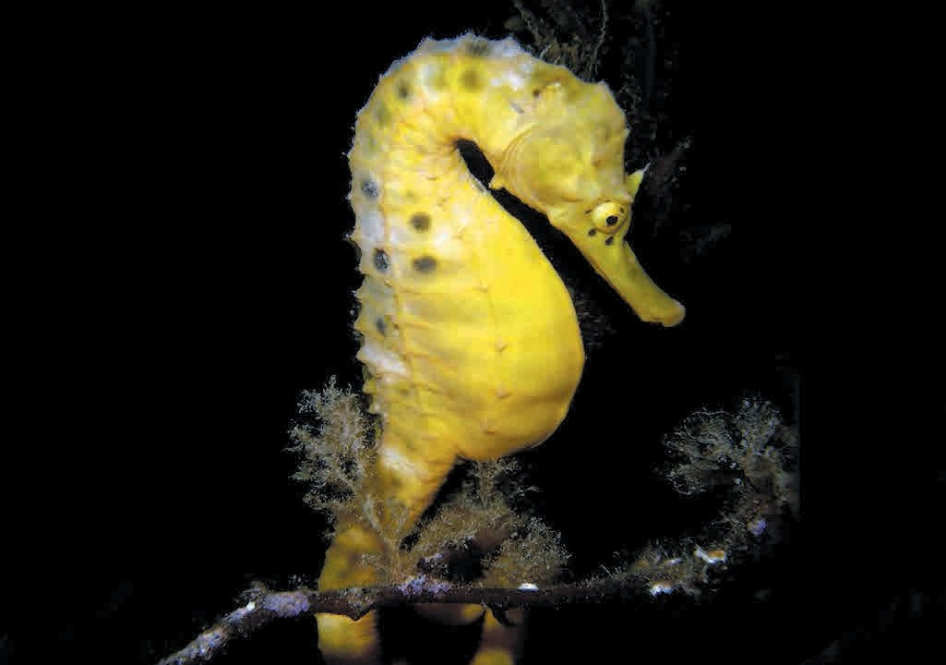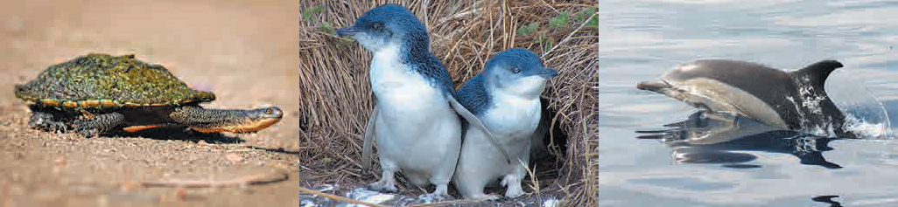

© The State of Victoria Department of Economic Development, Jobs, Transport and Resources, 2015

This work is licensed under a Creative Commons Attribution 3.0 Australia licence. You are free to re-use the work under that licence, on the condition that you credit the State of Victoria as author. The licence does not apply to any images, photographs or branding, including the Victorian Coat of Arms, the Victorian Government logo and the Department of Economic Development, Jobs, Transport and Resources logo. To view a copy of this licence, visit http://creativecommons.org/licenses/by/3.0/au/deed.en
Printed by (name of printer, suburb) ISBN 978-1-74146-732-1 (Print)
ISBN 978-1-74146-733-8 (pdf)

Accessibility
If you would like to receive this publication in an alternative format, please telephone the Customer Service Centre
136 186, email customer.service@ecodev.vic.gov.au, via the National Relay Service on 133 677, www.relayservice.com.au. This document is also available on the internet at www.economicdevelopment.vic.gov.au

Disclaimer
This publication may be of assistance to you but the State of Victoria and its employees do not guarantee that the publication is without flaw of any kind or is wholly appropriate for your particular purposes and therefore disclaims all liability for any error, loss or other consequence which may arise from you relying on any information in this publication.

Contents
Introduction 3
Birds 5
Albatrosses 5
Gulls 7
Gannet, Penguin and Prion 8
Petrels and Sea-Eagle 9
Shearwaters (Muttonbirds) 10
Terns 11
Cormorants (Shags) 13
Coot 14
Waterfowl 15
Grebes 18
Mammals 19
Seals 19
Sea Lion 20
Whales 21
Dolphins 23
Native Rats 24
Reptiles and Amphibians 25
Turtles 25
Snakes 26
Lizard and Frog 27
Fish 29
Sharks 29
Marine, Estuarine and Freshwater 30
Sygnathids 33
Pipefish 33
Sea Horses 34
Sea Dragon 35
Image and Text Credits 36
Index 42

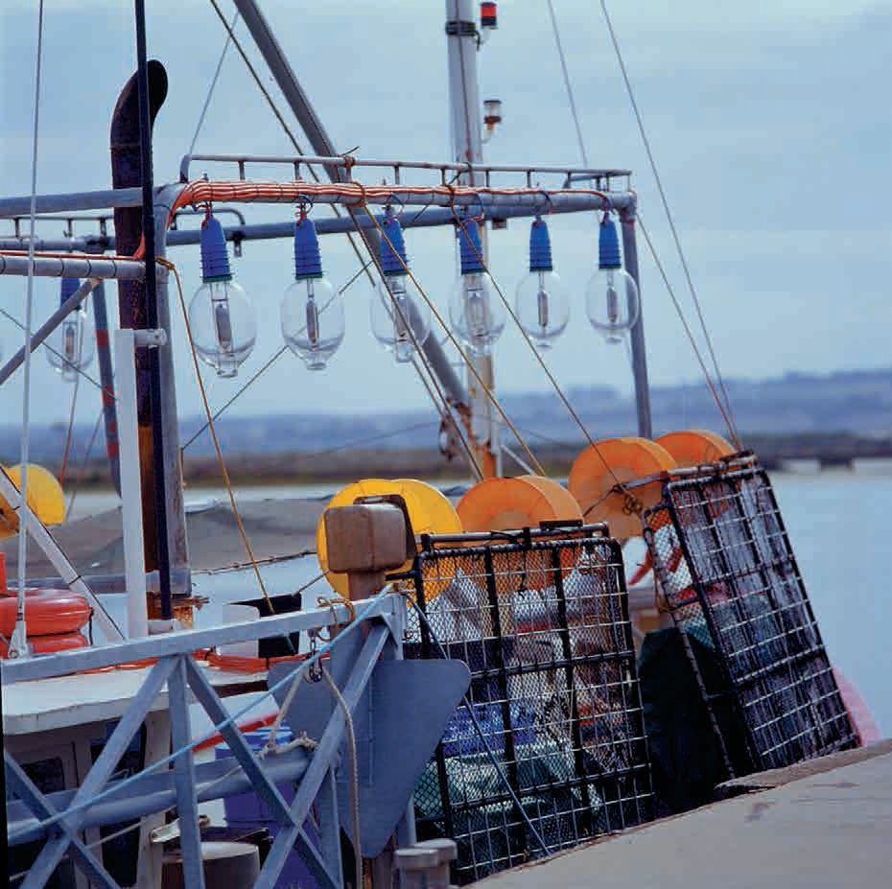

Introduction

What is this guide for?
This species identification guide has been developed for Victorian commercial fishers who are required to report on interactions with protected species. Accurate identification of species is critical in ensuring that any commercial fishing impacts on protected species are properly reported and understood.

What it is/isn’t
This guide has been compiled based on protected species that commercial fishers are likely to come into contact with while fishing, and species currently listed as threatened under Victoria’s Flora and Fauna Guarantee Act 1988 (FFG Act). For example, birds that feed by diving and occur in areas where fishing activity takes place have been included, but wading birds, which are unlikely to be impacted by commercial fishing operations, have not.
This guide is not an exhaustive list of species covered by the reporting requirements. Common species that are readily identifiable such as silver gulls (seagulls) or pelicans also have not been included. More comprehensive guides and smart phone apps should be consulted for further information.
In Victoria, all native mammals, birds, reptiles and amphibians, fish listed under the FFG Act and sygnathids (sea horses, sea dragons etc) are protected species.
Interactions with any of these species should be reported, regardless of whether they appear in this identification guide.

How this guide works
The species in this guide are organised according to class of animal (eg bird, mammal) and are coloured to indicate whether they are found in inland or coastal areas.

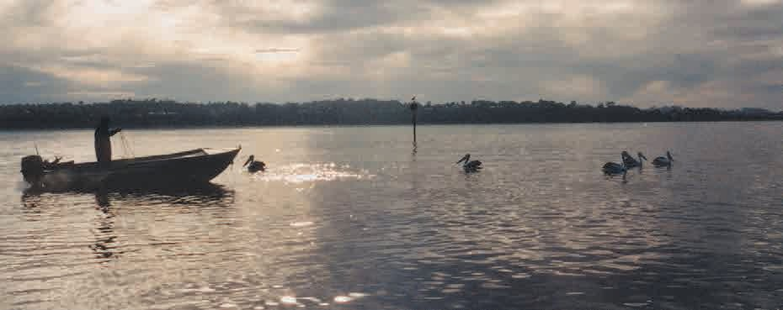

Birds 5
Birds
Albatrosses 5
Gulls 7
Gannet, Penguin and Prion 8
Petrels and Sea-Eagle 9
Shearwaters (Muttonbirds) 10
Terns 11
Cormorants (Shags) 13
Coot 14
Waterfowl 15
Grebes 18

Albatrosses
Coastal

Grey-headed Albatross
Thalassarche chrysostoma
- Length: 70 - 85 cm
- Wingspan: 1.8 - 2.05 m
- Grey head, neck and mantle
- Black bill with yellow stripes on top and bottom
- White body

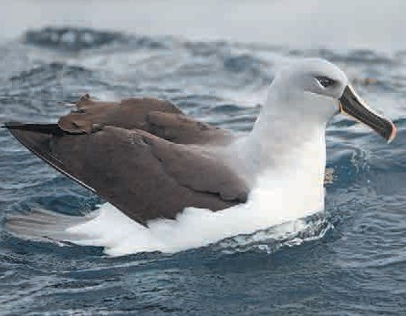Photo: JJ Harrison

Light-mantled Sooty Albatross
Phoebetria palpebrata
Birds
- Length: 78 - 90 cm
- Wingspan: 1.8 - 2.2 m
- Sooty brown plumage with grey mantle, back and rump
- White crescent around each eye

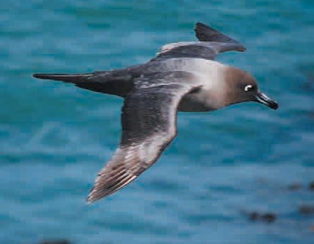Photo: Natalie Tapson
Coastal

Southern Royal Albatross
Diomedea epomophora
- Length: 112 - 123 cm
- Wingspan: 2.9 - 3.3 m
- Pure white head and body
- Pink bill with black line on cutting edge
- Dark brown or black wings with white upper wing

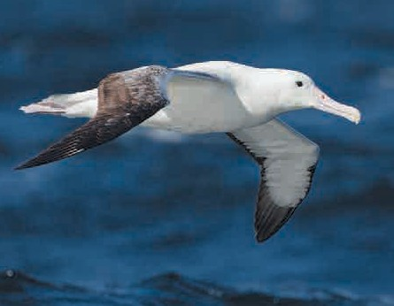Photo: JJ Harrison
Coastal

Albatrosses
Shy Albatross
Coastal
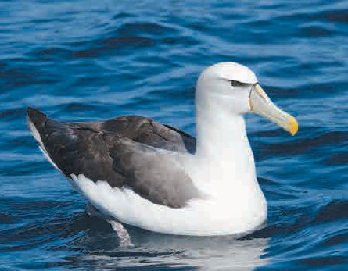Thalassarche cauta
  - Length: 90 - 99 cm
  - Wingspan: 2.1 - 2.6 m
  - White head and neck, pale grey cheeks
  - Grey bill with yellow tip
  - Grey-black mantle, tail and upper wing

Sooty Albatross
Phoebetria fusca
  - Length: 85 cm
Birds
  - Sooty brown plumage with head darker than body
  - Fine white crescent above eye
  - Black bill with pale yellow/orange stripe
  - Slender, pointed wings, wedge shaped tail
Photo: JJ Harrison

Wandering Albatross
Diomedea exulans
  - Largest of the albatross family
  - Wingspan: 2.5 - 3.5 m
  - White head and back with fine grey wavy lines on feathers
  - Pale pink bill
  - White tail, tipped with black

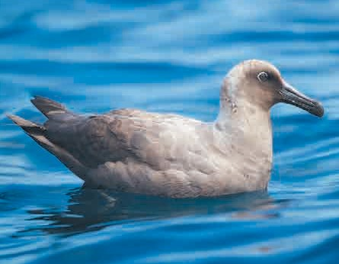Photo: JJ Harrison
Coastal

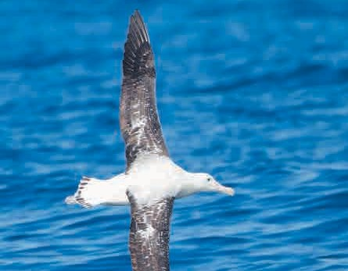Photo: JJ Harrison
Coastal

Albatrosses and Gulls
Black-browed Albatross
Coastal
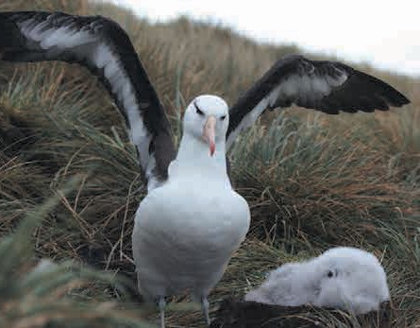Thalassarche melanophris
    - Length: 80—95 cm
    - Most common member of albatross family
    - White with black brow, back, upper wing and tail
    - Black edges to underwing
    - Orange-yellow bill
    - Bluish-grey legs and feet

Photo: Liam Quinn

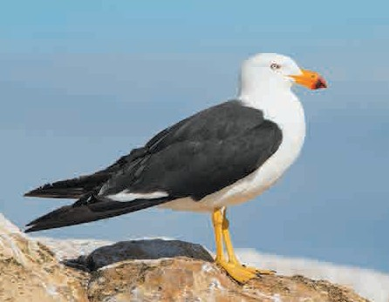
Coastal
Photo: JJ Harrison

Pacific Gull
Stercorarius antarcticus
- Length: 58 - 66 cm
Birds
- Wingspan: 137 - 157 cm
- Mostly white with dark wings and back, black band on tail
- Thick, powerful, red-tipped yellow bill
- Yellow legs and feet

Kelp Gull
Larus dominicanus
- Length: 54 - 65 cm
- Wingspan: 128 - 142 cm
- Black upperparts and wing
- White head, underparts, tail and wing tips
- Yellow bill with red spot
- Greenish-yellow legs

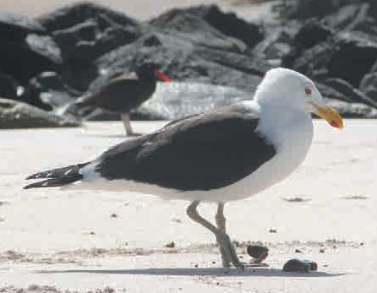Photo: Jason Quinn
Coastal

Gannet, Penguin and Prion
Australasian Gannet
Coastal
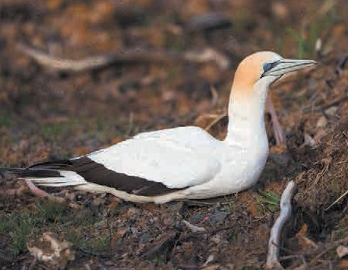Morus serrator
  - Length: 84—95 cm
  - Mostly white, black flight feathers at the wingtips
  - Yellow head
  - Pale, blue-grey bill edged with black
  - Bill has backward pointing serrations
  - Spectacular plunge divers

Little Penguin
Eudyptula minor
  - Length: 30 - 33 cm
Birds
  - Blue head, upperparts and flippers
  - White underneath
  - Pink feet above with black soles and webbing
Photo: JJ Harrison

Fairy Prion
Pachyptila turtur
  - Length: 23 - 28 cm
  - Wingspan: 56 cm
  - Short, narrow bill with strong hook
  - Grey-blue above, darker grey crown, grey eye stripe
  - Triangular tail with dark tip

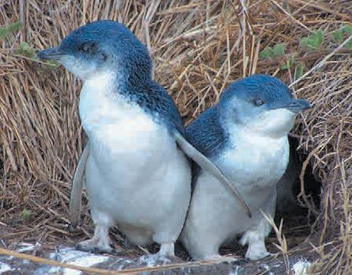Photo: M Kuhn
Coastal

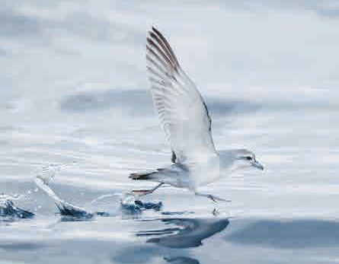Photo: JJ Harrison
Coastal

Petrels and Sea-Eagle
Northern Giant Petrel
Coastal
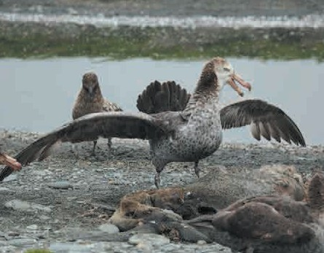Macronectes halli
    - Wingspan: 1.5 - 2.1 m
    - Large straw-coloured bill, tipped with pinkish-red or orange
    - Pale grey eye
    - Dark crown with a whitish face and throat

Photo: Liam Quinn

Coastal
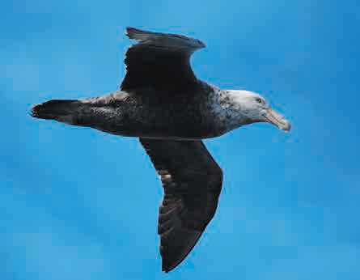
Photo: Natalie Tapson

Southern Giant Petrel
Macronectes giganteus
- Length: 87 cm
Birds
- Wingspan: 1.8 - 2.05 m
- Greenish-tipped, straw coloured bill
- Pale underwing leading edge near body

White-bellied Sea-Eagle
Haliaeetus leucogaster
- Length: 75 - 85 cm
- Wingspan: 180 - 220 cm
- White head, breast, belly and legs
- Grey back and wings with black tips
- Grey tail with white tip
- Bluish-grey bill with black tip

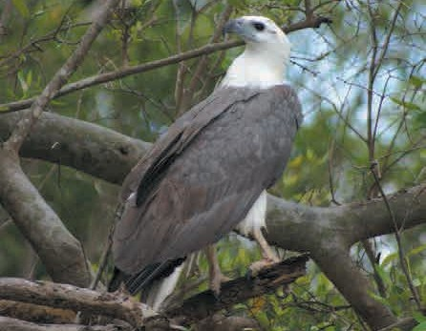Photo: MagicFlute1983
Coastal

Shearwaters (Muttonbirds)
Flesh-footed Shearwater
Coastal
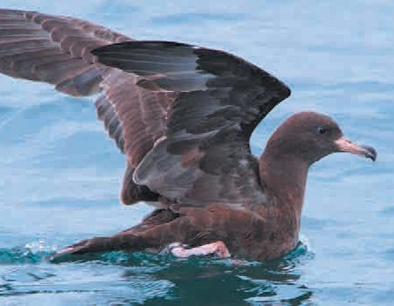Ardenna carneipes/Puffinus carneipes
  - Length: 40 - 47 cm
  - Wingspan: 99 - 107 cm
  - Blackish-brown plumage
  - Flesh coloured bill with black tip
  - Flesh-pink legs and feet

Fluttering Shearwater
Puffinus gavia
  - Length: 37 cm
Birds
  - Dark grey-brown upper parts, white under parts
  - Long, thin, dark bill
  - Rapid bursts of fluttering, interspersed with short glides
  - Seen in Aust from Feb - Aug
Photo: Teddymacollege

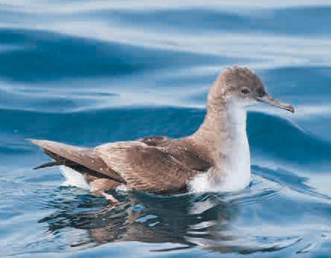Short-tailed Shearwater
Coastal
Puffinus tenuirostris
  - Length: 40 - 45 cm
  - Wingspan: 1m
  - Dark brown plumage
  - Short, blackish-brownish tail
  - Slender bill with hooked end
Photo: JJ Harrison

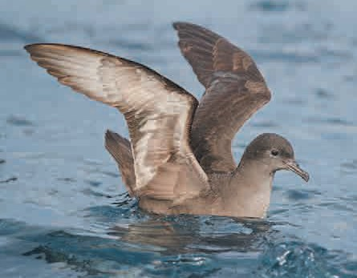
Coastal
Photo: JJ Harrison

Terns

Coastal
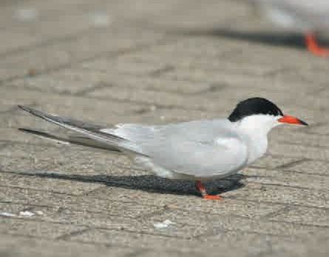
Photo: Hans Hillewaert

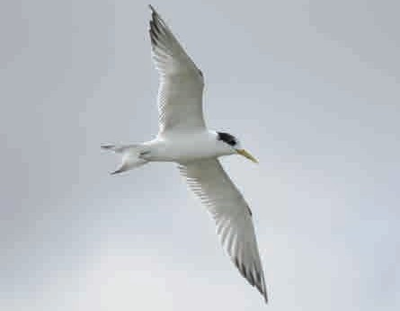
Coastal
Photo: DELWP

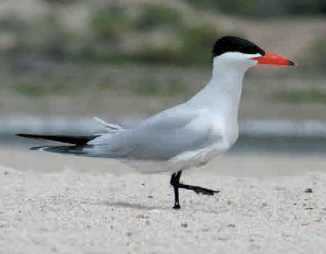
Coastal and Inland
Photo: Dick Daniels

Common Tern
Sterna hirundo
- Length: 31 - 35 cm
- Wingspan: 77 - 98 cm
- 6 - 9 cm fork in tail
- Grey upperparts, very pale grey underparts
- Black cap
- Orange-red legs
- Common in eastern Victoria

Crested Tern
Thalasseus bergii
- Length: 46 - 49 cm
Birds
- Wingspan: 125 - 130 cm
- Grey upperparts, white underparts, shaggy black crest
- Long, yellow bill

Caspian Tern
Hydroprogne caspia,
formerly Sterna caspia
- Largest tern, length: 53 - 60 cm
- Wingspan: 127 - 145 cm
- Long, thick, red-orange bill with small black tip
- White head with a black cap and white neck, belly and tail
- Pale grey upper wings and back
- Known breeding colonies in Corner Inlet, Mud Island and Mallacoota

Terns
Gull-billed Tern
Gelochelidon nilotica,
formerly Sterna nilotica
  - Length: 33 - 42 cm
  - Wingspan: 76 - 91 cm
  - Thick, black, gull-like bill
  - White plumage with black crown, grey back and upper wings

Little Tern
Sternula albifrons
  - Length: 20 - 28 cm
Birds
  - Wingspan: 41 - 47 cm
  - Breeding birds have black cap, with band extending beyond eye to the bill
  - Otherwise white and pale grey plumage
  - Slender with narrow wings and long, deeply forked tail

Fairy Tern
Sterna nereis
  - Length: 22 - 27 cm
  - Wingspan: 44 - 53 cm
  - Bulky, round bodied
  - Pale grey-white plumage, with a black crown, nape, ear coverts and patch in front of the eyes
  - White forehead, yellow-orange bill

Coastal and Inland
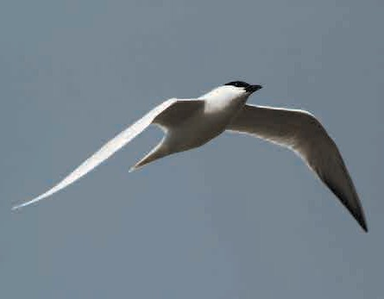
Photo: Frankzed

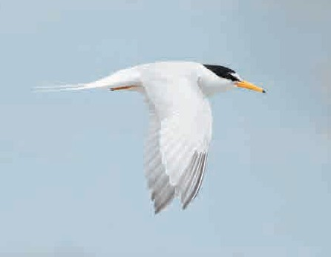
Coastal
Photo: JJ Harrison

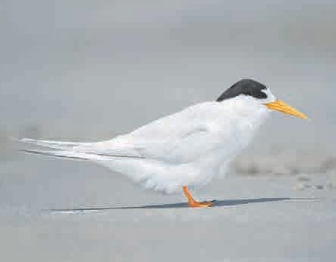Photo: JJ Harrison
Coastal

Cormorants (Shags)
Great (Black) Cormorant
Coastal and Inland
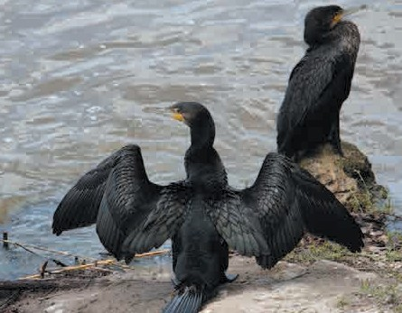Phalacrocorax carbo
    - Length: 70 - 102 cm
    - Wingspan: 121 - 160 cm
    - Black plumage with white and yellow chin
    - Grey bill, black feet and legs

Photo: Heather

Little Black Cormorant
Phalacrocorax sulcirostris
- Length: 60 - 65 cm
Birds
- Wingspan: up to 105 cm
- Black plumage
- Long, slender grey bill
- Found in large flocks, sometimes fly in V formation

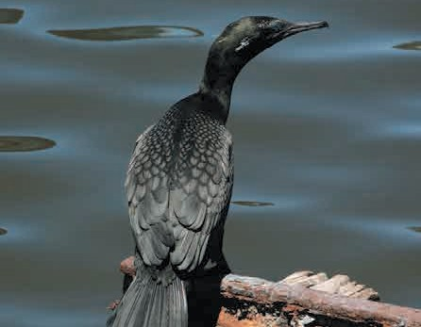Photo: Heather
Coastal and Inland

Black-faced Cormorant
Phalacrocorax fuscescens
- Length: 60 - 70 cm
- Black upperparts, face and bill
- White underparts
- Dark grey bill, blue-green eyes
- Only found in coastal and marine areas

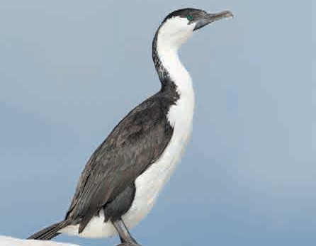Photo: JJ Harrison
Coastal

Cormorants and Coot
Pied Cormorant
Coastal and Inland
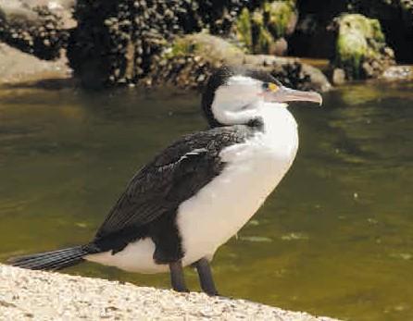Phalacrocorax varius
  - Length: 65 - 85 cm
  - Black, glossed-green back with white underparts
  - Black stripes on thighs
  - Long, grey, hooked bill
  - Orange eye patch
  - Flies in V formation

Little Pied Cormorant
Microcarbo melanoleucos
  - Length: 56 - 58 cm
Birds
  - Black above and white below
  - Short, yellow bill
  - Small crest
  - Solitary benthic feeder

Eurasian Coot
Fulica atra
  - Length: 32 - 42 cm
  - Black plumage with white frontal shield and bill
Photo: Jorg Hempel

Coastal and Inland
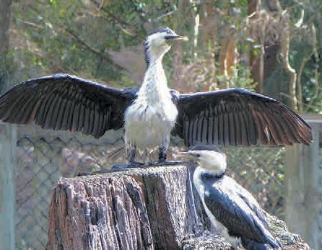
Photo: SeanMack

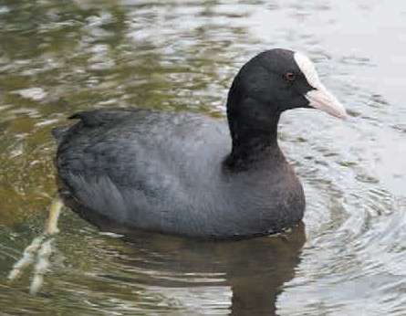Photo: Theleastweasel
Coastal and Inland

Waterfowl

Coastal and Inland
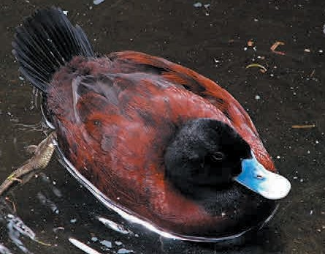
Photo: Dale Gillard

Blue-billed Duck
Oxyura australis
- Length: 40 cm
- Adult breeding male has black head, chestnut to brown body and wings, blue bill
- Adult female and non-breeding male has medium grey plumage with light barring to head and body, dark bill

Chestnut Teal
Anas castanea
- Male has glossy green head and white flank patch
Birds
- Female and juvenile male similar to Grey Teal but darker
- Common in brackish coastal lagoons, saltwater estuaries and lower reaches of creeks

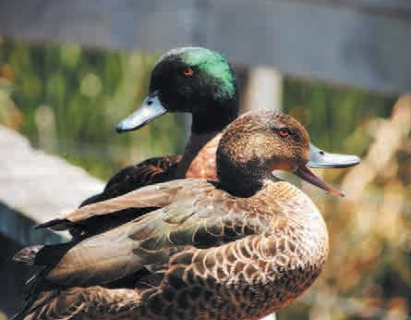Photo: PsJeremy
Coastal and Inland

Grey Teal
Anas gracilis
- Mottled brown with white and green flashes on wings
- Males and females share same colouration
- Lighter coloured neck and paler face than female chestnut teal

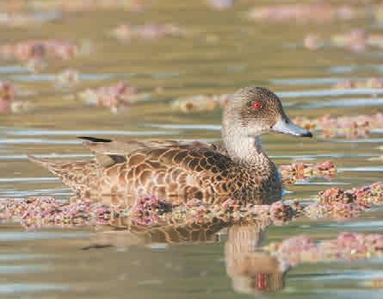Photo: JJ Harrison
Coastal and Inland

Waterfowl
Hardhead
Inland
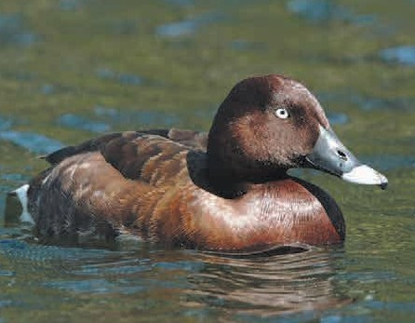Arthya australis
  - Medium size, dark brown with white feathers under tail
  - Male has white eyes
  - Generally found on large lakes, swamps and rivers with deep, still water

Freckled Duck
Stictonetta naevosa
  - Heavily bodied, dark grey, brown
Birds
  - Off-white speckles all over
  - Underwings pale
  - Distinctive shaped bill, adult breeding male has bright red base of bill
Photo: Quoll2

Musk Duck
Biziura lobata
  - Dark grey-brown, slightly pin-striped plumage
  - Male has pendulous lobe of skin beneath the bill
  - Stiff tail
  - Prefers deep, still lakes and wetlands

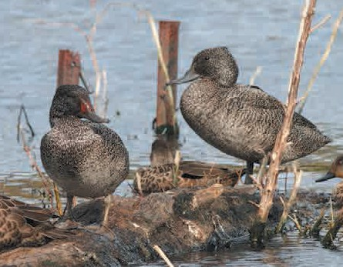Photo: Frankzed
Inland

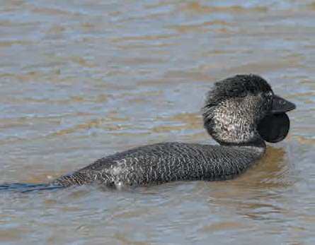Photo: MdeKool
Inland

Waterfowl

Inland
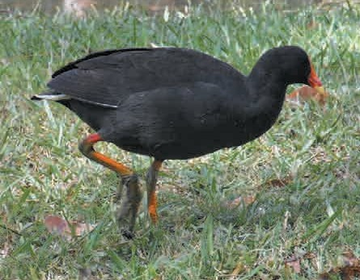
Photo: Quartl

Dusky Moorhen
Gallinula tenebrosa
- Length: 34 - 38 cm
- Dark grey-black with brown tinge to upperparts
- Orange-yellow legs
- Red bill with yellow tip

Purple (Eastern) Swamphen
Porphyrio porphyrio
Birds
- Length: 44—48 cm
- Purple-blue neck, breast and belly
- Red bill and face shield

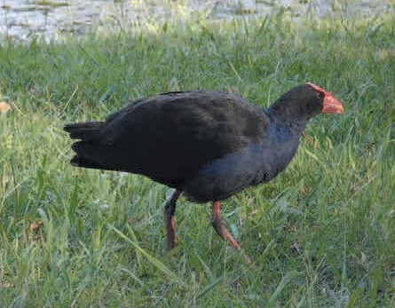Photo: Quartl
Inland

Grebes
Australasian Grebe
Tachybaptus novaehollandiae
  - Length: 25 - 27 cm
  - Breeding plumage dark brown above, glossy-black head and neck
  - Non breeding plumage dark grey- brown above, silver-grey below
  - Chestnut facial stripe from behind the eye to base of neck
  - Common on freshwater lakes and rivers

Great Crested Grebe
Podiceps cristatus
  - Length: 46 - 51 cm
Birds
  - Wingspan: 59 - 73 cm
  - Long neck and head with distinctive black crest
  - Dark brown wings, white underparts
  - Long, pointed, straight bill
  - Juveniles have striped black and white heads

Hoary-headed Grebe
Poliocephalus poliocephalus
  - Length: 25—30 cm
  - Small, dark grey and white bird
  - Black head with silvery-white streaking
  - Narrow black streak down back of neck

Inland
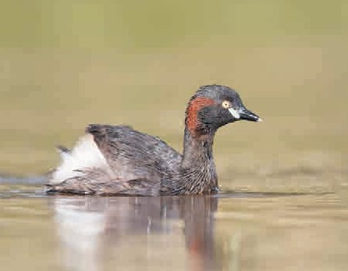
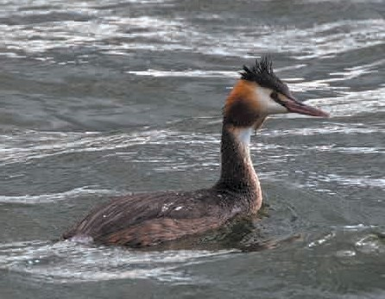Photo: JJ Harrison
Inland
Photo: Tony Hisgett

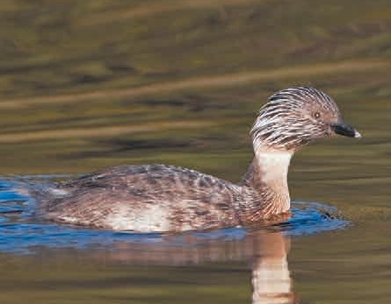Photo: JJ Harrison
Inland

Albatrosses 5
Gulls 7
Gannet, Penguin and Prion 8
Petrels and Sea-Eagle 9
Shearwaters (Muttonbirds) 10
Terns 11
Cormorants (Shags) 13
Coot 14
Waterfowl 15
Grebes 18
Mammals

Mammals | 19
Seals | 19
Sea Lion | 20
Whales | 21
Dolphins | 23
Native Rats | 24

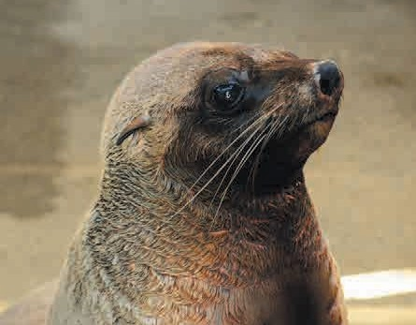Seals
Coastal

PPhhoottoo:: Chris Phutully

Australian Fur Seal
Arctocephalus pusillus
• Length: 1.5 - 2.5 m
- Adult male: greyish brown with paler chest and dark brown belly
- Adult female: pale fawn to greyish brown with pale chest and brown belly
- Larger than other fur seals, males are heavy chested with thick, dark mane

New Zealand Fur Seal
Arctocephalus forsteri
Mammals
- Length: 1.5 - 2 m
- Smaller than Australian fur seal and darker in colour
- Sharply pointed snout
- Grey to brown, female lighter underneath

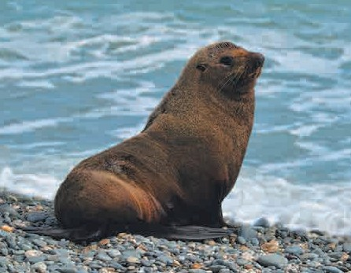PPhhoottoo:: Alexandre Roux
Coastal

Sub-Antarctic Fur Seal
Arctocephalus tropicalis
- Length: 1.5 - 2 m
- Dark grey with contrasting whitish-yellow face and chest
- Males have prominent black crest and thick mane
- Seen occasionally in Victoria

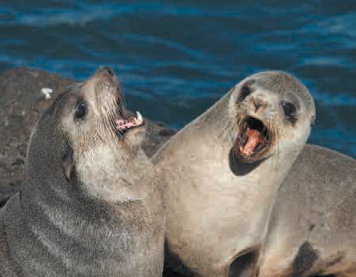PPhhoottoo:: Brian Gratwicke
Coastal

Seals and Sea Lion
Leopard Seal
Coastal
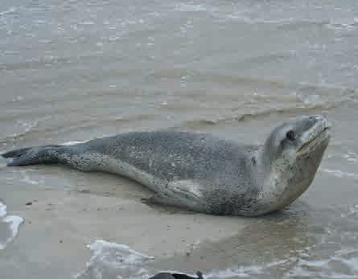Hydrurga leptonyx
  - Length: 4 - 4.5 m
  - Silver to dark blue-grey with pale silver underneath.
  - Dark areas spotted darker grey and black
  - Long neck, large, flat, reptilian head
  - Seen occasionally in Victoria

Southern Elephant Seal
Mirounga leonina
Mammals
  - Length: 4 - 6.5 m
  - Dark brown with lighter brown underneath
  - Adult male noticeably larger than female with trunk-like nose
  - Cumbersome on land

Australian Sea Lion
Neophoca cinerea
• Length: 1.8 - 2.5 m
  - Adult male: chocolate brown, yellow crown with dark muzzle, greyer back, dusky abdomen and flippers
  - Adult female: Dark back and top of head, creamy-yellow underbody and sides of head
  - Seen occasionally in Victoria
Photo: DELWP

Coastal
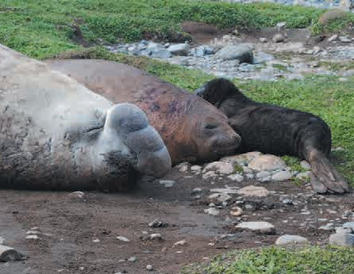
Photo: Natalie Tapson

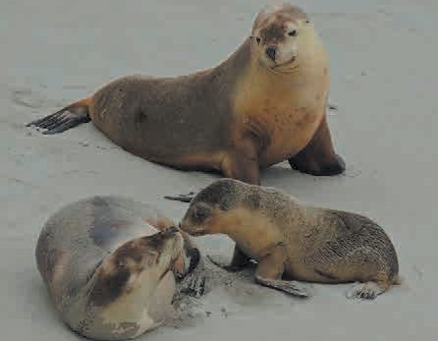Photo: Diver Dave
Coastal

Whales

Coastal
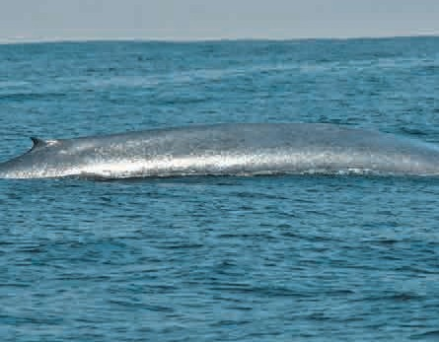
Photo: Jerry Kirkhart

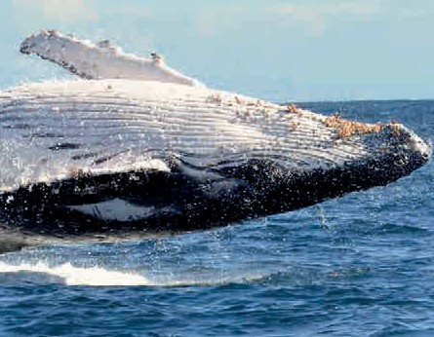
Coastal
Photo: DELWP

Blue Whale
Balaenoptera musculus
• Length: 31 - 33.5 m
- Silver-grey to grey-black
- Slender, streamlined body
- Tall, straight, powerful blow
- Occur along Continental shelf from Nov - May, especially west of Cape Otway

Humpback Whale
Megaptera novaeangliae
Mammals
- Black or bluish-grey upper body, white underside
- Throat pleats
- Long pectoral fins (1/3 body length)
- Prominent double blow holes
- Usually seen autumn - spring

Killer Whale (Orca)
Orcinus orca
- Length: 8.5 - 10 m
- Mainly black with white throat to abdomen and rear flanks
- Grey-white patch behind dorsal fin
- Round body with huge head and blunt nose
- Tall dorsal fin in males

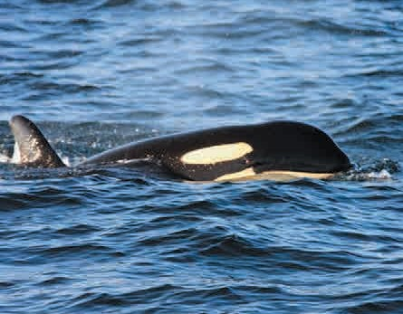Photo: Kat Kellner
Coastal

Whales
Pilot Whale
Globicephala melas
  - Length: 5.5 - 7 m
  - Black body with white diagonal strip towards the eyes, white saddle behind dorsal fin and anchor shaped pattern underneath
  - Beakless with round, bulbous head
  - Dorsal fin is broad at the base and curved back towards tail
  - Very long pectoral flippers

Southern Right Whale
Eubalaena australis
Mammals
  - Length: 16 - 18 m
  - Black body, may have irregular white blotches underneath
  - Callosities (growths) form rough white markings on head
  - V-shaped blow
  - Seen during winter, especially around Warrnambool

Coastal
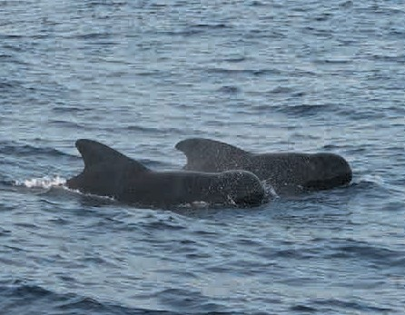
Photo: Alexander Baxevanis

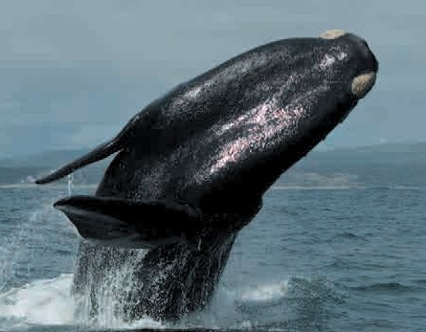Photo: Willem
Coastal

Dolphins

Coastal
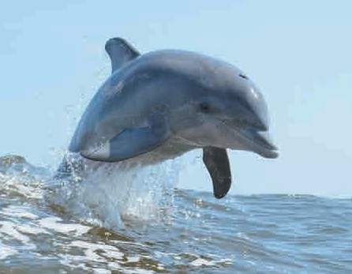
Photo: Juanma Carrillo

Bottlenose Dolphin
Tursiops truncatus
- Length: 3 m
- Dark bluish-grey, which shades gradually to off-white or pinkish underneath
- Prominent curved-back dorsal fin
- Stubby beak set off from robust head

Burrunan Dolphin
Tursiops australis
Mammals
- Length: to 2.6 m
- Dark grey upper side of the body, a paler grey midline, and a cream underside
- Described as distinct species in 2011
- Found in Port Phillip Bay and Gippsland Lakes

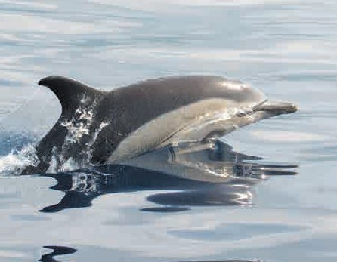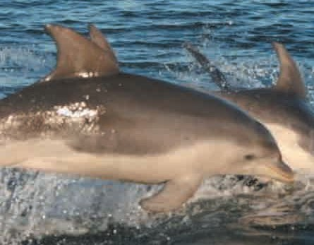Photo: Charlton-Robb K, Gershwin LA, Thompson R, Austin J, Owen K, McKechnie S
Coastal
Coastal

Common Dolphin
Delphinus delphis
- Length: 2 m
- Dark colouring on top, large yellowish panel on chest bordered by white flanks
- Small, round head with shirt and stocky beak

Photo: Bertrand

Native Rats
Swamp Rat
Rattus lutreolus
  - Body length: up to 20 cm
  - Tail length: up to 14 cm
  - Dark grey to dark brown body fur
  - Brown feet

Water Rat (Rakali)
Hydromys chrysogaster
Mammals
  - Body length: 23 - 37 cm
  - Tail length: 24 - 25 cm
  - Webbed hind legs
  - Black to brown fur with orange to white belly
  - Dark tail with white tip

Inland
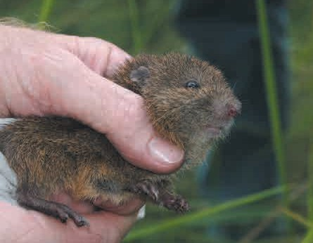
Photo: Doug Beckers

Inland
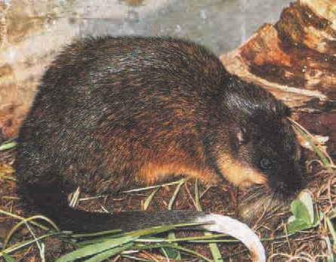
Photo: ZooPro

Albatrosses 5
Gulls 7
Gannet, Penguin and Prion 8
Petrels and Sea-Eagle 9
Shearwaters (Muttonbirds) 10
Terns 11
Cormorants (Shags) 13
Coot 14
Waterfowl 15
Grebes 18

Reptiles and Amphibians 25
Turtles 25
Snakes 26
Reptiles & Amphibians
Lizard and Frog 27

Turtles

Coastal
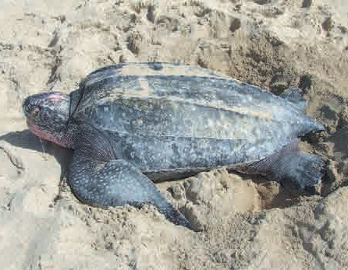
Photo: U.S. Fish and Wildlife Service Southeast Region

Leatherback Turtle
Dermochelys coriacea
- Shell length: nearly 2 m
- Largest of sea turtle species
- Mainly blackish above with grey-white speckles on head
- Streamlined, ridged shell
- Limbs modified as flippers, with front flippers especially large
Reptiles and Amphibians
- Upper beak notched in middle to form two prongs

Broad-shelled Turtle
Chelodina expansa
- Length of carapace: up to 45 cm
- Broad, flat upper shell, narrower lower shell
- Very long neck, long, relatively flat head, neck and head dark grey

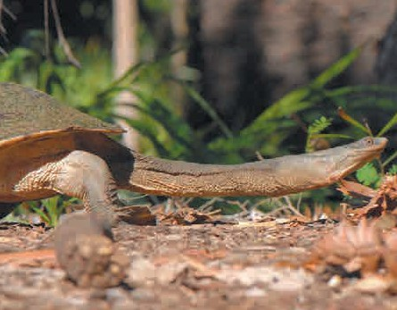Photo: Sam Fraser Smith
Inland

Eastern Snake-necked Turtle
(Long-necked Turtle)
Chelodina longicollis
- Shell length: up to 20 cm
- Flat circular shell, black to brown with yellow patches
- Long neck, webbed feet with claws

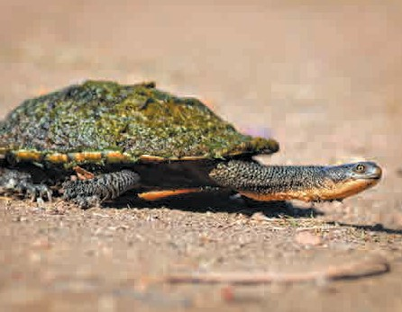Photo: Alexandre Roux
Inland

Snakes
Highland Copperhead Snake
Austrelaps ramsayi
  - Length: up to 1.2 m
  - Body light grey to red-brown, pale white-yellow to pink-orange underneath
  - Lips with dark vertical stripes and white edges around scales
Reptiles and Amphibians

Lowland Copperhead Snake
Austrelaps superbus
  - Length: up to 1.7 m
  - Grey to red-brown
  - Pale white-yellow to pink-orange underneath
  - Lips with faint vertical stripes

Inland
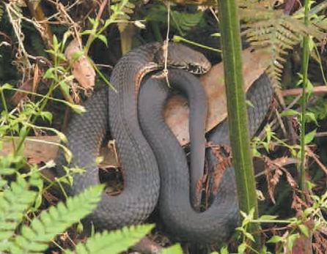
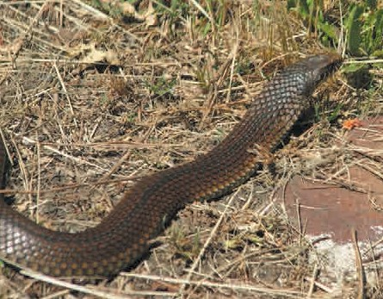Photo: Nathan Johnson
Inland

Tiger Snake
Notechis scutatus
  - Length: to 2 m
  - Colour varies from uniform light brown to black
  - Broad, flattened head
  - Striped markings not always present
Photo: Peter Shanks

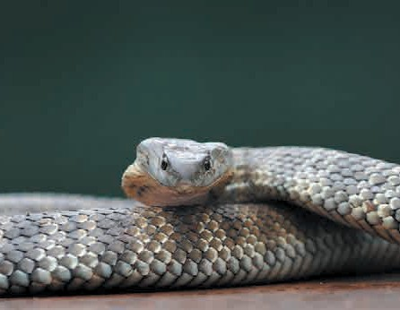Photo: DELWP
Inland

Lizard and Frog

Inland
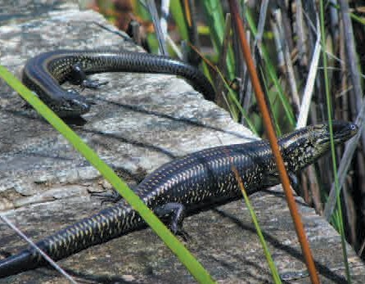
Photo: Vasco Pyjama

Inland
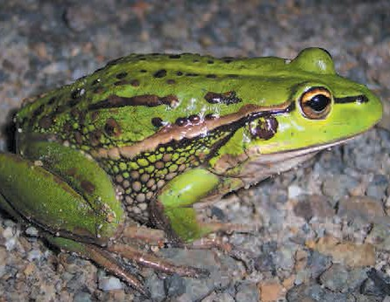
Photo: Tnarg 12345

Swamp Skink
Lissolepis coventryi
formerly Egernia coventryi
- Length: to 25 cm
- Greenish back with prominent black shoulder stripe on each side from nape to base of tail
Reptiles and Amphibians

Growling Grass Frog
Litoria raniformis
- Length: up to 104 mm
- Olive to bright emerald green with irregular gold, black or bronze spotting, white belly
- Warty back with pale green mid-dorsal stripe
- Cream or yellow stripe underlined by a dark brown stripe runs from the nostril, through the eye, above the inner ear and down the sides of the body
- No webbing on fingers but toes almost entirely webbed

Albatrosses 5
Gulls 7
Gannet, Penguin and Prion 8
Petrels and Sea-Eagle 9
Shearwaters (Muttonbirds) 10
Terns 11
Cormorants (Shags) 13
Coot 14
Waterfowl 15
Grebes 18

Turtles 25
Snakes 26
Lizard and Frog 27

Fish 29
Sharks 29
Marine, Estuarine and Freshwater 30
Fish

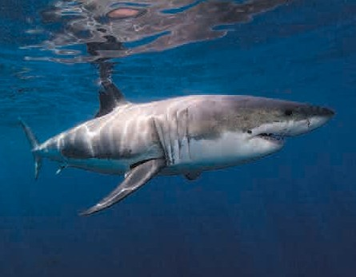Sharks
Coastal

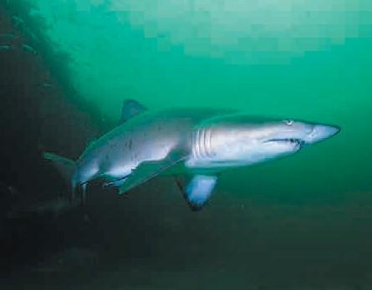PPhhoottoo:: Ken Bondy
Coastal

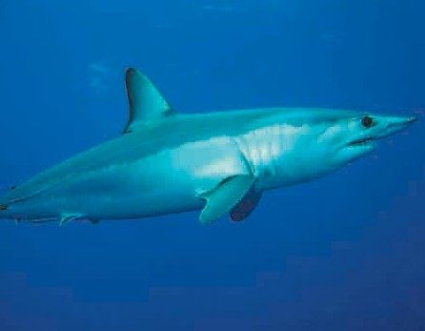PPhhoottoo:: Klaus Stiefel
Coastal

PPhhoottoo:: Patrick Doll

(Great) White Shark
Charcarius Taurus
- Length: up to 6.4 m
- Blue-grey to greyish-brown above, abruptly changing to a white underside
- Pointed snout
- Very high first dorsal fin, very small anal and second dorsal fins
- Crescent-shaped tail
- Large triangular serrated teeth

Grey Nurse Shark
Charcarius carcharias
- Length: up to 3.6 m
Fish
- Greyish-brown above, paler below
- Flattened, bluntly pointed snout
- Dagger-like teeth
- Dorsal, pelvic and anal fins of similar size
- Slow moving
- Rare in Victorian waters

Short Finned Mako Shark
Isurus oxyrinchus
- Length: up to 4 m
- Brilliant metallic blue above, white below
- Cylindrical in shape with vertically elongated tail
- Fastest species of shark, can jump up to 9 m in air
- Found in offshore Bass Strait in warmer waters

Marine, Estuarine and Freshwater
Australian Mudfish
Coastal
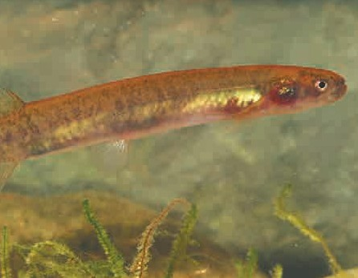Neochanna cleaveri
  - Length: up to 14 cm
  - Scaleless, tubular body
  - Rounded fins with fleshy bases
  - Small pelvic fins, very small eyes, large tubular nostrils
  - Found in coastal wetlands, estuarine and marine waters to 5 m

Cox’s Gudgeon
Gobiomorphus coxii
  - Length: to 19 cm
Fish
  - Dark brown to greenish brown, fading to pale brown or cream below
  - Blue, gold and yellow flecks on lower lateral scales
  - Dark midlateral stripe or series of midlateral blotches
  - Single black spot above pectoral fin base

Empire Gudgeon
Hypseleotris compressa
  - Length: to 12 cm
  - Females brown to golden, whitish below
  - Males in breeding season become bright orange-red on head and belly
  - Rare in Victoria
Photo: Tarmo A. Raadik

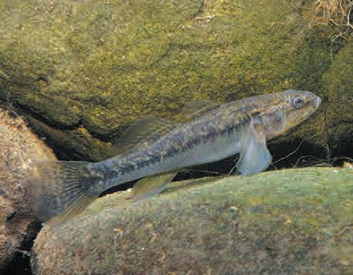
Inland
Photo: © Gunther Schmida/Lochman LT

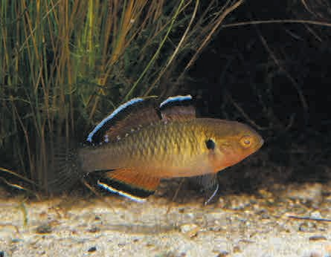
Inland
Photo: © Gunther Schmida/Lochman LT

Freshwater

Inland
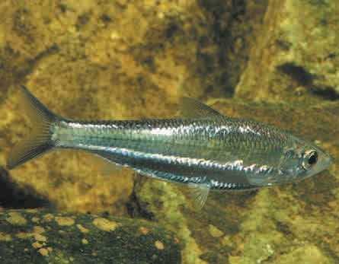
Photo: © Gunther Schmida/Lochman LT

Freshwater Herring
Poamalosa richmondia
- Length: 32 cm
- Usually silvery overall with greenish tinge
- 2 indistinct stripes below midline
- Fins colourless to yellowish
- Slender compressed body, single triangular pointed dorsal fin
- Found around Mallacoota in Victoria

Murray Cod
Maccullochella peelii
- Length: up to 1.8 m
Fish
- Round, depressed head with rounded snout and concave forehead
- Large mouth and jaws
- Olive green with small brown spots, creamy white undersides

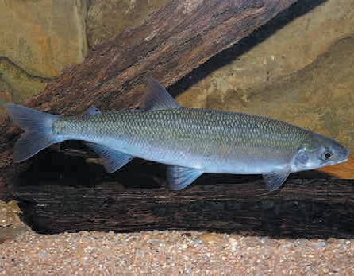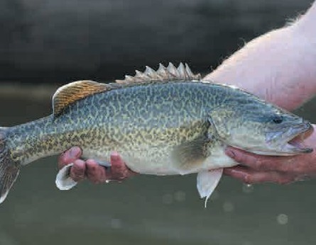Photo: Jarod Lyon
Inland
Inland

Photo: Tarmo A. Raadik

Australian Grayling
Prototroctes maraena
- Length: 17 - 33 cm
- Silvery with olive-grey back and whitish belly to olive green or brownish back with dark mid-lateral streak and greyish fins
- Large, bright yellow eyes, rounded snout and small head
- Strong cucumber smell when caught

Freshwater
Silver Perch
Bidyanus bidyanus
  - Length: 40 - 60 cm
  - Dark grey to grey-brown above, fading to silver and white, fins whitish to grey
  - Compressed elongate-oval body covered in small thin scales
  - Small head, small eyes positioned high on head
  - Single long-based dorsal fin divided into 2 sections

Trout Cod
Macullochella macquariensis
  - Length: 40 - 85 cm
Fish
  - Bluish grey or dark to light brown
  - Small dark irregular spots extending to lower sides and base of fins
  - Dusky grey to brownish fins with white or creamy margins

Inland
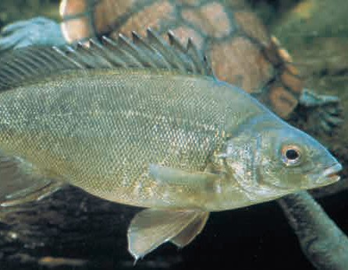
Photo: MDBA Gunther Schmida

Yarra Pygmy Perch
Edelia obscura or Nannoperca obscura
  - Length: up to 7.5 cm
  - Dusky, pale brownish-grey, sometimes greenish with a pale belly
  - Spots along midline and clear, faint yellow to black fins
  - Found from Bunyip River basin in West Gippsland through southern Victoria

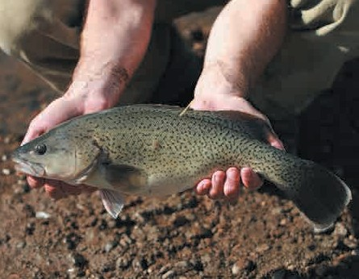Photo: Jarod Lyon
Inland

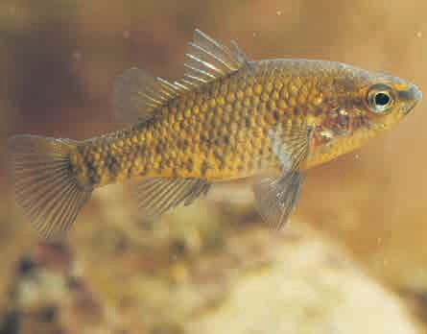
Inland
Photo: MDBA Gunther Schmida

Albatrosses 5
Gulls 7
Gannet, Penguin and Prion 8
Petrels and Sea-Eagle 9
Shearwaters (Muttonbirds) 10
Terns 11
Cormorants (Shags) 13
Coot 14
Waterfowl 15
Grebes 18
Sygnathids

Sygnathids | 33
Pipefish | 33
Sea Horses | 34
Sea Dragon | 35

Pipefish

Coastal
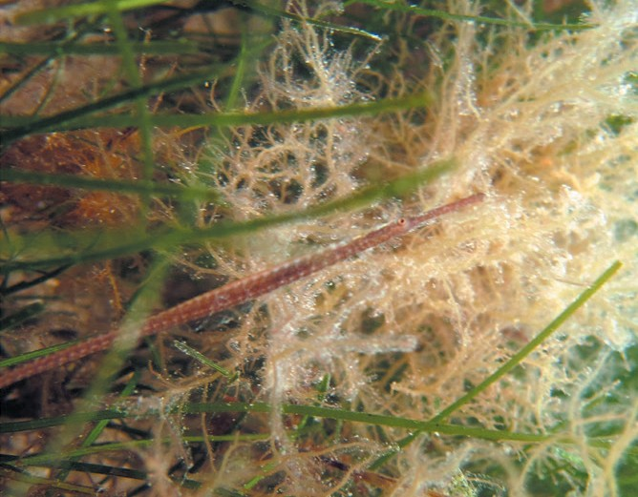
Photo: Saspotato

Spotted Pipefish
Stigmatopora argus
- Length: to 25 cm
- Very long body and snout
- No tail fin
- Usually greenish-brown with dark or pale spots

Widebody Pipefish
Sygnathids
Stigmatopora nigra
- Similar to spotted pipefish
- Variable colour, from greenish to brownish depending on habitat, females often with orange line along side
- During breeding season, females have swollen trunk, males have small pouch on underside of tail

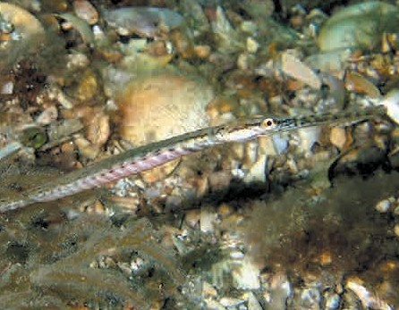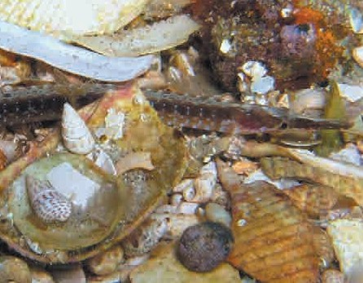Photo: Saspotato
Coastal
Coastal

Photo: Saspotato

Port Phillip Pipefish
Vanacampus phillip
- Moderately long snout
- Brownish with blue bars on sides and indistinct bars and spots
- Common in bays and estuaries

Pipefish and Sea Horses
Ringback Pipefish
Coastal
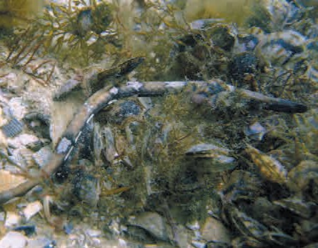Stipecampus cristatus
  - Length: up to 25 cm
  - Brown to yellowish brown
  - 9–11 narrow, irregular pale bars or blotches along the back
  - Elevated snout ridge
  - Found on reefs to 15 m
  - Seasonally migrates into Port Phillip Bay, often in large numbers

Big-bellied Sea Horse
Sygnathids
Hippocampus abdominalis
  - Length: up to 35 cm
  - Compressed body
  - Large abdomen, completely encased in bony rings,
  - Prehensile tail
  - Found in depths to 100 m
Photo: Saspotato

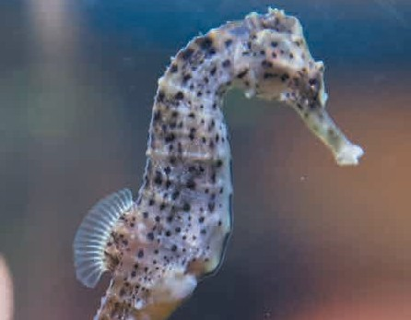Potbelly Sea Horse
Coastal
Hippocampus bleekeri
  - Length: up to 30 cm
  - Very similar to the Big Belly Seahorse, dispute about whether a separate species
  - Longer snout and commonly has head filaments
Photo: Mark6Mauro

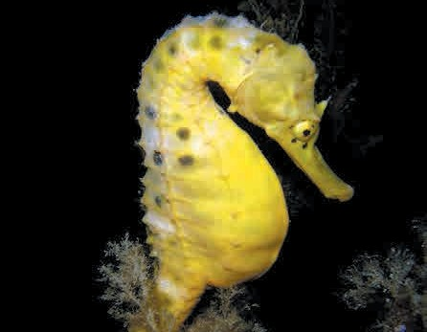Photo: Saspotato
Coastal

Sea Horses and Sea Dragons
Shorthead Sea Horse
Coastal
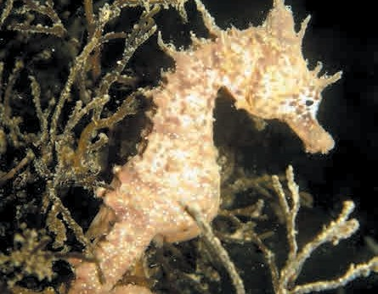Hippocampus breviceps
    - Length: up to 10 cm
    - Smallest sea horse found in southern waters
    - Short snout, fleshy tendrils on head and body
    - Found on reefs to 15 m
    - common in Port Phillip Bay, Victoria, especially in patches of Sargassum seaweed

Photo: Saspotato

Coastal
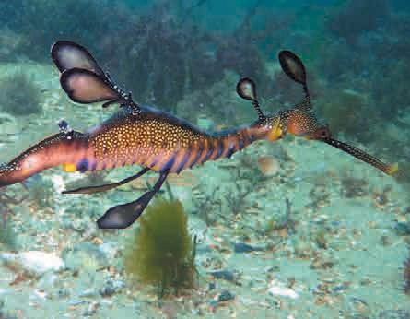
Photo: Saspotato

Weedy Sea Dragon
Sygnathids
Phyllopteryx taeniolatus
- Length: up to 45 cm
- Usually silvery overall with greenish tinge
- 2 indistinct stripes below midline
- Fins colourless to yellowish
- Slender compressed body, single triangular pointed dorsal fin
- Usually found in kelp-covered rocky reefs from 3 to 50 m

Image and Text Credits

Image | Page No. | Photographer | Source | Licence
Grey-headed Albatross | 5 | JJ Harrison | Own work, commons.wikimedia.org | BY-SA 3.0
Light-mantled Albatross | 5 | Natalie Tapson | Own work, Flickr | BY-NC-SA 2.0
Southern Royal Albatross | 5 | JJ Harrison | Own work, commons.wikimedia.org | BY-SA 3.0
Shy Albatross | 6 | JJ Harrison | Own work, commons.wikimedia.org | BY-SA 3.0
Sooty Albatross (immature) | 6 | JJ Harrison | Own work, commons.wikimedia.org | BY-SA 3.0
Wandering Albatross | 6 | JJ Harrison | Own work, commons.wikimedia.org | BY-SA 3.0
Black-browed Albatross and Chick | 7 | Liam Quinn | Own work, Flickr | BY-SA 2.0
Pacific Gull | 7 | JJ Harrison | Own work, commons.wikimedia.org | BY-SA 3.0
Kelp Gull | 7 | Jason Quinn | Own work, commons.wikimedia.org | BY-SA 3.0
Australasian Gannet | 8 | JJ Harrison | Own work, commons.wikimedia.org | BY-SA 3.0
Little Penguin | 8 | M Kuhn | Own work, Flickr | BY-NC-SA 2.0
Fairy Prion | 8 | JJ Harrison | Own work, commons.wikimedia.org | BY-SA 3.0
Northern Giant Petrel | 9 | Liam Quinn | Own work, Flickr | BY-SA 2.0
Southern Giant Petrel | 9 | Natalie Tapson | Own work, Flickr | BY-NC-SA 2.0
White Bellied Sea Eagle | 9 | MagicFlute1983 | Own work, commons.wikimedia.org | BY-SA 2.0
Flesh-footed Shearwater | 10 | Teddymacollege | Own work, commons.wikimedia.org | BY 3.0
Fluttering Shearwater | 10 | JJ Harrison | Own work, commons.wikimedia.org | BY-SA 3.0
Short-tailed Shearwater | 10 | JJ Harrison | Own work, commons.wikimedia.org | BY-SA 3.0
Common Tern | 11 | Hans Hillewaert | Own work, commons.wikimedia.org | BY-SA-4.0
Crested Tern | 11 | DELWP | Image library | All rights reserved
Caspian Tern | 11 | Dick Daniels | Own work, commons.wikimedia.org | BY-SA 3.0
Gull-billed Tern | 12 | Frankzed | Own work, commons.wikimedia.org | BY 2.0
Little Tern | 12 | JJ Harrison | Own work, commons.wikimedia.org | BY-SA 3.0
Fairy Tern | 12 | JJ Harrison | Own work, commons.wikimedia.org | BY-SA 3.0
Great (Black) Cormorant | 13 | Heather | Own work, Flickr | BY-NC 2.0
Little Black Cormorant | 13 | Heather | Own work, Flickr | BY-NC 2.0

Text Source
Department of the Environment (2015). Thalassarche chrysostoma in Species Profile and Threats Database, Department of the Environment, Canberra. Available from:
http://www.environment.gov.au/sprat. Accessed Tue, 21 Apr 2015 10:00:20 +1000.

Department of the Environment (2015). Phoebetria palpebrata in Species Profile and Threats Database, Department of the Environment, Canberra. Available from:
http://www.environment.gov.au/sprat. Accessed Tue, 21 Apr 2015 10:31:09 +1000.

Department of the Environment (2015). Diomedea epomophora epomophora in Species Profile and Threats Database, Department of the Environment, Canberra. Available from: http://www.environment.gov.au/sprat. Accessed Tue, 21 Apr 2015 10:47:34 +1000. And wikipedia entry for Southern Royal Albatross

Department of the Environment (2015). Thalassarche cauta cauta in Species Profile and Threats Database, Department of the Environment, Canberra. Available from: http://www.environment.gov.au/sprat.
Accessed Tue, 21 Apr 2015 11:05:07 +1000. And wikipedia entry for Shy Albatross
Image and Text Credits

Department of the Environment (2015). Phoebetria fusca in Species Profile and Threats Database, Department of the Environment, Canberra. Available from: http://www.environment.gov.au/sprat. Accessed Tue, 21 Apr 2015 11:47:10 +1000. And http://www.birdlife.org/datazone/speciesfactsheet.php?id=3967

https://en.wikipedia.org/wiki/Wandering_albatross

Department of the Environment (2015). Thalassarche melanophris in Species Profile and Threats Database, Department of the Environment, Canberra. Available from: http://www.environment.gov.au/sprat.
Accessed Mon, 1 Jun 2015 12:32:40 +1000

https://en.wikipedia.org/wiki/Pacific_gull https://en.wikipedia.org/wiki/Kelp_gull
Wikipedia entry for Australasian Gannet http://www.birdsinbackyards.net/species/Morus-serrator https://en.wikipedia.org/wiki/Little_penguin
Department of the Environment (2015). Pachyptila turtur subantarctica in Species Profile and Threats Database, Department of the Environment, Canberra. Available from: http://www.environment.gov.au/sprat. Accessed Mon, 27 Apr 2015 14:51:36 +1000.

Department of the Environment (2015). Macronectes halli in Species Profile and Threats Database, Department of the Environment, Canberra. Available from: http://www.environment.gov.au/sprat. Accessed Tue, 21 Apr 2015 13:29:01 +1000.

Department of the Environment (2015). Macronectes giganteus in Species Profile and Threats Database, Department of the Environment, Canberra. Available from: http://www.environment.gov.au/sprat.
Accessed Tue, 21 Apr 2015 14:04:33 +1000

https://en.wikipedia.org/wiki/White_bellied_sea_eagle

Department of the Environment (2015). Ardenna carneipes in Species Profile and Threats Database, Department of the Environment, Canberra. Available from: http://www.environment.gov.au/sprat.
Accessed Mon, 27 Apr 2015 14:52:48 +1000.

Gaskin, C.P. 2013. Fluttering shearwater. In Miskelly, C.M. (ed.) New Zealand Birds Online. www.nzbirdsonline.org.nz

Phillip Island Nature Park Nature Notes https://en.wikipedia.org/wiki/Common_tern https://en.wikipedia.org/wiki/Crested_tern

Department of the Environment (2015). Hydroprogne caspia in Species Profile and Threats Database, Department of the Environment, Canberra. Available from: http://www.environment.gov.au/sprat.
Accessed Wed, 22 Apr 2015 10:11:50 +1000. And Wikipedia entry for Caspian Tern

https://en.wikipedia.org/wiki/Gull-billed_tern

Department of the Environment (2015). Sternula albifrons in Species Profile and Threats Database, Department of the Environment, Canberra. Available from: http://www.environment.gov.au/sprat. Accessed Wed, 22 Apr 2015 09:41:44 +1000.

Department of the Environment (2015). Sternula nereis nereis in Species Profile and Threats Database, Department of the Environment, Canberra. Available from: http://www.environment.gov.au/sprat.
Accessed Wed, 22 Apr 2015 09:49:02 +1000.

https://en.wikipedia.org/wiki/Great_cormorant https://en.wikipedia.org/wiki/Little_black_cormorant

Image and Text Credits

Image | Page No. | Photographer | Source | Licence
Black-faced Cormorant | 13 | JJ Harrison | Own work, commons.wikimedia.org | BY-SA 3.0
Pied Cormorant | 14 | Jӧrg Hempel | Own work, commons.wikimedia.org | BY-SA 3.0
Little Pied Cormorant | 14 | SeanMack | Own work, commons.wikimedia.org | BY-SA 3.0
Eurasian Coot | 14 | Theleastweasel | Own work, Flickr | BY-SA 2.0
Blue-billed Duck | 15 | Dale Gillard | Own work, Flickr | BY-NC-SA 2.0
Chestnut Teal | 15 | PsJeremy | Own work, Flickr | BY 2.0
Grey Teal | 15 | JJ Harrison | Own work, commons.wikimedia.org | BY-SA 3.0
Hardhead | 16 | quoll2 | Own work, Flickr | BY-NC 2.0
Freckled Duck | 16 | Frankzed | Own work, commons.wikimedia.org | BY 2.0
Musk Duck | 16 | MdeKool | Own work, commons.wikimedia.org | BY-SA 3.0
Dusky Moorhen | 17 | Quartl | Own work, commons.wikimedia.org | BY-SA 3.0
Purple (Eastern) Swamphen | 17 | Quartl | Own work, commons.wikimedia.org | BY-SA 3.0
Australasian Grebe | 18 | JJ Harrison | Own work, commons.wikimedia.org | BY-SA 3.0
Great Crested Grebe | 18 | Tony Hisgett | Own work, Flickr | BY 2.0
Hoary-headed Grebe | 18 | JJ Harrison | Own work, commons.wikimedia.org | BY-SA 3.0
Australian Fur Seal | 19 | Chris Phutully | Own work, Flickr | BY 2.0
New Zealand Fur Seal | 19 | Alexandre Roux | Own work, Flickr | BY-NC-SA 2.0
Sub-Antarctic Fur Seal | 19 | Brian Gratwicke | Own work, Flickr | BY 2.0
Leopard Seal | 20 | DELWP | Image library | All rights reserved
Southern Elephant Seal | 20 | Natalie Tapson | Own work, Flickr | BY-NC-SA 2.0
Australian Sea Lion | 20 | Diver Dave | Own work, commons.wikimedia.org | BY-SA 3.0
Blue Whale | 21 | Jerry Kirkhart | Own work, Flickr | BY 2.0
Humpback Whale | 21 | DELWP | Image library | All rights reserved
Killer Whale (Orca) | 21 | Kat Kellner | Own work, Flickr | BY 2.0
Pilot Whale | 22 | Alexander Baxevanis | Own work, Flickr | BY 2.0
Southern Right Whale | 22 | Willem | Own work, Flickr | BY-NC 2.0
Bottlenose Dolphin | 23 | Juanma Carrillo | Own work, Flickr | BY-NC-SA 2.0
Burrunan Dolphin | 23 | Charlton-Robb, K., Gershwin LA, Thompson R, Austin  J, Owen K, McKechnie S | Own work, commons.wikimedia.org | BY 2.5
Common Dolphin | 23 | Bertrand | Own work, Flickr | BY-NC-SA 2.0
Swamp Rat | 24 | Doug Beckers | Own work, Flickr | BY-SA 2.0
Water Rat | 24 | ZooPro | Own work, commons.wikimedia.org | BY-SA 3.0
Leatherback Turtle | 25 | US Fish & Wildlife Service Headquarters | Own work, commons.wikimedia.org | BY 2.0
Broad-shelled Turtle | 25 | Sam Fraser Smith | Own work Flickr | BY 2.0
Eastern Snake-necked Turtle | 25 | Alexandre Roux | Own work, Flickr | BY-NC-SA 2.0

Text Source
https://en.wikipedia.org/wiki/Black-faced_cormorant https://en.wikipedia.org/wiki/Pied_cormorant https://en.wikipedia.org/wiki/Little_pied_cormorant https://en.wikipedia.org/wiki/Eurasian_coot
Department of Sustainability and Environment Action Statement No. 174 http://www.gma.vic.gov.au/education/better-hunting/know-your-waterfowl/game-duck-videos/chestnut-teal https://en.wikipedia.org/wiki/Grey_teal
http://www.gma.vic.gov.au/education/better-hunting/know-your-waterfowl/game-duck-videos/hardhead https://en.wikipedia.org/wiki/Hardhead

Department of Sustainability and Environment Action Statement No. 105
Image and Text Credits

http://www.gma.vic.gov.au/education/better-hunting/know-your-waterfowl/non-gamebird-videos/musk-duck https://en.wikipedia.org/wiki/Musk_duck

https://en.wikipedia.org/wiki/Dusky_moorhen https://en.wikipedia.org/wiki/Purple_swamphen

https://en.wikipedia.org/wiki/Australasian_grebe https://en.wikipedia.org/wiki/Great_crested_grebe https://en.wikipedia.org/wiki/Hoary-headed_grebe
Department of Sustainability and Environment Marine Mammals of Victoria Identification Guide Department of Sustainability and Environment Marine Mammals of Victoria Identification Guide Department of Sustainability and Environment Marine Mammals of Victoria Identification Guide Department of Sustainability and Environment Marine Mammals of Victoria Identification Guide

Department of Sustainability and Environment Marine Mammals of Victoria Identification Guide Department of Sustainability and Environment Marine Mammals of Victoria Identification Guide Department of Sustainability and Environment Marine Mammals of Victoria Identification Guide Department of Sustainability and Environment Marine Mammals of Victoria Identification Guide

Department of Sustainability and Environment Marine Mammals of Victoria Identification Guide Department of Sustainability and Environment Marine Mammals of Victoria Identification Guide
Department of Sustainability and Environment Marine Mammals of Victoria Identification Guide Department of Sustainability and Environment Marine Mammals of Victoria Identification Guide Atlas of Living Australia
http://bie.ala.org.au/species/Tursiops+australis

Department of Sustainability and Environment Marine Mammals of Victoria Identification Guide http://bwvp.ecolinc.vic.edu.au/fieldguide/fauna/australian-swamp-rat#details Accessed on 27 April 2015 https://en.wikipedia.org/wiki/Rakali
Museum Victoria, Field Guide to Victorian Fauna app

Museum Victoria, Field Guide to Victorian Fauna app Museum Victoria, Field Guide to Victorian Fauna app

Image and Text Credits

Image | Page No. | Photographer | Source | Licence
Highland Copperhead Snake | 26 | Nathan Johnson | Own work, Flickr | BY-NC-SA 2.0
Lowland Copperhead Snake | 26 | Peter Shanks | Own work, Flickr | BY 2.0
Tiger Snake | 26 | DELWP | Image library | All rights reserved
Swamp Skink | 27 | Vasco Pyjama | Own work, Flickr | BY-NC 2.0
Growling Grass Frog | 27 | Tnarg 12345 | Own work, commons.wikimedia.org | BY-SA 3.0
(Great) White Shark | 29 | Ken Boundy | Own work, Flickr | BY-NC-SA 2.0
Grey Nurse Shark | 29 | Klaus Stiefel | Own work, Flickr | BY-NC 2.0
Shortfin Mako Shark | 29 | Patrick Doll | Own work, commons.wikimedia.org | BY-SA 3.0
Australian Mudfish | 30 | Tarmo A Raadik | Own work | All rights reserved
Cox’s Gudgeon | 30 | Gunther Schmida/ Lochman LT | Own work | All rights reserved
Empire Gudgeon | 30 | Gunther Schmida/ Lochman LT | Own work | All rights reserved
Freshwater Herring | 31 | Gunther Schmida/ Lochman LT | Own work | All rights reserved
Murray Cod | 31 | Jarod Lyon | Own work | All rights reserved
Australian Grayling | 31 | Tarmo A Raadik | Own work | All rights reserved
Silver Perch | 32 | MDBA Gunther Schmida | Own work | BY-NC
Trout Cod | 32 | Jarod Lyon | Own work | All rights reserved
Yarra Pygmy Perch | 32 | MDBA Gunther Schmida | Own work | BY-NC
Spotted Pipefish | 33 | Saspotato | Own work, Flickr | BY NC SA 2.0
Widebody Pipefish | 33 | Saspotato | Own work, Flickr | BY NC SA 2.0
Port Phillip Pipefish | 33 | Saspotato | Own work, Flickr | BY NC SA 2.0
Ringback Pipefish | 34 | Saspotato | Own work, Flickr | BY NC SA 2.0
Big-bellied Seahorse | 34 | Mark6Mauro | Own work, Flickr | BY NC 2.0
Potbelly Seahorse | 34 | Saspotato | Own work, Flickr | BY NC SA 2.0
Shorthead Sea Horse | 35 | Saspotato | Own work, Flickr | BY NC SA 2.0
Weedy Sea dragon | 35 | Saspotato | Own work, Flickr | BY NC SA 2.0

Text Source
Museum Victoria, Field Guide to Victorian Fauna app

http://bwvp.ecolinc.vic.edu.au/fieldguide/fauna/lowland-copperhead Accessed on 27/4/15

http://bwvp.ecolinc.vic.edu.au/fieldguide/fauna/tiger-snake#details Accessed on 27/4/15

http://bird.net.au/bird/index.php?title=Swamp_Skink

Department of the Environment (2015). Litoria raniformis in Species Profile and Threats Database, Department of the Environment, Canberra. Available from: http://www.environment.gov.au/sprat. Accessed Tue, 28 Apr 2015 10:52:23 +1000

Museum Victoria, Field Guide to Victorian Fauna app Museum Victoria, Field Guide to Victorian Fauna app https://en.wikipedia.org/wiki/Shortfin_mako_shark
Image and Text Credits
Action Statement Flora and Fauna Guarantee Act 1998 No. 115, Department of Sustainability and Environment

Martin F. Gomon, 2011, Cox’s Gudgeon, Gobiomorphus coxii, in Fishes of Australia, accessed 28 Apr 2015, http://www.fishesofaustralia.net.au/home/species/4143

Martin F. Gomon & Dianne J. Bray, 2011, Empire Gudgeon, Hypseleotris compressa, in Fishes of Australia, accessed 28 Apr 2015, http://www.fishesofaustralia.net.au/home/species/4145

Gomon 2010, 2011, Freshwater Herring, Potamalosa richmondia, in Fishes of Australia, accessed 28 Apr 2015, http://www.fishesofaustralia.net.au/home/species/2063

Department of the Environment (2015). Maccullochella peelii in Species Profile and Threats Database, Department of the Environment, Canberra. Available from:
http://www.environment.gov.au/sprat. Accessed Tue, 28 Apr 2015 14:53:45 +1000

Department of the Environment (2015). Prototroctes maraena in Species Profile and Threats Database, Department of the Environment, Canberra. Available from:
http://www.environment.gov.au/sprat. Accessed Tue, 28 Apr 2015 16:11:54 +1000.

Action Statement Flora and Fauna Guarantee Act 1998 No. 202, Department of Sustainability and Environment

Department of the Environment (2015). Maccullochella macquariensis in Species Profile and Threats Database, Department of the Environment, Canberra. Available from: http://www.environment.gov.au/sprat. Accessed Tue, 28 Apr 2015 16:29:23 +1000.

Department of the Environment (2015). Nannoperca obscura in Species Profile and Threats Database, Department of the Environment, Canberra. Available from:
http://www.environment.gov.au/sprat. Accessed Tue, 28 Apr 2015 16:36:25 +1000.

Museum Victoria, Bunurong Marine National Park Field Guide app Museum Victoria, Bunurong Marine National Park Field Guide app
Dianne J. Bray & Vanessa Thompson, 2011, Port Phillip Pipefish, Vanacampus phillipi, in Fishes of Australia, accessed 16 Jun 2015, http://www.fishesofaustralia.net.au/home/species/3198

Dianne J. Bray, 2011, Ringback Pipefish, Stipecampus cristatus, in Fishes of Australia, accessed 16 Jun 2015, http://www.fishesofaustralia.net.au/Home/species/3194

Museum Victoria, Field Guide to Victorian Fauna app. Department of the Environment (2015). Hippocampus abdominalis in Species Profile and Threats Database, Department of the Environment, Canberra. Available from: http://www.environment.gov.au/sprat. Accessed Wed, 17 Jun 2015 08:52:16 +1000

http://australianmuseum.net.au/potbelly-seahorse-hippocampus-bleekeri-fowler-1908 http://www.iucnredlist.org/details/10057/0

Dianne J. Bray & Vanessa J. Thompson, 2011, Shorthead Seahorse, Hippocampus breviceps, in Fishes of Australia, accessed 16 Jun 2015, http://www.fishesofaustralia.net.au/home/species/1535

Museum Victoria, Field Guide to Victorian Fauna app https://en.wikipedia.org/wiki/Weedy_seadragon

Index

Introduction | 3
Birds | 5
Australasian Gannet | 8
Australasian Grebe | 18
Black-browed Albatross | 7
Black-faced Cormorant | 13
Blue-billed Duck | 15
Caspian Tern | 11
Chestnut Teal | 15
Common Tern | 11
Crested Tern | 11
Dusky Moorhen | 17
Eurasian Coot | 14
Fairy Prion | 8
Fairy Tern | 12
Flesh-footed Shearwater | 10
Fluttering Shearwater | 10
Freckled Duck | 16
Great (Black) Cormorant | 13
Great Crested Grebe | 18
Grey-headed Albatross | 5
Grey Teal | 15
Gull-billed Tern | 12
Hardhead | 16
Hoary-headed Grebe | 18
Kelp Gull | 7
Light-mantled Sooty Albatross | 5
Little Black Cormorant | 13
Little Penguin | 8
Little Pied Cormorant | 14
Little Tern | 12
Musk Duck | 16
Northern Giant Petrel | 9
Pacific Gull | 7
Pied Cormorant | 14
Purple (Eastern) Swamphen | 17
Short-tailed Shearwater | 10
Shy Albatross | 6
Sooty Albatross | 6
Southern Giant Petrel | 9
Southern Royal Albatross | 5
Wandering Albatross | 6
White-bellied Sea-Eagle | 9

Index

Fish | 29
Australian Grayling | 31
Australian Mudfish | 30
Cox’s Gudgeon | 30
Empire Gudgeon | 30
Freshwater Herring | 31
(Great) White Shark | 29
Grey Nurse Shark | 29
Murray Cod | 31
Short Finned Mako Shark | 29
Silver Perch | 32
Trout Cod | 32
Yarra Pygmy Perch | 32
Mammals | 19
Australian Fur Seal | 19
Australian Sea Lion | 20
Bottlenose Dolphin | 23
Blue Whale | 21
Burrunan Dolphin | 23
Common Dolphin | 23
Humpback Whale | 21
Killer Whale (Orca) | 21
Leopard Seal | 20
New Zealand Fur Seal | 19
Pilot Whale | 22
Southern Elephant Seal | 20
Southern Right Whale | 22
Sub-Antarctic Fur Seal | 19
Swamp Rat | 24
Water Rat (Rakali) | 24
Reptiles and Amphibians | 25
Broad-shelled Turtle | 25
Eastern Snake-necked Turtle (Long-necked Turtle) | 25
Growling Grass Frog | 27
Highland Copperhead Snake | 26
Leatherback Turtle | 25
Lowland Copperhead Snake | 26
Swamp Skink | 27
Tiger Snake | 26

Index

Sygnathids | 33
Big-bellied Sea Horse | 34
Port Phillip Pipefish | 33
Potbelly Sea Horse | 34
Ringback Pipefish | 34
Shorthead Sea Horse | 35
Spotted Pipefish | 33
Weedy Sea Dragon | 35
Widebody Pipefish | 33
Image & Text Credits | 36

Customer Service Centre 136 186
www.economicdevelopment.vic.gov.au

