A few easy steps to sell fish fresh from the boat

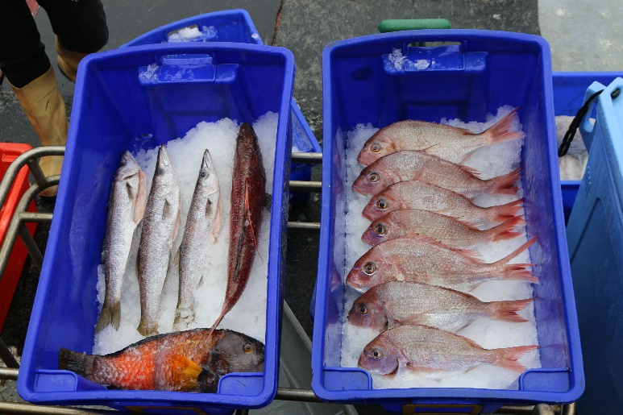
Thanks to the Victorian Fisheries exciting new Wild Harvest Seafood Trial, small sales permits holders now have the opportunity to take popular fish species such as snapper, whiting, calamari and gummy shark straight from the sea to sell from their vessel – giving locals and tourists at the dock a chance to experience just how fantastic Victorian freshly caught seafood is.

What Licences Do I Need to Sell Fresh Fish from My Vessel to the Public?

Getting licensed to sell your Small Sales catch is easy – simply click here to apply online or download the application form for the PrimeSafe Retailer (Vehicle) Licence.

What Are the Benefits of Obtaining a PrimeSafe Retailer (Vehicle) Licence?

You get a better return on the investments you make towards your business by being able to cut out the wholesaler and sell filleted fish taken under your Small Sales Permit direct to the customer! Both tourists and locals are happy to pay a premium price when they know the catch are fresh and that the money they spend will go straight into your pocket and support the local economy. As a bonus, it also authorises you to sell your Small Sales Catch to local restaurants and retailers.

How Much Does a PrimeSafe Retailer (Vehicle) Licence Cost?

For this licence you’ll need to pay a one-off application fee of $335 and a $670 annual payment fee, as well as the costs for contracting a third party auditor. A list of PrimeSafe approved accredited auditors can be found here.

How Long is the PrimeSafe Application Process for a Licence?

Application should be received 10 business days prior to the date you wish to commence operations.

What if I Only Want to Sell My Small Sales Permit Catch to Local Restaurants and Retailers?

If you do not want to be able to sell to the public, you will need to obtain a PrimeSafe Wildcatch licence which can be applied for here. This licence has a $145 application fee and a $290 annual payment fee.

Where Can I Find More Information, including Food Safety Programs?

For more information about obtaining PrimeSafe licences and food safety requirements, feel free to give the friendly PrimeSafe team a call on 03 9685 7333 or flick them an email at info@primesafe.vic.gov.au. You can also check out their website here and their Frequently Asked Questions Page here.

