Victorian commercial ocean wrasse fishery harvest strategy performance update: 2017/18

summary

- For 2017/18 the primary performance indicator was above the trigger reference point for all assessment zones suggesting that the current harvest from the available biomass is sustainable.
- The total wrasse catch by ocean wrasse fishery licences in 2017/18 equated to an 80% increase from 2016/17 as new licence owners became active in the fishery after license transferability. The increase in catch was attributed entirely to the Central and West assessment zones, with a catch reduction occurring in the East zone.
- Similar to catch, effort increased considerably in the Central and West assessment zones from 2016/17 to 2017/18, but not in the East zone.
- The rapid increases in catch and effort from 2016/17 to 2017/18 as new operators became active following licence transferability is not surprising but will be discussed with industry under the harvest strategy framework.
- The percentage of wrasse catch by pots was at the 10% level in 2017/18.

Background

This document summarises the performance of the Victorian ocean wrasse (OW) fishery in relation to the “Harvest Strategy for the Victorian Wrasse (Ocean) Fishery” that was established in early 2017 and is available at: https://vfa.vic.gov.au/commercial-fishing/wrasse. This annual harvest strategy review considers the key performance indicators of catch per unit effort (CPUE) and commercial wrasse harvest and effort up to and including the 2017/18 fiscal year. The percentage of total harvest that is taken by hook and line is also monitored due to the intent that this fishery remains a hook and line method dominated fishery.
While the OW license holders can operate throughout the State’s coastal waters, the harvest strategy reviews data at a finer zonal scale that relates to the spatially clustered nature of the wrasse fishery around ports and access points. The West, Central and East assessment zones applied in the harvest strategy reporting are indicated in Figure 1.

CPUE (kg/hr) as a Primary Performance Indicator
CPUE for hook and line method, measured as kg/hr of reported fishing time, is used as a proxy performance measure for available biomass. CPUE is expected to fluctuate in relation to the availability of legal sized wrasse. However, CPUE can also vary for reasons unrelated to available biomass; such as fisher skill, season/month and location of fishing etc. To reduce the influence of these factors on the CPUE biomass signal, the nominal or “raw” CPUE data are standardised using statistical procedures to reduce the effects of factors that may influence the CPUE but are not related to the available biomass. Prior to the data from catch and effort records being used to estimate CPUE, they are carefully reviewed, and any records considered erroneous and implausible are removed. The 3-year average standardised CPUE is used as the key performance indicator for the harvest strategy.

Percentage changes in catch and effort
Abrupt changes in catch and/or effort are also flagged by the harvest strategy, whereby a 50% change in effort and/or catch from one year to the next would require discussion and review with industry as the first management response.

Harvest strategy reference benchmarks
The 2017 harvest strategy has specified benchmarks (reference points) for CPUE that are designed to indicate acceptable, declining and poor biomass. These benchmarks are based on a reference period from 2004/05 – 2014/15. During this period catches were relatively stable compared with the overall catch history. Given the apparent stability of the recent catches, the focus of the harvest strategy is to provide management advice to safeguard the existing biomass from unsustainable depletion rather than to rebuild it.
The harvest strategy benchmarks for the 3-year averaged standardised CPUE are:
- Target reference point: Average of standardised CPUE for the reference period (biomass is at target level)
- Trigger reference point: 0.75 x average of standardised CPUE for the reference period (below which biomass is considered declining)
- Limit reference point: 0.50 x average of standardised CPUE for the reference period (below which biomass is considered poor)
In the context of the harvest strategy, when the 3-year averaged standardised CPUE remains above the trigger reference point, management action to protect biomass is unlikely to be required. However, there are currently no management decision or control rules attached to the CPUE reference points. These require further development in consultation with the industry. Currently, if the 3-year averaged standardised CPUE dropped below the trigger reference point, this would initiate a formal review with industry to obtain a better understanding of the situation and the need for management changes. Because the fishery is transitioning to the new license arrangements and operators, it is recognised that the initial harvest strategy may be adaptive when warranted, and may evolve as the fishery settles, and more data and potential indicators of stock/fishery performance become available.
Additional reporting fields were introduced to the catch and effort reporting forms from 2017, including; numbers of lines and hooks used, and discards. Over time, this new data will increase and improve the information available to assess performance of the fishery. The industry should be commended for improving the reporting of wrasse species. Over the last 5 years the catch of unspecified wrasse has reduced from 47% to 7% of the total reported catch.
In relation to the percentage of catch taken by hook and line, the harvest strategy document indicates that if it drops below 90% (i.e. > 10% of the catch is by pots) management may need to consider approaches to prevent further increases in the catch proportion by lobster pots.

Summary of fishery data

Catch
In 2017/18, 37 tonnes of wrasse were reported as harvested by commercial fishers in Victoria, with 33.5 tonnes taken by OW licences (Figure 2). Eighty seven percent of the catch was reported as bluethroat wrasse (Figure 2). The 2017/18 State-wide wrasse harvest represented an approximate 80% increase on the previous year’s catch (Figure 3). At the assessment zone level, it was clear that most of the increase was due to increases in the Central (80%) and West (148%) zones, with reduced catches from the East (-28%) (Figure 3). Therefore the 50% interannual catch change trigger under the harvest strategy was exceeded for the Central and West zones, and under the harvest strategy will require discussion with industry. However, the increase is not surprising given it occurred during the period of implementing licence transferability, and new fishers had not become fully operational in 2016/17.
Sixty seven percent of the wrasse harvest in 2017/18 was from the Central assessment zone, consistent with the pattern over the last 5 years (Figure 4). Of the 22 OW licences, 16 licences reported catches in 2017/18.
The percentage of harvest taken by the hook and line method was at the 90% point in 2017/18, consistent with the intent for the pot catch not to exceed 10% per year (Figure 5).

Effort
At the State-wide level there was an approximate 50% and 60% increase in effort by hours and days respectively (Figure 6). At the assessment zone level, similar to the catch increase, it was clear that the overall effort increase from 2016/17 to 2017/18 was due to the West (159% hours, 113% days) and Central (39% hours, 27% days) zones, with negligible change in the East zone (Figure 6). The 50% interannual effort change trigger was therefore exceeded for the West zone and will require discussion with industry. Again, the abrupt increase in effort appeared due to activation of new fishers after the license changes.

CPUE
For the Central assessment zone, the primary CPUE indicator (3 year averaged standardised CPUE) was close to the target reference point for 2017/18, and the annual nominal and standardised CPUE are showing no sustained depleting trends. The CPUE data for the Central zone suggests that the available biomass is stable and at an acceptable level (Figure 7).
For the Eastern assessment zone, the primary CPUE indicator was between the target reference point and the trigger reference point in 2017/18. The annual nominal and standardised CPUE have stabilised since 2010. Given the recent low catches and effort from the Eastern assessment zone, the CPUE indicators may lack reliability. The low catches and recent stable CPUE data together suggest that the biomass is not currently at risk of depletion and is at an acceptable level (Figure 8).
For the Western assessment zone, the primary CPUE indicator was between the target reference point and the trigger reference point in 2017/18. The annual nominal and standardised CPUE show recent slight downward trends, which if continued would see the primary CPUE indicator reach the trigger reference point in the next few years. Overall, the data suggest the biomass is currently at an acceptable level (Figure 9).

Figures
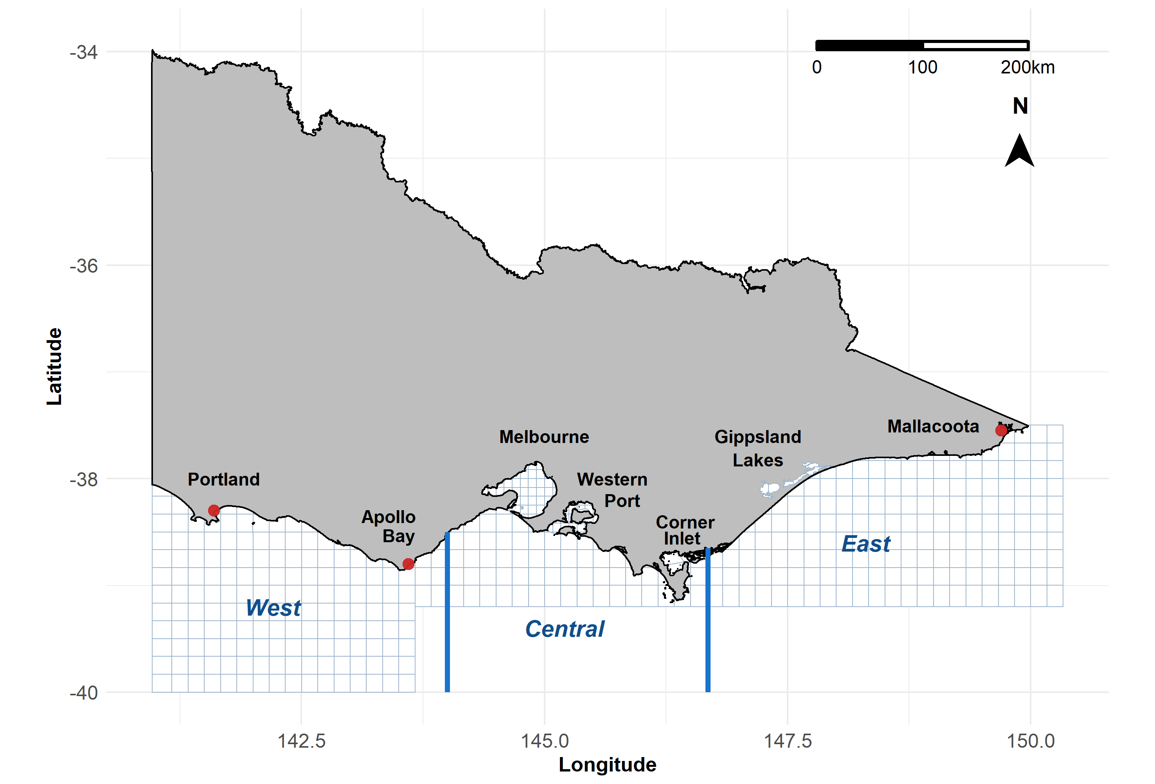
Figure 1. Map showing assessment zones and catch reporting grid cells for the Victorian ocean wrasse fishery.
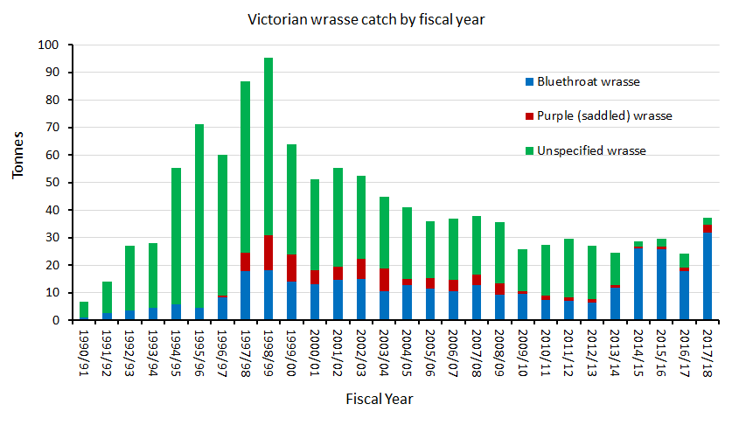Figure 2. Total commercial catches of wrasse in Victoria from 1990/91 – 2017/18.

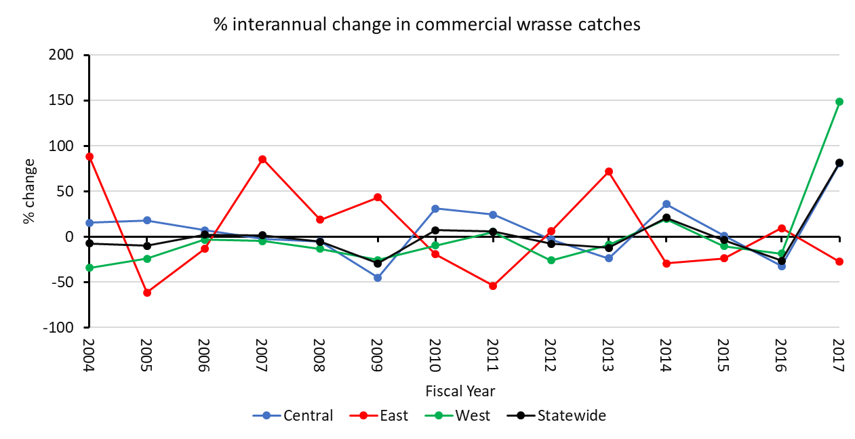

Figure 3. Percentage interannual changes in commercial catches of wrasse in Victoria by fiscal year from 2004/05 – 2017/18. Data represent difference in catch from the most recent to the previous year as a percentage of the previous year.

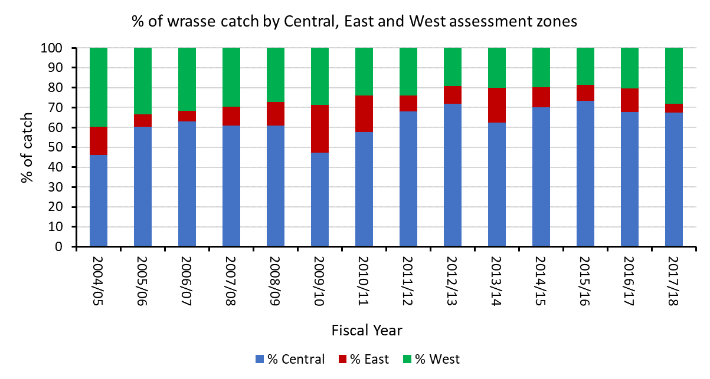
Figure 4. Percentage of total wrasse catches (excluding those taken by the rock lobster fishery) from each of the three assessment zones from 2004/05-2017/18.

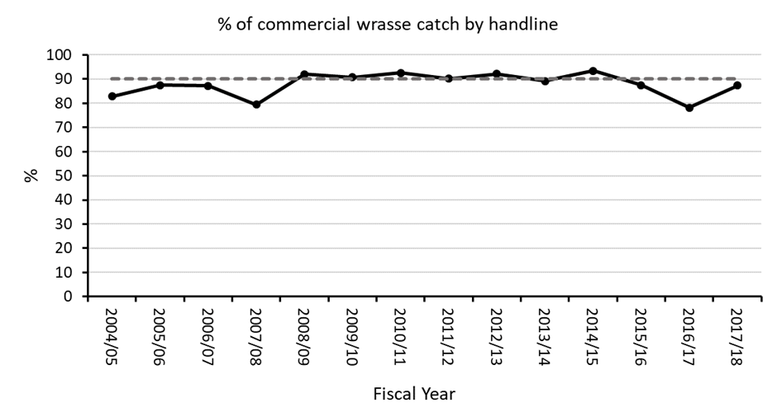
Figure 5. Percentage of the total wrasse harvest (all methods) taken by hook and line from 2004/05-2017/18.
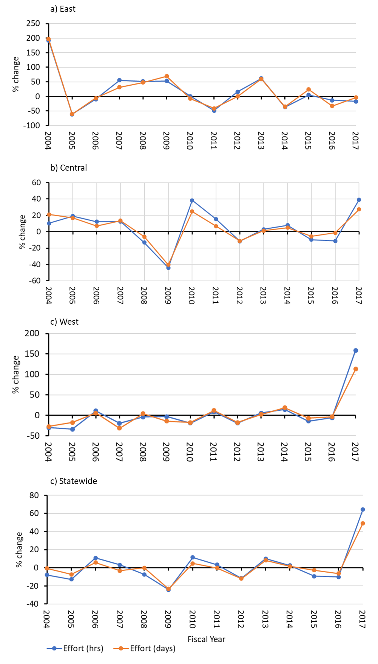

Figure 6. Percentage interannual changes in commercial OW effort fiscal year from 2004/05 – 2017/18. Data represent difference in effort from the most recent to the previous year as a percentage of the previous year.
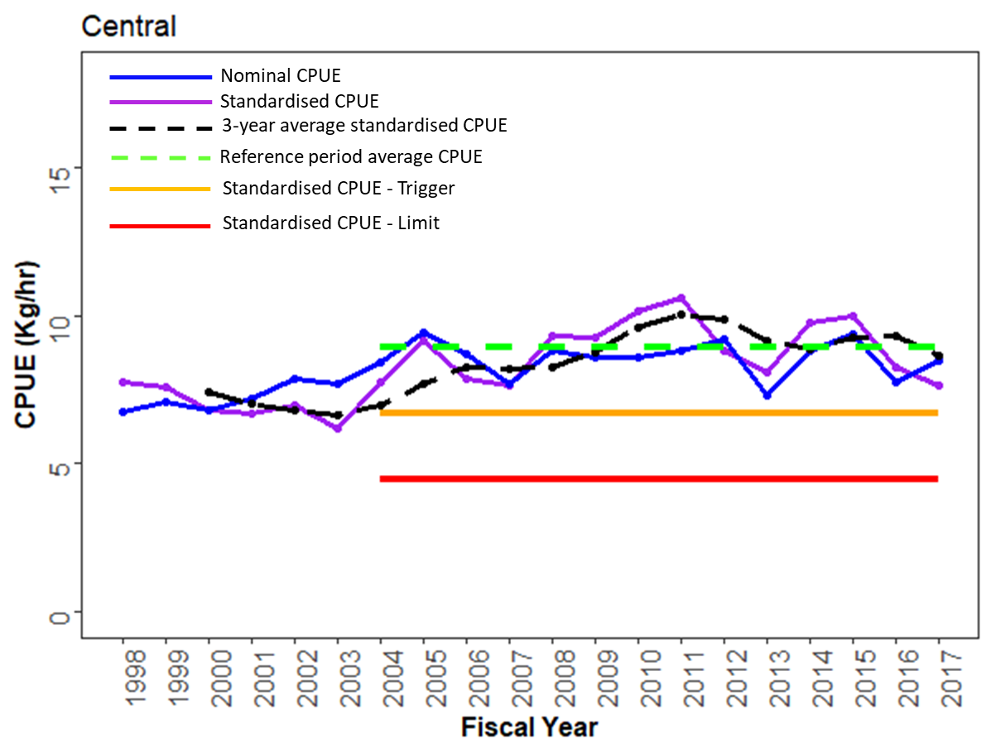
Figure 7. CPUE for wrasse by hook and line for the Central assessment zone by fiscal year (i.e. 2017 =2017/18).
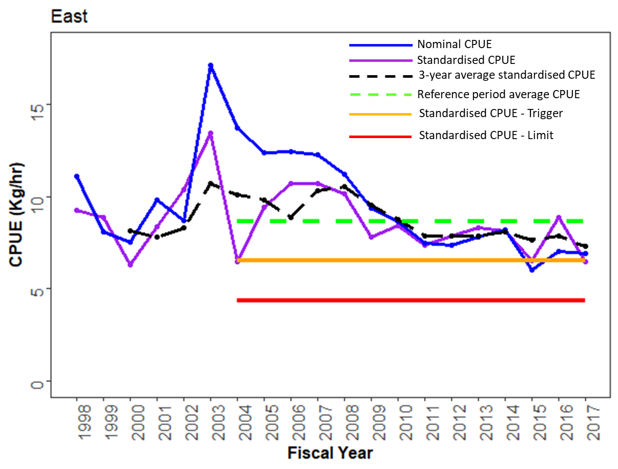
Figure 8. CPUE for wrasse by hook and line for the East assessment zone by fiscal year (i.e. 2017 = 2017/18).
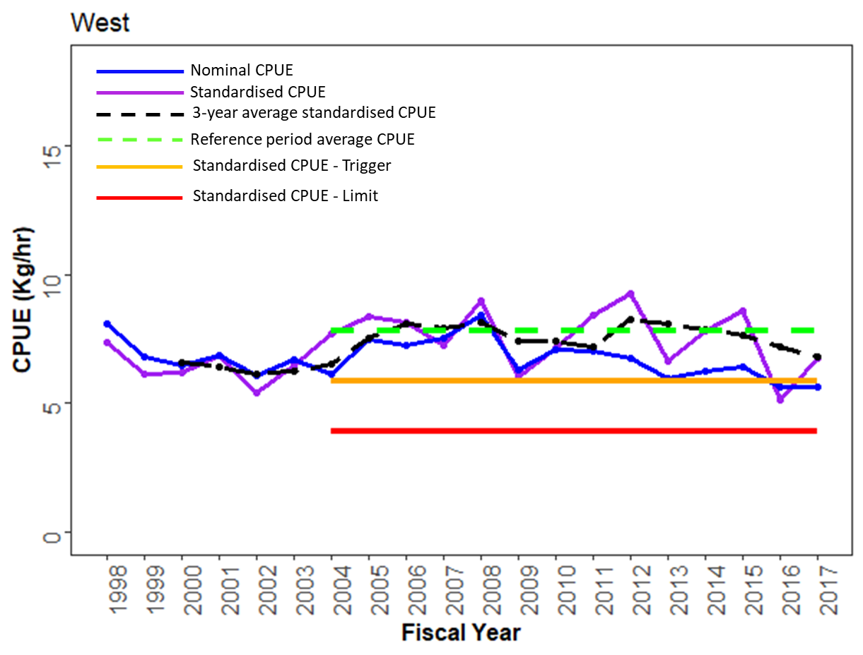
Figure 9. CPUE for wrasse by hook and line for the West assessment zone by fiscal year (i.e. 2017 = 2017/18).

