**Recreational Fishing Licence**

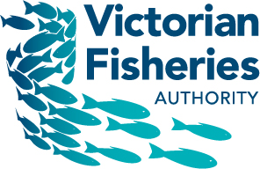

**Trust Account 2016/17**

A report to each House of Parliament on the disbursement of Recreational Fishing Licence Revenue

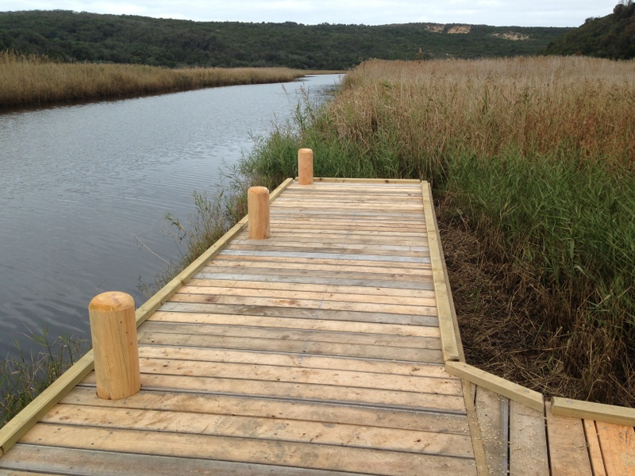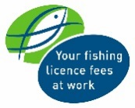

|  |
| --- |
| © The State of Victoria, Victorian Fisheries Authority  This work is licensed under a Creative Commons Attribution 3.0 Australia licence. You are free to re-use the work under that licence, on the condition that you credit the State of Victoria as author. The licence does not apply to any images, photographs or branding, including the Victorian Coat of Arms, the Victorian Government logo and the Victorian Fisheries Authority logo. To view a copy of this licence, visit <http://creativecommons.org/licenses/by/3.0/au/deed.en>  **Accessibility** If you would like to receive this publication in an alternative format, please telephone the Customer Service Centre 136 186, email rec.fishinggrants@vfa.vic.gov.au, via the National Relay Service on 133 677 www.relayservice.com.au. This document is also available on the internet at [www.vfa.vic.gov.au](http://www.vfa.vic.gov.au)  **Disclaimer** This publication may be of assistance to you but the State of Victoria and its employees do not guarantee that the publication is without flaw of any kind or is wholly appropriate for your particular purposes and therefore disclaims all liability for any error, loss or other consequence which may arise from you relying on any information in this publication. |

Cover image: Fishing platform on the Aire River funded through the RFL Large Grants Program.

Contents

Foreword 2

*Fisheries Act 1995* 3

Enforcement & Education 4

Financial Report 6

Notes to the Financial Report 8

Note 1 - Statement of Accounting Policies 8

Note 2 - Payments to Recreational Fishing Grants Program and other projects during 2016/17 9

[Note 3 - Proposal to fund 2016/17's approved Recreational Fishing Grant Program projects,   
and other items in 2017/18 and beyond as applicable 13](#_Toc362532354)

Note 4 - Cash assets 23

Statutory Certification 24

Independent Audit Report from Auditor-General 25

Foreword

A report to each House of Parliament on the disbursement of Recreational Fishing Licence Revenue from the Recreational Fishing Licence Trust Account, 2016/17

Revenue from the sale of recreational fishing licences is annually disbursed from the Recreational Fishing Licence (RFL) Trust Account by the Victorian Government, to projects that improve recreational fishing.

As the Minister for Agriculture, I recognise the significant contribution that recreational fishing continues to make to the State’s economy and the social wellbeing it brings to those who participate in this activity.

Over the last 12 months the Recreational Fishing Grants Working Group has continued to provide me with valuable advice on how RFL funds should be disbursed through the Recreational Fishing Grants Program.

In June 2017, I announced that $702,000 will be allocated to 13 new projects through the 2016/17 round of the Large Grants Program. These projects include increasing fish habitat in the Goulburn, Buckland and Little Murray Rivers, installing fish cleaning tables at Point Richards and Indented Head, a state-wide recreational tagging program to investigate mulloway movements, and research to assess the post-release survival of swordfish from recreational fishing.

A further $349,800 was allocated via the Commissioning Grants Program; $219,800 for the production of a range of popular education and communication products that assist recreational anglers to understand and comply with fishing regulations, and $130,000 for the monitoring of key marine and estuarine fisheries.

The Small Grants Program has again been very popular with over $108,000 being provided for 41 projects during 2016/17. This program has now funded over 300 projects worth more than $800,000 since its inception in 2010.

I am also very pleased to advise that during 2016/17 an additional $2,300,000 was allocated towards the implementation of the Target One Million plan, which included the marine species stocking program, the Better Fishing Facilities Fund, Stronger Fishing Clubs Grants Program, expanding the Angler Diary Program and developing new recreational fisheries for trout cod.

During 2016/17, Recreational Fishing Licence Trust Account funds were again committed or disbursed to fund:

* Increased fish stocking into lakes and rivers;
* The deployment of thirteen Fisheries Officers to boost enforcement and education;
* VRFish, to provide advice to the Victorian Government about the broad range of recreational fishers’ views on the management of the State’s fisheries resources;
* The Victorian Fishcare program, which delivers responsible fishing education and events to the community;
* Projects approved through previous rounds of the Recreational Fishing Grants Program for access and facilities, education, information and training, recreational fisheries research and fish habitat improvement.
* Recreational Fishing Licence commissions paid to sellers; and
* The costs incurred in the administration of the Recreational Fishing Licence, Grants Program and the Recreational Fishing Grants Working Group.

Fishing licence revenue and the Target One Million plan are delivering unprecedented investment into recreational fishing to grow participation and help regional businesses that rely on tourism. Better facilities, more fish stocking, more enforcement and more education are the foundations for sustainable fishing long term and I look forward to seeing the next generation of anglers enjoying the benefits.

I have pleasure in providing to each House of Parliament this report on the receipts and disbursements from the Recreational Fishing Licence Trust Account for 2016/17.

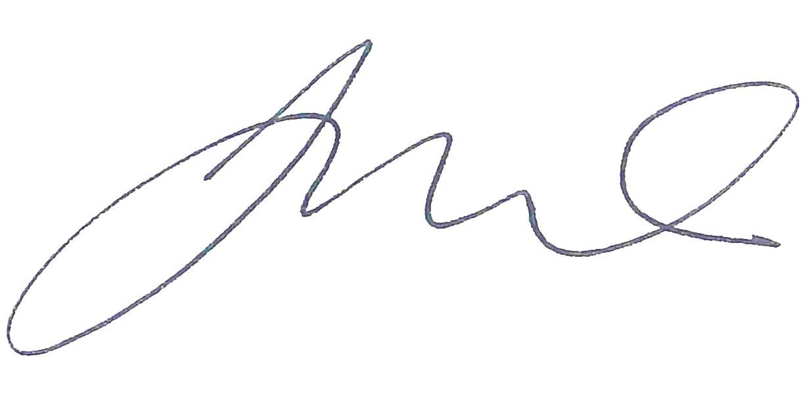

Hon Jaala Pulford MP  
Minister for Agriculture

16 October 2017*Fisheries Act 1995*

Pursuant to Section 151B(4) of the *Fisheries Act 1995*, the Minister (responsible for Victoria’s fisheries) must cause a report on how amounts paid into the Recreational Fishing Licence (RFL) Trust Account were disbursed –

(a) to be prepared by 1 October each year; and

(b) to be laid before each House of Parliament on or before the seventh sitting day of that House after the report has been prepared.

For the information of Honourable Members, the RFL Trust Account came into effect on 1 April 2001.

The 2016/17 financial year is the sixteenth full year of the RFL Trust Account’s operation.

The Victorian Auditor-General has audited the receipts received, and disbursements made from the RFL Trust Account in 2016/17.

Enforcement & Education

In 2016/17, Recreational Fishing Licence (RFL) Trust Account receipts contributed $2,260,726.87 to Fisheries Victoria’s compliance budget.

RFL Trust Account receipts, when added to ongoing recurrent funding of fisheries compliance (education and enforcement) activities, contributes substantially to the delivery of recreational fisheries compliance services in Victorian coastal and inland locations.

Fisheries Officers have continued to have good contact with recreational fishers in the field during the last year. Table 1 summarises yearly totals for contacts in the recreational fishing sector. The work is divided into categories based on species, locations or other activities. Over 51,800 total contacts were made with recreational fishers by Fisheries Officers during the reporting period. Compliance contacts with Fisheries Officers totalled over 46,000, with Table 1 showing the number of offenders, verbal warnings, official warnings, infringement notices, and briefs of evidence for the year.

In addition, Fisheries Officers attended 24 angling club meetings, conducted5,132 advisory contacts with recreational fishers, made 88 contacts during fish stocking events and 183 contacts during recreational fishing related shows, forums and clinics.

Table 1.

|  |  |  |  |  |  |  |
| --- | --- | --- | --- | --- | --- | --- |
| **Recreational** | **Officer contacts with recreational fishers** | **Number of offenders** | **Verbal warnings issued** | **Official warnings issued** | **Infringement notices issued** | **Briefs of evidence compiled** |
| Abalone (intertidal zone) | 428 | 274 | 168 | 95 | 152 | 5 |
| Abalone (on land) | 1174 | 240 | 66 | 163 | 146 | 9 |
| Abalone (on water) | 97 | 20 | 5 | 9 | 15 | 0 |
| Bass yabbies | 54 | 2 | 0 | 1 | 1 | 0 |
| Bay & Inlet - other (on land) | 5138 | 392 | 155 | 143 | 110 | 3 |
| Bay & Inlet - other (on water) | 1894 | 137 | 72 | 42 | 34 | 0 |
| Bay & Inlet - Port Phillip (on land) | 10203 | 783 | 308 | 292 | 191 | 15 |
| Bay & Inlet - Port Phillip (on water) | 1850 | 143 | 47 | 61 | 48 | 2 |
| Bay & Inlet - Western Port (on land) | 3469 | 236 | 97 | 86 | 54 | 0 |
| Bay & Inlet - Western Port (on water) | 551 | 29 | 3 | 9 | 14 | 0 |
| Freshwater (on land) | 8113 | 641 | 223 | 257 | 209 | 5 |
| Freshwater (on water) | 3164 | 268 | 151 | 63 | 68 | 0 |
| Intertidal other | 157 | 81 | 42 | 21 | 24 | 0 |
| Intertidal pipis | 1248 | 126 | 64 | 37 | 47 | 0 |
| Intertidal Port Phillip | 608 | 247 | 162 | 94 | 78 | 0 |
| Intertidal red shore crab | 148 | 29 | 4 | 13 | 18 | 0 |
| Marine Safety (on land) | 39 | 39 | 28 | 4 | 17 | 0 |
| Marine Safety (on water) | 106 | 106 | 98 | 3 | 19 | 1 |
| Murray cod | 2142 | 107 | 36 | 40 | 39 | 1 |
| Ocean (on land) | 3819 | 315 | 133 | 138 | 73 | 2 |
| Ocean (on water) | 656 | 30 | 9 | 14 | 9 | 0 |
| Rock lobster (on land) | 407 | 32 | 11 | 12 | 10 | 1 |
| Rock lobster (on water) | 130 | 10 | 8 | 1 | 3 | 0 |
| Scallops (on land) | 5 | 1 | 0 | 0 | 1 | 0 |
| Scallops (on water) | 0 | 0 | 0 | 0 | 0 | 0 |
| Spiny Cray | 799 | 76 | 29 | 35 | 17 | 0 |
| **Totals** | **46,399** | **4,364** | **1,919** | **1,633** | **1,397** | **44** |

All Fisheries Officers provide services to the recreational fishing sector and interact with recreational fishers through:

* contact with recreational fishers in the field;
* attending angling club meetings;
* attending recreational fishing-related shows, family fishing events, forums and clinics;
* attending fish stocking/liberation events;
* liaising with grant recipients regarding the successful completion of infrastructure projects under the annual Recreational Fishing Grants Program (Large Grants);
* advising fisheries management on issues relating to recreational fishing;
* assisting Fisheries Management and Science Branch on matters relating to recreational fishing;
* responding to recreational fishing issues raised from the 13FISH Offence Reporting Line;
* producing recreational fishing-related media releases/distributing booklets and pamphlets;
* investigating recreational fishing-related offences and prosecuting where necessary;
* collecting intelligence related to recreational fishing offences;
* participating in recreational fishing-related educational activities with school groups and the broader recreational fishing community; and
* engaging with culturally and linguistically diverse communities.

Fisheries Victoria in conjunction with the recreational fishing community strives to achieve high levels of voluntary compliance amongst recreational fishers. By working collaboratively and by continuing to promote responsible and ethical fishing, we are better positioned to ensure both fish for now and fish for the future.

Financial Report

Report concerning how amounts paid into the Recreational Fishing Licence Trust Account were disbursed in 2016/17 financial year

|  |  |  |
| --- | --- | --- |
| **Receipts 2016/17** | **$** |  |
| **Total receipts from RFL sales**  271,395 RFL's sold (as at 26 July 2017) including: 34,293 three-year licences, 118,661 one-year licences, 15,745 28-day licences, 101,604 three-day licences and 1,092 48-hour licences. | $8,556,139.78 |  |
| **Interest - investments** | $37,328.77 | *Fisheries Act 1995*, S. 151B(5) enables money standing to the credit of the Account to be invested in any manner in which funds may be invested under the *Trustee Act* *1958*. |
| **Refunds: RFGP projects** | $204,268.20 | Project 14/15/16 Association of Geelong & District Angling Clubs. Gellibrand/Latrobe Creek Junction fishing platform. $21,208.00  Project SG410 Sunbury Angling Club. Junior Day. $1,197.00  Project 13/14/55 Harrietville Community Forum. Upper Ovens River instream habitat restoration. $246.10  Project 13/14/06 Fisheries Victoria Marine and estuarine finfish recreational fisheries monitoring and assessment. $31,721.00  Project 14/15/23 VRFish. Future Young Leaders Forum 2015. $11,819.85  Project SG68 Wimmera Catchment Management Authority. Daniel carp trap trials. $1,873.97  Fisheries Victoria. Licence Reform Project. $136,202.28 |
| **GST Recoverable** | $1,369.39 |  |
| **Total receipts for the year** | $8,799,106.14 |  |

|  |  |  |  |  |
| --- | --- | --- | --- | --- |
| **Disbursements 2016/17** | **$** | |  | |
| **Recreational Fishing Grants Program and other projects** | $1,870,247.83 | | Payments to 84 projects - see Note 2. | |
| **Target One Million Implementation** | $2,300,000.00 | |  | |
| **Fisheries Enforcement & Education Branch** | $2,260,726.87 | |  | |
| **Fish Stocking**  The purchase and liberation of native and salmonid fish to stock into Victorian rivers. | $901,923.09 | |  | |
| **VRFish** | $447,604.00 | |  | |
| **Fishcare Victoria Inc.** | $213,681.83 | |  | |
| **Community Information**  Recreational Fishing Grants Program/Recreational Fishing Licence disbursement reporting related advertising & publicity. | $30,977.07 | |  | |
| **Recreational Fishing Licence (RFL) 6% sales commissions**  Applicable to sales commissions incurred during 2015/16, paid in 2016/17 financial year. | $156,379.27 | |  | |
| **Costs and expenses incurred in the administration of RFLs** |  | |  | |
| Salaries and on-costs. | $324,117.53 | |  | |
| Business, corporate & other levies (common domain access levy, OH&S levy, training & development levy, centre leader levy, CBD accommodation and workstation charge, computer internal lease costs). | $190,465.24 | |  | |
| Professional and contract services. | $325,598.29 | |  | |
| Agency labour hire. | $100,708.96 | |  | |
| Postal expenses, parking, vehicle hire, accommodation, printing, stationery, telephones, banking charges, office equipment, software maintenance, external learning and  IT assistance. | $64,915.66 | |  | |
| **Recreational Fishing Grants Working Group**  Sitting fees, sustenance, accommodation, vehicle hire, venue hire, and personal expenses. | $2,789.36 | |  | |
| **Total disbursements for the year** | $9,190,135.00 | |  | |
| **Net cash inflow/(outflow)** | ($391,028.86) | |  | |
| **Cash as at 1 July 2016** | $4,368,440.51 | |  | |
| **Cash as at 30 June 2017** | $3,977,411.65 | | Provision to fund previously approved Recreational Fishing Grant Program projects extending into 2017/18 and beyond as applicable and other items totalling $1,864,175.99- see Note 3.  Cash balance includes $2,500,000 which has been invested – see Note 4. | |
| Amounts are net of applicable GST | |  | |  |

Notes to the Financial Report

These notes form part of and should be read in conjunction with the financial report of the Recreational Fishing Licence Trust Account.

Note 1 - Statement of Accounting Policies

*Basis of preparation.*

This special purpose financial report has been prepared in accordance with the provisions of the *Fisheries Act 1995*.

The report has been prepared on a cash basis to report on how levies and application fees received in respect of recreational fishing licences have been disbursed from the trust account.

Note 2 - Payments to Recreational Fishing Grants Program and other projects during 2016/17

|  |  |  |
| --- | --- | --- |
| **Projects initially announced in 2010/11** |  |  |
| **Large Grants Program** |  |  |
| ‘Fishers tracking fish’ - recreational fishers ’tuning’ in to understand why Port Phillip Bay is so important to snapper. Balance of funding. Total project funding of $221,386. | $58,138.60 | DEDJTR, Fisheries Victoria |
| **Sub-Total** | **$58,138.60** |  |
| **Projects initially announced in 2011/12** |  |  |
| **Large Grants Program** |  |  |
| Rock Fishing Safety Campaign: Don't Put Your Life on the Line; a State-wide media campaign. Balance of 10% of funding. Total project funding of $300,000. | $30,000.00 | Life Saving Victoria |
| **Sub-Total** | **$30,000.00** |  |
| **Projects initially announced in 2012/13** |  |  |
| **Large Grants Program** |  |  |
| Develop and implement a consistent method for assessing the sustainability of Murray cod in the Murray Darling Basin. 90% instalment of year three funding. Total project funding of $150,000. | $45,000.00 | Greenfish Consulting Pty Ltd |
| Victorian ‘Fishers for Fish Habitat’ Program. Balance of 10% funding. Total project funding of $114,000. | $11,400.00 | DELWP, Arthur Rylah Institute |
| Fishcare ‘Fish Right’ workshops – conduct 450 junior recreational fisher workshops across Victoria. Balance of funding. Total project funding of $113,500. | $7,319.09 | Fishcare Victoria Inc. |
| **Sub-Total** | **$63,719.09** |  |
| **Projects initially announced in 2013/14** |  |  |
| **Commissioning Grants Program** |  |  |
| Better Recreational Fishing Through Informed Fish Stocking (stocking an additional 1,110,000 fish over 3 years, fish surveys, development of an on-line fish stocking search engine, and captive breeding of Macquarie perch). 90% instalment of year three funding. Total project funding of $990,600.00 over three years. | $300,420.00 | DEDJTR, Fisheries Victoria |
| Wild Trout Fisheries Management Program (investigate the likely cause(s) of the decline in wild trout fishing in Victoria and, where possible, improve wild trout fishing through informed fisheries management interventions). 90% instalment of year three funding. Total project funding of $560,000.00 over three years. | $117,000.00 | DEDJTR, Fisheries Victoria |
| **Sub-Total** | **$417,420.00** |  |
| **Large Grants Program** |  |  |
| Mitta Mitta River Habitat Rehabilitation Project- Eskdale to high water mark of Lake Hume. 90% instalment of year three funding. Total project funding of $266,981.82 over three years. | $81,114.55 | North East Catchment Management Authority |
| Improving Recreational Fishing Access at Konongwootong Reservoir. 90% instalment of year three funding. Total project funding of $231,818.18 over three years. | $53,181.82 | Wannon Water Corporation |
| Install a further 90 ‘Seal the loop' fishing line disposal bins around Victoria. 90% instalment of year three funding. Total project funding of $60,000.00 over three years. | $18,000.00 | Zoological Parks And Gardens Board |
| Evaluating the status of the Murray crayfish recreational fishery in Victoria'. The project will focus on waterways of northern Victoria where Murray crayfish are known to occur, including the Mitta Mitta, Kiewa, Ovens and Goulburn rivers. 90% instalment of year three funding and 10% balance. Total project funding of $65,818.18 over three years. | $10,018.18 | Nature Glenelg Trust |
| Native Fish Habitat Enhancement in the Lower Broken Creek between Numurkah and Nathalia. Balance of 10% of funding. Total project funding of $68,727.27 over two years. | $6,872.72 | Goulburn Broken Catchment Management Authority |
| Improving access to and evaluating the effectiveness of a Merri River Estuary Fish Habitat Hotspot. 90% instalment of year three funding. Total project funding of $80,181.82 over three years. | $4,090.91 | Glenelg Hopkins Catchment Management Authority |
| Construct an all abilities fishing platform and increase fish habitat in the Tarwin River estuary/Andersons Inlet at Tarwin Lower. Balance of 10% of funding. Total project funding of $34,150.00 over two years. | $3,415.00 | West Gippsland Catchment Management Authority |
| Install a solar light above the Clifton Springs boat ramp. Balance of 10% of funding. Total project funding of $11,677. | $1,167.70 | Association of Geelong & District Angling Clubs Inc. |
| **Sub-Total** | **$177,860.88** |  |
| **Projects initially announced in 2014/15** |  |  |
| **Commissioning Grants Program** |  |  |
| 2015/16 Communication and Compliance Products (production of a series of communication products and measuring devices to provide recreational fishers with up-to-date information on Fisheries regulations). Balance of 10% of funding. Total project funding of $171,347.19. | $17,134.72 | DEDJTR Fisheries Victoria |
| **Sub-Total** | **$17,134.72** |  |
| **Large Grants Program** |  |  |
| Increasing knowledge of Victoria’s growing recreational yellowtail kingfish fishery. 90% instalment of year two funding. Total project funding of $147,907.50. | $44,820.00 | DEDJTR Fisheries Victoria |
| Implementing better practice Murray cod fishery management. 90% instalment of year two funding. Total project funding of $99,935. | $29,916.00 | DEDJTR Fisheries Victoria |
| Assessing the sustainability of Venus Bay’s recreational and commercial pipi harvest. 90% instalment of year two funding. Total project funding of $71,565. | $23,375.70 | University of Melbourne |
| Cool Tools to Learn the Rules. 90% instalment of year two funding. Total project funding of $50,000. | $15,300.00 | DEDJTR Fisheries Victoria |
| Understanding the stock structures, biology and population status of mulloway in Victoria. 90% instalment of year two funding. Total project funding of $78,545.45. | $13,614.55 | Nature Glenelg Trust |
| River Blackfish Translocation Pilot Study. 90% instalment of year two funding and balance of funding. Total project funding of $60,150.91. | $9,206.00 | West Gippsland Catchment Management Authority |
| Horsham - Angling for Abilities Project. Balance of 10% of funding. Total project funding of $72,109.09. | $7,210.91 | Horsham Rural City Council |
| Lake Tyers Beach Accessible Fishing Landing (northern end of Lakeside Drive). Balance of 10% of funding. Total project funding of $65,218.18. | $6,521.82 | East Gippsland Shire Council |
| Recreational Fishing Pontoon, Wimmera River, Dimboola Recreation Reserve. Balance of 10% of funding. Total project funding of $47,828.18. | $4,782.82 | Hindmarsh Shire Council |
| Recreational Fishing Pontoon, Wimmera River, Jeparit. Balance of 10% of funding. Total project funding of $42,609.09. | $4,260.91 | Hindmarsh Shire Council |
| **Sub-Total** | **$159,008.71** |  |
| **Projects initially announced in 2015/16** |  |  |
| **Commissioning Grants Program** |  |  |
| 2016/17 Communication and Compliance Products (production of a series of communication products and measuring devices to provide recreational fishers with up-to-date information on Fisheries regulations). Total project funding of $192,674.43. | $173,406.99 | DEDJTR Fisheries Victoria |
| **Sub-Total** | **$173,406.99** |  |
| **Large Grants Program** |  |  |
| Install large woody structure into the estuarine reaches of the Mitchell River flowing in to the Gippsland Lakes. 90% instalment of year one funding plus 10% balance of funding. Total project funding of $90,909.09. | $90,909.09 | East Gippsland Catchment Management Authority |
| Rebuild 400 square metre patches of shellfish dominated natural reefs in Port Phillip Bay and monitor the benefits of these reefs to recreational fishers. 90% instalment of year one funding. Total project funding of $133,636.36. | $90,000.00 | Albert Park Yachting & Angling Club |
| Three fishing platforms for the area on Sawtells Inlet upstream from the bridge and flood gates. 90% instalment of year one funding. Total project funding of $82,272.73. | $74,045.45 | Tooradin Foreshore Committee of Management |
| Construction of Boat Ramp and fishing platform on the Surry river at Narrawong. 90% instalment of year one funding. Total project funding of $63,636.36. | $57,272.73 | Department of Environment, Land, Water & Planning |
| Construction of a fishing jetty on the Yarriambiack Creek Weir pool in the township of Warracknabeal. 90% instalment of year one funding. Total project funding of $63,000. | $56,700.00 | Warracknabeal Angling Club |
| Marine and estuarine finfish recreational fisheries monitoring program 2016/17. 90% instalment of year one funding. Total project funding of $62,000. | $55,800.00 | DEDJTR Fisheries Victoria |
| Continuation of State-wide Angler Diary Program in 2016/17. 90% instalment of year one funding. Total project funding of $54,000. | $48,600.00 | DEDJTR Fisheries Victoria |
| Creating Sustainable Anglers Program (600 school based workshops and 150 community events). 90% instalment of year one funding. Total project funding of $109,090.91. | $32,727.27 | Fishcare Victoria |
| Partnering with recreational fishers in a tagging program to understand the movements of Victorian King George whiting to their spawning areas. 90% instalment of year one funding. Total project funding of $69,944.55. | $29,737.64 | University of Melbourne |
| Create marine fish habit maps which can be used by key managers of marine habitats and associated catchments to improve recreational fishing outcomes. 90% instalment of year one funding. Total project funding of $30,000. | $27,000.00 | DEDJTR Fisheries Victoria |
| Installation of two fish cleaning tables at Crouch’s Inlet, Warneet. 90% instalment of year one funding. Total project funding of $26,122.73. | $25,861.50 | Warneet Fishing Club |
| Assess the feasibility of hatchery production of fingerlings of selected flathead species for a marine stock enhancement program. 90% instalment of year one funding. Total project funding of $25,000. | $22,500.00 | DEDJTR Fisheries Victoria |
| Installation of a floating fishing platform at Weir Park to support land based anglers and those using self-propelled fishing craft. 90% instalment of year one funding plus 10% balance of payment. Total project funding of $22,381.82. | $22,381.82 | Horsham Rural City Council |
| Managing redfin perch in Lake Purrumbete - modelling impacts of fish reduction on population size and structure. 90% instalment of year one funding. Total project funding of $14,500. | $13,050.00 | Lake Purrumbete Angling Club |
| Pilot Multicultural Responsible Fishing Program to provide information to targeted multicultural groups on litter management, fish size and bag limits along the lower Barwon estuary. 90% instalment of year one funding. Total project funding of $14,090.91. | $12,681.82 | Barwon Coast Committee of Management |
| Monitoring of river blackfish that were translocated into rehabilitated habitat sites in the Tarwin River. 90% instalment of year one funding. Total project funding of $20,191.04. | $6,057.31 | West Gippsland Catchment Management Authority |
| **Sub-Total** | **$665,324.63** |  |
| **Small Grants Program** |  |  |
| Constructing fish havens in the lower Loddon River | $5,000.00 | North Central Catchment Management Authority |
| Wimmera River, Jeparit fishing pontoon solar light | $5,000.00 | Hindmarsh Shire Council |
| Family Come and Try Fishing Day 2016 | $5,000.00 | Nathalia Angling Club Inc. |
| Propagation of the endangered Macquarie perch | $5,000.00 | Native Fish Australia |
| Community Fishing Festival 2016 | $4,990.00 | Yarra Valley Fly Fishers |
| The Great Pipi Hunt: A Citizen-Science Event | $4,970.90 | University of Melbourne |
| Cohuna Festival and Catch A Carp Day | $4,636.36 | North Central Catchment Management Authority |
| Primary school education and fishing day | $4,320.00 | Nangiloc Fishing Club |
| Kids Fishing Fun Program and Fishathon 2017 | $3,938.36 | City of Wodonga |
| Mates Day on the Bay 2016 | $3,899.09 | Futurefish Foundation |
| Fisheries related notice board | $3,547.27 | Lake Purrumbete Frontage Reserve Committee of Management |
| Promotion of fly fishing at Melbourne Boat Show | $3,522.73 | Australian Trout Foundation |
| Lake Glenmaggie Fishing Festival 2016 | $3,330.91 | Lake Glenmaggie Community Representative Group |
| Junior Fishing Day | $3,300.00 | Sunbury Angling Club Inc. |
| Felltimber Fishathon and Kids Fishing Program 2016 | $3,208.64 | City of Wodonga |
| National Gone Fishing Day events | $3,150.00 | That’s The Thing About Fishing |
| Club Information & Guest Speaker Day | $3,075.00 | Werribee South Fishing Club Inc. |
| Come and Try Fishing Day | $2,970.00 | Calder Fly Fishing Association |
| Junior Come Try Fishing Day | $2,850.00 | Kyabram Anglers Club |
| Come & Try Fishing Day | $2,692.00 | St Leonards Angling Club |
| Ron Nelson Memorial Junior Fishing Clinic 2016 | $2,610.45 | Association of Geelong & District Angling Clubs Inc. |
| Come & Try Fishing Day for people with disabilities | $2,000.00 | Nathalia Angling Club Inc. |
| Assist with Mates Day 2017 | $2,000.00 | Victoria Police Angling Club |
| Fishing in Greater Shepparton | $1,818.18 | Greater Shepparton City Council |
| Hooked on Fishing program | $1,818.18 | Notre Dame College |
| Schools Fishing Program | $1,763.64 | Colac Otway Shire |
| Campaspe Carp Catch 2016 | $1,727.27 | North Central Catchment Management Authority |
| Come Try Fishing Day | $1,722.73 | Outdoor School |
| Come Try Kids Fishing Day | $1,500.00 | Gippsland Lakes Fishing Club |
| Lighting - Curdievale Boat Ramp | $1,450.00 | Curdievale Anglers Club |
| Come and Try Fishing Day | $1,300.00 | Nicholson Angling Club |
| 2017 Catch A Carp Day | $1,270.00 | Fishcare East Gippsland |
| School recreational fishing and sustainability program | $1,251.82 | Kismet Park Primary School |
| Come and Try Fishing Activity | $1,200.00 | Port Welshpool Working Group Inc. |
| Hopetoun College and Rainbow Secondary College fishing clinic | $1,190.00 | Bellarine Light Game & Sportfishing Club Inc. |
| Ladies Fly Fishing event | $1,109.00 | Yarra Valley Fly Fishers |
| Twilight Fishing on the River | $1,046.00 | Horsham Angling Club Inc. |
| Kids Come and Try Fishing Day 2016 | $1,017.50 | Ballarat District Anglers Association |
| Fishcare Fun Day 2017 | $900.00 | Bemm River Angling Club |
| Junior Come Try Fishing Day | $600.00 | Donald Angling Club |
| Lorne/Aireys Schools Fishing program | $538.18 | Lorne Aquatic & Angling Club |
| **Sub-Total** | **$108,234.21** |  |
| **Disbursements net of GST** | **$1,870,247.83** |  |

Note 3 - proposal to fund 2016/17’s approved Recreational Fishing Grant Program projects, and other items in 2017/18 and beyond as applicable

Proposal to fund previously approved Recreational Fishing Grants Program projects extending into 2017/18 financial year and beyond as applicable, and other items

| **Project No.** | **Region** | **Project category** | **Proponent** | **Project site** | **Type of waters** | **Project duration** | **Proposal** | **Funding** | **Other contributions/comments** |
| --- | --- | --- | --- | --- | --- | --- | --- | --- | --- |
| COM00001 | State-wide | Commissioning Grant | Victorian Fisheries Authority | State-wide | State-wide | 1yr | 2017/18 Commissioning and Compliance Products. Total project funding of $219,800. | $219,800.00 | Victorian Fisheries Authority: in-kind project management. |
| COM00022 | State-wide | Commissioning Grant | Victorian Fisheries Authority | State-wide | Marine & estuarine | 1yr | Informing sustainable management and optimisation of Victoria’s wild catch marine and estuarine recreational fisheries. Total project funding of $130,000. | $130,000.00 | Victorian Fisheries Authority: management, analysis and reporting of recreational fishery catch data collected, along with the analysis of data from other monitoring programs: $170,000. |
| 16/17/97 | Northern | Research | DELWP, Arthur Rylah Institute | Northern | Inland | 2yr | Wild Trout Fisheries Management Program – Phase 2. Total project funding of $105,454.55. | $105,454.55 | $60,000 from Target One Million program to fund 2 annual wild trout fishing conferences. Victorian Fisheries Authority project management - $15,200. |
| 13/14/00005 | State-wide | Commissioning Grant | DEDJTR Fisheries Victoria | State-wide | Inland | 3yr | Better Recreational Fishing Through Informed Fish Stocking (stocking an additional 1,110,000 fish over 3 years, fish surveys, development of an on-line fish stocking search engine, and captive breeding of Macquarie perch). Balance of funding. Total project funding of $990,600. | $99,060.00 |  |
| 16/17/94 | State-wide | Research | Victorian Fisheries Authority | State-wide | Inland | 2yr | Population status and report cards for key native recreational fisheries. Total project funding of $90,909.09. | $90,909.09 | DELWP: $300,000 over 3 years. Victorian Fisheries Authority: $200,000 over 3 years (2016/17, 2017/18 & 2018/19). |
| 16/17/95 | Northern | Sustainability & Habitat Improvement | North Central Catchment Management Authority | Northern | Inland | 1yr | Increasing fish habitat in the Little Murray River. Total project funding of $89,834.55. | $89,834.55 | VicRoads: $10,000 to transport 10 truckloads of timber. NCCMA in-kind project management: $16,870. |
| 16/17/48 | State-wide | Research | IMAS - University of Tasmania | State-wide | Marine | 1yr | Assessing post-release survival of Swordfish from recreational fishing. Total project funding of $80,549.09. | $80,549.09 | $68,580 - Fisheries Research and Development Corporation.  $30,000 - Tasmanian State Government. $5,000 - Game Fishing Association of Australia. $9,000 - TarFISH. |
| COM/10/11/04 | Northern | Commissioning Grant | DEDJTR Fisheries Victoria | Northern Victoria | Inland | 3yr | Building northern native fisheries, great fishing on the Campaspe, Loddon & Gunbower systems. Balance of 10% of funding. Total project funding of $779,500. | $77,950.00 | Fisheries Victoria $260,000. |
| 15/16/01 | State-wide | Education, Information & Training | Fishcare Victoria Inc. | State-wide | State-wide | 3yr | Creating Sustainable Anglers Program (600 school based workshops and 150 community events). 2nd and 3rd year and balance of funding. Total project funding of $109,090.91. | $76,363.63 | Anticipated dollar for dollar contribution of in-kind Fishcare volunteer effort to match this grant. |
| 13/14/61 | Northern | Sustainability & Habitat Improvement | King Valley Tourism Association | Northern | Inland | 3yr | Renewed Fish Habitat for both Native & Trout Fishing in King River NE Victoria. 3rd year and balance of funding. Total project funding of $190,226.82. | $73,292.27 | In-kind: NECMA project management. |
| 16/17/70 | Northern | Sustainability & Habitat Improvement | Goulburn Broken Catchment Management Authority | Northern | Inland | 1yr | Wild Trout Fisheries - Upper Goulburn Instream Habitat Enhancement. Total project funding of $65,681.82 | $65,681.82 | State Government funded Angler Riparian Partnership Program - $100,000 over 4 years |
| 16/17/67 | Northern | Sustainability & Habitat Improvement | Australian Trout Foundation | Northern | Inland | 1yr | Lower Buckland River In-stream Habitat and Riparian Restoration. Total project funding of $58,100. | $58,100.00 |  |
| 13/14/00007 | Northern | Commissioning Grant | DEDJTR Fisheries Victoria | Northern | Inland | 3yr | Wild Trout Fisheries Management Program (investigate the likely cause(s) of the decline in wild trout fishing in Victoria and, where possible, improve wild trout fishing through informed fisheries management interventions). Balance of funding. Total project funding of $560,000. | $56,500.00 |  |
| 16/17/63 | State-wide | Research | Nature Glenelg Trust | State-wide | Marine & Estuarine | 3yr | A state-wide recreational tagging program to investigate mulloway movements. Total project funding of $51,272.73. | $51,272.73 | Recreational fishers in-kind: $74,000. Victorian Fisheries Authority, Fishcare and the Australian National Sportfishing Association in-kind: $20,000. Nature Glenelg Trust in-kind: $10,000. |
| 15/16/17 | Port Phillip | Sustainability & Habitat Improvement | Albert Park Yachting & Angling Club | Port Phillip | Marine | 2yr | Rebuild 400 square metre patches of shellfish dominated natural reefs in Port Phillip Bay and monitor the benefits of these reefs to recreational fishers. 2nd year and balance of funding. Total project funding of $133,636.36. | $43,636.36 | Total co-funds = $150,000 (inc. $20,000 from Albert Park Yachting Angling Club). Minimum of $30,000 of in-kind contribution. |
| 14/15/33 | Northern | Research | DEDJTR Fisheries Victoria | Northern | Inland | 3yr | Implementing better practice Murray cod fishery management. 3rd year and balance of funding. Total project funding of $99,935. | $40,526.00 | In-kind. Volunteer recreational anglers: $57,600. |
| 15/16/30 | Port Phillip & Western Port | Research | University of Melbourne | Port Phillip & Western Port | Marine | 3yr | Partnering with recreational fishers in a tagging program to understand the movements of Victorian King George whiting to their spawning areas. 2nd and 3rd year and balance of funding. Total project funding of $69,944.55. | $40,206.90 | $10,000 per annum co-funding for salary support. Volunteer labour contribution of anglers, 2000 hours @$25 per hour = $50,000. |
| 16/17/87 | Gippsland | Education, Information & Training | Victorian Fisheries Authority | Gippsland | Estuarine | 1yr | Dusky flathead conference: capturing the status and planning for the future. Total project funding of $30,200. | $30,200.00 | $10,000 through the 'Target One Million' initiative. $10,000 in-kind. |
| L11/12/03 | Northern | Sustainability & Habitat Improvement | North East Catchment Management Authority | Ovens River, Wangaratta | Inland | 3yr | Fish habitat enhancement of the Ovens River (Wangaratta region). 3rd & final year of funding. Total project funding of $75,000. | $30,000.00 | North East CMA will contribute $55,000 to install a rock ramp fish way and remove exotic trees. |
| 13/14/54 | Northern | Sustainability & Habitat Improvement | North East Catchment Management Authority | Northern | Inland | 3yr | Mitta Mitta River Habitat Rehabilitation Project- Eskdale to high water mark of Lake Hume. Balance of 10% of funding. Total project funding of $266,981.82. | $26,698.18 | Financial: $325,000 from MDBA for fish surveys, bank stabilisation works, fence and revegetation works.  In-kind: NECMA project management. |
| 12/1323 | State-wide | Research | DEDJTR Fisheries Victoria | State-wide | Marine | 3yr | Development of approaches to monitor and manage recreational catch of ‘western stock’ snapper to meet sustainability and recreational fishery objectives. Balance of 10% funding. Total project funding of $262,206. | $26,320.60 |  |
| 14/15/40 | Gippsland | Research | University of Melbourne | Venus Bay | Marine | 3yr | Assessing the sustainability of Venus Bay’s recreational and commercial pipi harvest. 3rd year and balance of funding. Total project funding of $71,565. | $26,055.60 | Financial: $8,600. In-kind: $89,105. |
| 13/14/27 | Northern | Access & Facilities | Wannon Region Water Corporation | Northern | Inland | 3yr | Improving Recreational Fishing Access at Konongwootong Reservoir. Balance of 10% of funding. Total project funding of $231,818.18. | $23,181.82 | Financial: Wannon Water $301,500 in safety upgrades and a cultural heritage project as part of the Master Plan.  In-kind: Project management. |
| 16/17/84 | Northern | Sustainability and Habitat Improvement | Goulburn Broken Catchment Management Authority | Northern | Inland | 1yr | Goulburn River Instream Habitat Enhancement - Mid Goulburn River - Mangalore. Total project funding of $21,560.00. | $21,560.00 | The GB CMA are undertaking a number of complimentary riparian restoration projects (including fencing, weed control and re-vegetation). |
| COM/15/16/13 | State-wide | Commissioning Grant | DEDJTR Fisheries Victoria | State-wide | State-wide | 1yr | 2016/17 Communication and Compliance Products (production of a series of communication products and measuring devices to provide recreational fishers with up-to-date information on Fisheries regulations). Balance of 10% of funding. Total project funding of $192,674.43. | $19,267.44 |  |
| L/11/12/04 | Northern | Sustainability and Habitat Improvement | DEDJTR Fisheries Victoria | Kerang Lakes | Inland | 3yr | Install recreational fishing reefs in the Kerang Lakes. Balance of 10% of funding. Total project funding of $162,500. | $16,250.00 | In-kind contribution: Goulburn Murray Water will provide $102,000 in equipment use, risk assessment and signage. |
| 14/15/06 | South West | Research | Nature Glenelg Trust | South West | Estuarine | 3yr | Understanding the stock structures, biology and population status of mulloway in Victoria. 3rd year of funding. Total project funding of $78,545.45. | $16,232.73 | In-kind: Recreational fishers: $37,000 for the collection of samples. SARDI-PIRSA, Murdoch University and Fish Ageing Services Pty Ltd - $15,000.  Nature Glenelg Trust: $10,000. |
| 12/1317 | Northern | Research | Greenfish Consulting Pty Ltd | Murray Darling Basin | Inland | 3yr | Develop and implement a consistent method for assessing the sustainability of Murray cod in the Murray Darling Basin. Balance of 10% of funding. Total project funding of $150,000. | $15,000.00 | FRDC $375,000, Native Fish Strategy $23,900, Fisheries Victoria $36,000, PIRSA Fisheries $30,000. |
| 14/15/34 | Port Phillip & Western Port | Research | DEDJTR Fisheries Victoria | Port Phillip & Western Port | Marine | 2yr | Increasing knowledge of Victoria’s growing recreational yellowtail kingfish fishery. Balance of funding. Total project funding of $147,907.50. | $14,790.75 | Fisheries Victoria: $20,000 financial, $83,000 in-kind. |
| 15/16/36 | West Gippsland | Research | West Gippsland Catchment Management Authority | Tarwin River | Inland | 3yr | Monitoring of river blackfish that were translocated into rehabilitated habitat sites in the Tarwin River. 2nd and 3rd year and balance of funding. Total project funding of $20,191.04. | $14,133.73 | The WGCMA will contribute $3,118.50 to produce a promotional video for the project. |
| 16/17/74 | Northern | Sustainability and Habitat Improvement | Goulburn Broken Catchment Management Authority | Hughes Creek | Inland | 3yr | Hughes Habitat Connections - Tarcombe Road Stream Gauge. Total project funding of $13,636.36. | $13,636.36 | GBCMA - stock fencing: $28,080. off stream water establishment subsidy: $6,000.  Promotion: $1,000. Work site supervision throughout 3 year project period: $57,600.  Signage artwork $1,000 |
| S&HI/10/11/05 | Northern | Sustainability and Habitat Improvement | Native Fish Australia | Northern | Inland | 3yr | Establish a reliable supply of catfish fingerlings to restore Victoria’s catfish recreational fishery. Balance of 10% funding. Total project funding of $133,920. | $13,392.00 | In-kind labour contribution of $83,500 from the Department of Environment and Primary Industries and Native Fish Australia. |
| 16/17/80 | South West | Access & Facilities | Bellarine Bayside Foreshore Committee of Management | Point Richards | Marine | 1yr | Point Richards Boat Ramp Fish Cleaning Table. Total project funding of $13,256.36. | $13,256.36 | Bellarine Bayside Foreshore Committee of Management in-kind: $1,400. |
| 16/17/81 | South West | Access & Facilities | Bellarine Bayside Foreshore Committee of Management | Indented Head | Marine | 1yr | Indented Head Boat Ramp Fish Cleaning Table. Total project funding of 13,056.36. | $13,056.36 | Bellarine Bayside Foreshore Committee of Management in-kind: $1,400. |
| 12/135 | South West | Research | Lake Purrumbete Angling Club Inc. | Lake Purrumbete and Bullen Merri | Inland | 3yr | Monitor the Chinook salmon fish stocking program at lakes Purrumbete and Bullen Merri. Balance of 10% funding. Total project funding of $115,667. | $11,566.70 |  |
| 15/16/24 | Western Port | Access & Facilities | Tooradin Foreshore Committee of Management | Tooradin | Estuarine | 1yr | Three fishing platforms for the area on Sawtells Inlet upstream from the bridge and flood gates. Balance of 10% of funding. Total project funding of $82,272.73. | $8,227.27 | The Tooradin Foreshore Committee - design ($5,000) and a further commitment of $18,000 towards the project. |
| 13/14/56 | South West | Access & Facilities | Glenelg - Hopkins Catchment Management Authority | South West | Estuarine | 3yr | Improving access to and evaluating the effectiveness of a Merri River Estuary Fish Habitat Hotspot. Balance of 10% funding. Total project funding of $80,181.82. | $8,018.18 | Financial: Co-investment of at least $33 k per annum from 2014-17 from DEPI to create instream fish habitat.  In-kind: DEPI $80,000 for six recreational fishing events, the development of a promotional DVD, habitat condition monitoring and mapping of habitat condition. WCC $10,500 project management. Community Volunteers $4,000 for assistance with revegetation. Fishcare $500 for a FishRight clinic. |
| 15/16/66 | South West | Education, Information & Training | Balmoral & District Angling Club Inc. | Balmoral | Inland | 1yr | Balmoral Fishing Information Shelter. Total project funding of $7,416.36. | $7,416.36 | $550 financial contribution. $2,400.00 labour in-kind. |
| 15/16/20 | South West | Access & Facilities | Department of Environment, Land, Water & Planning | Surry River | Estuarine | 1yr | Construction of Boat Ramp and fishing platform on the Surry river at Narrawong. Balance of 10% of funding. Total project funding of $63,636.36. | $6,363.64 | Financial: $5,000. |
| 15/16/52 | Northern | Access & Facilities | Warracknabeal Angling Club | Warracknab-eal | Inland | 1yr | Construction of a fishing jetty on the Yarriambiack Creek Weir pool in the township of Warracknabeal. Balance of 10% of funding. Total project funding of $63,000. | $6,300.00 | $6,000 concrete abutment Warracknabeal Angling Club. $2,000 project management Yarriambiack Shire Council |
| 15/16/56 | State-wide | Research | DEDJTR Fisheries Victoria | State-wide | Estuarine & Marine | 1yr | Marine and estuarine finfish recreational fisheries monitoring program 2016/17. Balance of funding Total project funding of $62,000. | $6,200.00 | Fisheries Victoria is committed to fund the management, analysis and reporting of recreational fishery catch data collected. |
| 14/15/11 | Northern | Sustainability & Habitat Improvement | North Central Catchment Management Authority | Pyramid Creek | Inland | 1yr | Increasing Fish Habitat in the Pyramid Creek. Balance of 10% of funding. Total project funding of $61,342.72. | $6,134.27 | North Central CMA. Financial: $112,000 contribution to Native Fish Recovery Plan. In-kind: $12,860. |
| 13/14/25 | State-wide | Education, Information & Training | Zoological Parks And Gardens Board | State-wide | State-wide | 3yr | Install a further 90 ‘Seal the loop' fishing line disposal bins around Victoria. Balance of 10% funding. Total project funding of $60,000. | $6,000.00 | In-kind: Interpretive displays, presentations and an onsite education program at Melbourne Zoo to accompany the initiative. Communication and media support. |
| 15/16/54 | State-wide | Research | DEDJTR Fisheries Victoria | State-wide | State-wide | 1yr | Continuation of State-wide Angler Diary Program in 2016/17. Balance of 10% of funding. Total project funding of $54,000. | $5,400.00 | Fisheries Victoria project management, analysis and reporting support. In-kind $60,000. |
| 14/15/27 | State-wide | Education, Information and Training | DEDJTR Fisheries Victoria | State-wide | State-wide | 3yr | Cool Tools to Learn the Rules. Balance of 10% of funding. Total project funding of $50,000. | $5,000.00 | Fisheries Victoria. In-kind $90,000. |
| 14/15/17 | South West | Access & Facilities | Association of Geelong & District Angling Clubs Inc. | Aire River | Estuarine | 1yr | All Abilities Fishing Platform on the Aire River. Balance of 10% of funding. Total project funding of $42,615.91. | $4,261.59 | Co-funding from Fisheries Victoria: the Recreational Fishing Initiative - $47,377.50. In-kind: Association of Geelong and District Angling Clubs $2,000.00 |
| 15/16/43 | State-wide | Sustainability & Habitat Improvement | DEDJTR Fisheries Victoria | Marine | Inland | 1yr | Create marine fish habit maps which can be used by key managers of marine habitats and associated catchments to improve recreational fishing outcomes. Balance of 10% of funding. Total project funding of $30,000. | $3,000.00 | Project management in- kind contribution from Fisheries Victoria. $15,000. |
| 15/16/09 | Western Port | Access & Facilities | Warneet Fishing Club | Warneet | Marine | 1yr | Installation of two fish cleaning tables at Crouch’s Inlet, Warneet. Balance of 10% of funding. Total project funding of $26,122.73. | $2,873.50 | Warneet Foreshore Committee will be supplying machinery and fully qualified and insured tradesman to level the land where the fish cleaning tables are to be installed. |
| 14/15/15 | South West | Access & Facilities | Association of Geelong & District Angling Clubs Inc. | Princetown | Estuarine | 1yr | Fishing Platform on the Gellibrand River at Princetown. Balance of 10% of funding. Total project funding of $27,921.65. | $2,792.16 | Co-funding from Fisheries Victoria: the Recreational Fishing Initiative - $32,434.45. In-kind: Association of Geelong and District Angling Clubs $1,500.00 |
| 15/16/46 | State-wide | Research | DEDJTR Fisheries Victoria | State-wide | Estuarine and Marine | 1yr | Assess the feasibility of hatchery production of fingerlings of selected flathead species for a marine stock enhancement program. Balance of 10% funding. Total project funding of $25,000. | $2,500.00 | The project team will seek to obtain matching funds from the Target-one-Million (TOM) program in 2016/17. |
| 14/15/41 | Northern | Research | Bendigo & District Fly Fishers Inc. | Harcourt | Inland | 1yr | Rebuilding the trout fishery at Barkers Creek (Harcourt) Reservoir. Balance of 10% of funding. Total project funding of $24,946. | $2,494.60 | In-kind: Fisheries Victoria - $3,000. Bendigo and District Fly Fishers Club - $3,000. ARI - ‍$2,350. |
| 12/1335 | Port Phillip | Education, Information and Training | City of Melbourne | Docklands | Estuary | 1yr | Develop the Docklands Recreational Fishing Strategy. Balance of 10% of funding. Total project funding of $22,000. | $2,200.00 |  |
| 14/15/04 | Northern | Sustainability & Habitat Improvement | Birchip & District Angling Club | Tchum Lake | Inland | 1yr | Tchum Lake- Resnagging Project. Balance of 10% of funding. Total project funding of $18,000. | $1,800.00 | Not specified. |
| 15/16/19 | South West | Research | Lake Purrumbete Angling Club Inc. | Lake Purrumbete | Inland | 1yr | Managing redfin perch in Lake Purrumbete - modelling impacts of fish reduction on population size and structure. Balance of 10% funding. Total project funding of $14,500. | $1,450.00 |  |
| 15/16/06 | South West | Education, Information and Training | Barwon Coast Committee of Management | Barwon River | Estuarine | 1yr | Pilot Multicultural Responsible Fishing Program to provide information to targeted multicultural groups on litter management, fish size and bag limits along the lower Barwon estuary. Balance of 10% funding. Total project funding of $14,090.91. | $1,409.09 | Barwon Coast – Transport for participants to attend 4 fishing clinics - $1200. In-kind: Barwon Coast - $3500. Parks Victoria - $2950. Fisheries Victoria - $600 City of Greater Geelong - $2950. Fishcare - $450. |
|  |  |  |  |  |  |  | **Sub-total** | **$1,833,576.28** |  |

Other items

| **Project No.** | **DEPI Region** | **Project category** | **Proponent** | **Project site** | **Type of waters** | **Project duration** | **Proposal** | **Funding** | **Other contributions/comments** |
| --- | --- | --- | --- | --- | --- | --- | --- | --- | --- |
| Not applicable | State-wide | Not applicable | Fishcare Victoria Inc. | State-wide | State-wide | 1yr | 2016/17 Core funding. Total project funding of $216,847.71 | $21,684.77 | Nil financial contributions. |
|  |  |  |  |  |  |  | **Sub-total** | **$21,684.77** |  |
|  |  |  |  |  |  |  | **Sub-total** | **$1,855,261.05** |  |

Proposal to fund RFL sales commission not claimed

|  |  |  |  |  |  |  | **Proposal** | **Funding** |  |
| --- | --- | --- | --- | --- | --- | --- | --- | --- | --- |
|  |  |  |  |  |  |  |  | $8,914.94 | Excludes RFL sales commission receipts not submitted by licence sellers. |
|  |  |  |  |  |  |  | **Sub-total** | $8,914.94 |  |
|  |  |  |  |  |  |  | **Sub-total** | **$1,864,175.99** |  |

Proposal to fund 2016/17’s approved Recreational Fishing Grants Program projects and emerging recreational fisheries issues in 2017/18

|  |  |  |  |  |  |  | **Proposal** | **Funding** |  |
| --- | --- | --- | --- | --- | --- | --- | --- | --- | --- |
|  |  |  |  |  |  |  |  | $2,113,235.66 |  |
|  |  |  |  |  |  |  | **Total** | **$**3,977,411.65 |  |
|  |  |  |  |  |  |  | Balance remaining | $0.00 |  |

Note 4 - Cash assets

Cash as at 30 June 2017 of $3,977,411.65 shown in the financial statement includes $2,500,000 which has been invested pursuant to Section 151B(5) *Fisheries Act 1995.*

Statutory Certification

I certify the attached Financial Report for the Recreational Fishing Licence Trust Account has been prepared in accordance with the *Fisheries Act 1995*.

I further state that, in my opinion, the information set out in the Receipts & Disbursements Report and notes to the financial report, presents fairly the financial transactions during the year ended 30 June 2017.

I am not aware of any circumstance which would render any particulars included in the financial report to be misleading or inaccurate.

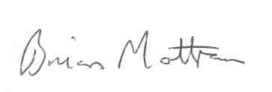

**Brian Mottram**Manager – Recreational Fishing Improvements  
Victorian Fisheries Authority

25 September 2017

Independent Audit Report from Auditor-General

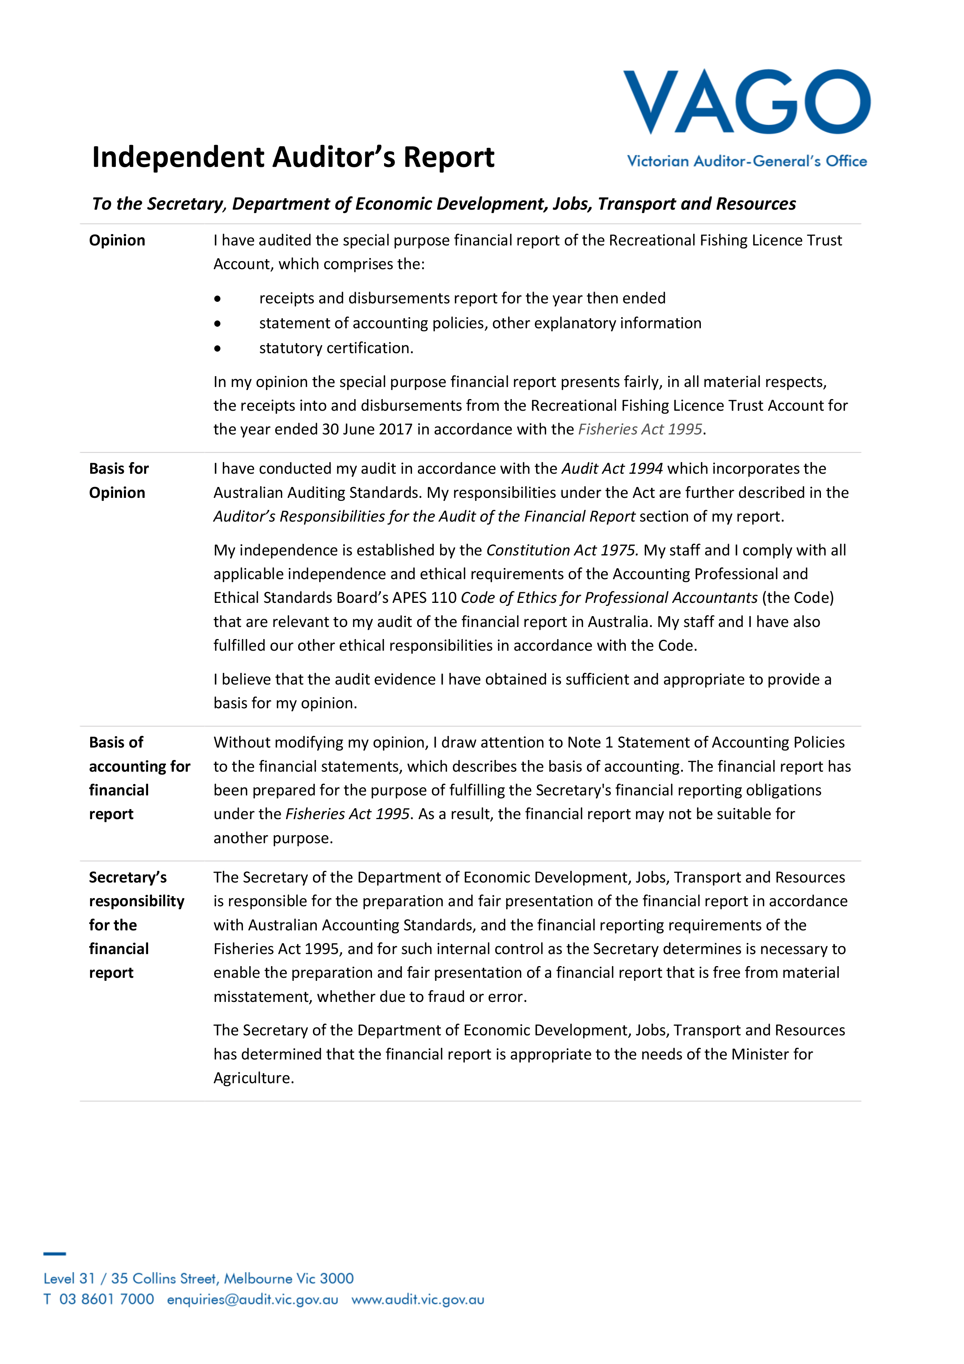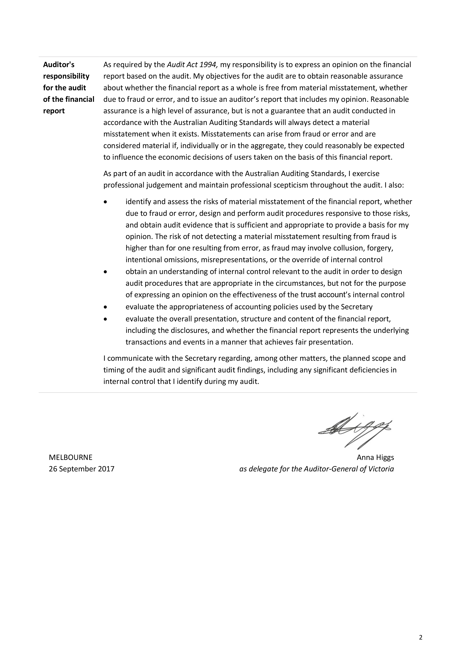

This page is intentionally blankThis page is intentionally blank

Customer Service Centre **136 186**

vfa.vic.gov.au