Streamside vegetation change, water temperature and trout

John Morrongiello
School of BioSciences, University of Melbourne Victoria

Aim:
Understand how changes to streamside (riparian) vegetation can affect water temperature, and how local events such as willow removal compare to broader, regional-scale, processes.

Background:
Riparian zones are the narrow strips of land along the banks of streams. Trees and shrubs in this zone are called riparian vegetation and these plants play a very important role in determining water temperature and water quality, the amount of in-stream habitat (e.g. snags, undercut banks), and also provide leaves and other organic material that can underpin freshwater food-webs (e.g. food for insect nymphs). All these factors affect the health of fish populations, including trout.

Brown and rainbow trout are cool-water species, meaning that they struggle to survive when water temperatures pass critical limits. For example, scientists have shown that brown trout stop growing if water temperatures get hotter than 19ºC, and they are at great risk of dying if the water gets hotter than 24-25ºC. This means that processes that cause water temperatures to increase may cause a decline in trout populations.

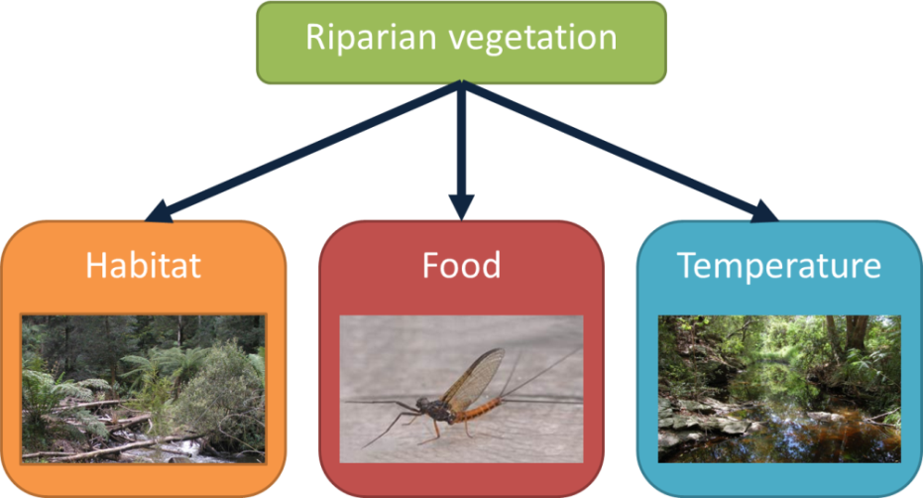
Riparian vegetation affects fish by influencing instream habitat (e.g. snags), food supply (e.g. leaves for aquatic insects to eat), and temperature (via shading).

All else being equal, a shaded pool will be cooler than an unshaded pool. However, in reality water temperature is not just dependent on the size and number of trees at a particular spot. The flowing nature of streams mean that things happening upstream and across the catchment (area of land a stream drains) can often be more important than local processes in determining water temperature.
Some larger scale drivers of stream temperature include:
- Season and air temperature (it is hotter in summer)
- Landscape (topography- do nearby hills or steep banks shade the stream?)
- Stream flow and depth (like in a kettle, smaller streams [less water] warm faster than bigger streams [more water])
- Channel width and orientation (vegetation is less effective at shading wider streams, and east-west flowing streams get hotter than north-south flowing streams because they get no afternoon shade; similar to westerly facing windows in a house letting in more heat)
- Large scale changes in riparian vegetation (cleared farmland verus forest, bushfire)
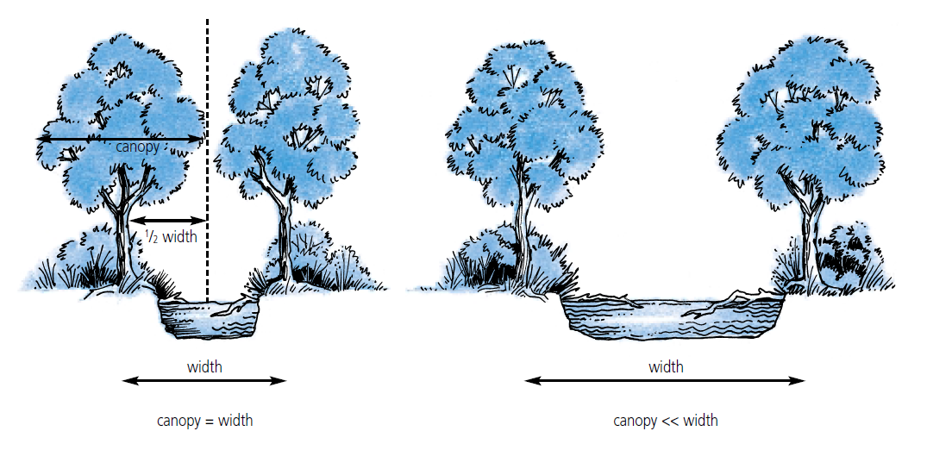
Partially shaded bigger stream
Completely shaded small stream
Example of how channel width can influence riparian vegetation shade. Shading is dependent on canopy size and channel width. A given tree canopy may shade all of a small stream, but this shading effect becomes less effective as channel width increases (modified from Bunn etal 2004).

What we did:
Anglers are concerned that the removal of willows along streams has caused a decline in Victoria’s trout fishery. Willows are removed by managers because they are a major environmental weed, but this removal causes a very obvious change to the local stream amenity for trout anglers. It is acknowledged that willows can provide shade, habitat and food for trout at a local scale.

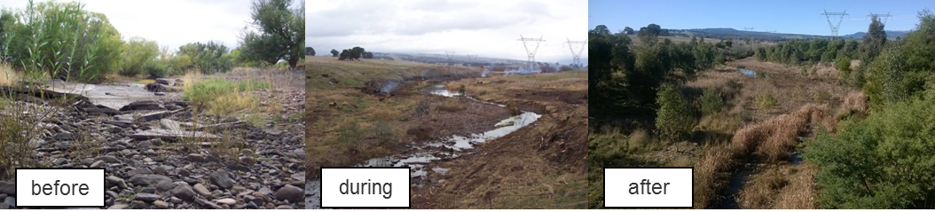
Does willow removal, like that seen here on the Broken River, affect stream temperature
enough make conditions unfavourable for trout?
Note significant revegetation after willow removal (credit: M. Turner & J. Morrongiello)

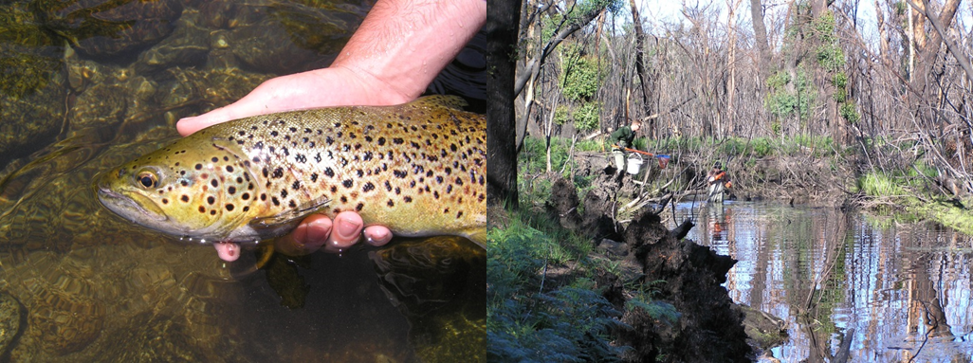
This good sized brown trout took a Royal Wulff in a north-east Victorian stream. Conducting fish surveys after the 2007 bushfires. Note the lost canopy cover (credit: J. Morrongiello)
We explored concerns about willow removal in the upper Goulburn River catchment above Lake Eildon by putting it action in the broader context of riparian change, recent climate and river flows.

- The Delatite, Howqua and Jamieson Rivers all flow east-west, meaning that during summer their waters are exposed to the sun all day long and are vulnerable to warming.

- Much of the lower Delatite flows through farmland with limited riparian vegetation. The other rivers flow through forested catchments. Areas of willow removal across the four rivers are very small compared to total channel length and is concentrated in downstream reaches.
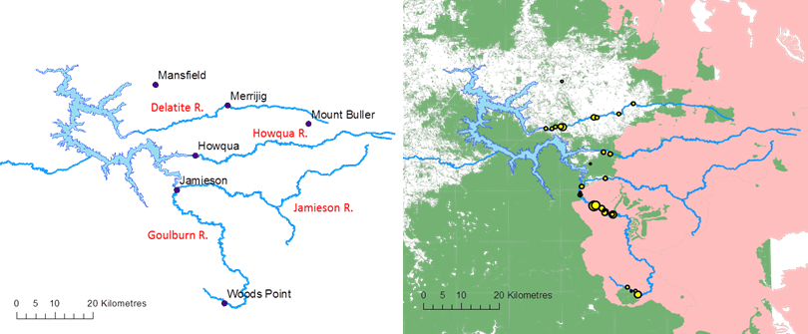

N
The upper Goulburn River showing river orientation. The Yellow circles on the right indicate areas of willow removal, green is existing vegetation and pink is area burnt by the 2006-07 bushfires.

- Vast areas of the catchment were severely burnt in the 2006-07 bushfires. These fires removed most of the canopy along riparian zones and even today it has still not recovered fully.
- The last decade has been very warm and very dry. Summer air temperatures at Mt Buller are two degrees warmer than the longer-term average. Delatite River flows are dramatically lower than they have been in recorded history. During the Millennium Drought (1997-2009) flows were 40% lower than average. Despite the drought breaking in 2009, flows are still 30% below average.

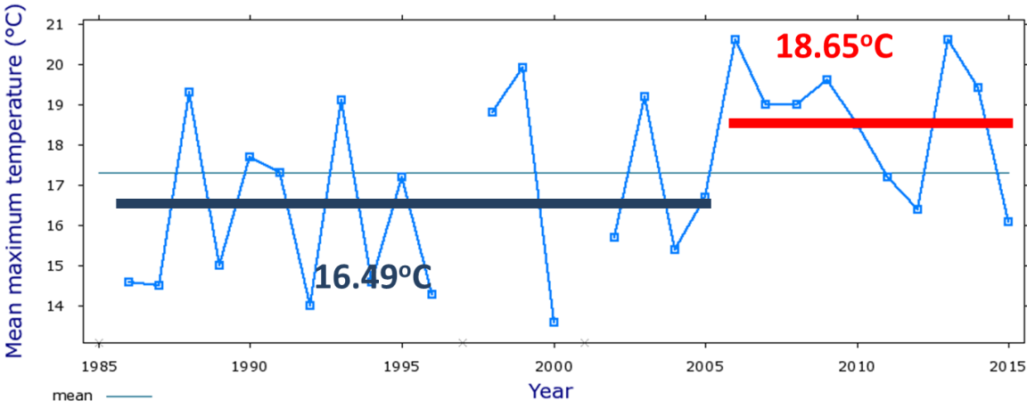
Mean maximum air temperature for January over the last 30 years at Mt Buller (Source: BoM)

Key findings and implications to date:
- Vegetation plays an important role in shading streams and keeping waters cool.
- Massive bushfires in 2006-07 dramatically reduced native riparian vegetation cover across much of the upper Goulburn catchment, especially in small headwater streams. This likely caused big increases in stream temperature due to a lack of shading.
- The last 10 years have been particularly hot and dry, further amplifying the impacts of the bushfire. 2013 and 2014 were some of the hottest summers on record. These conditions are likely to become more common in the future.
- The east-west orientation of rivers makes many upper Goulburn trout streams naturally exposed to the hot summer sun and thus vulnerable to increased warming.
- Willow removal is unlikely to have caused the observed declines in trout because it has neither been extensive enough, nor occurring in the upper parts of the catchment where the majority of stream shading should occur.
- Willow removal can affect local scale shade, habitat and food for trout, but on a river scale the impact from willow removal on trout pales in significance against broader catchment issues like climate, drought, bushfire and topography.

Next steps:
Work with the Goulburn-Broken Catchment Management Authority to prioritise areas for revegetation in the upper Goulburn catchment to maximise stream shading at a local and catchment scale.

