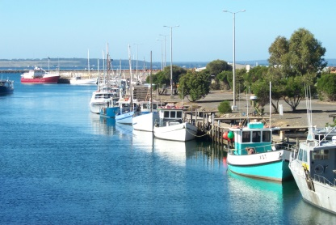
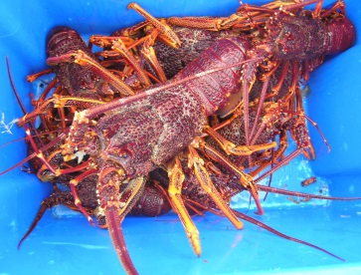
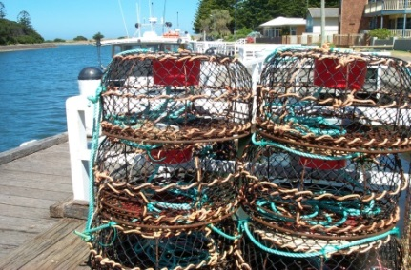
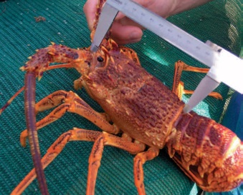

Victorian Rock Lobster Fishery

Management Plan

Victorian Rock Lobster Fishery Management Plan

Victorian Fisheries Authority

Published by the Victorian Fisheries Authority (VFA), December 2017

© The State of Victoria, VFA, Melbourne, December 2017
This publication is copyright. No part may be reproduced by any process except in accordance with the provisions of the Copyright Act 1968.

Authorised by the Victorian Government, 1 Spring Street, Melbourne.

Printed by VFA Melbourne, Victoria.

Preferred way to cite this publication:
Victorian Rock Lobster Fishery Management Plan 2017

ISBN 978-1-925733-6 (Print)
ISBN 978-1-925733-40-2 (pdf/online)

Author Contact Details:
Victorian Fisheries Authority
1 Spring Street
Melbourne VIC 3001

Copies are available from the website www.vfa.vic.gov.au

For more information contact the Customer Service Centre 136 186

Disclaimer
This publication may be of assistance to you but the State of Victoria and its employees do not guarantee that the publication is without flaw of any kind or is wholly appropriate for your particular purposes and therefore disclaims all liability for any error, loss or other consequence which may arise from you relying on any information in this publication.

Accessibility
If you would like to receive this publication in an accessible format, such as large print or audio, please telephone 136 186, or email customer.service@ecodev.vic.gov.au.

Deaf, hearing impaired or speech impaired? Call us via the National Relay Service on 133 677 or visit www.relayservice.com.au.

This document is also available in PDF format on the internet at www.vfa.vic.gov.au.

Minister’s Foreword
I am pleased to be able to declare this management plan for the Victorian Rock Lobster Fishery.
This is the third plan for the fishery declared under the Fisheries Act 1995. It builds on the progress
made in the previous two plans to ensure that the fishery remains viable, profitable and sustainable
for all users of the resource.
Consistent with our commitment for effective consultation, this plan was developed through intensive consultation and guided by an independently chaired stakeholder-based Steering Committee. I would like
to thank members of the Steering Committee for its sustained effort working through complex issues and
all stakeholders who made a submission to the draft plan during the public consultation period.
Rock lobster is one of the Australia’s most highly prized seafood delicacies and Victoria’s most valuable commercial fishery. The fishery has a Gross Value Product of over $25 million and supports fishing and processing businesses and regional employment in ports across the State.
It’s vital we continue to look after this important fishery by ensuring it remains sustainable. A key outcome of this management plan is a new harvest strategy for the commercial fishery. The strategy provides clear and prescriptive rules to determine the annual quotas and make management decisions in response to conditions in the fishery.
Rock lobsters are highly valued by recreational fishers but there has been little data collected on catch
from this sector. On 1 July this year, Victoria commenced a three-year tagging trial that will provide a robust estimation of the recreational catch. I thank the many recreational fishers who have signed up to report important fishing data via the new ‘VicRLTag’ app and website.
Once again, I would like to congratulate all involved in the development of the Victorian Rock Lobster Fishery Management Plan. I am confident that it will help to ensure the fishery continues to be managed on a sustainable basis into the future while allowing for ongoing development, growth and prosperity.

The Hon. Jaala Pulford, MP
Minister for Agriculture

Contents
Minister’s Foreword i
Executive Summary v
1. Introduction 1
1.1 Overview 1
1.2 Past management plans 2
1.3 Term of plan 2
2. Victoria’s Rock Lobster Fishery 3
2.1 Description of the fishery 3
2.2 Overview of sectors using the resource 5
2.3 Catch history in the commercial fishery 7
2.4 Economic characteristics of the fishery 12
3. Framework for Managing the Fishery 13
3.1 Legislative and policy framework 13
3.2 Ecologically sustainable development risk assessment 15
4. Objectives, Strategies and Actions 17
4.1 Fishery objectives and strategies 17
4.2 Actions 18
5. Managing the Rock Lobster Fishery 20
5.1 Recreational fishing management arrangements 20
5.2 Commercial fishery management arrangements 22
6. Monitoring and Assessment 25
6.1 Data collection 25
6.2 Stock assessment 26
7. Rock Lobster Fishery Harvest Strategy 29
7.1 Operational objectives 29
7.2 Principles of the harvest strategy 29
7.3 Decision rules to set the TACC 32
7.4 TACC tables 33
8. Glossary 35
9. References 37
Appendix 1: Rock Lobster Tagging Program 39

List of Tables

Table 1. Key elements of the Rock Lobster Fishery………………………………………………………………...... | 6
Table 2: Key elements of the commercial fishery…………………………………………………………………...... | 6
Table 3. History of TACCs for each quota period from 2001/02 to 2016/17 in the Western Zone…………….... | 7
Table 4. History of TACCs for each quota period from 2002/03 to 2016/17 in the Eastern Zone……………….. | 10
Table 5. Factors considered a high level risk from the ESD risk assessment process………………………….... | 16
Table 6. Fishery level objectives, strategies and actions for the Rock Lobster Fishery…………………………… | 18
Table 7. The annual TACC-setting process for the Rock Lobster Fishery………………………………………….. | 28
Table 8. CPUE thresholds and corresponding TACC levels for the Western Zone……………………………….. | 33
Table 9. CPUE thresholds and corresponding TACC levels for the Eastern Zone……………………………….. | 33

List of Figures

Figure 1. Extent and spatial structure of the Victorian Rock Lobster Fishery……………………………………… | 3
Figure 2. Total catch (tonnes) and unstandardised effort (x1000 pot lifts) in the Western Zone from 1978/79 to 2015/16. Arrow indicates TACC introduction (320t) in 2001/02……………………………………… | 8
Figure 3. Standardised and nominal catch rates in the Western Zone between 1978/79 and 2016/17………... | 8
Figure 4. Model estimated levels of available biomass and the associated fishing exploitation rates in the Western Zone between 1979/80 and 2016/17…………………………………………………………..... | 9
Figure 5. Total catch (tonnes) and unstandardised effort (x1000 pot lifts) in the Eastern Zone from 1978/79 to 2016/17. Arrow indicates TACC introduction (42t) in 2001/02…………………………….. | 10
Figure 6. Standardised and nominal catch rates in the Eastern Zone between 1978/79 and 2016/17.……….. | 11
Figure 7. Model estimated levels of available biomass and the associated fishing exploitation rates in the Eastern Zone between 1978/79 and 2016/17……………………………………………………………… | 11
Figure 8. Changes in the average beach price and catch in the Western Zone from 1993/94 to 2015/16……. | 12
Figure 9. Theoretical construction of the proposed harvest strategy framework…………………………………. | 30

Executive Summary
The Victorian Rock Lobster Fishery Management Plan establishes arrangements to manage the commercial and recreational catch at levels that prevent overfishing and ensure that Victorians can enjoy a plentiful resource for generations to come.
The commercial fishery has been under a quota management system since 2001 and is now the State’s most valuable wild-catch fishery with a production value of approximately $25 million in 2016/17. The majority of the catch is exported to international markets, predominantly in Asia, so the effective implementation of this management plan is required to enable the commercial fishing industry to maintain the approval issued by the Commonwealth Government to export products taken from the fishery.
This management plan is the third management plan for the fishery and replaces the previous plan declared in 2009 (Department of Primary Industries 2009). The first management plan for the Rock Lobster Fishery was introduced in 2003 (Department of Primary Industries 2003) and focused on rebuilding rock lobster stock and improving the economic prosperity of the commercial fishery. Each subsequent plan has expanded on the directions and incentives of the first plan and enhanced the sustainability of the rock lobster stock for all utilising the resource.
The management plan specifies the policies, management objectives and strategies for managing Victoria’s rock lobster resource under the requirements of the Fisheries Act 1995 and the principles of ecologically sustainable development.
The objectives for the Rock Lobster Fishery are:
Objective 1: Ensure the sustainability of the rock lobster resource
Objective 2: Ensure a fair and equitable allocation of the rock lobster resource
Objective 3: Ensure optimal economic utilisation of the rock lobster resource
Objective 4: Cost-effective and participatory management
Objective 5: Maintain the ecological integrity of the fishery ecosystem
This management plan introduces a new catch rate-based harvest strategy and a new program to estimate recreational catch. Both are focused on ensuring that the rock lobster resource is managed sustainably, that the total annual removal of stock from the resource by the commercial and recreational sectors is known and that analyses of the stock are accurate.
An important new principle that has been embraced in this management plan is one of continuous improvement. This is reflected by embedding an annual review process into the science program underpinning the assessment of the rock lobster resource and in the development of annual work plans. This ensures constant evaluation and identification of changing conditions to allow management activity to be directed appropriately and the resource to continue to be managed efficiently and effectively.
The status of the stock and the existing management arrangements in the fishery have been reviewed in consultation with stakeholders. The Victorian Fisheries Authority would like to thank the members of the steering committee for their involvement and effort in developing this management plan and to all members
of the community who provided input.

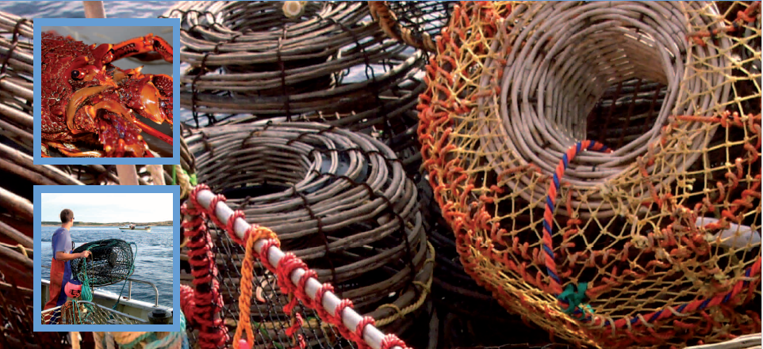
- Introduction

1.1 Overview
This management plan applies to the Victorian Rock Lobster Fishery. The fishery is based primarily on the Southern Rock Lobster, Jasus edwardsii, which is a high value and iconic species both in Australia and overseas. The fishery spans the length of the Victorian coast and supports both commercial and recreational rock lobster fisheries. It is the most valuable commercial fishery in Victoria, making it an important contributor to the State’s economy.
The Victorian Rock Lobster Fishery Management Plan specifies the policies, management objectives and strategies for managing Victoria’s rock lobster resource under the requirements of the Fisheries Act 1995 and the principles of ecologically sustainable development. It is the third management plan for the fishery and outlines the management direction for at least the next five years to ensure that the commercial, recreational, conservation and Aboriginal sectors in Victoria have a clear framework specifying how the resource will be sustainably managed.
The objectives, strategies and actions in this management plan build on those from previous plans and maintain the focus on continued stock rebuilding and ensuring community acceptance of the use of marine resources. The strategies and actions will inform the development of an annual work plan of specific and time bound activities. The annual work plan, including implementation of ‘continuous improvement’ opportunities identified as part of a new annual review process, will be developed in consultation with stakeholders.
The harvest strategy introduced in this management plan is based on commercial catch rate and is more transparent and less reliant on model outputs than the previous version. It takes a precautionary approach with a primary focus of rebuilding the rock lobster stock over time and uses egg production, standardised catch rate and numbers of juvenile lobsters in the population as determinants for setting the annual quotas.
Also new in this management plan is the introduction of a three-year trial to quantify the proportion of rock lobster taken by the recreational sector, which is currently unknown. From 1 July 2017, all recreational fishers have been required to tag the rock lobsters they catch and keep and to report their catch using a smartphone app web portal. The tags are registered to individuals and the numbers used represent the number of rock lobsters caught in that year.

1.2 Past management plans
During the late 1990s and early 2000s, it was recognised that catch rates in the Rock Lobster Fishery had declined and excessive pressure had been placed on the stock. In response, the first Rock Lobster Fishery Management Plan (Department of Primary Industries 2003) contained two key objectives: (i) rebuild the rock lobster biomass and (ii) promote commercial use for economic prosperity.
The second management plan (Department of Primary Industries 2009) was prepared after undertaking a review of the effectiveness of the first plan and an ecological risk assessment of the fishery. In the years between the two plans, available biomass had only marginally increased and catch rates had fallen sharply in some areas of the fishery. It was recognised that a significant shortcoming of the first plan was a lack of clear decision rules with the ability to react quickly to declining biomass indicators. Consequently, the core objective of the second plan was a deliberate stock rebuilding scheme where commercial catches were constrained to levels that ensured a significant increase in the available biomass over the life of the plan.
The scheme, which was implemented though a harvest strategy, included a rebuilding target and application
of commercial catch quotas that maintained stock biomass growth along a predetermined trajectory to a target. The target was to rebuild the available biomass to 40 percent of the estimated biomass in 1951 (the first year of records for the fishery) over ten years. The available biomass, the annual total allowable commercial catch (TACC) and other aspects of the fishery such as level of recruitment were estimated using fishery dependent and independent data and the rock lobster fishery model (Punt and Kennedy 1997).
Since the introduction of the second plan, the stocks in both zones of the fishery have consistently improved as a result of reducing the TACC in accordance with the requirements of the harvest strategy and despite lower than average recruitment to the fishery over the past decade. Correspondingly, catch rates have also increased, resulting in a more economically efficient commercial fishery.

1.3 Term of plan
This management plan came into effect following its declaration in the Victoria Government Gazette and remains in place until a new plan is declared or it is cancelled in accordance with the requirements of the Fisheries Act 1995.

- Victoria’s Rock Lobster Fishery
  - Description of the fishery
    - Area of the fishery
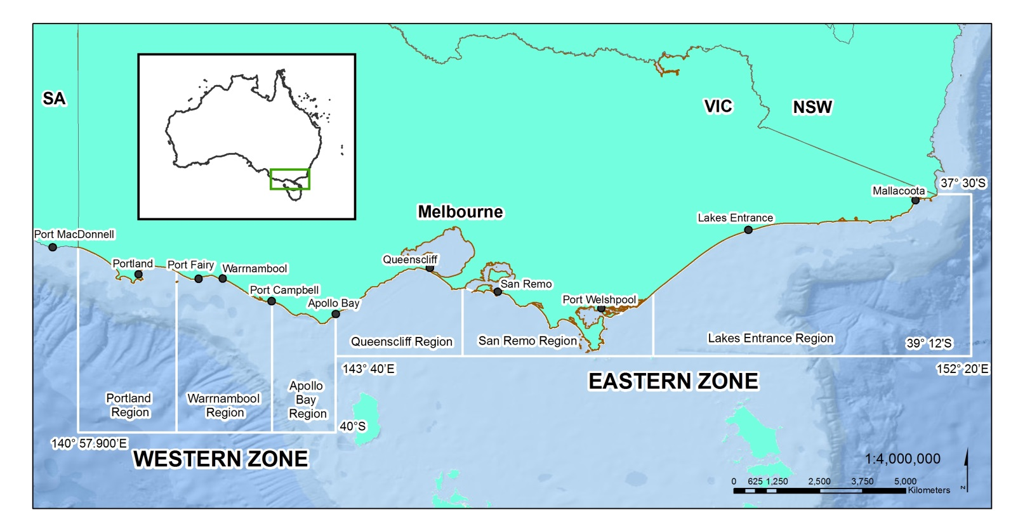
The Rock Lobster Fishery spans the length of the Victorian coast and is divided into two separately managed fishing zones: the Western Zone, which extends from the South Australian border to Apollo Bay, and the Eastern Zone, extending from Apollo Bay to the New South Wales border (Figure 1). The Victorian Government has jurisdiction over the commercial Rock Lobster Fishery in Commonwealth waters adjacent to Victoria under an Offshore Constitutional Settlement Arrangement with the Commonwealth Government.
Figure 1. Extent and spatial structure of the Victorian Rock Lobster Fishery.
Marine national parks and sanctuaries
Victoria was the first jurisdiction in the world to establish an entire system of highly protected marine areas where activities such as fishing, mining of seabed materials and dumping of waste are prohibited under the National Parks (Marine National Parks and Marine Sanctuaries) Act 2002. This system of parks and sanctuaries protects over five per cent of the Victoria’s coastal waters.
Two marine national parks and three marine sanctuaries are located in the Western Zone. Seven marine national parks and three marine sanctuaries are situated in the Eastern Zone. Parks Victoria is responsible for management of these parks and sanctuaries and under a service agreement with Parks Victoria, the Victorian Fisheries Authority is responsible for the delivery of fisheries compliance in these areas.
It is estimated that eight and 16 percent of the biomass in the Western and the Eastern Zones, respectively, were incorporated into the marine national parks at their establishment (Hobday et al. 2005).

    - Species
Southern Rock Lobster
The main species targeted and harvested in the Rock Lobster Fishery is Southern Rock Lobster
(Jasus edwardsii). The species is found on temperate coastal reefs and has a range that encompasses
the south-west coast of Western Australia to the south coast of New South Wales and includes Tasmania and New Zealand.
The most productive fishing grounds exist in New Zealand. In Australia, the waters adjacent to South Australia support the largest fishery for the species, followed by Tasmania and then Victoria.
Because the species is distributed continuously across southern Australia, the population is considered
to be a single biological stock. Southern Rock Lobsters have extensive larval dispersal and can be found to depths of 150 metres, with most of the catch coming from inshore waters less than 100 metres deep.
Eastern Rock Lobster
Small quantities of Eastern Rock Lobster (Sagmariasus verreauxi) are taken off eastern Victoria, particularly near the border of New South Wales and Victoria.
The Fisheries Act 1995 defines rock lobster as all species in the family Palinuridae, which includes both Southern and Eastern Rock Lobsters. As such, while the TACC is set for Southern Rock Lobster, it also includes any catch of Eastern Rock Lobster. Commercial fishers must report catch separately by species in the daily catch logbook.
    - Life history and biology
The life cycle of the rock lobster is complex. After mating in autumn, fertilised eggs are carried under the tail of the female for approximately three months before being released, typically between September and November. Rock lobster larvae, or phyllosoma, live in the plankton and undergo 11 developmental stages over a period of 12 to 18 months while being carried by ocean currents before metamorphosing to a benthic existence.
Rock lobsters grow by moulting or shedding their exoskeleton. The frequency of the moulting cycle declines with age from five per year for newly settled juveniles to once per year for mature adults. Males grow faster and larger than females, reaching around 160 millimetres in carapace length after ten years. Females generally reach about 120 millimetres in the same period. Growth rates also vary spatially, with growth faster in the east than in the west of the State. Female rock lobsters are thought to mature around the same age as males but, due to variation of growth, generally mature at a larger size in the east (112 millimetres) compared to those in the west (90 millimetres).
Adult rock lobsters are carnivorous and feed mostly at night on a variety of bottom dwelling invertebrates such as molluscs, crustaceans and echinoderms. The major predators of rock lobster include octopus, various large fish and sharks.
In Victoria, the abundance of rock lobsters reduces from west to east reflecting a decreasing area of suitable rocky reef habitat.
    - Stock status
The stock status of Southern Rock Lobster across south-eastern Australia is classified as a sustainable stock by the assessment undertaken in the Status of key Australian fish stocks report 2016 (SAFS report) (Flood et al. 2014). The determination of stock status is based on egg production outputs from the rock lobster stock assessment model used in South Australia, Victoria and Tasmania. The combined egg production across the south-eastern region in 2014/15 was estimated to be 21 percent of the unfished level. The SAFS reports specifies a limit reference point of 20 percent of the unfished biomass, the rock lobster stock is therefore not considered to be recruitment overfished.
The classification of stocks through the SAFS report contributes to the ability of a fishery to gain or maintain export approval, which is granted by the Commonwealth Government.
  - Overview of sectors using the resource
Aboriginal Fishing Sector
Aboriginal people have a strong connection to country and water that is central to their identity and culture. For Aboriginal people, cultural values are informed by, and interconnected with, traditional uses, spiritual connection, ancestral ties and respect for waterways, land, sea and the resources these provide.
There is currently no information on the catch history of rock lobsters by Aboriginal fishers. An action in this plan is for the Victorian Fisheries Authority to increase the traditional owner input into the management of the rock lobster resource.
Recreational Fishing Sector
Fishing for rock lobster is an important activity for many Victorians who most commonly collect them whilst snorkelling, diving or using hookah, or with the use of hoop nets. Unless exempt, a fisher must hold a Victorian Recreational Fishing Licence to take rock lobsters. The recreational catch is managed using daily bag limits, possession limits, minimum size limits and closed seasons. The recreational closed season and restrictions correspond with the commercial fishery.
The number of rock lobster caught annually by the recreational sector has been a significant data gap for many years. A three-year trial program commenced in July 2017 in which recreational fishers are required to tag the rock lobsters they catch and keep, and then report the use of that tag. The number of tags used will represent the number of rock lobster harvested from the stock.
A summary of the key elements of the fishery, recreational and commercial, is in Table 1.
More detail on the management arrangements, including the tagging requirements, is in Section 5.1.
Commercial Fishing Sector
Commercial rock lobster fishers must hold a Rock Lobster Fishery Access Licence to harvest rock lobster from Victorian waters. The commercial fishery is quota managed, using annual TACCs and individual transferable quota units. Separate licences and quotas exist for each of the two zones. Fishing operations mainly occur from the 11 coastal ports identified in Figure 1.
Rock lobsters are caught with baited pots that are generally set and hauled once each day. Commonly used baits include barracouta, Australian salmon, mackerel, carp and some imported fish species.
An overview of the commercial management arrangements is summarised in Table 1 and a summary
of the key elements for each zone is in Table 2. More detail on the history and current status of the fishery is in Section 2.1.6 and further detail on the management arrangements in the commercial fishery is in Section 5.2.
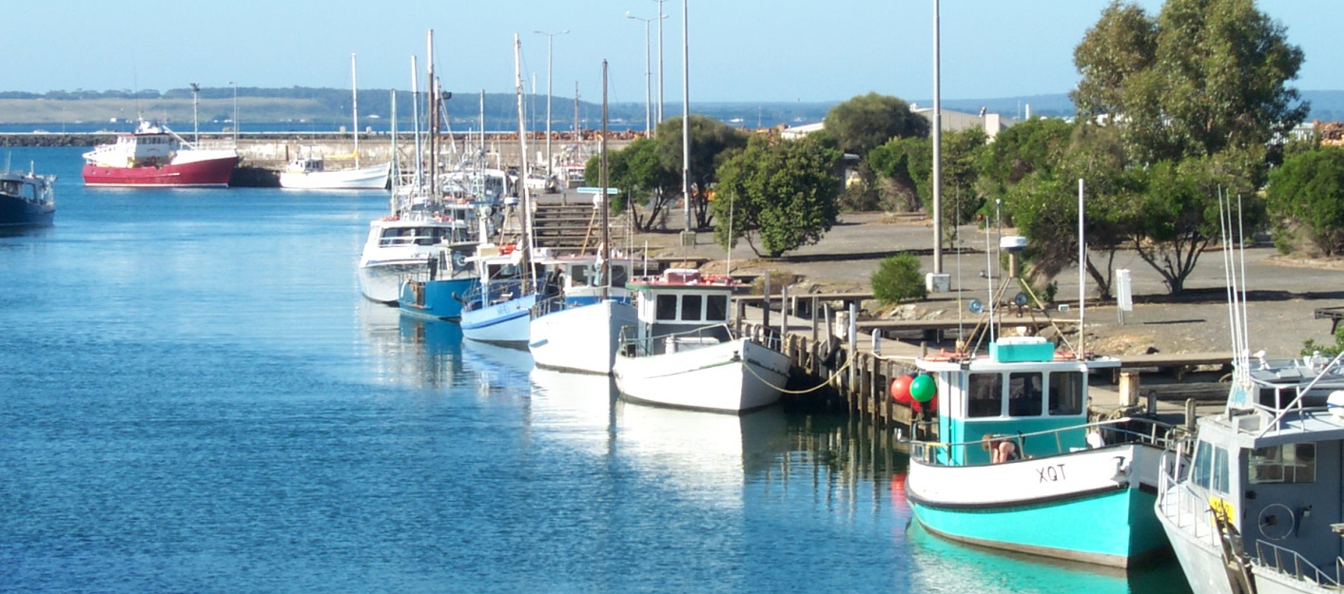
Table 1. Key elements of the Rock Lobster Fishery.
Aspect of fishery | Commercial Fishery | Recreational Fishery
Access to fishery | Entry limited to holders of a Rock Lobster Fishery Access Licence | Recreational Fishery Licence (unless exempt)  Unlimited entry
Allowed fishing method/equipment | Baited pots | Hand capture and hoop nets
Management zones | Eastern Zone and Western Zone | State-wide –no zones
Primary method of control | Total Allowable Commercial Catch and individual transferable quotas | Daily bag limit: 2 lobster  Possession limit: 4 lobster
Method of monitoring | Quota Management System | Tag and reporting system  Random inspection for recreational catch
Secondary controls | Legal minimum length  Gear restrictions  Closed seasons | Legal minimum length  Gear restrictions  Closed seasons

Table 2: Key elements of the commercial fishery.
Commercial Fishery
 | Western Zone | Eastern Zone
Zone boundary | Longitude 143º40’E  Longitude 140º57.9’E  Latitude 40ºS | Longitude 143º40’E  Longitude 150º20’E  Latitude 39º12’S
Maximum number of licences | 71 | 36
Maximum number of licences per boat | Not limited | Not limited
Total number of quota units per zone | 3633.48 | 1000
Total number of pots in zone | 5162 | 2021
Maximum number of pots per boat | 140 | 120
Minimum number of pots to activate licence | 20 | 15
Minimum quota holding per licence | 10 units | 5 units
Maximum quota holding per licence | No maximum | No maximum

  - Catch history in the commercial fishery
The commercial rock lobster fishery has been managed as a separate and limited-entry fishery since
1968. During 2001, the fishery moved to output controls in the form of quota management, changing the emphasis from restricting fishing effort to allocating and limiting the catch. The commercial fishery is now managed primarily by limiting the number of Rock Lobster Fishery Access Licences allocated across the two zones; restricting the TACC in each of the zones, which are divided into individual transferable quota units; and restricting the number of pots that can be used in each zone.
Western Zone Rock Lobster Fishery
During the 1990s and early 2000s, catches in the Western Zone Rock Lobster Fishery ranged between
408 and 525 tonnes (t). With the implementation of quota management in November 2001, the first TACC for a complete season was set at 450 t (note that a TACC of 320 t was introduced for a shortened season from November 2001 to 31 March 2002). The TACC remained at 450 t until 2006/07 but was never fully caught. A fishery restructure and reductions in quota in the years since that time have resulted in constraining TACCs, reductions in effort and improvements in catch rates and stock biomass (Table 3, Figures 2, 3 and 4).
Since 2009/10, TACCs have remained between 230 and 260 t due to the stock rebuilding harvest strategy implemented in the previous management plan. In 2009/10, after five years of consistent decline in catch rate, the fishery reached a historical low of 0.34 kg/pot lift (standardised catch per unit effort, CPUE). Reduced fishing pressure from the decreased TACCs has allowed the CPUE to recover, and in 2016/17 was 0.54 kg/pot lift (standardised catch rate) (Figure 3).
Corresponding trends are evident in the exploitation rates and stock biomass in the fishery. Under the increasing exploitation rates experienced between 1980/81 and 2000/01, the biomass in the fishery underwent a ten-year downward trend before entering a phase of stability between 1993/94 and 2003/04
at approximately 850 to 980 t. Exploitation rates dropped with the introduction of quota, but steadily increased to a historical high of 66 percent in 2006/07. The corresponding available biomass decreased and reached a low of 524 t in 2008/09. After 2006/07, the exploitation rate dropped significantly and the available biomass improved. In 2016/17, the available biomass was estimated to be 708 t, with a corresponding fishing exploitation rate of 29 percent (Figure 4).
Table 3. History of TACCs for each quota period from 2001/02 to 2016/17 in the Western Zone.
Year | Season | TACC set | TACC Caught |  | Number of active licenses | Number of  vessels
 |  | (tonnes) | (tonnes) | per cent
2001-02* | 1 Nov – 31 Mar | 320
2002-03 | 1 Apr – 31 Mar | 450 | 440 | 98 | 79 | 83
2003-04 | 1 Apr – 31 Mar | 450 | 436 | 97 | 80 | 79
2004-05 | 1 Apr – 31 Mar | 450 | 421 | 94 | 79 | 86
2005-06 | 1 Apr – 31 Mar | 450 | 405 | 90 | 75 | 77
2006-07 | 1 Apr – 31 Mar | 450 | 329 | 73 | 71 | 68
2007-08 | 1 Apr – 31 Mar | 380 | 319 | 84 | 68 | 64
2008-09 | 1 Apr – 31 Mar | 320 | 244 | 76 | 61 | 60
2009# | 1 Apr– 30 Jun | 55.2 | 36 | 64 | 54 | 53
2009-10 | 1 Jul – 30 Jun | 240 | 230 | 96 | 54 | 53
2010-11 | 1 Jul – 30 Jun | 240 | 237 | 99 | 54 | 58
2011-12 | 1 Jul – 30 Jun | 240 | 237 | 99 | 50 | 53
2012-13 | 1 Jul – 30 Jun | 260 | 258 | 99 | 47 | 45
2013-14 | 1 Jul – 30 Jun | 260 | 260 | 100 | 47 | 47
2014-15 | 1 Jul – 30 Jun | 230 | 230 | 100 | 48 | 47
2015-16 | 1 Jul – 30 Jun | 230 | 230 | 100 | 47 | 48
2016-17 | 1 Jul – 30 Jun | 230 | 209^ | 100^ | 43 | 42
* Quota was introduced 1 November 2001 for a shortened quota period. Data Source: Victorian Fisheries Authority FILS Database.
# At the request of industry, the quota year was shifted to 1 July – 30 June beginning 2009/10.
^ The 2016/17 catch was reduced from 230t to 209t as a result of a compensation packaged offered to fishers by Origin Energy in recognition of the loss of access to fishing grounds during survey activity. A condition of accepting compensation was to retire an agreed amount of quota for the remainder of the 2016/17 season.

Quota introduced
Figure 2. Total catch (tonnes) and unstandardised effort (x1000 pot lifts) in the Western Zone from 1978/79 to 2016/17. Arrow indicates TACC introduction (320t) in 2001/02.

Figure 3. Standardised and nominal catch rates in the Western Zone between 1978/79 and 2016/17.

Quota introduced

Figure 4. Model estimated levels of available biomass and the associated fishing exploitation rates in the Western Zone between 1979/80 and 2016/17. Note: available biomass is the model-estimated value from mid-November at the start of each fishing season.

Eastern Zone Rock Lobster Fishery
Annual catch in the Eastern Zone Rock Lobster Fishery declined from 143 t in 1982/83 to 41 t in 2008/09. TACCs were introduced in 2001 and an initial TACC was set at 42 t for the partial season between
1 November and 31 March. The TACC for the first complete season was set at 60 t, where it remained until 2006/07. In 2007/08, the TACC was increased to 66 t but catch levels remained beneath the annual TACC until 2010/11. The TACC was reduced to 48 t in 2012/13 and since that time has seen several modest increases to 59 t, where it has been for the past three seasons (2014/15 to 2016/17). An overview of the quota history is in Table 4 and the historical catch and effort in the zone is in Figure 5.
Standardised CPUE was at its lowest in 1995/96 at 0.26 kg/pot lift. By the time quota was introduced
in 2001, CPUE had increased to 0.35 kg/pot lift. The increasing trend continued through to 2012/13
when it reached 0.63 kg/pot lift, but since that time has fallen each season to 0.45 kg/pot lift in 2016/17 (standardised catch rate) (Figure 6).
Despite a variable exploitation rate ranging between 21 and 38 percent throughout the late 1980’s to 2009/10, the stock biomass in the fishery remained relatively stable. The biomass then experienced a substantial increase from approximately 190 t to 270 t between 2009/10 and 2013/14 due to a large recruitment event in 2009. Since then however, the biomass has been in decline and the rate of exploitation has increased (Figure 7).

Table 4. History of TACCs for each quota period from 2002/03 to 2016/17 in the Eastern Zone.
Year | Season | TACC set | TACC Caught |  | Number of active licenses | Number of  vessels
 |  | (tonnes) | (tonnes) | per cent
2001-02* | 1 Nov - 31 Mar | 42
2002-03 | 1 Apr - 31 Mar | 60 | 49.9 | 83 | 39 | 34
2003-04 | 1 Apr - 31 Mar | 60 | 54.4 | 91 | 41 | 36
2004-05 | 1 Apr - 31 Mar | 60 | 53.2 | 89 | 41 | 39
2005-06 | 1 Apr - 31 Mar | 60 | 55.7 | 93 | 30 | 29
2006-07 | 1 Apr - 31 Mar | 60 | 53.5 | 89 | 30 | 30
2007-08 | 1 Apr - 31 Mar | 66 | 50.1 | 76 | 31 | 31
2008-09 | 1 Apr - 31 Mar | 66 | 41.3 | 63 | 26 | 24
2009# | 1 Apr - 30 Jun | 6.9 | 5.8 | 84 | 19 | 20
2009-10 | 1 Jul - 30 Jun | 66 | 43.9 | 67 | 22 | 21
2010-11 | 1 Jul - 30 Jun | 66 | 64.8 | 98 | 29 | 28
2011-12 | 1 Jul - 30 Jun | 66 | 65.3 | 99 | 26 | 27
2012-13 | 1 Jul - 30 Jun | 48 | 47.3 | 99 | 26 | 25
2013-14 | 1 Jul - 30 Jun | 51 | 50.8 | 100 | 27 | 26
2014-15 | 1 Jul – 30 Jun | 59 | 59 | 100 | 24 | 22
2015-16 | 1 Jul – 30 Jun | 59 | 58 | 99 | 21 | 21
2016-17 | 1 Jul – 30 Jun | 59 | 52.6 | 89 | 24 | 21
*Quota was introduced 1 November 2001 for a shortened quota period. Data Source: Victorian Fisheries Authority FILS Database.
#At the request of industry, the quota year was shifted to 1 July – 30 June beginning 2009/10.

Quota introduced
Figure 5. Total catch (tonnes) and unstandardised effort (x1000 pot lifts) in the Eastern Zone from
1978/79 to 2016/17.

Figure 6. Standardised and nominal catch rates in the Eastern Zone between 1978/79 and 2016/17

Quota introduced
Figure 7. Model estimated levels of available biomass and the associated fishing exploitation rates in the Eastern Zone between 1978/79 and 2016/17. Note: available biomass is the model-estimated value from mid-November at the start of each fishing season.
  - Economic characteristics of the fishery
An objective of this management plan is to increase the level of economic data collected for the commercial and recreational aspects of the fishery and to better understand the value to the State.
The two zones of the fishery operate on different economic scales. The smaller Eastern Zone fishery operates, in general, closer to the coastline and main ports. Operational costs are therefore somewhat less than those for the Western Zone where many fishers will use bigger boats, more pots and often travel further offshore.
Although TACCs have been reduced in the fishery, the average beach price has steadily increased from the mid-2000s (Figure 8 shows an example of the average beach prices in the Western Zone between 1993/94 and 2015/16). The fishery has therefore been able to remain profitable whilst undergoing adjustments to lower the TACCs to levels that better reflect the status of the stocks.

Figure 8. Changes in the average beach price and catch in the Western Zone from 1993/94 to 2015/16.

- Framework for Managing the Fishery
  - Legislative and policy framework
    - Victorian legislation and regulation
The Rock Lobster Fishery is managed in accordance with the Fisheries Act 1995 and the Fisheries Regulations 2009. The Fisheries Act provides the legislative framework for managing Victoria’s fisheries resources and sets out the general provisions applicable to all recreational fishing activities and commercial access licences including the Rock Lobster Fishery Access Licence.
The objectives of the Fisheries Act are:
- To provide for the management, development and use of Victoria's fisheries, aquaculture industries and associated aquatic biological resources in an efficient, effective and ecologically sustainable manner;
- To protect and conserve fisheries resources, habitats and ecosystems including the maintenance of aquatic ecological processes and genetic diversity;
- To promote sustainable commercial fishing and viable aquaculture industries and quality recreational fishing opportunities for the benefit of present and future generations;
- To facilitate access to fisheries resources for commercial, recreational, traditional and non-consumptive uses;
- To promote the commercial fishing industry and to facilitate the rationalisation and restructuring of the industry; and
- To encourage the participation of resource users and the community in fisheries management.
The Fisheries Regulations provide the general detail regarding the activities authorised by a recreational fishery licence and specific detail regarding authorised activities and the obligations of the Rock Lobster Fishery Access Licence holder and persons acting on their behalf. In addition, there may be further conditions which will be expressed or referred to on the licence itself.
All Australian governments, including Victoria, have made a commitment to manage fisheries according to the principles of ecologically sustainable development. These principles include:
- Ensuring that fishing is carried out in a biologically and ecologically sustainable manner;
- Ensuring that there is equity within and between generations regarding the use of fish resources;
- Maximising economic and social benefits to the community from fisheries within the constraints of sustainable utilisation;
- Adopting a precautionary approach to management, particularly for fisheries with limited
data; and
- Ensuring that the processes and procedures involved in management of a fishery are appropriate, transparent and inclusive.
Management of the Rock Lobster Fishery will be consistent with other key legislation, including,
but not limited to:
- Environment Protection Act (Victoria) 1970;
- National Parks Act 1975;
- Historic Shipwreck Act 1976;
- Marine Act (Victoria) 1988;
- Seafood Safety Act 2003; and
- Occupational Health and Safety Act 2004.
    - Victorian policies and frameworks
Cost Recovery Framework
A new cost recovery approach was implemented by the Victorian Government in 2014. The approach changed the collection of levies from being retrospective to being prospective (i.e. a forward-budgeting approach). This change occurred in order to more accurately reflect the real costs of managing the resource as well as to provide an opportunity for engaging with industry to design and deliver services
that are more cost effective.
Cost recoverable services are those that provide a direct benefit to the commercial fishing sector or
are required due to the risks generated by the commercial sector. The categories of cost recoverable services are compliance, management, research and administration. The costs of delivering these services are recovered through levies in line with the Victorian Department of Treasury and Finance
Cost Recovery Guidelines.
Cost recovery is in place only for the commercial fishing sector, and there is no transfer of levies
collected from the commercial sector to the management of the recreational sector or to address illegal fishing activity.
In accordance with the principles of cost recovery, Rock Lobster Fishery Access Licence holders will continue to contribute to the cost of management, compliance and research through an annual levy imposed at licence renewal.
Seismic Surveying Activity in Victorian Waters
Seismic surveying is commonly used in the earth resources sector to gain a better understanding of subsurface geology.
In line with legislated responsibilities, the VFA is committed to ensuring that where possible, seismic surveys cause minimal disturbance to fisheries, fish habitat and the businesses and community accessing these resources in Victorian-managed waters.
The policy is primarily intended to provide clarity about the role of the VFA in assisting either a proponent seeking approval to undertake seismic surveys in Victorian-managed waters, or a fisher operating in waters in which seismic surveying is planned to take place. It describes the fishing related matters and mitigation strategies to be considered by proponents when planning and implementing seismic surveys in commercially and recreationally fished waters.
For more information on the policy, refer to the VFA website.
    - Commonwealth legislation
The Environment Protection and Biodiversity Conservation Act 1999
The Environment Protection and Biodiversity Conservation Act 1999 (EPBC Act) is administered by the Commonwealth Government and is Australia’s key piece of environmental legislation.
The EPBC Act provides for the protection of the environment by identifying key threatening processes, protecting critical habitat, promoting the conservation of biodiversity, and providing for the protection of listed species, protected areas and communities in Commonwealth areas.
Under Part 13A of the EPBC Act, all fisheries intending to export product must be assessed against the Guidelines for the Ecologically Sustainable Management of Fisheries to ensure that fisheries are managed in an ecologically sustainable manner.
The Victorian Rock Lobster Fishery was first given export approval under the EPBC Act in March 2004. The approval has been successfully maintained, with periodic assessments every five years. In 2014, the Commonwealth Government extended the length of the export approval from five to ten years for any commercial fisheries assessed as posing low environmental risk. In August 2016, the Victorian Rock Lobster Fishery was granted export approval until 28 August 2026.
This plan has been prepared in recognition of the sustainability guidelines in order to assist the Victorian Rock Lobster industry to maintain access to export markets into the future.
Offshore Constitutional Arrangements
Under international law, Australia controls all economic resources, including fishing, mining and oil exploration within its exclusive economic zone, which extends 200 nautical miles from the territorial sea baseline (normally the low water mark). The division of management arrangements between the Commonwealth and the States within the exclusive economic zone is an important constitutional issue.
Under the Offshore Constitutional Settlement, states generally have responsibility over areas up to three nautical miles from the territorial sea baseline (i.e. coastal waters). Offshore Constitutional Settlement agreements between states and the Commonwealth provide an integrated legislative framework for managing commercial fisheries resources that move between the two jurisdictions by conferring management responsibility on Commonwealth or state fisheries management authorities (Attorney-Generals Department 2007).
  - Ecologically sustainable development risk assessment
A risk assessment was undertaken to inform the development of this management plan. The methodology of the assessment was based on the National Ecologically Sustainable Development (ESD) Reporting Framework for Australian Fisheries (Fletcher et al. 2002). The framework was developed in response to the Australia’s National Strategy for Ecologically Sustainable Development (Australian Government 1992), which defines ecologically sustainable development as: ‘using, conserving and enhancing the community’s resources so that ecological processes, on which life depends, are maintained, and the total quality of life, not and in the future, can be increased’.
The risk assessment methodology involves identifying relevant risks to the resource, prioritising those risks and then specifying an appropriate level of management response. In cases where a management regime already exists, the risk assessment is undertaken to assess the effectiveness of that regime.
The Rock Lobster Fishery was assessed with the input from relevant stakeholders in the commercial, recreational, scientific and management sectors.
The commercial fishery is highly regulated, under quota management and stock status is monitored and assessed annually. The stock biomass is considered sustainable and level of fishing is at an appropriate intensity. As a result, the risks to the ecosystem from the activities of the commercial fishery are, in the context of the ESD assessment, moderate.
The rock lobster resource is also utilised by the recreational sector. The level of recreational fishing effort is unknown and there have been few reliable estimates of recreational rock lobster catch undertaken. The ESD assessment identified this data gap as a significant risk to the effective management of the resource in Victoria.
Table 5 describes the issues identified as high risk through the ESD risk assessment to be addressed in this management plan.

Table 5. High priority issues identified in the ESD risk assessment process.
Risk (Issue) | Risk Rating | Proposed Management Response
Recreational take in the Eastern Zone is higher than the assumed 10% proportion of the total allowable commercial catch | High | Develop a methodology for obtaining a more comprehensive and accurate representation of the recreational catch of rock lobsters in both zones of the fishery  Engage with the recreational sector, with input from other relevant sectors, to undertake an appropriate assessment of recreational catch
Concentrated recreational fishing effort depletes stocks at a local level within the Eastern Zone | High | Develop a methodology for obtaining a more comprehensive and accurate representation of the recreational catch of rock lobsters in both zones of the fishery  Engage with the recreational sector, with input from other relevant sectors, to undertake an appropriate assessment of recreational catch
Quota lease prices are too high and only limited quota is available for lease | High | Include options in the management plan and harvest strategy that focus on improving the sustainability and profitability of the fishery, and as a consequence, increase TACCs
Insufficient information available to properly manage the recreational and illegal sectors | High | Develop options for a means to identify recreational catch, such as tags, that clearly separates legal and illegal take of rock lobsters
Insufficient socio-economic information on the fishery (all sectors) | High | Include relevant strategies and actions within the management plan to address this issue. Specific actions will be developed on an annual basis through annual work plans

- Objectives, Strategies and Actions
  - Fishery objectives and strategies

The objectives for this management plan build on those in previous plans. Actions have been developed for each of the strategies and these are detailed in Table 6. The intent is that the strategies, actions and outcomes from annual reviews inform the development of an annual work plan of specific and time bound activities. The annual work plan will be developed in consultation with stakeholders.

Objective 1: Ensure the sustainability of the rock lobster resource
Strategy 1: Ensure the reproductive capacity is at a level that sustains the fishery into the future.
Strategy 2: Ensure management arrangements effectively promote the sustainable use of the resource.
Strategy 3: Collect sufficient data and information to ensure that accurate harvest strategy determinations and management decisions are made.

Objective 2: Ensure a fair and equitable allocation of the rock lobster resource
Strategy 4: Provide equitable access to all sectors utilising the resource.

Objective 3: Ensure optimal economic utilisation of the rock lobster resource
Strategy 5: Continue to rebuild the stock biomass.
Strategy 6: Promote a profitable and viable commercial fishery, within the constraints of ecological sustainability.
Strategy 7: Maximise the cultural, recreational and lifestyle benefits of fishing for those who participate in utilising the resource.
Strategy 8: Promote the benefit of the fishery to the broader community.

Objective 4: Cost-effective and participatory management
Strategy 9: Promote stakeholder participation in decision making.
Strategy 10: Engage with other agencies around fisheries issues.
Strategy 11: Deliver cost-effective management arrangements.
Strategy 12: Achieve compliance with legislation.

Objective 5: Maintain the ecological integrity of the fishery ecosystem
Strategy 13: Ensure sustainability of bycatch and by-product species;
Strategy 14: Minimise interactions with threatened, endangered and protected species.
Strategy 15: Minimise impact on habitat.
Strategy 16: Minimise impact on the ecosystem.

  - Actions
Table 6. Fishery level objectives, strategies and actions for the Rock Lobster Fishery.
Objective | Strategy | Actions
Ensure the sustainability of the rock lobster resource | - Ensure reproductive capacity is at a level that sustains the fishery into the future | 1(i) Set the TACCs in accordance with the harvest strategy
 |  | 1(ii) Ensure the operation of the fishery is consistent with the principles of ecologically sustainable development and the precautionary principle
 | - Ensure management arrangements effectively promote the sustainable use of the resource | 2(i) Annually assess the effectiveness of management arrangements and add actions to annual work plan as necessary
 |  | 2(ii) Ensure other input and output controls are effective in supporting the sustainable use of the rock lobster resource
 | - Collect sufficient data and information to ensure that  accurate harvest strategy determinations and management decisions are made | 3(i) Improve commercial data recording technology and systems
 |  | 3(ii) Assess the fishery using quantitative stock assessment techniques
 |  | 3(iii) Maintain fishery-independent monitoring programs
 |  | 3(iv) Harmonise reporting across the southern rock lobster stock and work with States to improve the efficiency of data collection of and methods of assessing stock
 |  | 3(v) Develop measures to measure the catch taken by recreational and traditional owner sectors
Ensure a fair and equitable allocation of the rock lobster resource | - Provide equitable access to all sectors utilising the resource | 4(i) Ensure management strategies for the commercial, recreational and traditional owner sectors are within the sector allocations
 |  | 4(ii) Maintain recreational and traditional owner access and use
 |  | 4(iii) Maintain appropriate recreational size, bag and possession limits
Ensure optimal economic utilisation of the rock lobster resource | - Continue to rebuild the  stock biomass | 5(i) Develop a long-term Maximum Economic Yield target reference point for the stock
 | - Promote a profitable and viable commercial fishery, within the constraints of ecological sustainability | 6(i) Improve the collection of economic information so as to assist in making informed management decisions
 |  | 6(ii) Develop a set of economic indicators for the fishery
6(iii) Provide flexible management arrangements that allow commercial fishers to be
economically efficient
 | - Maximise cultural, recreational and lifestyle benefits of fishing for those who participate in utilising the resource | 7(i) Ensure that social and cultural issues are considered when any new management strategies are developed
 |  | 7(ii) Estimate the value of recreational fishing to the Victorian community
 | - Promote benefit of the fishery to the broader community | 8(i) Maximise flow of economic benefit from the fishery to the Victorian community
 |  | 8(ii) Develop a set of economic objectives to measure community benefit (e.g. Gross State Product, employment etc)
Cost-effective and participatory management | - Promote stakeholder participation in decision-making | 9(i) Effective and timely consultation undertaken by Victorian Fisheries Authority
 |  | 9(ii) Ensure transparent decision-making processes by Government and fisheries management advisory bodies
 |  | 9(iii) Ensure Stakeholders from all sectors are adequately represented on fisheries management advisory groups
 | - Engage with other agencies around fishery issues | 10(i) Ensure fishery’s information and interests are considered in the decision making processes of other agencies
 | - Deliver cost-effective management arrangements | 11(i) Ensure licence fees recovered from commercial licence holders are used in accordance with the Government’s cost recovery policy
 |  | 11(ii) Ensure management arrangements are effective at achieving management objectives whilst minimising costs
 | - Achieve compliance with legislation | 12(i) Develop annual compliance strategies that incorporate a compliance risk assessment
 |  | 12(ii) Develop annual compliance report and present to stakeholders
Maintain the ecological integrity of the fishery ecosystem | - Ensure the sustainability of bycatch and by-product species | 13(i) Maintain fishery-independent surveys to collect information on levels of bycatch and by- product including bait species
 |  | 13(ii) Manage the harvest of key by-product species to ensure that all risks to the species are acceptable
 | - Minimise interactions with threatened, endangered and protected species | 14(i) Ensure commercial data recording systems capture fishing interactions with threatened, endangered and protected species and that risks to these species are acceptable
 | - Minimise impact on habitats | 15(i) Manage the distribution of fishing effort to ensure that risks to the habitat are acceptable
 | - Minimise impact on the ecosystem | 16(i) Manage the catch to ensure that risks to the ecosystem are acceptable

- Managing the Rock Lobster Fishery
  - Recreational fishing management arrangements
Management arrangements for the recreational catch of rock lobsters are established in the regulations which are subordinate to the Fisheries Act. Unlike the commercial fishery, there are no regulated zones and recreational fishers are allowed to fish for rock lobster in all areas other than the intertidal area in Port Phillip Bay. Most recreational catch of rock lobsters occurs in water less than 20 metres deep and in coastal waters that are easily accessible from shore.
    - Licences
Unless a recreational fisher is exempt, a Recreational Fishing Licence is required to take rock lobsters from marine waters in Victoria. Recreational licences in Victoria are non-specific so there is no specific recreational rock lobster entitlement.
    - Management controls
The recreational fishery is managed using daily bag and possession limits, closed seasons, size limits, marking requirements and gear restrictions.
Limits
- Daily bag limit: 2 rock lobsters
- Possession limit: 4 rock lobsters (‘possession’ refers to the number of rock lobster in a person’s possession in, on or adjacent to Victorian waters).
- Size limit: the legal minimum length is 110 millimetres for male rock lobsters and 105 millimetres for female rock lobsters. The length is determined by the length of the carapace, which is measured from the front edge of the groove between the large antennae to the nearest part of the rear edge of the carapace. Divers are required to measure rock lobster underwater prior to placing them in their catch bags.
Marking of rock lobsters
All rock lobster taken by recreational fishers must be tagged and tail-clipped or tail-punched with a hole not less than 10 millimetres in diameter. This must be done within five minutes of bringing rock lobster onto a boat or, if taken from the shore, within five minutes of landing and within 50 metres of the place of landing.
Fishing methods
Rock lobsters can be collected by hand (SCUBA, snorkel and hookah are permitted) or with hoop nets. No more than two hoop nets are allowed per person.
A hoop net is a cylindrical net open at the top, consisting of one or two hoops not exceeding 77 centimetres in diameter and with a drop of up to 50 centimetres. Hoop nets must have a label, which remains above the surface of the water, displaying the recreational fisher’s full name and place of residence.
From 15 September to 15 November, hoop nets cannot be used, set or immersed in any marine waters other than Port Phillip Bay, Western Port, Gippsland Lakes or in any inlet.
Closed seasons
The closed season for female rock lobsters is from 1 June to 15 November. The purpose is to protect females in berry (i.e. with eggs attached) during the spawning period. The take or possession of soft-shelled rock lobster or female rock lobster in berry, or the removal of eggs, spawn, setae or fibres from females, is prohibited in Victoria.

Fishing for male rock lobsters is prohibited between 15 September to 15 November to protect males during the moulting period when soft shells increase their vulnerability.
The recreational closed season and restrictions correspond with the commercial fishery.
Catch estimation – Recreational Rock Lobster Tagging Program
The stock assessment process currently includes a notional recreational catch share equivalent to five and ten percent of the commercial TACCs for the Western Zone and Eastern Zone, respectively. There is a lack of current data on the level of recreational catch to verify if the notional estimates are accurate and the absence of a direct measure of catch is a substantial impediment to understanding and managing for the total amount of rock lobster removed from the stock annually.
Consequently, on 1 July 2017, the VFA implemented a three-year pilot program requiring all recreational fishers to tag the lobsters they catch and keep, and report the use of tags.
The objective of the program is to obtain an estimate of the annual recreational catch by using the
number of tags used in that season to represent the number of rock lobsters removed from the stock and ascertain whether the actual catch is in line with the assumed notional catch share. Underpinning the concept is the requirement for recreational fishers to create an online account through which they order tags and report tag use. The online platform is accessible via a website (www.vic.gov.au/lobstertag)
and smartphone app (VicRLTag).
The key principles and concepts of the program are detailed in Appendix 1. The main concepts are:
- Use of tags is mandatory
All recreational fishers, regardless of whether they are exempt from the requirement to hold a Victorian Recreational Fisheries Licence (RFL), are required to use tags. Allowances for families with children under the age of 18 and under the supervision of an adult have been included. Tags must be placed on the horn of the lobster at the point of landing.
- Tags are free and the program is managed online
Recreational fishers are required to create an online account through which they order tags and report tag use.
- Possession limit of 20 tags per person
The total number of tags available per season is unlimited, but there is a possession limit of 20 tags per person. Reporting tag use allows a ‘top-up’ to 20 tags at any time.
- Tags are transferrable.
Tags can be transferred online from one registered user to another.
- All tags, used or unused, must be reported by the end of the season.
Recreational fishers are required to provide data on their tag use, the date the tag was used, the location (east or west of Apollo Bay, which aligns with the commercial fishing zones) and an approximate carapace length. Fishers can also participate in a voluntary ‘Citizen Science Program’ in which they provide additional data; fishing method, time spent fishing, sex of lobster, and regional location of catch.
The concepts and requirements of the program will be reviewed at the end of each season to identify opportunities for improvement. There will be no changes to the bag and possession limits during the pilot. The data collected will be used to enhance the accuracy of the annual stock assessment analyses. Management arrangements will be reviewed in consultation with fishery stakeholders at the end of the three-year program when more data is available.
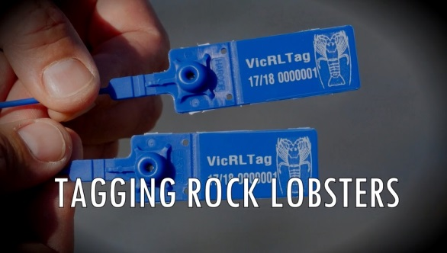
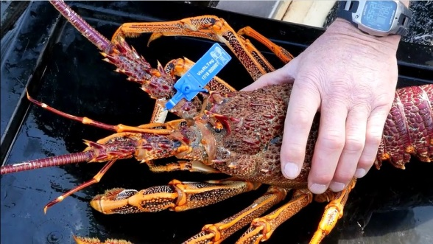

  - Commercial fishery management arrangements
As with the recreational fishery, management arrangements for the commercial fishery are established in the Fisheries Regulations, which are subordinate to the Fisheries Act.
    - Rights and entitlements
Rock lobster fishing entitlements are based on the legal ownership of a Rock Lobster Fishery Access Licence and the licence provides access to the fishery. Within each zone, access licences are fully transferrable and the quota units and pot entitlements on access licences are separate and independently tradeable commodities.
The fishery is a limited-entry fishery. No additional licences will be issued in either zone of the fishery and licences will not be replaced when cancelled by a court or removed from the fishery through mechanisms such as restructure or non-renewal.
Rock Lobster Fishery Access Licences are issued for one year and must be renewed prior to expiry in order for the licence holder to commence fishing at the start of a new quota period. Licence holders will not receive a quota notice for a new quota period until their licence is renewed.
    - Management controls
The commercial fishery has been managed as a separate and limited-entry fishery since 1968. During 2001, the fishery moved to output controls in the form of quota management, involving an annual TACC and individual transferrable quotas, which changed the emphasis from restricting fishing effort to allocating and limiting the catch. A number of input controls were retained: licence conditions, total number of pots per zone and per boat, legal minimum length, and closed seasons.
Individual transferrable quota and total allowable commercial catch
The primary catch control tool for the Rock Lobster Fishery is individual quotas. The quota units are attached to Rock Lobster Fishery Access Licences and each licenced commercial fisher is annually assigned a proportion of the TACC through the individual transferable quota units.
Individual quota units are tradable and a licence holder may apply to transfer the quota units to the holder of another Rock Lobster Fishery Access Licence within the same zone. Individual transferable quota units may be transferred permanently or for a quota period.
Each fishing zone has a total number of individual transferable quota units. The number of quota units was established when the quota management system was introduced and quota units allocated through an Initial Quota Order. There are 1000 quota units in the Eastern Zone. As a result of a structural adjustment program implemented in the Western Zone in 2009, 366.52 quota units were permanently removed from that zone. The Initial Quota Order for the Western Zone was therefore amended from 4000 quota units to 3633.48 quota units (refer to Table 2).
It is a requirement that a minimum amount of quota be attached to a licence before it may be used. The minimum amounts of quota are ten units in the Western Zone and five units in the Eastern Zone. There is no maximum number of quota units that can be attached to a licence in either zone. Licences may be transferred without quota but cannot be operated until the required minimum quota units are attached.
Once the annual TACC is determined, it is divided by the number of quota units in the zone, which
results in a kilogram value for each unit. A quota notice is then issued by the Minister or delegate to
each access licence holder stating the TACC for each zone, the kilogram value of a quota unit in each
zone and the period for which the quota notice applies (refer to Sections 6.2. and 7 for more detail on
the TACC-setting process).
The TACC set includes both southern and eastern rock lobster species. The catch is predominantly Southern Rock Lobster but small amounts of Eastern Rock Lobster (S. verreauxi) are landed.
Catches of each species must be recorded separately in the daily catch logbook. If the annual catch of Eastern Rock Lobster exceeds one tonne, a management review will be triggered and controls to manage
the fishery will be introduced if necessary.
Quota management system
The number of individual transferable quota units assigned to a Rock Lobster Fishery Access Licence is known and tracked the Quota Management System. As rock lobsters are caught, the weight of the catch is subtracted from the quota balance assigned to the Rock Lobster Fishery Access Licence. When the entire quota assigned to a licence has been caught, the holder must either acquire more quota units or cease fishing for the remainder of the quota period.
The Rock Lobster Quota Management System is based on telephone and written records. Fishers
record the number of rock lobsters caught in their daily catch logbook and also report via telephone
using the Quota Monitoring Interactive Voice Response (IVR) System. The IVR report must be made within the regulated minimum time prior to the vessel entering any of the ports or mooring areas at which rock lobster can be landed in Victoria. Daily catch records are submitted to the Victorian Fisheries Authority each month.
Rock lobster catches must be weighed and reported through the interactive voice response system no more than 20 minutes after landing. Rock lobsters sold or taken from the place of landing must be recorded in catch disposal records. Catches, boats and required documentation are inspected regularly
by Fisheries Officers.
Cross-jurisdictional management arrangements
Rock lobster catches from Victorian waters may be landed in Port MacDonnell, South Australia and in Eden, New South Wales. Licence holders must apply each year for a condition to allow for interstate landings to be added to their licence.
Licence conditions
Licence holders may apply to vary the conditions relating to the operators, boat and pot entitlements on a Rock Lobster Fishery Access Licence. No more than two operators can be named on a licence and either person may operate the licence. The same boat may be specified on multiple access licences in the same zone but not different zones. This allows multiple licences to be operated from one boat.
Pots, pot entitlements and limits
In the commercial fishery, rock lobsters can only be harvested using pots. Pot design and size is
specified in regulation. Pots must have only one entrance, one chamber and at least one escape gap
of a regulated size.
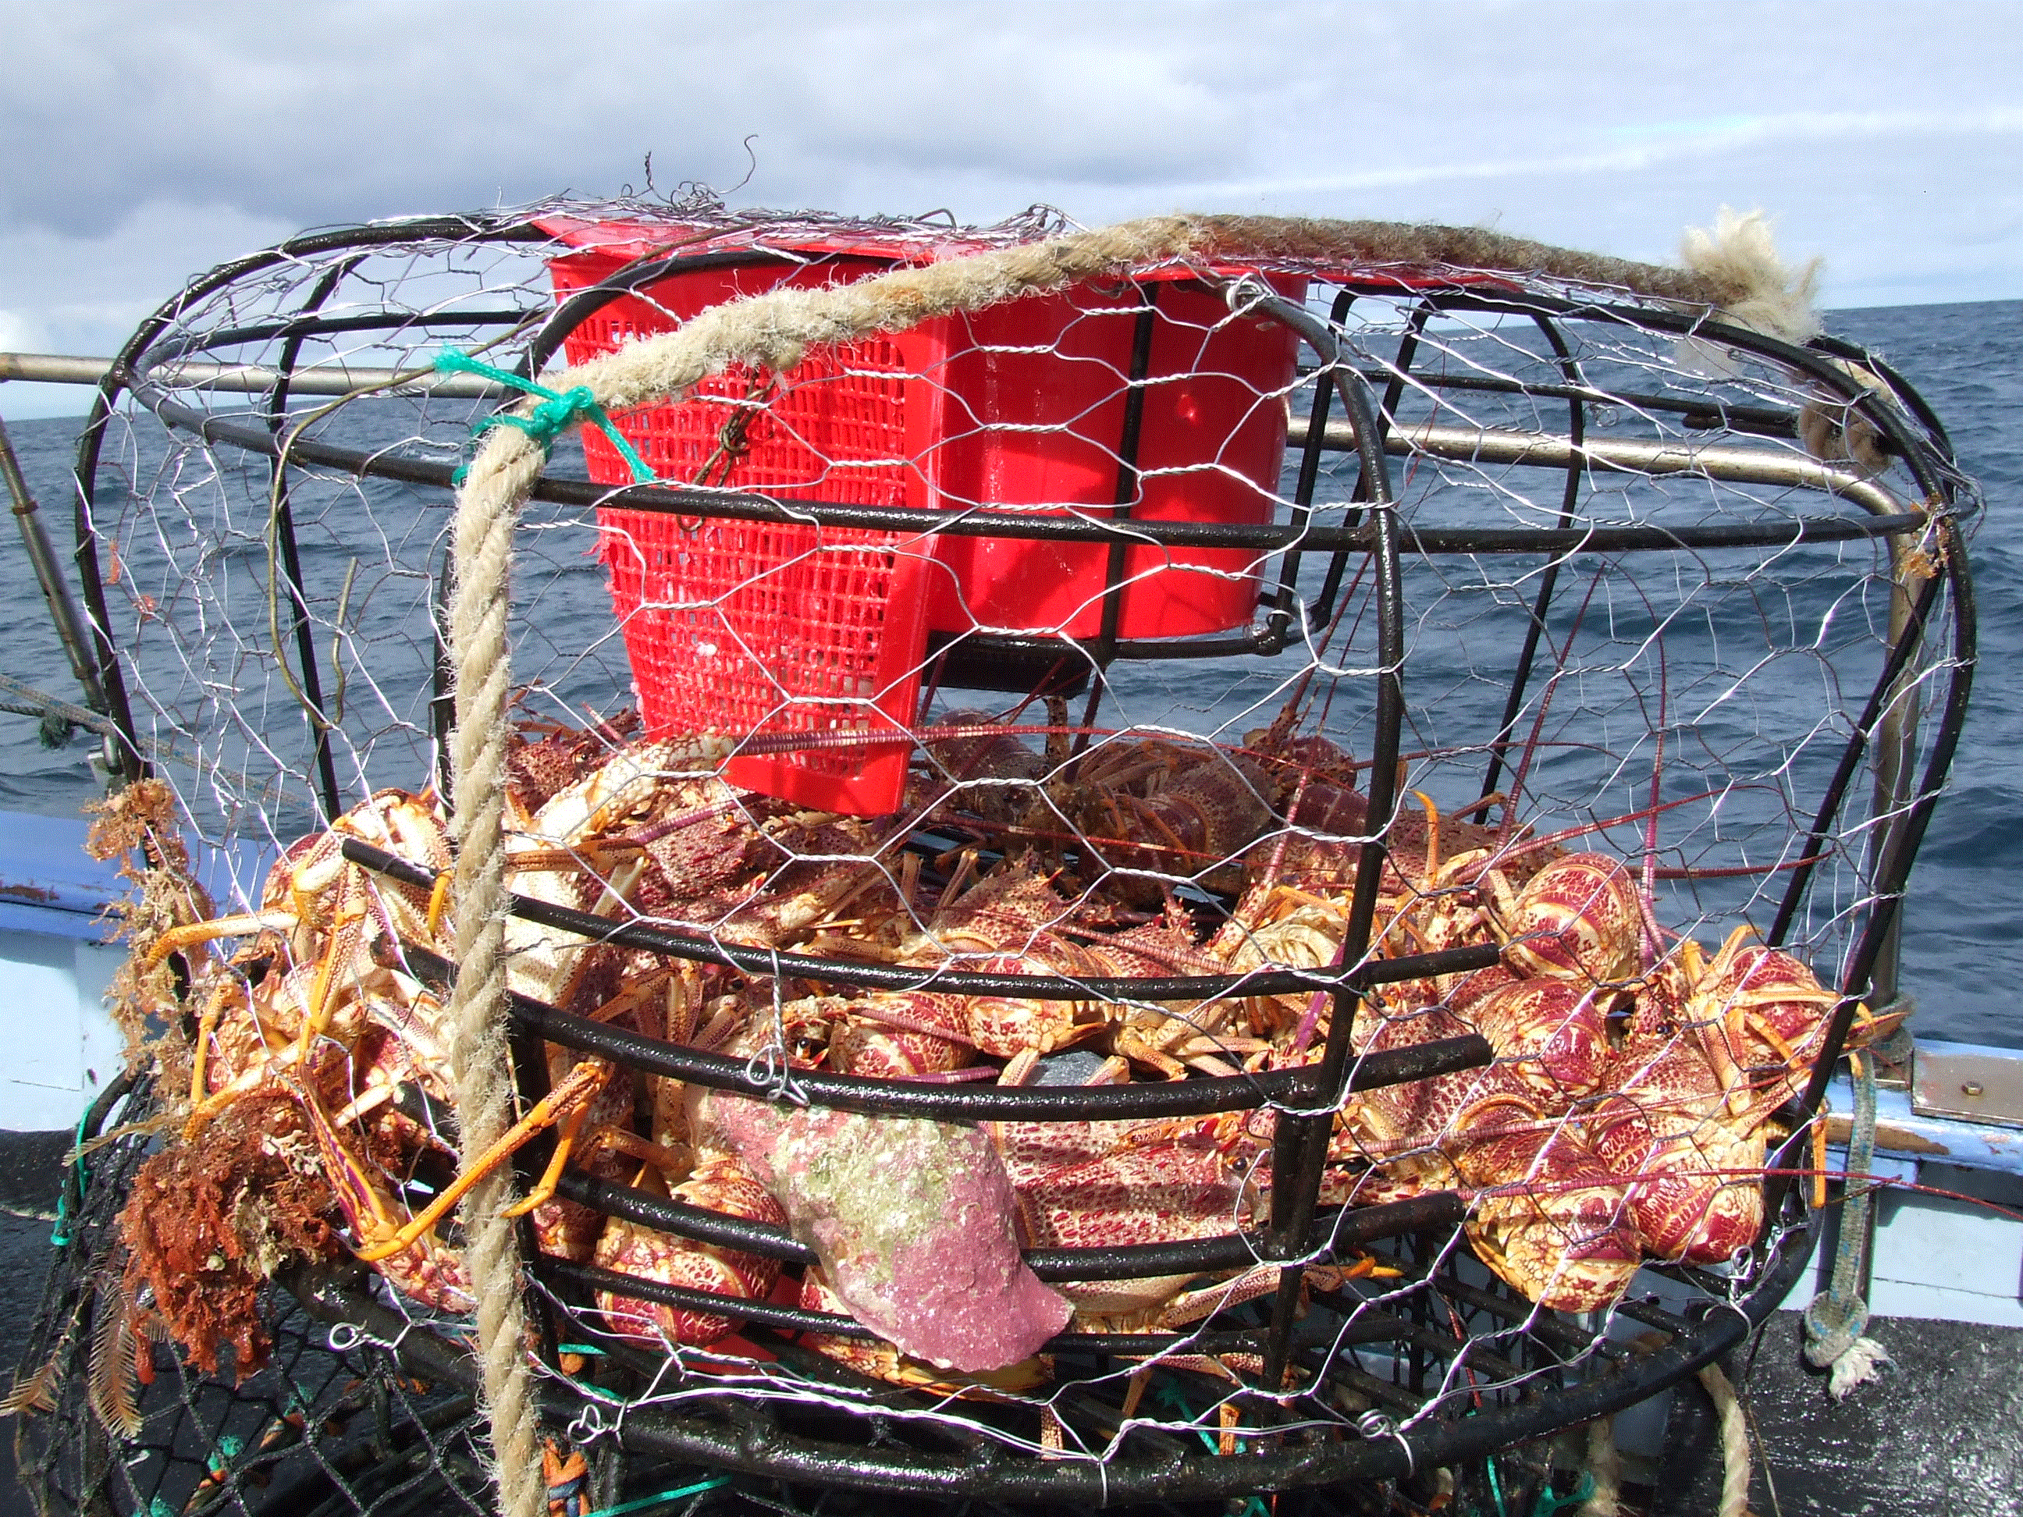
Pots may be transferred permanently, or for one licensing period, between Rock Lobster Fishery Access Licences within a zone.
The overall number of pots in the fishery is limited to 5162 in the Western Zone and 2021 in the Eastern Zone. No more than 140 pots can be fished from a commercial rock lobster fishing boat at any one time.
Licence holders must have a minimum of 15 and 20 pots to operate in the Eastern Zone and the Western Zone, respectively. A licence holder can own quota without pots but cannot operate in the fishery unless these minimum requirements are met.

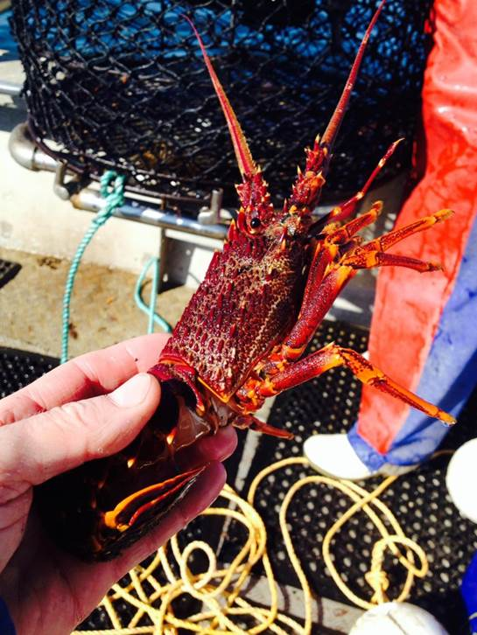
Size limits
The legal minimum length and the method of determining the length
is the same in the commercial and recreational sectors. That is, legal minimum length for male rock lobsters is 110 millimetres and for females
is 105 millimetres. The length of a rock lobster is determined by the carapace length, which is measured from the front edge of the groove between the animal’s large antennae to the nearest part of the rear edge of its carapace.
Due to differences in size at the onset of sexual maturity and growth
rates of male and female rock lobsters, the legal minimum length may
be reviewed as part of the TACC-setting process to manage available
and spawning biomass in each zone.
Closed seasons
The commercial fishing season is consistent with the recreational fishing season. Fishing for rock lobster
is prohibited during closed seasons and no soft-shelled rock lobster can be taken at any time.
The closed season for female rock lobsters is from 1 June to 15 November. This protects females
with eggs attached during the spawning period. The removal of eggs, spawn, setae or fibres from
females is prohibited.
The closed season for male rock lobster is from 15 September to 15 November and protects males during the moulting period when soft shells increase their vulnerability.
Fisheries regulations are in place to manage the environmental risks associated with leaving rock lobster pots unattended during closed seasons (i.e. holding ground). Under the Fisheries Regulations, holders of Rock Lobster Fishery Access Licence must not, during the closed season for male rock lobster, use any rock lobster pot or leave or have any rock lobster pot immersed or set in Victorian waters.
Coffs and wet wells
A coff is a sea cage used to store rock lobster alive. A wet well is a water-filled chamber on board a
rock lobster fishing boat used to store rock lobster alive. Rock Lobster Fishery Access Licence holders may continue to use coffs and wet wells. Licence holders are entitled to three coffs per licence. Additional coffs can be requested through application to the VFA and an assessment of the particular circumstances will be conducted.
This management plan provides for mandatory reporting of rock lobster mortality in coffs and wet wells to assist in quantifying mortalities. Measures to manage deaths in coffs and wet wells will be developed early in the life of the plan and, if it is established that loss of stock that has been removed from the fishery is considered unacceptable, new management mechanisms and/or regulations will be introduced as required
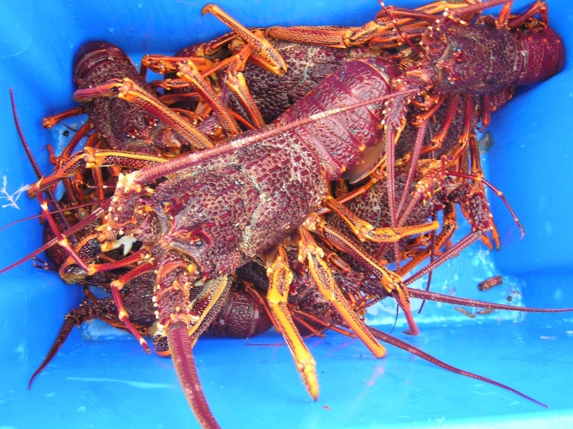

- Monitoring and Assessment
A vital component in the management of the Rock Lobster Fishery is the collection and analysis of data. The Rock Lobster Fishery has a comprehensive data collection program that informs the annual stock assessment and is used in setting the TACC and directing management decisions.
The data collection program incorporates a range of fishery-dependent and fishery-independent data.
  - Data collection
    - Fishery-dependent data
Commercial catch and effort logbooks
The requirement to complete daily commercial logbooks has been in place since 1978. Logbooks are submitted monthly and the information currently recorded includes:
- Fishing location;
- The minimum and maximum depths of pot set;
- Number of pot lifted;
- Number and weight of rock lobsters caught;
- Number of undersize rock lobsters;
- Number of females in berry;
- Number and weight of octopus caught;
- Number of dead rock lobsters; and
- Weight of other species caught as bycatch or by-product.
The data collected in commercial logbooks comprises a significant proportion of the stock assessment modelling and analysis. The standardised CPUE of legally-sized rock lobsters is the primary determinant of the annual TACC and underpins the stock assessment.
Voluntary pot sampling
A small number of fishers currently measure catch from three specially marked pots each day. This data supplements the data collected by on-board observers. An electronic logger and wet tags combination is being trialled with the aim to streamline the data collection process and improve industry participation. If successful, there is a significant potential to greatly improve the spatial and temporal coverage of data collected across the fishery.
Wildlife interaction data
It is a requirement under the EPBC Act to report all interactions with threatened, endangered and protected species. This requirement has been incorporated into the commercial logbook.
    - Fishery-independent data
There are currently three sources of fishery-independent data collected in the fishery.
- On-board sampling
The on-board sampling program has been in place since 2004 and has been responsible for, on average, 8,900 observations taken over approximately 140 days annually. Data is collected at sea and includes length, sex, colour, shell hardness, reproductive condition, undersize and bycatch species. There is a commitment to maintaining approximately 80 observer days in the Western Zone and 60 observer days in the Eastern Zone, annually.
- Fixed-site surveys
Fixed-site surveys have been conducted on an annual basis in the Western Zone since 2002 and in the Eastern Zone since 1996. The data set is considered one of the most comprehensive throughout the south-east Australian rock lobster fisheries. The surveys are conducted at the same times and sites each year, with eight sites in the Western Zone and two in the Eastern Zone. Currently, the escape gaps of the pots in the Western Zone are closed in an attempt to capture a higher number of undersize rock lobsters. The data on undersize animals is crucial in providing a predictive indicator of the potential stock size available to the fishery one to three years into the future.
Commercial rock lobster fishers are contracted on an annual basis to provide their expertise and fishing vessels for the survey and VFA staff assist in setting pots and recording data. The data collected includes length, sex, colour, shell hardness, reproductive condition, undersize and bycatch species.
Undersize lobsters are tagged as part of the tag and recapture program and between 2,500 and 7,000 lobsters are tagged each year. When recaptured, the tagging data provides important information on the growth and movement of rock lobsters. Approximately 12 to 14 percent of tags have been returned, mostly by commercial fishers.
- Puerulus collection
Crevice collectors are placed just above the sea floor and are serviced monthly by divers. The program began in 1994 and there are currently 12 collectors in Apollo Bay and six in Port Campbell. The number and length of puerulus are recorded for each collector.
  - Stock assessment
The status of the rock lobster resource in Victoria is reviewed annually and published in a Stock Assessment Report. The data collected in the fishery is designed to provide a picture of the current status of the fishery, through the analysis of catch and effort data, as well as the likely future status through analysis of trends in puerulus, pre-recruits and recruits. The cornerstone of the assessment is a length-structured population model (Hobday et al. 2005), which uses data and biological information such as growth and reproductive characteristics to provide estimates of the current stock biomass.
Currently, data is assessed to the end of the ‘fishing year’, which runs from 16 November to the following 14 September.
    - Catch rate standardisation and modelling
The stock assessment model uses standardised CPUE. Prior to standardisation, the data are filtered to ensure that only data from fishers contributing logbook returns in more than two separate fishing years and contributing 200 or more records are included in the CPUE standardisation.
CPUE standardisation
After filtering, the CPUE is standardised for each zone separately by adjusting for differences among the regions, depth ranges, fishing seasons, months, fishers and vessels.
For the standardisation, the regions are Portland, Warrnambool and Apollo Bay in the Western Zone, and Queenscliff, San Remo and Lakes Entrance in the Eastern Zone and the fishing depth ranges are <40 m and ≥40 m. The model uses the interactions between region and year to create yearly estimates of standardised CPUE by region (Walker et al. 2012, Linnane et al. 2015).
Modelling
The model is fitted simultaneously to several data sets: monthly standardised CPUE, expressed as kilograms per pot lift; monthly mass and number of rock lobsters landed and length-frequency distribution of the catch observed at-sea (above and below legal minimum length (Walker et al. 2012).
Marine Protected Areas are accounted for in the model (eight percent in the Western Zone and 16 percent in the Eastern Zone) and levels of recreational catch are assumed (five percent of the TACC in the Western Zone and ten percent of the TACC in the Eastern Zone).

The model estimates two stock performance indicators: ‘egg production’ and ‘available biomass’. Egg production is a measure of the number of eggs produced by mature female rock lobsters. Available biomass is a measure of the stock biomass of rock lobsters that can be legally caught.
The model infers change and absolute levels of stock abundance. It estimates levels of recruitment to the fishery by combining changes in mean size and size distribution of the catch from length-frequency data, and on changes in CPUE (Linnane et al. 2015).
    - Stock assessment and reporting
The results of the modelling, combined with summarised fishery data, comprise the annual stock assessment for the fishery. The results of the assessment are used to set the TACC for the upcoming season.
Data is collected across the range of life stages of rock lobster and long-term trends are analysed as a way of strengthening the understanding of the current status of the fishery and likely future scenarios. Trends in the following are considered throughout the stock assessment process:
- Catch and fishing effort;
- Nominal and standardised CPUE;
- Egg production;
- Puerulus settlement;
- Pre-recruitment (to 60 mm carapace length);
- Numbers of undersize (approx. 80 mm carapace length up to just under legal minimum length);
- Available biomass; and
- Exploitation rate.
The results of the analysis are presented in the annual Stock Assessment Report, which is publicly available and provided to stakeholders. The report provides an evaluation of the fishery and an interpretation of the stock assessment results against the management objectives for the fishery, the stock performance indicators and reference points. The report also provides the information needed to set the TACC for the following season in accordance with the decision rules in the harvest strategy of this management plan (refer to Section 7).
    - TACC-setting process
Upon completion of the Stock Assessment Report, the VFA will coordinate a meeting of the Rock Lobster and Giant Crab Resource Assessment Group (RLRAG) to analyse and discuss the results. The RLRAG is an expertise-based committee comprising representatives from the commercial, recreational, scientific and management sectors. The role of the RLRAG is to provide advice and recommendations to the VFA on the status of the fishery.
The RLRAG assesses the stock assessment results and provides a recommendation on the outcomes and the application of the harvest strategy. The Stock Assessment Report is then disseminated to stakeholders in preparation for broad consultation on the TACC proposed for the following season.
As part of the decision making process, the rock lobster fishing industry will be invited to provide comment on the stock assessment, particularly the CPUE. It is acknowledged that on occasion the CPUE can be affected by factors that are external to the status of the stock but which result in portions of TACC being uncaught or lower CPUE levels. Such factors could include, but are not limited to:
- Environmental conditions;
- Market failure;
- Currency fluctuations in Australia or in export destinations;
- Factors impacting price (product fluctuations, market forces, logistics costs); or
- Fluctuations in fuel and bait prices
The rock lobster fishing industry must submit a written statement to the VFA providing factual and credible evidence to support any claims of these external factors on that year’s CPUE.
The VFA will also conduct broader consultation with all relevant stakeholders on the proposed TACC in accordance with the consultation principles outlined in the Fisheries Act.
The VFA will then consider all submissions and a resulting TACC will be recommended to the Minister, or the Minister’s delegate. The Minister, or delegate, has the responsibility of determining the value of a quota unit and setting the TACC under the Fisheries Act and publishing the Further Quota Statement in the Victoria Government Gazette.
The annual TACC-setting process is summarised in Table 7 below.

Table 7: Annual TACC-setting process for the Rock Lobster Fishery
Action | Responsibility
The annual assessment of the rock lobster stock is conducted and results are presented in the Stock Assessment Report | Stock assessment science provider
The RLRAG reviews the Stock Assessment Report and provides advice to the VFA on the status of the fishery and application of the harvest strategy | RLRAG
The Stock Assessment Report is disseminated to all relevant stakeholders | VFA
Through industry representative groups, the industry provides a written statement documenting credible evidence to support any claims of external factors influencing that year’s CPUE | Industry groups
The VFA convenes annual Stock Assessment Forum with relevant stakeholders | VFA
The VFA prepares a draft Further Quota Order for statutory consultation (minimum two weeks), with the quota for each zone included | VFA
The Minister (or delegate) makes a decision regarding the TACC following consideration of all available information and consultation submissions | Minister (or delegate)
The annual TACCs are gazetted and published on the VFA’s website. The VFA writes to all stakeholders to inform them of the decision | VFA

- Rock Lobster Fishery Harvest Strategy
Harvest strategies provide a structured framework for assessing the status of a fishery and a set of rules to determine what the annual catch limits will be. Decisions regarding catch limits are therefore set out in advance, ensuring that fishers, fishery managers and other relevant stakeholders know what action will be taken in response to the conditions in the fishery (Sloane et al 2014).
The foundation of this harvest strategy is the exploitation rate, which is the proportion of the available stock that can be caught. Unlike the previous harvest strategy used for the fishery, it does not include a rebuilding target so conservative exploitation rates that ensure that stocks rebuild, catch rates improve, profits are maximised and the objectives of this harvest strategy and management plan are met are used.
  - Operational objectives
This harvest strategy aims to achieve two main operational objectives, both of which link to the overarching objectives for the management of the fishery. These operational objectives are:
- Continue to rebuild the rock lobster population by setting appropriately conservative TACCs
on an annual basis.
- Maintain catch rates above 0.40 kg/pot lift (standardised).
  - Principles of the harvest strategy
- The harvest strategy is based on standardised CPUE from commercial catch and effort logbook information and is derived from the ‘fishing year data series’ (i.e. November to September).
All estimates of standardised CPUE are rounded to two decimal places.
- TACCs are predetermined and have been calculated using agreed rates of exploitation.
- TACCs are set by assessing the fishing zone’s performance against stock performance
indicators, biological reference points and applying decision rules. These factors include the standardised CPUE from that year’s stock assessment, a pre-recruit index (PRI) and predefined TACC tables that determine whether the annual TACC is increased, maintained or decreased
in the following season.
- The rate of exploitation is constant unless the annual standardised CPUE falls below 0.40kg/pot lift (the upper limit reference point), when it is incrementally reduced (Figure 9).
- The annual standardised CPUE will be rounded to two decimal points when it is at and above the upper limit reference point and the exploitation rate is constant (refer to the green zone in Figure 9). It will be increased to three decimal points when the annual standardised CPUE falls between the upper and lower limit reference points (refer to the orange zone in Figure 9).
- The fishery will be closed if the catch rate falls to 0.25kg/pot lift (the lower limit reference point)
or less (Figure 9).
- To receive an increase in TACC, the annual PRI must be above the PRI threshold set for
each zone.
- The TACC can only be increased by one level at any time (‘one-jump rule’).
- An upper limit, or cap, on TACC levels has been included in this harvest strategy. The cap
for the Western Zone is 300 tonnes and 70 tonnes for the Eastern Zone.

Lower limit reference point
Fishery closed
Upper limit reference point
Harvest rate decreases

Exploitation rate
 |  | Constant harvest rate
30%
15%
0
 | 0 | 0.25 | 0.275 | 0.300 | 0.325 | 0.350 | 0.4 | 0.45 | 0.5 | 0.55 | 0.6 | 0.65 | 0.7 | 0.75 | 0.8
Standardised CPUE (kg/pot lift)

Figure 9. Theoretical construction of the proposed harvest strategy framework.

    - Exploitation rates
- The exploitation rates when the catch rate is at and above the upper reference point are:
  - 32.5% in the Western Zone; and
  - 15.0 % in the Eastern Zone.
    - Stock performance indicators
Performance indicators measure and track the performance of the stock against the operational objectives in this harvest strategy and are integral in determining the level at which the TACC will be set.
Three biological performance indicators are used in setting the TACC:
- Egg production – an estimate of the spawning size of the population. It is a crucial determinant of the health of the stock and is used in this strategy as a primary indicator in the decision rules.
- Standardised CPUE – CPUE data comes from the catch and effort logbooks submitted by commercial fishers. In lobster fisheries, CPUE is accepted as being a proxy representing the abundance of rock lobsters in the fishery above the legal minimum length. It is expressed as the effort required to harvest a defined amount of catch. Standardised CPUE has had irregularities in the data removed and it has been standardised for a range of factors that affect catchability, such as month, year, depth, region and fisher (i.e. the ability and practices of fishers)
- Pre-recruit index – is the number of undersize lobsters per pot lift and is derived from the data collected through the fixed-site survey and on-board observer programs. The annual PRI will be rounded to two decimal places.
A further performance indicator, available biomass, will be used in the assessment of the fishery. This indicator however does not result in explicit TACC adjustments in the fishery in the way egg production, standardised CPUE and pre-recruit index do. Available biomass, as well as historic exploitation rates, is used to provide a more comprehensive picture of the status of the fishery and trends over time.

    - Reference points for the performance indicators
Reference points are the benchmarks of performance that define acceptable levels of impact on a stock (Sloane et al. 2014). Reference points are usually linked to the performance indicators and three types have been used; these are limit, threshold and target reference points.
Limit reference points
Limit reference points (LRP) act like a safety measure as they establish the point at which there is significant risk to the sustainability of the stock. The LRPs used in this harvest strategy are:
- Egg production LRP
Model estimated egg production must be above the LRP of 20% of E₁₉₅₁ with a 90% probability.
- Standardised CPUE LRP
An upper and a lower LRP have been established, both of which are CPUE-based.
  - Upper LRP: 0.40kg/pot lift
  - Lower LRP: 0.25kg/pot lift
If the standardised CPUE falls below the upper LRP, the harvest rates are decreased sequentially to avoid reaching the lower LRP. If the LRP point is breached, the fishery will be closed to all fishing.
Threshold reference point
Threshold reference points can represent a threshold value which triggers a certain management action or a pre-determined management response.
Pre-recruit index threshold
In this harvest strategy, threshold reference points have been established for the PRI.
The PRI threshold is determined using data from the fixed-site surveys and on-board observer program and is averaged, weighted by region based on past commercial catch during a reference period of 2005 to 2014.
To be eligible for an increase in the TACC in an upcoming season, the PRI for that stock assessment period must be above the threshold level for that zone.
The PRI thresholds are:
- 1.81 undersize per pot lift in the Western Zone; and
- 0.32 undersize per pot lift in the Eastern Zone.
Target reference point
The target reference point defines the level or value of an indicator that is considered ideal or desirable and at which management should aim.
Maximum economic yield
A target reference point is not explicit in this harvest strategy; however, it is an objective of the management plan to develop a long-term maximum economic yield (MEY) target reference point for
the stock. MEY is the theoretical catch or effort level that maximises the profit of the commercial fishery.
MEY occurs when the total fishing revenue minus total fishing costs is maximised. Economic efficiency
in a fishery suggests that the stock is protected and the net returns (i.e. the profits) for fishers are maximised (Australian Government 2007).

  - Decision rules to set the tacc
The annual TACC will be set using the following decision rules:
Decision Rule 1: Egg production
Model estimated egg production must be above the limit reference point of 20% of E₁₉₅₁ with a 90% probability. This decision rule must be satisfied before the CPUE-based harvest strategy can be used to set the TACC.

If this decision rule is not met, the TACC will be determined using the rock lobster fishery model to ensure that the TACC returns the egg production to above the limit reference point within two years with a 90% probability.
Decision Rule 2: TACC Determination
When Decision Rule #1 has been met, the TACC is set using the standardised CPUE tables. Refer to Tables 7 and 8, for the Western and Eastern Zones, respectively.

Step 1: Use the standardised CPUE from the stock assessment to identify the CPUE band.

Step 2: Determine the TACC level according to the following conditions:

  - The TACC will be increased to the next level when:

    - the standardised CPUE is in a band higher than in the previous season;
AND
    - the PRI (rounded to two decimal places) is at or above the threshold level of 1.80 undersize per pot lift for the Western Zone or 0.32 undersize per pot lift for the Eastern Zone.

One-jump rule: the TACC can only be increased one level per year.

  - The TACC will remain at the same level when:

    - the standardised CPUE remains in the current band;
OR
    - the standardised CPUE has increased to a higher band but the PRI is below the trigger point.

  - The TACC will be decreased when:

    - the standardised CPUE has decreased into any lower band.

The TACC will be set at the level that corresponds to the standardised CPUE.

Decision Rule 3: TACC Cap
A TACC cap of 300 tonnes in the Western Zone and 70 tonnes in the Eastern Zone will be used over the life of the harvest strategy.

  - Tacc tables
The levels of TACC are pre-set and based on the chosen harvest rate. The values of the TACCs and the corresponding CPUE are in the Tables 8 and 9. These tables, in association with the decision rules will be used to set the TACCs for the fishery over the life of the Management Plan.
- The TACC tables consist of CPUE bands and corresponding TACC levels. The tables comprise three levels, which correspond to the upper and lower limit reference points:
  - The CPUE are set at bands of 0.05kg/pot lift when the standardised CPUE is above the upper limit reference point of 0.40kg/pot lift.
  - The band-widths of the TACC levels reduce to 0.025kg/pot lift when the standardised CPUE is between 0.25kg/pot lift and 0.40kg/pot lift.
- If the standardised CPUE drops below 0.25kg/pot lift, the fishery in that zone will be closed
to all fishing (commercial and recreational). To determine the status of the fishery in that zone
after the closure:
  - Fishing is to be undertaken through the fixed-site survey program, using the survey protocols used in previous seasons;
  - A fixed-site survey measure of CPUE will be computed; and,
  - A re-scaling method will be applied to convert the fixed-site survey CPUE to standardised CPUE.

Table 8. CPUE thresholds and corresponding TACC levels for the Western Zone.

WESTERN ZONE
CPUE band | TACC Levels - with 300t cap
<0.25 | 0
0.250 - <0.275 | 19
0.275 - <0.300 | 42
0.300 - <0.325 | 69
0.325 - <0.350 | 100
0.350 - <0.375 | 134
0.375 - <0.40 | 171
0.40 - <0.45 | 219
0.45 - <0.50 | 245
0.50 - <0.55 | 271
0.55 - <0.60 | 297
0.60 - <0.65 | 300
0.65 - <0.70 | 300
0.70 - <0.75 | 300
0.75 - <0.80 | 300
Table 9. CPUE thresholds and corresponding TACC levels for the Eastern Zone.

EASTERN ZONE
CPUE band | TACC Levels - with 70t cap
<0.25 | 0
0.250 - <0.275 | 4
0.275 - <0.300 | 8
0.300 - <0.325 | 14
0.325 - <0.350 | 20
0.350 - <0.375 | 26
0.375 - <0.400 | 33
0.40 - <0.45 | 42
0.45 - <0.50 | 47
0.50 - <0.55 | 51
0.55 - <0.60 | 56
0.60 - <0.65 | 60
0.65 - <0.70 | 65
0.70 - <0.75 | 69
0.75 - <0.80 | 70

- Blue TACC values refer to the TACC cap
- Green TACC values refer to standardised CPUE values that are above the upper LRP and have a constant exploitation rate (32.5% in the Western Zone and 15% in the Eastern Zone).
- Orange TACC values refer to standardised CPUE values below the upper LRP and have incrementally decreasing exploitation rates.

- Glossary
These terms are intended to be used for the purpose of this management plan only and are not intended to be inconsistent with fisheries legislation.
Available biomass: The mass of the rock lobster stock that is above the legal minimum length and therefore available to the fishery.
Bag limit: The maximum number of a species that can be legally be taken per day by a recreational fisher.
Biomass: The total weight or volume of individuals in a fish stock.
Bycatch: The component of the catch that is not a targeted species and which is returned to the water.
By-product: Non-targeted catch that is commercially valuable and retained by commercial fishers.
Catch per unit effort: A measure of fishing success with a type or unit of fishing gear. Catch per unit effort in the lobster fishery is measured as the weight of lobster captured per pot lift.
Ecologically Sustainable Development: The use of natural resources in a manner that maintains the life-support systems of nature and does not diminish the potential of the resource to meet the needs and aspirations of future generations.
Egg production: The mass of stock that has reached sexual maturity and contributes to recruitment. Egg production is an estimate of the spawning capacity.
Exploitation rate: The ratio of annual legally sized catch (tonnes) divided by the exploitable biomass (tonnes).
Fishery: The act, process and or industry of catching fish. In Victoria, fisheries are defined by the species to be taken, the equipment used or area as specified in the Fisheries Regulations.
Fishery-dependent data: The information collected by the participants in fishery about that fishery or fish stock, e.g. commercial catch and effort logbooks.
Fishery-independent data: The information collected about a fishery or fish stock by researchers independent of the fishery. e.g. scientific surveys, on-board observers.
Harvest: The total number or weight of fish caught and kept from an area over a period of time.
Individual transferable quota units: A management tool by which portions of the total allowable commercial catch are allocated amongst licence holders as quota.
Input controls: Indirect restraints on catch including regulation of the amount or type of fishing gear (e.g. numbers of pots) and fishing period (e.g. closed seasons).
Limited entry fishery: A fishery where the number of operators or vessels is restricted.
Maximum economic yield (MEY): MEY is the theoretical catch or effort level that maximises the profit of the commercial fishery. MEY occurs when the total fishing revenue minus total fishing costs is maximised. Economic efficiency in a fishery suggests that the stock is protected and the net returns (i.e. the profits) for fishers are maximised.
Nominal fishing effort: ‘Nominal’ means raw data, including commercial catch data, as reported by fishers before any analyses or statistical transformations have been carried out on the data. Nominal effort refers to measures of fishing effort or vessel carrying capacity that have not been standardised.
Offshore Constitutional Settlement (OCS): An agreement between the State(s) and the Commonwealth whereby the State or the Commonwealth (or in some cases a Joint Authoruty) is given jurisdiction for a particular fishery occurring in both coastal waters and the Australian Fishing Zone.
Output controls: A direct limit on catch in a fishery (e.g. a Total Allowable Catch) or on an access licence holder (e.g. individual transferable quota).
Possession limit: The number of a species in a person’s possession in, on or adjacent to Victorian waters.
Pre-recruit index (PRI): The pre-recruit index is an indicator of the likely future stock levels in the fishery. It is measured by the number of undersize animals (i.e. below the legal minimum length) in each pot lift averaged over all pot lifts.
Precautionary principle: This concept asserts that where there are threats of serious or irreversible damage, lack of full scientific certainty shall not be used as a reason for postponing measures to prevent environmental degradation. In the application of the precautionary principle, public and private decision making should be guided by: (i) careful evaluation to avoid, wherever practicable, serious or irreversible damage to the environment, and (ii) an assessment of the risk-weighted consequences of various options.
Quota: A limit on the weight or number of fish of a particular stock or from specified waters that may be caught in a specified timeframe.
Recruitment: The addition of new individuals of legal size to a stock.
Reference point: An indicator level of fishing (or stock size) to be used as a benchmark for assessment or decision making.
Size limit: A minimum or maximum size limit that determines the legal size at which a given species can be retained.
Species: A group of organisms capable of interbreeding freely with each other but not with member of other species.
Stakeholder: An individual or organisation, including peak bodies, with a vested interest or an historical association with a fishery resource.
Stock: A group of individuals of a species occupying a well-defined spatial range independent of other groups of the same species, which can be regarded as an entity for management or assessment purposes.
Target reference point: The target reference point defines the level or value of an indicator that is considered ideal or desirable and at which management should aim.
Total Allowable Catch: The mass of rock lobster that may be taken by commercial and
recreational fishers.
Total Allowable Commercial Catch (TACC): The mass of rock lobster that may be taken within a quota period by commercial access licence holders according to the final quota order.
Total Allowable Recreational Catch: The mass of rock lobster that may be taken by recreational fishers. The Total Allowable Recreational Catch is limited to five and ten per cent of the Total Allowable Commercial Catch in the Western Zone and the Eastern Zone, respectively.
Trigger or threshold points: Events or measures that, if they occur or if they reach specified levels, are used to determine when a response should be made. The action to be taken is usually prescribed.

- References

Attorney-Generals Department (2007). The Offshore Constitutional Settlement. Attorney-Generals
Office, Canberra.

Australian Government (1992) National Strategy for Ecologically Sustainable Development. AGPS Press, Canberra. http://www.environment.gov.au/about-us/esd/publications/national-esd-strategy

Department of the Environment and Water Resources (Australian Government) (2007). Guidelines for
the Ecologically Sustainable Management of Fisheries – Edition 2. http://www.environment.gov.au/marine/publications/guidelines-ecologically-sustainable-management-fisheries

Department of Primary Industries (2003). Rock Lobster Fishery Management Plan. Fisheries Victoria Management Report Series No.1, Department of Primary Industries, Melbourne.

Department of Primary Industries (2009). Victorian Rock Lobster Fishery Management Plan. Fisheries Victoria Management Report Series No.70, Department of Primary Industries, Melbourne.

Fletcher, W.J., Chesson, J., Fisher, M., Sainsbury, K.J., Hundloe, T., Smith, A.D.M. and B. Whitworth (2002) National ESD Reporting Framework for Australian Fisheries: The ‘How to’ Guide for Wild Capture Fisheries. FRDC Project 2000/145, Canberra, Australia.

Flood, M, Stobutzki, I, Andrews, J, Ashby, C, Begg, G, Fletcher, R, Gardner, C, Georgeson, L, Hansen, S, Hartmann, K, Hone, P, Horvat, P, Maloney, L, McDonald, B, Moore, A, Roelofs, A, Sainsbury, K, Saunders, T, Smith, T, Stewardson, C, Stewart, J & Wise, B (eds) (2014), Status of key Australian fish stocks reports 2014, Fisheries Research and Development Corporation, Canberra.

Hobday, D, Punt, A and Smith D (2005). Modelling the effects of marine protected areas on Victoria’s southern rock lobster, Jasus edwardsii, fishery. New Zealand Journal of Marine and Freshwater Research 39(3), pp. 675-686.

Linnane, A, McGarvey, R, McLeay, L, Feenstra, J, and Reilly, D (2015). Victorian Rock Lobster and Giant Crab Fisheries Status Report – 2013/14 Fishing Year. Fishery Status Report to Fisheries Victoria. South Australian Research and Development Institute (Aquatic Sciences), Adelaide.

Punt, A, and Kennedy, R (1997). Population modelling of Tasmanian rock lobsters, Jasus edwardsii, resources. Marine and Freshwater Research 48, 967-980

Sloan, S. R., Smith, A.D.M., Gardner, C., Crosthwaite, K., Triantafillos, L., Jeffries, B. and Kimber, N (2014) National Guidelines to Develop Fishery Harvest Strategies. FRDC Report – Project 2010/061. Primary Industries and Regions, South Australia, Adelaide, March. CC BY 3.0

Walker, T, Trinne, F, and Reilly, D (2012). CPUE data screening, selection and standardisation for stock assessment of southern rock lobster (Jasus edswardsii) in Victoria. Report to Rock Lobster and Giant Crab Resource Assessment Group, Meeting #7, 8 March 2012. Fisheries Victoria, Department of Primary Industries, Queenscliff, Victoria.

Appendix 1: Rock Lobster Tagging Program

Program Objective
To quantify the annual recreational harvest of rock lobster using tags to represent the number of rock lobsters caught in that year.

Tagging System Principles
- Three-season* pilot trial (commenced 1 July 2017).
- Tags are free.
- The number of issued tags each year is unlimited.
- Tags are individually numbered and expire seasonally.
- Tags will be available online through the Victorian Fisheries Authority website: vic.gov.au/lobstertag,
the VicRLTag app (available from the App Store and Google Play), and selected Victorian
Government Offices.
- There will not be any changes to bag or possession limits or existing tail fin clipping requirements.

Requirements
- Tagging is mandatory
  - From 1 July 2017, all recreational fishers, even if exempt from holding a Recreational Fishing Licence, must tag the lobsters they keep.
- Possession limit of 20 tags
  - You can have up to 20 tags at any one time.
  - To order more tags, simply report the ones you’ve used through the website or VicRLTag app and then order more.
- Tags are transferrable
  - Unused tags can be transferred to another registered fisher via the app or website as long as that fisher holds less than 20 tags.
  - The transfer will require validation from the receiving fisher (through email).
  - The receiving fisher assumes responsibility for reporting the tags.

*Seasons =
Season 1: 1 Jul 2017 – 15 Nov 2018;
Season 2: 16 Nov 2018 – 15 Nov 2019;
Season 3: 16 Nov 2019 – 15 Nov 2020.
The closed season of 15 Sept to 15 Nov each year remains unchanged
- Use of tags
  - You must use tags that are registered to you.
  - Exception: Children fishing for rock lobster who are under the age of 18 years and under the supervision of an adult can use the tags assigned to the adult.
  - Tags must be attached securely to the base of lobster’s antenna.
  - Tags must be attached to the lobster within 5 minutes of bringing the lobster onto a boat or, if taken from the shore, within 5 minutes of landing and within 50 metres of the place of landing (this is consistent with existing tail clipping/punching requirements).
- Requirement to report on tags allocated
  - Used tags must be reported with the date of use, location used (east or west of Apollo Bay) and the carapace length.
  - To be eligible for tags in a subsequent season, all tags in your possession must be reported as used, unused or lost by the end of that season.

Process
Through Victorian Fisheries Authority’s website or VicRLTag app:
- Create account.
- Order tags.
- Use tags.
- Report use of tags.
- Order more tags.

vfa.vic.gov.au

A structural adjustment program was undertaken in the Western Zone in 2008 that resulted in 14 licences, 366.52 quota units being permanently removed from the Western Zone Rock Lobster Fishery. The Initial Quota Order for the Western Zone was amended from 4000 quota units to 3633.48 quota units in accordance with the requirements of the Fisheries Act.

