Victorian Giant Crab Fishery

Stock Assessment Report
2015/16 Season

Table of contents
Victorian Giant Crab Stock Assessement Report
1 Summary 2
2 Introduction 2
3 Stock Assessment Results: 2015/16 3

Victorian Giant Crab Fishery

Stock Assessment Report 2015/16

Summary
In 2015/16, the total allowable commercial catch (TACC) for giant crab was 10.5 tonnes. The total landed catch was 10.0 tonnes, of which 9.0 tonnes was targeted.
The targeted catch rate in 2015/16 was 0.91 kg/24 hour potlift, which is above the limit reference point of 0.52 kg/24 hour potlift for the fishery.

Introduction
This document reports time series of giant crab (Pseudocarcinus gigas) catch and catch rate (expressed as kg per 24 hour potlift) from mandatory daily logbook returns. The catch data are summarised by licencing year (July-June), while the catch rate data are summarised by fishing year (November–September).
Separate giant crab and southern rock lobster fishing returns were mandated with the introduction of quota management in November 2001. For returns prior to April 1998, target species was not specified and effort targeted at giant crab was separated from effort targeted at southern rock lobster on the basis of two criteria. Where pots were set at depths greater than 140 metres or where more than 70% of the combined catch of these two species was giant crab, all of the effort was assumed to be targeted at giant crab.
Following the introduction of quota management, separate logbooks for the giant crab and southern rock lobster fisheries led to some inconsistencies in the reporting of the target species. This resulted in a reduced giant crab catch per unit effort (CPUE) overall, which was inconsistent with the observations of the most active fishers. A second measure of CPUE was therefore introduced involving the targeted catch and effort for only those fishers landing more than one tonne of giant crab in a fishing year.
Giant crab targeted CPUE is expressed as kg per 24 hour potlift because the pots are usually left to soak for several days. Prior to 2001/02, soak days were estimated by counting days between entries in the daily logbook, with the maximum soak days in this calculation capped at seven days. Logbooks were modified during the 2001/02 fishing year to collect soak days directly. A recent review undertaken by the Victorian Rock Lobster and Giant Crab Resource Assessment Group highlighted that a four-day soak-time cap was more appropriate. In addition, a slope value of 0.38 was implemented for the relationship between soak time and catch rate.

Stock Assessment Results: 2015/16
The total landed catch of giant crab by all fishers in 2015/16 was 10.0 tonnes of which 9.0 tonnes was targeted (Figure 1). The targeted catch rate in 2015/16 was 0.91 kg/24 hour potlift (Figure 2).
The assessment was undertaken comparing the biological stock performance indicator of targeted CPUE against the giant crab biological reference points (Figure 2). The reference points prescribed in the Management Plan are based on ‘fishing year’ (November–September) and include a limit reference point (mean for the 3‐fishing‐year period from 1998/99 to 2000/01) (0.52 kg/24 hour potlift), and the trigger reference point (80% of limit reference point) (0.42 kg/24 hour potlift).
Based on the estimate of 0.91 kg/24 hour potlift, the targeted CPUE in 2015/16 was above the limit reference point (0.52 kg/24 hour potlift). No additional size-frequency data was collected in 2015/16, the average size of landed crabs has remained relatively consistent since 2006/07.
Catch and effort data for 1.8t of targeted catch from the partially completed 2016/17 season was available at the time of this assessment. This was insufficient to produce a meaningful CPUE estimate for this season.

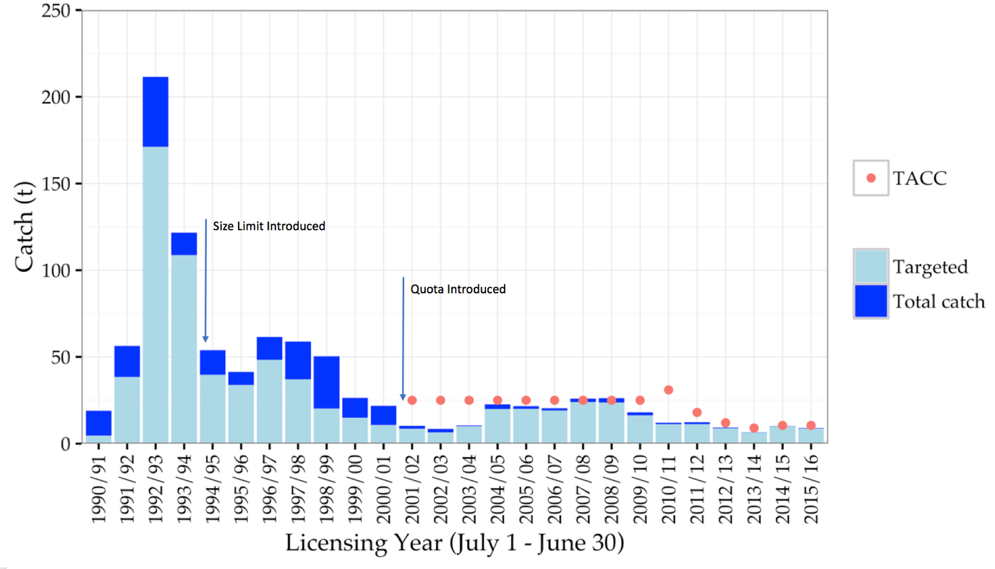
Figure 1: Total catch (t) and targeted catch history for the Victorian Giant Crab Fishery. Red dots indicate the TACC which was introduced for the 2001/02 season.

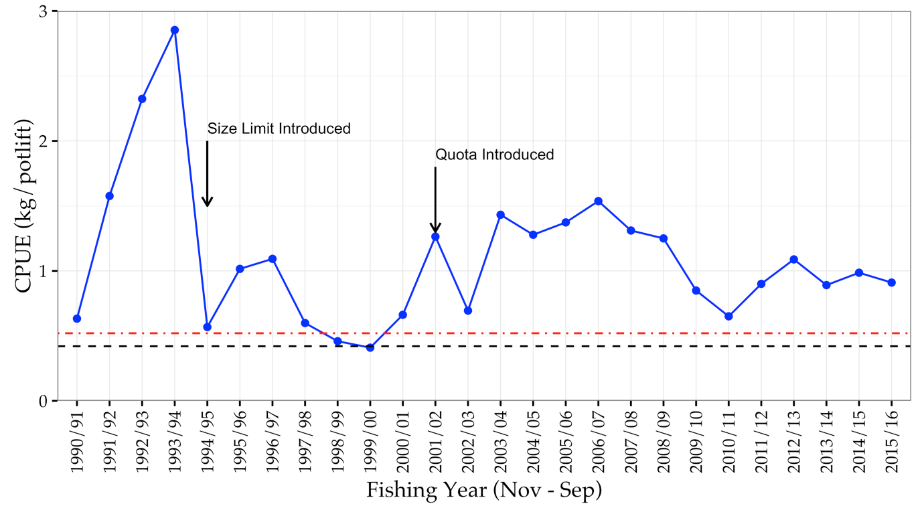
Figure 2: Catch rate of giant crab (kg/24 hour potlift) corrected for a maximum of 4 days soak, with a slope of 0.38 for all fishers landing > 1000kg of giant crab in a given year and with > 300 days of fishing overall. Dashed red line and solid black line represent limit and trigger reference points, respectively.

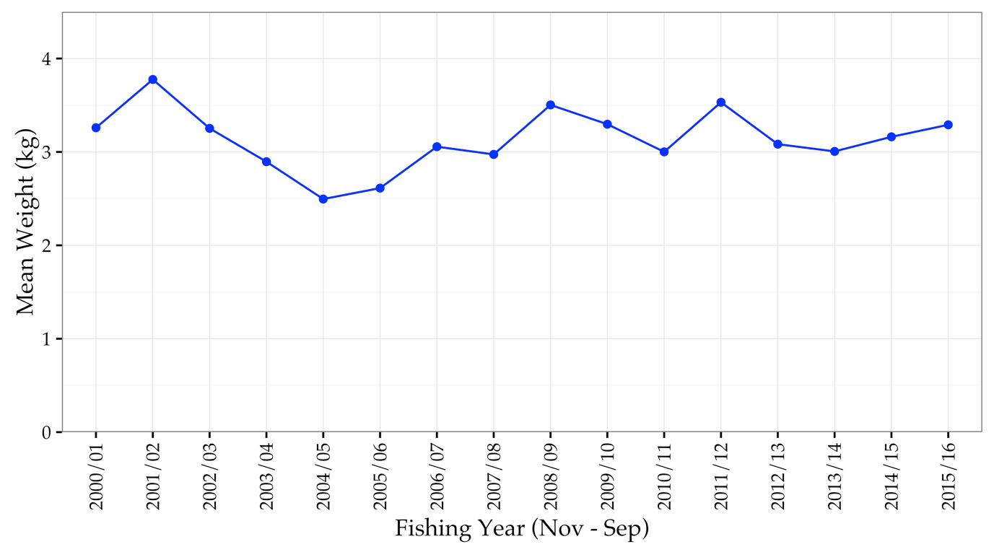
Figure 3: Mean weight (kg) per crab for all fishers from the 2000/01 fishing year onwards.

Table 1: Giant crab total catch, and catch rate during fishing years (16 November–14 September) from 90–91 to 15–16.
Fishing Year | Total Catch (t) | Catch Rate (fishers > 1t)
1990/91 | 18.9 | 0.63
1991/92 | 56.7 | 1.58
1992/93 | 226.8 | 2.32
1993/94 | 122.3 | 2.85
1994/95 | 38.8 | 0.57
1995/96 | 44.4 | 1.02
1996/97 | 68.7 | 1.09
1997/98 | 51.0 | 0.60
1998/99 | 50.4 | 0.46
1999/00 | 25.3 | 0.41
2000/01 | 19.7 | 0.66
2001/02 | 9.5 | 1.26
2002/03 | 8.4 | 0.69
2003/04 | 10.5 | 1.43
2004/05 | 22.7 | 1.28
2005/06 | 21.7 | 1.37
2006/07 | 20.3 | 1.54
2007/08 | 27.6 | 1.31
2008/09 | 27.2 | 1.25
2009/10 | 16.4 | 0.85
2010/11 | 11.3 | 0.65
2011/12 | 12.6 | 0.90
2012/13 | 8.8 | 1.09
2013/14 | 6.5 | 0.89
2014/15 | 10.5 | 0.99
2015/16 | 10.0 | 0.91

Table 2: Giant crab total allowable commercial catch by quota year between 2001–02 and 2015–16.

Year | Season | TACC Set (t)
2001/02 | 16 Nov – 31 Mar | 25
2002/03 | 1 Apr – 31 Mar | 25
2003/04 | 1 Apr – 31 Mar | 25
2004/05 | 1 Apr – 31 Mar | 25
2005/06 | 1 Apr – 31 Mar | 25
2006/07 | 1 Apr – 31 Mar | 25
2007/08 | 1 Apr – 31 Mar | 25
2008/09 | 1 Apr – 31 Mar | 25
2009/10 | 1 Apr – 31 Mar | 25
2010/11 | 1 Apr – 30 Jun | 31
2011/12 | 1 Jul – 30 Jun | 18
2012/13 | 1 Jul – 30 Jun | 12
2013/14 | 1 Jan 14 – 30 Jun | 9
2014/15 | 1 Jul - 30 Jun | 10.5
2015/16 | 1 Jul - 30 Jun | 10.5

