Are summer water temperatures adversely impacting river trout fisheries?

Jason Lieschke, Canran Liu, Andrew Pickworth, John Mahoney
Arthur Rylah Institute, DELWP

Aim:
To determine how river trout respond to changes in water temperatures e.g. When it gets too hot, do trout move or die? If they are moving, where do they go?

Background:
Anglers in north east Victoria have expressed concerns about the status of wild trout populations with reports of poor fishing across many streams, particularly during the summer of 2013-14.
Trout are a cold water species, when the water heats up we don’t know whether they die or actively move away.
Cool water refuge is likely to be found in higher altitudes (upstream) or in deeper habitats (e.g. Lake Eildon or deep pools). An improved understanding of fish response to increased water temperatures may benefit anglers and give them a better idea where to find fish and adapt their fishing practices accordingly. Fisheries managers will also gain an understanding of how water temperatures may affect the fishery in the future.

What did we do:
We placed nine acoustic receivers in the Delatite River from Mirimbah to Lake Eildon in October 2014. The transmitters, which are implanted in the Brown trout, send out an acoustic signal into the water at regular intervals (see Figure 1 below). When they are in range of a receiver, the signal from the transmitter is picked up, and the ID of the fish is recorded, along with the date and time.
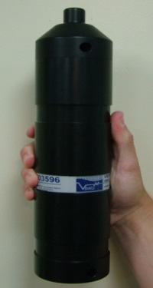
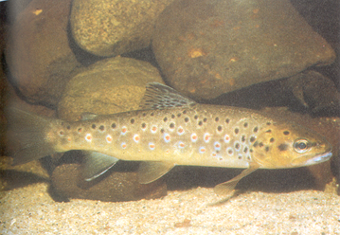
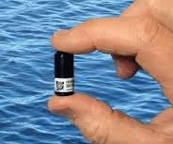

Acoustic tag transmits a unique signal Acoustic receiver picks up the unique signal and records it along with the date and time

Figure 2. How a transmitter and receiver work.

Four receivers were placed above the Mansfield water supply offtake and five below, including one in Lake Eildon (Figure 2). At seven of the acoustic receivers, instream temperature data loggers were also placed, recording water temperatures every hour.
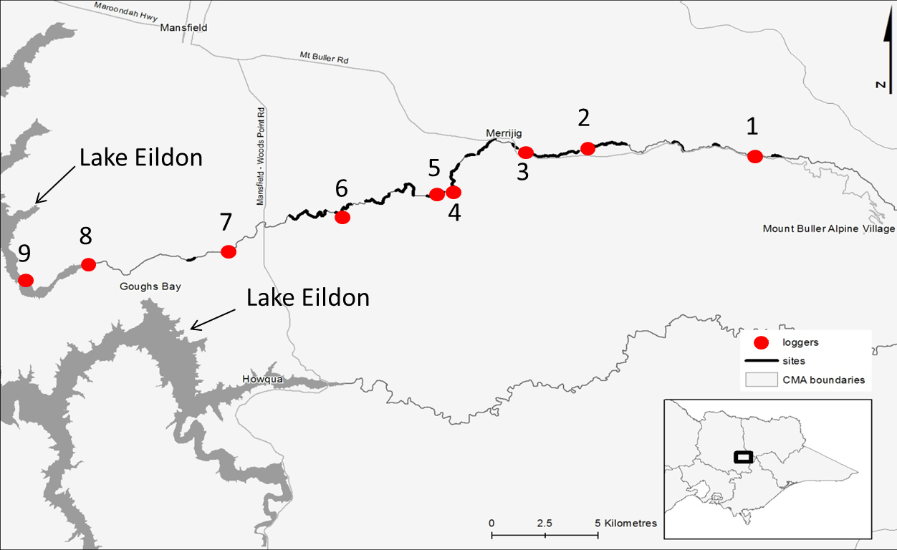
Mirrimbah
Mansfield Water Supply Offtake
Figure 1. Location of receivers in the Delatite river.
Note darker sections of the river represent areas where brown trout were tagged.
One hundred brown trout were captured via electrofishing between Lake Eildon and Mirimbah between October and November 2014. Captured fish were anaesthetised, measured for length, weighed and tagged (acoustic transmitter and externally tagged with a t-bar tag). Fish ranged from 19.5 cm to 57 cm fork length and 100 to 1860 grams (4lb). Fish were tagged throughout the whole river, with over 22 river kilometres fished. All fish were released back into the river.
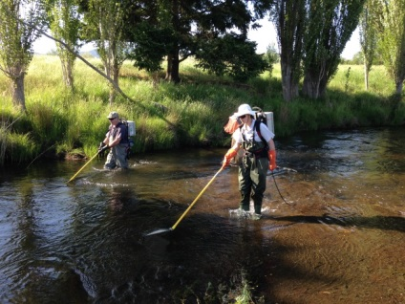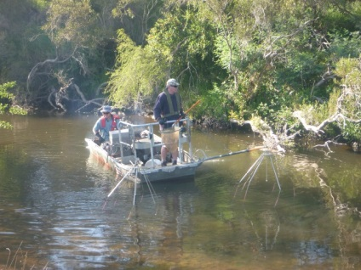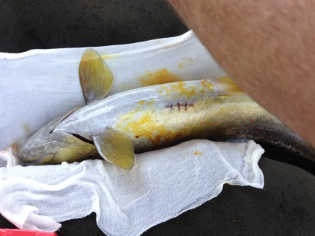
Photos of capturing trout via backpack and boat electrofishing
and a brown trout following implantation of a transmitter.

Key findings and implications to date:

Water temperature

The water temperature of the river increased as soon as it was out of the forested area (see Figure 3). The peak temperature at Receiver 1 (Mirrimbah) was 23.1 °C with a daily variation of 7.2 °C. The peak temperature at Receiver 2 was 27.8 °C with a maximum daily variation of 9.8 °C. The peak temperature at receiver 7 was the highest at 29.0 °C, however its daily variation was only 5.6 °C, not as much as the upstream sites.

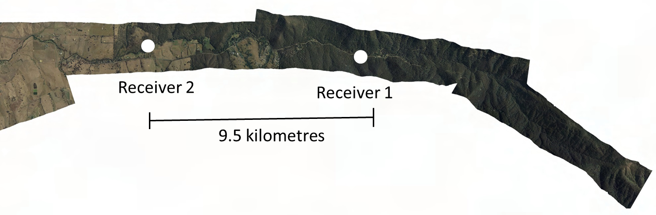
Figure 3 Aerial imagery of receiver locations one and two showing differences in tree cover

The Summer of 2014/15 was mild compared to previous years. For example, during the millennium drought and in the summer of 2013-14 the number of hot days was greater compared to the summer of 2014-15. As we have no previous instream water temperature data, the maximum daily temperature from Mount Buller was used as a surrogate for instream water temperature (Figure 4.). These “hot” days would have also caused water temperatures to increase.

Figure 4. Number of days temperature is 25°C or above at Mount Buller.
Used as a surrogate for water temperature where instream water temperature data is not available.
Note there were no days 25°C or above in summer of 2014-15.

Trout movement and temperature
We investigated the relationship between fish movement, fish length, water level and water temperature and found that:
- Larger fish were more active;
- Fish movement increased as water level increased;
- Fish movement increased slightly as temperature increased, however, movement increased abruptly when temperature was above 22 °C (Figure 5);
- Long distance movements (between Receivers) increased as temperature increased
(Figure 5).
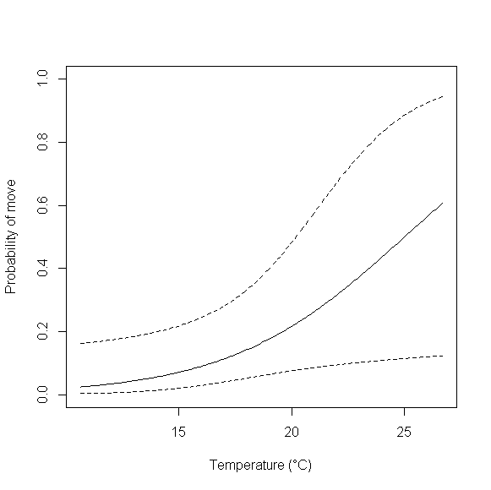
Figure 5. The probability of a fish moving and water temperature.

Where did the trout move?
- Ninety three fish did not move large distances (typically they moved < 2.5 km);
- Seven of the 100 fish were recorded on multiple receivers, i.e. from 3 to 7.5 km apart;
- One fish moved upstream from receiver 6 to receiver 7 (i.e. 3.5 km);
- Six fish moved upstream from receivers 2 and 3 (i.e. 7 km);
- No fish moved downstream;
- The fish that moved from receiver 2 to receiver 3 all moved with the peak in temperature and most returned back to their original location one week after initial upstream movement, which correlated with a decrease in temperature following a large rain event.

Summary of movement
- Larger fish were more likely to move than smaller fish;
- An increase in temperature was more likely to trigger a long distance movement (between receivers) and this movement was always upstream. However, most fish didn’t move;
- No fish moved as far upstream as Receiver 1 (Mirrimbah), where temperature did not go above 23°C, suggesting that fish found a place where they were not temperature stressed before reaching this area.
- The summer of 2014/15 was a mild year (as evidenced by Mount Buller maximum daily temperature);
- Temperature increased dramatically and had a high daily variation once the river flowed out of the forested area.

Next steps:
- There are still 70 fish with transmitters that will be active over the summer of 2015/16;
- As a bonus, we will also get spawning movement (if any) for these fish for the 2015 spawning period (yet to be analysed).

