

Draft HARVEST STRATEGY FOR the Eastern zone of the victorian abalone fishery

2024

C. Dixon and J. Lowe

November 2024

About MRAG Asia Pacific

MRAG Asia Pacific is an independent fisheries and aquatic resource consulting company dedicated to the sustainable use of natural resources through sound, integrated management practices and policies. We are part of the global MRAG group with sister companies in Europe, North America and the Asia Pacific.

2/29 Woodstock Rd PO Box 732 P: +61 7 3371 1500

Toowong Qld 4066 Toowong Qld 4066 F: +61 7 3100 8035

Australia Australia E: info@mragasiapacific.com.au

Preferred citation: Dixon, C.D., and Lowe, J. (2024). Draft Harvest Strategy for the Eastern Zone of the Victorian Abalone Fishery 2024. MRAG Asia Pacific, Brisbane, Australia.

ISBN:

Published: 15 November 2023

Acknowledgements

Funds for this work were obtained through the Victorian Fisheries Authority (VFA), obtained through licence fees. We are grateful to Anthony McGrath (VFA) for reviewing the document.



|  |
| --- |
| Disclaimer: The results and analyses contained in this Report are based on a number of technical or otherwise specified assumptions and parameters. The user must make their own assessment of the suitability for its use of the information or material contained in or generated from the Report. Although all reasonable efforts have been made to ensure quality, MRAG does not warrant that the information in this report is free from errors or omissions. To the extent permitted by law, MRAG does not accept any liability to any party for expenses, losses, damages and costs arising directly or indirectly from using this Report. |

Table of Contents

1. Introduction 2

2. Results 3

3. Discussion 7

4. Future research 7

5. References 8

6. Appendix 1 9

1.1. Step 1. Calculate nominal CPUE from raw data provided by VFA 9

1.2. Step 2. Standardisation of CPUE data 9

1.3. Step 3. Smooth standardised CPUE data for the reference period and calculate Reference Points 9

1.4. Step 4. Categorise CPUE for current and previous five years of data against the Reference Points 10

1.5. Step 5. Determine which Catch Control Rule applies 10

1.6. Step 6. Calculate the Primary Indictor (4yr gradient change) and categorise 10

1.7. Step 7. Calculate the Secondary Indicator (2yr ratio) and categorise 11

1.8. Step 8. Calculate the Primary Categorisation Result based on the Primary and Secondary Indicators 11

1.9. Step 9. Calculate the Tertiary Indicator (4yr gradient change) and categorise 11

1.10. Step 10. Determine the final category 12

1.11. Step 11. Determine the catch, lower and upper limits 13

# Introduction

A harvest strategy sets out a decision framework necessary to achieve defined biological and economic objectives for commercial fish stocks in a given fishery (DAWR 2018). Harvest strategies outline:

* processes for monitoring and assessing the biological (and economic) conditions of commercially fished species within fisheries against fishery-specific reference levels (a reference point or points)
* pre-determined rules that control fishing activity according to the biological conditions of the fishery (as defined by monitoring and/or assessment)—these rules are referred to as harvest control rules or decision rules.

The primary tool used to manage the Victorian Abalone Fishery is a Total Allowable Commercial Catch (TACC). In the Draft Harvest Strategy for the Victorian Eastern and Central Zone Blacklip Abalone Fishery (VFA 2019a), a suggested TACC range for each zone is arrived at via explicit decision rules that result in upper and lower catch limits (referred to as Optimal Target (OT) catches) at the Spatial Management Unit (SMU) scale. VFA (2019a) states *“Decisions regarding catch limits are therefore set out in advance, ensuring that fishers, fishery managers and other relevant stakeholders know what action will be taken in response to the conditions in the fishery”*.

This Harvest Strategy Report documents the results from applying data from the most recent complete season for the Eastern Zone Abalone Fishery through the Draft Harvest Strategy process, as documented in Version 2 of VFA (2019a). This report uses data up to and including the current quota year as provided by VFA:

* CPUE_1979_2023.xlsx, received 16/9/2024

The Fishery Independent Survey (FIS) was not undertaken in 2022 while a review was being undertaken (Dixon 2023). In 2023, a FIS was done, however a selection of only 15 sites were surveyed following outcomes of the FIS review. In 2024, only 10 of these 15 sites were surveyed. The low number of sites precludes meaningful assessment at the SMU scale, and therefore these Harvest Strategy results rely only on CPUE data, as they did in 2022 and 2023.

A step-by-step summary of how the reference points and the primary, second and tertiary (not calculated in 2024) indicators were calculated and classified is provided in the Appendix, designed to be read in conjunction with previous Victorian Abalone Methods reports (VFA 2019a; VFA 2019b). All rules are applied at the SMU scale.

The operational objectives of the Draft Harvest Strategy from VFA (2019a) state that “*This harvest strategy aims to achieve three main operational objectives, which link to the overarching objectives for the management of the fishery*.” These operational objectives are to:

1. Maximise the likelihood of biomass remaining within the target range.
2. Minimise the risk of biomass falling to levels where it could impair recruitment.
3. Minimise the risk of biomass falling below the limit reference point.

# Results

Table 1 contains the calculated Reference Points, the Current Status and applicable Catch Control Rules for each SMU within the Eastern Zone. This table was created using the methods (Steps 1 to 3) outlined in the Appendix.

Table 2 contains the calculations of the Primary and Secondary Indicators used to determine the Primary Category, the Tertiary Indicator (not calculated in 2024), and the Final Category and suggested OT ranges for each SMU within the Eastern Zone. This table was created using the methods (Steps 4 onwards) outlined in the Appendix.

The Primary and Secondary Indicator for the Eastern Zone is plotted in Figure 1. Nominal and standardised CPUE datasets for the Eastern Zone is plotted in Figure 2, relative to the Reference Points.

Mean standardised CPUE was above the Threshold RP for all SMUs and was above the Target level for the Airport SMU (Table 1). All seven SMUs have been above the threshold levels for a long period of time (29-31 years) and on this basis Catch Control Rule 1 is applied. For SMUs that have been above the Threshold RP level for two years or more and have an Increasing Final Category, the Harvest Strategy allows an increased upper Optimal Target (OT) catch of 125% (i.e. a 25% increase allowed). This rule did not apply to any SMU in 2023.

The Primary Indicator was Stable for all Eastern Zone SMUs except Mallacoota West, which was Decreasing (Table 2). Figure 1 shows decreases in the 4-year trends in CPUE in all SMUs. The Secondary Indicator was Decreasing at all SMUs except for the Airport SMU, which was Stable (Table 2). As a result, the Airport SMU had a Stable Primary Category while all other SMUs had a Decreasing Primary Category. Each Final Category were the same as the Primary Category because there was no Tertiary Indicator calculated. The TACC for 2023/24 was 284.6 t. The suggested TACC range for 2024/25, based on summing the upper and lower ranges of the suggested OTs for each SMU, was 250.5 t to 278.8 t.

Table 1: Reference points for Eastern Zone SMUs, mean annual CPUE from 2018 - 2023 and applicable catch control rules (CCR).

| SMU | Limit RP | Threshold RP | Target RP | 2018 | 2019 | 2020 | 2021 | 2022 | 2023 | Current Status | Years above Threshold | CCR |
| --- | --- | --- | --- | --- | --- | --- | --- | --- | --- | --- | --- | --- |
| Airport | 50 | 70 | 100 | 105.8 | 118.2 | 110.9 | 104.8 | 105.0 | 109.9 | Above Target | 31 | 1 |
| Mallacoota Central | 50 | 70 | 100 | 101.1 | 109.5 | 91.8 | 98.6 | 92.5 | 90.1 | Above Threshold | 31 | 1 |
| Mallacoota East | 40 | 60 | 110 | 101.2 | 106.7 | 98.9 | 107.4 | 98.7 | 90.4 | Above Threshold | 35 | 1 |
| Mallacoota Large | 40 | 60 | 100 | 90.8 | 100.3 | 87.5 | 93.0 | 86.1 | 93.2 | Above Threshold | 36 | 1 |
| Mallacoota Small | 50 | 70 | 100 | 105.7 | 110.7 | 101.6 | 106.5 | 91.6 | 88.9 | Above Threshold | 31 | 1 |
| Mallacoota West | 50 | 70 | 110 | 103.8 | 119.8 | 91.6 | 99.5 | 90.3 | 90.7 | Above Threshold | 32 | 1 |
| Marlo | 50 | 70 | 130 | 127.5 | 126.4 | 110.4 | 117.2 | 109.3 | 90.8 | Above Threshold | 33 | 1 |

Table 2: Harvest Strategy results for Eastern Zone SMUs, with suggested target catch ranges.

| SMU | 4yr gradient | Primary Indicator | 2yr ratio (% change) | Secondary Indicator | Primary Category | Tertiary Indicator | Final Category | Current Target Catch (OT, t) | Total catch, Lower (t) | Total catch, Upper (t) |
| --- | --- | --- | --- | --- | --- | --- | --- | --- | --- | --- |
| Airport | -0.27 | Stable | 4.6 | Stable | Stable | NA | Stable | 80.0 | 76.0 | 84.0 |
| Mallacoota Central | -1.21 | Stable | -2.6 | Stable | Stable | NA | Stable | 34.8 | 33.1 | 36.5 |
| Mallacoota East | -3.31 | Stable | -8.4 | Decreasing | Decreasing | NA | Decreasing | 19.7 | 16.7 | 18.7 |
| Mallacoota Large | 1.18 | Stable | 8.3 | Increasing | Stable | NA | Stable | 18.5 | 17.6 | 19.4 |
| Mallacoota Small | -5.06 | Decreasing | -3.0 | Stable | Decreasing | NA | Decreasing | 7.8 | 6.6 | 7.4 |
| Mallacoota West | -1.26 | Stable | 0.4 | Stable | Stable | NA | Stable | 12.0 | 11.4 | 12.6 |
| Marlo | -5.72 | Decreasing | -17.0 | Decreasing | Decreasing | NA | Decreasing | 35.8 | 30.4 | 34.0 |
| Total |  |  |  |  |  |  |  | 208.6 | 191.8 | 212.6 |

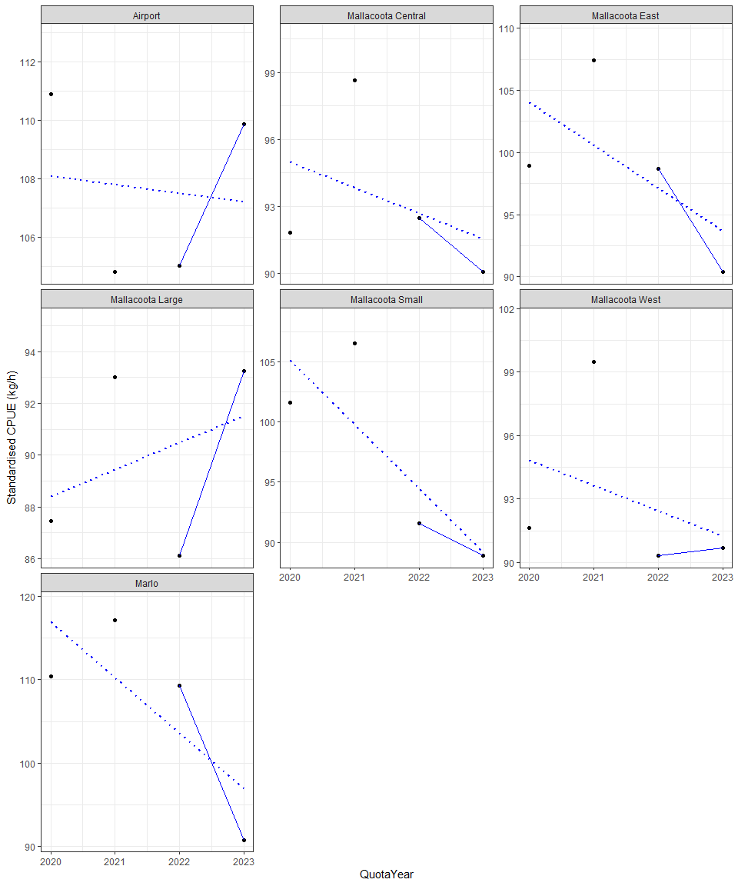

Figure 1: Standardised CPUE for each SMU in the Eastern Zone from 2020 to 2023. Dashed line and equation represent line of best linear regression fit (i.e. Primary Indicator) for time step 1 through to time step 4, while the solid line represents the ratio from the two most recent years (i.e. Secondary Indicator). Note: y-axes differ between SMUs.

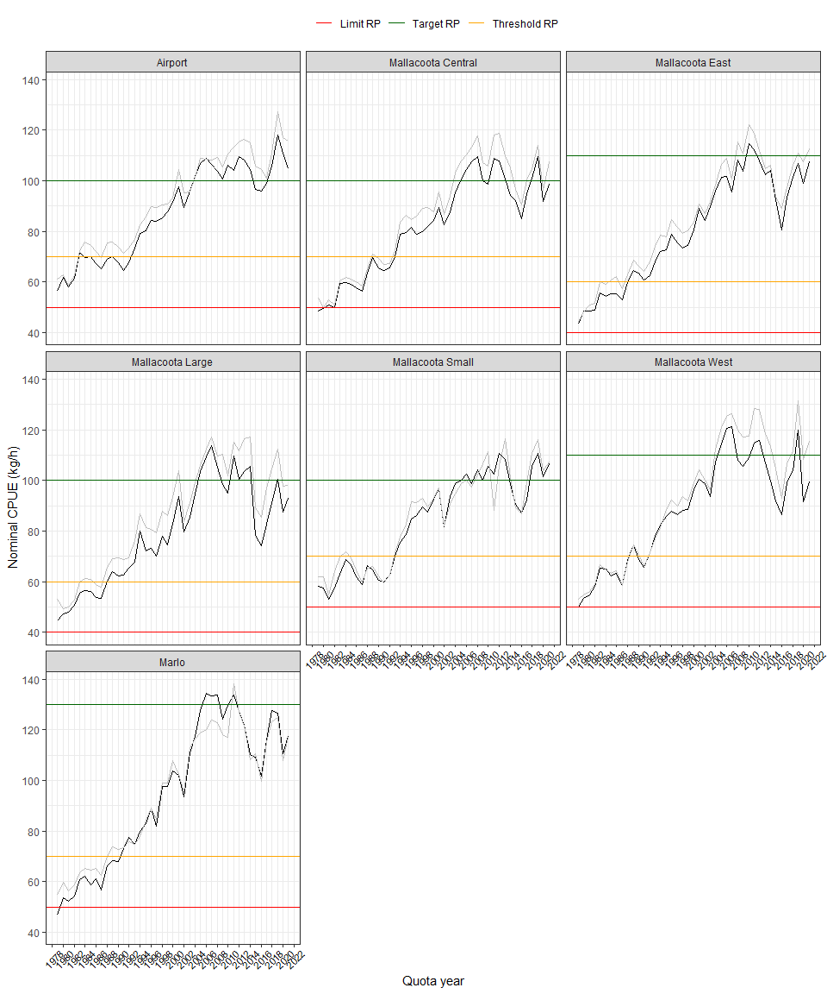

Figure 2: Standardised and nominal CPUE (black and grey lines, respectively) for the Eastern Zone from 1979 to 2022. Note that the Reference Points are calculated from rules applied to the 3-year running average of standardised CPUE between 1989 and 2015 (see Appendix).

# Discussion

The results from the Harvest Strategy for the Eastern Zone in 2024 rely entirely on commercial CPUE data as only 10 FIS sites were surveyed in 2024. All SMUs were above the Threshold RP, while the Airport SMU was also above the Target RP. Regarding the Final Categories, three of the seven Eastern Zone SMUs were assessed as Decreasing; Mallacoota East, Mallacoota Small and Marlo. All other SMUs were assessed as Stable. The 2024/25 TACC was 208.6 t, and the suggested catch range for 2025/26 is 191.8–212.6 t for the Eastern Zone overall.

The data were standardised using a revised approach agreed by the Abalone Scientific Working Group (ASWG), coded in R. The Limit, Threshold and Target RPs were also calculated from the revised standardisation model from the reference period 1979 to 2015, following the rules to establish the original RPs based on nominal CPUE, using data from 1979 to the current year.

The original Reference Points in the Draft Harvest Strategy (VFA 2019a) were based on nominal CPUE data, as was the CPUE measure. Standardised data have been used since 2019 for both the measure and the Reference Points. The use of standardised CPUE changes the model outputs each year as new data are added, and thus the Reference Points have changed over time. In practical terms this has had no effect on the suggested OTs because the Reference Points are set very low relative to contemporary CPUE estimates. It is recommended that the approach to the determination of Reference Points be reviewed through the ASWG.

# Future research

Like all fishery assessment tools, harvest strategies evolve over time as new information is acquired. The current Draft Harvest Strategy was first implemented in the 2017/18 season. Since 2018/19, Draft Harvest Strategy outcomes, along with stock assessment weight of evidence information, have been presented at TACC setting meetings where final recommendations on the OT for an SMU are determined by stakeholders.

Previous assessments have described weaknesses associated with the Draft Harvest Strategy including the heavy reliance on hyperstable CPUE data, the limited influence of the tertiary indicator (which is no longer available), non-conservative reference levels that determine limit, threshold and target values, and the reliance on data from a previous season to inform a TACC for a future season. These issues should continue to be addressed through the ASWG. This year’s Draft Harvest Strategy results used a revised CPUE standardisation model. As discussed above, the use of standardized CPUE for Reference Points should be reviewed through the ASWG.

While this year’s Draft Harvest Strategy results suggest reductions in OT are required at three SMUs, it must be noted that large reductions in OTs were voluntarily proposed by industry and implemented by VFA, at five of the seven EZ SMUs, including the three identified as “Decreasing” in this report. As such, it appears the industry has “gotten ahead” of these results, and on this basis MRAGs recommendations regarding OTs is to maintain stable OTs following a “wait and see” approach, unless divers suggest that particular SMUs or reefcodes require further reductions.

The FRDC Project 2019-118: Drawing strength from each other: simulation testing of Australia’s abalone harvest strategies, is close to completion. Dr Cathy Dichmont shared some of the results of the Management Strategy Evaluation (MSE) work with MRAG staff prior to its publication. The main criticism of the current Harvest Strategy is that it is overly conservative and, under certain circumstances, can result in declines in catch over time. Theoretically, this occurs when CPUE fluctuates with variation around a stable mean level so that the Secondary Indicator drives the Primary Category result. Nevertheless, it should be noted that TACC decisions for the EZ have not followed the outcomes of the Harvest Strategy in recent years. Moreover, having some conservatism in the Harvest Strategy when stocks have been in decline should be seen as a positive. It is hoped that the MSE model can be used to help inform the development of a revised harvest strategy for the fishery in future.

# References

DAWR. 2018. “Commonwealth Fisheries Harvest Strategy Policy. Second Edition” Melbourne: Department of Agriculture; Water Resources, Canberra, Australia.

Dichmont, C.M, Dixon, C.D., and Potts, J. 2022. Developing a new CPUE standardisation for the Central and Eastern Zones of the Victorian Abalone Fishery. MRAG Asia Pacific, Brisbane, Australia.

Dixon, C.D., J. Lowe and J. Potts. 2022. “2021/22 Draft Stock Assessment for the Eastern Zone of the Victorian Abalone Fishery.” MRAG Asia Pacific, draft version November 2022.

Dixon, C.D. 2023. Review of fishery-independent surveys for the Central and Eastern zones of the Victorian abalone fishery. Year 1 Report. MRAG Asia Pacific, Brisbane, Australia.

VFA. 2019a. “Draft Harvest Strategy Victorian Central and Eastern Zone Blacklip Abalone Fishery. Draft Version 2. VFA, February 2019.”

VFA. 2019b. “Victorian Abalone - Methods used for fishery assessment, Version 1.4 30 June 2019.”

# Appendix 1

## Step 1. Calculate nominal CPUE from raw data provided by VFA

Raw data provided by VFA contains a unique record of catch per diver per day, for each Reef Code. The following set of filters, agreed through the ASWG in 2024, were applied to the dataset before the calculation of nominal and standardised CPUE:

• Removed CPUE <25 kg/h and >250 kg/h at the reefcode/day scale

• Removed daily catches <20 kg/day and >800 kg/day

• Removed daily effort <20 minutes/day and >9 hours/day

• Removed the first 50 days of each divers records (learning period)

Using these data, the arithmetic mean CPUE for each Quota Year and SMU was calculated. Throughout this report, these data are referred to as the *nominal CPUE data*.

## Step 2. Standardisation of CPUE data

The model for standardisation of CPUE was revised through the ASWG in 2024. A linear mixed-effects model at the Zone level was specified as follows:

log(Blacklip) = 0 + offset(log(Effort)) + QuotaYear + (1|Diver) + SMU + (1|SMU:Year.Qtr) + ReefCode + (1|ReefCode/QuotaYear) + (1|ReefCode:Year.Qtr)

The linear mixed-effects model at the SMU level was specified as follows:

(log(Blacklip) ~ 0 + offset(log(Effort)) + QuotaYear + (1|Diver) + ReefCode + (1|ReefCode/QuotaYear) + (1|ReefCode:Year.Qtr)

Throughout this report, this is referred to as the *standardised CPUE*.

## Step 3. Smooth standardised CPUE data for the reference period and calculate Reference Points

Peaks and troughs in annual standardised CPUE (calculated in Step 2) were smoothed by using a running three-year average. These data are referred to as the *smoothed standardised CPUE* throughout this report.

Reference Points (RPs) are based on the smoothed standardised CPUE for the reference period 1989 to 2015, as 1989 was the first year the TACC was established. The limit, threshold and target reference points were based on the following rules:

* The Limit RP was 2/3 of the minimum smoothed standardised CPUE in the series, rounded up to the nearest 10 (e.g., 2/3rds of 63 kg/hr would be 42 kg/hr, rounded up to 50 kg/hr).
* The Threshold RP was the minimum CPUE in the series, rounded up to the nearest 10.
* The Target RP was the maximum CPUE in the series, rounded down to the nearest 10.

In situations when the *Limit and Threshold* are equal, or the *Threshold and Target* are equal, firstly the Threshold was increased and the Target was increased, resulting in a conservative outcome.

## Step 4. Categorise CPUE for current and previous five years of data against the Reference Points

For the current year, and previous five years of data, the standardised CPUE calculated in Step 2 for each SMU is categorised against the RP calculated in Step 3 using the Catch Control Rules defined in Table 3. If the CPUE is below the Limit Threshold, it is categorised “Below Limit” (and coloured red, Table 3), if the CPUE is between the Limit and the Target Threshold, it is categorised as “Limit to Threshold” (coloured orange, Table 3), and if the CPUE is above the Target Threshold, it is categorised as “Above Threshold” (coloured green, Table 3).

## Step 5. Determine which Catch Control Rule applies

To determine which Catch Control Rule (CCR) applies, the categorisation of the current year’s CPUE and duration at the current status is matched against the CCR provided in Table 3. For example, if the current CPUE is above the Threshold reference point, and has been for the previous 2 years, Catch Control Rule 1 (CCR1) applies, but if it has been above the Threshold reference point for greater than 2 years, Catch Control Rule 1 applies with an OT of 125% (Table 3). If the current CPUE has been between the Limit and the Threshold reference points for the previous 5 years, CCR1 applies; but if for greater than five years, Catch Control Rule 2 applies (CCR2). In instances when the CPUE has fallen below the Limit reference point for the previous 2 years, CCR2 applies, and if for greater than 2 years, then the fishery is closed and a structured fishing survey is implemented (Table 3).

Table 3: Applicable catch control rules (CCR).

|  | Duration at current status | | | |
| --- | --- | --- | --- | --- |
| Current Status | ≤ 2yrs | >2yrs | ≤ 5yrs | >5yrs |
| Above Threshold | CCR1 |  |  |  |
| Above Threshold |  | CCR1, 125% |  |  |
| Limit to Threshold |  |  | CCR1 |  |
| Limit to Threshold |  |  |  | CCR2 |
| Below Limit | CCR2 |  |  |  |
| Below Limit |  | Close fishery & implement structured fishing |  |  |

## Step 6. Calculate the Primary Indictor (4yr gradient change) and categorise

To calculate the Primary Performance Indicator (i.e. the four-year gradient) the four most recent years of data (2017 to 2020 quota years) were plotted and a linear regression line was fitted (see Appendix 1). The percentage change in CPUE over the four years as defined by the line of best fit, was calculated (see Appendix 1). This Primary Indicator was categorised against the rules defined in Table 4. For example, if the indicator is > 5%, it is classified as Increasing; if the indicator is between -5 and 5%, it is classified as Stable, and if the indicator is less than -5%, it is classified as Decreasing (Table 4).

Table 4: Applicable performance indicator change rules.

| Performance Indicator % Change | Category |
| --- | --- |
| >5% | Increasing |
| -5 to 5% | Stable |
| <5% | Decreasing |

## Step 7. Calculate the Secondary Indicator (2yr ratio) and categorise

To calculate the Secondary Performance Indicator, the ratio of the standardised mean CPUE estimates from 2020 were compared to the 2019 estimates. This Secondary Indicator was categorised against the rules in Table 4.

## Step 8. Calculate the Primary Categorisation Result based on the Primary and Secondary Indicators

Based on the Primary Indicator calculated in Step 6 and the Secondary Indicatory calculated in Step 7, Table 8 is used to determine the Primary Categorisation. For example, if the Primary Indicator trend is Decreasing, regardless of the trend in the Secondary Indicator, the Primary Categorisation is always Decreasing. If the Primary Indicator trend is Stable, and the Secondary Indicatory trend is Decreasing, and the Primary Categorisation is Decreasing, otherwise it is Stable. If the Primary Indicator is Increasing and the Secondary indicator is Decreasing, the Primary Categorisation is Stable, otherwise it is Increasing (Table 8).

Table 5: Primary Categorisation rules.

|  |  | Secondary Indicator trend | | | |
| --- | --- | --- | --- | --- | --- |
|  |  |  |  |  |  |
|  |  | Decreasing | Stable | Increasing | NA |
| Primary Indicator Trend | Decreasing | Decreasing | Decreasing | Decreasing | Decreasing |
| Stable | Decreasing | Stable | Stable | Stable |
| Increasing | Stable | Increasing | Increasing | Increasing |

## Step 9. Calculate the Tertiary Indicator (4yr gradient change) and categorise

The Tertiary Indicator, for each SMU, was calculated as followed:

1. Obtain the legislated LML for the target SMU
2. Using the Length Frequency data set, convert the measured length of abalone within the target SMU to weight using the following relationship: $Weight=3.34*{10}^{-4}*(Length)^{2.857}$
3. Using the Length Frequency data set, determine the number of abalone that are 0-20 mm (N20) and 0-40 mm (N40) below the LML, for each Site within the target SMU, per year (i.e., between 2017 and 2021).
4. Using the Length Frequency data set, estimate the average weight (calculated in (2)) of N20 abalone (calculated in (3)) for each Site within the target SMU, per year.
5. Estimate the total weight of N20 abalone by multiplying the number of individuals in the N20 class (from (3)) with the average weight of individuals in that class (from (4))
6. Calculate the ratio of N20 to N40 abalone (from (5)) for the target SMU, per year (i.e., summed over Site within SMU)
7. Estimate the average weight per individual abalone in the N20 group, weighted by the sample size from each Site
8. Adjust the Genstat standardised abundances from the FIS with the ratio in (6). This is the number of PreRecruits Corrected.
9. Multiply the PreRecruits.Corrected (from (8)) by the average weighted mean of each N20 abalone in (5) to obtain the Final Grams Per 30 m Transect.
10. Fit a simple linear model to the final grams of abalone per 30 m transect and estimate the 4 yr percent gradient change.

## Step 10. Determine the final category

The Final Categorisation Rules are defined in Table 6 and depend on the Primary categorisation and the trend of the Tertiary Indicator. For example, if the Primary categorisation is Decreasing and the Tertiary Indicator trend is Increasing, the Final Categorisation is Stable, otherwise it is Decreasing. If the Primary categorisation is Stable, regardless of the Tertiary Indicator, the Final Categorisation is Stable. If the Primary Categorisation is Increasing, and the Teritary indicator is Decreasing, the Final Categorsation is Stable, otherwise it is Increasing (Table 6).

Table 6: Final Categorisation rules.

|  |  | Tertiary Indicator trend | | |
| --- | --- | --- | --- | --- |
|  |  |  |  |  |
|  |  | Decreasing | Stable | Increasing |
| Primary Categorisation Result | Decreasing | Decreasing | Decreasing | Stable |
| Stable | Stable | Stable | Stable |
| Increasing | Stable | Increasing | Increasing |

NB., in situations when the resulting CCR is “1 -125%” (Step 5), the Final Category *must be* Increasing, otherwise the CCR is overwritten as “1.”

## Step 11. Determine the catch, lower and upper limits

Firstly, the percentage change applicable needs to be identifed from Table 7, based on the CCR identified in Step 5 and the Final Category from Step 10. These percentage changes are used to calculate the lower and upper limits of Total Allowable Catch.

Table 7: Rules to calculate the percent change in OT based on CCR and Final Category.

| CCR | Final Category | Lower bound | Upper bound |
| --- | --- | --- | --- |
| 1 - 125% | Increasing | 0-5 | 15-25 |
| 1 | Increasing | 0-5 | 15 |
| 1 | Stable | -5 | 5 |
| 1 | Decreasing | -15 | -5 |
| 2 | Increasing | -5 | 5 |
| 2 | Stable | -15 | -5 |
| 2 | Decreasing | -25 | -15 |