HOOKED ON BELLARINE 4 Oct 2026  Free Family Fishing Competition  8.00am to 1.50pm – Weigh-in 1-2.00pm | 

Your Name: | Age if Junior/Nipper :

DIVISIONS |  | Please tick |  | Please tick |  |  | Please tick
Novice | Male Adult |  |  | Male Junior 10-16 |  | Male Nipper 0-9
Novice | Female Adult |  |  | Female Junior 10-16 |  | Female Nipper 0-9

 |  | Please tick |  | Please tick |  |  | Please tick
Experienced | Male Adult |  |  | Male Junior 10-16 |  | Male Nipper 0-9
Experienced | Female Adult |  |  | Female Junior 10-16 |  | Female Nipper 0-9

RULES  - Must Register prior to fishing.  - All state fishing laws and regulations must be adhered to.  - Lines down 8.00 am - Lines up 1.50pm  - Fish must be fresh, as caught, not cleaned or gutted, not frozen or otherwise damaged.  - Weigh in from 1.00pm to 2.00pm at Bellarine Pirates Marquee  - Presentations 2-15pm | 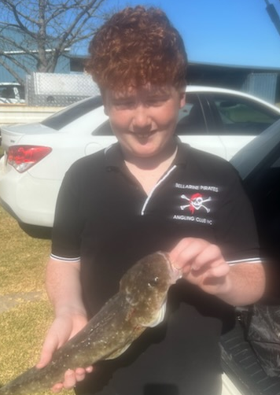
SPECIES – weigh in ONE of each species for aggregate bag

flathead, whiting, snapper, squid, leatherjacket, aus salmon, garfish,
(Squid includes calamari and arrow squid)

1 species  + 2 points | 2 species  + 4 points | 3 species  + 6 points | 4 species  + 8 points | 5 species  + 10 points | 6 species  + 12 points | 7 species  + `14 points
PLUS 1 point for each Heaviest of species
(where a tie exists – earliest time weighed in wins)

PRIZES and TROPHIES
Overall Champion (most points) – Trophy and Voucher
Trophies for heaviest of each species - PLUS vouchers for 5 mystery weights

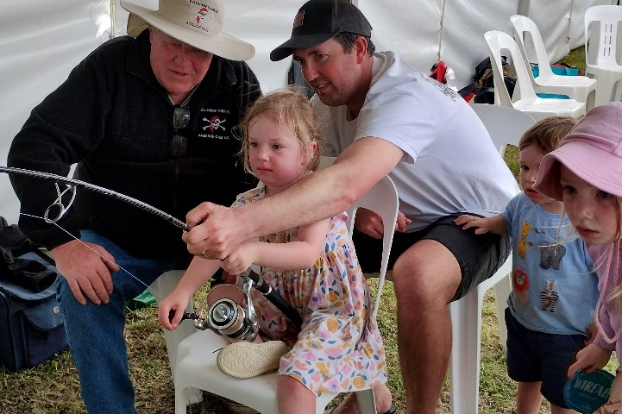  Fishing Simulator | 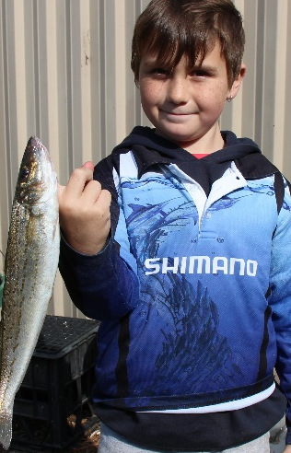 | 