**Fisheries Act 1995**

**FISHERIES NOTICE 2025**

I, Travis Dowling, Chief Executive Officer of the Victorian Fisheries Authority, as delegate of the Minister for Outdoor Recreation and having undertaken consultation in accordance with section 3A of the **Fisheries Act 1995** (the Act), make the following Fisheries Notice under sections 114 and 152 of that Act:

Date:

**Travis Dowling**

**Chief Executive Officer**

**Victorian Fisheries Authority**

## Fisheries (Rock FISHING SAFETY) Notice 2025

1. **Title**

This Notice may be cited as the Fisheries (Rock Fishing Safety) Notice 2025.

1. **Objectives**

The objective of this Notice is to improve recreational fisher safety at specified rock fishing platforms across the State.

1. **Authorising provision**

This Notice is made under sections 114 and 152 of the Act.

1. **Commencement**

This Notice comes into operation on 28 February 2025.

1. **Definitions**
2. In this Fisheries Notice –

***approved lifejacket*** means a Type 1, 2 or 3 lifejacket as defined in Parts 5, 6 and 7, respectively, of Schedule 1 of the **Marine Safety Regulations 2023**;

***child*** means a person who is under the age of 12 years;

***hand-held spear*** has the same meaning as defined in Regulation 5 of the **Fisheries Regulations 2019**;

***recreational fishing equipment*** has the same meaning as defined in Regulation 6 of the **Fisheries Regulations 2019**;

***spear gun*** has the same meaning as defined in Regulation 5 of the **Fisheries Regulations 2019**;

***specified rock fishing platform*** means all natural rock structures found between the high tide mark and the low tide mark and the spray zone of the areas shown hatched on the plans in the Schedule;

***spray zone*** means any area of natural rock that is dampened by ocean spray from high waves, including any natural rocks that may be submerged during high tides or storms;

***Type 1 lifejacket*** meansa Type 1 lifejacket as defined in Part 5 of Schedule 1 of the **Marine Safety Regulations 2023**;

***use*** includes assist in the use of;

***wear*** in relation to a lifejacket, means wear with all closing or fastening devices such as zippers, buckles and tapes correctly secured as specified by the manufacturer.

1. Despite subclause (1), a lifejacket is not an approved lifejacket for the purposes of this clause if:

(a) the lifejacket relies solely on oral inflation for buoyancy; or

(b) the lifejacket is not the correct size for the wearer; or

(c) the lifejacket is not in good condition.

1. Despite subclause (1), an inflatable lifejacket is not an approved lifejacket for the purposes of this clause unless:

(a) the lifejacket was purchased or otherwise acquired new by the current owner no more than 12 months ago; or

(b) the lifejacket has been serviced:

(i) at intervals of 12 months or less; or

(ii) at least at such longer intervals as are indicated by the manufacturer’s instructions (if any) provided for the lifejacket.

1. **Prohibition on fishing or the possession and use of recreational fishing equipment at specified rock fishing platforms**

(1) For the purposes of section 114 of the Act, the possession or use of recreational fishing equipment on any specified rock fishing platform is prohibited.

**Note**

Contravention of any prohibition under section 114 of the Act, as set out in this Fisheries Notice, is an offence under section 114(3) of the Act. A maximum penalty of 100 penalty units or 6 months imprisonment or both applies.

(2) A person must not permit a child in the person’s care or supervision to possess or use recreational fishing equipment on any specified rock platform.

Penalty: 20 penalty units

1. For the purposes of the Act, the catch limit with respect to –
2. the taking; or
3. possession –

of any fish by a person while on a specified rock platform is zero.

1. Sub-clauses (1), (2) and (3) do not apply to a person who is wearing an approved life jacket, and any child under their care or supervision on the specified rock fishing platform is wearing a Type 1 lifejacket.
2. Sub-clauses (1) or (2) does not apply to a person –
3. in possession of a hand-held spear or spear gun and who is not in possession of any other recreational fishing equipment other than an abalone tool; or
4. wearing, or in the process of donning or removing, diving equipment and who is not in possession of any other recreational fishing equipment other than an abalone tool.
5. Sub-clause (3)(b) does not apply to a person who –
6. possesses fish that were not taken by the person while on a specified rock platform; and
7. is transiting through the specified rock platform.
8. **Power of authorised officer to direct person to cease engaging in activities prohibited by this notice**
9. If an authorised officer is of the opinion that a person may engage in an activity that contravenes a provision of this fisheries notice, the officer may direct the person not to engage in that activity.
10. If an authorised officer is of the opinion that a person is contravening or has contravened a provision of this fisheries notice, the officer may direct the person –
11. to cease engaging in the activity; and/or
12. to remove any fishing equipment in the person’s possession or control from a specified rock fishing platform.

**Note**

It is an offence under section 111(1)(i) of the Act to contravene or fail to comply with a lawful direction of an authorised officer. A maximum penalty of 60 penalty units applies.

1. **Application to fisheries reserves**

For the purposes of section 152(4) of the Act, this notice applies to all fisheries reserves.

1. **Revocation**

Unless sooner revoked, this Notice will be revoked on 27 February 2026.

**SCHEDULE**

**Specified rock fishing platform *–* Cape Bridgewater blowholes, near Cape Bridgewater**

**Specified rock fishing platform *–* Sheoak Falls, near Lorne**

**Specified rock fishing platform *–* Artillery Rocks, near Lorne**

**Specified rock fishing platform *–* Jump Rocks, near Lorne**

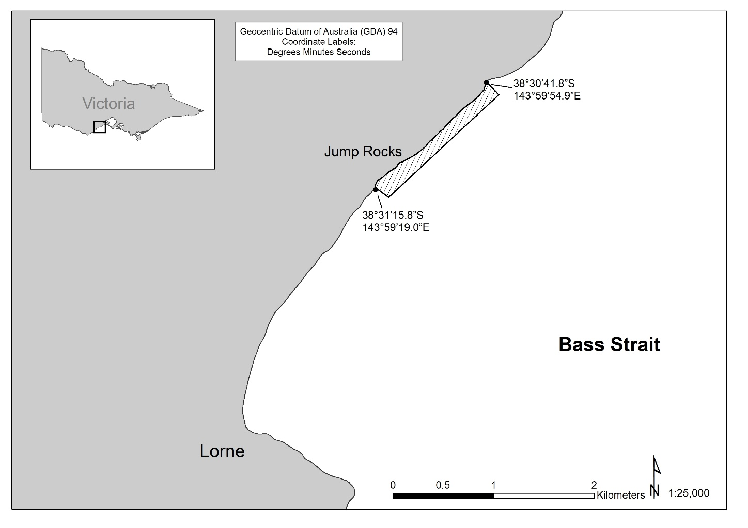

**Specified rock fishing platform – Point Nepean to West Head (near Flinders)**

**Specified rock fishing platform *–* Cowries Rock Platform, Phillip Island**

**Specified rock fishing platform *–* Kitty Miller Bay, Phillip Island**

**Specified rock fishing platform *–* Pyramid Rocks, Phillip Island**

**Specified rock fishing platform *–* Sunderland Bay, Phillip Island**

**Specified rock fishing platform *–* Bore Beach (near San Remo) to Kilcunda (including Punchbowl Rocks)**

**A map of the island of st.**