Victorian Rock Lobster Fishery
Stock Assessment Report

2013/14 SEASON

March 2015



© The State of Victoria Department of Economic Development, Jobs, Transport and Resources

This work is licensed under a Creative Commons Attribution 3.0 Australia licence. You are free to re-use the work under that licence, on the condition that you credit the State of Victoria as author. The licence does not apply to any images, photographs or branding, including the Victorian Coat of Arms, the Victorian Government logo and the Department of Environment and Primary Industries logo. To view a copy of this licence, visit http://creativecommons.org/licenses/by/3.0/au/deed.en
ISBN 1 74146 111 1
Accessibility
If you would like to receive this publication in an alternative format, please telephone the Customer Service Centre 136 186, email customer.service@depi.vic.gov.au, via the National Relay Service on 133 677 www.relayservice.com.au. This document is also available on the internet at www.economicdevelopment.vic.gov.au
Disclaimer
This publication may be of assistance to you but the State of Victoria and its employees do not guarantee that the publication is without flaw of any kind or is wholly appropriate for your particular purposes and therefore disclaims all liability for any error, loss or other consequence which may arise from you relying on any information in this publication.

Victorian Rock Lobster Fishery Stock Assessment Report: 2013/14 Season

Adrian Linnane¹, Richard McGarvey¹, John Feenstra¹, Lachlan McLeay and David J. Reilly²

¹South Australian Research and Development Institute, PO Box 120, Henley Beach, South Australia 5022
²Fisheries Victoria, Dept of Economic Development, Transport, Jobs and Resources, PO Box 114, Queenscliff, Victoria 3225

Summary
Western Zone
In 2013/14, the catch in Western Zone Rock Lobster Fishery over the fishing year (November – September) was 266 tonnes (t). This was the fifth consecutive season that the total allowable commercial catch (TACC) was fully taken. The TACC is set for a quota year (June – July) and was 260 t in 2013-14. Effort required to take this catch was 479,000 potlifts,. Effort has been reasonably stable for the past three seasons.
Between the 1993/94 to 2003/04 fishing years, nominal catch per unit effort (CPUE) was stable at 0.59–0.70 kg/potlift, but then progressively declined over the next six years to an all-time low of 0.37 kg/potlift in 2009/10. Over the last four seasons, nominal CPUE has increased and was 0.56 kg/potlift in 2013/14. Trends in standardised catch rate broadly reflect those of nominal catch rate, with standardised CPUE increasing from 0.29 kg/potlift to 0.41 kg/potlift over the same period.
The fishery stock assessment model estimated egg production in 2013/14 at 71% of the egg production in the 2001/02 reference year. This was well above the Limit Reference Point of 35%. Available biomass was estimated at 73% of the available biomass in the 2001/02 reference year. This was well below the 159% target required by 2020/21.
The model estimates that a 165 t TACC is required for the 2015/16 quota year to maintain biomass rebuilding on the target trajectory based on a 50% probability forward projection.
The reason for the required TACC reduction is primarily twofold; (i) lower than average recruitment in the fishery in four of the last five seasons, and (ii) as a result of reduced recruitment, a lower TACC is required to increase available biomass at a rate sufficient to meet the rebuild target by 2020/21. Reduced recruitment levels in the fishery are corroborated by pre-recruit estimates from fixed-site surveys, which show a consistent decline in the abundance of both male and female undersized lobsters over the last three seasons.
Eastern Zone
In 2013/14, catch in Eastern Zone Rock Lobster Fishery over the fishing year was 59 t. This reflected the fourth consecutive season that the TACC was fully taken (the quota year TACC was 51 t). Effort required to take this catch was 114,000 potlifts, which is comparable to 2011/12 when a similar TACC was taken. Following annual increases from 1996/97 to 2003/04, nominal CPUE decreased from 0.43 kg/potlift in 2005/06 to 0.37 kg/potlift in 2008/09. Over the last five seasons, nominal CPUE has again increased from 0.37 kg/potlift in 2008/09 to 0.52 kg/potlift in 2013/14. Trends in standardised catch rate broadly reflect those of nominal catch rate, with standardised CPUE increasing from 0.29 kg/potlift to 0.44 kg/potlift over the same period.
The stock assessment model estimated egg production in 2013/14 at 125% of the egg production in the 2001/02 reference year. This was above the Limit Reference Point of 104%. Available biomass was estimated at 141% of the available biomass in the 2001/02 reference year. This was well below the 184% target required by 2020/21.
The model estimates that a 51 t TACC is required for the 2015/16 quota year to maintain biomass rebuilding on the target trajectory. As with the Western Zone, the lower than average recruitment in four of the last five seasons are reflected in biomass estimates that are not increasing at a rate sufficient to meet the rebuild target by 2020/21 at the current (59 t) TACC level. Pre-recruit estimates from fixed-site surveys show a consistent decline in the abundance of both male and female undersized lobsters over the last two seasons, which validates the reduced recruitment estimates.
Three conclusions are drawn against the decision rules of the Rock Lobster Fishery Management Plan:
- Egg production is above the limit in both the Western Zone and the Eastern Zone.
- A TACC of 165 tonnes in the Western Zone and a TACC of 51 tonnes in Eastern Zone is required for the 2015/16 quota year to maintain biomass rebuilding on the target trajectories based on a 50% probability forward projection.
- The model available biomass trajectory is consistent with an upward trend in nominal CPUE from 2010/11 to 2013/14 in both the Western Zone and the Eastern Zone.

Introduction
The Victorian Rock Lobster Fishery Management Plan requires annual assessment of the southern rock lobster (Jasus edwardsii) (SRL) stock in Victoria to enable review of the Total Allowable Commercial Catch (TACC). The Management Plan requires the fishery to be assessed using prescribed stock performance indicators, biological reference points, triggers and a rebuild rate (Department of Primary Industries 2009).
The primary control tool for the fishery is individual catch quotas, where each licence holder is annually assigned a proportion of the TACC through individual transferable quota units.
Stock Assessment Model
The stock assessment uses a stock assessment model that has been designed for rock lobster fisheries in Victoria, South Australia, and Tasmania. It was developed through CSIRO and a series of FRDC projects (Hobday and Punt 2001; Hobday and Punt 2009; Hobday et al. 2005). The model is length-structured and currently set up in Victoria to account for numbers of SRLs in 5-mm length-classes.
The model infers change and absolute levels of stock abundance principally from three data sources; (i) standardised CPUE, to which biomass is assumed to vary in direct proportion, (ii) catches in both weight and number, which provide a highly precise measure of mean weight of lobsters in the catch, and (iii) length-frequency data interpreted in combination with the length-transition matrices to yield estimates of mortality rate and absolute biomass.
Recruitment in the model is dependent on changes in mean size and size distribution of the catch from length-frequency data, and on changes in CPUE, where, for example, a rise in CPUE and a decrease in mean size signals an increase in recruitment and visa-versa. For males and females separately, the model tracks, for each month, the number of SRLs in the population of size equal to or larger than 60 mm carapace length. The model also accounts for both natural mortality and fishing mortality.

Growth is modelled using length-transition matrices that specify the proportion of lobsters in each length category that grow into larger length classes during each summer and autumn moulting period. Growth in the model is sex specific, as is length-selectivity. Catchability by month is non-sex specific. The length-transition matrices were estimated using extensive tag-recovery data. The model accounts for Marine Protected Areas (8% in Western Zone and 16% in Eastern Zone) and assumed levels of recreational catch (~5% in Western Zone and ~10% in Eastern Zone).
Catch Rate Standardisation
The stock assessment model uses standardised CPUE (Walker et al. 2012). All catch and effort data are obtained from mandatory logbook returns and are firstly checked for any errors before being entered into the Fisheries Victoria rock lobster database. Prior to standardisation, the data are filtered to ensure that only data from fishers contributing returns in more than two separate fishing years and contributing 200 or more records are included in the CPUE standardisation. CPUE is then standardised for each zone separately by adjusting for differences among the regions, depth ranges, fishing seasons, months, fishers and vessels. For standardisation, the regions are Portland, Warrnambool and Apollo Bay in the WZ and Queenscliff, San Remo and Lakes Entrance in the EZ. The fishing depth ranges are <40 m and ≥40 m. Only interactions between region and year are now included, which permits yearly estimates of standardised CPUE by region.
Biological Performance Indicators
The model estimates two stock performance indicators prescribed in the Management Plan: ‘egg production’ and ‘available biomass’. ‘Egg production’ is a measure of the number of eggs produced by mature female SRLs. ‘Available biomass’ is a measure of the stock biomass of SRLs that can be legally caught (dependent on separate open seasons and size of SRLs relative to the separate legal minimum lengths for males and females). Each of these two stock performance indicators (each expressed with a specific probability) can be produced for the history of the fishery since 1951/52, when CPUE data first became available, and for various forward projections based on assumed constant catches adopted as proxies for alternative TACCs.
The only trajectories shown for the purpose of the present stock assessment are the 75% probability trajectory for annual egg production (i.e. 75% chance of being above and 25% chance of being below) and the 50% trajectory for annual available biomass (i.e. 50% chance of being above and 50% chance of being below).
Decision Framework
The decision rules in the Management Plan (Attachment 1) require comparing the stock performance indicators with biological reference points (BRP) referred to as the ‘limit BRP’ and the ‘target BRP’. In this assessment, the BRP for egg production is 35% and 104% of 2001/02 egg production for the Western and Eastern Zones respectively. The target BRP for available biomass is 159% and 184% of the 2001/02 available biomass in the Western and Eastern Zones respectively.
Under the decision rules, if a stock assessment indicates that egg production is below the limit BRP (i.e. limit BRP has been triggered), the Management Plan prescribes adoption of a reduced TACC that lifts egg production above the limit BRP within two years. Otherwise, the Management Plan prescribes adoption of the TACC required to reach the target BRP for available biomass by 2020/21.
The Management Plan also requires consideration of whether there is agreement between the trend in the model available biomass trajectory and nominal CPUE over the last two years of the assessment. For the present stock assessment, the two-year period is from 2011/12 to 2013/14.

Note: In 2012, the Rock Lobster and Giant Crab Resource Assessment Group developed a simplified version of the decision framework published in the 2009 Victorian Rock Lobster Fishery Management Plan. The simplifications did not alter the intent of the decision framework and modifications are detailed in Attachment 2.

Stock Assessment Results
Western Zone Stock Assessment
With the exception of the 2003/04 fishing year (Nov-Sept), catch in the Western Zone decreased by 55% between 2000/01 (525 t) and 2008-09 (235 t; Table 1, Figure 1). With the implementation of quota management in 2001/02, an initial TACC of 450 t was set but was reduced to 320 t in 2008/09. Over the last five years, catch has remained stable and in 2013/14 was 266 t (with a TACC of 260 t). Total effort did not decrease at the same rate as catch, remaining at around 657,000 potlifts from 2001/02 to 2008/09. Since 2010/11, effort has declined and in 2013/14 was 479,000 potlifts. The TACC has been fully taken in the fishery over the last five seasons (Table 2). In 2013/14, the highest catch was in January (53 t), with the lowest in June (< 1 t) (Table 3).
Nominal and standardised CPUE (kg/potlift) show broadly similar trends over time (Figure 2). From 2003/04 to 2009/10, nominal CPUE decreased by 47% from 0.70 kg/potlift to 0.37 kg/potlift, the lowest on record. Nominal CPUE has increased in the last four years and in 2013/14 was 0.56 kg/potlift, representing a 51% increase from 2009/10 (0.37 kg/potlift). Standardised CPUE has increased by 41% from 0.29 kg/potlift to 0.41 kg/potlift over the same period (2009/10–2013/14).
Within the regions, the highest catch came from the Portland region, followed by Warrnambool and Apollo Bay. Catch rates in Portland and Apollo Bay showed an increase in both nominal and standardised, while declines were evident in Warrnambool (Figure 3).
Despite increases in CPUE, model outputs and estimates from fixed-site surveys suggest that recruitment levels in the fishery have been low in recent seasons. Model estimated recruitment to 60 mm carapace length has been below average in four of the last five seasons (Figure 4), while pre-recruit estimates of undersized lobster abundance have declined over the last three seasons (Figure 5).
The current stock assessment model estimated egg production in 2013/14 at 71% of the level of egg production in the reference year of 2001/02 (based on 75% probability projection). This estimate is well above the limit BRP of 35% of egg production in 2001/02 (Figure 6). The model estimated available biomass at 73% of the level of available biomass in the reference year of 2001/02 (based on 50% probability projection), which is well below the target BRP of 173% of the level of available biomass in 2001/02 (Figure 7). The current TACC (230 t) will not reach the target BRP by 2020/21 (Figure 8). The model estimates that a 165 t TACC is required for the 2015/16 quota year to maintain biomass rebuilding on the target trajectory (based on a 50% probability forward projection).
The reason for the required TACC reduction is twofold; (i) lower than average recruitment in the fishery in four of the last five seasons, and (ii) as a result of reduced recruitment, a lower TACC is required to increase available biomass at a rate sufficient to meet the rebuild target by 2020/21.
Average annual nominal CPUE and average nominal CPUE for the four month period November–February are consistent with the model 50% probability trajectory of available biomass indicating an increase in abundance during the two year period from 2011/12 to 2013/14 (Figure 9).
Eastern Zone Stock Assessment
Since the implementation of a TACC in 2001, catches in the Eastern Zone have ranged between 39 t (2008/09) and 66 t (2010/11) (Table 4, Figure 10). In 2013/14, the fishing catch (Nov-Sept) was 59 tonnes. This reflected the fourth consecutive season that the TACC was fully taken (Table 5). Effort required for this catch was 114,000 potlifts, representing a 24% decrease since 2010/11 when 150,000 potlifts were used to take the TACC of 66 t. In 2013/14, the highest catch was in August (13 t), with the lowest in May and June (2 t) (Table 6).
Nominal and standardised CPUE (kg/potlift) show broadly similar trends over time (Figure 11). Over the last five seasons, nominal CPUE has increased by 41% from 0.37 kg/potlift in 2008/09 to 0.52 kg/potlift in 2013/14. Standardised CPUE has increasing by 52% from 0.29 kg/potlift to 0.44 kg/potlift over the same period. The breakdown of catch within the regions was consistent with that of previous years, with the majority of catch coming from Queenscliff and San Remo (Figure 12).
Despite increases in CPUE, model outputs and estimates from fixed-site surveys suggest that recruitment levels to the fishery have been low in recent seasons. Model estimated recruitment to 60 mm carapace length has been below average in four of the last five seasons (Figure 13), while pre-recruit estimates of undersized lobster abundance from fixed-site surveys has declined over the last two seasons (Figure 14).
The stock assessment model estimated egg production in 2013/14 at 125% of the egg production in the 2001/02 reference year (Figure 15). This was above the Limit Reference Point of 104%. Available biomass was estimated at 141% of the available biomass in the 2001/02 reference year (Figure 16). This was well below the 184% target by 2020/21. The current TACC (59 t) does not achieve the target BRP by 2020/21 (Figure 17). The model estimates that a 51 t TACC is required for the 2015/16 quota year to maintain biomass rebuilding on the target trajectory (based on a 50% probability forward projection). As with the Western Zone, lower than average recruitment in four of the last five seasons indicates that biomass estimates that are not increasing at a rate sufficient to meet the rebuild target by 2020/21 at the current TACC level.
Average annual nominal CPUE and average nominal CPUE for the 4-month period November–February are consistent with the model 50% probability trajectory of available biomass indicating an increase in abundance during the 2-year period from 2011/12 to 2013/14 (Figure 18).

References

Department of Primary Industries (2009). Victorian Rock Lobster Fishery Management Plan 2009. 'Fisheries Victoria Management Report Series No. 70'. vi + 51 pp. Department of Primary Industries, Melbourne, Victoria, Australia.
Hobday, D., and Punt, A. E. (2001). Size-structured population modelling and risk assessment of the Victorian southern rock lobster, Jasus edwardsii, fishery. Marine & Freshwater Research 52, 1495–1507.
Hobday, D., and Punt, A. E. (2009). How much spatial structure can data for rock lobster off Victoria, Australia support? New Zealand Journal of Marine and Freshwater Research 43, 373–385.
Hobday, D., Punt, A. E., and Smith, D. C. (2005). Modelling the effects of Marine Protected Areas (MPAs) on the southern rock lobster (Jasus edwardsii) fishery of Victoria, Australia. New Zealand Journal of Marine and Freshwater Research 39, 675–686.
Walker, T.I., Giri, K., Trinnie, F.I., and Reilly, D.J. (2012). CPUE data screening, selection and standardisation for stock assessment of southern rock lobster (Jasus edwardsii) in Victoria. pp 23−74. In ‘Sustainability of the rock lobster resource in south-eastern Australia in a changing environment: implications for assessment and management.’ Draft final report to Fisheries Research and Development Corporation. November 2012. South Australian Research and Development Institute (Aquatic Sciences), Adelaide, South Australia, Australia.

Western Zone

Table 1. Western Zone catch, fishing effort and CPUE (Fishing Year: November-September; SRL: Southern rock lobster; CPUE: Catch per unit effort).
Fishing  Year | Catch  (tonne) | Catch  (‘000) | Nominal effort  (‘000 potlifts) | Nominal CPUE  (kg per potlifts) | Standardised CPUE  (kg per potlifts) | Mean mass of SRL  (kg)
1951-52 | 102 |  | 42 | 2.41
1952-53 | 132 |  | 54 | 2.43
1953-54 | 177 |  | 69 | 2.56
1954-55 | 292 |  | 115 | 2.54
1955-56 | 177 |  | 87 | 2.03
1956-57 | 134 |  | 75 | 1.79
1957-58 | 152 |  | 93 | 1.64
1958-59 | 147 |  | 84 | 1.75
1959-60 | 182 |  | 104 | 1.75
1960-61 | 268 |  | 138 | 1.95
1961-62 | 396 |  | 202 | 1.96
1962-63 | 326 |  | 226 | 1.44
1963-64 | 279 |  | 201 | 1.39
1964-65 | 233 |  | 175 | 1.33
1965-66 | 325 |  | 250 | 1.30
1966-67 | 308 |  | 288 | 1.07
1967-68 | 372 |  | 373 | 1.00
1968-69 | 413 |  | 455 | 0.91
1969-70 | 430 |  | 495 | 0.87
1970-71 | 441 |  | 497 | 0.89
1971-72 | 458 |  | 583 | 0.79
1972-73 | 463 |  | 638 | 0.73
1973-74 | 429 |  | 555 | 0.77
1974-75 | 286 |  | 430 | 0.67
1975-76 | 303 |  | 406 | 0.75
1976-77 | 339 |  | 464 | 0.73
1977-78 | 309 |  | 433 | 0.71
1978-79 | 486 | 485 | 622 | 0.78 | 0.88 | 1.00
1979-80 | 453 | 444 | 576 | 0.79 | 0.76 | 1.02
1980-81 | 549 | 548 | 680 | 0.81 | 0.76 | 1.00
1981-82 | 499 | 499 | 637 | 0.78 | 0.73 | 1.00
1982-83 | 460 | 455 | 608 | 0.76 | 0.75 | 1.01
1983-84 | 421 | 414 | 571 | 0.74 | 0.68 | 1.02
1984-85 | 406 | 394 | 578 | 0.70 | 0.62 | 1.03
1985-86 | 345 | 346 | 569 | 0.61 | 0.54 | 1.00
1986-87 | 351 | 353 | 595 | 0.59 | 0.53 | 0.99
1987-88 | 345 | 349 | 557 | 0.62 | 0.53 | 0.99
1988-89 | 304 | 322 | 577 | 0.53 | 0.47 | 0.94
1989-90 | 331 | 355 | 613 | 0.54 | 0.48 | 0.93
1990-91 | 317 | 337 | 650 | 0.49 | 0.44 | 0.94
1991-92 | 408 | 439 | 712 | 0.57 | 0.54 | 0.93
1992-93 | 408 | 433 | 779 | 0.52 | 0.50 | 0.94
1993-94 | 448 | 456 | 754 | 0.59 | 0.52 | 0.98
1994-95 | 435 | 444 | 789 | 0.55 | 0.46 | 0.98
1995-96 | 423 | 442 | 761 | 0.56 | 0.45 | 0.96
1996-97 | 402 | 414 | 787 | 0.51 | 0.40 | 0.97
1997-98 | 466 | 492 | 841 | 0.55 | 0.44 | 0.95
1998-99 | 516 | 568 | 861 | 0.60 | 0.48 | 0.91
1999-00 | 521 | 592 | 897 | 0.58 | 0.46 | 0.88
2000-01 | 525 | 598 | 895 | 0.59 | 0.45 | 0.88
2001-02 | 438 | 510 | 704 | 0.62 | 0.48 | 0.86
2002-03 | 430 | 495 | 630 | 0.68 | 0.51 | 0.87
2003-04 | 461 | 515 | 659 | 0.70 | 0.51 | 0.89
2004-05 | 408 | 451 | 667 | 0.61 | 0.45 | 0.90
2005-06 | 358 | 405 | 705 | 0.51 | 0.37 | 0.88
2006-07 | 336 | 392 | 698 | 0.48 | 0.36 | 0.86
2007-08 | 289 | 338 | 668 | 0.43 | 0.32 | 0.85
2008-09 | 235 | 268 | 606 | 0.39 | 0.29 | 0.88
2009-10 | 239 | 277 | 650 | 0.37 | 0.29 | 0.86
2010-11 | 254 | 307 | 590 | 0.43 | 0.35 | 0.83
2011-12 | 233 | 279 | 475 | 0.49 | 0.38 | 0.83
2012-13 | 259 | 296 | 485 | 0.53 | 0.40 | 0.87
2013-14 | 266 | 296 | 479 | 0.56 | 0.41 | 0.90
Data Source: Fisheries Victoria Catch and Effort Database (December 2014) for period 1978-79 to 2013-14.

Table 2. Western Zone history of TACCs for each quota period from 2001-02 to 2013-14 (TACC: Total Allowable Commercial Catch).

 |  | TACC set | TACC Caught |  | Number of  months fished | Number of active  licenses | Number of  vessels
 |  | (tonne) | (tonne) | per cent | Number of  months fished | Number of active  licenses | Number of  vessels
2001-02* | 1 Nov - 31 Mar | 320
2002-03 | 1 Apr - 31 Mar | 450 | 440 | 98 | 12 | 79 | 83
2003-04 | 1 Apr - 31 Mar | 450 | 436 | 97 | 12 | 80 | 79
2004-05 | 1 Apr - 31 Mar | 450 | 421 | 94 | 12 | 79 | 86
2005-06 | 1 Apr - 31 Mar | 450 | 405 | 90 | 12 | 75 | 77
2006-07 | 1 Apr - 31 Mar | 450 | 329 | 73 | 12 | 71 | 68
2007-08 | 1 Apr - 31 Mar | 380 | 319 | 84 | 12 | 68 | 64
2008-09 | 1 Apr - 31 Mar | 320 | 244 | 76 | 12 | 61 | 60
2009 | 1 Apr– 30 Jun | 55.2 | 36 | 64 | 3 | 54 | 53
2009-10 | 1 Jul – 30 Jun | 240 | 230 | 96 | 12 | 54 | 55
2010-11 | 1 Jul – 30 Jun | 240 | 237 | 99 | 12 | 54 | 55
2011-12 | 1 Jul – 30 Jun | 240 | 237 | 99 | 12 | 51 | 54
2012-13  2013-14 | 1 Jul – 30 Jun  1 Jul – 30 Jun | 260  260 | 258  260 | 99  100 | 12  12 | 47  48 | 46  48
* Quota was introduced 1 November 2001 for a shortened quota period.
Data Source: Fisheries Victoria FILS Database.

Table 3. Monthly catch and effort in the Western Zone fishery during the 2013/14 fishing year.

Month | Catch (t) | Effort (000s potlifts)
November | 24.5 | 37
December | 47.8 | 73
January | 53.4 | 79
February | 41.6 | 66
March | 33.1 | 60
April | 11.0 | 26
May | 5.1 | 15
June | 0.4 | 2
July | 14.0 | 41
August | 27.1 | 61
September | 7.9 | 20

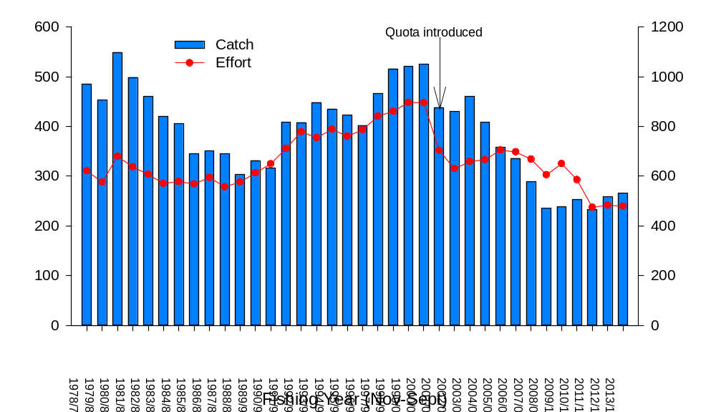
Figure 1. Total catch (tonnes) and nominal effort (x1000 potlifts) in the Western Zone from 1978/79–2013/14. Arrow indicates TACC introduction (450 t) in 2001/02.

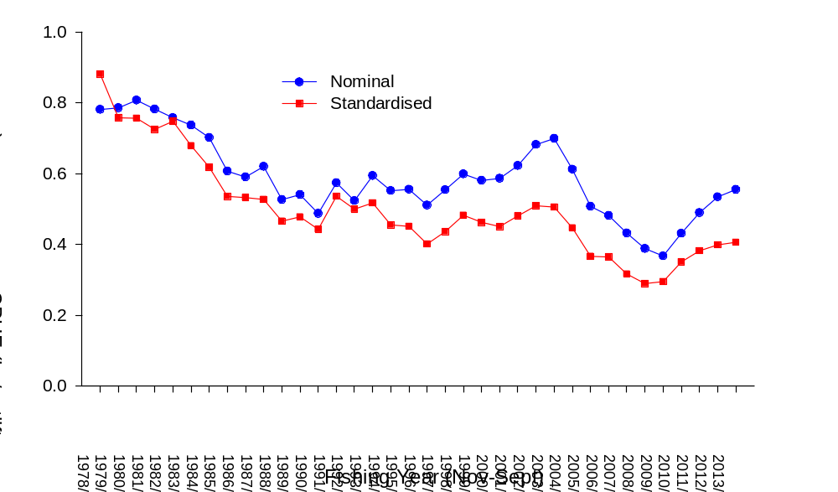
Figure 2. Nominal and standardised CPUE (kg/potlift) in the Western Zone from 1978/79–2013/14.

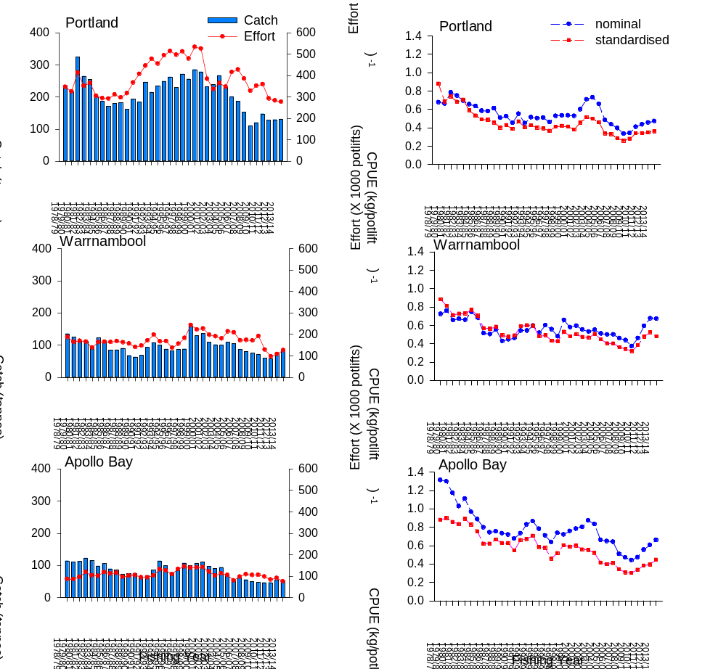

Figure 3. Regional catch (tonnes), effort (x1000 potlifts), and nominal and standardised CPUE (kg/potlift) in the Western Zone from 1978/79-2013/14.

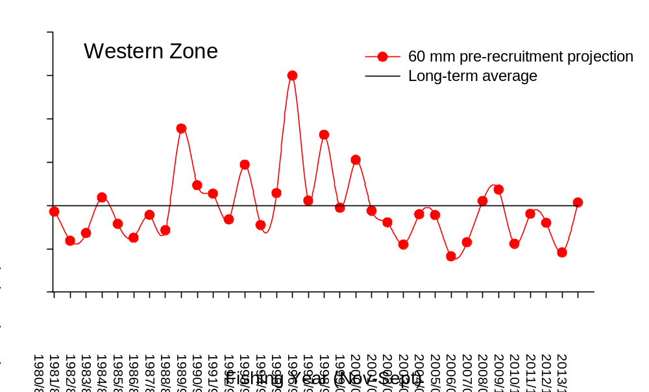

Figure 4. Relative abundance of recruitment to 60 mm CL in the Western Zone as used in the length-frequency model. Long-term historical average (solid black line) also indicated.

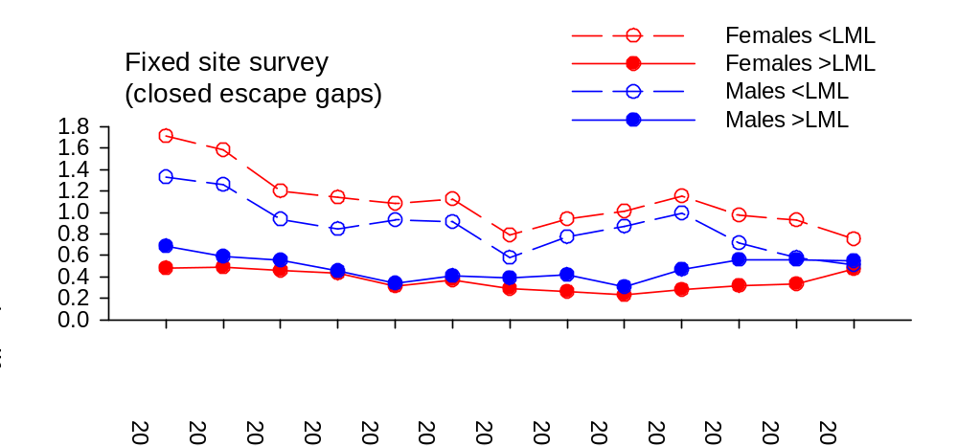

Figure 5. Number of legal-sized and undersized female (LML = 105 mm CL) and male (LML = 110 mm CL) lobsters per potlift in fixed-site surveys in the Western Zone fishery from 2001/02 to 2013/14.

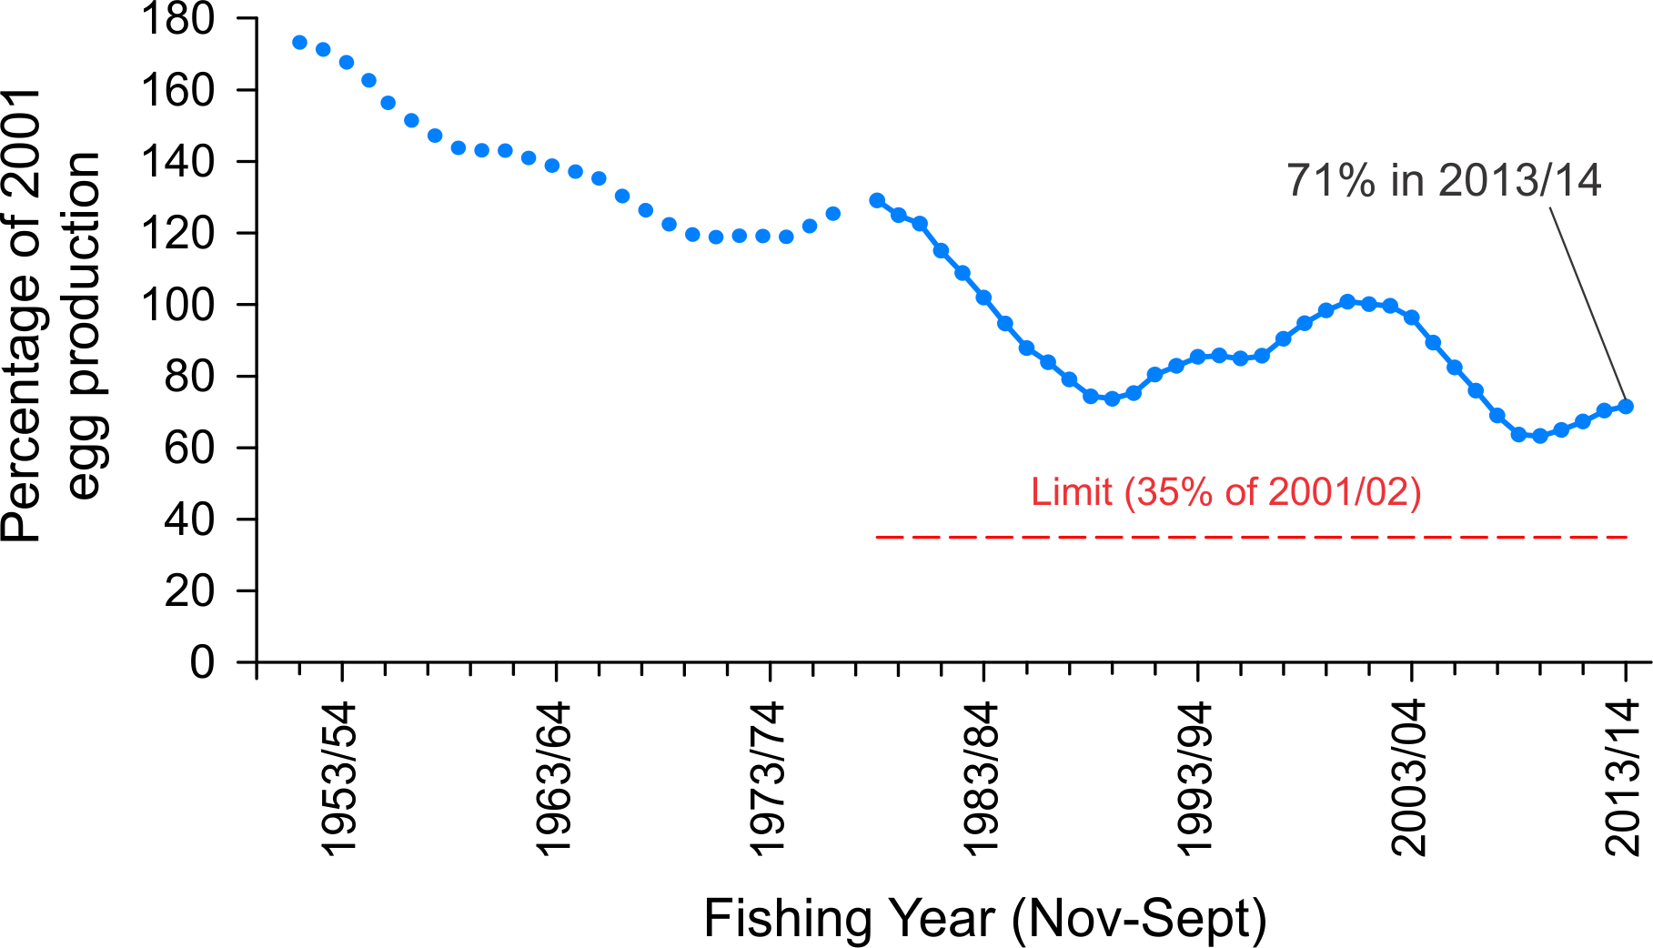

Figure 6. Model estimated level of egg production through time in the Western Zone fishery (above, with 75% probability; blue line). Limit reference point (35% of egg production in 2001/02; red line).

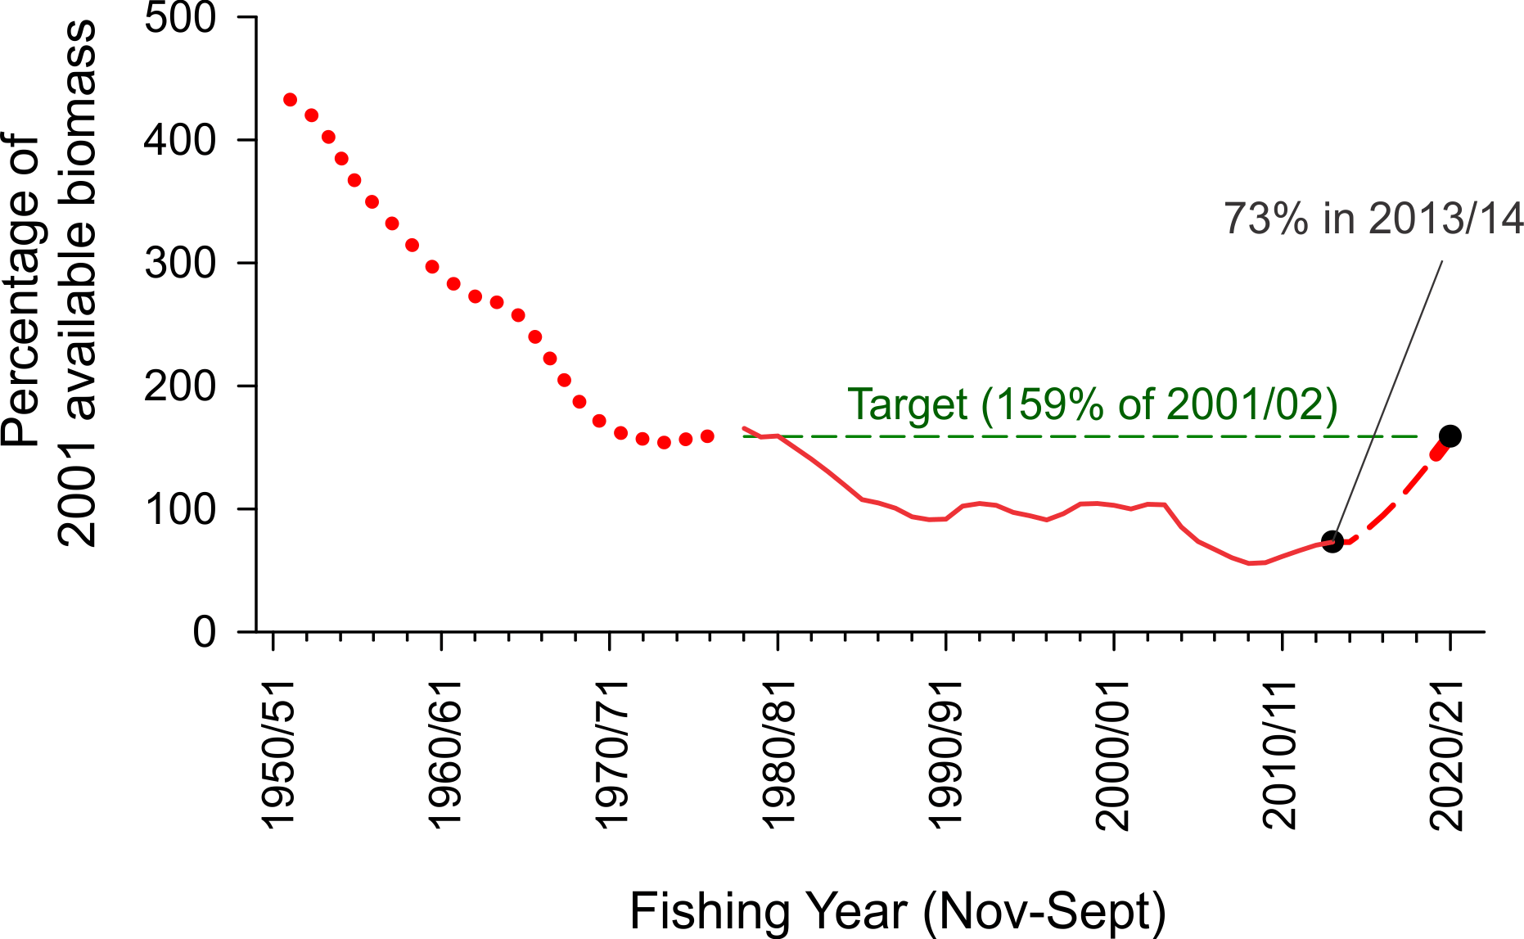

Figure 7. Model estimated levels of available biomass in the Western Zone (solid red line). Target reference point (159% of available biomass in 2001/02; green line). Projected available biomass (dashed red line) given a TACC of 165 t/yr to rebuild available biomass to the biological reference point target by 2020/21 with 50% probability.
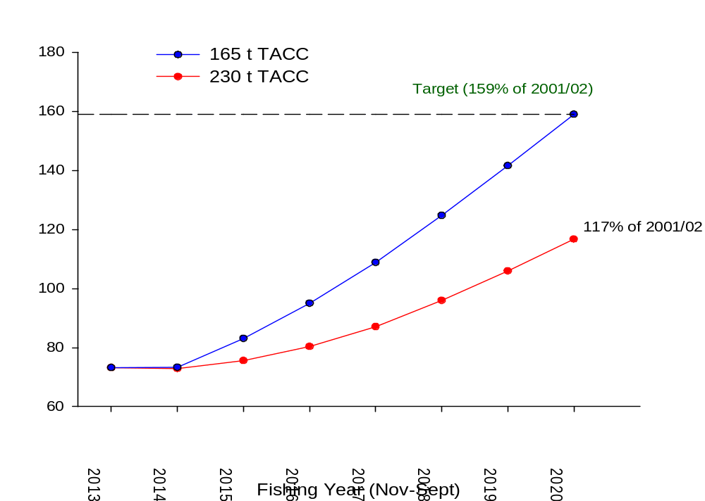

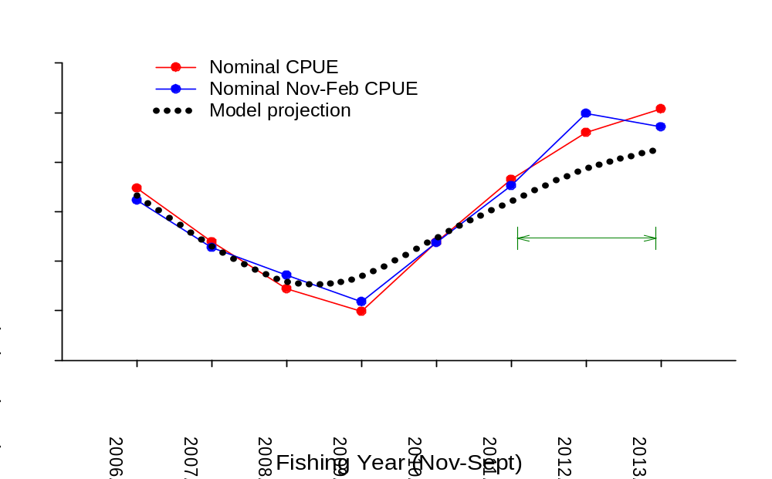
Figure 8. Projected available biomass levels in the Western Zone at 165 t and 230 t TACC levels.

Figure 9. Model estimated available biomass in the Western Zone (black line) from fitting standardised CPUE compared with measures of annual nominal CPUE (red line) and nominal CPUE from November to February (inclusive; blue line) from 2006/07 to 2013/14. The most recent two year period for comparison of model and CPUE trends is indicated by the green line.
Eastern Zone

Table 4. Eastern Zone catch, fishing effort and CPUE (Fishing Year: November-September; SRL: Southern rock lobster; CPUE: Catch per unit effort).
Fishing year | Catch  (tonne) | Catch  (‘000) | Nominal effort  (‘000 potlifts) | Nominal CPUE  (kg per potlifts) | Standardised CPUE  (kg per potlifts) | Mean mass of SRL  (kg)
1951-52 | 92 |  | 34 | 2.70
1952-53 | 141 |  | 68 | 2.07
1953-54 | 166 |  | 77 | 2.16
1954-55 | 182 |  | 66 | 2.75
1955-56 | 116 |  | 51 | 2.27
1956-57 | 116 |  | 57 | 2.01
1957-58 | 147 |  | 76 | 1.93
1958-59 | 123 |  | 82 | 1.50
1959-60 | 135 |  | 73 | 1.84
1960-61 | 147 |  | 86 | 1.70
1961-62 | 177 |  | 92 | 1.92
1962-63 | 158 |  | 84 | 1.88
1963-64 | 139 |  | 91 | 1.52
1964-65 | 121 |  | 99 | 1.22
1965-66 | 131 |  | 105 | 1.25
1966-67 | 120 |  | 109 | 1.10
1967-68 | 77 |  | 77 | 1.01
1968-69 | 107 |  | 93 | 1.15
1969-70 | 174 |  | 159 | 1.10
1970-71 | 160 |  | 176 | 0.91
1971-72 | 123 |  | 183 | 0.97
1972-73 | 118 |  | 169 | 0.70
1973-74 | 128 |  | 152 | 0.84
1974-75 | 93 |  | 114 | 0.81
1975-76 | 104 |  | 123 | 0.84
1976-77 | 108 |  | 130 | 0.83
1977-78 | 102 |  | 122 | 0.83
1978-79 | 139 | 123 | 192 | 0.72 | 0.71 | 1.13
1979-80 | 116 | 108 | 171 | 0.67 | 0.55 | 1.07
1980-81 | 133 | 123 | 180 | 0.74 | 0.56 | 1.09
1981-82 | 131 | 120 | 193 | 0.68 | 0.49 | 1.09
1982-83 | 143 | 132 | 212 | 0.68 | 0.53 | 1.09
1983-84 | 136 | 128 | 230 | 0.59 | 0.48 | 1.06
1984-85 | 113 | 96 | 201 | 0.56 | 0.40 | 1.17
1985-86 | 95 | 81 | 175 | 0.54 | 0.35 | 1.17
1986-87 | 78 | 66 | 145 | 0.54 | 0.36 | 1.18
1987-88 | 70 | 62 | 130 | 0.54 | 0.32 | 1.13
1988-89 | 64 | 60 | 145 | 0.44 | 0.30 | 1.06
1989-90 | 83 | 85 | 198 | 0.42 | 0.30 | 0.99
1990-91 | 72 | 72 | 172 | 0.42 | 0.32 | 1.00
1991-92 | 65 | 64 | 175 | 0.37 | 0.29 | 1.02
1992-93 | 69 | 63 | 224 | 0.31 | 0.24 | 1.10
1993-94 | 79 | 68 | 260 | 0.30 | 0.21 | 1.16
1994-95 | 72 | 58 | 253 | 0.28 | 0.19 | 1.24
1995-96 | 57 | 48 | 220 | 0.26 | 0.19 | 1.19
1996-97 | 60 | 48 | 222 | 0.27 | 0.18 | 1.25
1997-98 | 66 | 54 | 221 | 0.30 | 0.19 | 1.23
1998-99 | 67 | 58 | 220 | 0.31 | 0.22 | 1.16
1999-00 | 75 | 71 | 232 | 0.32 | 0.23 | 1.05
2000-01 | 73 | 67 | 219 | 0.33 | 0.23 | 1.08
2001-02 | 53 | 50 | 151 | 0.35 | 0.25 | 1.08
2002-03 | 52 | 48 | 134 | 0.39 | 0.27 | 1.09
2003-04 | 56 | 51 | 133 | 0.42 | 0.30 | 1.09
2004-05 | 55 | 49 | 136 | 0.40 | 0.30 | 1.13
2005-06 | 52 | 46 | 122 | 0.43 | 0.31 | 1.14
2006-07 | 54 | 48 | 136 | 0.40 | 0.31 | 1.13
2007-08 | 46 | 39 | 123 | 0.37 | 0.28 | 1.19
2008-09 | 39 | 32 | 108 | 0.37 | 0.29 | 1.24
2009-10 | 55 | 50 | 146 | 0.38 | 0.30 | 1.11
2010-11 | 66 | 62 | 150 | 0.44 | 0.33 | 1.05
2011-12 | 62 | 55 | 114 | 0.54 | 0.40 | 1.13
2012-13 | 48 | 43 | 94 | 0.51 | 0.42 | 1.11
2013-14 | 59 | 48 | 114 | 0.52 | 0.44 | 1.22
Data Source: Fisheries Victoria Catch and Effort Database (December 2014) for period 1978-79 to 2013-14.

Table 5. Eastern Zone history of TACCs for each quota period from 2002/03 to 2013/14 (TACC: Total Allowable Commercial Catch).

 |  | TACC set | TACC Caught |  | Number of  months fished | Number of active  licenses | Number of  vessels
 |  | (tonne) | (tonne) | Per cent | Number of  months fished | Number of active  licenses | Number of  vessels
2001-02* | 1 Nov - 31 Mar | 42
2002-03 | 1 Apr - 31 Mar | 60 | 49.9 | 83 | 12 | 39 | 34
2003-04 | 1 Apr - 31 Mar | 60 | 54.4 | 91 | 12 | 41 | 36
2004-05 | 1 Apr - 31 Mar | 60 | 53.2 | 89 | 12 | 41 | 39
2005-06 | 1 Apr - 31 Mar | 60 | 55.7 | 93 | 12 | 30 | 29
2006-07 | 1 Apr - 31 Mar | 60 | 53.5 | 89 | 12 | 30 | 30
2007-08 | 1 Apr - 31 Mar | 66 | 50.1 | 76 | 12 | 31 | 31
2008-09 | 1 Apr - 31 Mar | 66 | 41.3 | 63 | 12 | 26 | 24
2009-09 | 1 Apr - 30 Jun | 6.9 | 5.8 | 84 | 3 | 19 | 20
2009-10 | 1 Jul - 30 Jun | 66 | 43.9 | 67 | 12 | 22 | 21
2010-11 | 1 Jul - 30 Jun | 66 | 64.8 | 98 | 12 | 29 | 28
2011-12 | 1 Jul - 30 Jun | 66 | 65.3 | 99 | 12 | 25 | 26
2012-13 | 1 Jul - 30 Jun | 48 | 47.3 | 99 | 12 | 26 | 25
2013-14 | 1 Jul - 30 Jun | 51 | 50.8 | 100 | 12 | 27 | 27
* Quota was introduced 1 November 2001 for a shortened quota period.
Data Source: Fisheries Victoria FILS Database.

Table 6. Monthly catch and effort in the Eastern Zone fishery during the 2013/14 fishing year.

Month | Catch (t) | Effort (000s potlifts)
November | 4 | 7
December | 10 | 16
January | 7 | 12
February | 4 | 7
March | 3 | 5
April | 3 | 5
May | 2 | 5
June | 2 | 5
July | 8 | 18
August | 13 | 24
September | 4 | 9

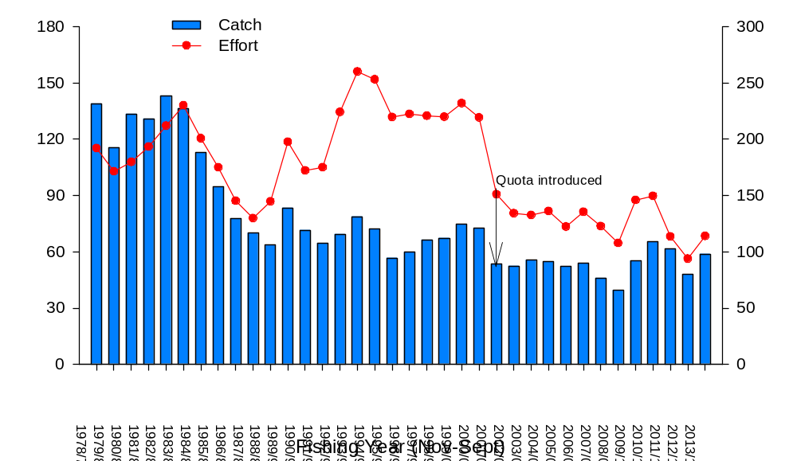
Figure 10. Total catch (tonnes) and nominal effort (x1000 potlifts) in the Eastern Zone from 1978/79–2013/14. Arrow indicates TACC introduction (60 t) in 2001/02.

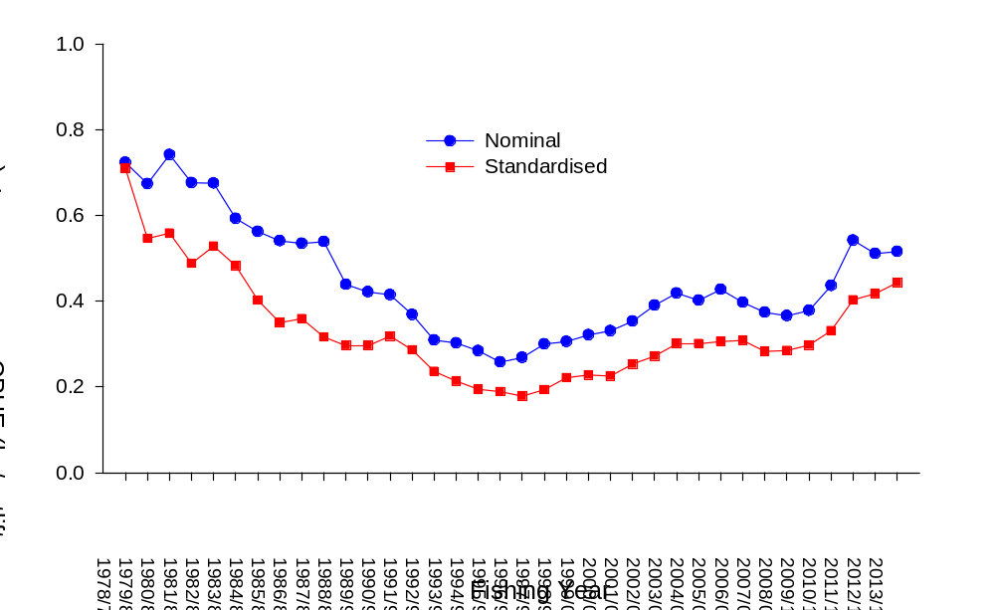
Figure 11. Nominal and standardised CPUE (kg/potlift) in the Eastern Zone from 1978/79–2013/14.
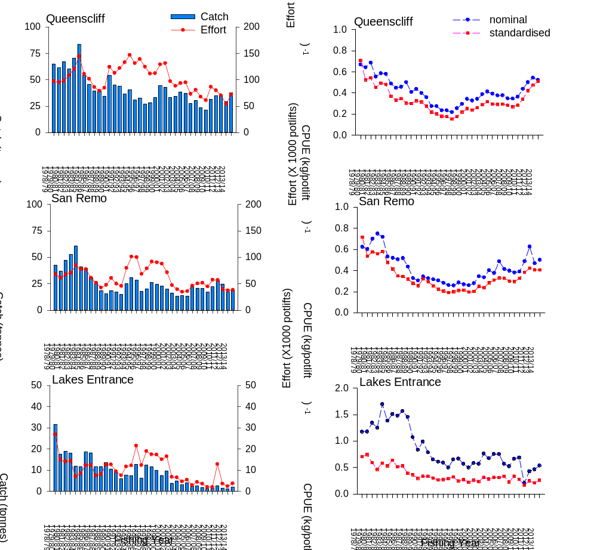

Figure 12. Regional catch (tonnes), effort (x1000 potlifts), and nominal and standardized CPUE (kg/potlift) in the Eastern Zone from 1978/79-2013/14.

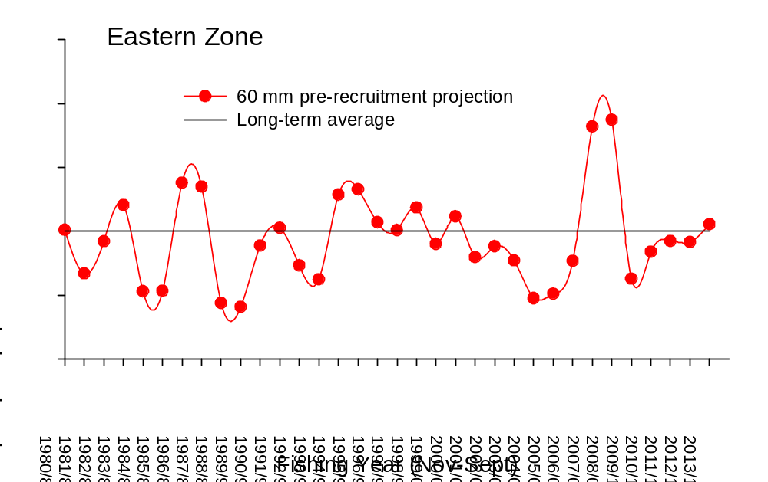

Figure 13. Relative abundance of recruitment to 60 mm CL in the Eastern Zone as used in the length-frequency model. Long-term historical average (solid black line) also indicated.

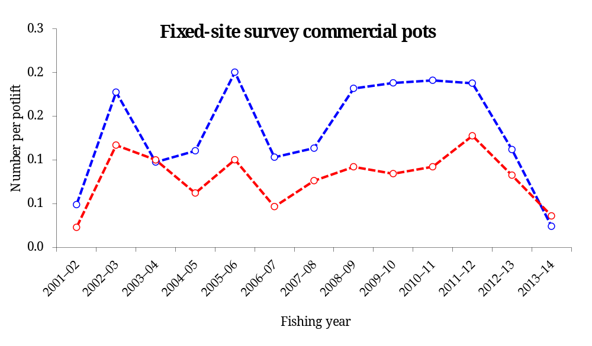

Figure 14. Number of undersized female (LML = 105 mm CL) and male (LML = 110 mm CL) lobsters per potlift in fixed-site surveys in the Eastern Zone fishery from 2001/02 to 2013/14. Legal sized lobster abundances not reported for confidentiality reasons.

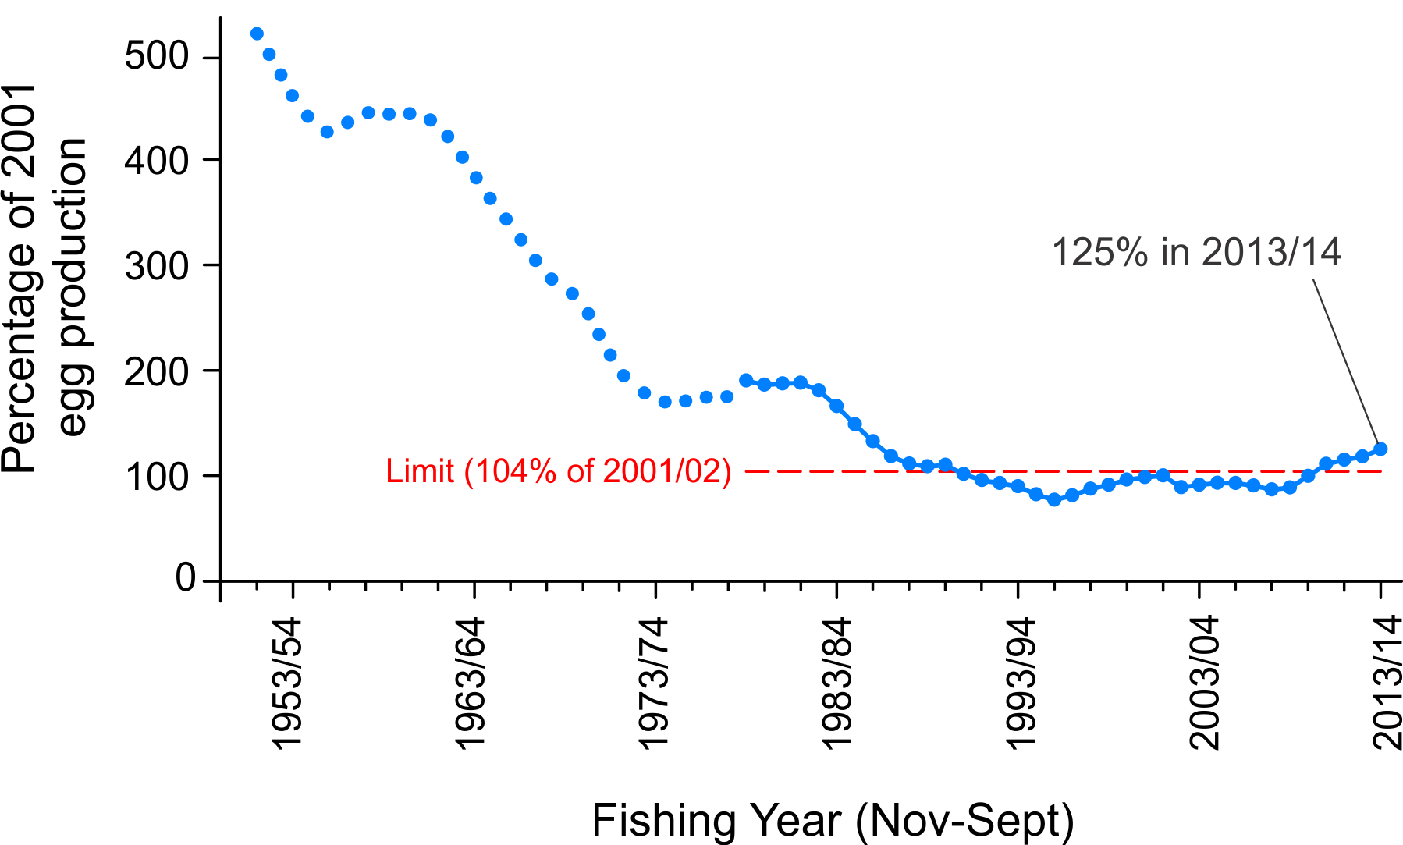

Figure 15. Model estimated level of egg production through time in the Eastern Zone fishery (above, with 75% probability; blue line). Limit reference point (104% of egg production in 2001/02; red line).
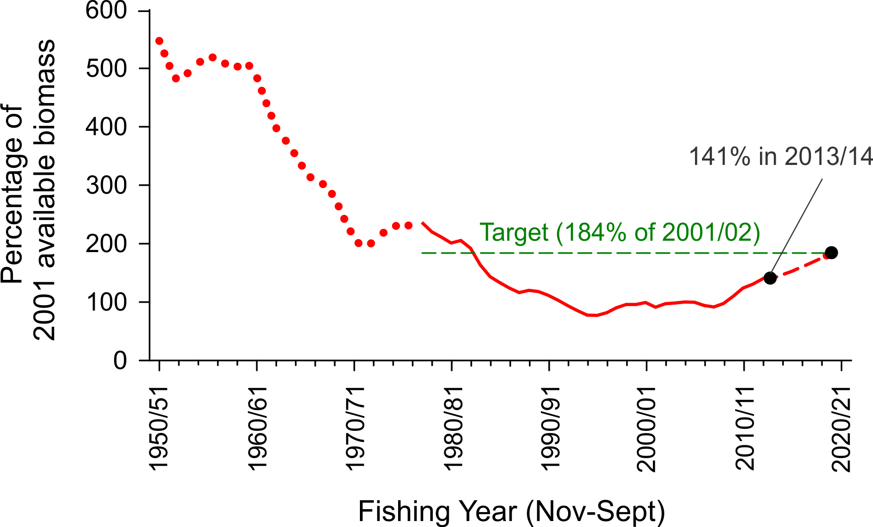

Figure 16. Model estimated levels of available biomass in the Eastern Zone (solid red line). Target reference point (184% of available biomass in 2001/02; green line). Projected available biomass (dashed red line) given a TACC of 51 t/yr to rebuild available biomass to the biological reference point target by 2020/21 with 50% probability
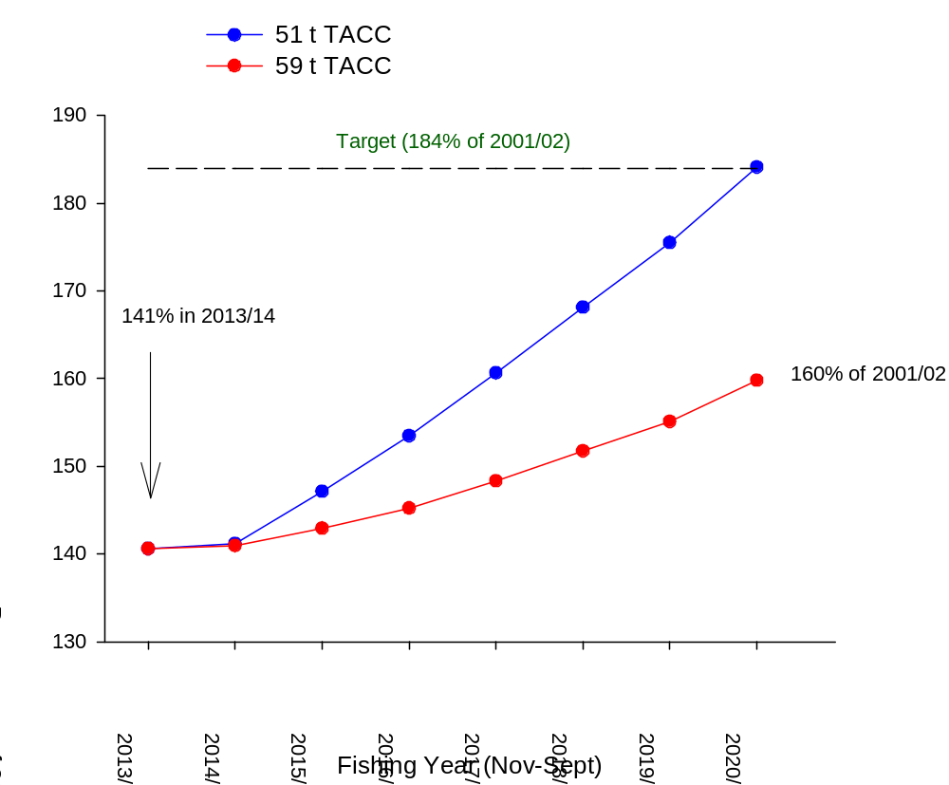
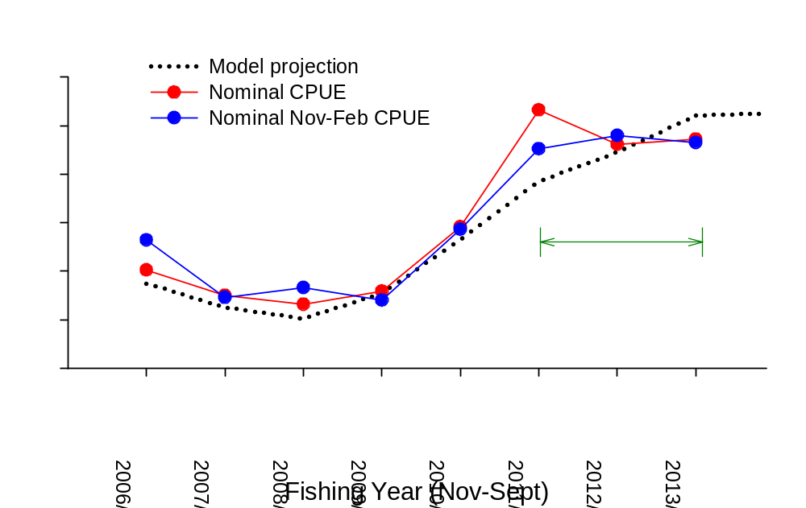
Figure 17. Projected available biomass levels in the Eastern Zone at 51 t and 59 t TACC levels.

Figure 18. Model estimated available biomass in the Eastern Zone (black line) from fitting standardised CPUE compared with measures of nominal CPUE (red line) and nominal CPUE from November to February (inclusive; blue line) from 2006/07 to 2013/14. The most recent two year period for comparison of model and CPUE trends is indicated by the green line.
Attachment 1

VICTORIAN ROCK LOBSTER HARVEST STRATEGY

Harvest Strategy Operational Objective
- Rebuild the available biomass in both zones to the target reference point by 2020/21

Stock performance indicators
Primary biological performance indicator: Egg production (model estimated)
Secondary biological performance indicator: Available biomass (model estimated)

Reference points
Limit reference point: egg production above the equivalent of 20% of the estimated egg production level in 1951 (reference year was changed from 1951 to 2001/02)
Eastern Zone: 104% of egg production in 2001/02, with 75% probability
Western Zone: 35% of egg production in 2001/02, with 75% probability

Target reference point: available biomass in 2020/21 that is equivalent of 40% of the available biomass in 1951 (reference year was changed from 1951 to 2001/02)
Eastern Zone: 184% of the available biomass in 2001/02, with 50% probability
Western Zone: 159% of the available biomass in 2001/02, with 50% probability

Management decision rules (see Figure 1)
- If the egg production estimate is not above the limit reference point, the TACC must be reduced or maintained at the current level to return the egg production to above the limit reference point within two years, with a 75% probability.
- If the available biomass is not at the target, a TACC must be adopted that achieves the target by 2020/21.
- If the available biomass is at the target, a TACC must be set that maintains the available biomass at the target.
- If the two-year trend in the nominal CPUE is consistently opposite to the trend in standardised CPUE over the same period, the RLRAG must review the model outputs to establish the reason for the inconsistency.
- If the two-year trend in the nominal CPUE is consistent with the trend in standardised CPUE over the same period, the proposed TACC is accepted.
Attachment 1, Figure 1
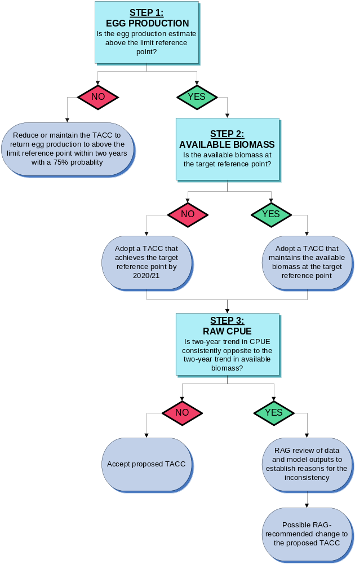
Figure 1. Victorian Rock Lobster Fishery Decision Framework

Attachment 2
Table 1: 2012 review of performance indicators and reference points in the Victorian Rock Lobster Fishery Management Plan

Performance Indicator | 2009 Management Plan | Recommended Change | Rationale
Reference year | 1951 | 2001 | The time series of catch data began in 1951, however the robustness of this early data is limited and may affect the resultant model projections. Data from 2001 onwards represents the introduction of quota and therefore more stringent catch and effort recording. All catch data is still considered in the analyses of stock abundance.
Primary management strategy | Rebuild the available biomass in both zones to the target reference point of 40% of B₁₉₅₁ by 2020/21 | Rebuild the available biomass to the target reference point of 159% of B₂₀₀₁ in the western zone and 184% of B₂₀₀₁ in the eastern zone by 2020/21 | The primary strategy of the 2009 MP is sound. The change reflects the modification to the reference year. The modified target reference points are equivalent to the 1951 reference; the target, therefore, has not changed.
Spawning biomass | The measure of the stock of mature females contributing to recruitment | The term ‘egg production’ will replace spawning biomass. | Egg production is used internationally as the descriptor for the reproductive status of the stock
Spawning biomass limit reference point | Above 20% of B₁₉₅₁ with a 75% probability | Egg production to be no less than 35% of B₂₀₀₁ in the western zone and 104% of B₂₀₀₁ in the eastern zone, with 75% probability | Egg production is considered to be the critical factor in stock sustainability. The value is estimated by the model and must be kept above the limit reference point to ensure stocks are not at risk of collapse
Spawning biomass target reference point | Above 40% of B₁₉₅₁ with a 50% probability | Removed | With the primary strategy of the Management Plan to achieve a target related to available biomass, and egg production protected by the limit reference point, it was considered unnecessary to have the extra complexity of another target reference point
Available biomass limit reference point | Above 20% of B₁₉₅₁ with a 75% probability | Removed | The sustainability of the stocks is protected by the egg production limit reference point, therefore it was considered unnecessary to have the extra complexity of a second limit reference point

Available biomass target reference point | Above 40% of B₁₉₅₁ with a 50% probability | Target reference point of 173% of B₂₀₀₁ in the western zone and 219% of B₂₀₀₁ in the eastern zone by 2020/21, with a 50% probability | This is the primary target of the Management Plan. The only changes reflect the recalculation to the reference year of 2001
Rebuild rate | 10 years | 10 years. Fisheries Victoria would like to include the option to also have a five-year rebuild rate | No change to original timeframe, but inclusion of an option to implement a faster rebuild rate if necessary
Rebuild rate window | The starting point for the window will be the biomass for the 2010/11 year and the upper and lower bounds defined by the time required to reach the 40% target between 2016 (5-year build rate) and 2020/21 (10-year build rate). The TACC will be set to ensure the projected available biomass five years into the future lies within the build rate window | Removed | The rebuild window has caused considerable confusion and uncertainty in application and outcomes. The need for this complexity is not justified given the very simple primary strategy of the Management Plan
Rebuild rate window (cont.) | If the 5-year available biomass projection is below the build-rate window, the TACC must be set to bring the projections above the 50% build-rate within five years | Removed | This is a component of the rebuild rate window and has therefore been removed
Rebuild rate window (cont.) | If the build rate projection is above the 50% mid-point for two consecutive years, the TACC may be increased by up to 10% providing the build rate remains above the 50% line | Removed | This is a component of the rebuild rate window and has therefore been removed

