Smarter trout stocking through marking hatchery fish

Brett A. Ingram¹ and Fletcher Warren-Myers²
¹ Fisheries Victoria, DEDJTR, ² University of Melbourne

Aim:
- To determine if brown trout stocked into Lake Eildon contribute to river trout fisheries.
- To improve management of trout stocking programs by implementing a cost effective method of mass-marking hatchery-bred trout to distinguish them from wild-born fish.

Background:
Fisheries Victoria periodically releases brown and rainbow trout into Lake Eildon to support the lake fishery. However, it is not clear if these fish also move into the steams above the lake and thus enhance the stream fisheries in these areas. Understanding the contribution of lake fish to the river fishery, and river fish to the lake fishery, will inform fisheries management practices about the effectiveness of fish stocking in Lake Eildon and closed seasons in rivers.
To answer this question, we need to distinguish the stocked fish from wild fish, as well as distinguish fish stocked into different locations. To achieve this, hatchery-bred trout will require marking before they are released, which can be costly and time consuming to undertake. Although there is a wide range of methods currently available for marking fish, this project will develop and implement a cost-effective method to tag all trout produced at the Snobs Creek hatchery that is quick and simple to apply. In the long-term, being able to distinguish between stocked and wild fish will have broader implications for the future assessment and improved management of Victorian trout stocking program.
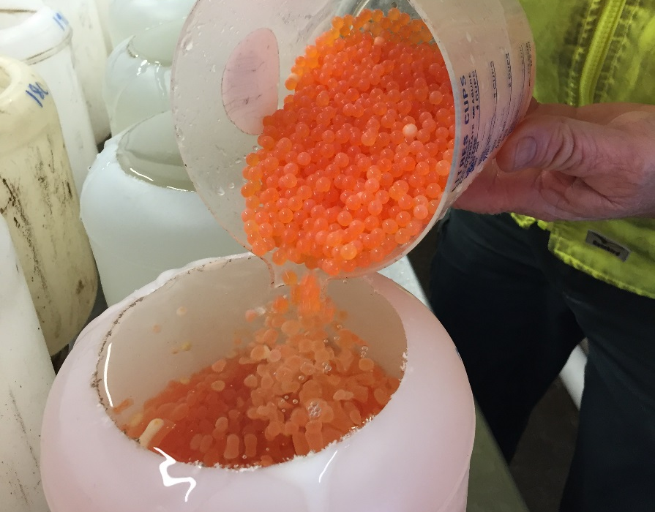
Trout eggs transferred into a solution of barium for marking

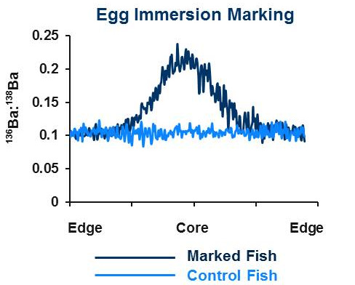 | 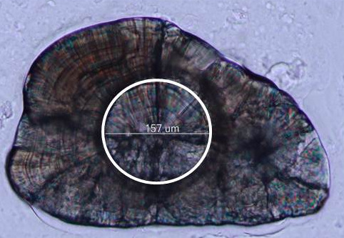
A Mass Spectrometry scan of an otolith marked with Ba137 via egg immersion (left).
Picture is of a fish otolith analysed using LA-ICP-MS, circle indicates the size of the laser spot
used for detecting the Ba137 mark (right)

What we did:
An initial review was undertaken to identify trout marking methods to mass-mark fish produced at Snobs Creek. Marking with Barium (Ba) isotopes was selected because the method is simple, cost effective, safe to use, does not affect the welfare of fish, and large numbers of fish can be quickly marked with different Ba isotopes. In this method, eggs, yolk-sac larvae, or juvenile fish can be immersed in a water bath containing a small amount of enriched Ba which then becomes incorporated into the calcified structures (i.e. otoliths) of the fish as it grows in the month following immersion. This alters the chemical composition of the otolith, which can be detected by analysis with a laser.
During the 2015 breeding season, marking trials were conducted at the Snobs Creek hatchery. Two marking methods were tested on brown trout, which involved bathing either eggs or yolk-sac larvae. Brown trout were also treated with either Ba135 or Ba137 so that fish stocked into different locations can be distinguished. All rainbow trout produced during the breeding season were also marked with Ba137.

Next steps:
Samples of marked fish will be tested to confirm uptake of Ba.
Fish marked during the 2015 breeding season will be reared at Snobs Creek. In 2016, brown trout yearlings marked with Ba137 will be released into Lake Eildon while fish marked with Ba135 will be released into the Howqua and upper Goulburn Rivers. The latter fish will also be fin-clipped with the help of Volunteers from Mansfield and District Flyfishing Club as an external ‘flag’ that can be seen by fisheries researchers and by anglers.
During 2017 samples of brown trout will be collected from Lake Eildon and connecting rivers by volunteer anglers and ARI survey teams undertaking research for other projects. The otoliths (ear bones) from these fish will be removed and analysed for the presence of Ba marks.

