

Stock assessment FOR the central zone of the victorian abalone fishery

2023/24

C. Dixon and J. Lowe

May 2025

Draft 17 February 2021

About MRAG Asia Pacific

MRAG Asia Pacific is an independent fisheries and aquatic resource consulting company dedicated to the sustainable use of natural resources through sound, integrated management practices and policies. We are part of the global MRAG group with sister companies in Europe, North America and the Asia Pacific.

2/29 Woodstock Rd PO Box 732 P: +61 7 3371 1500

Toowong Qld 4066 Toowong Qld 4066 F: +61 7 3100 8035

Australia Australia E: info@mragasiapacific.com.au

Preferred citation: Dixon, C.D., and Lowe, J. (2025). Stock Assessment for the Central Zone of the Victorian Abalone Fishery 2023/24. MRAG Asia Pacific, Brisbane, Australia.

ISBN: 978-0-6454622-8-9

Published: 15 May 2025

Acknowledgements

Funds for this work were obtained through the Victorian Fisheries Authority (VFA), obtained through licence fees. We are grateful to Michael Cleland for his assistance in the provision and interpretation of data. Anthony McGrath and Melissa Schubert provided constructive reviews of the document.



|  |
| --- |
| Disclaimer: The results and analyses contained in this Report are based on a number of technical or otherwise specified assumptions and parameters. The user must make their own assessment of the suitability for its use of the information or material contained in or generated from the Report. Although all reasonable efforts have been made to ensure quality, MRAG does not warrant that the information in this report is free from errors or omissions. To the extent permitted by law, MRAG does not accept any liability to any party for expenses, losses, damages and costs arising directly or indirectly from using this Report. |

Contents

1. General Introduction 2

1.1. Overview 2

1.2. Description of the Central Zone 2

1.3. Objectives 3

1.4. Abalone Fishery Scientific Working Group 3

2. Methods 3

2.1. Data sources and uncertainties in the assessment 3

2.1.1. Catch, effort, and CPUE 3

2.1.2. Mean daily catch 5

2.1.3. Fishery-independent survey abundance 5

2.1.4. Size structure data 6

2.1.5. Size limits 7

2.2. Approaches to assessment of stock status 8

2.3. Quality Control 9

3. Results 10

3.1. Central Zone Blacklip Assessment 10

3.1.1. Catch and effort 10

3.1.2. Catch per unit effort (CPUE) 11

3.1.3. FIS abundance 12

3.1.4. Central Zone Performance Measures 13

3.2. Spatial management unit (SMU) blacklip assessment 14

3.2.1. SMU Performance Measures 14

3.2.2. Distribution of the catch 15

3.2.3. Draft Harvest Strategy outputs 15

3.2.4. Cape Otway (Large SMU) 18

3.2.5. Back Beaches (Large SMU) 22

3.2.6. Phillip Island (Medium SMU) 26

3.2.7. Shipwreck Coast (Medium SMU) 30

3.2.8. Prom Westside (Medium SMU) 34

3.2.9. Flinders (Medium SMU) 38

3.2.10. Kilcunda (Small SMU) 42

3.2.11. Cape Liptrap (Small SMU) 45

3.2.12. Prom Eastside (Small SMU) 47

3.2.13. Cliffy Group (Small SMU) 50

3.2.14. Surf Coast (Small SMU) 52

3.2.15. PPB 54

4. Greenlip Abalone 55

5. Conclusions and recommendations 57

5.1. Analytical approaches to stock assessment 57

5.1.1. Performance Indicators 57

5.1.2. Draft Harvest Strategy 57

5.1.3. Weight of evidence 58

5.2. TACC setting and Optimal Target catches 58

5.3. Central Zone trends in available data 58

5.4. Stock Status 59

5.4.1. Zone scale 59

5.4.2. SMU scale 60

5.5. Future Monitoring and Research 61

6. References 62

7. Appendices 64

7.1. Appendix 1: FIS length frequency data for (a) all sites and (b) Top 15 sites at each SMU where FIS were conducted historically. 64

7.2. Appendix 2: Comparison of size structure data gathered in FIS since 2003. 71

7.3. Appendix 3: Summary of abalone length measuring in CZ updated to December 2024. 73

7.4. Appendix 4: Summary of LML changes 86

##### List of Figures

Figure 1: Map of the Central Zone Abalone Fishery showing the Spatial Management Units and Marine Protected Areas. 2

Figure 2: Historic catch (t) and effort (minutes) from 1979 to 2023. Quota was introduced in 1988 with the quota year running from April to March. All data prior to 2020 are from April to March. In 2020, the quota year was changed to the financial year, resulting in the 2020 quota year being 15 months in duration. 10

Figure 3: Catch (t) and mean daily catch (kg per fishing day) from 2003 to 2023. Grey line nominal annual mean (+/-SE). Solid black line standardised annual mean. Dashed black line standardised quarterly mean. All data prior to 2020 are from April to March. In 2020, the quota year was changed to the financial year, resulting in the 2020 quota year being 15 months in duration. 11

Figure 4: Central Zone catch and CPUE (nominal and standardised) from 1992/1993 – 2023/24. Catch = bars. Grey line nominal annual mean (+/-SE). Solid black line standardised annual mean. Dashed black line standardised quarterly mean. MPs = introduction of Marine Parks. Quota was introduced in 1988 with the quota year running from April to March. All data prior to 2020 are from April to March. In 2020, the quota year was changed to the financial year, resulting in the 2020 quota year being 15 months in duration. 11

Figure 5: FIS recruit abundance (1992-2023) and catch (1992/93 – 2023/24) for the Central Zone. Catch = bars, grey dashed series = nominal abundance across all FIS sites (+/-SE). Black series = nominal (dotted line, open datapoint in 2023; +/- SE) and standardised (solid line, solid datapoint in 2023) abundance across the Top 15 sites only. 12

Figure 6: Pre-recruit abundance (1992-2023) and catch (1992/93 – 2023/24) for the Central Zone. Catch = bars, Grey dashed series = nominal abundance across all FIS sites (+/-SE). Black series = nominal (dotted line, open datapoint in 2023; +/- SE) and standardised (solid line, solid datapoint in 2023) abundance across the Top 15 sites only. 13

Figure 7: Relative distribution of catch at each SMU in the Central Zone by quota year. 15

Figure 8: Cape Otway SMU catch, and CPUE (nominal and standardised) from 1992/1993 – 2023/24. Nominal annual = grey series (+/- SE), standardised annual = solid black, standardised quarterly = dashed black. Numbers indicate changes to LMLs. MPs = introduction of Marine Parks 19

Figure 9: Total catch and mean daily catch for the Cape Otway SMU from 2003 to 2023. Nominal annual = grey series (+/- SE), standardised annual = solid black, standardised quarterly = dashed black. 19

Figure 10: Recruit abundance (grey dashed, nominal all sites 1992 – 2021; black, Top 15 standardised (solid) 2003 – 2023) including catch from 1992/1993 – 2022/23 for the Cape Otway SMU. MPs = introduction of Marine Parks; numbers reflect size limit changes. 20

Figure 11: Pre-recruit abundance (grey dashed, nominal all sites 1992 – 2021; black, Top 15 standardised (solid) 2003 – 2023) including catch from 1992/1993 – 2022/23 for the Cape Otway SMU. MPs = introduction of Marine Parks; numbers reflect size limit changes. 21

Figure 12: Back Beaches SMU catch, and CPUE (nominal and standardised) from 1992/1993 – 2023/24. Nominal annual = grey series (+/- SE), standardised annual = solid black, standardised quarterly = dashed black. Numbers indicate changes to LMLs. MPs = introduction of Marine Parks. 23

Figure 14: Recruit abundance (grey dashed, nominal all sites 1992 – 2021; black, Top 15 standardised (solid) 2003 – 2023) including catch from 1992/1993 – 2022/23 for the Back Beaches SMU. MPs = introduction of Marine Parks; numbers reflect size limit changes. 24

Figure 15: Pre-recruit abundance (grey dashed, nominal all sites 1992 – 2021; black, Top 15 standardised (solid) 2003 – 2023) including catch from 1992/1993 – 2022/23 for the Back Beaches SMU. MPs = introduction of Marine Parks; numbers reflect size limit changes. 25

Figure 16: Phillip Island SMU catch, and CPUE (nominal and standardised) from 1992/1993 – 2023/24. Nominal annual = grey series (+/- SE), standardised annual = solid black, standardised quarterly = dashed black. Numbers indicate changes to LMLs. MPs = introduction of Marine Parks. 27

Figure 17: Total catch and mean daily catch for the Phillip Island SMU from 2003 to 2023. Nominal annual = grey series (+/- SE), standardised annual = solid black, standardised quarterly = dashed black. 27

Figure 18: Recruit abundance (grey dashed, nominal all sites 1992 – 2021; black, Top 15 standardised (solid) 2003 – 2023) and catch from 1992/1993 – 2020/21 for the Phillip Island SMU. MPs = introduction of Marine Parks; numbers reflect size limit changes. 28

Figure 19: Pre-recruit abundance (grey dashed, nominal all sites 1992 – 2021; black, Top 15 standardised (solid) 2003 – 2023) including catch from 1992/1993 – 2022/23 for the Phillip Island SMU. MPs = introduction of Marine Parks; numbers reflect size limit changes. 29

Figure 20: Shipwreck Coast SMU catch, and CPUE (nominal and standardised) from 1992/1993 – 2023/24. Nominal annual = grey series (+/- SE), standardised annual = solid black, standardised quarterly = dashed black. Numbers indicate changes to LMLs. MPs = introduction of Marine Parks. 31

Figure 21: Total catch and mean daily catch for the Shipwreck Coast SMU from 2003 to 2023. Nominal annual = grey series (+/- SE), standardised annual = solid black, standardised quarterly = dashed black. 31

Figure 22: Recruit abundance (grey dashed, nominal all sites 1992 – 2021; black, Top 15 standardised (solid) 2003 – 2023) including catch from 1992/1993 – 2022/23 for the Shipwreck Coast SMU. MPs = introduction of Marine Parks; numbers reflect size limit changes. 32

Figure 23: Pre-recruit abundance (grey dashed, nominal all sites 1992 – 2021; black, Top 15 standardised (solid) 2003 – 2023) including catch from 1992/1993 – 2022/23 for the Shipwreck Coast SMU. MPs = introduction of Marine Parks; numbers reflect size limit changes. 33

Figure 24: Prom Westside SMU catch, and CPUE (nominal and standardised) from 1992/1993 – 2023/24. Nominal annual = grey series (+/- SE), standardised annual = solid black, standardised quarterly = dashed black. Numbers indicate changes to LMLs. MPs = introduction of Marine Parks. 35

Figure 25: Total catch and mean daily catch for the Prom Westside SMU from 2003 to 2023. Nominal annual = grey series (+/- SE), standardised annual = solid black, standardised quarterly = dashed black. 35

Figure 26: Recruit abundance (grey dashed, nominal all sites 1992 – 2021; black, Top 15 standardised (solid) 2003 – 2023) including catch from 1992/1993 – 2022/23 for the Prom Westside SMU. MPs = introduction of Marine Parks; numbers reflect size limit changes. 36

Figure 27: Pre-recruit abundance (grey dashed, nominal all sites 1992 – 2021; black, Top 15 standardised (solid) 2003 – 2023) including catch from 1992/1993 – 2022/23 for the Prom Westside SMU. MPs = introduction of Marine Parks; numbers reflect size limit changes. 37

Figure 28: Flinders SMU catch, and CPUE (nominal and standardised) from 1992/1993 – 2023/24. Nominal annual = grey series (+/- SE), standardised annual = solid black, standardised quarterly = dashed black. Numbers indicate changes to LMLs. MPs = introduction of Marine Parks. 39

Figure 29: Total catch and mean daily catch for the Flinders SMU from 2003 to 2023. Nominal annual = grey series (+/- SE), standardised annual = solid black, standardised quarterly = dashed black. 39

Figure 30: Recruit abundance (grey dashed, nominal all sites 1992 – 2021; black, Top 15 standardised (solid) 2003 – 2023) including catch from 1992/1993 – 2022/23 for the Flinders SMU. MPs = introduction of Marine Parks; numbers reflect size limit changes. 40

Figure 31: Pre-recruit abundance (grey dashed, nominal all sites 1992 – 2021; black, Top 15 standardised (solid) 2003 – 2023) including catch from 1992/1993 – 2022/23 for the Flinders SMU. MPs = introduction of Marine Parks; numbers reflect size limit changes. 41

Figure 32: Kilcunda SMU catch, and CPUE (nominal and standardised) from 1992/1993 – 2023/24. Nominal annual = grey series (+/- SE), standardised annual = solid black, standardised quarterly = dashed black. Numbers indicate changes to LMLs. MPs = introduction of Marine Parks. 43

Figure 33: Total catch and mean daily catch for the Kilcunda SMU from 2003 to 2023. Nominal annual = grey series (+/- SE), standardised annual = solid black, standardised quarterly = dashed black. 43

Figure 34: Cape Liptrap SMU catch, and CPUE (nominal and standardised) from 1992/1993 – 2023/24. Nominal annual = grey series (+/- SE), standardised annual = solid black, standardised quarterly = dashed black. Numbers indicate changes to LMLs. MPs = introduction of Marine Parks. 45

Figure 35: Total catch and mean daily catch for the Cape Liptrap SMU from 2003 to 2023. Nominal annual = grey series (+/- SE), standardised annual = solid black, standardised quarterly = dashed black. 46

Figure 36: Prom Eastside SMU catch, and CPUE (nominal and standardised) from 1992/1993 – 2023/24. Nominal annual = grey series (+/- SE), standardised annual = solid black, standardised quarterly = dashed black. Numbers indicate changes to LMLs. MPs = introduction of Marine Parks. 48

Figure 37: Total catch and mean daily catch for the Prom Eastside SMU from 2003 to 2023. Nominal annual = grey series (+/- SE), standardised annual = solid black, standardised quarterly = dashed black. 48

Figure 38: Cliffy Group SMU catch, and CPUE (nominal and standardised) from 1992/1993 – 2023/24. Nominal annual = grey series (+/- SE), standardised annual = solid black, standardised quarterly = dashed black. Numbers indicate changes to LMLs. MPs = introduction of Marine Parks. 50

Figure 39: Total catch and mean daily catch for the Cliffy Group SMU from 2003 to 2023. Nominal annual = grey series (+/- SE), standardised annual = solid black, standardised quarterly = dashed black. 51

Figure 40: Surf Coast SMU catch, and CPUE (nominal and standardised) from 1992/1993 – 2023/24. Nominal annual = grey series (+/- SE), standardised annual = solid black, standardised quarterly = dashed black. Numbers indicate changes to LMLs. MPs = introduction of Marine Parks. 52

Figure 41: Total catch and mean daily catch for the Surf Coast SMU from 2003 to 2023. Nominal annual = grey series (+/- SE), standardised annual = solid black, standardised quarterly = dashed black. 53

Figure 42: Port Phillip Bay SMU catch, and CPUE (nominal only) from 1992/1993 – 2023/24. Nominal CPUE = grey series (+/- SE). Numbers indicate changes to LMLs. MPs = introduction of Marine Parks. 54

Figure 43: Total catch and mean daily catch for the Port Phillip Bay SMU from 2003 to 2023. 55

Figure 44: Bubble plot of catch distribution for greenlip abalone in the Central Zone from 1979 to 2023 quota years. Only SMUs where >1 t of greenlip have been caught in total are shown. 56

Figure 45: Catch distribution for greenlip abalone in the Central Zone from 2009 to 2023 quota years. 56

Size frequency distributions for the Cape Otway SMU from (A) 2003 to 2021 for all sites and (B) from 2003 to 2023 for the four Top 15 sites. Black bars represent undersize abalone, grey bars represent (current) legal size abalone. FIS data were not collected in 2022. Note scales differ slightly. 64

(A) 64

Size frequency distributions for the Back Beaches SMU from (A) 2003 to 2021 for all sites and (B) from 2003 to 2023 for the three Top 15 sites. Black bars represent undersize abalone, grey bars represent (current) legal size abalone. FIS data were not collected in 2022. 65

Size frequency distributions for the Phillip Island SMU from (A) 2003 to 2021 for all sites and (B) from 2003 to 2023 for the two Top 15 sites. Black bars represent undersize abalone, grey bars represent (current) legal size abalone. FIS data were not collected in 2022. 66

Size frequency distributions for the Shipwreck Coast SMU from (A) 2003 to 2021 for all sites and (B) from 2003 to 2023 for the two Top 15 sites. Black bars represent undersize abalone, grey bars represent (current) legal size abalone. FIS data were not collected in 2022. 67

Size frequency distributions for the Flinders SMU from (A) 2003 to 2021 for all sites and (B) from 2003 to 2023 for the two Top 15 sites. Black bars represent undersize abalone, grey bars represent (current) legal size abalone. FIS data were not collected in 2022. 68

Size frequency distributions for the Prom West SMU from (A) 2003 to 2021 for all sites and (B) from 2003 to 2023 for the two Top 15 sites. Black bars represent undersize abalone, grey bars represent (current) legal size abalone. FIS data were not collected in 2022. 69

Size frequency distributions for the Cape Liptrap SMU from 2003 to 2021 for all sites. Black bars represent undersize abalone, grey bars represent (current) legal size abalone. FIS data were not collected in 2022 or 2023. 70

##### List of Tables

Table 1: Performance indicators used in the assessment of the Central Zone abalone fishery. LML = Legal Minimum Length. 8

Table 2: Assessment of zone wide performance measures. * Recruit and pre-recruit abundance data are for 2022/23 13

Table 3: Performance measures used in the assessment of the Central Zone abalone fishery at the SMU scale (Zone totals repeated for reference). OTs include carry-over TACC. 14

Table 4: Standardised reference points for Central Zone SMUs, standardised mean annual CPUE from 2018- 2023 and catch control rules (CCR). 16

Table 5: Draft Harvest Strategy results (standardised reference points) for Central Zone SMUs with suggested target catch ranges. 16

Table 6: Nominal reference points (VFA 2019b) for Central Zone SMUs, standardised mean annual CPUE from 2018- 2023 and catch control rules (CCR). 17

Table 7: Draft Harvest Strategy results (nominal reference points) for Central Zone SMUs, with suggested target catch ranges. 17

Table 8: Summary of Catch, Optimal targets and CPUE performance indicators for the Cape Otway SMU. The LML and nominal mean daily catch are also shown. 18

Table 9: Catches (kg) by reefcode for the Cape Otway SMU from 2018/19 to 2023/24 and the five-year average catch from 2018/19 to 2022/23. 20

Table 10: Summary of Catch, Optimal targets and CPUE performance indicators for the Back Beaches SMU. The LML and mean daily catch are also shown. 22

Table 11: Catches (kg) by reefcode for the Back Beaches SMU from 2018/19 to 2023/24 and the five-year average catch from 2018/19 to 2022/23.* 24

Table 12: Summary of Catch, Optimal targets and CPUE performance indicators for the Phillip Island SMU. The LML and mean daily catch are also shown. 26

Table 13: Catches (kg) by reefcode for the Phillip Island SMU from 2018/19 to 2023/24 and the five-year average catch from 2018/19 to 2022/23. 28

Table 14: Summary of Catch, Optimal targets and CPUE performance indicators for the Shipwreck Coast SMU. The LML and mean daily catch are also shown. 30

Table 15: Catches (kg) by reefcode for the Shipwreck Coast SMU from 2018/19 to 2023/24 and the five-year average catch from 2018/19 to 2022/23. 32

Table 16: Summary of Catch, Optimal targets and performance indicators for the Prom Westside SMU. The LML and mean daily catch are also shown. 34

Table 17: Catches (kg) by reefcode for the Prom Westside SMU from 2018/19 to 2023/24 and the five-year average catch from 2018/19 to 2022/23. 36

Table 18: Summary of Catch, Optimal targets and CPUE performance indicators for the Flinders SMU. The LML and mean daily catch are also shown. 38

Table 19: Catches (kg) by reefcode for the Flinders SMU from 2018/19 to 2023/24 and the five-year average catch from 2018/19 to 2022/23. 40

Table 20: Summary of Catch, Optimal targets and CPUE performance indicators for the Kilcunda SMU. The LML and mean daily catch are also shown. 42

Table 21: Catches (kg) by reefcode for the Kilcunda SMU from 2018/19 to 2023/24 and the five-year average catch from 2018/19 to 2022/23. 44

Table 22: Summary of Catch, Optimal targets and CPUE performance indicators for the Cape Liptrap SMU. The LML and mean daily catch are also shown. 45

Table 23: Catches (kg) by reefcode for the Cape Liptrap SMU from 2018/19 to 2023/24 and the five-year average catch from 2018/19 to 2022/23. 46

Table 24: Summary of Catch, Optimal targets and CPUE performance indicators for the Prom Eastside SMU. The LML and nominal mean daily catch are also shown. 47

Table 25: Catches (kg) by reefcode for the Prom Eastside SMU from 2018/19 to 2023/24 and the five-year average catch from 2018/19 to 2022/23. 49

Table 26: Summary of Catch, Optimal targets and CPUE performance indicators for the Cliffy Group SMU. The LML and nominal mean daily catch are also shown. 50

Table 27: Summary of Catch, Optimal targets and CPUE performance indicators for the Surf Coast SMU. The LML and nominal mean daily catch are also shown. 52

Table 28: Catches (kg) by reefcode for the Surf Coast SMU from 2018/19 to 2023/24 and the five-year average catch from 2018/19 to 2022/23. 53

Table 29: Summary of Catch and Optimal targets for the Port Phillip Bay SMU. The LML is also shown. There are insufficient data for assessment against CPUE performance indicators. 54

Table 30: Summary of changes in LML for the Central Zone. All measurements are in millimetres. Multiple LMLs indicate different LMLs for reefcodes within an SMU. 86

##### Acronyms

CPUE Catch per unit effort

FIS Fishery independent survey

DEDJTR Department of Economic Development Jobs Transport and Resources

VFA Victorian Fisheries Authority

SMU Spatial management unit

OT Optimal target

TACC Total allowable commercial catch

AFAL Abalone Fishery Access Licence

GLMM Generalised linear mixed model

LML Legal minimum length

PIs Performance Indicators

##### Executive Summary

This Stock Assessment Report builds on previous annual reports for the Central Zone of the Victorian Abalone Fishery. The report analyses fishery-dependent catch and effort data (up to 30 June 2024) and fishery independent survey (FIS) data (up to July 2023, as no FIS was completed in 2024) against a framework of performance indicators to assess the status of the blacklip abalone stock. In addition, an analysis of commercial length frequency data was provided independently by industry (attached as an appendix) and is considered in the weight of evidence assessment at the Spatial Management Unit (SMU) scale. The report compares the weight of evidence outcomes against the results of the Draft Harvest Strategy and also provides a high-level assessment of greenlip catch.

At the zonal scale, all indicators of stock abundance are trending positively. The commercial catch in the Central Zone for 2023/24 was 222.3 t, which was 99.7% of the 222.9 t Total Allowable Commercial Catch (TACC). Compared to 2020/21, Catch per unit effort (CPUE) has increased by 12%, mean daily catch has increased by 7% and average length from the commercial catch has increased substantially at 8 of the 10 SMUs for which data are available (representing 92% of the 2023/24 total catch). While the Top 15 FIS sites were not surveyed in 2024 (as per the FIS review plan), recruit and pre-recruit abundance had increased by 16% and 37% respectively, in 2023. Several of these positive trends extend beyond the last four years. While uncertainties in each data source remain, these combined positive measures provide much greater confidence in the weight of evidence assessment.

Catches at the SMU scale were close to their respective Optimal Targets (OTs) at all large and medium SMUs. While stability in catches at the SMU scale is a positive outcome for the fishery, there is some concern in the current assessment regarding changes in the distribution of the catch at the reefcode scale. Reefcode catches generally show a high degree of variation on an annual basis, however the magnitude of changes in 2023/24 was unusual, particularly for Phillip Island and Cape Liptrap SMUs. An improved understanding of the reasons for these distributional shifts in catch is required.

Outcomes from the Draft Harvest Strategy generally aligned with the weight of evidence assessment. While increases in OT are suggested for several SMUs, it is recommended that any increases in OT be modest to assist with continuation of stock recovery. A review of the Reference Points in the Draft Harvest Strategy is required.

It is unequivocal that the spatial extent of the fishery has contracted substantially in the last two decades, and the fishery now concentrates heavily on shallow water, high catch-rate reefs. Prior to the 2024 stock assessment, there was little confidence in the assessment of stock status on these shallow water reefs and thus precautionary management advice was provided. This report provides the strongest evidence to date that biomass is likely recovering. However, it should be noted that stocks likely remain well below the conceptual target of biomass at Maximum Sustainable Yield (MSY). It is recommended that the continuation of a precautionary approach be applied by maintaining the TACC at levels that will continue to promote stock recovery under the assumption that recruitment to the stock remains consistent.

The 2024/25 quota period has a TACC of 225.1 t. Although data for the current 2024/25 quota year are not presented in this report, it is understood that the total catch for 2024/25 is likely to be well below the TACC due to unfavourable market conditions. While these circumstances are unfortunate for the fishery, low catches will be positive for the stock. However, it should be acknowledged that targeted fishing behaviours may affect the assessment of CPUE performance measures (i.e. kg/h and kg/day) next year.

# General Introduction

## Overview

This Stock Assessment Report builds on previous annual reports for the Central Zone of the Victorian Abalone Fishery (e.g. VFA 2018; Dixon and Dichmont 2019, Dixon et al 2021, 2022a, 2023; Dixon and Lowe 2024). The report analyses fishery-dependent catch and effort data (up to 30 June 2024) to assess the blacklip abalone stock against performance measures. There was insufficient Fishery Independent Surveys (FIS) completed to assess against performance measures. Catch, effort, CPUE and historic FIS data are presented in various manners for assessment of stock status in a multiple lines of evidence approach at the Zone level and for each Spatial Management Unit (SMU). Summary results from the Central Zone Draft Harvest Strategy are provided and discussed for each SMU. This report also provides advice to improve the stock assessment process going forward.



## Description of the Central Zone

The Central Zone Abalone Fishery extends along the coast of Victoria from just east of the Hopkins River at Warrnambool in the west, to Lakes Entrance in the east of the state (Figure 1). The fishery is limited entry and the primary method for managing commercial abalone fishing is to set an annual Total Allowable Commercial Catch (TACC) for each management Zone. There are 34 Abalone Fishery Access Licences (AFALs) and 680 quota units in the Central Zone. Licences and quota units are transferable (i.e. they can be leased or sold) amongst licence and non-licence holders. A minimum of five quota units must be attached to each AFAL. Fishers may be owner-operators or contract divers.



Figure 1: Map of the Central Zone Abalone Fishery showing the Spatial Management Units and Marine Protected Areas.

The TACC for the Central Zone is set at a Zonal scale, but management of the fishery occurs at a finer spatial scale defined by the twelve SMUs (Figure 1). An Optimal target (OT) is set for each SMU based on current quota reference points, catch history and stock assessment outputs. The combined value of all OTs then equates to the TACC. Total catches for each SMU for the following fishing season are intended to meet the OT for that SMU. Further details regarding the history of the fishery and current management goals and arrangements are described in the Victorian Wild Harvest Abalone Fishery Management Plan (DEDJTR 2015).

## Objectives

The Victorian Government’s overarching policy objective is to optimise the commercial, social and cultural value to Victoria derived from the use of fisheries resources and associated ecosystems. This objective is pursued within the context of the broader policies and instruments applicable to fisheries including: the *Fisheries Act 1995* and subordinate legislation; Offshore Constitutional Settlements; commitments made by all Australian governments to manage fisheries according to the principles of ecologically sustainable development; and Victorian Government policies to facilitate economic productivity (including reducing regulatory burden) and to conserve environmental assets.

A TACC is set for each management Zone which aims *“To obtain optimum harvests from the fishery, whilst conserving sufficient reproductive capacity to maintain or rebuild population recruitment and ensuring that sufficient aggregations remain on reefs to preclude habitat loss”* (DEDJTR 2015). A reference to habitat is included in the context of evidence indicating that the presence of abalone on reefs helps to ensure that the habitat remains suitable for post-larval settlement and survival, and this means that more abalone may need to be retained on reefs than the minimum required to maintain levels of reproduction (Miner et al. 2006; Mundy and Jones 2017).

The Management Plan specifies the objectives, strategies and actions for managing the fishery for at least five years from the declaration of the plan. Objectives include:

* Objective 1: Rebuild or maintain abalone stocks
* Objective 2: Secure access to the resource
* Objective 3: Enable improvements in economic productivity
* Objective 4: Empower effective industry representation, organisation and funding
* Objective 5: Ensure fisheries compliance
* Objective 6: Ongoing monitoring and targeted research.

## Abalone Fishery Scientific Working Group

In February 2024, an Abalone Scientific Working Group (ASWG) was established by the Victorian Fisheries Authority (VFA) to utilise the experience and expertise of independent scientific personnel, fishery managers and abalone industry members to provide recommendations on how best to assess and monitor the Victorian Abalone Fishery across all three zones. The short-term priorities identified by the ASWG were focussed on improvements to the stock assessment process, specifically changes to the filters applied to the CPUE dataset, and changes to the CPUE standardisation modelling. The recommended changes have been applied to this report.

# Methods

## Data sources and uncertainties in the assessment

### Catch, effort, and CPUE

The commercial Victorian abalone fishery commenced around 1962 in the Mallacoota region, with the Central Zone of the fishery created in 1970 by subdivision of the existing Eastern and Western Zones (Gorfine et al 2008). Detailed daily logbooks providing catch, effort and spatial data at the reefcode level were established during 1978 with logbook data presented in this report from 1 April 1979.

Catch per unit effort, referred to as CPUE, is a commonly used index of abundance for fisheries stock assessment. However, recent Stock Assessment Reports (Dixon et al 2020, 2021, 2022; Dixon and Lowe 2024) and a review of the current CPUE standardisation approach (Dichmont et al 2022) have discussed in detail the limitations of CPUE data as an index of abundance for the Central Zone abalone fishery. The key issues include:

* hyperstability due to their cryptic nature and aggregating behaviour,
* changes in the spatial or temporal distribution of the catch,
* effort creep due to improvements in technology,
* reliability of reporting,
* environmental conditions.

In summary, because abalone aggregate and divers generally target the densest visible aggregations, CPUE can be maintained even if overall population abundance is declining. As a result of these circumstances, stable or increasing trends in CPUE may not be reflective of trends in stock abundance. Declines in CPUE are generally considered to reflect declining abundance, however they are also unlikely to be linear, with rates of decline potentially more severe than CPUE data would suggest. Complicating these issues, declines in CPUE in the short-term may also be attributed to other influencing factors such as an increase in size limit, or changes in market forces. Other factors such as diver experience can also affect abalone CPUE trends.

In addition to these factors, Dichmont et al (2022) identified that the quality of logbook data was poor, stating “*There are many issues with the accuracy of the logbook data. The spatial location of divers at the local scale is missing and we were unable to untangle important small-scale changes over time such as moving inshore or discovering new reefs within a reefcode. Given the extent of outliers in the linear models, it is possible that the data may include periods where some divers may not have recorded catch, effort and location information with the accuracy needed to use this data as a reliable index of abundance*”.

To partially address the issue of data outliers, the ASWG examined catch, effort and CPUE data in detail from 2003 onward to remove data that appeared unrealistic. As a result, the following set of filters were applied to the CPUE datasets before standardisation was undertaken:

* Removed CPUE <25 kg/h and >250 kg/h at the reefcode/day scale
* Removed daily catches <20 kg/day and >1300 kg/day for the Shipwreck SMU and >800 kg/day for all other SMUs
* Removed daily effort <20 minutes/day and >9 hours/day

It should be noted that a diver experience filter was applied for the recent Eastern Zone stock assessment (Dixon and Lowe 2024) but this was removed for this Central Zone assessment as too many data points were removed by the filter.

The CPUE data in previous reports were standardised following Giri and Gorfine (2018). However, the approach did little to improve the index of abundance as there was little difference between nominal and standardised trends at all spatial and temporal scales. Several alternative standardisation models were tested by Dichmont et al (2022), and during 2024 a revised standardisation model was agreed upon through the ASWG. The revised model removed some of the interaction terms and included a “quarter” term (Qtr) to replace the “month” term. The revised model was first applied for the recent Eastern Zone stock assessment (Dixon and Lowe 2024). A further refinement for this Central Zone assessment has resulted in a single linear mixed-effects model being run for the Zone and SMU levels simultaneously, specified as follows:

Figures presented in this report that plot nominal versus standardised CPUE use filtered data for both nominal and standardised measures to best determine the impact of the standardisation process. Thus, nominal figures in this report differ to those of previous reports. Also, standardised CPUE measures presented in this report are not adjusted to the mean nominal CPUE as in previous reports.

While approaches to improving the information base for the fishery continue to evolve, this assessment remains heavily reliant on CPUE as its primary source of information. Thus, there is substantial uncertainty in the interpretation of the data that drive the stock status assessment and Draft Harvest Strategy outcomes.

### Mean daily catch

Estimates of mean daily catch are another approach to examining catch per unit effort, with the unit being a day’s diving rather than average catches per hour of diving. This measure only includes days when divers fished a single SMU and more than 20 kg of abalone was recorded as the daily catch.

Mean daily catch was also standardised using a linear mixed-effects model, specified as follows:

As for CPUE assessment, both nominal and standardised values use filtered data and standardised values are not adjusted.

### Fishery-independent survey abundance

Several fishery-independent survey (FIS) approaches have been developed for abalone fisheries in Australia. Commencing in 1992, the Victorian FIS provides a long-term, annual dataset measuring recruit and pre-recruit abundance (standardised using GLMM following VFA 2019a), along with size structure data. The Victorian FIS was recently reviewed (Dixon 2023). Several outcomes from the review are critical to this report and the assessment of stock status for the Central Zone.

Of greatest importance, both commercial fishing effort and FIS locations were mapped using GIS software to obtain an understanding of how well (or otherwise) FIS sites represented the biomass upon which the Central Zone fishery is currently based. In general, the results of this analysis suggested that FIS sites are a very poor representation of the current fishing grounds. As hypothesized in previous Stock Assessment Reports, declines in FIS abundance observed over a decade from around 2003 represented declines in abundance on intermediate and deeper water reefs. The loss of these reefs did not impact CPUE in a linear manner, as catch rates were largely maintained during the period when a shift in the distribution of effort moved toward shallower reefs where FIS sites were not located (due to logistic reasons). On this basis, the declines in FIS abundance during this period do reflect a reduction in biomass from intermediate and deeper reefs, however the rate of decline in abundance is much greater than the rate of decline in total biomass. In summary, historical FIS sites are a negatively biased representation of changes in total biomass.

With declines in FIS abundance providing overly pessimistic trends and CPUE providing overly optimistic trends, the contrasting signals from these data sources have caused substantial uncertainty in the assessment of stock status for many years. The relationship between these measures has been studied in detail in previous reports and has been included as an appendix in this report (Appendix 1). To address these issues, the FIS review process has identified an urgent need to establish new FIS locations in shallow reefs that are representative of the current fishing grounds. It is anticipated that the first of these sites will be in place by 2024.

The FIS review process also resulted in a reduction in the number of historic FIS sites surveyed in the Central Zone. While no FIS was conducted in 2022, data were gathered from 15 old FIS sites referred to as the “Top 15” (Dixon 2023) during 2023. No surveys were conducted in 2024. While the Top 15 sites are not considered as representative of the primary fishing grounds, they were selected as they maintained reasonable levels of abalone abundance, and they were generally adjacent to and slightly deeper than areas of more intense fishing effort. It was considered by the group that these “adjacent sites” may be the first historic FIS sites that would show signs of potential stock recovery. While data from these sites alone are not considered to be representative of trends in biomass for the overall fishery, they contribute some useful information toward the assessment of stock status. Recruit and pre-recruit abundance as well as size frequency data are presented at the SMU scale up to 2023, however the number of Top 15 FIS sites at this scale varies between 2 and 4 at 6 of the 11 SMUs in the Central Zone. Thus, interpretation of these trends should be treated with caution. Analyses from Dixon (2023) suggest that trends for the Top 15 sites at the zone scale have similar statistical precision to previous years when around 60 sites were surveyed.

FIS data are standardised using a linear mixed-effects model, specified as follows:

### Size structure data

#### Fishery-independent survey

Size structure data from FIS are available from 1992. However, the approach to collecting length frequency data changed in 2003 when abalone were removed after the transect survey counts from areas immediately outside of the site radius in a “timed swim” approach, rather than removing all abalone encountered on the transects themselves.

Data are weighted by the standardised abundance at each site to ensure that the size distribution is representative of the sampled population, rather than the samples measured, which reduces bias. Length frequency samples from each site were converted from counts to percentage frequency and were then scaled by the total count at each site to determine the percentage length frequency at the SMU scale. The percent frequency was then multiplied by the standardised total abundance (i.e. standardised pre-recruit abundance + standardised recruit abundance) for each year. These data are then presented graphically with associated statistics and reported in Appendix 2. Data from all FIS sites are presented at the SMU level from 2003 to 2021, and data from the Top 15 FIS sites are presented at the SMU level from 2003 to 2023, for the six SMUs with Top 15 sites. Interpretations of the data are included in the summary assessment for each SMU.

To examine the effect of the change in the method of length-frequency data collection, Dixon (2023) compared the ratio of recruit to pre-recruit abundances on transects versus timed collections and found that length frequency gathered since 2003 was strongly biased toward the collection of larger abalone. The results from this analysis are presented in Appendix 3. It is considered unlikely that bias in size structure would result from the in situ transect counts as abalone are encountered in a systematic manner. This view is supported by Gorfine (1998) who states “*Because the application of radial transacts avoids targeting some emergent abalone to the exclusion of others, there is less potential for divers to bias their sample towards larger abalone as may occur with time searches…. Time searches do not necessarily permit this separation of pre recruits from post recruits because of the potential for divers to collect larger, more accessible abalone at the expense of smaller abalone*”.

Therefore, there are two sources of bias that have recently been identified in the FIS length-frequency data. Firstly, as previously described, FIS site locations are not representative of the entire stock and as a result represent a negatively biased estimate of biomass. And secondly, changes in the approach to collecting length frequency data has biased the size data towards larger abalone, suggesting they are not representative of the abalone population. While comparisons of trends among years for each consistent sampling approach provide some useful information, the interpretation of these data should be given little weight in the overall assessment.

Finally, FIS length frequency data previously enabled abundance measures to be split into pre-recruit indices for the Draft Harvest Strategy, however this is no longer the case and the Tertiary Indicator needs to be reassessed.

#### Commercial length frequency

Size structure data from the commercial catch are a very important source of information to monitor changes in the fished population. While interpretation of these data can be affected by changes in size limits or changes in market demands, a shift towards “knife-edge fishing”, where more abalone are being caught closer to the size limit, can reflect higher levels of fishing mortality on a stock. Conversely, increases in mean size of abalone caught over time under a consistent legal minimum length (LML) may be a positive indicator of reduced fishing mortality. This latter measure may also reflect lower recruitment to the fishery, so the data need to be interpreted in conjunction with other relevant information.

Analyses of length data from the commercial catch were first provided by Abalone Victoria Central Zone (AVCZ) in 2021 (Dixon et al 2021a). An improved summary of up-to-date data has been provided for this report (Appendix 3). The assessment is done independently of MRAG and has not been altered. As such, the views expressed in the appended report are those of the author only.

The analyses conducted have not been independently reviewed or audited. The report identifies and discusses uncertainties in the assessment that include but are not limited to the temporal and spatial replication influenced by the number of divers from which data were collected, particularly in the last two years. Nevertheless, they provide very useful information in the overall weight of evidence approach, and each SMU section in this report provides a brief overview of the relevant data presented in Appendix 3.

### Size limits

Spatial and temporal changes in size limits impacts fishing selectivity (availability) which makes it difficult to interpret temporal trends in CPUE and the impact that changes in TACCs have on exploitable biomass. For example, a decrease in the LML generally allows access to a larger biomass of smaller abalone and may result in a consequent increase in fishery CPUE over a short time frame and a reduction in mean length of the catch. Changes in LML need to be factored into the interpretation of all data, particularly trends in CPUE over time.

While size limits have been relatively stable in recent years (other than small incremental increases at some SMUs), there had been numerous size limit changes, regulated and voluntary, within the Central Zone during the previous decade. These changes at times applied at the reef code scale; however, more recently some changes were applied at SMU scale recognising the practical implications for enforcement and administrative burden. A table representing the history of LML changes is provided in Appendix 5.

The changes to LML have included both increases and decreases over time. Size limits have been increased due to stakeholder and government concern about the state of the resource, but they have also been decreased to manage fishing effort more sustainably across SMUs (VFA 2018). These changes in LML have further complicated the interpretation of historic data within the assessment. A significant benefit of maintaining stable size limits is reduced uncertainty in the assessment. However, the size limits need to be appropriate for each sub-stock.

## Approaches to assessment of stock status

#### Performance Indicators

The first approach for assessing stock status is assessment against the Performance Indicators (PIs) published in VFA (2018), as presented in Table 1. Recent stock assessments have identified limitations in several of these measures, and in some cases these data have not been collected on an ongoing basis (e.g. FIS data). While this report still provides analyses of the measures in Table 1, the focus of the performance assessment framework has shifted over time.

The primary PIs in the current assessment are standardised CPUE and mean daily catch. Standardised FIS recruit and pre-recruit abundance are assessed, however the data are now from a limited number of sites, and data were not collected in 2024. The PIs are assessed across two spatial scales (Zone and SMU) and three temporal scales (long-term: 2003/04 to current, short-term: 2009/10 to current, and the most recent 4 years). The long and short-term PIs for recruit and pre-recruit abundance are presented at the Zone scale for the “Top 15” sites only up to 2023. As described above, there are many issues with these measures that result in substantial uncertainty in the interpretation of the PIs.

Table 1: Performance indicators used in the assessment of the Central Zone abalone fishery. LML = Legal Minimum Length.

| Performance Indicator | Description | Units | Source and time series |
| --- | --- | --- | --- |
| Catch | Commercial catch reported at Zonal and SMU scale | Tonnes | FA Commercial catch returns 1992 – current |
| Catch per unit effort (CPUE) | Catch / Effort for individual fishers. Average and standard error (nominal only) calculated at Zonal and SMU scale  Used as a proxy indicator of legal biomass Primary and secondary indicator in draft HS | Nominal kg/hr  Standardised kg/hr | VFA Commercial catch returns 1979 - current |
| Short and long-term trend analysis of CPUE | Objective statistical method used to determine if a change in trend occurs and if the trend is positive, negative, or statistically non-significant | Significant or non-significant trend  Positive or negative percentage change | VFA Commercial catch returns 1992 – current |
| Pre-recruit abundance | Used as an indication of the strength of recruitment.  Tertiary indicator in draft HS | Average number of abalone per 30 m transect. Nominal and Standardised | VFA FIS 1992-current |
| Recruit abundance | Used as an indicator of adult abundance | Average number of abalone per 30 m transect. Nominal and Standardised | VFA FIS 1992-current |
| Short and long-term trend analysis of pre-recruit and recruit abundance | Objective statistical method used to determine if a change in trend occurs and if the trend is positive, negative, or statistically non-significant | Significant or non-significant trend  Positive or negative percentage change | VFA FIS 1992-current |
| Length frequency statistics (FIS) | Used to show changes in size composition of the abalone populations at Zone/ SMU relative to the LML from survey data | %<LML  Median calculated as the mid-point of the length distribution | VFA FIS 2003-current |

#### Weight of evidence

The second approach used to assess stock status is the weight of evidence approach that considers all sources of available scientific data. As discussed above, for the Central Zone these data sources include catch, effort, CPUE data (kg/h and catch/day), FIS abundance and size-structure, as well as size structure of the commercial catch. Note that formal weightings to each of these data sources has not been agreed, thus trends in all these data sources are considered subjectively in an overall manner, considering their various uncertainties, to determine stock status as done in previous years. Future assessments need to integrate additional data sources into the weight of evidence approach, in particular data collected from new FIS sites and other data collected through the commercial data logger programs (e.g. Vessel Monitoring System (VMS), length-frequency and depth data).

#### Draft Harvest Strategy

A summary of the 2023/24 Draft Harvest Strategy results is provided in Section 3.2.3. The Draft Harvest Strategy comprises operational objectives, performance indicators, reference levels and decision (or control) rules which directly link to TACC setting. The Draft Harvest Strategy requires further validation before it is formally integrated into the TACC setting process. In this report, we compare the independent weight of evidence assessment of stock status at the SMU scale with the outcomes of the Draft Harvest Strategy.

Both the stock assessment and Draft Harvest Strategy results are presented at the annual TACC setting workshop. The TACC will continue to be set this year based upon a ‘bottom up’ multiple lines of evidence approach as detailed in the Victorian Wild Harvest Abalone Fishery Management Plan (DEDJTR 2015). Catch targets for each SMU are to be reviewed during the annual workshops and these will directly influence the recommended TACC for the following season. Additional evidence that underpins the rationales for agreed catch target at the TACC setting meeting will be recorded and compared to both the stock assessment and Draft Harvest Strategy outcomes as part of the validation of the Draft Harvest Strategy.

## Quality Control

Raw catch effort and CPUE data were received by MRAG Asia Pacific (MRAG AP) on 10 September 2024. Data were provided by VFA in a validated form.

The new CPUE standardisation model was developed by Jake Lowe (MRAG) and Duncan Worthington (AMBRAD) and was coded into R Script by Jake Lowe.

MRAG AP manages all data under an ISO 9001 certified Quality Management System (QMS).

# Results



## Central Zone Blacklip Assessment

### Catch and effort

Catch ranged from a peak of 750 t in 1984 to 535 t in 1988 before the introduction of quota. Catch steadily increased to 693 t in 1992 and remained relatively stable before declining to 663 t in 2002 when Marine Parks were first introduced. Catch slowly declined to 591 t in 2007 when the abalone viral ganglioneuritis (AVG) first hit the Central Zone with catch reducing to 462 t in 2008 and 297 t in 2010. In the last 12 years catch has declined slowly and was 253 t in 2022, which was around one third of the peak catch.

Reported effort peaked around 1,000,000 minutes in 1980 and has generally declined thereafter. Currently, reported effort is only 20% of the historic peak.

The total catch for 2023/24 was 222.3 t, which was close to 100% the TACC of 222.9 t. The 2023/24 catch was 12% lower than the previous years’ catch.

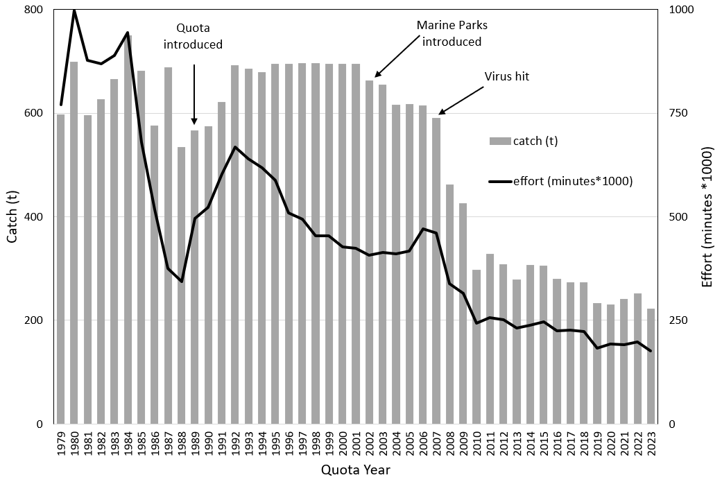

Figure 2: Historic catch (t) and effort (minutes) from 1979 to 2023. Quota was introduced in 1988 with the quota year running from April to March. All data prior to 2020 are from April to March. In 2020, the quota year was changed to the financial year, resulting in the 2020 quota year being 15 months in duration.

Nominal mean daily catch has ranged from 350 to 450 kg/day over the last two decades (Figure 3). Standardised trends depart substantially from the nominal means, with a general decline from 2003 to 2013, stable trends to 2020 and an increase in the last four years.

Figure 3: Catch (t) and mean daily catch (kg per fishing day) from 2003 to 2023. Grey line nominal annual mean (+/-SE). Solid black line standardised annual mean. Dashed black line standardised quarterly mean. All data prior to 2020 are from April to March. In 2020, the quota year was changed to the financial year, resulting in the 2020 quota year being 15 months in duration.

### Catch per unit effort (CPUE)

Nominal CPUE generally increased from 1992 to 2001, declined from 2001 to 2010, and has been relatively stable thereafter (Figure 4). Standardised CPUE generally declined from 2003 to 2019 and has increased for the last 4 seasons. Standardised CPUE is currently the highest it has been since 2009.

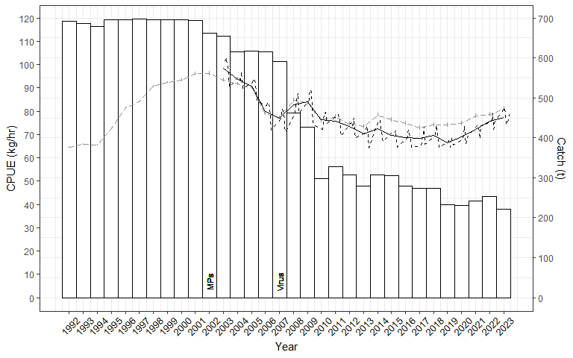

Figure 4: Central Zone catch and CPUE (nominal and standardised) from 1992/1993 – 2023/24. Catch = bars. Grey line nominal annual mean (+/-SE). Solid black line standardised annual mean. Dashed black line standardised quarterly mean. MPs = introduction of Marine Parks. Quota was introduced in 1988 with the quota year running from April to March. All data prior to 2020 are from April to March. In 2020, the quota year was changed to the financial year, resulting in the 2020 quota year being 15 months in duration.

### FIS abundance

#### Recruit abundance

Figure 5 plots recruit abundance from FIS sites from 1992 to 2023. The grey line is the nominal data from all FIS sites surveyed, with the black lines representing the nominal (dashed) and standardised (solid line) values for the Top 15 sites only. There was little difference between nominal and standardised trends. Recruit abundance at the Top 15 sites declined substantially from 2003 to 2009, then was relatively stable between 2009 and 2016 before declining to historic low levels in 2018. Recruit abundance has increased thereafter and in 2023 was around the 2009 levels.

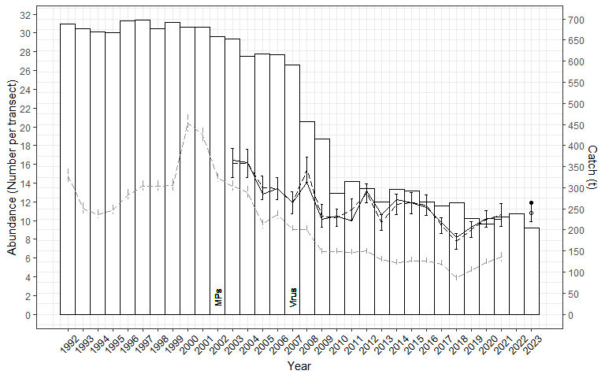

Figure 5: FIS recruit abundance (1992-2023) and catch (1992/93 – 2023/24) for the Central Zone. Catch = bars, grey dashed series = nominal abundance across all FIS sites (+/-SE). Black series = nominal (dotted line, open datapoint in 2023; +/- SE) and standardised (solid line, solid datapoint in 2023) abundance across the Top 15 sites only.

#### Pre-recruit abundance

Figure 6 plots pre-recruit abundance from FIS sites from 1992 to 2023. As for Figure 5, the grey line is the nominal data from all FIS sites surveyed, with the black lines representing the nominal (dashed) and standardised (solid line) values for the Top 15 sites only. There was little difference between nominal and standardised trends. Pre-recruit abundance at the Top 15 sites declined consistently from 2003 to 2008, was relatively stable from 2008 to 2020 before declining to a historic low in 2021. Surveys were not conducted in 2022 but in 2023 pre-recruit abundance increased by 87% relative to 2021 and was the highest observed since 2008.

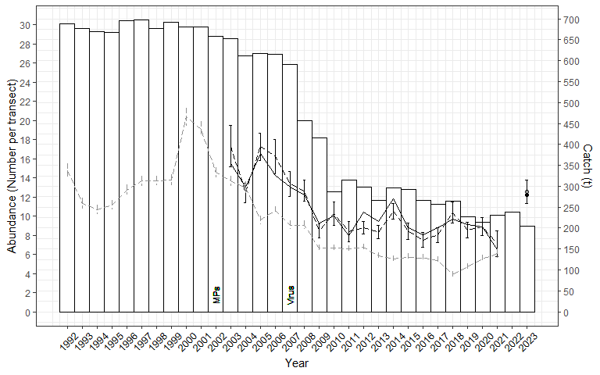

Figure 6: Pre-recruit abundance (1992-2023) and catch (1992/93 – 2023/24) for the Central Zone. Catch = bars, Grey dashed series = nominal abundance across all FIS sites (+/-SE). Black series = nominal (dotted line, open datapoint in 2023; +/- SE) and standardised (solid line, solid datapoint in 2023) abundance across the Top 15 sites only.

### Central Zone Performance Measures

The catch in 2023/24 totalled 222.3 t, which was 99.7% of the TACC (222.9 t, Table 2). Catch has declined by 66% in the long term (since 2003/04), 48% in the short-term (since 2009/10) and 2% in the last four years. Standardised CPUE in 2023/24 was 22% lower than the long-term and 8% lower than the short-term, but 12% higher than 4 years ago. Standardised mean daily catch showed similar trends to CPUE, being 19% lower in the long-term and 7% lower in the short-term, and 7% higher than 4 years ago.

Insufficient FIS data were collected in 2023/24 for assessment against the PIs, thus data from 2022/23 are presented. Recruit abundance at the Top 15 sites has declined by 26% in the long-term, but was 13% higher than the short-term and 16% higher than 4 years ago. Pre-recruit abundance has declined by 6% in the long-term but was 10% higher than the short-term and 37% higher than 4 years ago.

Table 2: Assessment of zone wide performance measures. * Recruit and pre-recruit abundance data are for 2022/23

|  |  |  |  |  |
| --- | --- | --- | --- | --- |
| Measure | 2023/24 | Long term (since 2003/04) | Short term (since 2009/10) | Last 4 years |
| Standardised CPUE (kg/h) | 77.3 | 98.5 (↓22%) | 84.0 (↓8%) | 66.5 (↑12%) |
| Standardised mean daily catch (kg/day) | 359 | 446 (↓19%) | 384 (↓7%) | 336 (↑7%) |
| Recruit abundance (Top 15 n/transect) | 11.9* | 16.1 (↓26%) | 10.5 (↑13%) | 10.2 (↑16%) |
| Pre-recruit abundance (Top 15 n/transect) | 12.2* | 13.0 (↓6%) | 10.0 (↑22%) | 8.9 (↑37%) |
| Catch (t) | 222.3 | 654.4 (↓66%) | 426.2 (↓48%) | 226.6 (↓2%) |
| 2023/24 TACC (t, %) | 222.9 t, 99.7% | | | |

## Spatial management unit (SMU) blacklip assessment

### SMU Performance Measures

In 2023/24, catches were close to the OT at all SMUs (Table 3). While Prom East and Cliffy Group SMUs were more than 15% below their respective OTs, the combined “under catch” was only 2.4 t. The 2023/24 catch was the most stable distribution of catches relative to OTs since this measure has been assessed.

Long-term declines in CPUE (ranging from 8-27%) occurred all SMUs, however 2003/04 was a highly productive period of the fishery and the declines in abundance of offshore and mid depth reefs since this time have been well documented. The short-term comparisons from 2009/10 show stable or declining trends that are less severe than the long term. In the last four years, trends in CPUE have been more positive, showing stable or increasing trends at all SMUs (ranging from a 1% decline to a 28% increase).

Table 3: Performance measures used in the assessment of the Central Zone abalone fishery at the SMU scale (Zone totals repeated for reference). OTs include carry-over TACC.

| Spatial Management Unit (SMU) | Catch | | | | CPUE | | |
| --- | --- | --- | --- | --- | --- | --- | --- |
| Total Catch 2022/23 | | OT (t) | SMU Category | Long-term (2003/04) | Short-term (2009/10) | 4 years (2019/20) |
| (t) | (%) TACC |
| Cape Otway | 47 | 21.1% | 49 | L | -24 | -15 | 0 |
| Back Beaches | 42.5 | 19.1% | 40 | L | -15 | 1 | 15 |
| Phillip Island | 32.7 | 14.7% | 32.3 | M | -8 | 2 | 28 |
| Shipwreck Coast | 25.1 | 11.3% | 29.2 | M | -17 | N/A | 17 |
| Prom West | 23.1 | 10.4% | 21 | M | -27 | -7 | -1 |
| Flinders | 22.2 | 10.0% | 20.5 | M | -14 | 3 | 22 |
| Kilcunda | 11.6 | 5.2% | 10.3 | S | -26 | -12 | 8 |
| Cape Liptrap | 8.9 | 4.0% | 9.4 | S | -25 | -17 | 15 |
| Prom East | 3.8 | 1.7% | 4.8 | S | -22 | -12 | 7 |
| Cliffy Group | 3.3 | 1.5% | 4.7 | S | -22 | -13 | 11 |
| Surfcoast | 2.1 | 0.9% | 1.7 | S | -18 | -3 | 7 |
| PPB | 0 | 0.0% |  | S |  |  |  |
| Central Zone | 222.3 | 99.7% | 222.9 |  | -22 | -8 | 12 |

*Notes: Coloured shading indicates whether catch has been caught within the OT, Threshold or exceeded the Limit. Green (within OT range) indicates catch was <±15% of the OT, Yellow (within threshold range) indicates catch was ±15-30% OT, Red (exceeding limit range) indicates catch was >±30% of the OT for the 2023/24 quota year. SMU catch categories (% of zone catch): Large ≥ 15%, Medium 10-15%, Small < 10%.*

### Distribution of the catch

Since 2002, there have been some substantial changes in catch distribution among the 12 SMUs in the Central Zone (Figure 7). Most notably, catches from the Flinders SMU, which were historically the highest within the zone, are now lower than several other SMUs. The Cape Otway, Back Beaches, Phillip Island and Shipwreck Coast SMUs are now the highest contributors to the Central Zone catch. While catches from the Back Beaches and Phillip Island SMUs have been relatively consistent since 2002, catches from the Cape Otway SMU have declined substantially in the last decade. The decrease in catch in the Shipwreck Coast SMU was largely attributed to closures and reduced TACCs post the abalone virus, although recent increases in catch suggest post-virus stock recovery. Catches from most other SMUs are lower and relatively stable except for decreases in the Port Phillip Bay SMU that has been associated with environmental influences (Mayfield et al. 2012).

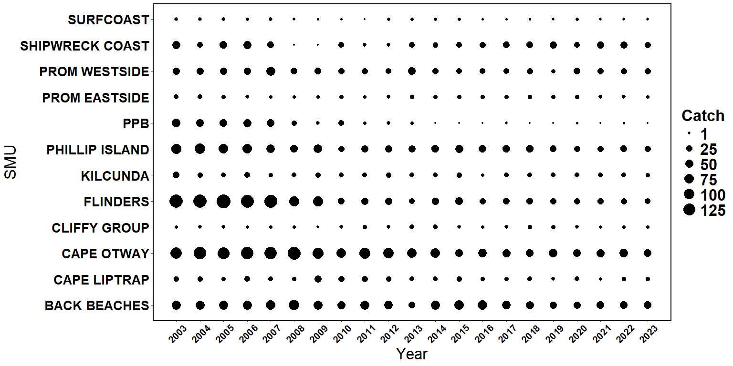

Figure 7: Relative distribution of catch at each SMU in the Central Zone by quota year.

### Draft Harvest Strategy outputs

The full Draft Harvest Strategy results are published in a separate report for the Central Zone fishery. In recent years, MRAG has assessed the Draft Harvest Strategy using reference points calculated from standardised CPUE data following the original rules used to establish the nominal CPUE reference points of the Draft Harvest Strategy (VFA 2019b). During 2024, the ASWG requested examination of the Draft Harvest Strategy results considering the original reference points as well. In addition, the ASWG recommended using the new CPUE standardisation model as the basis for the CPUE performance measure. Therefore, the following presents two sets of Draft Harvest Strategy outputs. Tables 4 and 5 present the assessment for standardised CPUE reference points, while Tables 6 and 7 present results for the original nominal reference points following VFA (2019b).

*Standardised reference points*

Current CPUE was above the Threshold at all SMUs except for Prom Eastside, where it is currently between the Threshold and Limit levels (Table 4). CPUE has been below the Threshold but above the Limit at Prom East for 14 consecutive years and thus Catch Control Rule (CCR) 2 applies for this SMU. CCR1 applies at all other SMUs, with “Increasing” Final Categories (Table 5) at Back Beaches, Flinders and Phillip Island resulting in potential increases in OT of up to 25%.

There were no FIS data to inform the Tertiary Indicator and thus the Final Category was the same as the Primary Category result. The Final Category for the Back Beaches, Phillip Island and Flinders were all assessed as Increasing, while all other SMUs were assessed as “Stable” (Table 5). The suggested total catch range for the Central Zone for 2025/26 was 218.2 t to 255.3 t.

Table 4: Standardised reference points for Central Zone SMUs, standardised mean annual CPUE from 2018- 2023 and catch control rules (CCR).

| SMU | Limit RP | Threshold RP | Target RP | 2018 | 2019 | 2020 | 2021 | 2022 | 2023 | Current Status | Years at Status | CCR |
| --- | --- | --- | --- | --- | --- | --- | --- | --- | --- | --- | --- | --- |
| BACK BEACHES | 50 | 70 | 90 | 67.1 | 65.0 | 68.8 | 73.5 | 79.0 | 79.3 | Above Threshold | 3 | 1 - 125% |
| CAPE LIPTRAP | 40 | 60 | 90 | 63.9 | 61.7 | 62.9 | 66.1 | 73.1 | 72.8 | Above Threshold | 21 | 1 |
| CAPE OTWAY | 50 | 70 | 100 | 70.2 | 68.8 | 71.2 | 70.9 | 68.9 | 71.5 | Above Threshold | 1 | 1 |
| CLIFFY GROUP | 40 | 60 | 80 | 66.7 | 60.9 | 62.5 | 65.0 | 68.6 | 69.6 | Above Threshold | 21 | 1 |
| FLINDERS | 40 | 60 | 90 | 56.3 | 55.8 | 56.5 | 66.0 | 66.1 | 69.9 | Above Threshold | 3 | 1 - 125% |
| KILCUNDA | 40 | 60 | 100 | 60.8 | 58.5 | 60.7 | 64.7 | 66.4 | 64.9 | Above Threshold | 4 | 1 |
| PHILLIP ISLAND | 40 | 60 | 90 | 60.4 | 61.1 | 58.6 | 62.0 | 69.3 | 72.2 | Above Threshold | 3 | 1 - 125% |
| PROM EASTSIDE | 40 | 60 | 70 | 52.0 | 47.7 | 49.5 | 51.0 | 53.0 | 52.9 | Limit to Threshold | 14 | 2 |
| PROM WESTSIDE | 40 | 60 | 90 | 59.5 | 53.5 | 66.7 | 61.8 | 67.3 | 66.3 | Above Threshold | 4 | 1 |
| SHIPWRECK COAST | 50 | 80 | 130 | 97.2 | 90.4 | 83.6 | 96.0 | 96.6 | 97.9 | Above Threshold | 21 | 1 |
| SURFCOAST | 40 | 60 | 70 | 51.7 | 54.2 | 55.4 | 54.7 | 60.3 | 61.5 | Above Threshold | 2 | 1 |

Table 5: Draft Harvest Strategy results (standardised reference points) for Central Zone SMUs with suggested target catch ranges.

| SMU | 4yr gradient | Primary Indicator | 2yr ratio (% change) | Secondary Indicator | Primary Category | Tertiary Indicator | Final Category | 2024/25 Target Catch (OT, t) | Total catch, Lower (t) | Total catch, Upper (t) |
| --- | --- | --- | --- | --- | --- | --- | --- | --- | --- | --- |
| BACK BEACHES | 5.30 | Increasing | 0.3 | Stable | Increasing | NA | Increasing | 41.5 | 41.5, 43.6 | 47.7, 51.9 |
| CAPE LIPTRAP | 1.46 | Stable | -0.4 | Stable | Stable | NA | Stable | 9.4 | 8.9 | 9.9 |
| CAPE OTWAY | -0.15 | Stable | 3.8 | Stable | Stable | NA | Stable | 49.0 | 46.6 | 51.5 |
| CLIFFY GROUP | 3.98 | Stable | 1.5 | Stable | Stable | NA | Stable | 4.7 | 4.5 | 4.9 |
| FLINDERS | 6.89 | Increasing | 5.8 | Increasing | Increasing | NA | Increasing | 20.5 | 20.5, 21.5 | 23.6, 25.6 |
| KILCUNDA | -0.77 | Stable | -2.2 | Stable | Stable | NA | Stable | 9.3 | 8.8 | 9.8 |
| PHILLIP ISLAND | 8.27 | Increasing | 4.1 | Stable | Increasing | NA | Increasing | 34.0 | 34.0, 35.7 | 39.1, 42.5 |
| PROM EASTSIDE | 2.49 | Stable | -0.2 | Stable | Stable | NA | Stable | 4.8 | 4.1 | 4.6 |
| PROM WESTSIDE | 0.67 | Stable | -1.5 | Stable | Stable | NA | Stable | 21 | 20.0 | 22.1 |
| SHIPWRECK COAST | 4.98 | Stable | 1.4 | Stable | Stable | NA | Stable | 29.2 | 27.7 | 30.7 |
| SURFCOAST | 4.35 | Stable | 1.9 | Stable | Stable | NA | Stable | 1.7 | 1.6 | 1.8 |
| Total |  |  |  |  |  |  |  | 225.1 | 218.2, 223.0 | 245.7, 255.3 |

*Nominal reference points*

Current CPUE was above the Threshold at all SMUs except for Flinders, Kilcunda and Prom Westside, where it was currently between the Threshold and Limit levels (Table 6). CPUE has been below the Threshold but above the Limit at Flinders, Kilcunda and Prom Westside for 18, 14 and 13 years, respectively and thus Catch Control Rule (CCR) 2 applies for all three of these SMUs. CCR1 applies at all other SMUs, with an “Increasing” Final Category (Table 7) at Back Beaches resulting in a potential increase in OT of up to 25%.

There were no FIS data to inform the Tertiary Indicator and thus the Final Category was the same as the Primary Category result. The Final Category for the Back Beaches, Phillip Island and Flinders were all assessed as Increasing, while all other SMUs were assessed as “Stable” (Table 7). The suggested total catch range for the Central Zone for 2025/26 was 213.0 t to 241.7 t.

Table 6: Nominal reference points (VFA 2019b) for Central Zone SMUs, standardised mean annual CPUE from 2018- 2023 and catch control rules (CCR).

| SMU | Limit RP | Threshold RP | Target RP | 2018 | 2019 | 2020 | 2021 | 2022 | 2023 | Current Status | Years at Status | CCR |
| --- | --- | --- | --- | --- | --- | --- | --- | --- | --- | --- | --- | --- |
| BACK BEACHES | 50 | 70 | 100 | 67.1 | 65.0 | 68.8 | 73.5 | 79.0 | 79.3 | Above Threshold | 3 | 1 - 125% |
| CAPE LIPTRAP | 40 | 60 | 120 | 63.9 | 61.7 | 62.9 | 66.1 | 73.1 | 72.8 | Above Threshold | 21 | 1 |
| CAPE OTWAY | 50 | 70 | 100 | 70.2 | 68.8 | 71.2 | 70.9 | 68.9 | 71.5 | Above Threshold | 1 | 1 |
| CLIFFY GROUP | 40 | 60 | 110 | 66.7 | 60.9 | 62.5 | 65.0 | 68.6 | 69.6 | Above Threshold | 21 | 1 |
| FLINDERS | 50 | 70 | 100 | 56.3 | 55.8 | 56.5 | 66.0 | 66.1 | 69.9 | Limit to Threshold | 18 | 2 |
| KILCUNDA | 50 | 70 | 110 | 60.8 | 58.5 | 60.7 | 64.7 | 66.4 | 64.9 | Limit to Threshold | 14 | 2 |
| PHILLIP ISLAND | 50 | 70 | 110 | 60.4 | 61.1 | 58.6 | 62.0 | 69.3 | 72.2 | Above Threshold | 3 | 1 |
| PROM EASTSIDE | 40 | 50 | 80 | 52.0 | 47.7 | 49.5 | 51.0 | 53.0 | 52.9 | Above Threshold | 3 | 1 |
| PROM WESTSIDE | 50 | 70 | 100 | 59.5 | 53.5 | 66.7 | 61.8 | 67.3 | 66.3 | Limit to Threshold | 13 | 2 |
| SHIPWRECK COAST | 40 | 60 | 130 | 97.2 | 90.4 | 83.6 | 96.0 | 96.6 | 97.9 | Above Threshold | 21 | 1 |
| SURFCOAST | 40 | 60 | 70 | 51.7 | 54.2 | 55.4 | 54.7 | 60.3 | 61.5 | Above Threshold | 2 | 1 |

Table 7: Draft Harvest Strategy results (nominal reference points) for Central Zone SMUs, with suggested target catch ranges.

| SMU | 4yr gradient | Primary Indicator | 2yr ratio (% change) | Secondary Indicator | Primary Category | Tertiary Indicator | Final Category | 2024/25 Target Catch (OT, t) | Total catch, Lower (t) | Total catch, Upper (t) |
| --- | --- | --- | --- | --- | --- | --- | --- | --- | --- | --- |
| BACK BEACHES | 5.30 | Increasing | 0.3 | Stable | Increasing | NA | Increasing | 41.5 | 41.5, 43.6 | 47.7, 51.9 |
| CAPE LIPTRAP | 1.46 | Stable | -0.4 | Stable | Stable | NA | Stable | 9.4 | 8.9 | 9.9 |
| CAPE OTWAY | -0.15 | Stable | 3.8 | Stable | Stable | NA | Stable | 49.0 | 46.6 | 51.5 |
| CLIFFY GROUP | 3.98 | Stable | 1.5 | Stable | Stable | NA | Stable | 4.7 | 4.5 | 4.9 |
| FLINDERS | 6.89 | Increasing | 5.8 | Increasing | Increasing | NA | Increasing | 20.5 | 19.5 | 21.5 |
| KILCUNDA | -0.77 | Stable | -2.2 | Stable | Stable | NA | Stable | 9.3 | 7.9 | 8.8 |
| PHILLIP ISLAND | 8.27 | Increasing | 4.1 | Stable | Increasing | NA | Increasing | 34.0 | 32.3 | 35.7 |
| PROM EASTSIDE | 2.49 | Stable | -0.2 | Stable | Stable | NA | Stable | 4.8 | 4.6 | 5.0 |
| PROM WESTSIDE | 0.67 | Stable | -1.5 | Stable | Stable | NA | Stable | 21 | 17.9 | 20.0 |
| SHIPWRECK COAST | 4.98 | Stable | 1.4 | Stable | Stable | NA | Stable | 29.2 | 27.7 | 30.7 |
| SURFCOAST | 4.35 | Stable | 1.9 | Stable | Stable | NA | Stable | 1.7 | 1.6 | 1.8 |
| Total |  |  |  |  |  |  |  | 225.1 | 213.0, 218.1 | 240.6, 241.7 |

In general, the nominal reference points from VFA (2019b) were more conservative than the standardised reference points. Notably, there were several changes in the standardised reference points this year compared to last due to the application of a new CPUE standardisation model.

The reference points are calculated based on a reference period between 1979 and 2015 following VFA (2019b). Thus, for the calculation of standardised reference points, a dataset extending back to 1978 was used. In previous Draft Harvest Strategy results we have used the standardised CPUE measure from this full dataset to assess against the reference points. However, this has drawn criticism because of difference in the model outputs between the model outputs from the Draft Harvest Strategy and Stock Assessment reports. On that basis, in this report we have used only the data considered reliable from 2003 to determine the CPUE performance measure to ensure consistency with stock assessment outputs. This further complicates the interpretation of Draft Harvest Strategy results. On this basis, it is recommended that the Performance Indicators should be reviewed prior to the next stock assessment, based on an alternative reference period that better reflects stock objectives.



### Cape Otway (Large SMU)

The Cape Otway SMU was the most important in terms of total catch with 47.0 t harvested in 2023/24 representing 21.1% of the total catch (Table 8) and TACC (Table 3). The catch was 2 t below the OT of 49.0 t which included carry-over (3.9 t). Standardised CPUE has declined since 2003 by 24%, with a 15% reduction observed since 2009 and no change over the last 4 years.

Table 8: Summary of Catch, Optimal targets and CPUE performance indicators for the Cape Otway SMU. The LML and nominal mean daily catch are also shown.

| Catch | | | | | | Standardised CPUE Performance Indicators (%change) | | |
| --- | --- | --- | --- | --- | --- | --- | --- | --- |
| 2023/24 | | OT + carryover* (t) | | | | Long-term | Short-term | Last 4 years |
| (t) | (%) | 22/23 | 23/24 | 24/25 | | 2003/04 – 2023/24 | 2009/10 – 2023/24 | 2020/21 – 2023/24 |
| 47.0 | 21.1 | 57.9* | 49.0* | 49 | | -24 | -15 | 0 |
| LML 2023/24 = 125 mm | | | | | Mean daily catch 2023/24 (nominal) = 445 kg | | | |

The Cape Otway SMU has been an important contributor to the TACC since 1992, with an average catch of 84 t during this period and a peak catch of 159 t taken during 2008, the year after the virus became apparent in the west of the Central Zone (Figure 3). Catches have generally declined thereafter, reaching a low catch of 40 t in 2015 and an average catch of 50 t over the past 8 years.

Standardised CPUE generally declined from 2003 to 2015 then increased to 2018 and has been stable thereafter (Figure 8). Standardised CPUE shows a substantial departure from nominal CPUE between 2006 and 2021, with a smaller difference in recent years.

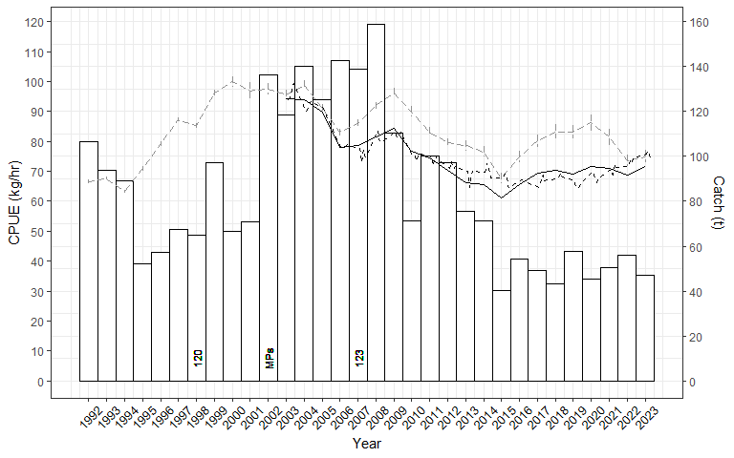

Figure 8: Cape Otway SMU catch, and CPUE (nominal and standardised) from 1992/1993 – 2023/24. Nominal annual = grey series (+/- SE), standardised annual = solid black, standardised quarterly = dashed black. Numbers indicate changes to LMLs. MPs = introduction of Marine Parks

Standardised mean daily catch decreased slowly from 2003 to 2015, increased slowly from 2015 to 2018 and has been stable thereafter (Figure 9). Nominal mean daily catch was 445 kg/day in 2023/24. Standardised trends differed substantially from nominal trends from 2017 to 2020.

Figure 9: Total catch and mean daily catch for the Cape Otway SMU from 2003 to 2023. Nominal annual = grey series (+/- SE), standardised annual = solid black, standardised quarterly = dashed black.

Table 9: Catches (kg) by reefcode for the Cape Otway SMU from 2018/19 to 2023/24 and the five-year average catch from 2018/19 to 2022/23.

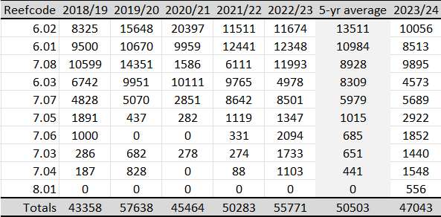

The Cape Otway SMU comprises 10 reefcodes (Table 9). In 2023/24, 6.02 remained the highest producing reefcode. Catches from 6.03 were well below the previous 5-year average for the second consecutive year. The catches from 7.05, 7.04 and 8.01 were the highest of the last 6 years.

*FIS recruit abundance (Four Top 15* *sites)*

Nominal trends in pre-recruit abundance across all sites show decline since 2000 (Figure 10). While highly variable, the abundance of recruit sized abalone at Top 15 sites generally decreased from 2003 to a historic low in 2016 and have slowly increased thereafter.

*FIS pre-recruit abundance (Four Top 15 sites)*

Nominal trends in pre-recruit abundance across all sites show consistent decline since 1992 (Figure 11). The abundance of pre-recruits at Top 15 sites has been highly variable since 2003.

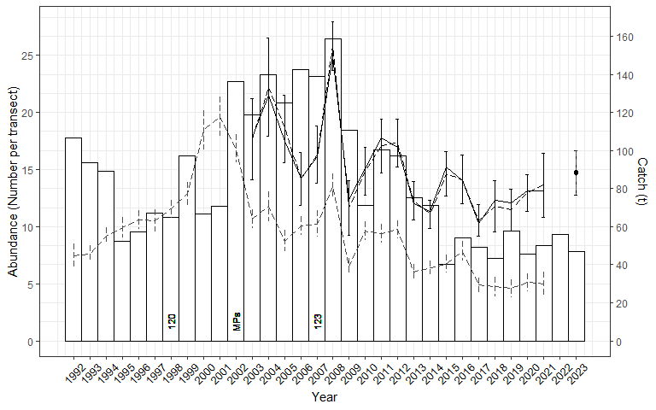

Figure 10: Recruit abundance (grey dashed, nominal all sites 1992 – 2021; black, Top 15 standardised (solid) 2003 – 2023) including catch from 1992/1993 – 2022/23 for the Cape Otway SMU. MPs = introduction of Marine Parks; numbers reflect size limit changes.

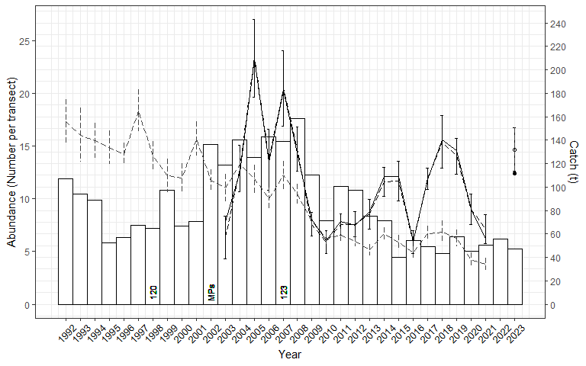

Figure 11: Pre-recruit abundance (grey dashed, nominal all sites 1992 – 2021; black, Top 15 standardised (solid) 2003 – 2023) including catch from 1992/1993 – 2022/23 for the Cape Otway SMU. MPs = introduction of Marine Parks; numbers reflect size limit changes.

*Length frequency data – FIS*

The size structure of the surveyed population at the Cape Otway SMU has remained stable over time despite declines in abundance (Appendix 1). The increase in pre-recruit abundance observed in the four Top 15 sites surveyed in the 2023 FIS was primarily abalone within 10 mm of the current size limit.

*Length frequency data – commercial*

From 2017/18 to December 2024, the standardised average length of abalone in the commercial catch has increased from around 131 mm to around 134 mm, which is 9 mm above the current LML (Appendix 3, Appendix 4). The size structure for the last 2 years was stable, although fewer data were collected in these years. While more variable over time, the same trends are apparent in the raw data. The LML was increased from 123 mm to 125 mm on 1 April 2020, however results of an analysis to account for LML increases in Appendix 3 also demonstrates an increase in size over and above the LML increase. The increase in average length has led to a >5% increase in average weight and a reduction in the number of abalone harvested for a given TACC.

*Summary*

A peak catch of 159 t was harvested from the Cape Otway SMU during 2008, the year after the virus first affected the west of the Central Zone. Catches have generally declined thereafter, reaching a low of 40 t in 2015. Catch in 2023/24 was 47.0 t. The size limit was increased from 123 to 125 mm on 1 April 2021. Standardised CPUE generally declined from 2003 to 2015 then increased to 2018 and has been stable thereafter. Standardised mean daily catch has also been stable since 2018. In 2023/24, 6.02 remained the highest producing reefcode. Catches from 6.03 were well below the previous 5-year average for the second consecutive year. The catches from 7.05, 7.04 and 8.01 were the highest of the last 6 years.

Recruit abundance from the 4 Top 15 FIS sites has fluctuated without clear trend for the last 15 years. Pre-recruit abundance has been variable over time but more than doubled between 2021 and 2023 and was high in an historic sense.

The standardised average length of abalone in the commercial catch has increased from 131 mm in 2017/18 to 134 mm in 2023/24, which is 9 mm above the LML.

The total catch in the Cape Otway SMU of 47.0 t was 2.0 t below the OT (49.0 t). Mean CPUE (71.5 kg/h) was above the Threshold level (70 kg/h). Both the Primary Indicator and Secondary Indicators are Stable, resulting in a Stable Final Category. For 2024/25 the OT was maintained at 49.0 t, so this suggests an OT of 46.6–51.5 t.

**Following reduced catches in 2015, standardised CPUE increased until 2018 and has been stable thereafter. Mean daily catch has also been stable since 2018. At the 4 Top 15 FIS sites, recruit abundance is stable and pre-recruit abundance was high in 2023 in historical terms. No FIS was done in 2024. The standardised average length of the commercial catch has steadily increased for the last 7 years. The Draft Harvest Strategy suggests a Stable OT which is supported by the weight of evidence for the Cape Otway SMU.**

### Back Beaches (Large SMU)

The Back Beaches SMU was the second most productive Central Zone SMU with 42.5 t harvested in 2023/24 representing 19.1% of the total catch (Table 10) and TACC (Table 3). The total catch exceeded the OT by 1.0 t. Standardised CPUE has declined since 2003 by 15%, was similar in the short-term (1% increase) and was 15% higher than 4 years ago.

Table 10: Summary of Catch, Optimal targets and CPUE performance indicators for the Back Beaches SMU. The LML and mean daily catch are also shown.

| Catch | | | | | | Standardised CPUE Performance Indicators (% change) | | |
| --- | --- | --- | --- | --- | --- | --- | --- | --- |
| 2023/24 | | OT + carryover* (t) | | | | Long-term | Short-term | Last 4 years |
| (t) | (%) | 22/23 | 23/24 | 24/25 | | 2003/04 – 2023/24 | 2009/10 – 2023/24 | 2020/21 – 2023/24 |
| 42.5 | 16.8 | 40 | 40 | 41.5 | | -15 | 1 | 15 |
| LML 2023/24 = 119 mm | | | | | Mean daily catch 2023/24 (nominal) = 483 kg | | | |

The Back Beaches SMU is an important contributor to the Central Zone TACC, with an average catch of 59 t since 1992 and a peak catch of 95 t taken during 2008 (Figure 12). Catches generally declined in subsequent years reaching a low catch of 32 t in 2013. Catches ranged from 52 to 78 t from 2014 to 2018 and have ranged from 35 to 43 t thereafter.

Standardised CPUE generally declined from 2003 to 2017 and has increased thereafter (Figure 8). Standardised CPUE has followed similar annual trends to nominal CPUE.

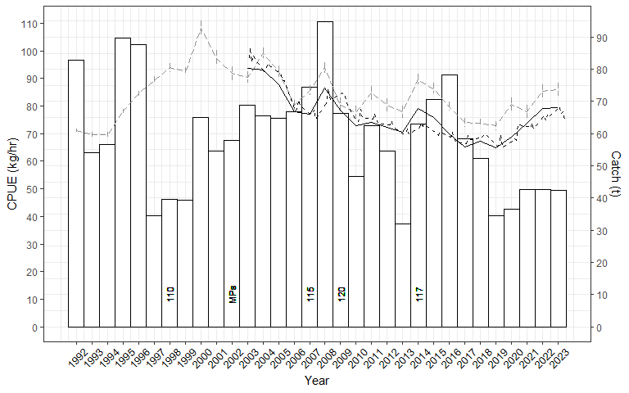

Figure 12: Back Beaches SMU catch, and CPUE (nominal and standardised) from 1992/1993 – 2023/24. Nominal annual = grey series (+/- SE), standardised annual = solid black, standardised quarterly = dashed black. Numbers indicate changes to LMLs. MPs = introduction of Marine Parks.

Standardised mean daily catch slowly declined from 2003 to 2017 and has slowly increased thereafter (Figure 13). Nominal mean daily catch was 483 kg/day in 2023/24.

Figure 13: Total catch and mean daily catch for the Back Beaches SMU from 2003 to 2023. Nominal annual = grey series (+/- SE), standardised annual = solid black, standardised quarterly = dashed black.

Table 11: Catches (kg) by reefcode for the Back Beaches SMU from 2018/19 to 2023/24 and the five-year average catch from 2018/19 to 2022/23.*

The Back Beaches SMU comprises 5 reefcodes, 4 of which regularly produce high catches (Table 11). Catches in 2023/24 were similar to the previous 5-year average for the four main reefcodes. A catch of 417 kg was harvested from 12.01 for the first time in the last 6 years.

*FIS recruit abundance (Three Top 15 sites)*

The abundance of recruit sized abalone on FIS was highly variable from 1992 to 2015 before declining to a historic low in 2017 and 2018 (Figure 14). Abundance has been higher thereafter but remains low in a historic context.

*FIS pre-recruit abundance (Three Top 15 sites)*

Pre-recruit abundance at the Top 15 sites declined substantially from 2003 to very low levels in 2021, however in 2023 pre-recruit abundance levels increased to be equal with historic high levels (Figure 15).

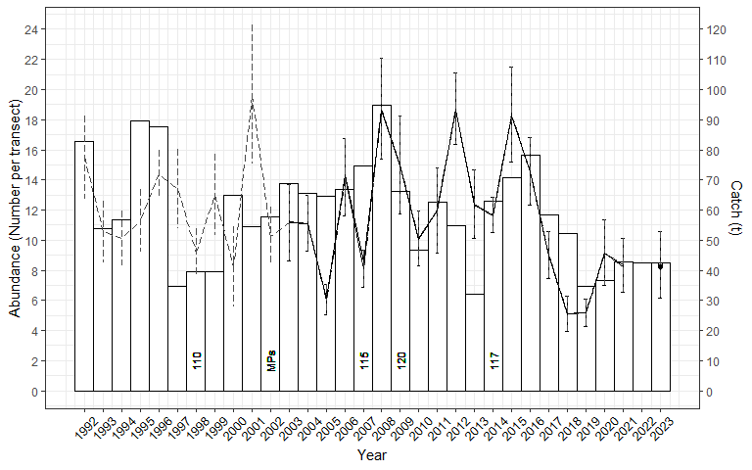

Figure 14: Recruit abundance (grey dashed, nominal all sites 1992 – 2021; black, Top 15 standardised (solid) 2003 – 2023) including catch from 1992/1993 – 2022/23 for the Back Beaches SMU. MPs = introduction of Marine Parks; numbers reflect size limit changes.

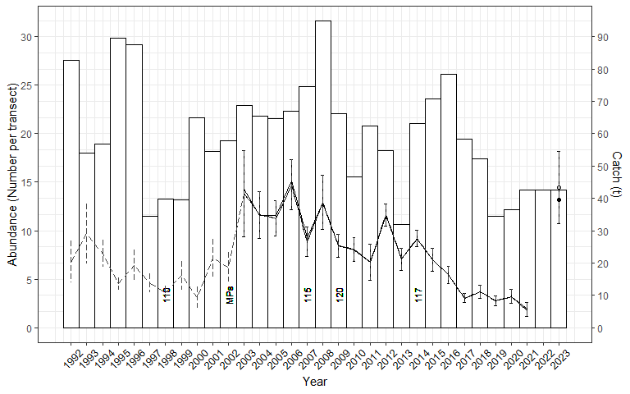

Figure 15: Pre-recruit abundance (grey dashed, nominal all sites 1992 – 2021; black, Top 15 standardised (solid) 2003 – 2023) including catch from 1992/1993 – 2022/23 for the Back Beaches SMU. MPs = introduction of Marine Parks; numbers reflect size limit changes.

*Length frequency data – FIS*

The size structure of the surveyed population at the Back Beaches SMU has remained stable over time despite variations in abundance (Appendix 1). The increase in pre-recruit abundance observed in the three Top 15 sites surveyed in the 2023 FIS was across a range of pre-recruit size categories.

*Length frequency data – commercial*

From 2016/17 to 2019/20, the standardised average length of abalone in the commercial catch was relatively stable around 125 mm, which was around 8 mm above the LML at that time (Appendix 3, Appendix 3). The LML increased to 119 mm on 1 April 2020 and mean size increased by around 2 mm at that time. Thereafter, average size has steadily increased on an annual basis and is currently around 134 mm, which is 15 mm above the LML. It is noted that raw data show very similar trends as standardised data over time. Increases in length lead to increases in weight and a reduction in the number of abalone harvested for a given TACC, with estimates of weight increase greater than 10% for the Back Beaches SMU.

*Summary*

The Back Beaches SMU maintained high catches and catch rates particularly from 2000 to 2009. The peak catch of 95 t in 2008 occurred either side of increases in LML in 2007 and 2009. Catches declined thereafter until 2014 when the LML was decreased and catches again increased to reach almost 80 t in 2016. Catches then declined again, with 36.5 t harvested in the 2020/21 quota year before increasing to around 42.5 t for the last three years. Standardised CPUE declined from 2003 to 2017 but has increased thereafter. Standardised mean daily catch per day has also increased in the last three years. The distribution of catches by reefcode is stable.

At the three Top 15 FIS sites in 2023, recruit abundance remains low in a historical context but is almost twice as high as it was in 2017 and 2018. The abundance of pre-recruits increased dramatically in 2023 to be the equal highest observed (same as 2006). No FIS was done in 2024.

The standardised average length of the commercial catch has increased substantially from around 125 mm in 2019/20 to around 134 mm in 2024/25, which is 15 mm above the LML.

Total catch in the Back Beaches SMU (42.5 t) was 2.5 t above the OT (40.0 t). Mean CPUE (79.3 kg/h) was above the Threshold level (70 kg/h) for the third consecutive year. The Primary Indicator was Increasing and Secondary Indicator was Stable, resulting in an Increasing Final Category. As a result, increases in catch of up to 25% above the current OT could be considered. The OT was increased to 41.5 t for 2024/25, suggesting an OT from 41.5 t to 51.9 t for 2025/26.

**Following the lower catches harvested since 2019, the weight of evidence assessment for the Back Beaches SMU is now overwhelmingly positive. Both CPUE and mean daily catch have increased, and the distribution of catches among reefcodes is stable. The average length of abalone in the commercial catch has increased substantially, implying that fewer individual abalone are harvested annually for a given TACC. FIS recruit abundance is low but stable however pre-recruit abundance increased dramatically in 2023 and was at equal record levels. The Draft Harvest Strategy suggests another increase in OT can be considered, however if this is recommended then any increase should again be modest to ensure continued recovery of the stock.**

### Phillip Island (Medium SMU)

The Phillip Island SMU was third highest contributor to the Central Zone total catch with 32.7 t harvested in 2023/24 representing 14.7% of the total catch (Table 12) and TACC (Table 3). The catch was 0.4 t above the OT. Standardised CPUE has declined by 8% in the long-term, increased by 2% in the short-term and by 28% in the last 4 years.

Table 12: Summary of Catch, Optimal targets and CPUE performance indicators for the Phillip Island SMU. The LML and mean daily catch are also shown.

| Catch | | | | | | Standardised CPUE Performance Indicators (% change) | | |
| --- | --- | --- | --- | --- | --- | --- | --- | --- |
| 2023/24 | | OT + carryover* (t) | | | | Long-term | Short-term | Last 4 years |
| (t) | (%) | 22/23 | 23/24 | 24/25 | | 2003/04 – 2023/24 | 2009/10 – 2023/24 | 2020/21 – 2023/24 |
| 32.7 | 14.7 | 34.0 | 32.3 | 34.0 | | -8 | 2 | 28 |
| LML 2023/24 = 112 mm | | | | | Mean daily catch 2023/24 (nominal) = 455 kg | | | |

The Phillip Island SMU has had an average catch of 61 t since 1992 and a peak catch of 121 t harvested during 1998 (Figure 16). Following the peak, catches generally declined reaching a low catch of 26 t in 2010. Catches ranged from 33 to 51 t between 2011 and 2018 but have stabilised in the last 4 years under a catch cap.

Standardised CPUE slowly declined from 2003 to 2017 but has increased thereafter, with substantial increases since 2020. CPUE in 2023/24 was higher than 2006/07 levels (Figure 16).

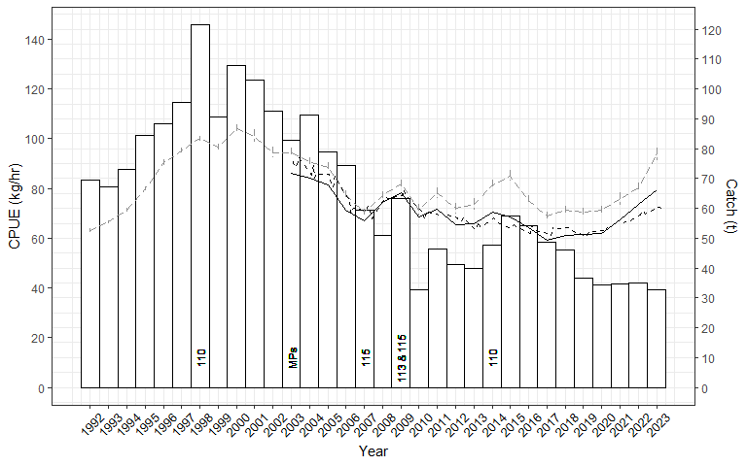

Figure 16: Phillip Island SMU catch, and CPUE (nominal and standardised) from 1992/1993 – 2023/24. Nominal annual = grey series (+/- SE), standardised annual = solid black, standardised quarterly = dashed black. Numbers indicate changes to LMLs. MPs = introduction of Marine Parks.

Standardised mean daily catch generally declined from 2003 to 2010 and has been variable thereafter (Figure 17). Nominal mean daily catch was 455 kg/day in 2023/24.

Figure 17: Total catch and mean daily catch for the Phillip Island SMU from 2003 to 2023. Nominal annual = grey series (+/- SE), standardised annual = solid black, standardised quarterly = dashed black.

Table 13: Catches (kg) by reefcode for the Phillip Island SMU from 2018/19 to 2023/24 and the 5-year average catch from 2018/19 to 2022/23.

The Phillip Island SMU comprises 11 reefcodes, 4 of which (14.03, 14.02, 14.04, 14.09) produce most of the catch (Table 13). In 2023/24, the catch from 14.03 was less than half of the 5-year average. Catches from 14.02 were the highest recorded in the last 6 years, as were catches from 14.01. Most other reefcodes catches were similar to previous years.

*FIS recruit abundance (Two Top 15 sites)*

Recruit abundance declined sharply at Top 15 sites from 2004 to 2008 and was highly variable until it reached a contemporary low in 2017 (Figure 18). Since then, recruit abundance has linearly increased and in 2023, recruit abundance doubled relative to 2021 and was at the highest levels observed since 2004.

*FIS pre-recruit abundance (Two Top 15 sites)*

Pre-recruit abundance at Top 15 sites has been highly variable since 2004 (Figure 19). Historic low levels were observed in 2015, increasing slightly thereafter but remaining low in a historic context. In 2023, pre-recruit abundance almost doubled relative to 2021 and was high in a historical context.

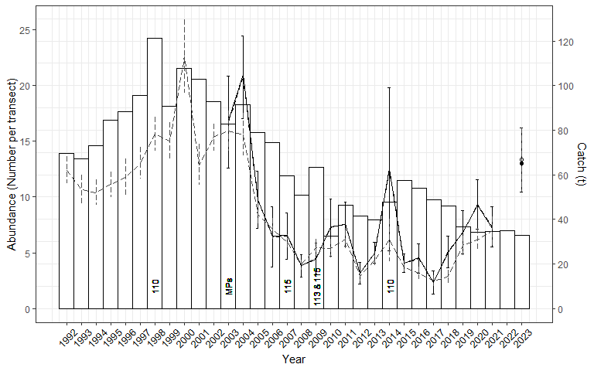

Figure 18: Recruit abundance (grey dashed, nominal all sites 1992 – 2021; black, Top 15 standardised (solid) 2003 – 2023) and catch from 1992/1993 – 2020/21 for the Phillip Island SMU. MPs = introduction of Marine Parks; numbers reflect size limit changes.

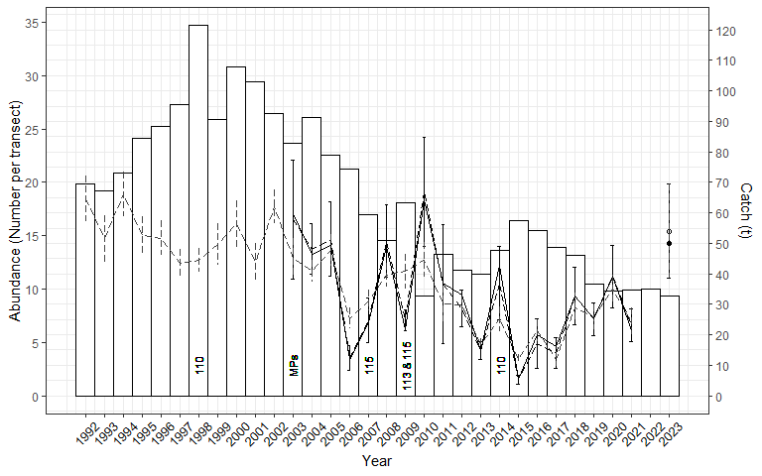

Figure 19: Pre-recruit abundance (grey dashed, nominal all sites 1992 – 2021; black, Top 15 standardised (solid) 2003 – 2023) including catch from 1992/1993 – 2022/23 for the Phillip Island SMU. MPs = introduction of Marine Parks; numbers reflect size limit changes.

*Length frequency data – FIS*

The size structure of the surveyed population at the Phillip Island SMU has remained stable over time despite variations in abundance (Appendix 1). The increase in pre-recruit abundance observed in the two Top 15 sites surveyed in the 2023 FIS was across a range of pre-recruit size categories.

*Length frequency data – commercial*

From 2016/17 to 2019/20, the standardised average length of abalone in the commercial catch increased from around 115 mm to 119 mm, which was 5 to 9 mm above the LML at that time (Appendix 3, Appendix 4). The LML increased to 112 mm on 1 April 2020 and mean size increased by almost 3 mm in 2021 to around 122 mm. Standardised average length has continued to increase annually to be around 127 mm in the first half of 2024/25, which is 15 mm above the current LML. Raw data show similar trends of increase over time. Increases in length lead to increases in weight and a reduction in the number of abalone harvested for a given TACC, with estimates of weight increase greater than 10% for the Phillip Island SMU.

*Summary*

The Phillip Island SMU has had an average catch of 6 t since 1992 and a peak catch of 121 t harvested during 1998. Following the peak, catches generally declined reaching a low catch of 26 t in 2010. Catches ranged from 33 to 51 t between 2011 and 2018 but have stabilised in the last 5 years under a catch cap. These stable catches have resulted in increasing CPUE and stable mean daily catches. The primary concern relates to the distribution of catches among reefcodes. In 2023/24, the catch from the previously highest producing reefcode 14.03 was less than half of the 5-year average, while catches from 14.02 and 14.01 were the highest recorded in the last six years.

Recruit abundance at the two Top 15 FIS sites had declined substantially between 2003 and 2017 but has increased thereafter, with 2023 levels amongst the highest recorded. Similar trends have occurred for pre-recruit abundance, with 2023 levels close to the historic high.

Since 2016/17, the standardised average length of the commercial catch has increased from 115 mm to 127 mm in the first half of 2024/25, which is 15 mm above the current LML. These increases in size imply that fewer individual abalone are being caught annually for the stable Phillip Island OT.

Total catch in the Phillip Island SMU of 32.7 t was just above the OT (32.3 t). Mean CPUE (72.2 kg/h) was above the Threshold Reference Point (60 kg/h) for the third consecutive year. The Primary Indicator was Increasing and Secondary Indicator was Stable, resulting in an Increasing Final Category. As a result, increases in catch of up to 25% above the current OT could be considered. The OT was increased to 34.0 t for 2024/25, suggesting an OT from 34.0 t to 42.5 t for 2025/26.

**As for the Back Beaches, the Phillip Island SMU appears to have responded positively to the lower, stable catches maintained in recent years, with all available stock indicators appearing positive. The primary concern relates to the distribution of catches among reefcodes, with the 2023/24 catch from 14.03 being less than half of the 5-year average and the catch from 14.02 the highest from the last 6 years. An improved understanding of the reasons for this shift is required. While the Draft Harvest Strategy outcomes suggest another increase in OT can be considered, potential concerns regarding reefcode catches should be addressed first. As for the Back Beaches SMU, any potential increase in OT should be modest at best to promote further stock recovery.**

### Shipwreck Coast (Medium SMU)

The Shipwreck Coast SMU had the fourth highest catch with 25.1 t in 2023/24 representing 11.3% of the total catch (Table 14) and TACC (Table 3). The catch was 4.1 t below the OT which included carryover (3.9 t). This SMU was severely affected by the virus in 2007 (VFA 2018) and there was no fishing in 2008 and 2009. Standardised CPUE has declined by 17% in the long-term and has increased by 17% in the last 4 years.

Table 14: Summary of Catch, Optimal targets and CPUE performance indicators for the Shipwreck Coast SMU. The LML and mean daily catch are also shown.

| Catch | | | | | | Standardised CPUE Performance Indicators (% change) | | |
| --- | --- | --- | --- | --- | --- | --- | --- | --- |
| 2023/24 | | OT + carryover* (t) | | | | Long-term | Short-term | Last 4 years |
| (t) | (%) | 22/23 | 23/24 | 24/25 | | 2003/04 – 2023/24 | 2009/10 – 2023/24 | 2020/21 – 2023/24 |
| 25.1 | 11.3 | 34.3* | 29.2* | 29.2 | | -17 | N/A | 17 |
| LML 2023/24 = 130 mm | | | | | Mean daily catch 2023/24 (nominal) = 576 kg | | | |

The Shipwreck Coast SMU has had an average catch of 26 t since 1992 with a peak catch of 49 t harvested during 2002 (Figure 20). Catches gradually increased post-virus and following a low catch of 17 t in 2022/23, catches were the highest post-virus in 2021/22 (38.4 t).

Standardised CPUE declined from 2003 to 2007 prior to the impact of the virus and has fluctuated without any significant trend post-virus (Figure 20).

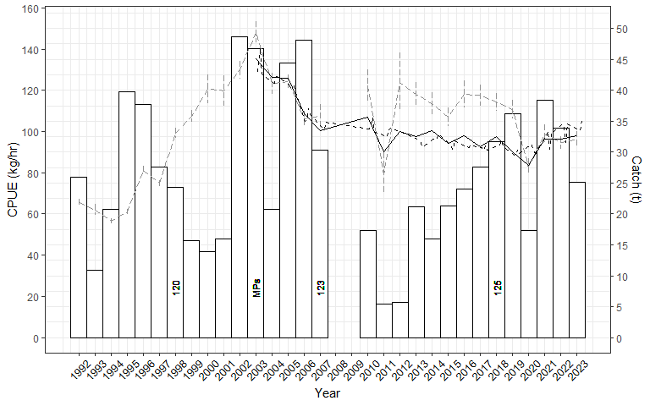

Figure 20: Shipwreck Coast SMU catch, and CPUE (nominal and standardised) from 1992/1993 – 2023/24. Nominal annual = grey series (+/- SE), standardised annual = solid black, standardised quarterly = dashed black. Numbers indicate changes to LMLs. MPs = introduction of Marine Parks.

Standardised mean daily catch declined from 2003 to 2007 prior to the virus and has been relatively stable thereafter (Figure 21). Nominal mean daily catch was 576 kg/day in 2023/24.

Figure 21: Total catch and mean daily catch for the Shipwreck Coast SMU from 2003 to 2023. Nominal annual = grey series (+/- SE), standardised annual = solid black, standardised quarterly = dashed black.

Table 15: Catches (kg) by reefcode for the Shipwreck Coast SMU from 2018/19 to 2023/24 and the 5-year average catch from 2018/19 to 2022/23.

All 5 reefcodes have contributed regularly to the catch from the Shipwreck Coast SMU in the past 6 years (Table 15). In 2023/24, catches were close to the 5-year average at all reefcodes except for a low catch at 4.01.

*FIS recruit abundance (Two Top 15 sites)*

FIS were not implemented in the Shipwreck SMU until 2004. The abundance of recruit sized abalone declined substantially and significantly from 2004 to 2009, seemingly independent of the virus introduction (Figure 22). At Top 15 sites, recruit abundance has generally increased post-virus.

*FIS pre-recruit abundance (Two Top 15 sites)*

The abundance of pre-recruit abalone has been variable over time (Figure 23). The abundance of pre-recruits generally increased post-virus until 2020 and has been at relatively low levels thereafter.

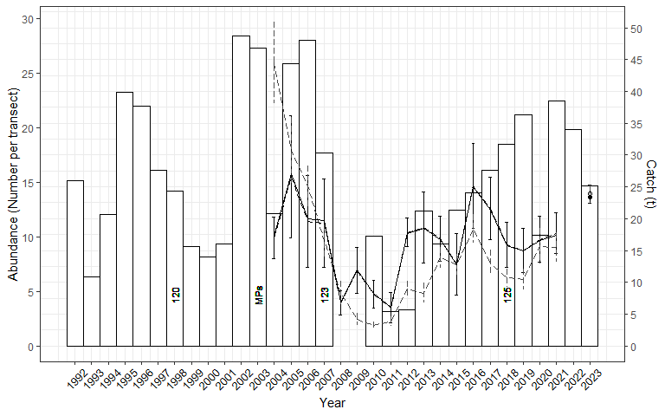

Figure 22: Recruit abundance (grey dashed, nominal all sites 1992 – 2021; black, Top 15 standardised (solid) 2003 – 2023) including catch from 1992/1993 – 2022/23 for the Shipwreck Coast SMU. MPs = introduction of Marine Parks; numbers reflect size limit changes.

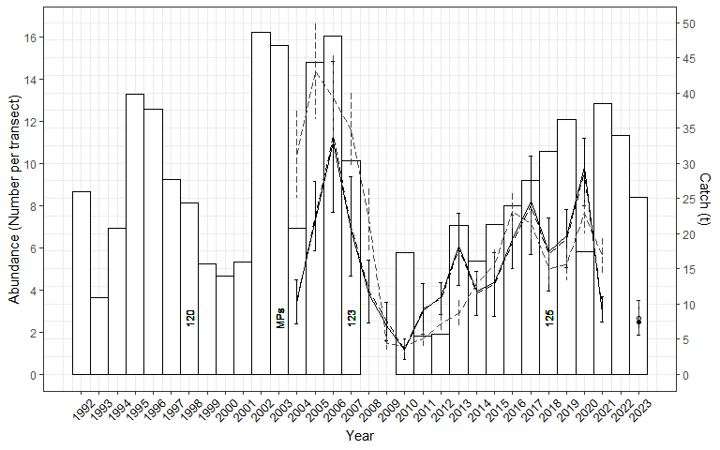

Figure 23: Pre-recruit abundance (grey dashed, nominal all sites 1992 – 2021; black, Top 15 standardised (solid) 2003 – 2023) including catch from 1992/1993 – 2022/23 for the Shipwreck Coast SMU. MPs = introduction of Marine Parks; numbers reflect size limit changes.

*Length frequency data – FIS*

The size structure of the surveyed population at the Shipwreck Coast SMU changed prior to the virus, showing declines in mean size (Appendix 1). The size structure has varied post-virus but few clear trends are evident.

*Length frequency data – commercial*

From 2016/17 to 2019/20, the standardised average length of abalone in the commercial catch was stable around 134 to 135 mm, which was 9 to 10 mm above the LML at that time (Appendix 3, Appendix 4). The LML increased to 130 mm on 1 April 2020 and mean size increased by around 3 mm to around 138 mm in 2021 and has remained relatively stable thereafter. Results of an analysis to account for LML increases demonstrate an increase in size over and above the LML increase. Raw data show similar trends to standardised data over time. Increases in length lead to increases in weight and a reduction in the number of abalone harvested for a given TACC. While the increases in length at Shipwreck Coast SMU are smaller in magnitude than other SMUs, due to the higher average length, estimated weight increases are greater than 20% for the Shipwreck Coast SMU.

*Summary*

The Shipwreck Coast SMU was severely affected by the abalone virus in 2007 (VFA 2018) and there was no fishing in 2008 and 2009. Catches have recovered substantially since and recent catches are around or above the historic average. Post-virus, standardised CPUE and mean daily catch have fluctuated without any trend despite an increase in LML from 125 to 130 mm on 1 April 2020. Catches at the reefcode scale tend to be highly variable and either reflects diver preferences or possibly differing recovery rates of reefs. In 2023/24, the catch from reefcode 4.01 (2.8 t) was the lowest recorded in the last 6 years.

FIS were not implemented in the Shipwreck SMU until 2004. Following the virus outbreak, both recruit and pre-recruit abundance increased substantially at the two Top 15 sites up to 2016 and have fluctuated thereafter. Recruit abundance was high in relative terms while pre-recruit abundance was low.

The standardised average length of the commercial catch has increased from around 134 to 138 mm since 2016/17. While this is not as large of an increase in length as other SMUs, due to the large size of Shipwreck Coast abalone this equates to a >20% increase in weight and a proportional reduction in the number of individual abalone harvested for a given TACC.

The total catch in the Shipwreck Coast SMU of 25.1 t was below the OT with carry-over (29.2 t). Mean CPUE (97.9 kg/h) was above the Threshold (80 kg/h) Reference Point. The Primary and Secondary Categories were Stable and therefore the Final Category was Stable. The OT was maintained at 29.2 t for 2024/25, suggesting an OT of 27.7 to 30.7 t.

**While it is noted that the current OT is around 3 t above the long-term historic average catch, given its history of being virus infected it remains difficult to determine whether these catches are sustainable in the long-term. On a positive note, increases in mean length of the commercial catch indicate that fewer individual abalone are being harvested for a given OT. In addition, all indicators for the stock have remained stable in recent years despite a large increase in the LML in 2020. The Draft Harvest Strategy suggests a stable catch and it seems appropriate to maintain this strategy for 2025/26.**

### Prom Westside (Medium SMU)

The Prom Westside SMU contributed 23.1 t in 2023/24 representing 10.4% of the total catch (Table 16) and TACC (Table 3). This was 2.1 t above the OT. Standardised CPUE has declined by 27% in the long-term and 7% in the short term but is similar (1% decrease) over the last four years.

Table 16: Summary of Catch, Optimal targets and performance indicators for the Prom Westside SMU. The LML and mean daily catch are also shown.

| Catch | | | | | | Standardised CPUE Performance Indicators (% change) | | |
| --- | --- | --- | --- | --- | --- | --- | --- | --- |
| 2023/24 | | OT + carryover* (t) | | | | Long-term | Short-term | Last 4 years |
| (t) | (%) | 22/23 | 23/24 | 24/25 | | 2003/04 – 2023/24 | 2009/10 – 2023/24 | 2020/21 – 2023/24 |
| 23.1 | 10.4 | 21.0 | 21.0 | 21.0 | | -27 | -7 | -1 |
| LML 2023/24 = 115 / 120 mm | | | | | Mean daily catch 2023/24 (nominal) = 476 kg | | | |

The Prom Westside has a catch average of 31 t since 1992 and a peak catch of 62 t in 2007 that likely reflected catch displacement following the virus first reaching the western end of the Central Zone (Figure 24). In all other years, catches have generally ranged from 20-40 t, except for the low catch (8 t) in 2019 that likely resulted from an increase in size limit to 120 mm across the SMU. The split size limit (115/120 mm) was re-instated in 2020 and catches have increased.

Standardised CPUE generally declined from 2003 to 2014, was stable until 2018 and has generally increased over the last 5 years (Figure 24).

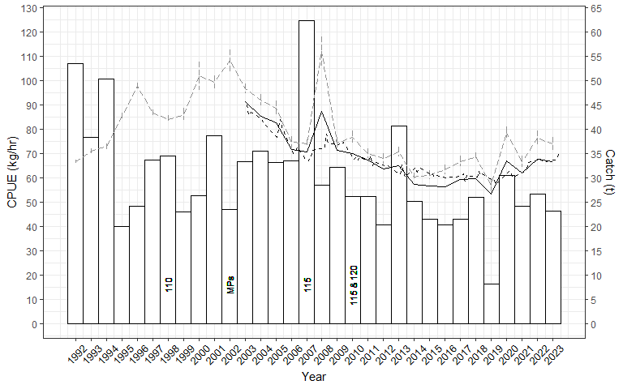

Figure 24: Prom Westside SMU catch, and CPUE (nominal and standardised) from 1992/1993 – 2023/24. Nominal annual = grey series (+/- SE), standardised annual = solid black, standardised quarterly = dashed black. Numbers indicate changes to LMLs. MPs = introduction of Marine Parks.

Standardised mean daily catch slowly declined from 2003 to 2014, was stable until around 2019 and has increased thereafter (Figure 25). Nominal mean daily catch was 476 kg/day in 2023/24.

Figure 25: Total catch and mean daily catch for the Prom Westside SMU from 2003 to 2023. Nominal annual = grey series (+/- SE), standardised annual = solid black, standardised quarterly = dashed black.

Table 17: Catches (kg) by reefcode for the Prom Westside SMU from 2018/19 to 2023/24 and the 5-year average catch from 2018/19 to 2022/23.

The Prom Westside SMU comprises ten reefcodes, with two reefcodes (17.02, 17.10) producing more than half of the SMU catch (Table 17). In 2023/24 most reefcode catches were close to the previous 5 year average.

*FIS recruit abundance (Two Top 15 sites)*

Trends between all sites and Top 15 sites were similar for recruit abundance (Figure 26). Abundance generally declined from 2003 to 2009 and increased thereafter, however it was low in a historical context in 2023.

*FIS recruit abundance (Two Top 15 sites)*

Pre-recruit abundance has been relatively stable over time but was also low in a historical context in 2023 (Figure 27).

Figure 26: Recruit abundance (grey dashed, nominal all sites 1992 – 2021; black, Top 15 standardised (solid) 2003 – 2023) including catch from 1992/1993 – 2022/23 for the Prom Westside SMU. MPs = introduction of Marine Parks; numbers reflect size limit changes.

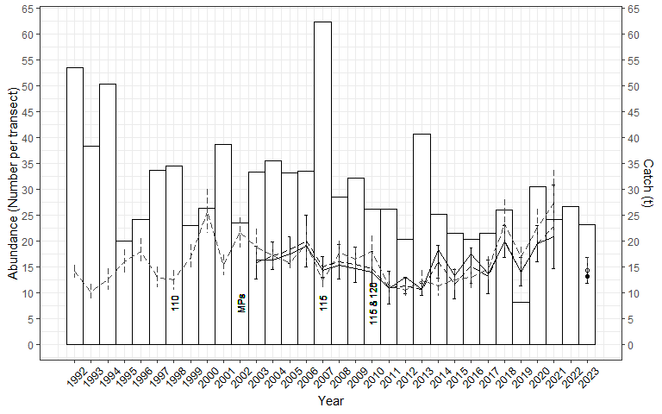

Figure 27: Pre-recruit abundance (grey dashed, nominal all sites 1992 – 2021; black, Top 15 standardised (solid) 2003 – 2023) including catch from 1992/1993 – 2022/23 for the Prom Westside SMU. MPs = introduction of Marine Parks; numbers reflect size limit changes.

*Length frequency data – FIS*

The size structure at Prom Westside FIS sites has been relatively stable over time, with few trends evident (Appendix 1).

*Length frequency data – commercial*

While the standardised average length of abalone in the commercial catch at Prom Westside has shown some variability, the average size has increased from 124 mm in 2016/17 to 127 mm in 2023/24 (Appendix 3). Average size across the SMU is confounded by multiple size limits (115 and 120 mm), with an increase in size observed for 2019/20 when the LML was temporarily increased to 120 mm across the SMU. The raw data at Prom West are variable over time and do not show the same increasing trends. The increase in average length has led to a >5% increase in average weight and a reduction in the number of abalone harvested for a given TACC.

*Summary*

A peak catch of 62 t was harvested from the Prom Westside SMU in 2007, likely the result of catch displacement following the virus first reaching the western end of the Central Zone. In all other years, catches generally ranged from 20-40 t per quota year between 1995 and 2018 until 2019 when the 8.1 t caught was the lowest recorded, likely influenced by the increase in LML. Catches have subsequently returned to prior levels. Standardised CPUE declined from 2003 to 2014 but has increased in the last 5 years. Standardised mean daily catch has slowly increased over the last 6 years. During 2023/24, the distribution of catches was very close to their previous 5-year averages at all reefcodes.

The abundance of recruit and pre-recruit sized abalone at the two Top 15 FIS sites had shown increasing trends since around 2010, however both measures declined substantially in 2023.

The standardised average length of the commercial catch has increased from around 124 mm in 2016/17 to 127 mm in 2023/24.

The total catch in the Prom Westside SMU of 23.1 t was 2.1 t above the OT (21.0 t). Mean CPUE (66.3 kg/h) was above the Threshold (60 kg/h) Reference Point. The Primary and Secondary Categories were Stable, resulting in a Stable Final Category. The OT in 2024/25 was maintained at 21.0 t, suggesting an OT between 20.0 and 22.1 t.

**Acknowledging that there was a low catch in 2019, the four subsequent years catches have all been above the OT. Nevertheless, CPUE and mean daily catch indicators remain positive, and the distribution of catches was stable across all SMUs. Whilst recruit and pre-recruit abundance at Top 15 FIS sites declined substantially in 2023, this was from limited sites and no FIS was done in 2024. Given catches at the Prom Westside SMU have been historically variable, stabilising catches at the current OT may improve the stock indicators as it has for other important SMUs. On this basis, maintaining the Draft Harvest Strategy outcome of “Stable” appears to be an appropriate strategy.**

### Flinders (Medium SMU)

The Flinders SMU contributed 22.2 t in 2023/24 representing 10.0% of the total catch (Table 18) and TACC (Table 3). The catch was 1.7 t above the OT. Standardised CPUE has 14% in the long term but increased by 3% in the short term and by 22% in the last four years.

Table 18: Summary of Catch, Optimal targets and CPUE performance indicators for the Flinders SMU. The LML and mean daily catch are also shown.

| Catch | | | | | | Standardised CPUE Performance Indicators (% change) | | |
| --- | --- | --- | --- | --- | --- | --- | --- | --- |
| 2023/24 | | OT + carryover* (t) | | | | Long-term | Short-term | Last 4 years |
| (t) | (%) | 22/23 | 23/24 | 24/25 | | 2003/04 – 2023/24 | 2009/10 – 2023/24 | 2020/21 – 2023/24 |
| 22.2 | 10.0 | 24.2 | 20.5 | 20.5 | | -14 | 3 | 22 |
| LML 2023/24 = 114 mm | | | | | Mean daily catch 2023/24 (nominal) = 388 kg | | | |

The Flinders SMU has been the most important historical contributor to the Central Zone TACC, with an average of 109 t since 1992 and a peak of 231 t taken during 1993 (Figure 28). Catches remained above 150 t up until and including 2008, when a size limit increase was implemented. A catch of 88 t was harvested in both 2008 and 2009 and catches have ranged from 20-44 t per year since.

Standardised CPUE generally declined from 2003 to 2013, was variable until 2017 and has steadily increased for the last six years (Figure 28).

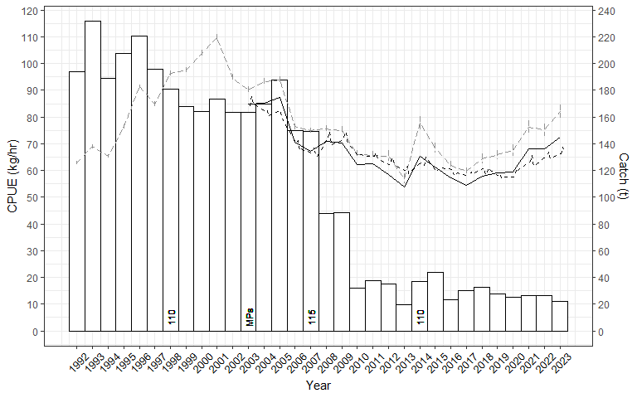

Figure 28: Flinders SMU catch, and CPUE (nominal and standardised) from 1992/1993 – 2023/24. Nominal annual = grey series (+/- SE), standardised annual = solid black, standardised quarterly = dashed black. Numbers indicate changes to LMLs. MPs = introduction of Marine Parks.

Standardised mean daily catch decreased from 2003 to 2013 and has been relatively stable thereafter (Figure 29). Nominal mean daily catch was 388 kg/day in 2023/24.

Figure 29: Total catch and mean daily catch for the Flinders SMU from 2003 to 2023. Nominal annual = grey series (+/- SE), standardised annual = solid black, standardised quarterly = dashed black.

Table 19: Catches (kg) by reefcode for the Flinders SMU from 2018/19 to 2023/24 and the 5-year average catch from 2018/19 to 2022/23.

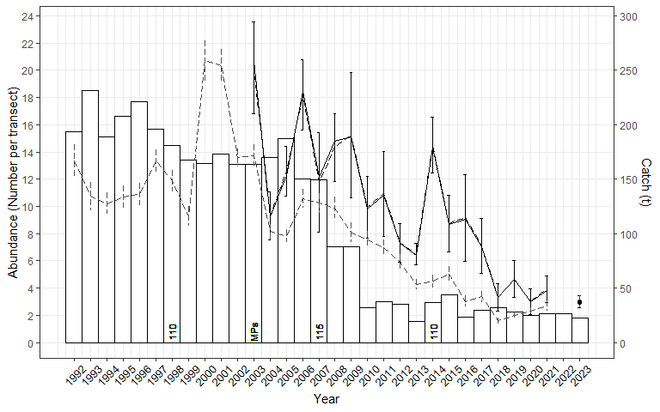

The Flinders SMU comprises 8 reefcodes, with 12.06 the key contributor since 2017/18 (Table 19). Catches were generally within the recent historic range at most SMUs except for 13.04 where the lowest catch was harvested in the last 6 years.

*FIS recruit abundance (Two Top 15 sites)*

The abundance of recruit sized abalone on has declined over time at all sites and Top 15 sites and in 2022/23 remains at low historical levels (Figure 30).

*FIS recruit abundance (Two Top 15 sites)*

The abundance of pre-recruit sized abalone also declined over time at all sites and Top 15 sites, however there was a large increase in pre-recruit abundance at Top 15 sites in 2023 with abundance levels similar to 2016 (Figure 31).

Figure 30: Recruit abundance (grey dashed, nominal all sites 1992 – 2021; black, Top 15 standardised (solid) 2003 – 2023) including catch from 1992/1993 – 2022/23 for the Flinders SMU. MPs = introduction of Marine Parks; numbers reflect size limit changes.

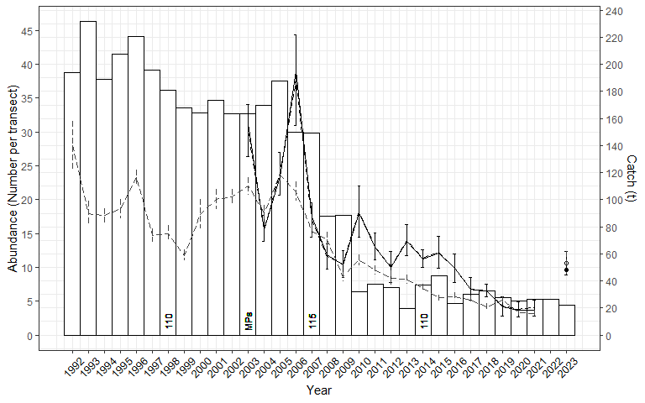

Figure 31: Pre-recruit abundance (grey dashed, nominal all sites 1992 – 2021; black, Top 15 standardised (solid) 2003 – 2023) including catch from 1992/1993 – 2022/23 for the Flinders SMU. MPs = introduction of Marine Parks; numbers reflect size limit changes.

*Length frequency data – FIS*

While the abundance of abalone has declined substantially over time, there are few clear trends evident in the size structure data from FIS (Appendix 1). The increase in pre-recruit abundance observed at the two Top 15 sites in 2022/23 occurred across a range of pre-recruit size categories.

*Length frequency data – commercial*

From 2016/17 to 2019/20, the standardised average length of abalone in the commercial catch increased from around 115 to 118 mm, which was 5 and 8 mm, respectively, above the LML at that time (Appendix 3, Appendix 4). The LML increased to 112 mm on 1 April 2020 and to 114 mm on 1 April 2021. Standardised average length has increased annually since 2019/20 and is currently around 127 mm in 2024/25, which is 13 mm above the LML. Results of the analysis to account for LML increases in Appendix 4 demonstrate an increase in size over and above the LML increase. Raw data show similar trends to standardised data over time. Increases in length lead to increases in weight and a reduction in the number of abalone harvested for a given TACC, with estimates of weight increase greater than 10% for the Flinders SMU.

*Summary*

The Flinders SMU has been the most important historical contributor to the Central Zone TACC, with an average catch of 109 t (since 1992) and a peak of 231 t (1993). Catches remained above 150 t up until 2007 but declined thereafter ranging from 20-44 t per year since 2010. Standardised CPUE declined substantially from 2003 to 2013 but has increased steadily in the last 6 years. Standardised mean daily catch has been stable during this period. The distribution of catch among reefcodes has generally been stable in recent years, although in 2023/24 the lowest catch was harvested in the last 6 years from 13.04.

The abundance of recruit sized abalone at the two Top 15 FIS sites has declined substantially since 2003 and remains low in a historic context. Pre-recruit abundance declined at a similar rate, however in 2023 pre-recruit abundance increased substantially to around the levels observed in 2016.

The standardised average length of the commercial catch has increased from around 115 in 2016/17 to 127 mm in 2024/25, which is 13 mm above the LML.

The total catch in the Flinders SMU of 22.2 t was 1.7 t above the OT with carryover (20.5 t). Mean CPUE (69.9 kg/h) was above the Threshold (70 kg/h) Reference Point for the third consecutive year. The Primary and Secondary Indicators were Increasing, resulting in an Increasing Final Category. As a result, increases in catch of up to 25% above the current OT could be considered. The OT was 20.5 t for 2024/25, suggesting an OT from 20.5 t to 25.6 t for 2025/26.

**The once productive deeper water reefs of the Flinders SMU have declined substantially, and the fishery currently relies primarily on inshore shallow reefs. While most indicators remain poor relative to the long-term, the short-term outlook is more positive. CPUE has increased in the last 5 years, while mean daily catch has remained stable. The average length of the commercial catch has also increased substantially and all of these measures remain positive despite a combined 4 mm LML increase since 2020. While there are only 2 Top 15 FIS sites, these showed a large increase in pre-recruit abundance in 2023, consistent with the nearby Phillip Island and Back Beaches SMUs. In 2023/24, the OT was reduced to 20.5 t and this was maintained for 2024/25. While the Draft Harvest Strategy suggests that an increase in OT can be considered, given the importance of the Flinders SMU historically, strong consideration should be given to maintaining the current OT to further build on the positive indicators from recent years.**

### Kilcunda (Small SMU)

The Kilcunda SMU contributed 11.6 t in 2023/24 representing 5.2% of the total catch (Table 20) and TACC (Table 3). The catch was 1.3 t above the OT which included carryover (1 t). Standardised CPUE has declined by 26% in the long term and 12% in the short term but increased by 8% in the last 4 years.

Table 20: Summary of Catch, Optimal targets and CPUE performance indicators for the Kilcunda SMU. The LML and mean daily catch are also shown.

| Catch | | | | | | Standardised CPUE Performance Indicators (% change) | | |
| --- | --- | --- | --- | --- | --- | --- | --- | --- |
| 2023/24 | | OT + carryover* (t) | | | | Long-term | Short-term | Last 4 years |
| (t) | (%) | 22/23 | 23/24 | 24/25 | | 2003/04 – 2023/24 | 2009/10 – 2023/24 | 2020/21 – 2023/24 |
| 11.6 | 5.2 | 11.8* | 10.3* | 9.3 | | -26 | -12 | 8 |
| LML 2023/24 = 110/115 mm | | | | | Mean daily catch 2023/24 (nominal) = 334 kg | | | |

The Kilcunda SMU has an average catch of 19 t since 1992 with a peak catch of 46 t taken during 2001 (Figure 32). Catch history appears to have two distinct periods, with catches ranging from 20-46 t from 1992 to 2003 (average 30 t), then from 2004 to 2022 catches ranged from 4-19 t (average 12 t). Current catches are around the average level harvested since 2003.

Standardised CPUE generally declined slowly from 2003 to 2015, was stable until 2019 and has increased thereafter (Figure 32).

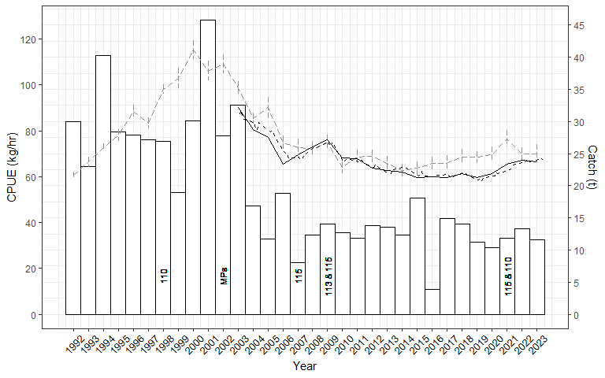

Figure 32: Kilcunda SMU catch, and CPUE (nominal and standardised) from 1992/1993 – 2023/24. Nominal annual = grey series (+/- SE), standardised annual = solid black, standardised quarterly = dashed black. Numbers indicate changes to LMLs. MPs = introduction of Marine Parks.

Standardised mean daily catch generally declined from 2003 to 2013 and has marginally increased thereafter (Figure 33). Nominal mean daily catch was 334 kg/day in 2023/24.

Figure 33: Total catch and mean daily catch for the Kilcunda SMU from 2003 to 2023. Nominal annual = grey series (+/- SE), standardised annual = solid black, standardised quarterly = dashed black.

Table 21: Catches (kg) by reefcode for the Kilcunda SMU from 2018/19 to 2023/24 and the 5-year average catch from 2018/19 to 2022/23.

Of the 5 reefcodes in the Kilcunda SMU, the majority of catch has come from 15.01 (Table 21). In 2023/24, the catches from 15.05 were more than twice as high as any of the previous six years.

*Length frequency data – commercial*

The standardised average length of abalone in the commercial catch at Kilcunda has been relatively stable over time, ranging from around 123 to 124 mm (Appendix 3). Average size across the SMU is confounded by multiple size limits (110 and 115 mm). There was no difference in the average size when the LML was temporarily increased to 115 mm across the SMU on 1 April 2021. Raw data show similar trends to standardised data over time.

*Summary*

The Kilcunda SMU had a period of high catches from 1992 to 2003 where an average of 30 t per year was maintained, however since 2004 average catches have been less than half of this level (12 t). Whilst standardised CPUE declined from 2003 to 2015 before stabilising, it has slowly increased since 2019. Mean daily catch has been stable for over a decade. There is no FIS data for the Kilcunda SMU.

The standardised average length of the commercial catch has been relatively stable since 2016/17, although analysis of these data are confounded by different LMLs within the SMU.

The total catch of 11.6 t was 1.3 t above the OT with carryover (10.3 t). Mean CPUE (64.9 kg/h) was above the Threshold (60 kg/h). The Primary and Secondary Indicators were Stable, resulting in a Stable Final Category. The 2024/25 OT was reduced to 9.3 t, with a resulting suggested OT of 8.8 to 9.8 t.

**The indicators for CPUE, mean daily catch and average commercial length have all been relatively stable in recent years. It is noted that the OTs for this SMU have been reduced in recent years from 11.8 to 9.3 t. The Draft Harvest Strategy suggests a stable OT, and this appears to be an appropriate strategy.**

### Cape Liptrap (Small SMU)

The Cape Liptrap SMU catch was 8.9 t in 2023/24 and represented 4.0% of the total catch (Table 22) and TACC (Table 3). The catch was 0.5 t below the OT which included carryover (1 t). Standardised CPUE has declined by 25% in the long term and 17% in the short term but has increased by 15% in the last 4 years.

Table 22: Summary of Catch, Optimal targets and CPUE performance indicators for the Cape Liptrap SMU. The LML and mean daily catch are also shown.

| Catch | | | | | CPUE Performance Indicators | | | |
| --- | --- | --- | --- | --- | --- | --- | --- | --- |
| 2023/24 | | OT + carryover* (t) | | | Long-term | | Short-term | Last 4 years |
| (t) | (%) | 22/23 | 23/24 | 24/25 | 2003/04 – 2023/24 | | 2009/10 – 2023/24 | 2020/21 – 2023/24 |
| 8.9 | 4.0 | 12.1* | 9.4* | 9.4 | -25 | | -17 | 15 |
| LML 2023/24 = 110 mm | | | | | | Mean daily catch 2023/24 (nominal) = 366 kg | | |

The Cape Liptrap SMU contributed <20 t of catch prior to 2009 when a peak catch of 41 t was harvested (Figure 34). The 2009 catch coincided with a decrease in size limit, which followed an increase in size limit in 2007 that reduced catches to around 5 t in 2008. Catch in the last 4 years has averaged around 8 t which is well below historical levels (average catch 13 t from 2012 to 2018).

Standardised CPUE declined from 2003 to 2016, was stable until 2020 and has increased thereafter (Figure 35).

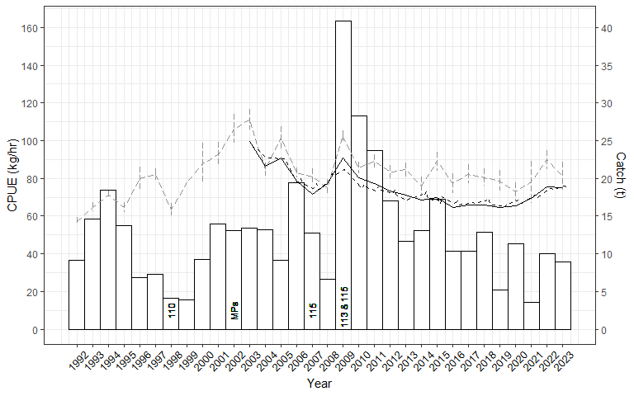

Figure 34: Cape Liptrap SMU catch, and CPUE (nominal and standardised) from 1992/1993 – 2023/24. Nominal annual = grey series (+/- SE), standardised annual = solid black, standardised quarterly = dashed black. Numbers indicate changes to LMLs. MPs = introduction of Marine Parks.

Standardised mean daily catch generally decreased from 2003 to 2014 and has been variable thereafter (Figure 35). Nominal mean daily catch was 445 kg/day in 2023/24.

Figure 35: Total catch and mean daily catch for the Cape Liptrap SMU from 2003 to 2023. Nominal annual = grey series (+/- SE), standardised annual = solid black, standardised quarterly = dashed black.

Table 23: Catches (kg) by reefcode for the Cape Liptrap SMU from 2018/19 to 2023/24 and the 5-year average catch from 2018/19 to 2022/23.

The Cape Liptrap SMU comprises 5 reefcodes, with three reefcodes contributing most of the catch (16.04, 16.03, 16.06) in the previous 5 years (Table 23). In 2023/24, the catch distribution was very different to the previous 5 year averages. Catches were well below the average at 16.04 and 16.06 while catches at 16.03 and 16.02 were around twice the highest catch in the previous 5 years.

*Length frequency data – commercial*

From 2016/17 to 2019/20, the standardised average length of abalone in the commercial catch was stable around 117 to 118 mm, with multiple LMLs (110 and 115 mm) at that time (Appendix 3, Appendix 4). The LML increased to 115 mm across the SMU on 1 April 2020 and average length increased to just above 120 mm in 2020/21 and 2021/22. Average length has increased substantially in the last two years and was 129 mm in 2023/24 from a sample size of around 5000 shells. Raw data show similar trends to standardised data over time. Increases in length lead to increases in weight and a reduction in the number of abalone harvested for a given TACC, with estimates of weight increase greater than 20% for the Cape Liptrap SMU.

*Summary*

The Cape Liptrap SMU produced consistent, low catches from 1992 to 2008. While the increase in size limit appeared to reduce catch in 2007, the decrease in size limit in 2009 likely increased the available biomass and a catch 3.5 times the long-term average was harvested. Catches in the last 5 years have been below the historical average. Standardised CPUE declined from 2003 to 2016, was stable until 2020 and has increased thereafter. Standardised mean daily catch has varied without trend for the last decade.

The primary uncertainty for the stock regards changes in the distribution of the catch among reefcodes in 2023/24. Catches were well below the average at 16.04 and 16.06 while catches at 16.03 and 16.02 were around twice the highest catch in the previous 5 years.

The standardised average length of the commercial catch increased from 117 mm in 2016/17 to 120 mm in 2021/22, with the LML increased to 115 mm across the entire SMU on 1 April 2020. Average length has increased substantially in the last two years and was 129 mm in 2023/24.

The total catch in the Cape Liptrap SMU of 8.9 t was 0.5 t below the OT with carryover (9.4 t). Mean CPUE (72.8 kg/h) was above the Threshold (60 kg/h) Reference Point. The Primary and Secondary Categories were Stable, resulting in a Stable Final Category. In 2024/25, the OT was maintained 9.4 t, with a suggested OT for 2025/26 of 8.9 to 9.9 t.

**Available indicators of stock status appear to be improving for the Cape Liptrap SMU. Standardised CPUE and the average length of abalone in the commercial catch have both increased in recent years, while mean daily catch has been stable. The only concern regards the distribution of catches among reefcodes. As for the Phillip Island SMU, an improved understanding of the reasons for these shifts in catch distribution is required. The OT was 9.4 t in 2024/25, and maintaining a stable OT appears to be an appropriate strategy for 2025/26, noting the uncertainty due to shifts in catch distribution.**

### Prom Eastside (Small SMU)

The Prom Eastside SMU contributed 3.8 t in 2023/24 representing 1.7% of the total catch (Table 24) and TACC (Table 3). The catch was 1.0 t below the OT. Standardised CPUE has declined by 22% in the long term and by 12% in the short term but has increased by 7% in the last 4 years.

Table 24: Summary of Catch, Optimal targets and CPUE performance indicators for the Prom Eastside SMU. The LML and nominal mean daily catch are also shown.

| Catch | | | | | | Standardised CPUE Performance Indicators (% change) | | |
| --- | --- | --- | --- | --- | --- | --- | --- | --- |
| 2023/24 | | OT + carryover* (t) | | | | Long-term | Short-term | Last 4 years |
| (t) | (%) | 22/23 | 23/24 | 24/25 | | 2003/04 – 2023/24 | 2009/10 – 2023/24 | 2020/21 – 2023/24 |
| 3.8 | 1.7 | 5.7 | 4.8 | 4.8 | | -22 | -12 | 7 |
| LML 2023/24 = 110 mm | | | | | Mean daily catch 2023/24 (nominal) = 314 kg | | | |

The Prom Eastside SMU was inconsistently fished from 1992 to 2012 (Figure 36). Annual catch has averaged around 5 t, with a peak catch of 11 t in 2003. A consistent catch of 7-8 t was harvested between 2013 and 2020 before catches of 4-5 t thereafter.

Standardised CPUE declined from 2003 to 2007 and has varied without trend thereafter (Figure 36).

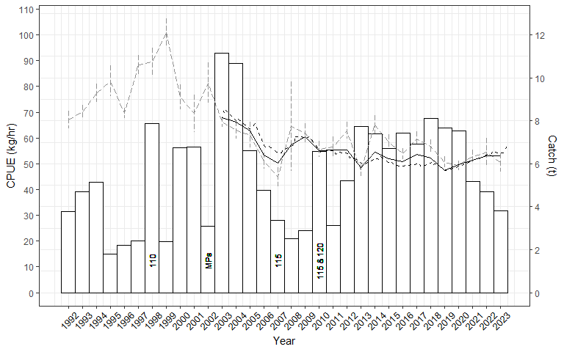

Figure 36: Prom Eastside SMU catch, and CPUE (nominal and standardised) from 1992/1993 – 2023/24. Nominal annual = grey series (+/- SE), standardised annual = solid black, standardised quarterly = dashed black. Numbers indicate changes to LMLs. MPs = introduction of Marine Parks.

Standardised mean daily catch marginally declined from 2003 to 2013 and has been relatively stable thereafter (Figure 37). Nominal mean daily catch was 314 kg/day in 2023/24.

Figure 37: Total catch and mean daily catch for the Prom Eastside SMU from 2003 to 2023. Nominal annual = grey series (+/- SE), standardised annual = solid black, standardised quarterly = dashed black.

Table 25: Catches (kg) by reefcode for the Prom Eastside SMU from 2018/19 to 2023/24 and the 5-year average catch from 2018/19 to 2022/23.

The Prom Eastside SMU comprises 5 reefcodes, two of which (18.04, 18.03) contribute most of the total SMU catch (Table 25). In 2023/24, the catch at 18.05 was the highest recorded in the last six years while the catch at 18.04 was the lowest.

*Length frequency data – commercial*

The standardised average length of abalone in the commercial catch at Prom Eastside increased from 116 mm in 2016/17 to 123 mm in 2023/24, with reductions in average size observed during 2020/21 and 2021/22 (117 mm, Appendix 3). The LML has been stable over this time at 110 mm (Appendix 4). Raw data are more variable but show similar trends over time. Increases in length lead to increases in weight and a reduction in the number of abalone harvested for a given TACC, with estimates of weight increase greater than 5% for the Prom Eastside SMU.

*Summary*

The Prom Eastside SMU had produced only variable catches until consistent catches were harvested from 2013 to 2020. In the last few years catches have been considerably lower. Standardised CPUE and mean daily catch have fluctuated without trend in recent years. The standardised average length of the commercial catch has increased since 2016/17 and is currently 13 mm above the LML.

The total catch in the Prom Eastside SMU of 3.8 t was 1.0 t below the OT (4.8 t). Mean CPUE (52.9 kg/h) remained below the Threshold (60 kg/h) and above the Limit Reference Point (40 kg/h). The current CPUE measure has been below the Threshold and Above the Limit for 14 consecutive years, and as a result, Catch Control Rule 2 applies. The Primary and Secondary Categories were Stable, resulting in a Stable Final Category. With an OT of 4.8 t for 2024/25, the suggested range of OTs for 2025/26 is 4.1 to 4.6 t.

**The weight of evidence in this assessment suggests that the key indicators of the stock are now stable or improving. CPUE has increased slightly in recent years and mean daily catch has been stable. Commercial length data suggest that the average size harvested has been increasing. While the Draft Harvest Strategy recommends a reduction in OT, this appears to be an artefact of the reference point calculation which requires review. Given the OT was reduced last year and is currently well below recent historical levels of catch, maintaining the current OT appears to be an appropriate outcome.**

### Cliffy Group (Small SMU)

The Cliffy Group SMU contributed 3.3 t in 2023/24 representing 1.5% of the total catch (Table 26) and TACC (Table 3). The catch was 1.4 t below the OT. Standardised CPUE has declined 22% in the long term and 13% in the short term but increased by 11% in the last four years.

Table 26: Summary of Catch, Optimal targets and CPUE performance indicators for the Cliffy Group SMU. The LML and nominal mean daily catch are also shown.

| Catch | | | | | | Standardised CPUE Performance Indicators (% change) | | |
| --- | --- | --- | --- | --- | --- | --- | --- | --- |
| 2023/24 | | OT + carryover* (t) | | | | Long-term | Short-term | Last 4 years |
| (t) | (%) | 22/23 | 23/24 | 24/25 | | 2003/04 – 2023/24 | 2009/10 – 2023/24 | 2020/21 – 2023/24 |
| 3.3 | 1.5 | 5.5 | 4.7 | 4.7 | | -22 | -13 | 11 |
| LML 2023/24 = 110 mm | | | | | Mean daily catch 2023/24 (nominal) = 474 kg | | | |

The Cliffy Group SMU was fished consistently at low levels of 2-5 t per year from 1992 to 2010 (Figure 38). Since 2010 annual catch has averaged over 6 t, although it has been quite variable ranging from 2 to 10 t. Catches in the last three years have been 2-3 t.

Standardised CPUE declined from 2003 to 2015 but has steadily increased since 2019 (Figure 38).

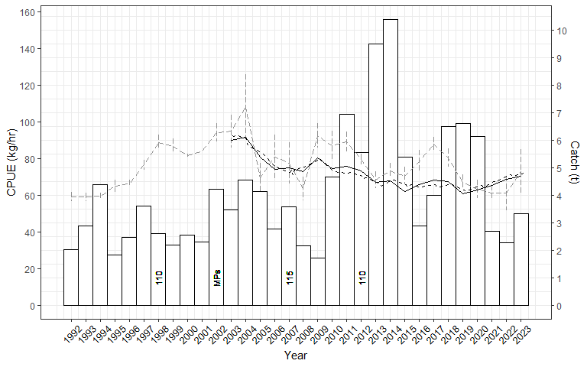

Figure 38: Cliffy Group SMU catch, and CPUE (nominal and standardised) from 1992/1993 – 2023/24. Nominal annual = grey series (+/- SE), standardised annual = solid black, standardised quarterly = dashed black. Numbers indicate changes to LMLs. MPs = introduction of Marine Parks.

Historically, the Cliffy Group was often reported as fished on the same day as Prom Eastside and thus mean daily catch data are incomplete (Figure 39). Standardised mean daily catch marginally declined from 2003 to 2013 and has been relatively stable thereafter. Nominal mean daily catch was 445 kg/day in 2023/24.

Figure 39: Total catch and mean daily catch for the Cliffy Group SMU from 2003 to 2023. Nominal annual = grey series (+/- SE), standardised annual = solid black, standardised quarterly = dashed black.

*Length frequency data – commercial*

From 2016/17 to 2019/20, the standardised average length of abalone in the commercial catch at Cliffy Group was stable around 122 to 123 mm but declined to around 119 mm in 2020/21 (Appendix 3), however it should be noted this remains 9 mm above the current LML of 110 mm (Appendix 4). No data have been collected in the last three years. Raw data show similar trends over time.

*Summary*

Catches from Cliffy Group SMU have been highly variable over time. Catches in the last three years have been below the historical average which followed a period of three years of relatively high catch. Standardised CPUE declined from 2003 to 2015 but has steadily increased since 2019. Standardised mean daily catch has been relatively stable for over a decade. The standardised average size of the commercial catch was stable from 2017/18 to 2019/20 before declining in 2020/21, however it remained 9 mm above the LML. No data were available for the last few years.

The total catch in the Cliffy Group SMU of 3.3 t was 1.4 t below the OT (4.7 t). Mean CPUE (69.6 kg/h) was above the Threshold (60 kg/h) Reference Point. The Primary and Secondary Categories were Stable, resulting in a Stable Final Category. The 2024/25 OT was maintained at 4.7 t, suggesting an OT for 2025/26 of 4.5 to 4.9 t.

**Low catches in recent years may have contributed to the stabilising of CPUE. While mean commercial length has declined it remained 9 mm above the LML in 2020/21 and no data have been gathered since. Maintaining a stable OT appears to be an appropriate strategy.**

### Surf Coast (Small SMU)

The Surf Coast SMU contributed 2.1 t in 2023/24 representing 0.9% of the total catch (Table 27) and TACC (Table 3). The catch was 0.4 t above the OT. Standardised CPUE declined by 18% in the long-term and 3% in the short-term but increased by 7% in the last four years.

Table 27: Summary of Catch, Optimal targets and CPUE performance indicators for the Surf Coast SMU. The LML and nominal mean daily catch are also shown.

| Catch | | | | | | Standardised CPUE Performance Indicators (% change) | | |
| --- | --- | --- | --- | --- | --- | --- | --- | --- |
| 2023/24 | | OT + carryover* (t) | | | | Long-term | Short-term | Last 4 years |
| (t) | (%) | 22/23 | 23/24 | 24/25 | | 2003/04 – 2023/24 | 2009/10 – 2023/24 | 2020/21 – 2023/24 |
| 2.1 | 0.9 | 2 | 1.7 | 1.7 | | -18 | -3 | 7 |
| LML 2023/24 = 110 mm | | | | | Mean daily catch 2023/24 (nominal) = 345 kg | | | |

The Surf Coast SMU produced catches from 20-40 t (average 26 t) between 1992 and 1997 (Figure 40). However, catches have ranged from 0.7 to 9 t (average 4.5 t) thereafter. The catch in 2020/21 was the highest recorded since the size limit was reduced in 2012 but it declined to 1-2 t in the last three years.

Standardised CPUE generally declined from 2003 to 2017 and has increased slightly thereafter (Figure 40).

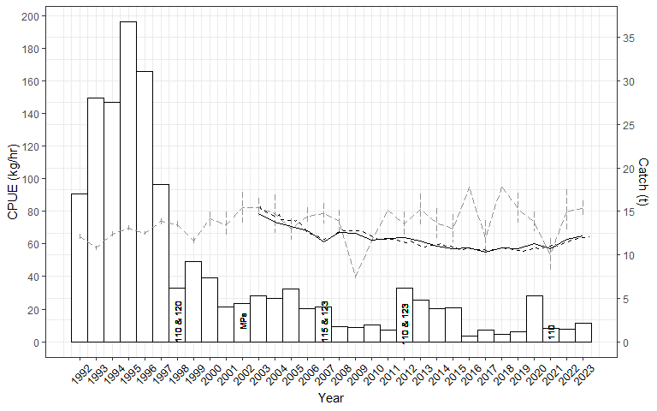

Figure 40: Surf Coast SMU catch, and CPUE (nominal and standardised) from 1992/1993 – 2023/24. Nominal annual = grey series (+/- SE), standardised annual = solid black, standardised quarterly = dashed black. Numbers indicate changes to LMLs. MPs = introduction of Marine Parks.

Standardised mean daily catch decreased from 2003 to 2011, was variable until 2018 and has been stable thereafter (Figure 41). Nominal mean daily catch was 345 kg/day in 2023/24.

Figure 41: Total catch and mean daily catch for the Surf Coast SMU from 2003 to 2023. Nominal annual = grey series (+/- SE), standardised annual = solid black, standardised quarterly = dashed black.

Table 28: Catches (kg) by reefcode for the Surf Coast SMU from 2018/19 to 2023/24 and the 5-year average catch from 2018/19 to 2022/23.

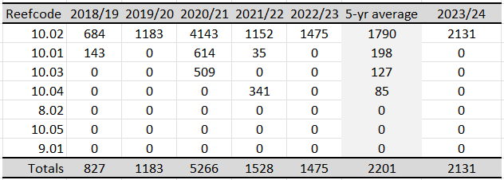

The Surf Coast SMU comprises 5 reefcodes, with most of the catch coming from 10.02, which was the only reefcode fished in 2022/23 and 2023/24 (Table 28).

*Length frequency data – commercial*

No commercial length frequency data are presented for the Surfcoast in Appendix 3.

*Summary*

The Surf Coast SMU averaged catches in excess of 25 t from 1992 to 1997, however catches declined rapidly thereafter. While trends in CPUE have been stable throughout the history of the fishery, catches from 2016/17 to 2019/20 were the lowest recorded. The catch in 2020/21 increased to 5.2 t, most of which was harvested from reefcode 10.02 (Thirteenth Beach) but reduced to 1.5 - 2 t in subsequent years.

The total catch in the Surf Coast SMU (2.1 t) was 0.4 t above the OT (1.7 t). Mean CPUE (61.5 kg/h) was above the Threshold (60 kg/h) Reference Point. The Primary and Secondary Categories were Stable, resulting in a Stable Final Category. The 2024/25 OT was maintained at 1.7 t, suggesting an OT for 2025/26 of 1.6 to 1.8 t.

**Recent catches from the Surf Coast SMU have been well below historic levels. Annual catches generally come from the one reefcode, with small catches from others in some years. Maintaining the current OT appears to be an appropriate strategy.**

### PPB

The Port Phillip Bay SMU did not contribute to the total catch of the Central Zone TACC in 2023/24. Short- and long-term indicators for CPUE could not be assessed (Table 29).

Table 29: Summary of Catch and Optimal targets for the Port Phillip Bay SMU. The LML is also shown. There are insufficient data for assessment against CPUE performance indicators.

| Catch | | | | | Standardised CPUE Performance Indicators (% change) | | | |
| --- | --- | --- | --- | --- | --- | --- | --- | --- |
| 2023/24 | | OT + carryover* (t) | | | Long-term | | Short-term | Last 4 years |
| (t) | (%) | 22/23 | 23/24 | 24/25 | 2003/04 – 2023/24 | | 2009/10 – 2023/24 | 2020/21 – 2023/24 |
| 0.0 | 0 | 0 | 0 | 0 |  | |  |  |
| LML 2023/24 = 105 mm | | | | | |  | | |

The Port Phillip Bay SMU was a very important contributor to the Central Zone TACC from 1992 to 2007, with an average catch of 56 t during this period and a peak catch of 102 t taken during 2000 (Figure 42). However, catches declined dramatically thereafter and have not exceeded 6 t since 2010. There was no catch from the PPB SMU in 2023/24.

Nominal CPUE generally increased from 1992 to 1998, reaching a peak of 82 kg/hr before declining substantially thereafter (Figure 42).

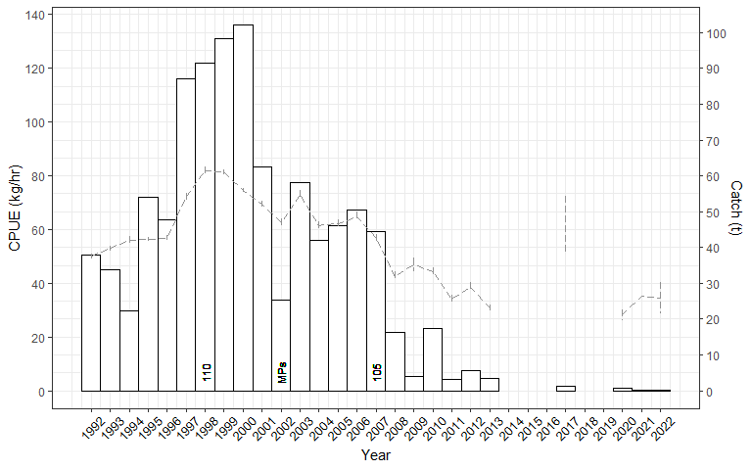

Figure 42: Port Phillip Bay SMU catch, and CPUE (nominal only) from 1992/1993 – 2023/24. Nominal CPUE = grey series (+/- SE). Numbers indicate changes to LMLs. MPs = introduction of Marine Parks.

Nominal mean daily catch declined substantially from 2003 to 2013 (Figure 43). Catches thereafter have been sporadic and low.

Figure 43: Total catch and mean daily catch for the Port Phillip Bay SMU from 2003 to 2023.

*Summary*

Prior to 2008, the Port Phillip Bay SMU was a very important contributor to the Central Zone TACC. Catch and CPUE data suggest that the decline in abundance of legal-size abalone from 2008 was substantial and occurred rapidly. FIS data indicate that significant declines in pre-recruit abundance began occurring in 2004, well before the declines in recruit abundance. The primary driver for the decline appears to be environmental effects, including changes to nutrient levels with a consequent reduction in algal productivity and an increase in urchin density (Mayfield et al. 2012).

**There is no OT for the Port Phillip Bay SMU and thus it was not assessed under the Draft Harvest Strategy. Maintaining a zero catch is appropriate.**

# Greenlip Abalone

Greenlip abalone are a small but important contributor to the Central Zone abalone catch. Catches of greenlip abalone have been recorded in commercial logbooks since 1979. Total catches greater than 1,000 kg have been recorded in nine of the 12 SMUs, as well as in a number of reefcodes that are now part of the Marine Park network (Figure 44). In the past decade, greenlip catches have been harvested from eight of the nine SMUs (Figure 45). Total catches since 2008 have been very consistent, with an average annual catch of 3,093 kg and a range of 2,507 to 3,546 kg, with the highest catch of 3,546 kg being harvested in both 2022 and 2023 (Figure 49).

Cape Liptrap has been the highest producing SMU in the Central Zone, with a total catch of 35,606 kg since 1979. More than half of this catch (20,610 kg) has been harvested in the last 16 years, with an average annual catch of 1,288 kg and a range of 933 to 2,002 kg.

With a total catch of 21,935 kg since 1979, the largest annual catches came from the Flinders SMU in the 1980s. From 1980 to 1986, around 13,000 kg of greenlip was harvested with a maximum annual catch of approximately 3,500 kg in 1985. In the last decade, an average of 617 kg has been harvested from the Flinders SMU with a peak annual catch of 1,003 kg in 2020.

The Surf Coast SMU has produced 21,573 kg of greenlip abalone since 1979. Since 2008, the Surf Coast SMU has had an average annual catch of 542 kg and a maximum catch of 1,472 kg in 2008, although only 157 kg was caught in 2023.

The Phillip Island SMU has produced 17,431 kg of greenlip since 1979. The stock produced consistent catches from 2008 to 2019, ranging from 272 kg to 758 kg with an average of 503 kg. The catch in 2023 was the highest recorded at 1,204 kg. Over the last four years the Phillip Island SMU has produced an average of 954 kg, which is well above the historic average.

Smaller contributions have come from the 5 other SMUs, while 2,961 kg in total was harvested from reefcodes that have subsequently been declared as Marine Parks. In the past decade, the Kilcunda, Prom West and Back Beaches SMUs have produced 2,265 kg of greenlip abalone in total.

**Catches from Phillip Island over the last four years are around twice of the average of the previous decade and higher than any other period since 1979. Catches from all other SMUs appear to be sustainable at current levels.**

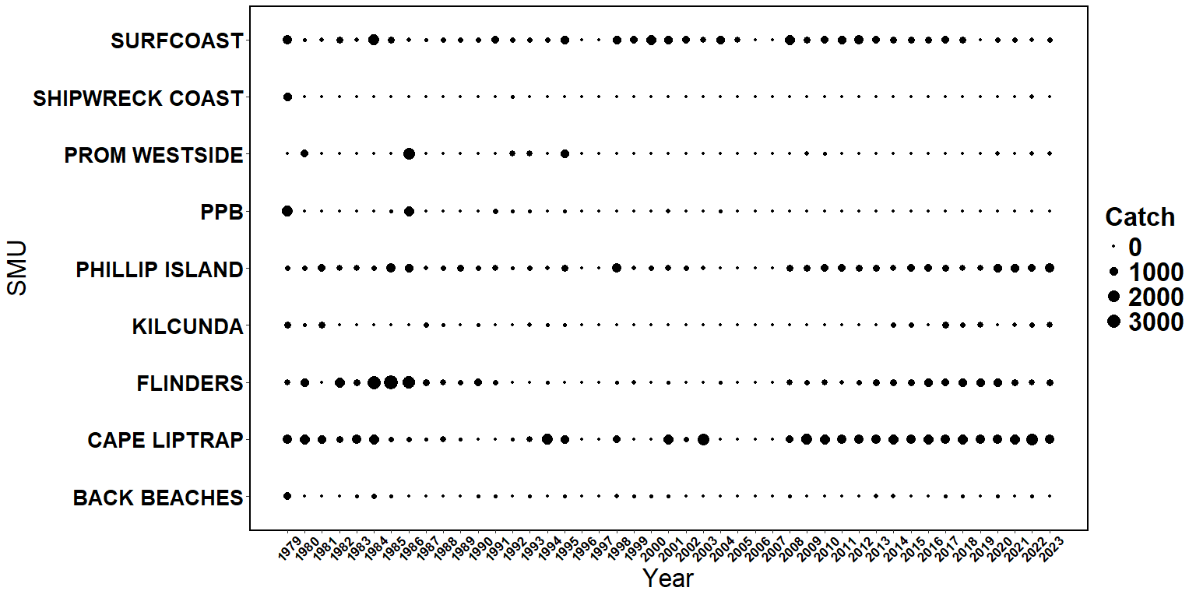

Figure 44: Bubble plot of catch distribution for greenlip abalone in the Central Zone from 1979 to 2023 quota years. Only SMUs where >1 t of greenlip have been caught in total are shown.

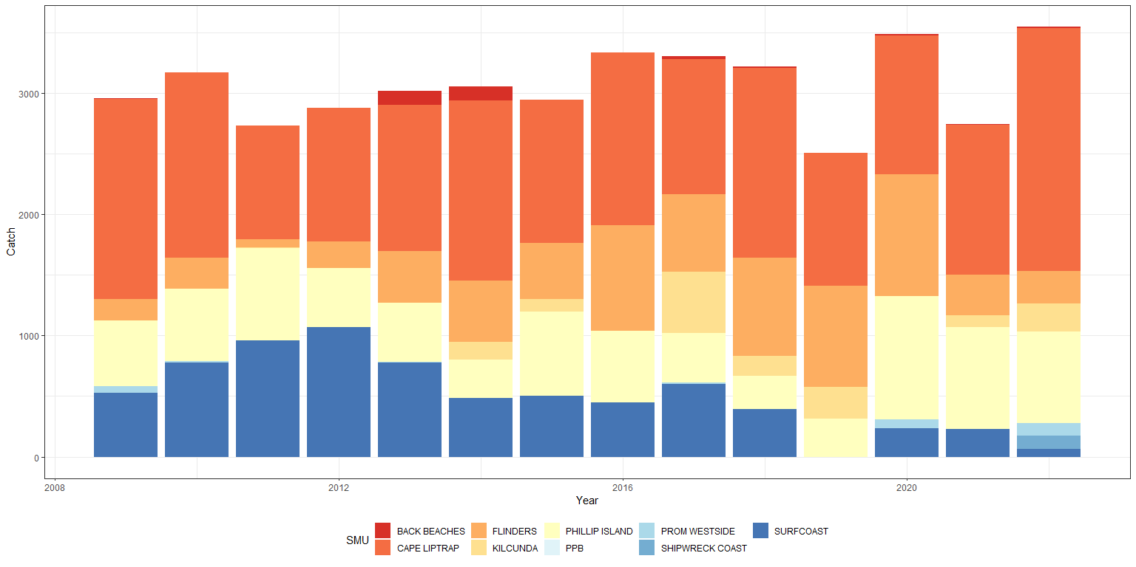

Figure 45: Catch distribution for greenlip abalone in the Central Zone from 2009 to 2023 quota years.



# Conclusions and recommendations

## Analytical approaches to stock assessment

Three main analytical approaches are employed when evaluating stock status to guide TACC decision-making: (i) assessment based on Performance Indicators, (ii) an overall weight of evidence assessment, and (iii) outcomes from the Draft Harvest Strategy. As reported in previous Stock Assessment Reports and associated review documents, there are substantial uncertainties associated with two of the primary sources of data that underpin the assessment of stock status. CPUE data are positively biased due to hyperstability, and therefore present an overly optimistic assessment of stock status. FIS data are negatively biased because FIS site locations are not representative of the entire stock, and thus they represent an overly pessimistic assessment of stock status.

To address these issues, the CPUE standardisation model has been recently revised through the ASWG and this report provides further advancements in the modelling approach. The revised model continues to use a mixed-model GLM but with fewer terms and uses only data from 2003 onward which are considered more reliable. While this appears to have improved the outputs presented, many of the uncertainties associated with CPUE data and its interpretation remain. The FIS program has also been revised, with a focus on improving the understanding of abalone abundance on shallow reefs that better represent the current fishery footprint. The program is only in its early stages, and thus this report relies only on historic FIS data.

This report also provides an updated analysis of commercial length frequency data gathered by industry (provided in Appendix 3). While the number of shells measured in the last two years has been lower than previous years, it provides critical information to supplement the weight of evidence approach. The ASWG will continue to work on approaches to further integrate these data formally into the assessment process.

### Performance Indicators

Recent reports have provided the basis for a revised suite of PIs. Historic PIs were assessed over the long-term from 2003 to current and for the short-term from 2009 to current. While these continue to be assessed, a more contemporary scale of changes over the last four years has also been added.

The PIs now include a measure of mean daily catch. The data are standardised in a similar manner to CPUE data. Last year’s report provided an assessment of FIS PIs from the “Top 15” sites. Insufficient data were gathered to inform this PI this year. New FIS sites in shallow grounds are anticipated to begin being established in 2025 in areas representative of the current fishing grounds. However, it will take several years before meaningful data from these sites can be incorporated as performance measures. Future reports should begin to incorporate additional PIs utilising commercial size frequency data as provided in Appendix 3, and potentially commercial effort logger data collected over the last few years.

### Draft Harvest Strategy

Like all fishery assessment tools, harvest strategies evolve over time as new information is acquired. The current Draft Harvest Strategy was first implemented in the 2017/18 season. Since 2018/19, results from the Draft Harvest Strategy have been prepared as a separate report and have also been included explicitly in this report and the stock assessment process. The five most recent stock assessments have used an independent weight of evidence assessment for each SMU and compared these directly with the Draft Harvest Strategy outcomes. These two sources of information have then been presented at TACC setting meetings where final recommendations on the OT for an SMU are determined by stakeholders.

A key limitation of the current Draft Harvest Strategy is its reliance on CPUE data. However, this will likely remain a reality while the assessment framework is updated and new measures developed. This year’s report used the new CPUE standardisation model to inform the CPUE measure. While this may have improved confidence in CPUE outputs, some of the challenges with CPUE data remain.

Section 3.2.3 presents two scenarios for Reference Points: the original nominal Reference Points presented in VFA (2019b), and those generated from a standardised CPUE dataset using the same rules from which the original reference points were determined. The changes to the CPUE modelling and the comparison of these two results suggest that a review of the Reference Points is required prior to the next assessments for each of the Central and Eastern Zones. On this basis, advice regarding suggested OTs during TACC setting will rely primarily on weight of evidence assessment.

The FRDC Project 2019-118 *“Drawing strength from each other: simulation testing of Australia’s abalone harvest strategies”* includes an MSE of the current Draft Harvest Strategy for Central and Eastern Zones. The results from this study may be useful in the re-evaluation of the Draft Harvest Strategy through the ASWG. In addition, Tasmania and South Australia have recently developed approaches to address hyperstability using diver logger data. The applicability of this approach for the Central Zone should be investigated.

### Weight of evidence

The weight of evidence assessment is impeded by the same data uncertainties as the Draft Harvest Strategy and Performance Indicators, particularly regarding the importance of CPUE as the primary data source. The FIS review has identified that historic FIS site locations are no longer representative of the current fishing grounds. The Top 15 sites provide some data for sites adjacent to the current fishing grounds, however these data need to be augmented with data from shallower sites to provide a more reliable index of abundance at the Zone scale, across current fishing grounds. Top 15 sites were not surveyed in 2024. Trends in standardised mean catch per day are presented at the zone and SMU scales. Historic length frequency data gathered during FIS include two sources of bias that limit their interpretation. Results are presented in the Appendices, but they do not add to the weight of evidence assessment. Commercial length frequency data were again provided by industry and these data provide critical information to augment the weight of evidence. Improved approaches to formally integrate these data into the assessment will be developed in future years.

## TACC setting and Optimal Target catches

The TACC setting process occurs in April each year for the Central Zone, around three quarters of the way through a current quota year. TACC setting is complicated by the lag time between the assessment of stock status based on data from the previous quota year and the need to establish a TACC for the following quota year. Informal assessments of up-to-date summaries of catch (SMU and reefcode) and CPUE (SMU only) are provided at the TACC setting meeting, and this will occur again in April 2025. The ASWG has recommended including “up-to-date data” into future assessments. This will likely translate to the inclusion of data from the first six months of the current fishing year into the assessment, although details of how this will be achieved are yet to be determined.

## Central Zone trends in available data

The commercial catch in the Central Zone for 2023/24 totalled 222.3 t, which was 99.7% of the TACC (222.9 t). In the last five quota years, catches have ranged from around 220 to 250 t, with one year extended to 15 months meaning the annual catch was lower than the 230 t harvested.

The key concern in the current assessment regards changes in the distribution of the catch. At Phillip Island, catches from the previously highest producing reefcode 14.03 were less than half of the lowest catch from the previous five years, while catches from the second most productive reefcode 14.02 were 50% higher than the previous five-year average. Similarly, at Cape Liptrap catches from the two most productive reefcodes (16.04 and 16.06) were <30% of their previous five-year average, while reefcodes 16.03 and 16.02 produced more than twice the highest catch from the previous five years. An improved understanding of the reasons for the distributional shifts in catch is required.

The current zonal standardised CPUE of 77.3 kg/h is 22% lower than it was in 2003/04, 12% lower than it was in 2009/10 but 12% higher than it was in 2020/21. Standardised CPUE was very stable from 2015/16 to 2020/21 ranging from 68.3 to 69.5 kg/h, but has increased annually thereafter and is currently around 2010/11 levels. The new CPUE standardisation model does demonstrate some departure from nominal trends, with the standardised measure being lower than the nominal from 2011 onward. While this does not mean that CPUE is a good measure of abundance, the new model appears to behave more as expected than previous versions (on the assumption that biomass has declined over the longer term).

Standardised mean daily catch in 2023/24 was 359 kg/day, which was 19% lower than 2003/04 and 7% lower than 2009/10 but 7% higher than 2020/21. The standardisation model appears to stabilise mean daily catch estimates, with a general decline from 2003 to 2013, stable trends to 2020 and an increase in the last four years. These trends are similar to those observed for CPUE.

In 2023, FIS data were gathered from the “Top 15” sites that indicated a large increase in abundance at all sites between Cape Otway and Phillip Island, particularly for pre-recruit abalone. FIS data were not collected in 2024 but are expected to be gathered during 2025. Confirmation of the positive results from 2023 will increase confidence in the interpretation of these trends.

Standardised average length of the commercial catch has increased consistently at most SMUs since 2016/17 (Appendix 3). This included the four most important SMU contributors toward total catch: Cape Otway, Back Beaches, Phillip Island, and Shipwreck Coast. These size increases were well over and above size limit increases that had been implemented at the SMU level. Increases in length result in increases in weight, which in turn means that fewer individual abalone are harvested for a given TACC. While there is some uncertainty in how representative the length samples are due to lower numbers of shells measured in the last two years, the increases in size over time are substantial and consistent.

## Stock Status

### Zone scale

This assessment relies primarily on catch and effort data, supplemented by historic FIS data and analyses of commercial length frequency data provided by industry. All available indicators are positive for the Central Zone abalone stock. While considerable uncertainties remain within each component of the weight of evidence approach, the positive direction of all indicators combined provides a stronger basis for assessment of stock status than for previous reports.

The uncertainties in the assessment framework are being strategically addressed by VFA, informed through the ASWG. This year’s report utilises an updated CPUE standardisation model with revised data filters. The report is also the first to standardise mean daily catch, which is an alternative measure of CPUE based on the catch for a day’s effort rather than an hour’s effort. The model used for mean daily catch was based on the same approach as that for CPUE. While there were no FIS data gathered for 2024, VFA have conducted a tender process that should see new FIS sites begin to be established in 2025 in shallow waters that are based on the recent fishery footprint. An updated assessment of the average length of abalone in the commercial catch was provided by industry. Participation rates have reduced in recent years that result in some uncertainty in how representative the data are of the entire fishery. However, this uncertainty is largely countered by the consistent and substantial trends over time. Future reports will aim to include data from the first six months of the current fishing year into the assessment which will further reduce uncertainty.

At the zonal scale, CPUE (kg/h), mean daily catch (kg/day), FIS abundance (recruit and pre-recruit) and average length from the commercial catch are all trending positively. Compared to 2020/21, CPUE has increased by 12%, mean daily catch has increased by 7% and average length from the commercial catch has increased substantially at 8 of the 10 SMUs for which data are available (representing 92% of the 2023/24 total catch). While Top 15 FIS sites were not surveyed in 2024, recruit and pre-recruit abundance had increased by 16% and 37% respectively, in 2023. Certainty in this measure will be improved when surveys are completed in 2025.

The primary concern in the current assessment regards changes in the distribution of the catch at the reefcode scale. Reefcode catches generally show a high degree of variation on an annual basis, however the magnitude of changes in 2023/24 was unusual, particularly for Phillip Island and Cape Liptrap SMUs. While the reasons for these changes are unknown, there is some concern that market preferences for larger abalone may be the driver. If this is the case, then the concerns are heightened as the increase in catches on some reefcodes may be unsustainable. Approaches to improving the understanding of these finer scale changes are required.

It is unequivocal that the spatial extent of the fishery has contracted substantially in the last two decades, and now concentrates heavily on shallow water reefs. In previous stock assessment reports, uncertainty in the status of these shallow water stocks has required precautionary advice to be provided. This report provides the strongest evidence to date that biomass is at least stable and likely recovering. However, it should be noted that stocks likely remain well below the conceptual target of biomass at Maximum Sustainable Yield (MSY). It is recommended that the continuation of a precautionary approach be applied by maintaining the TACC at levels that will continue to promote stock recovery under the assumption that recruitment to the stock remains consistent.

The 2024/25 quota period has a TACC of 225.1 t. Although data for the current 2024/25 quota year are not presented in this report, it is understood that the total catch for 2024/25 is likely to be well below the TACC due to unfavourable market conditions. While these circumstances are unfortunate for the fishery, it is expected that low catches will be positive for the stock. However, it should be acknowledged that targeted fishing behaviours may affect the assessment of CPUE performance measures (i.e. kg/h and kg/day) next year.

### SMU scale

Catch at the SMU scale was less than 15% from the OT at all high producing SMUs. While the difference between the total catch and OT was greater than 15% at Prom East, Cliffy Group and Surfcoast SMUs, these are the lowest producers and the differences in terms of catch to OT were each less than 1.4 t. While stability in catches at the SMU scale is a positive outcome for the fishery, as discussed above, an improved understanding of the catches within SMUs is required.

The evaluation of stock status at the SMU scale involves analysing Performance Indicators and conducting a weight of evidence assessment in comparison to the outputs of the Draft Harvest Strategy. The reduction in number of FIS sites means that a robust analysis of FIS Performance Indicators cannot be undertaken at the SMU scale. Thus, the only SMU Performance Indicators assessed in this report are for CPUE. CPUE remains below 2003/04 levels at all SMUs, and below 2009/10 levels at most SMUs. On a positive note, current CPUE is slightly higher than 2009/10 levels at the Back Beaches (1%), Phillip Island (2%) and Flinders (3%), which is the first time this has occurred. Further, four-year comparisons demonstrate stable or increasing CPUE at all SMUs.

These latter results are reflected in optimistic Draft Harvest Strategy outputs which are driven by CPUE trends over the last four years. The Back Beaches, Phillip Island and Flinders SMUs each had an “Increasing” Final Category, suggesting that increases in OT could be considered. All other SMUs were assessed as “Stable”.

The weight of evidence approach supports the Draft Harvest Strategy results for the Back Beaches and Phillip Island SMUs. This followed reductions in catch during 2019 of 34% and 21%, respectively. Importantly, catches at Phillip Island have remained stable thereafter, while catches at the Back Beaches have only been increased incrementally. Maintaining these stable lower catches appears to have assisted stock recovery in recent years. The primary concern for these stocks is the change in distribution of the catch at the reefcode scale at Phillip Island. Pending an improved understanding of this issue, it is recommended that the strategy of maintaining the OT or only allowing small incremental increases in OT be continued to facilitate further stock recovery.

The indicators at Flinders SMU have been slowly improving but not to the extent of Back Beaches and Phillip Island. The stock clearly remains in a highly depleted state relative to its historic levels, and maintaining the current OT appears to be an appropriate strategy. The weight of evidence for the remaining SMUs supports the Draft Harvest Strategy outputs of maintaining stable OTs. Again, the key concern among the “Stable” SMUs regards the distribution of catches among some reefcodes, particularly Cape Liptrap. It is not clear whether the high catches in 2023/24 from previously low producing reefcodes is sustainable. Discussions regarding catch distribution at the TACC setting forum will be important in determining appropriate OTs for all SMUs.

## Future Monitoring and Research

The research, assessment and management framework for the fishery is evolving, with progress structured through recommendations from the ASWG. This report identifies several key issues that should be considered as part of this strategic development.

The weight of evidence approach is substantially augmented by the inclusion of analyses of the commercial length frequency data gathered by industry. For example, increases in the size of abalone harvested may reflect increasing biomass and reduced fishing mortality. Alternatively, it may reflect market preferences, or increases in the average size harvested can also occur if recruitment to the fishery is declining. While it is acknowledged that markets forces are providing incentive for the harvest of larger abalone, when considering all available data, the increases in size are considered to largely reflect increasing biomass because CPUE has increased incrementally for at least 4 years and data from the FIS in 2023 suggest that recent recruitment may have increased (albeit with high uncertainty). Considering all data sources in this weight of evidence manner clearly provides a better basis for the assessment of stock status than any single measure. Of concern, the number of participants in this data logger program has declined in recent years, and thus all efforts should be made to improve the representativeness of the data gathered and to develop approaches to formally integrate these data into the assessment process.

This report has highlighted a need to improve the scale of the current assessment approach. While the overall catches at the SMU scale were closer to their OTs than in any recent year, there were substantial changes in the distribution of the catch among some reefcodes. Detailed examination of all available data should be considered for reefcodes of potential concern. For example, commercial length frequency data may provide an insight into whether targeting of larger abalone is occurring. Changes in the size distribution of the catch may also aid inferences on sustainability. It may also be worth examining the potential for assessing CPUE at the reefcode scale using the revised CPUE standardisation model.

While the Draft Harvest Strategy outputs were largely supported by the weight of evidence outcomes, changes to the CPUE standardisation model and comparison of nominal and standardised reference points in this years’ report highlight the urgent need for review of the Reference Points. In particular, the period from which the Reference Points are calculated needs to be reconsidered. While the Draft Harvest Strategy remains limited by its reliance on CPUE data, this situation is unlikely to change until improved performance measures are developed.

A tender process is currently underway for the establishment of new FIS survey sites in shallow water reefs that reflect the recent fishery footprint. The establishment of new survey sites and the development of a fishery-independent biomass measure that integrates data from new sites combined with data from previously established sites with a long research history, remains a high priority.

The FIS review undertaken in 2023 was the first formal approach at utilising VMS spatial effort data for the fishery. As with the commercial logger data above, developing ways to integrate these data into the assessment process is a high priority for the Central Zone.

# References

Burnell, O., Mayfield, S., and Bailleul, F. (2020). Assessment of the Central Zone Abalone (Haliotis laevigata & H. rubra) Fishery in 2019. Report to PIRSA Fisheries and Aquaculture. South Australian Research and Development Institute (Aquatic Sciences), Adelaide. SARDI Publication No. F2007/000611-11. SARDI Research Report Series No. 1078. 62pp.

Daume, S, Hartmann, K and Brand-Gardner, S. (2022). Western Australian Abalone Fishery. Public Certification Report. First Re-assessment. October 2022. <https://cert.msc.org/FileLoader/FileLinkDownload.asmx/GetFile?encryptedKey=Ih6ZdaU2HT27++VYrZCd3J457PVTQCDZFrEQ6ooDj0LkJpcslkS+XHF6UnFliYA4>

DEDJTR. 2015. “Victorian wild harvest fishery management plan – 2014.” Melbourne: Department of Environment; Primary Industries.

Dichmont, C.M, Dixon, C.D., and Potts, J. (2022). Developing a new CPUE standardisation for the Central and Eastern Zones of the Victorian Abalone Fishery. MRAG Asia Pacific, Brisbane, Australia.

Dixon, C.D. and Day, R.W. (2004). Growth responses in emergent greenlip abalone to density reductions and translocations. Journal of Shellfish Research. 23: 1223–1228.

Dixon, C., and C. Dichmont. 2019. “2018/19 Draft Stock Assessment for the Central Zone of the Victorian Abalone Fishery.” MRAG Asia Pacific.

Dixon, C., Potts, J., and C. Dichmont. 2021. “2019/20 Draft Stock Assessment for the Central Zone of the Victorian Abalone Fishery.” MRAG Asia Pacific.

Dixon, C., Potts, J., and C. Dichmont. 2022a. “2020/21 Draft Stock Assessment for the Central Zone of the Victorian Abalone Fishery.” MRAG Asia Pacific.

Dixon, C.D., Potts, J. and Dichmont, C.M. 2022b. Assessment of the Central and Eastern Zones of the Victorian Abalone Fishery 2019/20 to 2021/22. Final Report. MRAG Asia Pacific, Brisbane, Australia.

Giri, K., and H. Gorfine. 2018. “Application of a mixed modelling approach to standardize catch-per-unit-effort data for an abalone dive fishery in Western Victoria, Australia.” *Journal of the Marine Biological Association of the United Kingdom*, 1–9.

Gorfine, H., Taylor, B., and Smith D.C. (2008). Abalone ‐ 2001. Fisheries Victoria, Assessment Report Series No. 43.

Huchette S., Dixon C.D., Day R.W. and Shepherd S.A. (2005). Density-dependent growth of juvenile greenlip abalone (H. laevigata Donovan) in their natural habitat in Australia. In: Richard, G. (ed) Proceedings, 3rd international congress of European malacological societies. p 91.

Mayfield, S., C. Mundy, H. Gorfine, A. Hart, and D Worthington. 2012. “Fifty years of sustained production from the Australian abalone fisheries.” *Reviews in Fisheries Science* 20: 220–50.

Miner, C. M., J. M. Altstatt, P. T. Raimondi, and T. E. Minchinton. 2006. “Recruitment failure and shifts in community structure following mass mortality limit recovery prospects of black abalone.” *Marine Ecology Progress Series* 327: 107–17.

Mundy, C., and H. Jones. 2017. “Tasmanian abalone fishery assessment 2016.” Institute for Marine; Antarctic Studies, Hobart. MRAG 2019. Draft Stock Assessment for the Central Zone of the Victorian Abalone Fishery 2018/19.

Mundy, C., R. Chick, B. Stobart, VFA, L. Strain and O. Burnell. 2024. “Blacklip abalone *Haliotis rubra rubra*”, in Anthony Roelofs, Toby Piddocke, Crispian Ashby, Simon Conron, Klaas Hartmann, Alex Hesp, Patrick Hone, Ian Jacobsen, Marlee Jesson-Kerr, Stephen Mayfield, John Stewart, Michael Usher, James Woodhams and Daniel Wright (eds) 2024, Status of Australian Fish Stocks Reports 2024, Fisheries Research and Development Corporation, Canberra.

Mundy, C and McAllister, J. (2022). Tasmanian Abalone Fishery Assessment 2021. University of Tasmania. IMAS.

VFA. 2018. “2017/18 Draft Victorian Abalone Stock Assessment – Central Zone.”

VFA. 2019a. “Victorian Abalone - Methods used for fishery assessment, Version 1.4 30 June 2019.”

VFA. 2019b. “Draft Harvest Strategy Victorian Central and Eastern Zone Blacklip Abalone Fishery. Draft Version 2. VFA, February 2019.”

# Appendices



## Appendix 1: FIS length frequency data for (a) all sites and (b) Top 15 sites at each SMU where FIS were conducted historically.

|  |  |
| --- | --- |
| Size frequency distributions for the Cape Otway SMU from (A) 2003 to 2021 for all sites and (B) from 2003 to 2023 for the four Top 15 sites. Black bars represent undersize abalone, grey bars represent (current) legal size abalone. FIS data were not collected in 2022. Note scales differ slightly.  (A) | |
| Figure 6: Size frequency distributions for the Cape Otway SMU from 2003 to 2010. Black bars represent undersize abalone, grey bars represent legal size abalone, dark grey bar is where LML (123 mm) crosses the size category. | Figure 7: Size frequency distributions for the Cape Otway SMU from 2011 to 2019. Black bars represent undersize abalone, grey bars represent legal size abalone, dark grey bar is where LML (123 mm) crosses the size category. |
| (B) | |
| Figure 6: Size frequency distributions for the Cape Otway SMU from 2005 to 2012. Black bars represent undersize abalone, grey bars represent legal size abalone. | Figure 7: Size frequency distributions for the Cape Otway SMU from 2013 to 2023. Black bars represent undersize abalone, grey bars represent legal size abalone. |
| Size frequency distributions for the Back Beaches SMU from (A) 2003 to 2021 for all sites and (B) from 2003 to 2023 for the three Top 15 sites. Black bars represent undersize abalone, grey bars represent (current) legal size abalone. FIS data were not collected in 2022. | |
| (A) | |
| Figure 21: Size frequency distributions for the Back Beaches SMU from 2003 to 2010. Black bars represent undersize abalone, grey bars represent legal size abalone, dark grey bar is where the LML (117 mm) crosses the size category. | Figure 22: Size frequency distributions for the Back Beaches SMU from 2011 to 2019. Black bars represent undersize abalone, grey bars represent legal size abalone, dark grey bar is where the LML (117 mm) crosses the size category. |
| (B) | |
| Figure 21: Size frequency distributions for the Back Beaches SMU from 2003 to 2010. Black bars represent undersize abalone, grey bars represent legal size abalone, dark grey bar is where the LML (117 mm) crosses the size category. | Figure 22: Size frequency distributions for the Back Beaches SMU from 2011 to 2019. Black bars represent undersize abalone, grey bars represent legal size abalone, dark grey bar is where the LML (117 mm) crosses the size category. |

|  |  |
| --- | --- |
| Size frequency distributions for the Phillip Island SMU from (A) 2003 to 2021 for all sites and (B) from 2003 to 2023 for the two Top 15 sites. Black bars represent undersize abalone, grey bars represent (current) legal size abalone. FIS data were not collected in 2022. | |
| (A) | |
| Figure 11: Size frequency distributions for the Phillip Island SMU from 2003 to 2011. Black bars represent undersize abalone, grey bars represent legal size abalone. | Figure 12: Size frequency distributions for the Phillip Island SMU from 2012 to 2019. Black bars represent undersize abalone, grey bars represent legal size abalone. |
| (B) | |
| Figure 11: Size frequency distributions for the Phillip Island SMU from 2005 to 2012. Black bars represent undersize abalone, grey bars represent legal size abalone. | Figure 12: Size frequency distributions for the Phillip Island SMU from 2013 to 2023. Black bars represent undersize abalone, grey bars represent legal size abalone. |

|  |  |
| --- | --- |
| Size frequency distributions for the Shipwreck Coast SMU from (A) 2003 to 2021 for all sites and (B) from 2003 to 2023 for the two Top 15 sites. Black bars represent undersize abalone, grey bars represent (current) legal size abalone. FIS data were not collected in 2022. | |
| (A) | |
| Figure 26: Size frequency distributions for the Flinders SMU from 2003 to 2010. Black bars represent undersize abalone, grey bars represent legal size abalone. | Figure 27: Size frequency distributions for the Flinders SMU from 2011 to 2019. Black bars represent undersize abalone, grey bars represent legal size abalone. |
| (B) | |
| Figure 16: Size frequency distributions for the Shipwreck Coast SMU from 2005 to 2012. Black bars represent undersize abalone, grey bars represent legal size abalone. | Figure 17: Size frequency distributions for the Shipwreck Coast SMU from 2013 to 2023. Black bars represent undersize abalone, grey bars represent legal size abalone. |

|  |  |
| --- | --- |
| Size frequency distributions for the Flinders SMU from (A) 2003 to 2021 for all sites and (B) from 2003 to 2023 for the two Top 15 sites. Black bars represent undersize abalone, grey bars represent (current) legal size abalone. FIS data were not collected in 2022. | |
| (A) | |
| Figure 26: Size frequency distributions for the Flinders SMU from 2003 to 2010. Black bars represent undersize abalone, grey bars represent legal size abalone. | Figure 27: Size frequency distributions for the Flinders SMU from 2011 to 2019. Black bars represent undersize abalone, grey bars represent legal size abalone. |
| (B) | |
| Figure 26: Size frequency distributions for the Flinders SMU from 2005 to 2012. Black bars represent undersize abalone, grey bars represent legal size abalone. | Figure 27: Size frequency distributions for the Flinders SMU from 2013 to 2023. Black bars represent undersize abalone, grey bars represent legal size abalone. |

|  |  |
| --- | --- |
| Size frequency distributions for the Prom West SMU from (A) 2003 to 2021 for all sites and (B) from 2003 to 2023 for the two Top 15 sites. Black bars represent undersize abalone, grey bars represent (current) legal size abalone. FIS data were not collected in 2022. | |
| (A) | |
| Figure 32: Size frequency distributions for the Prom Westside SMU from 2003 to 2010. Black bars represent undersize abalone, grey bars represent legal size abalone. | Figure 33: Size frequency distributions for the Prom Westside SMU from 2011 to 2019. Black bars represent undersize abalone, grey bars represent legal size abalone. |
| (B) | |
| Figure 32: Size frequency distributions for the Prom Westside SMU from 2005 to 2012. Black bars represent undersize abalone, grey bars represent legal size abalone. | Figure 33: Size frequency distributions for the Prom Westside SMU from 2013 to 2023. Black bars represent undersize abalone, grey bars represent legal size abalone. |

|  |  |
| --- | --- |
| Size frequency distributions for the Cape Liptrap SMU from 2003 to 2021 for all sites. Black bars represent undersize abalone, grey bars represent (current) legal size abalone. FIS data were not collected in 2022 or 2023. | |
| Figure 39: Size frequency distributions for the Cape Liptrap SMU from 2004 to 2011. Black bars represent undersize abalone, grey bars represent legal size abalone. | Figure 40: Size frequency distributions for the Cape Liptrap SMU from 2012 to 2019. Black bars represent undersize abalone, grey bars represent legal size abalone. |

## Appendix 2: Comparison of size structure data gathered in FIS since 2003.

The manner in which length frequency data were gathered from historic FIS changed considerably over time. Originally, all abalone encountered on a transect were collected and brought to the surface to be measured before being returned to the bottom at the same site. This approach was modified when concerns were raised that collecting abalone from within the site may affect the abundance within the site the following year. On this basis, from 2000/01 all abalone encountered on transects were instead counted *in situ* in size categories (VFA 2019). At the end of each transect, divers were then instructed to collect the first 25 abalone randomly encountered. VFA (2019) state “*At the end of each transect 25 abalone are collected as far as possible without bias”.* On this basis, it appears the objective of the random collection was to gather an independent length-frequency sample that was representative of the surveyed population within transects.

To examine how well the length frequency samples reflected the abundance on transects by size category, we converted the length-frequency data into recruit and pre-recruit abundances and compared the proportion of recruits versus pre-recruits (juvenile counts were excluded) for each data source from data gathered for the Eastern and Central Zones between 2017 and 2020. To reduce the variation in these results, sites were excluded if the total abundance encountered on transects was less than 50 abalone, which approximately halved the number of data points available for the analysis to 222 total. As a result of this reduction, the total counts from length frequency samples ranged between 95 and 158 per site.

Figure 2 shows the proportion of recruits versus pre-recruits expressed as percentage of recruits for all data combined. The dashed grey line represents the line of best fit for these data. The solid black line that runs from the origin of the axis should be the theoretical line of best fit if there was no bias in these data collection methods. Clearly, there is a strong bias towards collecting larger abalone (i.e. recruits) when gathering length frequency samples at the end of each transect. This bias is strongest when the proportion of recruits observed during transects is low. Figure 3 breaks the dataset into Central and Eastern Zones, and the size limits 110 and 120 mm. The same bias exists at all spatial scales. Interestingly, data gathered from the Central and Eastern Zones were gathered by two different groups of research divers during this period, yet both showed the same trends suggesting this is more to do with the methods of data collection than the individuals involved.

It is considered unlikely that bias in size structure would result from the in situ transect counts as abalone are encountered in a systematic manner. This is supported by Gorfine (1998) who states “*Because the application of radial transacts avoids targeting some emergent abalone to the exclusion of others, there is less potential for divers to bias their sample towards larger abalone as may occur with time searches…. Time searches do not necessarily permit this separation of pre recruits from post recruits because of the potential for divers to collect larger, more accessible abalone at the expense of smaller abalone”.* It seems logical to conclude that the bias in length frequency counts has resulted from divers collecting in the manner of a timed-swim and not “*as far as possible without bias”*.

The bias suggests that caution should be applied in the analysis of trends in length frequency data gathered from historic surveys, including the pre-recruit measure in the Draft Harvest Strategy. Further, if independent length frequency samples are to be gathered away from fixed transects in any future surveys, strict methods for collection must be applied to ensure a systematic, unbiased, representative size structure is attained.



*The proportion of recruits versus pre-recruits, expressed as percentage of recruits. The dashed grey line, equation and R squared represents the line of best fit for these data. The solid black line that runs from the origin of the axis should be the theoretical line of best fit if there was no bias in these data collection methods.*

|  |  |
| --- | --- |
|  |  |
|  |  |

*The proportion of recruits versus pre-recruits, expressed as percentage of recruits for a) Central Zone, b) Eastern Zone, c) 120 mm LML and d) 110 mm LML. The dashed grey line represents the line of best fit for these data. The solid black line that runs from the origin of the axis should be the theoretical line of best fit if there was no bias in these data collection methods.*

## Appendix 3: Summary of abalone length measuring in CZ updated to December 2024.

Prepared by Dr Duncan Worthington, 28 February 2025

*Background*

Following a request from MRAG and ACV, an updated summary of the Central Zone (CZ) length measuring program at the scale of SMUs was completed, including all data available from the fishery until December 2024. This document will be attached as Appendix 3 to an earlier more detailed document summarising the measuring program and approach to analysis, which was first completed in June 2020 and last updated in February 2021 and with Appendix 1 and 2 added in April 2023 and April 2024. This document provides a brief update and summary of the available data, with fine-scale standardisation summarised at the scale of SMU, brief interpretation and recommendations for further development, particularly including interpretation at finer spatial and temporal scales, and importantly together with other fishery indicators and diver interpretation. This document updates the data summarised in April 2024 from December 2023 to December 2024 (i.e. new data from about 110k measured abalone for the two most recent fishing periods in 2023-24 and 2024-25).

Previous reports have described substantial increases in the average length of abalone landed by the commercial fishery in CZ from 2014 to 2023. This report describes further increases in the length of abalone landed in several SMU since December 2023. Increases in average length are often a positive indicator of change in the abalone stock, including from reduced fishing mortality and/or increasing biomass. Despite that, interpretation of trends in average length can also be confounded with several factors related to the stock and fishery (e.g. reduced recruitment, fishing to market preferred lengths), and the data summarised here should be further investigated and interpreted with other fishery indicators, diver interpretations, and in the broader stock assessment including at finer spatial scales. These data, showing an increase in the length of abalone landed by the commercial fishery, highlight the importance of also collecting estimates of abalone length from fishery-independent surveys in areas that are representative of the fishery. The large number of abalone measured can also provide significant information about finer-scale trends in abalone stocks (e.g. at scales of reefcode, and sites within-reefcodes).

The CZ measuring program in recent years has seen a significant reduction in the number of abalone measured and available for analysis, the number of divers measuring (e.g. only 4 divers measured most of the new data), the spatial extent of their measuring, and the limited resources and management of the program. In particular, there has been reduced funding available for the QA/QC needed for appropriate management of the measuring board program, database management and analysis. Reduced and limited resources for the program adds greater uncertainty to the data, its representation of the stock and fishery, and as a result interpretations made from the data. This includes impacts on the utility of the data set, particularly estimates of length within some SMU and at finer scales, and development of the important data set used for stock assessment in CZ.

*The measuring program, trends in length and their interpretation*

From April 2014 until December 2024, over 1.54 million individual abalone (i.e. weighing >550 t) have been measured with GPS-enabled measuring boards by commercial divers in the CZ abalone fishery (see Table 1 for count of abalone measured per SMU). Changes in legal minimum lengths have also occurred during this time, and a history of these within each SMU is shown in Table 2. Individual lengths and associated detail of collection time, date and location were initially downloaded from boards manually, then with upgraded internet-enabled measuring boards to an FTP site, and now mostly direct to a separate cloud-based MySQL database. Data were initially stored and combined with historical data in a SQL Server database, and now the FTP and MySQL files are transferred to the SQL Server database for summary and analysis. The data is filtered to remove outliers, and the average length of abalone landed per diver day within each of 134 Sites (i.e. initially identified as spatial clusters of diver activity and measuring) is calculated and standardised by a GLM with factors including the Year (i.e. Quota Year), Diver, Site and SMU. A mixed-effect GLM has also been developed for analysis, consistent with changes to the catch rate standardisation in the stock assessment. Standardised estimates of mean length are normalised to the raw average length within each SMU during the most recent full year (see Appendix 1 for raw means), to standardise to a distribution of catch represented by the most recent full year. Note this normalises PromW to a higher length consistent with more catch and measuring from the islands, and analysis includes standardised trends through time modelled as consistent across length.

During the current measuring program since 2014, the average length of abalone measured has increased in all SMU (see Figure 1 for standardised, and Figure 4 and Figure 10 for raw), except Cliffys where average length had declined by 2020-21 (i.e. and no data are available at Cliffys from July 2022 to Dec 2024). Increases in length were largest at Liptrap, Flinders, Back Beaches and Phillip Is, and lower at Kilkunda. Increases in length in recent years have been larger than in the 2000-2007 data set in most of the SMU with larger catch, and except Kilkunda, PromW, PromE and Cliffys. In most SMU, increase in average length occurred coincident with LML increases in some years, and similar increases in average length also occurred in years with no LML increase (Figure 1 and see Figure 2 which shows the impact of increased LML). In several SMU, the largest increase in average length occurred following the period of reduced catch in the 2020 calendar year (i.e. 109 t throughout CZ, related to Covid and weak markets), and LML increases in April 2020 (see Figure 2 and quarterly estimates in Figure 3).

Large increase in the length of abalone landed have been observed in most SMU in recent years. Increases in the length of abalone landed, imply proportional increases in their weight (see Figure 5 and 6) and regardless of the cause, lead to direct reductions in the number of abalone landed by the fishery for a given quota or TAC (see Figure 7 and 8). This should lead to more individual abalone being left on the reef for a given catch, which should help recovery. Landing of more larger abalone can also be caused by more directed and concentrated fishing at sites where abalone grow larger, which can increase fishing impacts at large-growing sites while reducing them at smaller-growing sites. Market preferences (and higher beach prices) can encourage divers to target sites where abalone grow larger, and to land and measure more large abalone. Length-frequency distributions when this occurs often include higher frequency length-classes well above the minimum size limit (i.e. and less frequency just above the LML), and such distributions are more common in recent years (e.g. Figure 9). While it is always difficult to discriminate between changes in length caused by fishing to market preferred lengths, and other changes in the stock, the large reduction in the number of divers measuring and abalone measured has made the measuring program more vulnerable to this uncertainty.

Figure 1. Trends in the average length of abalone landed for each SMU since 2014, with error bars showing SE among diver-days, and standardised values normalised to the raw average in the most recent fishing period with data in each SMU. The range of annual un-standardised average length from the earlier 2000- 2007 dataset are also shown for individuals above the size limits in 2019-20.

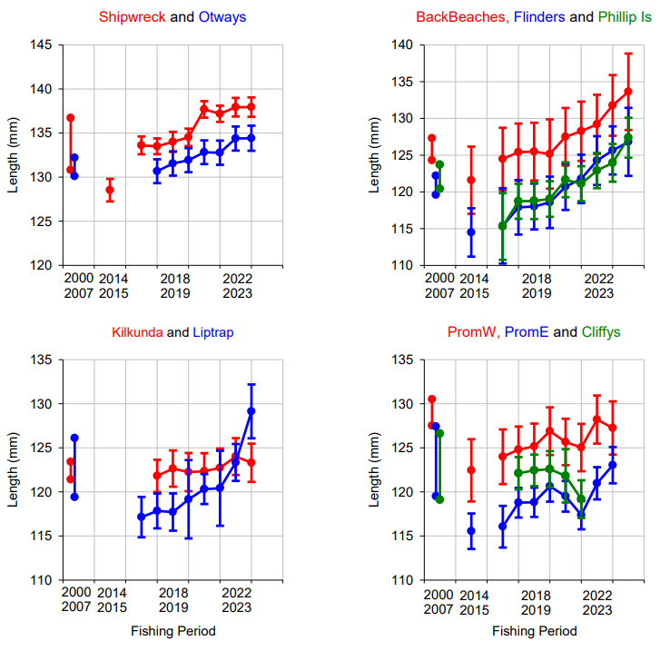

With the latest data in the most recent two Quota Years, the average length of abalone measured increased in all SMU with good data available, except Kilkunda where lengths were stable. Change in average length among adjacent SMU were similar, with strong inter-annual correlation at Flinders, Phillip Is and Back Beaches, in particular (Figure 1). Using the measured lengths to estimate weight, the weight of an individual abalone has also increased ranging from a >20% increase at Shipwreck and Liptrap to a >10% increase at Back Beaches, Flinders and Phillip Is, and a >5% increase at Otways, PromW and PromE, to a 6% decline at Cliffys (see also Figure 7). An increase in the average weight of individuals leads to fewer individuals being landed for the same catch or TAC. For example, at current average lengths, a 5 mm increase in length can increase weight by 11-13%, and so reduce abalone landed to catch the TAC.

This document provides estimates of trends in the average length of abalone for interpretation in stock assessment, ideally together with other indicators. Increase in average length are often a positive indicator for change in fishing mortality and the abalone stock. Despite that, interpretation of trends in average length can be confounded by several factors. For example, average length can increase with more larger abalone (e.g. from lower fishing mortality), or fewer small abalone (e.g. a decline in recruitment to the fishery). To investigate this, further analysis should develop other indicators from the length-frequency distributions, including change in the frequency of smaller and larger abalone (e.g. recent recruits compared to larger abalone, as is done in WZ) and their relationship with other stock indicators. Change in average length can also be impacted by change in the spatial distribution of catch and measuring. Effects of spatial change in the distribution of catch and measuring have been standardised by making comparisons through time at 134 Sites throughout CZ (i.e. averaging length within sites, not across them). Trends in average length can also be impacted by change in the minimum length limit (LML), diver’s daily catches and abalone size preference (e.g. market driven), and recent change in total catch and stock biomass (i.e. local and broader fishing mortality). For example, total catch in CZ in the 3 fishing periods prior to the start of the 2014-2024 measuring program was ~300 t, compared to ~240 t and below in the 3 most recent periods. Some SMU have also seen significant change in catch and LML over the 2014-2024 measuring program.

Importantly, the large reduction in catch during the 2020 calendar year (i.e. 109 t throughout CZ), coincident with Covid impacts and LML increases, appears to have strongly influenced the length of abalone in several SMU. Despite the range of possible confounding factors, ongoing increases in the average length of abalone landed, particularly when temporally consistent with reductions in catch (e.g. during 2020 and among years) and correlated among SMU, are likely to be associated with reduced fishing mortality (i.e. the relationship between total catch and the availability of legal-sized abalone and stock biomass). Further, an increase in the average length and weight of individuals also leads to fewer individuals being landed for the same catch. While changes in length appear to have gained momentum during 2020, it is also important that the increases in length continue through more recent years, including 2024-25.

*Effect of change in minimum size limits*

During the time covered by the measuring program the LML within many SMU has changed (see Table 2 for history of LML changes). To estimate the effect of the LML changes on the average length of abalone landed, the standardisation was calculated for abalone at the LML active in each year, and then repeated for all years at the current LML (i.e. 2022-23) for 5 selected SMU (Figure 2). Increases in average length for the active LML each year (i.e. coloured lines in Figure 2) were greater than those from the average length in each year above the current LML (i.e. black lines in Figure 2). This suggests increases in LML have increased the average length of abalone landed, as expected, but that increases related to the LML changes are small compared to the ongoing increases in length. There have been increases in average length in most SMU and years that have not been related to LML increases (i.e. black lines in Figure 2). As described above, there are a range of possible factors contributing to increases in average length, in addition to increased LML and spatial changes in effort (i.e. with some removed in standardisation), including reduced fishing mortality and other factors (e.g. recruitment changes and market preferences). Despite that, the consistency of patterns among SMU (e.g. particularly Flinders and Phillip Is) suggest broader-scale factors are also influencing the increase in average length within the CZ abalone fishery.

Historic length measuring data from 2002-07 were previously summarised using the 2019-20 LML, to aid comparison with more recent years. Since 2019-20, further LML changes have been made in several SMU, and the historic length-measuring data should be re-summarised consistent with the most recent LML. The historic length measuring data from 2002-07, also provides considerable information about the spatial location of the fishery in the early 2000s, to help interpret the spatial location of fishery-independent abundance survey sites.

Figure 2. Estimated effect of change in LML on trends in average length of abalone within 5 SMU. Coloured lines show length at the LML active in each year, and black lines show length above a constant minimum length equal to the LML in 2021-22 (i.e. Shipwreck 130 mm, Otways 125 mm, Back Beaches 119 mm, Flinders and Phillip Is 112 mm). The black line shows the estimated trend in average length if there was no change in LML.

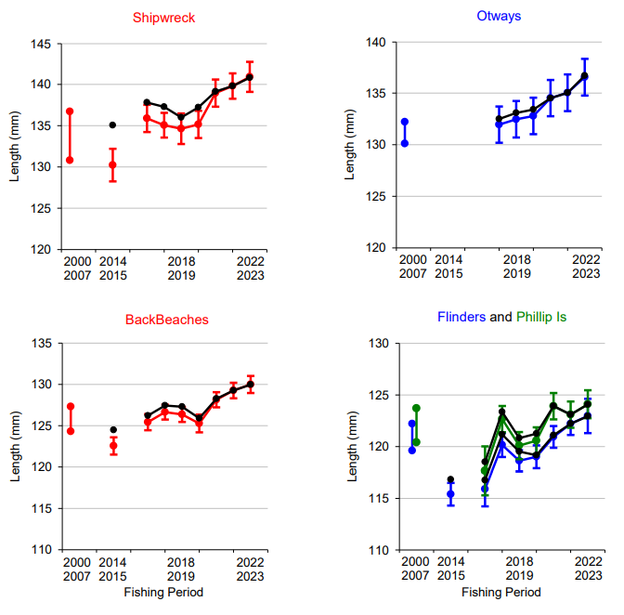

*Developing the approach to using length measuring*

This report has repeated the previous approach of standardisation developed in 2020, and applied in most years since then. As well as involving more divers in the collection of abalone length data while fishing, appropriate resources should be allocated to further develop and automate the approach for analysis and presentation of length measuring data in CZ. This should include development of indicators for smaller and larger abalone to aid interpretation (e.g. frequency of individuals near the LML, and length of abalone >20 mm above the LML), summary of historic data with current LML applied, greater consideration and development of spatial structure and the impact of both daily catch and total catch per SMU in recent years, and include more fine-scale assessment (e.g. Reefcode and below, and within years). There has also been interest in the development of approaches like SPR, that combine demographic models with observed length data to provide estimates of likely stock depletion and their relationship to target lengths. Two technical issues also need further investigation, and are highlighted in Figure 3. First, the potential for quarterly standardisation of data within the Back Beaches SMU on the left, and second, on the right the impacts of a potential malfunctioning measuring board are demonstrated at the Otways, and both need further investigation. For example, in several SMU, quarterly assessment of several fishery indicators, including catch, catch rate and lengths appear to show significant change in the stock, and particularly increase in average length, coincident with reduced catch related to Covid impacts during the 2020 calendar year (e.g. 27 t average catch per quarter in 2020, compared to 65 t for previous and subsequent 2 years) and LML increase (Figure 2). This quarterly change in fishery indicators in several key SMU, and catch at several spatial and time-scales (i.e. within 2020, and pre-2014 to recent years), each potentially related to reduction in fishing mortality suggested by the coincidence of reduced catch and increasing average length, does not appear to be considered in previous fishery Stock Assessment.

Figure 3. Trends in average length in two SMU, when standardised quarterly at Back Beaches, and when a possibly malfunctioning board is removed from the data set at Otways.

Significant resources have already been committed by Industry to the collection of data in the recent length measuring program for almost a decade, despite the significant reduction in resources in recent years. Appropriate resources should be devoted to this important program, particularly including the number of divers measuring abalone lengths, and also be used to allow better analysis, summary and use of the now large and growing data set. Change in the length of abalone observed in the measuring program for the CZ fishery are already significant for interpretation and understanding of the fishery and stock dynamics, at SMU, Reefcode and smaller spatial scales, as well as trends within and among years. There is very limited other data or stock indicators in areas frequently used by the fishery, and particularly with the Fishery Independent Survey sites not in areas frequently used by the fishery (i.e. as highlighter by FIS Review). As a consequence there is an urgent need to appropriately develop the length-measuring data and its interpretation into stock assessment approaches used by the fishery. An important part of this will be to encourage more divers to again ensure more abalone are measured throughout all SMU, and that appropriate resources are allocated for QA/QC, data management and analysis of this important data.

Table 1. Number of abalone measured within each SMU and Fishing Period from 2014 until December 2024, and used in the standardisation. Note, this includes filtering the lengths of abalone, and several other filters for sample consistency, including a spatial location within the Reefcodes and SMU (i.e. not a GPS outside the Reefcodes).

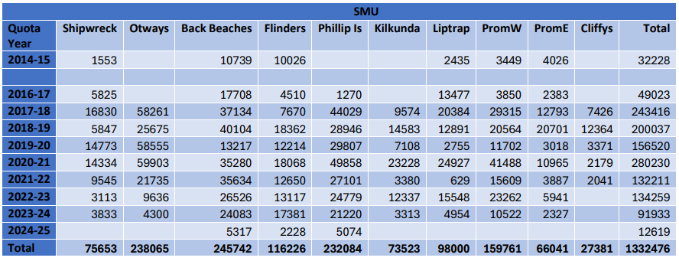

Figure 4. Trends in the raw average length of abalone landed for each SMU since 2014, with error bars showing SE (i.e. SD among means). The range of annual raw average length from the earlier 2000-2007 dataset are also shown for individuals above the size limits in 2019-20 (i.e. before the most recent LML increases).

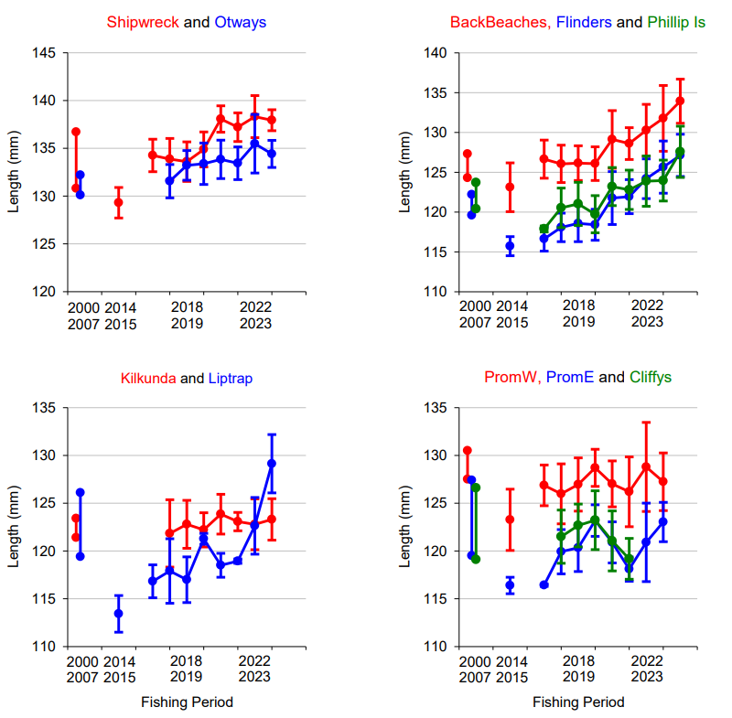

Figure 5. Standardised average length (+SE) of measured abalone by SMU.

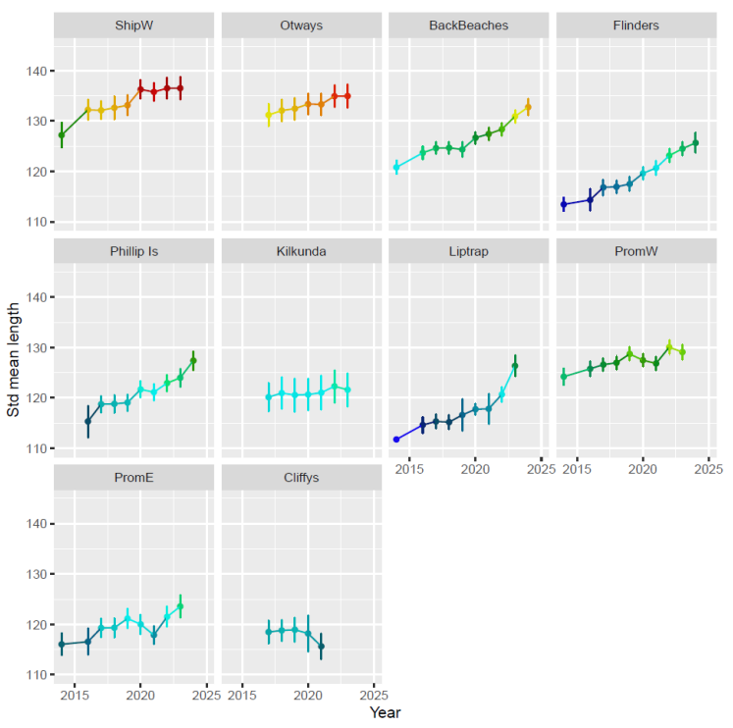

Figure 6. Standardised average weight of measured abalone by SMU, from standardised lengths and a length weight relationship.

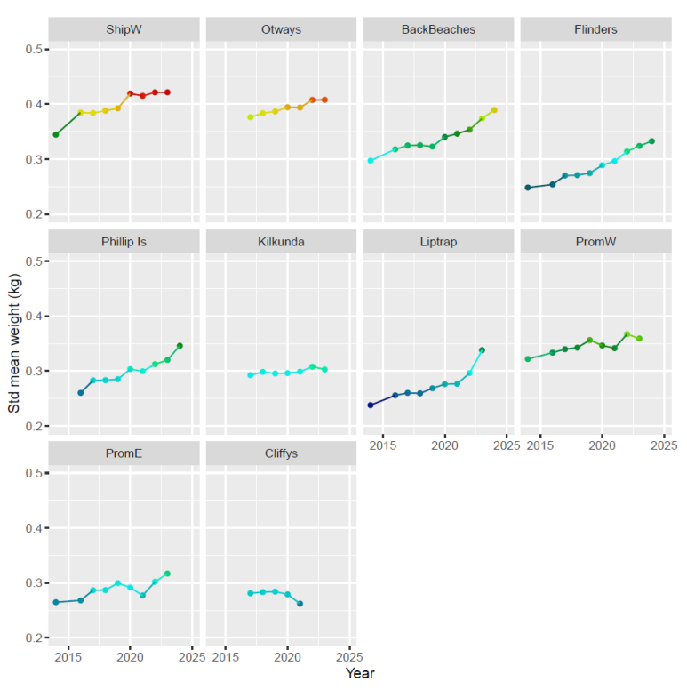

Figure 7. Standardised average weight change (i.e. as a proportion of those in 2016-17, shown by vertical blue line = 1.0) of measured abalone by SMU, from standardised lengths and a length-weight relationship. For example, the standardised average weight of an abalone measured at Flinders in 2024-25 is estimated about 25% larger (i.e. 1.25) than in 2016-17.

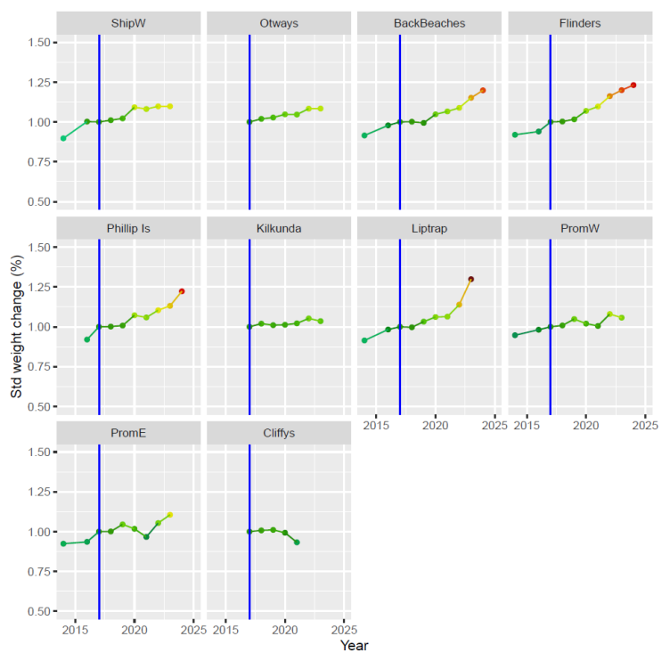

Figure 8. Estimated number of abalone per t of catch or TAC, from standardised length and weight of measured abalone by SMU.

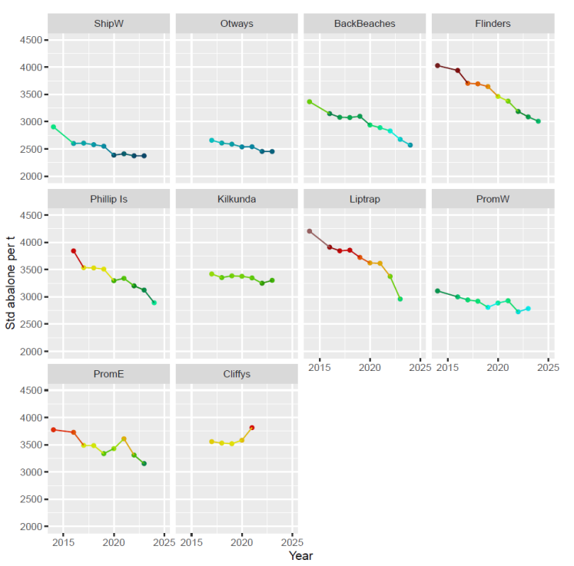

Figure 9. Length-frequency distributions at the scale of a site (i.e. SiteID 18) used for standardisation on the Back Beaches by Quota Year from 2017-2025, and with similar data from 2002-2007. Red text provides the number of abalone measured at the site each year, the number of diver-days, the average length, the length of the Top 10% (i.e. 90th percentile), and the % of abalone weight >400 g (i.e. using a length to weight relationship).

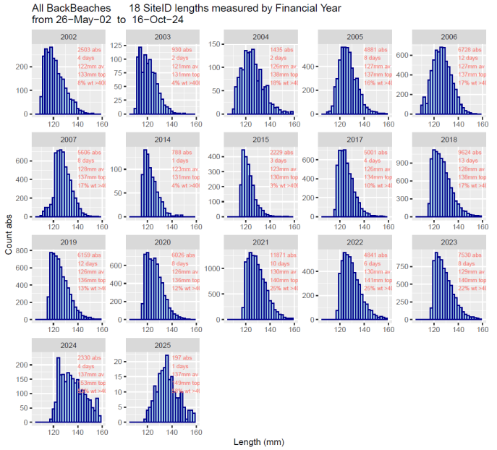

Figure 10. Raw average length per diver-day and site for measured abalone by SMU. Each dot represents a diver day within a defined site in each SMU with >30 measured abalone.

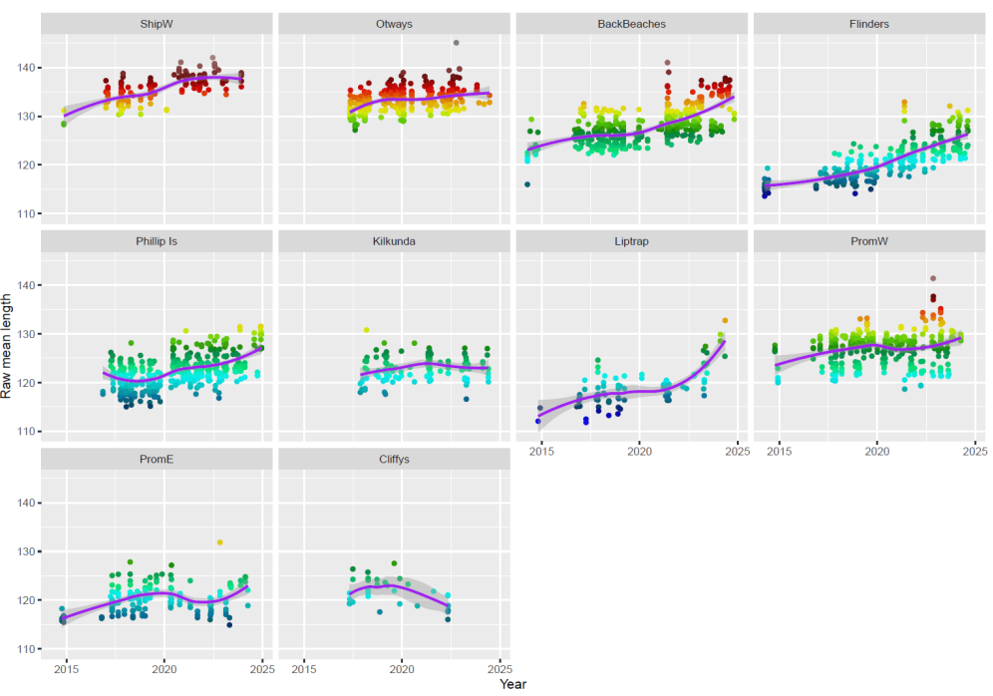



## Appendix 4: Summary of LML changes

Table 30: Summary of changes in LML for the Central Zone. All measurements are in millimetres. Multiple LMLs indicate different LMLs for reefcodes within an SMU.

| Date from | Shipwreck Coast | Cape Otway | Surf Coast | PPB | Back Beaches | Flinders | Phillip Island | Kilcunda | Cape Liptrap | Prom Westside | Prom Eastside | Cliffy Group |
| --- | --- | --- | --- | --- | --- | --- | --- | --- | --- | --- | --- | --- |
| 1 Apr 1998 | 120 | 120 | 110 & 120 | 100 | 110 | 110 | 110 | 110 | 110 | 110 | 110 | 110 |
| 1 Feb 2007 | 123 | 123 | 115 & 123 | 100 | 115 | 115 | 115 | 115 | 115 | 115 | 115 | 115 |
| 5 Mar 2009 | 123 | 123 | 115 & 123 | 105 | 120 | 115 | 113 & 115 | 113 & 115 | 105 | 115 | 115 | 115 |
| 1 Apr 2010 | 123 | 123 | 115 & 123 | 105 | 120 | 115 | 113 & 115 | 110 & 115 | 105 & 110 | 115 & 120 | 115 | 115 |
| 1 Apr 2012 | 123 | 123 | 110 & 123 | 105 | 120 | 115 | 113 & 115 | 110 & 115 | 105 & 110 | 115 & 120 | 115 | 110 |
| 1 Apr 2014 | 123 | 123 | 110 & 123 | 105 | 117 | 110 | 110 | 110 & 115 | 105 & 110 | 115 & 120 | 110 | 110 |
| 1 Apr 2016 | 123 | 123 | 110 & 123 | 105 | 117 | 110 | 110 | 110 & 115 | 105 & 110 | 115 & 120 | 110 | 110 |
| 1 Apr 2017 | 125 | 123 | 110 & 123 | 105 | 117 | 110 | 110 | 110 & 115 | 105 & 110 | 115 & 120 | 110 | 110 |
| 1 Apr 2018 | 125 | 123 | 110 & 123 | 105 | 117 | 110 | 110 | 110 & 115 | 105 & 110 | 115 & 120 | 110 | 110 |
| 1 Apr 2019 | 125 | 123 | 110 & 123 | 105 | 117 | 110 | 110 | 110 & 115 | 105 & 110 | 120 | 110 | 110 |
| 1 Apr 2020 | 130 | 125 | 110 & 123 | 105 | 119 | 112 | 112 | 115 | 110 | 115 & 120 | 110 | 110 |
| 1 July 2021 | 130 | 125 | 110 | 105 | 119 | 114 | 112 | 110 & 115 | 110 | 115 & 120 | 110 | 110 |